Creating and Using Logic Models
What is a Logic Model? A logic model is a visual way to illustrate how your project is intended to work. A project team can use it from the beginning to end of a project. As a project planning tool, a logic model can help clarify how the project will be implemented to accomplish intended results. It answers the questions: what resources are needed, what specific activities need to be carried out, what specific services or products needed to be developed or offered to ensure the desired outcomes or results become a reality? As a project management and monitoring tool, a logic model can help maintain accountability to the activities identified during the planning phase, as well as ensure the project stays on track during the implementation phase. A logic model is a living document that should be responsive to any changes a project may encounter that are outside the implementer’s control.
What are the Basic Components of a Logic Model? There are three basic components to a logic model:
- Resources or Inputs: the resources you expect to get (e.g., funding) or will need (e.g., staff) to successfully implement the project.
- Activities: the specific actions or steps you’ll take to implement the project. Activities usually result in specific products or services (e.g., training, mentoring, etc.) offered to project beneficiaries (these are usually called “Outputs”).
- Outcomes: the main reason you are implementing this project, i.e., what changes you expect to see because of project implementation (e.g., participants in training increase their level of awareness or knowledge or enhance their skills).
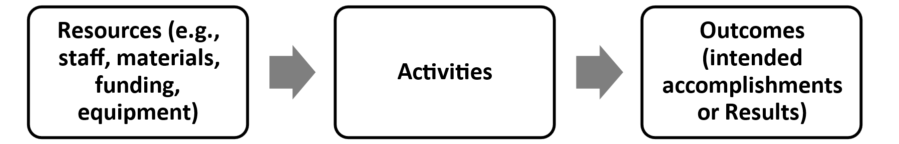
Developing a Logic Model: A suggested template is provided as a resource to develop a logic model. Key questions and prompts to guide developing a logic model include:
- What problem(s) is the project intended to address and who are the intended beneficiaries?
- What changes (outcomes) are expected because of project implementation?
- What specific activities need to be completed to ensure the outcomes are achieved?
- Looking at the activities identified, what resources are needed to successfully implement these activities?
- What assumptions are made about how the project is supposed to work (an example of an assumptions is: soft skills training leads to better employment and earning outcomes).
- Finally, what factors outside the control of the project may influence the achievement of the outcomes?

