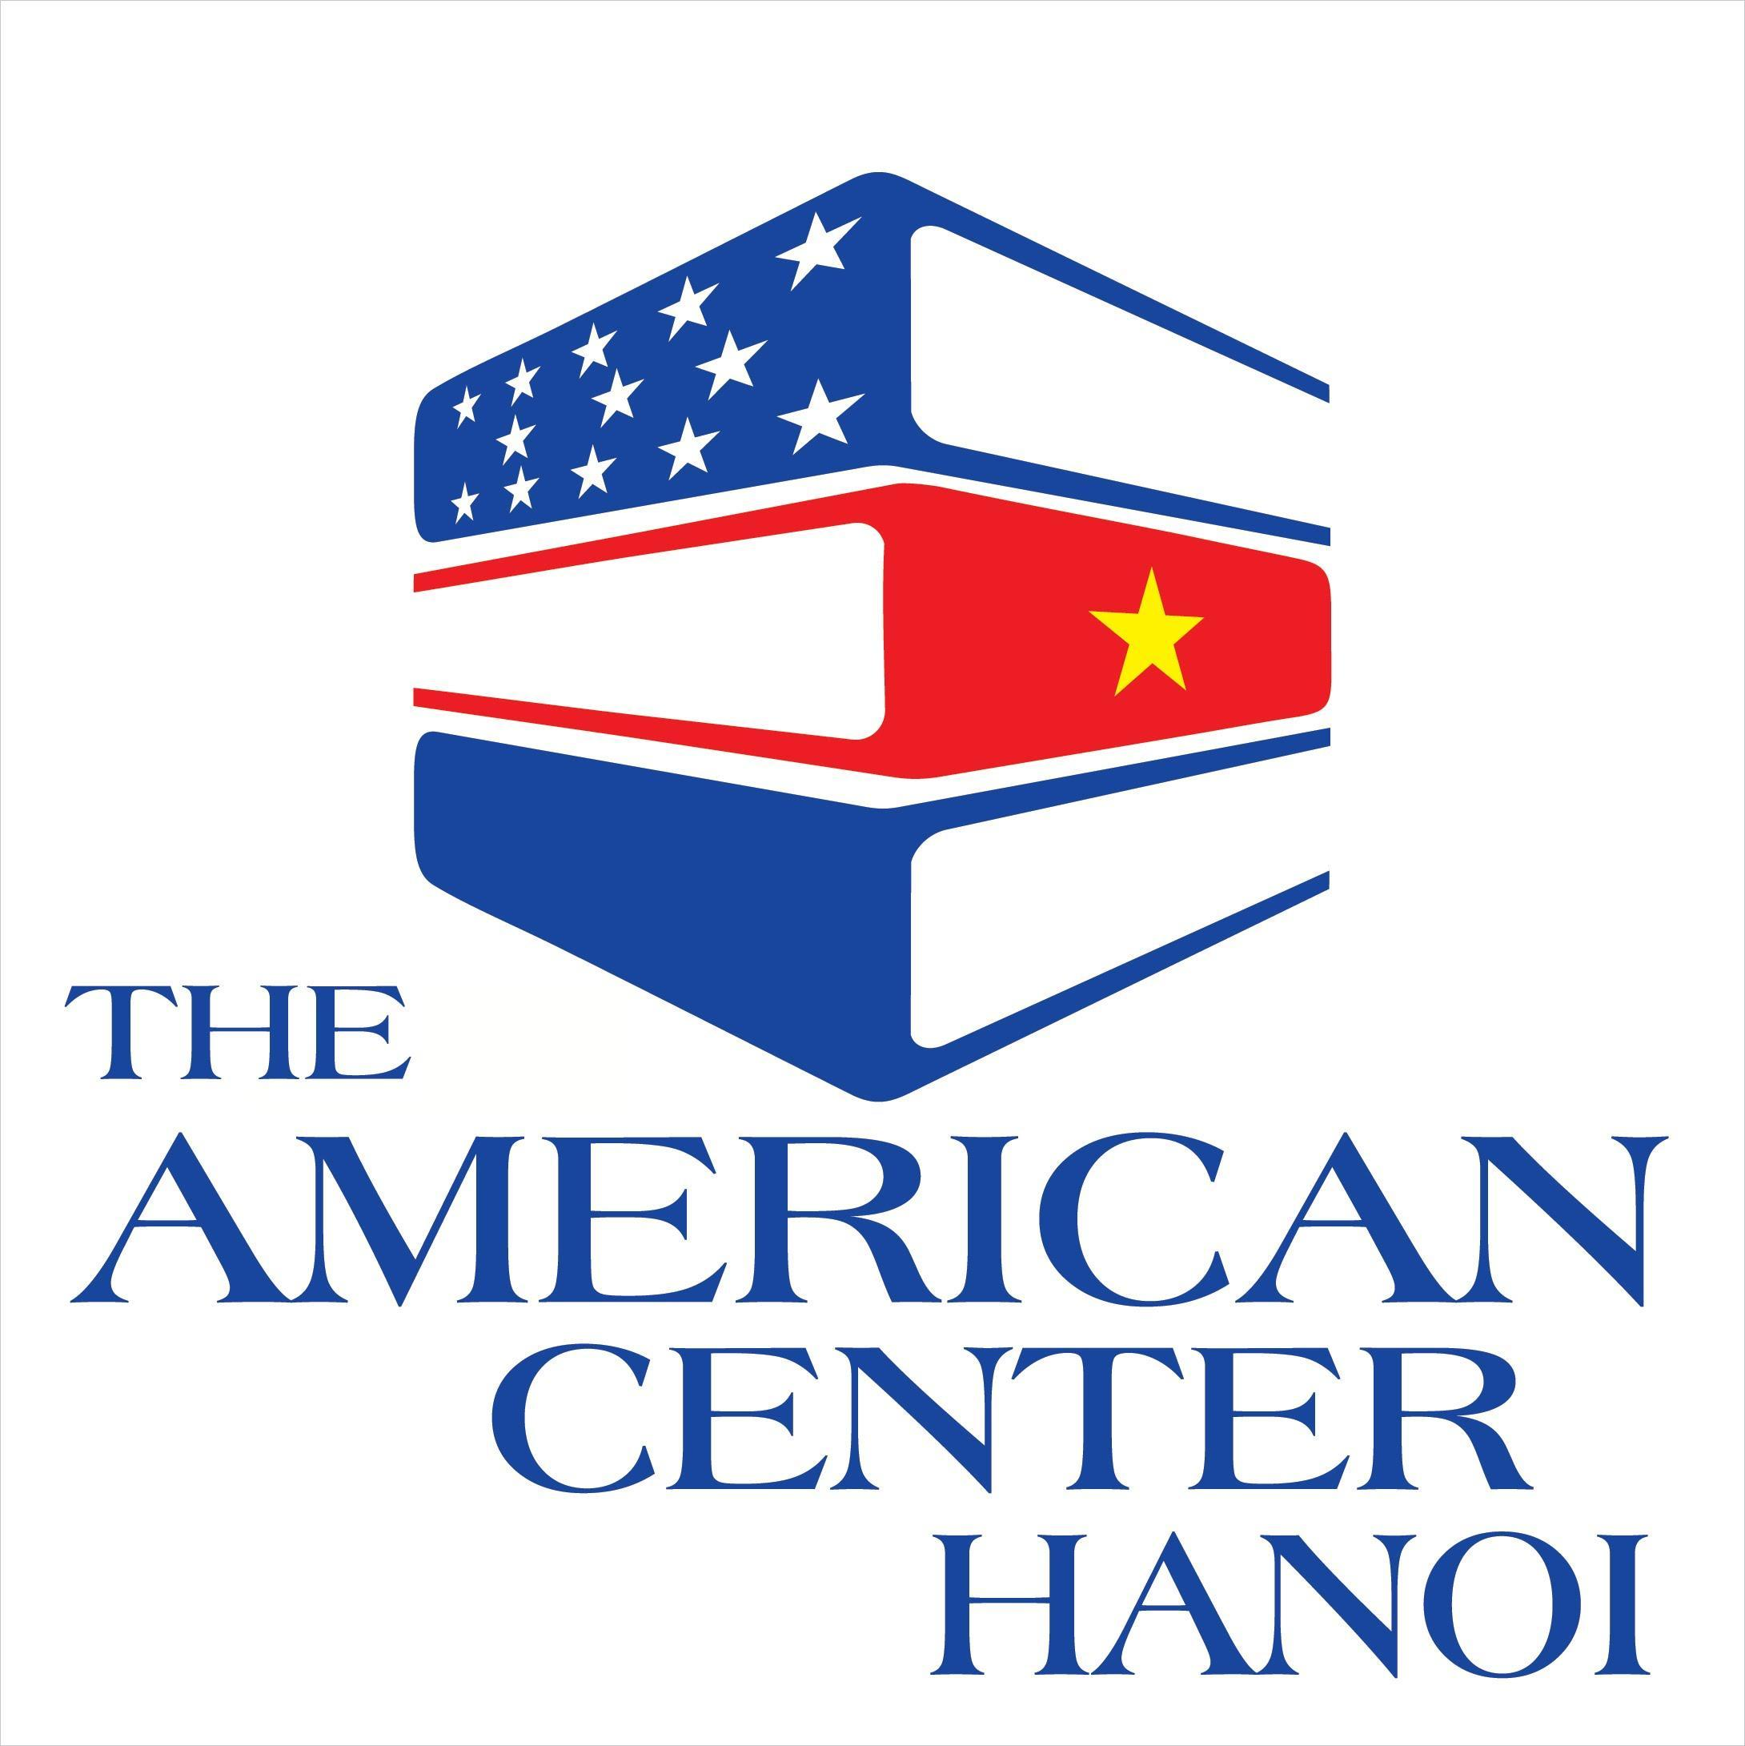
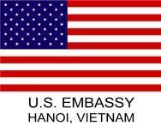
THE 2024 AMERICAN SPACES PROGRAM PROPOSAL
A – EXECUTIVE SUMMARY
Project Title
(less than 60 characters)
Project summary
Amount requested in U.S. Dollar
Amount of cost-sharing
(if any)
Source of cost-sharing
(if any)
Project Location
(could be held at the American Center or other place, please detail)
Number of direct audiences and who they are?
Date and Time to implement program
(Most of the American Spaces closes before 7p.m. and weekends)
Project Coordinator (POC to work with U.S. Embassy team)
Most recent grants received (if any), please list all | Project name:  Amount:  Date:
B - PROJECT DESCRIPTION
- PROJECT GOALS AND OBJECTIVES
Why do you want to implement this project? Please elaborate your project objectives
- AUDIENCE/BENEFICIARIES
The American Spaces audience is over 14 years old (If you want to benefit a younger age, please justify). Describe the specific audience for your program, project or event (e.g. university students). Then, provide information on the expected number of participants (i.e. organizers and audience), whether the event is closed or open to the public and whether you need assistance in recruiting participants.
- PROJECT FORMAT AND ACTIVITIES
What is the format of the event? How do you want to implement it?
- PROJECT TIMELINE
Please provide a basic project timeline, listing the main activities (Projects are expected to be held after Sep 2024, if you want an earlier time, please specify)
- JUSTIFICATION
Why do you believe your program will be effective? Why do you think your team or organization can run the program successfully? Please include information about project partners in this section.

- PROJECT EVALUATION
How will you evaluate the success of the project, including sustainability? Please provide indicators of success and potential risks associated with your project.

- MONITORING PLAN
Please select your preferred monitoring plan to update the U.S. Embassy on the project progress. Please note that your preferred plan will be subject to final approval by the U.S. Embassy. You must select at least two:
☐ Assessment survey
☐ Site/Event visit
☐ Phone call
☐ Email
☐ Others
- REPORTING PLAN
Please indicate how many Program Performance and Financial reports you plan to submit based on the timeline of your proposal, besides the final report which is mandatory. For some programs, you are required to submit quarterly reports. Please note that alternate reporting schedules require U.S. Embassy approval.
C – PERSONNEL
If you are submitting the proposal as an organization, please provide:
- background information about this organization and the organization website
- list similar programs you implemented in the past year. Mention any implementing partners you had. Feel free to include links to media coverage of your past programs or social media pages that capture your programs - if available
- Do you have an active SAM registration? ☐ Yes ☐ No

D – OTHER REQUIRED DOCUMENTS
- SF424 Form for Organizations, SF424A, SF424B
- Budget Narrative
- CV/Resume of key personnel who are proposed for the program
- Proof of SAM registration (Organizations only)

Complete these forms and Submit your application package via this link: https://bit.ly/3T4RlNp by 11:59 p.m., June 17, 2024 (Vietnam time)

Visit U.S. Embassy website for more details: https://vn.usembassy.gov/education-culture/grants-and-scholarship-opportunities/

Three-sentence summary on project's goals, activities, implementers, partners, target audiences/beneficiaries and number, and duration (up to 1 year), etc.

