Farmers’ Market Promotion Program (FMPP) – 2015
APPLICATION NARRATIVE FORM AND INSTRUCTIONS

This narrative form, including Appendix A, is mandatory. Thoroughly review the FMPP Request for Applications before completing this form.

- Project Title:
Must match title on SF-424 Form.

- Organization Name:  Email:  Phone:  Fax: |  |  |  | Mailing Address:
- Authorized Representative Name:  Email:  Phone:  Fax:  This person will be the main contact for any FMPP correspondence and is responsible for signing any documentation should the grant be selected. |  |  |  | Mailing Address:  ☐ Check if same as #2 above.
- Project Implementation Physical Address (record as many as applicable):
Address 1: |  |  | Address 2:
- Requested FMPP Funds:  Indicate the dollar amount (in whole dollars) of Federal funds requested. This must match the total amount provided in the Budget form. |  |  | $
- Entity Type: (Refer to the “FMPP Request for Applications” for definitions of each eligible entity type.)
☐ Agricultural cooperative  ☐ Nonprofit corporation  ☐ Local government  ☐ CSA association  ☐ Tribal government  ☐ Producer network |  | ☐ Producer association  ☐ Public benefit corporation  ☐ CSA network  ☐ Economic development corporation  ☐ Regional farmers market authority  ☐ Agricultural business entity
☐ Other (please specify): __________________________
 | Executive Summary: In 200 words or less, describe the project’s need and purpose, its goals, expected outcomes, and a timeframe for completing all activities.

Project Background:
- How will the project improve the situation/condition in the area/community?
- What are the project objectives (please list)?
  - Objective 1:
  - Objective 2:
  - Objective 3:
  - Objective 4:
  - (Add other objectives as necessary)
- Could you describe how this project will increase domestic consumption of and access to locally and regionally produced agricultural products?
- Could you describe how this project will develop, improve, and expand market opportunities, outreach, training, and technical assistance for farm and ranch operations serving domestic farmers’ markets, roadside stands, community-supported agriculture programs, agritourism activities, and other direct producer-to-consumer market opportunities?

 |  | Work Plan, Resources, and Timeline Requirements: Fill out the table as described below.
 |  | List and describe each planned activity (scope of work) including how it relates to the project objectives: | Anticipated date of completion: | Resources required to complete each activity: | Milestones assessing progress and success of each activity: | Who will do the work (include collaborative arrangements or subcontractors)?
 |  | Sample Activity 1 | October 2016 | Hire contractor  Special equipment | Milestone 1: Complete XX assessment  Milestone 2: Initiate XX equipment purchases | ABC Best Contracting Service  XYZ Company’s Executive Director
Expected Outcomes and Intended Beneficiaries:
- If the project completes its objectives, what results will be observed?
- Who are the intended beneficiaries?
- How will you evaluate the project benefits while the grant is in progress and upon grant conclusion?
- Using the quantitative metrics below, describe the expected outcomes of planning, developing, improving, and/or expanding a local or regional food business enterprise.
- Number of direct and indirect jobs retained and created:
- Number of markets expanded and/or new markets established, or expansion of the consumer base served:
- Dollar amount and percentage change in market sales:
- Number of farmer/producer beneficiaries:

Outreach:

- How will you disseminate project results electronically and/or in person to the target audience, stakeholders, and interested parties beyond those directly served by the project?
- How will you collect feedback on the results?
- How will outreach continue beyond the performance period of the project?

Budget Justification:

- Summarize how the project purpose/goals/objectives correlate with the requested budget line items on the completed “FMPP Project Budget” form (i.e. summarize what reviewers will see on your budget form—do not copy/paste the actual budget):
- How is the requested budget both reasonable and adequate for the proposed project?
- If you are using contractors, have you or will you use your own documented procurement procedures that reflect applicable State, local, and tribal laws and regulations provided they conform to applicable Federal law and the standards identified in 2 CFR §200.318? ☐ Yes ☐ No
- Are you expecting any program income (refer to 2 CFR §200.307) ☐ Yes ☐ No
  - Any generated program income you accrue during the period of performance must be used to further the purpose of the project. If you expect to generate program income explain how the funds will be used to further the project purpose:

Previous and Similar USDA Funding Opportunities:

- Have you submitted this project to another Federal grant program other than the FMPP for funding and/or is another Federal grant program other than the FMPP currently funding the project?
☐ Yes ☐ No
  - If so, identify the Federal grant program by name; describe how this proposal builds on the project funded by the other Federal grant program(s) (e.g. Local Food Promotion Program, Value-Added Producer Grant, etc.); and describe how this project is distinctly different.
  - If this project builds on a previously-funded FMPP project, how does this new FMPP proposal relate to the previous work and how is the project distinctly different? Answer “not applicable” if necessary.
Priority Project Selection: Priority will be given to project proposals that are located in and/or serve populations in at least one area of concentrated poverty with limited food access. However, it is NOT A REQUIREMENT that your project is associated with a low income/low food access priority area. All projects will be evaluated equally among the peer reviewers regardless of priority area. Priority selection will only be used by AMS should the targeted number of priority area projects not be met (refer to Section 1.4 in the Request for Applications).

Should USDA consider the project proposal under a low income/low food access priority area?
☐ Yes ☐ No

See instructions below on how to determine if you qualify for a priority area based on the Food Access Research Atlas* or a Promise Zone**.

Provide the following information for at least one community organization that the planning grant project will benefit:

☐ Check if same address as #2 above.
Name of Business or Organization:
Street Address:
City: State: Zip Code:
Email: Phone:

If using the Food Access Research Atlas to qualify, list the census tract(s) from the Atlas to identify the business/organization location(s) and/or targeted community/area(s): ________________________________

If qualifying based on your partnership with one of the five Promise Zone Lead Applicant Organizations, indicate the specific Zone: ________________________________

*Qualifying for priority consideration using the ERS Food Access Research Atlas (Atlas) at (http://www.ers.usda.gov/data-products/food-access-research-atlas.aspx):

Once you enter the Atlas, check one of the four the map layer(s) that applies to the proposal’s targeted community.
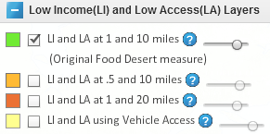
Zoom in on the map to identify your community. Clicking on your targeted area will produce the census tract and additional information about the locale.

In the example below, the dark green area qualifies as low income and low access, and the census tract would be 35047957600.

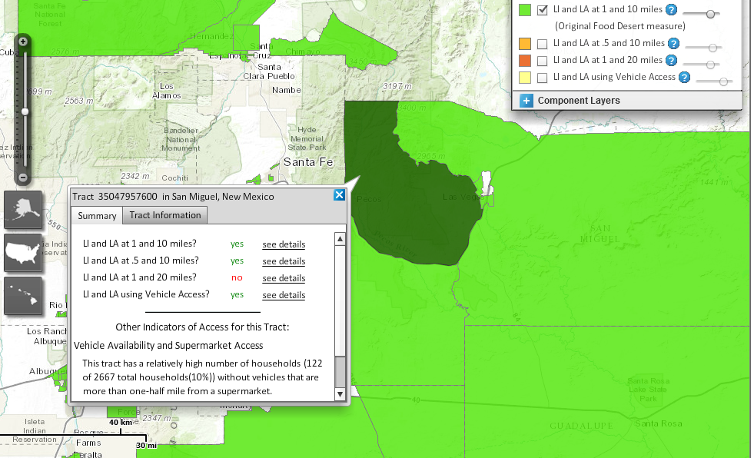

**Qualifying for consideration as a Promise Zone Lead Applicant Organization:

Identify the specific Promise Zone area in which your project will be implemented. Promise Zones identified by the White House are listed on the Department of Housing and Urban Development website: http://portal.hud.gov/hudportal/HUD?src=/program_offices/comm_planning/economicdevelopment/programs/pz. You may use 2014 or 2015 locations.

As stated in Section 4.3.8 of the RFA, attach a letter (on letterhead stationery) from and signed by the Promise Zone Lead Applicant Organization that certifies the partnership. The letter must include:
- The name of the organization applying to LFPP;
- The name of the project being implemented in the Promise Zone;
- The expected benefits of the project to the Promise Zone area;
- A statement expressing the nature of the partnership.

After completing the FMPP Grant Narrative form, submit this form with the following additional items. Items marked with an * ARE REQUIRED.

- *SF-424 “Application for Federal Assistance”
- *SF-424B “Assurances – Non-Construction Programs”
- *AD-3030, Representations Regarding Felony Conviction and Tax Delinquent Status for Corporate Applicants
- *AD-3031, Assurance Regarding Felony Conviction or Tax Delinquent Status for Corporate Applicants
- *FMPP Project Budget
- Promise Zone Lead Applicant Organization Letter (if applicable)
- Letter(s) indicating Critical Resources and Infrastructure are in place (if applicable)
- A copy of your approved indirect cost rate proposal if you are charging more than 10% indirect costs. Refer to section 4.7.1 of the RFA for further explanation, if applicable.
- Additional Supporting Documents, as necessary. May include:
  - Letter(s) of Commitment from Partners, Cooperators, and Contractors
  - Letter(s) of Support from Stakeholders or Beneficiaries
  - Personnel Qualifications – maximum 2 pages

