Systems Workshop Restitution Notes
To provide additional qualitative context to the development of the PAD and the eventual regional APS statements, USAID/Morocco conducted systems workshops in the target regions of Marrakech-Safi and Beni Mellal-Khenifra.
The objective of the workshop are to
- Better understand the system and enabling environment for economic growth and local governance
- Identify opportunities and context to help operationalize and implement recommendations in the PDR and other identified priorities
These workshops facilitated the mapping of the regional systems for local governance and employment using a systems thinking methodology. Participants mapped the systems for these thematic areas by identifying parts of the system, defining the system boundary and elaborating the relationship between the parts of the system. The systems maps
- Frame opportunities and challenges the system presents for the implementation of the recommendations and programs identified in the regional development plans (PDR).
- Identify additional priorities not necessarily identified in the PDR. It should be noted that not all stakeholders are aware of the PDR and its content.
- Learn about existing initiatives that the new program can build on
- Identify champions to continue to engage in the future.
- Introduce participants to systems thinking
During each workshop, small groups worked to create maps for the systems for local governance and employability. After this, the groups considered potential opportunities and challenges for the implementation of development programs in the region taking into account the systems.
The following notes provide highlights of the group restitution which explains the systems maps and outlines the identified opportunities and challenges for implementation of development programs.

Marrakech-Safi
In Marrakech-Safi, 28 workshop participants representing 21 organizations created systems maps around employment (2 groups) and local governance (2 groups).
Governance Group 1

The regional council is the central point of the governance in the region, highlighting its importance as the primary communication point for governance. The map highlights that there is a limited working relationship between the appointed officials at the local level and the regional council and elected officials. Provincial and communal councils also enjoy a strong, multi-directional relationship with each other in addition to the region as a supervisory body.
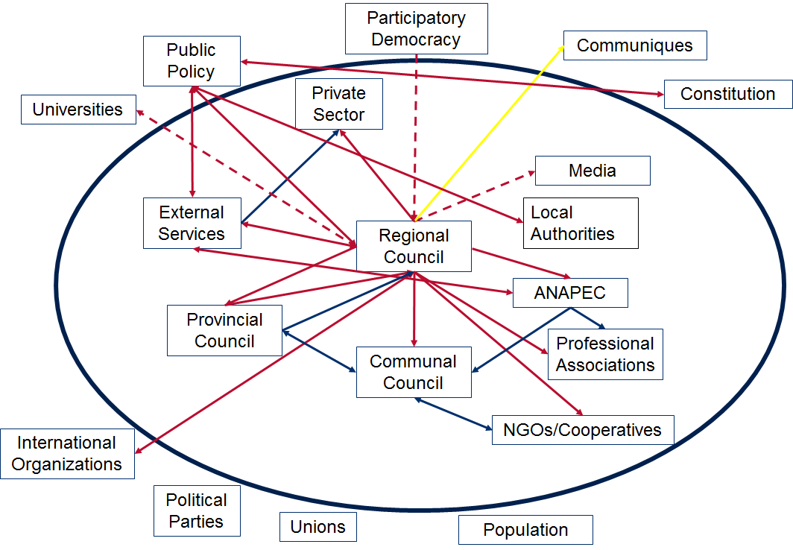

Governance Group 2
The second map highlights different characteristics of the relationships between key actors in the system, including direct/indirect and strong/weak relationships. This group’s takeaways focused on the role of elected officials. They highlighted elected officials:
- Have the power to make decisions and are often not consultative in this process.
- Have a direct relationship with citizens and CSOs
- Local elected officials have a stronger relationship with citizens than provincial or regional councils
- Lack coordination with other stakeholders

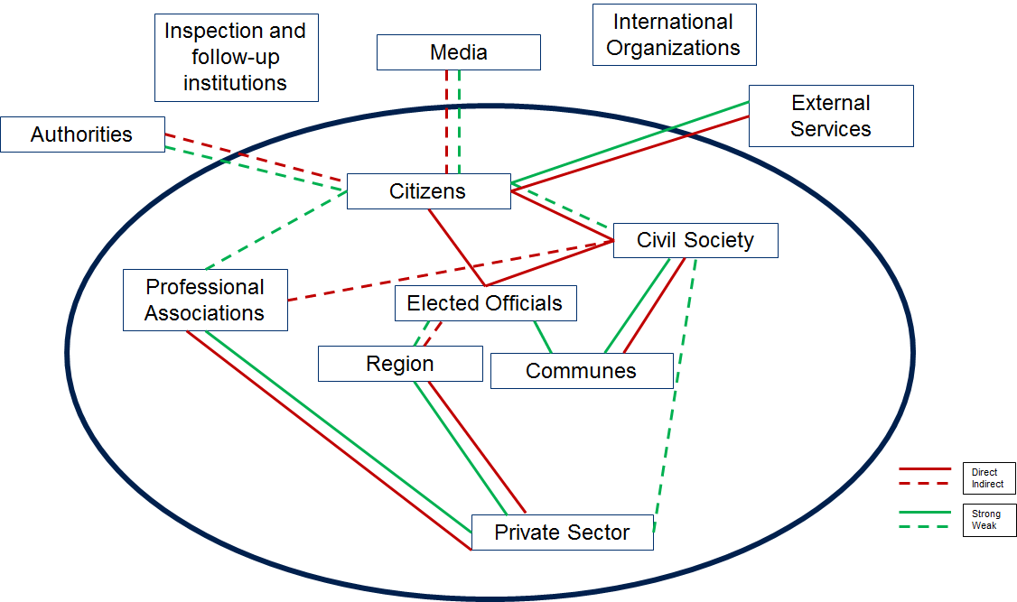

Employment Group 1
The two employment groups yielded different maps, with the regional council participants placing the regional council at the center of the map and the other group presenting a more decentralized, siloed system.

In the first map, the regional council acts as a spoke holding relationships with various actors throughout the system including local government, the private sector, ANAPEC, OFPPT, professional associations, civil society, universities, the education system, and civil society. This places the region as the primary actor responsible for economic growth.
This group also highlighted challenges with intraregional coordination and implementation of the increased role of elected officials in the region as key challenges to the implementation of a regional plan. One suggestion of the group is to create an entrepreneurial ecosystem that includes a pilot platform for support to entrepreneurs.
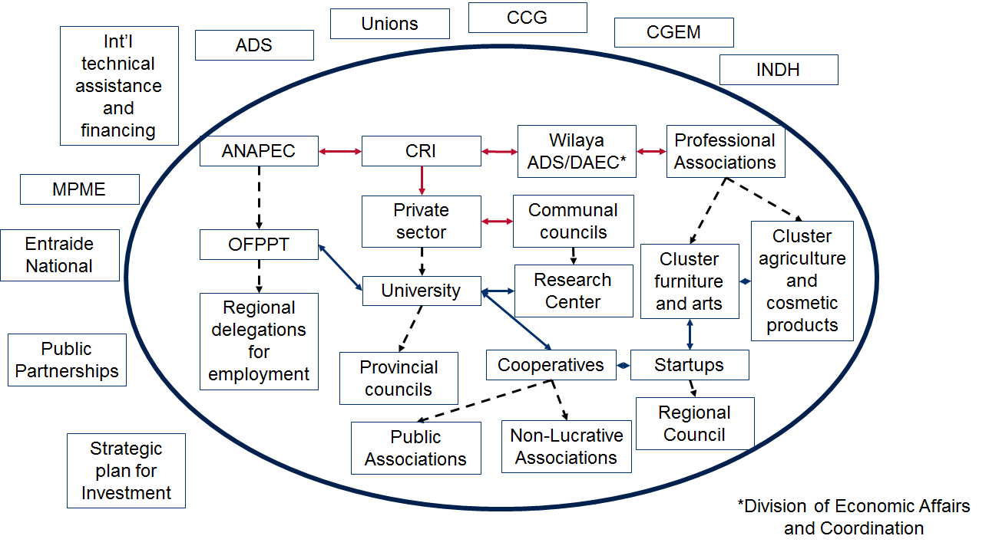

Employment Group 2
The second group highlighted a more siloed system for employment in the region, including 4 key actors; the Wilaya, professional associations, CRI, and ANAPEC. In this map, the actors in the ecosystem are not well connected highlighting the challenges with coordination and communication.
Programs for improvement of employment in the region are yet to be launched with the exception of Morocco Small to Medium Enterprises (SME).
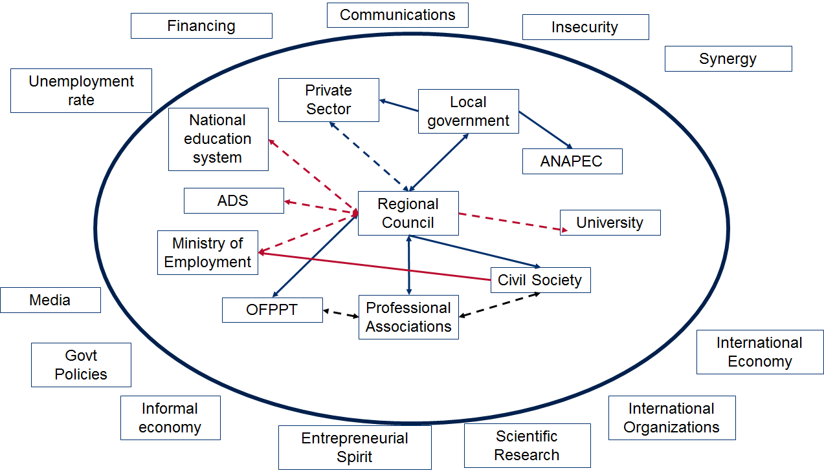

Groups in Marrakech focused on providing opportunities and challenges to the implementation of the programs laid out in the PDR. Lack of coordination and an existing expertise/capacity were raised by all groups as key challenges to the implementation of programs for development.

Specific recommendations include:
Program | Opportunity | Challenge
Value added tourism | Tourism infrastructure (including existing sites) &  Human resources | Insufficient road infrastructure, absence of a clear strategy, lack of coordination between stakeholders, lack of expertise in tourism sector
Promotion of regional entrepreneurship | Regional initiative, natural and agricultural resources, industrial zones, population and tourist market | Lack of independence in implementation of regional programs, absence of coordination between region and central level, multiplicity of actors, informal sector, gap between education and job market
Creation of logistics zones and agropoles |  | Accessibility, water shortages

Beni Mellal-Khenifra

In Beni Mellal-Khenifra, 25 workshop participants representing 17 organizations created systems maps around employment (2 groups) and local governance (2 groups).

The first group focused on governance places the Wilaya as the focal point with relationships to most actors within the system, including the three levels of elected government, central level ministries, and the center for regional investment. Of note, these relationships are one directional from the Wilaya to the other actors but not the other way around. Key external influences include the directives, laws, and speeches which shape national policy that influence the region but are outside of the region’s control. This group highlighted one major challenge in the system is a capacity deficiency of elected officials.

Governance Group 1
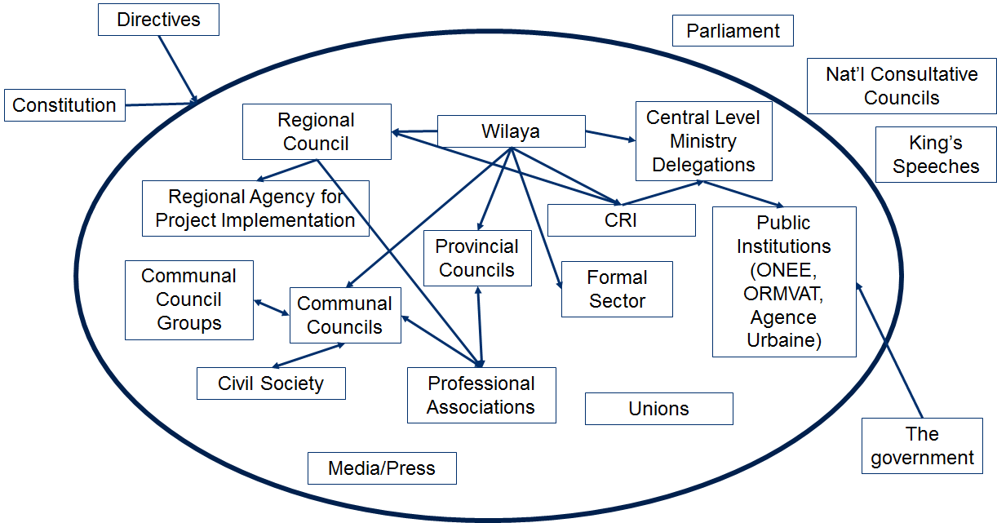

Governance Group 2
Unlike the first group, the regional council is the focal point for governance in this systems map. Of note, these relationships are one directional from the regional council to the other actors but not the other way around. There are weak relationships between the regional council and the media and universities. There is also a strong, multi-directional relationship between elected and appointed officials.
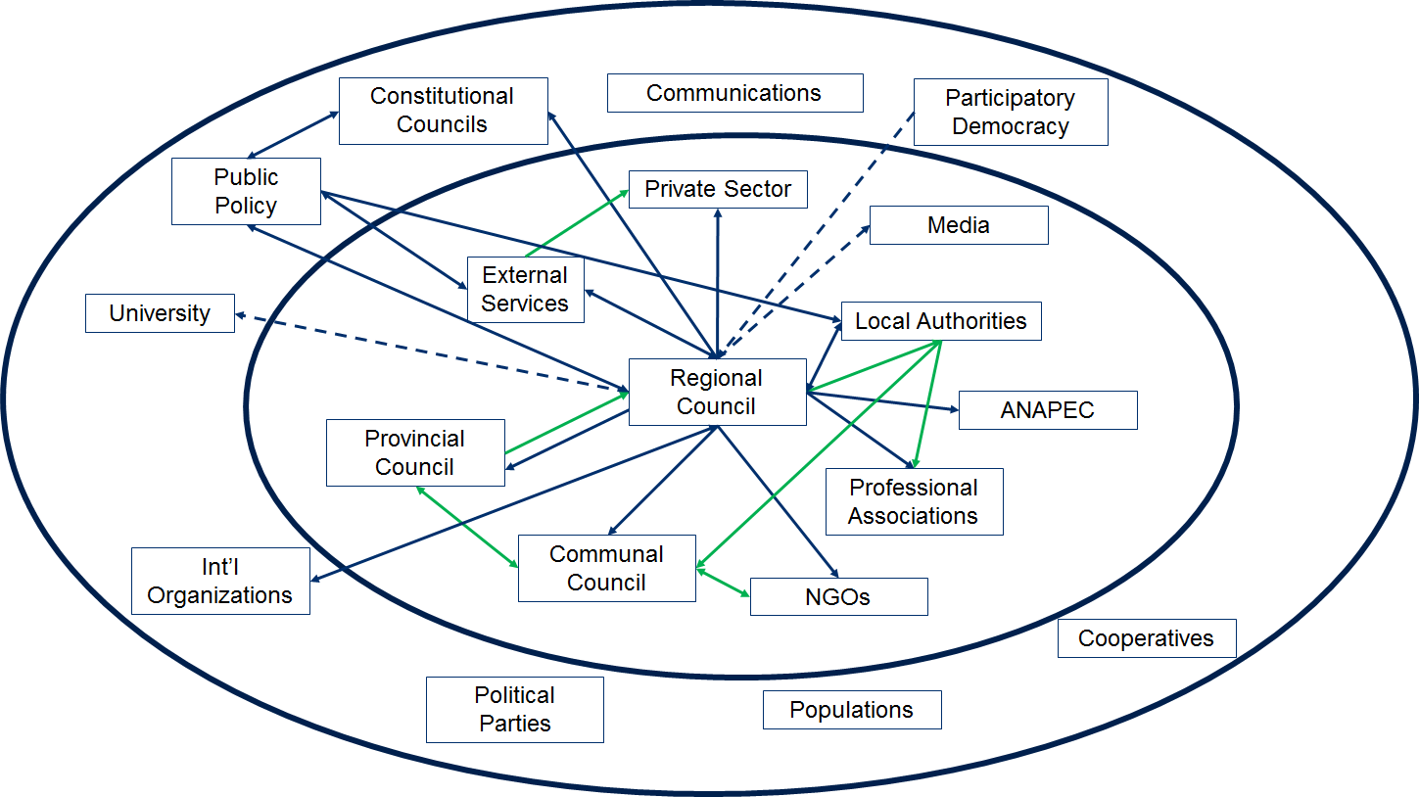
Employment Group 1
The first employment group place the private sector as a key player in employment within the region. As an actor within the system they have relationships with the public sector, elected officials, training institutions and job placement organizations. The map highlights how the elected officials serve as the contact point between the system and relevant regulations what are external. The region also highlighted the importance of macroeconomic factors that play a role in the region which is largely reliant on agriculture for employment and economic growth.

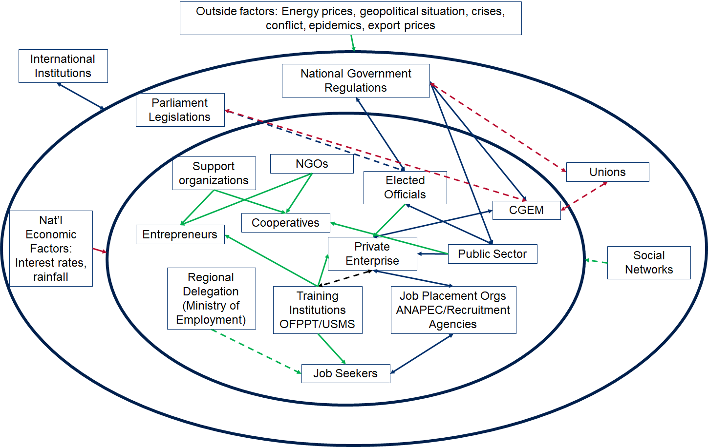

Employment Group 2
The map of the employment system in the region highlights the lack of connections between actors within the region. Key actors focused on employment and employability are not connected including ANAPEC and higher education organizations. Agricultural enterprises, a key economic driver in the region, has strong connections to the private sector and banks, but there not the elected or appointed government and regional investment center. This group highlights the Wilaya as a key actor in the region who holds relationships with the regional council, CRI, and institution which help prepare youth for employment.
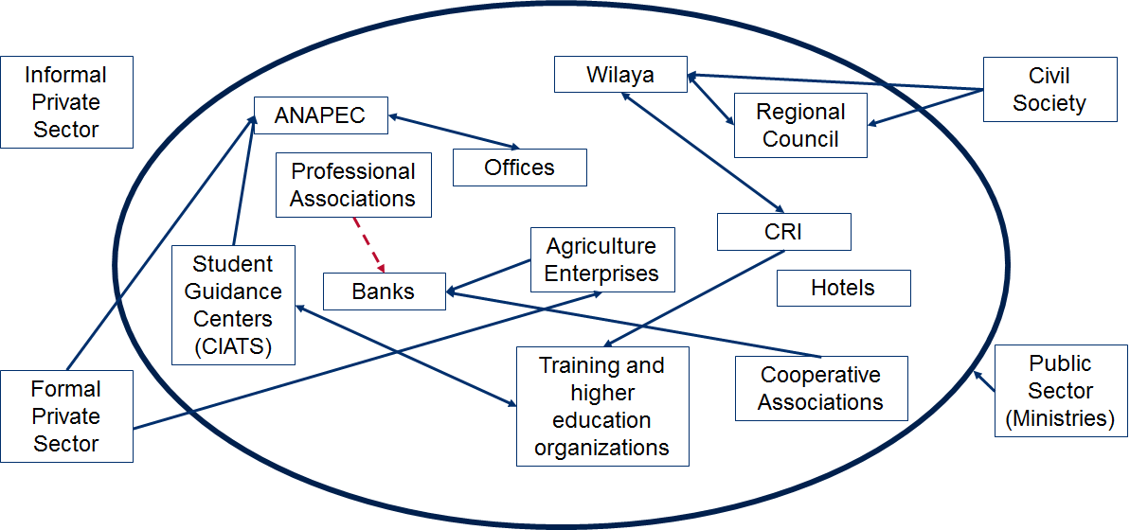

Groups in Beni Mellal focused on providing opportunities and challenges to the implementation of the development in the region.

Specific recommendations include:
Program | Opportunity | Challenge
Promote investment in natural resources, tourism and infrastructure (Agropole, medical sector) | Strategic geographic location,  Existing agriculture and tourism industries,  Focus on emerging industries such as agro-industry and renewable energies, | Challenges with delivery of quality, key services such as schools and health,  Lack of enterprise services available
Promote entrepreneurship  (service, internet based jobs, support industries for private sector businesses) | Youth, Marocains du Monde, Students and interns, universities that can facilitate applied research and trainings in entrepreneurial spirit | Lack of entrepreneurial spirit within students, lack of services for entrepreneurship at universities, lack of access to finance mechanisms for youth
Create and reinforce ecosystems for large businesses already in place or under development (OCP, CONSUMAR) | Strategic geographic location,  Existing agriculture and tourism industries,  Focus on emerging industries such as agro-industry and renewable energies, | Unclear position of the regional council within the system for employment,  Lack of enterprise services available

Axe 1 – Promotion de l’investissement

Potentialités :
· Ressources naturelles (hydriques, agricoles, sites touristiques)
· Position géographique stratégique au cœur du Maroc
· Patrimoine culturel riche
· Projets structurants (Agro-pôle, aéroport international, autoroute …)

Opportunités :
· Consolider les secteurs classiques : Agriculture et tourisme
· Appuyer les secteurs émergents : Agro-industrie, énergie renouvelable
· Développer de nouveaux secteurs à forte valeur ajoutée : en rapport avec les Métiers Mondiaux du Maroc (MMM)

Contraintes et opportunités d’amélioration :
· Améliorer le cadre de vie : Ecoles, santé, loisirs, shopping, cadre urbanistique, animation culturelle …)
· Développer les services aux entreprises : conseil, laboratoires, certification, agence de communication, emballage, maintenance industrielle, solutions numériques …
· Définir un positionnement de la Région et communiquer sur ce positionnement
· Créer et renforcer les Ecosystèmes autours des grandes unités installée ou à installer dans la Région (OCP, COSUMAR …). Exemple : Projet du « Fertiparc » et de la zone industrielle intégrée mise en place par le l’OCP.

Axe 2 – Promotion de l’entrepreneuriat

Potentialités :
· Bassin important de jeunes
· Bassin de MDM (Marocains Du Monde)
· Important nombre d’étudiants et de stagiaires

Opportunités :
· Opportunités dans les services aux personnes
· Opportunités dans les services aux entreprises è réseau de prestataires pour les grandes unités (écosystème)
· Opportunités dans les nouveaux métiers du Web.

Contraintes et opportunités d’amélioration :
· Stimuler l’esprit entrepreneurial, surtout dans le milieu estudiantin
· Renforcer les services d’incubation chez l’université
· Encourager l’innovation et appuyer les travaux de recherche appliquée
· Faciliter l’accès des jeunes à des mécanismes de financement

