U.S. Department of State
Bureau of Western Hemisphere Affairs (WHA)
Capacity Building for GBV Survivor Support Service Providers in Latin America and the Caribbean
SFOP0006940

Questions and Answers for Notice of Funding Opportunity
June 19, 2020

Q1. Support to designated countries. Is it necessary to propose activities in every country within each group (high-income and low-income countries)? Can we propose activities in one or two countries of each group?

A1. It is not necessary to include every WHA country within each group (high-income and low-income) in your proposal. Proposed activities can occur in one or two countries of each group, but preference is for a regional proposal with activities in multiple WHA countries.

Q2. Support to designated countries. Can some of the countries participate in only some of the activities carried out by the program? Can we propose that countries participate in a differentiated manner regarding activities? Are you looking for all activities to be implemented homogeneously?

A2. Activities do not need to be implemented homogeneously and can be sequenced in your proposal. All selected WHA countries should be involved in all four project objectives to an extent but countries to not need to overlap on all activities. Beneficiaries from different WHA countries could be included in objective 2 & 4 and do not need to overlap.

Q3. Target population. Can police forces be considered within the target institutions? *Given that police are usually the first responder for GBV victims, we consider that their inclusion would be very beneficial to achieve the program’s objectives.

A3. No, police forces cannot be considered for this opportunity. Other first responders such as Fire Departments, women’s shelters, health care providers, and others could be considered.

Q4. Organizational and Record of Performance. Can we have access to the methodology with which the institutional resources will be scored as adequate and appropriate?

A4. See page 13 of the WHA NOFO for criteria breakdown, and below.
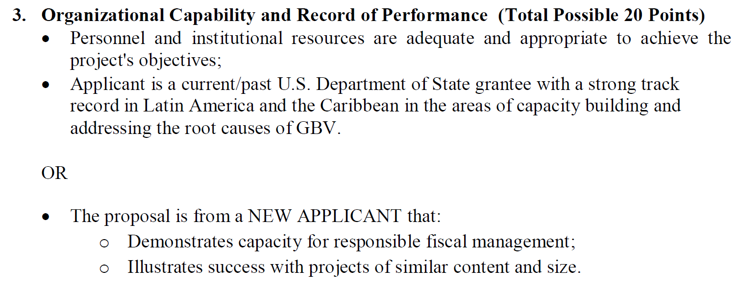

Q5. Budget. Are there limitations regarding the overhead rate or salaries that the WHA can finance? Which are they?

A5. Salaries must be reasonable, allocable, and allowable and consistent with the organization’s pay scale. For guidance on indirect costs, please follow PSI, section 9, NICRA/Indirect Cost Rate.

Q6. Other information. Does the proposal have to include the disclosures foreseen in this section explicitly (or can they be provided at a later stage, e.g. once a proposal has been accepted)? If so, can they be added as an annex?

A6. All documents for considerations should be submitted with the proposal in one package by the due date indicated in the NOFO.

Q7. The NOFO states that the award for lower income countries (in which Mexico would be involved) is up to 594,444 USD, and would be split in seven parts among the mentioned countries, the question is, is there a ceiling for the economic proposal lower than the 594,444?

A7. There is no other funding restriction, the $594,444 is the ceiling for low income countries that would be included in a proposal submission. The amount could be split between 2-4 low income WHA countries or two countries plus project overhead and salaries. It is up to the applicant to select the funding level appropriate to the proposed project activities for both high and low income countries in WHA with consideration of the funding ceiling that was provided in the NOFO.

Q8. In other matters, is there any difference between women and girls victims of GBV and GBV survivors? As is stated in the NOFO.

A8. The focus of this NOFO is to provide GBV survivor service providers with capacity building. For this NOFO, GBV women/girls survivors and women/girls victims of GBV are considered the same.

Q9. Is the fund available for Justice Centers for Women which depend on State Administrations? And if they are, how would they apply for a DUNS and SAM registration? If not, could they participate through a CSO?

A9. Only the prime (applicant) is required to apply/register for a DUNS/SAM registration. Sub-recipients also known as subawardees are required to have a valid DUNS number to receive funds. If the Justice Centers for Women is a project beneficiary and will be receiving training and capacity building from the applicant or partner, the centers are not required to register for a DUNS/SAMs account.

Q10. Regarding the objective 1, which states a service mapping or gap analysis in Latin America and the Caribbean about the survivor support services, in this we are a NGO based in Mexico, so this analysis only has to address only Mexico, is it correct?

A10. The NOFO is requesting a regional project with activities in multiple countries in the WHA region. Proposals submitted including only one country for project activities would not pass the technical review as the proposal would not meet the NOFO requirements

Q11. When it comes to the second objective, are the CSO's interested in taking part needed to provide services to GBV survivors or can the CSO's take part in the funding of this award by training municipal authorities, health care providers and developing methodologies so these care providers can make more efficient their actions? The core of this question is, can a NGO that does not directly attend nor addresses GBV but enhances governmental capacities (in the federal, state and municipal levels) throughout the professionalization of public servants participate in this award?

A11. Yes, NGOs that enhance governmental capacities (at different levels) through professionalization of public servants could participate in this award. The described NGOs could participate under Objective 2 and Objective 4 and/or be a partner through a subaward for enhancing governmental capacities in different WHA countries

Q12. Regarding objective 3, would the DoS support or involve in any way in the linking with other CSO's in order to create a global network?

A12. DOS will provide guidance and feedback but it is up to applicant to make necessary linkages for participating CSOs to an existing global network or creation of a new network. It is recommended that the applicant link participating CSOs to existing networks rather than create a new network.

Q13. About the objective 4, which states regional train-the-trainer modules, do these spaces have to be permanent as of their establishment, or is it just during the development of the project?

A13. Activities under objective 4 should be implemented during the period of performance of the award. Participating organizations of the train-the-trainer modules would then provide improved services and training to others either during the project or after. This is a sustainability component to ensure continued capacity building of CSOs that provide services to GBV survivors after the period of performance of the award

Q14. In the event of the submitted proposal being selected by Grants Officer, which is the procedure to legalize the award agreement? ¿Which is the procedure to the Contract settlement?

A14. Eligible proposals will be reviewed and evaluated by an independent review panel of subject matter experts that will provide their recommendation to the awarding bureau. Final decision resides with the DOS Grants Office. The recommended applicant will receive a notification. See page 12 of the NOFO Section IV. Application Evaluation and page 20 of the PSI document Section II. Application Review Information.

Q15. Where the Financial management survey can be viewed at?

A15. This will be provided to your organization if the proposal is selected and is meant for first-time prospective recipients of DOS/WHA funding.

Q16. In case the project proposal includes several beneficiaries such as: CSO, Municipal Governments and healthcare provider. This announcement allows to collect baseline data during the Project activities? Or conversely is mandatory to collect baseline data before the Project starts and evaluating projects results at the end.

A16. Yes, the applicant may collect baseline data at the beginning of the project and at end to help evaluate project results.

Q17. My question is around the number of countries we need to select for the project design. For example, for the high-income countries (Chile, Panama, Uruguay), can we only select Panama? Or would we need to design programming for all countries? We have the same question for the selection of middle- and low-income countries – could we design a program that only focuses on one, two, or three of the countries (Argentina, Belize, Brazil, Colombia, Costa Rica, Mexico and Peru), or do we have to consider all countries listed?

A17. Not all WHA countries from each income level must be selected and included in the project proposal, the countries listed in the NOFO are just examples. The NOFO is seeking a regional project with various WHA country participation and it is up to the applicant to select the number of participating countries.

Q18. We would like to inquiry if Capacity Building for GBV Survivor Support Service Providers in Latin America and the Caribbean. Assistance Funding Number 19.750, is available for service providers in Puerto Rico.

A18. No, Puerto Rico is not eligible to receive U.S. foreign assistance as it is a U.S. territory and U.S. citizen are not allowed to receive the funds either, please follow the guidance in the above-referenced funding opportunity.

Q19. After reviewing all of the materials on SAMS Domestic, there does not appear to be a Notice of Funding Opportunity that describes the project attached. Under the tab for additional information for the applicant, which is where these documents are normally found, there is only the PSI.

A19. This funding opportunity was published on www.grants.gov and the NOFO and related documents can be found there. Furthermore, per the NOFO, eligible organizations are required to apply through www.grants.gov

Q21. I am inquiring on whether including Bolivia in our regional GBV capacity building project excludes us from qualifying to submit to the above NOFO grant opportunity (SFOP0006940)? We are preparing a regional approach to our project which will include project activities in Argentina, Mexico and Bolivia. Bolivia being a critical component to the project given our 30-year history and nearly 120,000 clients in the country.

A21. Including Bolivia in your proposal would not disqualify the project for consideration. The applicant may include Bolivia in its proposal submission for the regional GBV capacity building project.

Q22. Will the award require to abide by the terms of Protecting Life in Global Health Assistance?

A22. Yes, the awardee will have to abide by Protecting Life in Global Health Assistance provision, also known as the Mexico City Policy.

Q23. More specifically, will the Required As Applicable standard provision RAA29 – Protecting Life in Global Health Assistance be part of the award?

A23. Yes, the Protecting Life in Global Health Assistance provision, also known as the Mexico City Policy, is part of the award as it applies to economic support funds (ESF)

