STATEMENT OF WORK

Marine Species Surveys in Support of Massachusetts Offshore Wind Development

PURPOSE
The purpose of this study is to provide funding through a cooperative agreement to continue the 10-year time series of aerial survey data within and surrounding the Massachusetts and Rhode Island offshore wind energy leases. Additional aerial and/or passive acoustic monitoring (PAM) surveys may occur contingent upon future funding. These surveys will contribute to providing the data needed to detect any changes in habitat utilization of large pelagic marine species by comparing the time series of data pre-construction to post construction data that may be collected. Surveys are currently funded through August 2022 after which a new cooperative agreement would be required to continue these important surveys. The surveys provide an essential baseline understanding of the distributions and abundances of North Atlantic Right Whales and other large whales, and sea turtles in the Massachusetts and Rhode Island wind energy leases. This research will help further characterize species’ usage of the MA Offshore Wind Energy Area in order to assist the Commonwealth of Massachusetts and the federal government in assessing the location and configuration of future offshore wind energy development.
Under the National Environmental Policy Act, BOEM and other federal agencies are required to review environmental assessments of offshore development and construction plans to identify and mitigate potential effects of development on marine species. This time series of consistent survey effort provides the information on the abundance and distribution of marine mammals and turtles in the survey area that are needed for these assessments. This information can also help wind energy developers plan the timing of activities, such as turbine construction, to minimize impacts on protected species.

BACKGROUND
The Massachusetts Clean Energy Center (MassCEC) has been managing surveys through the New England Aquarium (NEAq) since October 2011 in waters scheduled for wind energy development off Massachusetts and Rhode Island. All available lease areas have been leased and construction will occur in 2023. Surveys have followed consistent distance-sampling methods, which allowed a comparison of species distribution and abundance patterns over the past decade. Surveys conducted between October 2011 and June 2015 documented 969 cetacean sightings of more than 10,000 animals in 67,525 km of systematic line-transect survey effort (Stone et al., 2017). Peak presence of the twelve cetacean species observed (seven odontocete and five mysticete species) typically occurred in the spring and summer, except for the critically endangered North Atlantic right whale which occur mainly in the December to May timeframe. (Leiter et al., 2017). Photo-identification of right whales showed that the area was used by a significant portion of the population, including calving females (Leiter et al., 2017). These surveys also documented right whale feeding and surface-active groups (e.g., mating behaviors) in the survey area (Leiter et al., 2017).
Surveys conducted between February 2017 and October 2021 showed changes in right whale spatial distributions and increases in both right whale densities and the amount of time they spend in the survey area (O’Brien et al., 2021). These more recent surveys showed that right whales are using the eastern side of the survey area (i.e., in and adjacent to Nantucket Shoals). Right whale winter and spring density estimates remained stable from 2011-2015 (Leiter et al., 2017), but increased every year between 2017-2019 (O’Brien et al., 2021). Additionally, right whales consistently occurred in the survey area in summer and fall between 2017-2019 but were not observed in the survey area during these seasons between 2011-2015 (O’Brien et al., 2021).

OBJECTIVES
The objective of this study is to conduct surveys during each month to continue a time series of data to document species abundance and distribution across all the lease areas. Additional aerial and/or PAM surveys may occur contingent upon the availability of future funds. Some of the key objectives of the aerial surveys are to:
- Collect line-transect sightings from broad-scale surveys that can be used to map the distribution of large whales (with a focus on right, sei, humpback, fin, and minke whales) and turtles in the survey area and estimate their relative abundance.
- Collect opportunistic observer sightings of other cetaceans, seals, sharks, fish and bird aggregations.
- Collect digital photography to capture marine mammals, sea turtles, birds, and smaller cryptic species, and fixed fishing gear.
- Collect PAM data for continuous monitoring of before and after vocalization detection data.
- Conduct condensed, directed, and calibration surveys as needed to obtain fine-scale sightings and effort data, increase sample sizes, and understand the effects of conducting surveys at 1,500 feet, rather than 1,000 feet, during and after turbine construction.

DESCRIPTION OF WORK
Methods: The study would build on the existing survey methods completed since 2011. For aerial surveys, the survey area, design, and methodology that was previously reviewed and approved by BOEM. A post-flight report to all survey partners within 24 hours of each survey. Surveys will be flown at an altitude of 305 m (1,000 feet) or 457 m (1,500 feet) and a ground speed of approximately 185 km/h (100 kts) under Visual Flight Rules. A computer data-logger system will automatically record flight parameters (e.g., time, latitude, longitude, heading, altitude, and speed) at frequent intervals (every 2–5 sec). Two experienced aerial observers will be positioned aft of each pilot on each side of the aircraft and will scan the water out to 3.7 km (2 nm) from the transect line.

Aerial surveys – Three types of line-transect surveys and one type of directed survey will be conducted:
- broad-scale surveys,
- condensed surveys,
- directed surveys, and
- calibration surveys

Photographic data collection – Photographs and/or digital aerial photography will occur. Animals will be identified to species whenever possible. During aerial surveys, photographs of right whales for individual identification will be taken. Photographs of right whale callosity patterns will be used as a basis for identification and cataloging of individuals, following methods described by Kraus et al. (1986). Team members will process their photographic sightings data into the DIGITS (Digital Image Gathering and Information Tracking System) data management program curated by NEAq (Hamilton et al., 2007).

Survey data collection for right whales and other large whales - The right-angle sighting distance for each sighting will be recorded. For species with adequate sample sizes, the sighting distance can be used to estimate abundance and to compare detection rates at 1,000 and 1,500 feet. Sighting locations and effort data can also be used to calculate relative indices of abundance and information on seasonal occurrence and spatial distribution. Turtles and other identifiable large whales (that are not right whales) will be counted and recorded.

PAM data collection, analysis, and archival would be based upon the methods in van Parijs et al. (2021). PAM deployment locations would be coordinated with BOEM, the Wildlife and Offshore Wind Project (Project WOW), and the Regional Wildlife Science Collaborative (RWSC).

TASKS
Task 1: Post-award Teleconference

Task 2: Conduct aerial surveys covering all calendar months within the project area (Figure 1).

  - Collect data on large pelagic marine species.

Deliverable 1: Provide survey summaries with map and sightings details within 48 hours of survey completion.

Task 2: Analyze aerial survey data.

- Develop monthly distribution maps and abundance estimates.
- Set of all survey photographs (not only a subset) provided electronically.
- Develop SPUE for each species sighted.

Deliverable 2: A final survey report of all survey methods and data analysis with detailed survey sightings and effort; and analyses of species abundance and distribution patterns. All georeferenced observation files collected by each survey that contain species-specific sightings and survey effort.

Task 3: Conduct passive acoustic monitoring in the project area (Figure 2).

  - Collect data on large whales and harbor porpoises.
  - Provide a copy of all analyzed PAM data.
  - Analyze data and develop monthly distribution maps and vocalization rate estimates.

Deliverable 3: A final survey report of all survey methods and data analysis
Deliverable 4: Final technical report, survey data files, presentation(s), and peer-reviewed publication(s) of all aerial survey data and PAM data collected. The principal investigator shall complete and submit a draft final report, draft technical summary and survey data files to the Contracting Officer (CO), Project Officer (PO) and Environmental Studies Representative (ESPR) for scientific peer and editorial review. The report and technical summary shall be in the format specified at http://www.boem.gov/Environmental-Studies-Program-Report-Specifications/. The report shall contain the following language concerning its availability in ESPIS:

Scientific integrity is vital to Department of the Interior (DOI) activities under which scientific research, data, summaries, syntheses, interpretations, presentations, and/or publications are developed and used. Failure to uphold the highest degree of scientific integrity will result not only in potentially flawed scientific results, interpretations, and applications but will damage DOI’s reputation and ability to uphold the public’s trust. All work performed must comply with the DOI Scientific Integrity Policy posted to http://www.doi.gov, or its equivalent as provided by their organization or State law.

BUDGET
FY23: $500,000

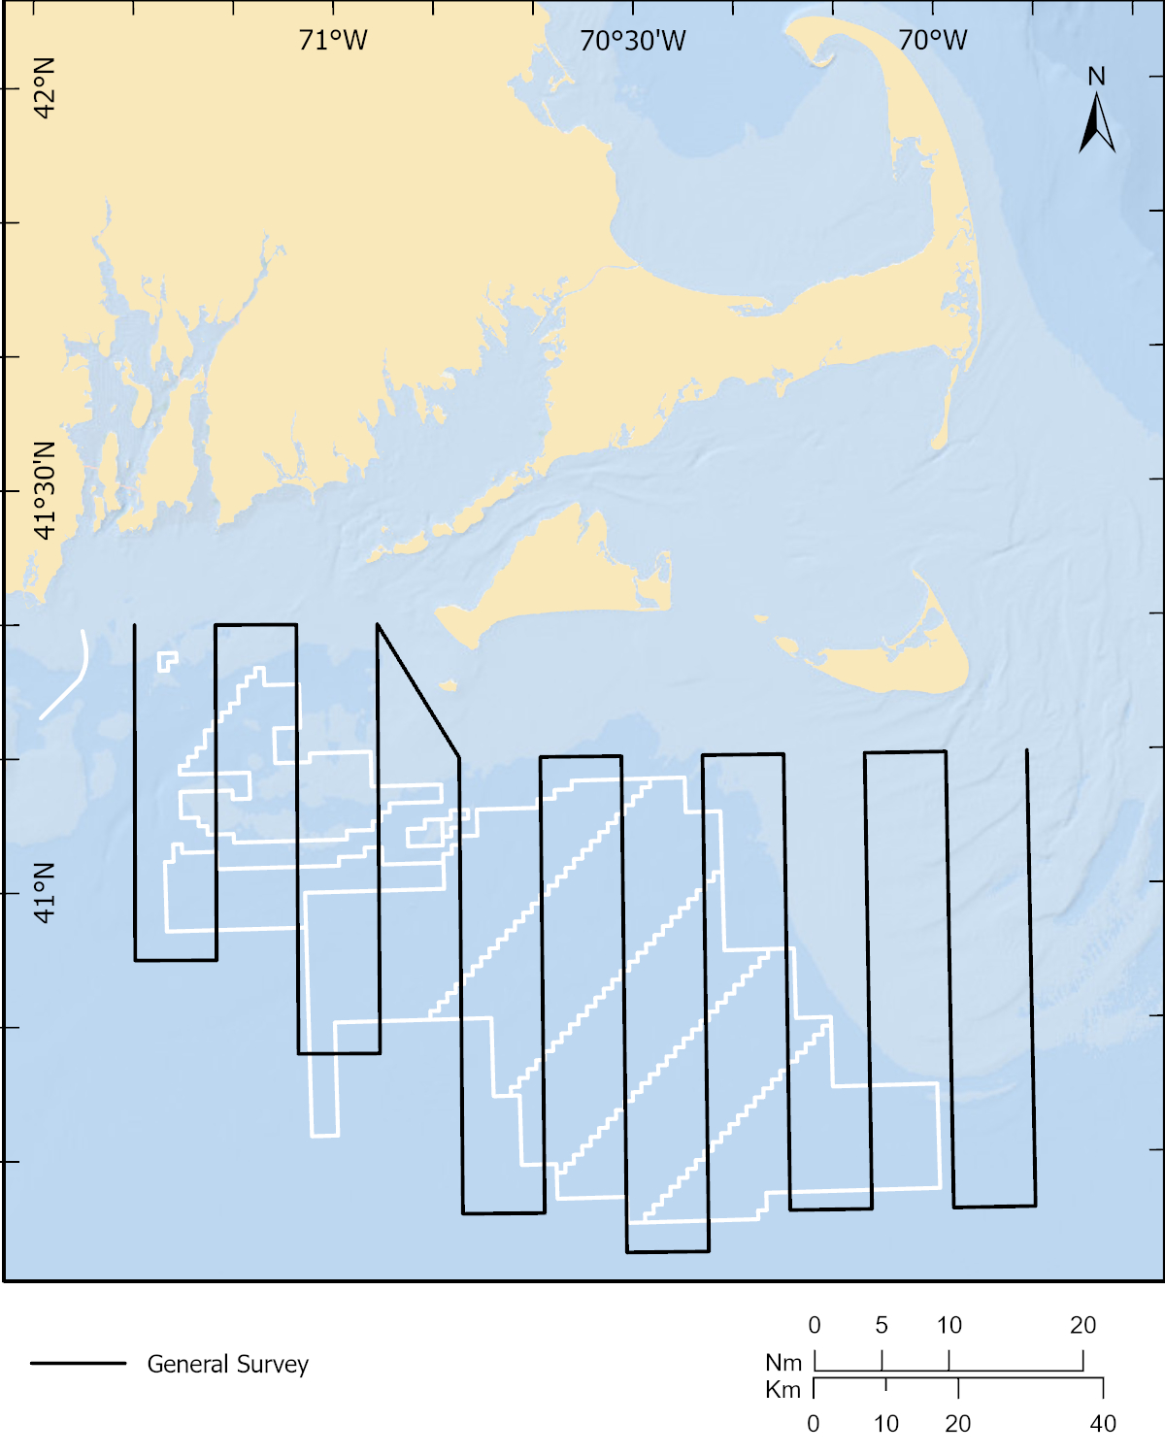
Broad-scale survey
Figure 1. Wind energy areas in the offshore waters of Massachusetts and Rhode Island are depicted by white lines. Examples of tracklines for a broad-scale survey are depicted by black lines. Survey areas may include “control” areas upon approval by BOEM.

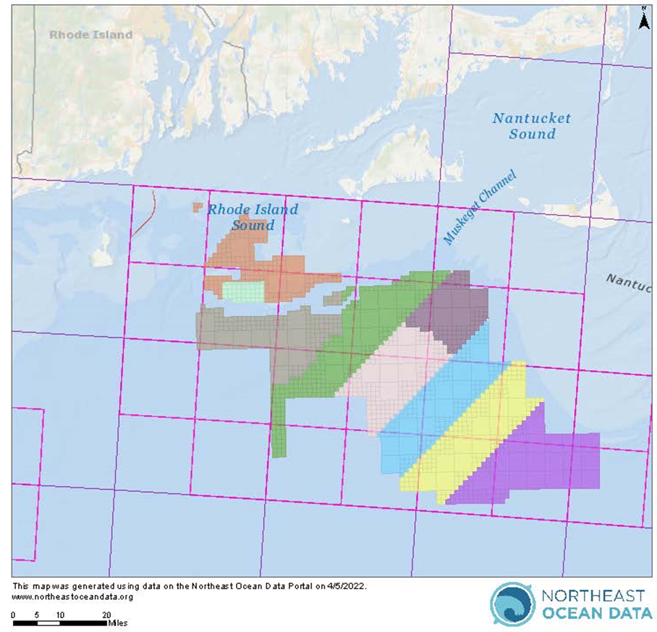
Figure 2. Wind energy areas in the offshore waters of Massachusetts and Rhode Island. Examples of PAM locations are depicted by the purple blocks.

REFERENCES

Kraus, S.D., Kenney, R.D., and Thomas, L. (2019). A Framework for Studying the Effects of Offshore Wind Development on Marine Mammals and Turtles. Report prepared for the Massachusetts Clean Energy Center, Boston, MA 02110, and the Bureau of Ocean Energy Management.
Leiter, S.M., Stone, K.M., Thompson, J.L., Accardo, C.M., Wikgren, B.C., Zani, M.A., et al. (2017). North Atlantic right whale Eubalaena glacialis occurrence in offshore wind energy areas near Massachusetts and Rhode Island, USA. Endangered Species Research 34, 45-59.
O’Brien, O., McKenna, K., Hodge, B., Pendleton, D., Baumgartner, M., and Redfern, J. (2021). Megafauna Aerial Surveys in the Wind Energy Areas of Massachusetts and Rhode Island with Emphasis on Large Whales: Summary Report Campaign 5, 2018-2019. BOEM 2021-033.
Parijs, SM, Baker K, Carduner J, Daly J, Davis GE, Esch C, Guan S, Scholik-Schlomer A, Sisson NB, Staaterman E. 2021. NOAA and BOEM Minimum Recommendations for Use of Passive Acoustic Listening Systems in Offshore Wind Energy Development Monitoring and Mitigation Programs. Frontiers in Marine Science. 8(1575).
Stone, K.M., Leiter, S.M., Kenney, R.D., Wikgren, B.C., Thompson, J.L., Taylor, J.K.D., et al. (2017). Distribution and abundance of cetaceans in a wind energy development area offshore of Massachusetts and Rhode Island. Journal of Coastal Conservation 21(4), 527-543. doi: 10.1007/s11852-017-0526-4.

(4.) Final Report and Final Technical Summary: The principal investigator shall revise the draft final report and draft technical summary according to feedback given by BOEM reviewers and the PO. She shall five (5) CD-ROMs, DVDs each containing searchable text in the pdf format of the final report with bookmarks and a pdf copy of the final technical summary.

Deliverables, Due Dates, and Distribution
Deliverable | Distribution | Due Date
A. Post Award Teleconference and Summary Notes | Chief, DES—One (1) electronic copy  ESPR—One (1) electronic copy  CO—One (1) electronic copy  All other participants in the teleconference—One (1) electronic copy | As soon as practical after BOEM funding award  Summary Notes due approximately one (1) week after teleconference
B. Quarterly E-mail Reports and Aerial Survey Data Files | Chief, DES—One (1) electronic copy  ESPR t—One (1) electronic copy  PO—One electronic (1) copy  CO—One (1) electronic copy | Within four (4) months from award and Quarterly afterward.
C. Draft Report and Technical Summary | Chief, DES—One (1) electronic copy (in MS Word format)  ESPR—One (1) electronic copy (in MS Word format)  PO—One (1) electronic copy (MS Word) for report  CO—One (1) electronic copy of transmittal letter only | Draft due two (2) months prior to the end of the period of performance
D. Final Report, and Technical Summary, Aerial Survey Data Files | Chief, DES—One electronic copy (in pdf format)  ESPR—One (1) electronic copy (in pdf format)  PO—One (1) electronic copy (in pdf format), three (3) bound paper copies and five (5) CD-ROM copies, containing both the technical report and the technical summary in Adobe Acrobat (.pdf) format and labeled with the study title, BOEM report number, BOEM contract number, contractor name and date  CO—One (1) copy transmittal letter only | Before the end of the period of performance

“To download a PDF file of this Environmental Studies Program report, go to the U.S. Department of the Interior, Bureau of Ocean Energy Management, Environmental Studies Program Information System website and search on OCS Study BOEM xxxx-xxx.”, where xxxx-xxx will be replaced with the assigned BOEM study number.
In addition, in the Acknowledgement of Sponsorship Section, the report shall contain the following disclaimer and acknowledgement language:

“Disclaimer: This report has been technically reviewed by BOEM, and it has been approved for publication. The views and conclusions contained in this document are those of the authors and should not be interpreted as representing the opinions or policies of the U.S. Government, nor does mention of trade names or commercial products constitute endorsement or recommendation for use.”;

and

“Acknowledgement: Study collaboration and funding were provided by the U.S. Department of the Interior, Bureau of Ocean Energy Management, Environmental Studies Program, Washington, DC under Agreement Number __________.”

Contact Information for Deliverables
Contracting Officer (CO) for BOEM
Ms. Christy Tardiff
Lead Contract Specialist
U.S. Department of the Interior
Bureau of Safety and Environmental Enforcement
Acquisition Policy and Financial Assistance Branch
45600 Woodland Rd., VAE-AMD
Sterling, Virginia 20170
Email: christy.tardiff@bsee.gov
Phone: 703-787-1367

Project Officer (PO), BOEM
Dr. Kyle Baker
Bureau of Ocean Energy Management
Office of Renewable Energy Program
45600 Woodland Road, MS VAM-OREP
Sterling, VA 20166
Office phone: 703-787-1741
e-mail: kyle.baker@boem.gov

Chief, DES, BOEM
Chief, Division of Environmental Sciences
U.S. Department of the Interior
Bureau of Ocean Energy Management (BOEM)
45600 Woodland Road, MS VAM-OEP
Sterling, Virginia 20166
Environmentalstudiesprogram2@boem.gov

ESPR Contact, BOEM
Dr. Timothy White
Bureau of Ocean Energy Management
Division of Environmental Sciences
45600 Woodland Road, MS VAM-OEP
Sterling, VA 20166
Office phone: 703-787-1732
Email: timothy.white@boem.gov

