Performance Monitoring Plan (PMP)
How-To Guide: Performance Indicators

This How-To Guide is designed to help CT/P grant applicants and grantees work with CT-P program managers (PMs) to develop PMPs. 18 FAM 301.4-3 requires every program or major project to create a PMP to outline how project implementation will be measured and monitored. This guidance focuses on performance indicators, a key component of all PMPs.

Performance Monitoring Plan (PMP) Components

PMP Component | Explanation | Examples/Context
Performance Indicator Type:  - Output-Level Indicators  - Outcome-Level Indicators | Select whether the indicator is an output- or outcome-level indicator:  - Output-Level: Measure what was delivered immediately and directly from a project’s activities. Typically measured as services or products (PMP must include at least two per outcome).  - Outcome-Level: Measure what was achieved based on a project’s outputs. Typically measured as a degree of change in knowledge, behavior, performance; changed conditions or results. Intended to capture higher-level results (PMP must include at least one per outcome). | - Output-Level: Number of people trained; number of trainings conducted, mentoring sessions held; equipment provided, assembled, etc.  - Outcome-Level: % change in knowledge gained/applied; # of SOPs or policies developed/improved/adopted, investigations conducted, cases processed, etc.
Performance Indicator | Performance indicators are used to monitor progress and measure actual results against expected results. Included indicators should be capable of being measured quantitatively (e.g., using numeric values, percentages, scales, etc.).  Remember that indicators should be “SMART”: Specific, Measurable, Achievable, Relevant, Time-Bound (see Annex I below).  Note: Grantees must use at least three relevant CT Standard Indicators (see Annex II below and/or included summary sheets if relevant), but they can also develop/use customized indicators if needed. Grantees/PMs should select a blend of the aforementioned indicator types that they believe most effectively measure the effects of their projects. | - Sample Custom Indicator (outcome-level): % change in knowledge of training participants in how to work with law enforcement on terrorism-related cases.  - Sample Custom Indicator (outcome-level): % of trained personnel using standard operating procedures to conduct proper fraudulent document detection.  - Sample CT Standard Indicator (outcome-level): Number of CT-supported, terrorism-related cases brought to trial.  - Sample CT Standard Indicator (output-level): Number of participants (disaggregated by type of activity, subject matter, etc.).  - Sample CT Standard Indicator (output-level): Number of pieces of equipment maintained in good standing
Indicator Definition | Defines how the indicator will be reliably measured throughout the life of the project. | - How: Explain how the indicator will measure the expected change.  - Why: Explain why it’s needed (i.e., how it will be used to monitor project progress).
Disaggregation | Disaggregation involves sub-dividing of data to create additional units of analysis, such as geography or sex, for a specific indicator. For example, if the indicator is "number of individuals trained," then this is disaggregated by female and male. | - Location  - Organization  - Age  - Sex
Data Source | Specifies how data to measure your performance indicators will be collected. Data can be collected directly by implementers, PMs, or from credible secondary sources; regardless, PMs should verify that data can easily, reliably and credibly be collected from each source. | Primary Data (collected by project):  - Interviews and focus groups  - Pre- and post-tests  - Surveys  - Site visits and direct observations  - Meeting minutes and attendance sheets  Secondary Data (from credible outside sources):  - Government or police records  - UN or NGO reports
Reporting Frequency | The timing for reporting results and setting targets; ideally, indicators should be updated no less than quarterly to coincide with Quarterly Report deadlines. However, not all data collection methods or indicators may allow for this. If you are unable to collect data quarterly, make note of it in the PMP. | - Monthly, quarterly, annually, every other year, etc.  - On specific dates (MM/YYYY)  - On the last day of each training  - Upon delivery of equipment
Responsible POC | The person(s) who will ensure data is collected and delivered complete and on time. | - Field-based: Course instructor, Mentor, Resident Legal Advisor  - DC/Non-Field: Implementer PM  - CT PM is also responsible.
Unit of Measure | What is the indicator measuring? | - Number  - Percentage  - Date
Initial Baseline | Data that are collected before or at the start of a project and provide a basis for planning and/or assessing subsequent progress and impact. | - For a new project, baselines are usually "zero” unless they are a direct continuation of the same activities from a previous iteration of the project.  - Baselines for continuing projects (e.g., through cost amendments, subsequent phases of a project) should include previous project figures (e.g., # of individuals previously trained or supported).  - If a project conducts a baseline using a needs assessment, or a gap analysis, then the baselines, indicators and targets would be updated with those figures once the study or assessment is completed.
Final Target | Final targets are the value of what we expect to achieve for each indicator over the life of the project.  They should be ambitious but achievable. Targets should be disaggregated for specific indicators. For those indicators with disaggregations, include disaggregated targets as well. Note that applicants will be expected to set and report against quarterly targets as well within their Performance Indicator Tracking Tables (PITT) (a PITT template/guidance will be provided to the successful applicant/grantee). | Factors influencing development of targets can include:  - Baseline data  - Project length and funding  - Number of PMs and implementers  - Historical trends and participant expectations  - Research findings

Performance Monitoring Plan: Definitions Table
- Robust PMPs should contain performance indicators that capture outputs, but more importantly, outcomes that demonstrate a project’s tangible achievements. Include at least one outcome-level indicator and two output-level indicators for each project outcome.
- To the extent possible, maximize the use of CT Standard Indicators - i.e., both CT-wide standard indicators (that can be applied across all CT programming categories – see Annex II below) and/or CT category-specific standard indicators (currently available for CT prosecutions, watchlisting/screening & aviation security projects – indicator summary sheets will be provided for relevant NOFOs).
- All ‘people’-related data must be disaggregated by demographic categories relevant to your project – e.g., organization, location, sex (see examples in the “Sample Project/Template below).
- Note: If an award is made, grantees will have another opportunity to revise and change the final PMP.

Performance Indicator Type | Performance Indicator | Indicator Definition, Disaggregation | Data Source | Data Collection |  | Unit of Measure | Initial Baseline | Final Target
 |  |  |  | Reporting Frequency | Responsible POC(s) | Unit of Measure | Initial Baseline | Final Target
Outcome 1: List each CT project outcome from the NOFO here.
State Indicator Type (output- or outcome-level) | Add performance indicator.  Indicators are used to monitor progress and measure actual results against expected results. Implementers should include CT standard indicators (see Annex II below) wherever applicable. | Defines how the indicator will be reliably measured throughout the life of the project. Ensure you explain: 1) How the indicator will measure the expected change; and 2) Why indicator is needed (i.e., how it will be used to monitor project progress).  Disaggregation: Sub-dividing of data to enable additional levels of analysis for comparative purposes (e.g., location, organizational unit, sex). | Source: Where will the data come from?  What tool(s) will be used to collect it? | Timing, frequency or schedule for reporting. | Who is responsible at the implementing organization for data collection, analysis, and reporting? | What is the indicator measuring – e.g., number, percentage, date. | Data that are collected before or at the start of a project and provide a basis for planning and/or assessing subsequent progress and impact. | Define targets for each indicator to report against actual progress.

Performance Monitoring Plan: Sample CT Project/Template
The following is an illustrative example of a CT project’s PMP intended to provide additional guidance to applicants and grantees in preparing their proposals’ PMPs or final project PMPs. It should be viewed as a reference tool rather than as a substitute for development of applicants’/grantees’ own PMP indicators/components, which should demonstrate their ability to effectively measure the results from their proposed/final project activities while accounting for the project’s operating environment.
Performance Indicator Type | Performance Indicator | Indicator Definition, Disaggregation | Data Source | Data Collection |  | Unit of Measure | Initial Baseline (POP start) | Final Target  (POP end)
 |  |  |  | Reporting Frequency | Responsible POC | Unit of Measure | Initial Baseline (POP start) | Final Target  (POP end)
Outcome 1: Protect U.S. citizens and interests by strengthening the prosecution of FTOs and other terrorist actors, consistent with U.S.-approved legal standards and practices (CT Prosecutions Standard Outcome 2)
Output-Level | Indicator 1.1: # of participants trained  (CT 1: [CT-Wide Standard Indicator 1]) | How: Calculate # of prosecutors who complete entire trial advocacy training. Why: Demonstrates # of prosecutors who have potential to improve results from their handling of terrorism-related cases. Disaggregation: Female/Male | Attendance records | Quarterly | “X” Implementer / POC | Number | 0 | 40
Output-Level | Indicator 1.1a: Disaggregation (female) | -- | Attendance records | Quarterly | “X” Implementer / POC | Number | 0 | 20
Output-Level | Indicator 1.1b: Disaggregation (male) | -- | Attendance records | Quarterly | “X” Implementer / POC | Number | 0 | 20
Outcome-Level | Indicator 1.2: % of training participants demonstrating improved knowledge in how to work with law enforcement on terrorism-related cases (custom indicator) | How: *Numerator: # of participants demonstrating improved knowledge (post-test score – pre-test score) on working with law enforcement on CT cases; **Denominator: Total # of participants who completed trainings. Why: Demonstrates extent of participants’ improved knowledge from training in how to work with law enforcement. Disaggregation: Female/Male | Pre- and Post-tests | Quarterly | “X” Implementer / POC | Percentage | 0 | 80%  (32*/40**)
Outcome-Level | Indicator 1.2a: Disaggregation (female) | -- | Pre- and Post-tests | Quarterly | “X” Implementer / POC | Percentage | 0 | 80%  (16*/40**)
Outcome-Level | Indicator 1.2b: Disaggregation (male) | -- | Pre- and Post-tests | Quarterly | “X” Implementer / POC | Percentage | 0 | 80%  (16*/40**)
Outcome-Level | Indicator 1.3: # of CT-supported, terrorism-related cases brought to trial  (PROS 2.5 – CT Prosecutions Standard Indicator 2.5) | How: Calculate # of terrorism-related cases brought to trial in Country X by CT-trained prosecutors in accordance with international standards. Why: Demonstrates how effective/efficient a country’s CT-supported judicial system is in moving charged individuals/groups to trial. Disaggregation: N/A | Periodic implementer project reports; verified gov’t records | Quarterly | “X” Implementer / POC | Number | 0 | 20
Outcome 2:
 | Indicator 2.1:
 | Indicator 2.2:
 | Indicator 2.3:
Outcome 3:
 | Indicator 3.1:
 | Indicator 3.2:
 | Indicator 3.3:
 | Etc…

ANNEX I: Explaining “SMART” Indicators
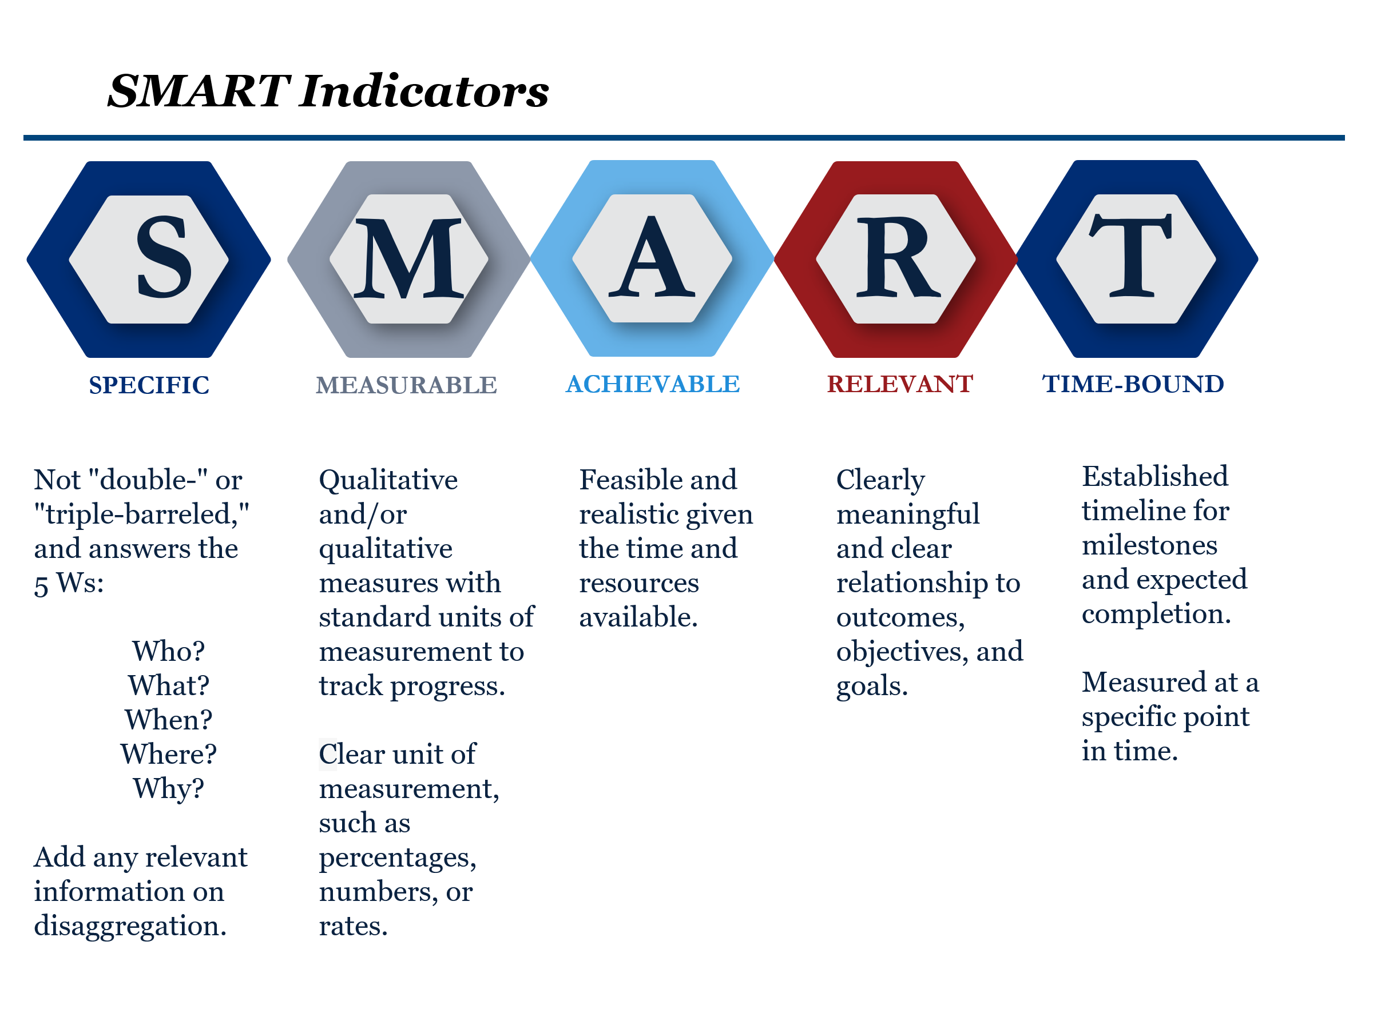

ANNEX II: CT-Wide Standard Indicators
Applicants/grantees must include at least three CT standard indicators, including at least one outcome-level indicator, along with appropriate disaggregations, from the list of CT-wide standard indicators below.
Category | CT Indicators | Indicator Type (Output or Outcome)
Training | CT 1 - Number of participants trained  Disaggregate wherever relevant by:  - CT 1.a: Sex – Female or Male  - CT 1.b: Location | Output
Events/Workshops | CT 2 - Number of events completed  Disaggregate wherever relevant by:  - CT 2.a: Type of activity – Training, meetings, TOT sessions, mentorship sessions, symposia | Output
Equipment | CT 3 - Number of pieces of equipment(s) provided. | Output
Course Materials | CT 4 - Number of course materials developed. | Output
Knowledge and Utility | CT 5 - Number of participants that report using trainings in their functions/roles/job to perform job-related tasks. | Outcome
Collaboration | CT 6 - Number of countries that incorporate skills and knowledge from CT-funded courses into their own training curriculum. | Outcome
Use of equipment | CT 7 - Number of participants that report frequently using equipment as part of their jobs. | Outcome
Use of equipment | CT 8 - Number of pieces of equipment maintained in good standing. | Outcome

“Outcomes” were formerly “objectives”
“Outcomes” were former “objectives”
For NOFOs focused on CT prosecutions, watchlisting/screening and/or aviation security projects, applicants will additionally be provided with standard indicator summary sheets in these categories and encouraged to include additional indicators from these sheets in their proposal’s PMP.

