Project Management Plan Template

The Project Management Plan (PMP) is an approved document that defines how the Recipient will execute, monitor, and control the project to accomplish the objectives. The specific contents, level of detail, and inclusion of subsidiary planning documents are tailored according to the needs of the project. Consequently, every PMP will be different based on the risk, visibility, and/or complexity of the project and the Recipient's established processes, procedures, and systems.

Title Page:

PROJECT MANAGEMENT PLAN

{Insert Project Title}

{Date Prepared}

SUBMITTED BY
{Organization Name}
{Organization Address}
{City, State, Zip Code}

PRINCIPAL INVESTIGATOR
{Name}
{Phone Number}
{E-mail}

SUBMITTED TO
U.S. Department of Energy
National Energy Technology Laboratory

This plan should be formatted to include the following sections with each section to include the information as described below:

- Executive Summary:

Provide a description of the project that includes the objective, project goals, and expected results. For purposes of the application, this information is included in the Project Narrative and should be simply copied to this document for completeness, so that the Project Management Plan is a stand-alone document.

- Project Organization and Structure:

Provide the following information in this section:
- Organizational Chart(s): Include a complete project organizational chart and sub-organization charts (if applicable), accompanied by a discussion of how the organizational structure will facilitate the performance of the Tasks and achievement of the objectives described in the SOPO within the time frame specified in the application.
- Roles and Responsibilities of Participants: Provide a discussion of key project team members, and the capacity in which each team member will assist in achieving the overall objective(s) of the proposed project. For multi-organizational or multi-investigator projects, describe the roles to be performed by each participant/investigator within the context of the Task/subtask structure contained in the SOPO. Include descriptions of any business agreements or intellectual property issues between the Recipient and other members of the project team, and how these agreements will be integrated and managed.
- Decision-making and Communication Strategy: Provide a discussion of how communication and decision-making will occur within the context of the organizational structure, with particular emphasis on scientific/technical direction and mechanisms for controlling project scope, cost, and schedule. Include a discussion of how the project team will communicate with DOE and external stakeholders during the performance of the project.
- Management Capabilities: Provide information relevant to the capabilities and experience of the PI and key project team members in managing technical projects of similar nature and complexity. If applicable, include examples that demonstrate the ability to successfully meet research objectives within scope, budget and schedule.

- Risk Management Plan:

Provide a summary description of the proposed approach to identify, analyze, and respond to perceived risks associated with the proposed project. Project risk events are uncertain future events that, if realized, impact the success of the project. Risk is inherent to all projects regardless of complexity, cost, or visibility. An effective Risk Management Plan will identify perceived risks and explain mitigation strategies for each risk. At a minimum, the Risk Management Plan shall include the initial identification of significant financial, cost/schedule, technical/scope, management, planning and oversight, ES&H, external factors, and management issues that have the potential to impede project progress and strategies to minimize impacts from those issues.

The following table format is provided but is not required:

Perceived Risks and Mitigation Strategies
Perceived Risk | Risk Rating |  |  | Mitigation/Response Strategy
Perceived Risk | Probability | Impact | Overall | Mitigation/Response Strategy
Perceived Risk | (Low, Med, High) |  |  | Mitigation/Response Strategy
Financial Risks:
Cost/Schedule Risks:
Technical/Scope Risks:
Management, Planning, and Oversight Risks:
ES&H Risks:
External Factor Risks:

- Milestone Log:

Provide milestones for each budget period of the project. Each milestone should be linked to a specific Task or Subtask and include a title, planned completion date, and a description of the method/process/measure used to verify completion. Milestones should be quantitative and show progress toward budget period and/or project goals. Conversely, periodic, mandatory progress reports are not considered to be Milestones.

Milestones are presumed to lie on the critical path of the project, i.e., unless all milestones are achieved, the Objectives as defined in the SOPO cannot be met completely. Recipients must provide at least two milestones per year throughout the course of the project.

Milestone Format
Task/  Subtask | Milestone Title & Description | Planned Completion Date | Verification method

[Note: During project performance, the Recipient will report the Milestone Status as part of the required quarterly progress report as prescribed under the Federal Assistance Reporting Checklist. The Milestone Status will present actual performance in comparison with Planned Milestones, and include:
(1) the actual status and progress of the project,
(2) specific progress made toward achieving the project's milestones, and,
(3) any proposed changes in the project's schedule required to complete milestones.]

- Costing Profile:

Provide a table (the Spend Plan) that projects the expenditures of government funds by fiscal year for each project team member.

Spend Plan by Fiscal Year Format
 | FY 20XX |  | FY 20XX |  | FY 20XX |  | FY 20XX |  | Total
 | DOE  Funds | Cost Share | DOE  Funds | Cost Share | DOE  Funds | Cost Share | DOE  Funds | Cost Share | DOE  Funds | Cost Share
Recipient
Subrecipient A, if proposed
Subrecipient B, if proposed
FFRDC/NL, if proposed
Total ($)
Total Cost Share %

- Project Timeline:

Provide a timeline of the project (similar to a Gantt chart) broken down by each task and subtask, as described in the Statement of Project Objectives. The timeline should include for each task, a start date, and end date. The timeline should show interdependencies between tasks and include the milestones that are identified in the Milestone Log (Section C).

Project Timeline (Gantt Chart) Example
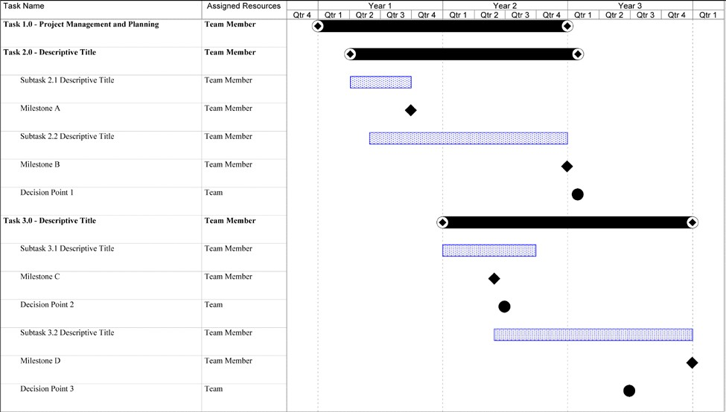

- Success Criteria:

Success criteria are used by the DOE to determine if specific goals and objectives were met at the end of budget period(s), go/no-go decision points, and/or project completion. The success criteria should be objective and stated in terms of specific, measurable, and repeatable data. Usually, the success criteria pertain to desirable outcomes, results, and observations from the project.

[Note: As the first task in the Statement of Project Objectives, Recipients will revise the version of the Project Management Plan that is submitted with their applications by including details from the negotiation process. This Project Management Plan will be updated by the Recipient as the project progresses, and the Recipient must use this plan to report scope, schedule, and budget variances.]

