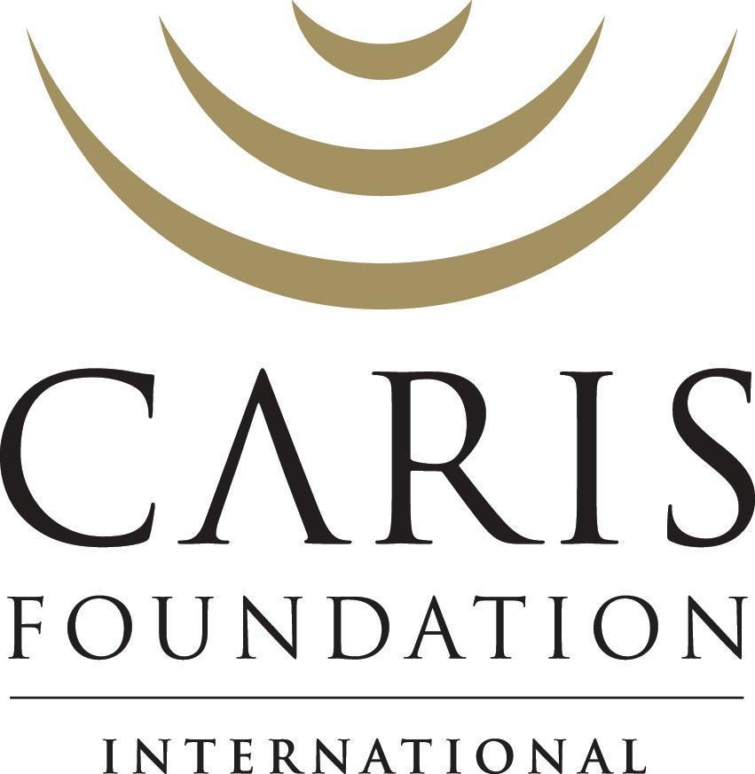

Annual Program Report Project Impact Youth
2022

Cooperative Agreement: 72052119CA00001

Viola Tombeau, MD; Tessa Lewis, MA; Sophia Charles, MD; Davidson Adrien

LIST OF TABLES

LIST OF TABLES 1
LIST OF FIGURES 2
ACRONYMS 3
OVERVIEW OF THE PROJECT 5
PROJECT DESCRIPTION AND RESULTS BY PROGRAM 8
Technical Approach 10
National Early Infant Diagnosis (EID) Program 10
Tracking of Patients/ Psychosocial Clubs 14
PMTCT Beneficiaries 14
HIV-Infected OVC 15
Mobile Health Application Usage 19
Nutrition Program 20
Schooling 21
Health Education 22
Household Economic Strengthening (HES) 23
Savings and Lending Groups (MUSO) 23
Kitchen Garden Program 25
Distribution of Medical and Non-Medical Products- Partnerships 26
DREAMS 27
Helpline 35
OVC_ SERV Indicator 35
OVC_HIVSTAT 41
SUCCESS STORIES 42
I- Empowering Haiti’s Women 42
CHALLENGES 44
LESSONS LEARNED / BEST PRACTICES 45

LIST OF FIGURES

Figure 1. | HAITI Caris/Impact Youth Offices and EID sites | 6
Figure 2. | Positivity rate in Children < 12 months in EID Program | 14
Figure 3. | PMTCT women enrolled in Psychosocial Clubs | 15
Figure 4. | OVC children enrolled in Psychosocial Support Clubs | 17
Figure 5. | Map of Impact Youth Kids and Teen Psychosocial Support Clubs in Haiti | 18
Figure 6. | Impact Youth OVC clinical cascade for the 9-17 years old | 19
Figure 7. | Communes with CARIS supported MUSO group, by number of groups | 23
Figure 8. | Number of active MUSO groups | 24
Figure 9. | Number of active kitchen gardens | 26
Figure 10. | AGYW_PREV Q4FY22 cumulative results vs annual target | 32
Figure 11. | OVC SERV – Number of beneficiaries served vs annual targets | 41

ACRONYMS

AGYW | Adolescent Girls and Young Women
AIDS | Acquired Immune Deficiency Syndrome
ART | Antiretroviral Therapy
BEST | Bien Et ak Sante Timoun (Wellbeing and Health of Children)
BKFA | Birthing Kit Foundation of Australia
BPM | Brigade de Protection des Mineurs
CHW | Community Health Worker
COP | Chief of Party
CRS | Catholic Relief Services
DCOP | Deputy Chief of Party
DREAMS | Determined, Resilient, Empowered, AIDS-free, Mentored, and Safe
EID | Early Infant Diagnosis
FY | Fiscal Year
GBV | Gender-Based Violence
GIS | Geographic Information System
GPS | Global Positioning System
HES | Household Economic Strengthening
HIV | Human Immunodeficiency Virus
HQ  HTG  IBESR  IP | Headquarters  Haitian Gourde  Institut du Bien-Être Social et de la Recherche  Implementing Partner
LTFU | Loss To Follow-Up
M&E | Monitoring and Evaluation
MUAC | Mid-Upper Arm Circumference
MUSO | Mutuelle de Solidarité (Savings and Lending Group)
OVC | Orphans and Vulnerable Children
PEPFAR | President’s Emergency Plan For AIDS Relief
PCR | Polymerase Chain Reaction
PMTCT | Prevention of Mother-To-Child-Transmission
RUTF | Ready-to-Use Therapeutic Food
SGBV | Sexual Gender Based Violence
SVAC | Sexual Violence Against Children
TM | Transforming masculinity
USAID | United States Agency for International Development

OVERVIEW OF THE PROJECT

Orphans and Vulnerable Children (OVC) programming has been a core component of PEPFAR since 2004, representing 10% of total funding each year. In 2018, Caris Foundation International was awarded a U.S. Agency for International Development (USAID) Cooperative Agreement to carry out the Impact Youth project, which offers a comprehensive package of care and support services to Orphans and Vulnerable Children and their households, with a particular focus on Adolescent Girls and Young Women (AGYW). Impact Youth addresses the needs of Orphans and Vulnerable Children in Haiti, ensuring adequate access to a wide range of prevention, care, and treatment services based on the ever-changing needs and circumstances of Orphans and Vulnerable Children, their caregivers, and families. Ensuring a continuum of care between facility-based PMTCT, pediatric HIV and community based OVC activities, requires that beneficiaries are able to access a variety of community-based supportive services, including health, nutrition, education, protection, psychosocial support, economic strengthening, and other social services. The continuum requires a strong system for referrals and counter referrals between facilities and communities.

Impact Youth supports Haitian children living with and affected by HIV/AIDS to grow into healthy, educated, young adults, free from violence and the ill-effects of HIV. Children and families deemed eligible for Orphans and Vulnerable Children activities are identified through clinical, community, and/or social service entry points. Children who are potential beneficiaries may be:

- HIV-infected or exposed, living with an HIV positive parent/caregiver, orphaned due to HIV/AIDS,
- Vulnerable to HIV infection and/or its effects by virtue of living in communities with high HIV burden and extreme poverty
- High levels of violence against children, exploitation or neglect, disability, or other risk factors.

The project encompasses most social determinants of health affecting HIV infected/affected children and pregnant women. It also engages the community in health education and activities in order to address stigma/discrimination, as well as HIV prevention. From ensuring healthcare needs are met, to providing education for the OVC population, Impact Youth strives to ensure that families are more financially stable and healthy.

Impact Youth has been designed to meet the following objectives:

1) Expand early identification of HIV-infected infants and ensure linkage to treatment;
2) Improve health care and social service delivery for HIV-infected and affected Orphans and Vulnerable Children; and
3) Increase the capacity of families and communities to care for Orphans and Vulnerable Children, including HIV risk prevention among adolescent girls and young women (AGYW)

Impact Youth’s comprehensive package for Orphans and Vulnerable Children and their households is offered in all 10 regions in Haiti via the collaboration with 141 clinical sites. These activities include:
- Supporting the National Early Infant Diagnosis (EID) Program of HIV throughout Haiti.
- Tracking Patients in all Impact Youth-supported sites (mainly HIV positive children 0-18 years old, as well as HIV-positive pregnant women)
- Psycho-Social Support Groups for HIV-Infected Individuals: Prevention of Mother to Child Transmission of HIV (PMTCT) /Mothers Clubs, Kids Clubs (3-17 years old) and Youth Clubs, (18-24 years old) - aimed at providing social support, and at encouraging retention in care and adherence to medication.
- Targeted HIV testing of eligible OVC.
- A Moderate Acute Malnutrition Program (6-59 months of age), which includes the screening and provision of Ready-to-Use Therapeutic Foods to children enrolled in the program.
- Schooling support for eligible Orphans and Vulnerable Children.
- Provision of medical and non-medical supplies to families of Orphans and Vulnerable Children (mainly chlorine-based water purifying products and Albendazole).
- Household Economic Strengthening (HES) programs, which include the Mutuelle Solidarité (MUSO) model (Savings and Lending Groups) and Agriculture via the ‘Kitchen Gardens’ Activities.
- HIV, Health, and Human Rights Education: Impact Youth addresses the health education needs of youth in the general population, through community clubs and health education messaging in school networks, with an emphasis on stigma and discrimination, in addition to HIV prevention.
- The DREAMS (Determined, Resilient, Empowered, AIDS-free, Mentored, and Safe) Program, which targets vulnerable adolescent girls and young women (AGYW) ages 10 - 24 years-old. Impact Youth puts the empowerment of adolescent girls and young women (AGYW) at the forefront of its programming, as gender inequities compounded with poverty and cultural barriers render them more vulnerable to Gender Based Violence (GBV) and HIV infection.

Implementation Staff

The leadership team of Impact Youth is based in Port-au-Prince (HQ office) and is involved in the strategic planning, coordination, supervision, Monitoring & Evaluation (M&E) of all our programs throughout our seven satellite offices, including the training of all teams and the continuous quality improvement of our programs. All Impact Youth regional/satellite offices are structured similarly. A regional office leader is the point person of contact for the HQ office; he/she oversees coordinating teams, composed of two nurses specialized in public health/HIV. Each team is responsible for the functioning of our programs for at least 7-10 clinical sites per team. They also supervise the work of Community Health Workers (CHW). Regional Office Leaders oversee the work of all staff members based out of their offices.
Figure 1. HAITI Caris/Impact Youth Offices and EID sites
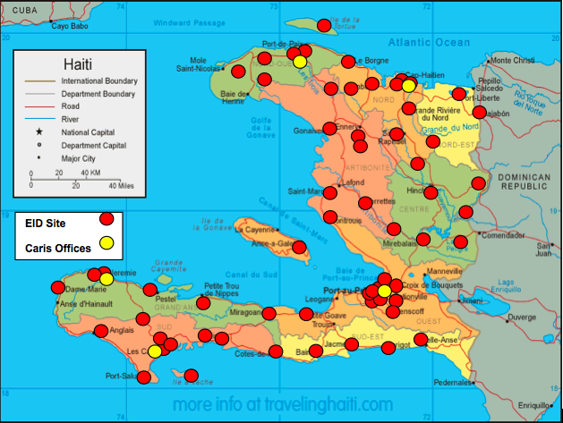

PROJECT DESCRIPTION AND RESULTS BY PROGRAM

Table 1. FY22 Summary Results
Indicators | Performance Indicator Definition | Target  FY22 | Annual Result  FY22 | Achievement
PMTCT_EID | Percent of infants born to HIV-positive women who had a virologic HIV test done within 12 months of birth | 90% | 87 %  (2,846/3,261) | 97%
PMTCT_HEI_POS | Number of HIV-infected infants identified in the reporting period, whose diagnostic sample was collected by 12 months of age. | NA | 94 | NA
PMTCT_HEI_POS on ART | Percentage of HIV-positive infants placed on ART in the reporting period, whose diagnostic sample was collected by 12 months of age.  10 of the 94 children died before being placed on ART. Thus, 79 of 84 (94%) living children were placed on ART. | 98% | 94%  (79/84) | 96%
OVC_HIV_STAT | Percentage of OVC (<18 years old) with HIV status reported to implementing partner (including status not reported), disaggregated by status type. | 100 % eligible | 100%  (69,082 / 69,082) | 100%
OVC_SERV | Number of active beneficiaries served by PEPFAR OVC programs for children and families affected by HIV/AIDS | 84,384 | 115,966 | 137 %
AGYW_ PREV | Number of active DREAMS beneficiaries that have started or completed any DREAMS service/intervention as of the end of the reporting period. | 18,000 | 18,415 | 102 %

Table 2. Overall FY22 APR Metrics
Expected Results | Achieved Results
80% of qualifying children with HIV infection receive antiretroviral therapy (ART). | 94% of EID positive children who are still alive received ARVs
100% of pediatric HIV sites have a system for referring clients for other critical services such as, nutrition, health, immunization, and household strengthening, etc. | 100% of pediatric HIV sites have a system for referring clients for other critical services such as, nutrition, health, immunization.
% of OVC have received bi-annual Vitamin A and deworming. | > 48,205 doses of deworming pills and 19,500 doses of vitamin A were distributed to eligible OVC.
% of OVC malnourished | FY22 15.6%  (FY21 10.7%; FY20: 17%; FY19: 16%; FY18: 11%; FY17: 20% FY16: 12%; FY15: 35%; FY14: 45%) Change due to the use of MUAC in FY16 – higher threshold for diagnosis.
% of OVC and families regularly access safe water | > 11,770 families received safe water products in FY22 (through psycho-social clubs, Community clubs, and Kitchen Garden groups)

Technical Approach

National Early Infant Diagnosis (EID) Program

Impact Youth is currently responsible for the support and implementation of the Haiti National Early Infant Diagnosis (EID) service, in collaboration with other EID partners. Infants and children who are part of Impact Youth programs are tested and followed up at these sites. Impact Youth teams train the service providers at selected sites on EID, PMTCT and Pediatric HIV, data collection requirements, pediatric HIV treatment protocols as well as specimen collection. Impact Youth teams are responsible for specimen transport to the central and satelite laboratories as well as result delivery. The number of sites offering PCR has stabilized as coverage of eligible sites has been reached.

Table 3. EID APR metrics FY22
Expected Results | Achieved Results in FY22
80% of infants born to enrolled HIV positive women received an HIV test within 12 months of birth. | FY22 100%  FY21 100%  FY20 100%  FY19 100%  FY 18 98%  FY 17 97%  FY16 92%,  FY15 98%,  FY14 90%
100% of collected samples delivered at laboratories within a 4-week period. | FY22 100% FY21 97% (FY20 100% same as FY14, FY15, FY16, FY17, FY18 and FY19)
100% of sites have personnel trained in collecting and storage of DBS samples. | FY22 100%; FY21 100% (same as FY14, FY15, FY16, FY17, FY18, FY19 and FY20)
100% of sites receive all PCR test results within a 6-week period from the time samples are taken. | FY22 85%  FY21 71%  FY20 97%,  FY19 95%, FY18 98%, FY17 96%, FY16 82%, FY15 95%, FY14: 90%

Once a pregnant woman is diagnosed as HIV-positive and enrolled in a PMTCT (Prevention of Mother-To-Child-Transmission) program at a site, she is closely followed by Impact Youth staff, which helps reduce attrition rate.
A positive PCR triggers an action plan to start the patient on ART immediately after obtaining results. Impact Youth teams enter into contact with the clinical teams at site-level in order to contact the families of children with a positive PCR. CHWs also conduct home visits to ensure that the child is brought in for the necessary follow-up.

PMTCT_EID Indicator

Project Impact Youth provides support to the National Early Infant Diagnosis program across Haiti. Its main objectives have been to:
- Ensure contact with all newly enrolled HIV positive pregnant women in collaboration with local hospitals and health centers;
- Track HIV-positive pregnant women by collaborating with clinical sites (option B+, regular follow-up; counseling regarding the importance of adherence, of giving birth in hospital milieu, and of providing newborn prophylaxis, of exclusive breastfeeding);
- Ensure that every infant born to an HIV-positive mother is tested through the EID component of the National HIV Testing Program in all Impact Youth sites.

The Impact Youth/Caris Teams supervise the day-to-day running of the National EID program. The teams train all the providers and technicians to enable the service, deliver materials needed and transport the specimens and results. Impact Youth assists sites with training of PMTCT service providers, reporting, data quality, ARV consumption forecasting and supply management (through close communication with PSM), supporting patient follow up/retention and support of mother mentoring programs. All DNA PCR HIV tests done in the context of EID pass through the data collection systems of Impact Youth.
The results are aggregated at the IM-level by creating the three requested categories during the data reporting stage; all of the data is extracted from the database in which all virological test results are entered. Impact Youth’s M&E team de-duplicates the results by checking that infant codes are unique and ensuring proper linkage of codes for each patient to only include one patient code per infant.
The results are aggregated from the IM-level by age at which infants under 12 months of age received a virologic HIV test during the data retrieval and analysis stage using lab records that were entered into Impact Youth’s EID patient database.
Project Impact Youth is able to report on the number of infants testing positive from lab records. The test results are communicated to Impact Youth shortly after they are communicated to facilities. The numerator (number of infants who had a virologic HIV test within 12 months of birth) is adjusted for the potential of double-counting by only counting first virologic tests for infants tested during the reporting period. The percentage reported for this indicator excludes pregnant women who follow in the ZLS and UGP networks as we are not granted access to any of their information and therefore are unable to provide any follow-up for these women.
During Q4 FY 22, 421 exposed infants underwent a virologic HIV test within 12 months of birth. Of these 421 infants, 294 were aged between zero and two months (70.0 %). To note that 228 specimens of the 421 are currently at the labs awaiting a result. 148 of them have exceeded 15 days. 26 specimens from hospitals around Carrefour, Petit Goave and Arcahaie regions are currently not able to be reached due to the ongoing unrest. We continue to monitor the situation closely.
It is to be noted that the socio-political unrest which has continued to create an unstable environment throughout Haiti has impacted all activities, including EID. Throughout FY22, the National Laboratory (LNSP) ran out of PCR reagents for several weeks. In August and September, all the specimens from Cap Haitien were processed in Port-au Prince due the lack of reagents. During three weeks of September, many clinical sites and LSNP were closed due to the fuel shortage and the increased number of road blocks across the country. Both the Port au Prince based testing labs have experienced long delays due to a back-log of viral load samples and this therefore affected the time taken to receive the PCR test results. A shortage of essential testing materials at the National Laboratory, roadblocks, street violence and fuel shortages all contribute to an increase in turnaround time. All of these factors hinder the project’s activities in many ways. The significant increase in major crime trends, gang-related incidents, roadblocks, street violence, hospital closures, and a steep rise in public transportation costs due to the recurring problems of fuel scarcity have led to a decrease in the number of specimens being collected at health facilities. Many pregnant women from dangerous areas (Martissant, Bizoton, Cite Soleil, Croix des Bouquets, Raboteau etc.) have left their homes without any notice. This makes it difficult for the field team to find those patients for clinical follow ups. Many parents of asymptomatic patients eligible for PCR testing refuse to come to the sites located in high-violence areas.
Of note, over the course of FY22, LNSP informed the Impact Youth team that they would be handling the specimen transport for 17 sites across the country. Since, we are no longer able to register those specimens on our database, it complicates the follow up of HIV positive cases as we are not notified of the results. For the 17 sites mentioned, the IY teams have to enquire with each site directly with regards HIV positive cases. It is estimated that the 17 sites would have generated approximately 300 specimens which IY no longer has access to. This therefore has affected our annual targets for EID. In addition to this, due to the closure of five sites located in designated ‘red zones’ we estimate an additional decrease of approximately 90 specimens.

Table 4. EID- Descriptive Statistics
Number of infants who had a virologic HIV test within 12 months of birth | Infants who received a virologic test within 2 months of birth | Infants with a positive virologic test result within 12 months of birth | Number of new women enrolled in PMTCT programs (estimated through MESI) | Percentage of infants born to HIV-positive women who had a virologic HIV test done within 12 months of birth
FY22: 2846  (FY21 3396  FY20 3860  FY19 3660  FY18 3373  FY17 3069  FY16 2817  FY15 3133  FY14 3195) | FY22: 1939 (68%)  (FY21 2254, 66%  FY20 2336, 61%  FY19 2460, 67%  FY 18 2319, 69%  FY17 2051, 67%  FY16 1808, 64%  FY15 1747, 56% FY14 1935, 61%) | FY22: 94 (3.3%)  (FY21 155: 4.6%  FY20 152 4.9%  FY19 172 4.7%  FY18 173 5.1%  FY17 169, 5.5%  FY16 162, 5.7%  FY15 150, 4.7% FY14 177, 5.5%) | (FY22) 1782*  (FY21 1916*  FY20 3740  FY19 2879*  FY18 3427  FY17 3140  FY16 3047  FY15 3194  FY14 3554) | (FY22) 87%  (FY21 94 %  FY20 100 %  FY19 100%  FY18 98%  FY17 98%  FY16 98%  FY15 98%  FY14: 90%)
*The number reported for this indicator excludes pregnant women who follow in the ZLS and UGP networks as we are not granted access to any of their information and therefore are unable to provide any follow-up for these women.

Figure 2. Positivity rate in Children < 12 months in EID Program
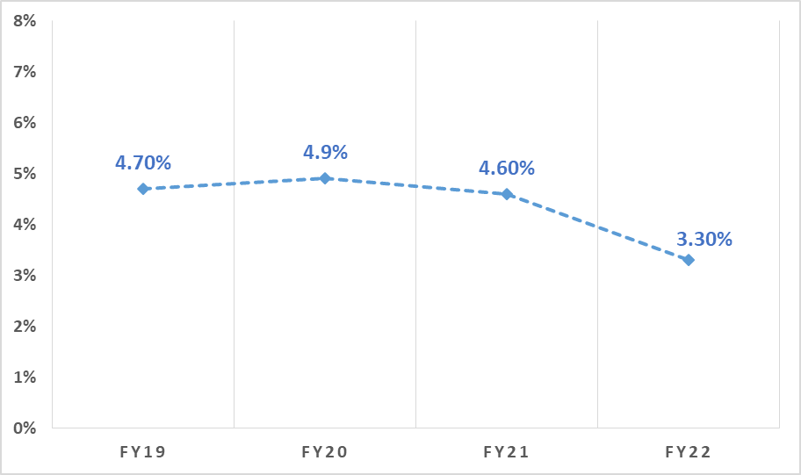

Tracking of Patients/ Psychosocial Clubs

PMTCT Beneficiaries

As mentioned previously, Impact Youth teams ensure the tracking of all enrolled PMTCT mothers, by obtaining monthly to bi-monthly lists of positive pregnant women at clinical sites. Impact Youth CHWs then visit all these women and records, with the beneficiary’s permission, the precise geographic location and details of each family’s household as well as information on the housing and economic characteristics. The women’s delivery dates are recorded or calculated and birth plans are devised with the mothers. CHWs ensure that they are on ART, and that they have regular follow-up. Impact Youth staff provide counseling regarding the importance of; adherence; giving birth in hospital milieu; providing prophylaxis to their newborn baby; exclusive breastfeeding. Impact Youth staff also ensure that the exposed infants are tested within the recommended time frame. In order to optimize PMTCT follow-up, Impact Youth also carry out psychosocial clubs which target HIV+ pregnant and breastfeeding women, as well as mothers with young children below 2 years of age whom they are encouraged to bring along. These clubs have a dual educative and psychosocial purpose. They provide a confidential and safe outlet for the women to learn about key health topics as well as having the opportunity to share experiences and ask questions to others living in a similar situation to themselves.

These clubs are run by Impact Youth Coordinators and meet monthly. The curriculum, developed by the Caris Education team, focuses on creating a safe space for discussion and learning about HIV, health, breastfeeding, family planning, caring for infants, child development and human rights, among other topics.
Across all 10 geopolitical departments, Impact Youth has over 3,513 HIV positive women enrolled into clubs (170 active groups), which are used as platforms to distribute safe water products, deworming anti-parasitic medication, condoms, prenatal vitamins, Birthing Kits, as well as Vitamin A supplements. The clubs are also used to sensitize beneficiaries on our Household Economic Strengthening (HES) programs (MUSO + and kitchen gardens).
Table 5. Mothers Clubs (PMTCT Support Clubs) by FY22
Clubs | Participants | Departments
FY22: 170  (FY21 200,FY20 166, FY19 226, FY18 198, FY17 162, FY16 115, FY15 84, FY14 46) | FY22: 3513  (FY21 3414;FY20 2242, FY19 3690, FY18 4237, FY17 4092, FY16 3491, FY15 2082, FY14 1639) | FY22: 10  (FY21 10; FY20 10, FY19:10, FY18, FY17:10, FY16: 9)

Figure 3. PMTCT women enrolled in Psychosocial Clubs

HIV-Infected OVC

Impact Youth also ensures the tracking of over 2,000 active HIV positive children (0-18 years old). This includes ensuring that they attend their medical appointments regularly, are adherent to treatment, have updated viral loads (in view of achieving viral suppression) and maintain appropriate weight. Tracking is ensured by accessing electronic medical records, having regular clinical site visits, collaborating closely with clinical staff, performing home visits and accompanying patients to the sites. Children who are eligible for ART are identified through our monthly monitoring program and the sites are encouraged to start treatment immediately. To date, 100% of HIV-positive children 0-18 years old, who are alive and in follow-up are currently on ART with no interruption to treatment.

In order to optimize clinical follow-up, Impact Youth established psychosocial support clubs (‘Kids Clubs’) which target HIV-positive children aged 9 to 17 years old at the clinical sites that we collaborate with. These clubs follow the same model that CARIS had created before the BEST program, when it identified the need for closer monitoring of adolescents and pre-adolescents. These clubs have a dual educative and psychosocial purpose.

In FY22, there have been 121 active Kids Clubs running monthly, up from 70 in FY20 in all of the 10 departments. Coordinators also ran 24 monthly clubs tailored for 288 youth aged 18 and over. All children eligible for Kids Clubs are given the opportunity to join the clubs and they are then registered as club members on the Caris database.

In FY22, 1,576 kids participated in the Kids Clubs and 18+ Clubs following the monthly curriculum developed by Caris. The aim is to improve OVC survival by increasing adherence, as well as to educate the children on their disease and management of HIV. It is also a confidential environment where the kids can be at ease and share any difficulties or challenges that they are experiencing. A further fundamental aim is to assist with the disclosure process so that each child knows their status (in an appropriate manner of comprehension) and understand their potential for development and happiness. This involved us working closely with psychologists and parents/caregivers to develop individual strategies. As our database shows that viral load suppression is lower amongst the population of 3-8 years old kids compared to the other age groups, Impact Youth, since 2020, started Psychosocial Support Clubs for children less than 9-years-old where the parents participate with their children in the activities. These clubs were running in select SANTÉ sites in all 10 departments of the Country and we plan to continue to run them in Ranfose Sante’s sites as well as other networks. This fiscal year, viral load coverage for children aged 3-8 enrolled in Kids Clubs was 99% and viral load suppression was 83%.

Table 6. Teen/Kids Psychosocial Support Clubs- Descriptive Statistics FY22
Age | Clubs | Participants | Departments
3-8 yrs | 38 | 217 | 8
9-17 yrs | 89 | 1288 | 9
18+ yrs | 24 | 288 | 8

Figure 4. OVC enrolled in Psychosocial Support Clubs
48% increase from FY19 to FY22

Figure 5. Map of Impact Youth Kids and Teen Psychosocial Support Clubs in Haiti
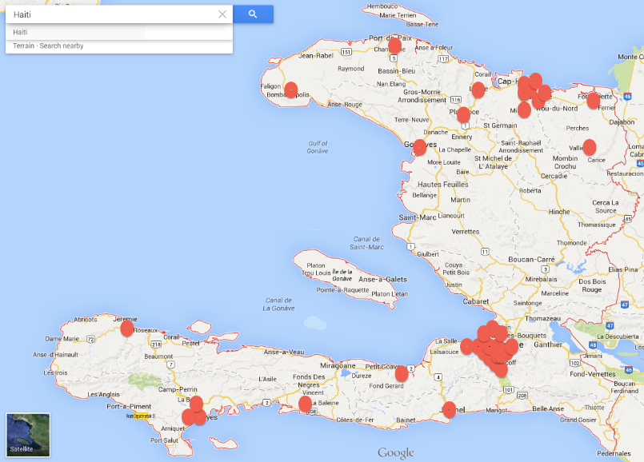

During the psychosocial club sessions, Caris provides a hot meal, a hygiene kit and a transport fee for each club member as well as materials for club activities. The hospitals donate their space for the clubs and help to identify potential new members. These clubs are also used as platforms to distribute safe water products and deworming anti-parasitic medication, as well as to introduce OVC to the holistic care package mentioned above.

At the end of FY22, Viral load coverage for the 9-17 kids in club was 98 % and Viral load suppression 87 %.

Mobile Health Application Usage

CHWs are responsible for ensuring home visits to beneficiaries. These have a variety of purposes, including routine care visits, reducing Loss-To-Follow-Up (LTFU), making sure the exposed infant is on prophylaxis, malnutrition follow-ups, schooling, and distribution of products. Visits are recorded on a mobile application called ‘CommCare’. If an immediate course of action needs to be undertaken, an email is generated and sent to nurse coordinators responsible for that particular beneficiary. The coordination is then ensured with the point person at the clinical facility (site/case manager, doctor or nurse).

Collecting, digitizing/storing and processing information in order to make decisions is at the core of Caris’ digital principles. CommCare is very user friendly and runs offline. This tool ensures faster data recovery even when activities are far from clinical sites and program offices. It is particularly adapted for low-resource environments and has a history of successful large-scale deployment in the Haitian context.

CommCare forms include qualitative and quantitative performance measures. The data collected in the field can be instantly available on Impact Youth’s database. Managers are able to fine-tune activities in the short-term and optimize deployment strategies in the longer term using this platform. GIS data collected through the CommCare platform also allows for deeper, more granular understanding of geographic differences in health service delivery. The technology can be rapidly learned, and forms evolve as the program changes.

Some of the benefits of using this mobile data collection platform are as follows:
- Monitoring of activity of health agents
- Large datasets and number of visits across Haiti
- Tracking of patients via GPS (with patient consent)
- Data analysis for programmatic reporting as well as individual/ subsets of patients
- It updates the database as soon as CHWs come into WIFI zone (home office) or data- capable cell phone service.
- Easy to implement – Caris developed Creole /French Training modules in addition to in-person training (3 days)
This system was put in place by our IT team and is monitored on a weekly basis. Over 81,590 visits have been recorded in the Caris database for FY22. We have been able to train all of our CHWs on the use of CommCare with a basic android phone. This technology is of minimal cost and therefore has scale-up potential.

Table 7. Number of recorded visits by program
Program | Number of visits FY22
Gardening | 28,084
Nutrition | 12,189
OVC services | 18,043
PMTCT | 23,282
Total | 81,598

Nutrition Program

Good nutrition is a critical factor in reducing infant mortality and builds a strong foundation for a child’s health, growth and development. In aiming to improve the healthcare and psychosocial status of HIV infected and affected Orphans and Vulnerable Children, Impact Youth teams track the HIV-exposed infants and HIV positive pediatric cases (0-18 years of age). This tracking also helps to identify and address malnutrition as early as possible especially in HIV-positive children under five years of age.

The weights of all HIV-exposed infants are recorded at their 1st PCR visit and thereafter by Caris CHW while being tracked. The Caris teams have been using the MUAC (Mid-Upper Arm Circumference Measurement) ever since it was adopted as the recommended method according to the 2016 Haiti Malnutrition guidelines. Malnourished infants, from the age of 6 months-59 months, are started on a Ready To Use Therapeutic Food (RUTF) ©Plumpy Nut regime, until they reach an adequate weight and MUAC.

Table 8. Malnutrition in HIV positive infants - FY 2022 (OVC_NUT)
Number of HIV-positive children (6-59 months) whose weight was surveyed | Number of malnourished* HIV positive children (6- 59 months) whose weight was recorded
(FY22) 160  (FY21 281, FY20 126, FY19 154, FY18 119, FY17 772, FY16 1083, FY15 815) | (FY22) 25  (FY21 30, FY20 17, FY19 25, FY18 13, FY17 159, FY16 131, FY15 281)

* moderately (MAM) and severely malnourished (SAM) infants were included

In addition to HIV infected children, children under five years old in vulnerable communities are also screened (MUAC, weight). If found to be malnourished, these children are firstly referred to the nearest malnutrition unit. If there are no possible options for a child to be admitted at one of these centers and these children are either MAM or SAM with no complications, they are enrolled in Impact Youth’s Nutrition Program. They are then provided with RUTF and are weighed by CHWs on a weekly basis to help them attain a normal measurement.

Impact Youth screened nearly 6,000 children and enrolled 1006 of them into our Nutrition program in FY22, among whom 25 are HIV-positive.

Schooling

Table 9. Schooling program - Descriptive Statistics FY22
# Children sent to school | # HIV-Positive children sent to school | # HIV-Negative children sent to school | Male | Female | # Beneficiaries surveyed
4,110 | 1,064 | 3,046 | 1,812 | 2,298 | 4,156

Formal schooling and literacy increase the capacity for financial independence and has been shown to increase the age of first pregnancy in girls. Numeracy and literacy are essential skills for working life and for running a business as a means for self-sufficiency. Reducing the barriers to essential educational services is a key factor in the Impact Youth project’s mission.

Schooling numbers increased from FY21 although the target was not reached due to multiple factors including: school closures; the ongoing socio-political turmoil which paralyzed activities on several occasions and the shortage of fuel over the course of the year. This year, the Impact Youth schooling program has schooled 4,110 OVC. To note, 20% of parents were able to independently pay their children’s school fees and therefore no longer required Caris’s assistance. As in previous years, the identity of each OVC had to be verified. In addition, the following information has to be verified and entered into our database: the family unit, caregiver identity, gender, age, home and school location, contact at the school, cost of tuition, amount supported by the project, school grade and school progression. A Caris designed and implemented mobile application linked to the program database was created to deal with the M&E and accounting demands. Of the total number of OVC assisted in full time education, 1064 were living with HIV. The schooling program is based on a participative principle, in which parents also contribute.

The Impact Youth CHWs actively track OVC through home visits and facilitate the enrollment of the children into school. Fees have been paid to the schools individually or in block grants if there are large numbers of OVC enrolled. Schooling agents make sure in advance that all children whose fees are paid for by Impact Youth, are enrolled at the schools before paying the fees.

All OVC who were enrolled in the Impact Youth schooling program for the previous academic year were automatically considered for the next school year with the exception of those who had graduated. Grades were collected and 93.4% of the surveyed children progressed in school to the next grade. It is to be noted that, due to the above-mentioned constraints, we were not able to collect grades for every child enrolled.

Vocational training for older children and those transitioning to adulthood is also offered through partnership with local entities for a selected group of individuals who are out of the classical schooling system and between the ages of 18 and 21 years-old. 49 beneficiaries (13 from 18+ clubs and 36 girls from DREAMS) participated.

Health Education

The Caris Health Education department has developed comprehensive curriculums for the Kids Clubs, Mothers Clubs, DREAMS program as well as a series of condensed health messages for the prevention and awareness of HIV aimed at community youth groups and schools. This curriculum addresses the gaps in knowledge on key health issues including HIV/AIDS and provides information with regards getting tested. For FY22, 154 teachers and 248 Community and Church leaders were trained.
The curriculum has been shared with 87 community clubs country-wide who reach a total of 3479 youth. Over 3,440 were 9-14 years of age and 3,395 of them completed the curriculum. Leaders of existing youth groups in the community (church, sports, scouts, etc.) were trained on the curriculum and they then disseminated short messages at least twice a month during their scheduled activities. This curriculum was also shared with over 60 schools within networks that include: PIH, Solidarité Laique and Reseau des Ecoles Adventistes of which 4,252 were 9-14 years old and 3,187 of them completed the curriculum.

Household Economic Strengthening (HES)

Savings and Lending Groups (MUSO)

The MUSO program mostly entails the creation of savings and lending groups, targeting areas of high HIV prevalence, in order to include a maximum number of OVC households. The groups are considered “Plus” as they receive the added benefit of health messaging, in addition to receiving financial and entrepreneurial training. Impact Youth currently has over 1,052 MUSO Plus groups, in all 10 departments. Of 27,061 OVC caregivers, 2,991 (11%) are living with HIV (PLHIV). The groups have been very successful in generating income.

Figure 7. Communes with CARIS supported MUSO group, by number of groups
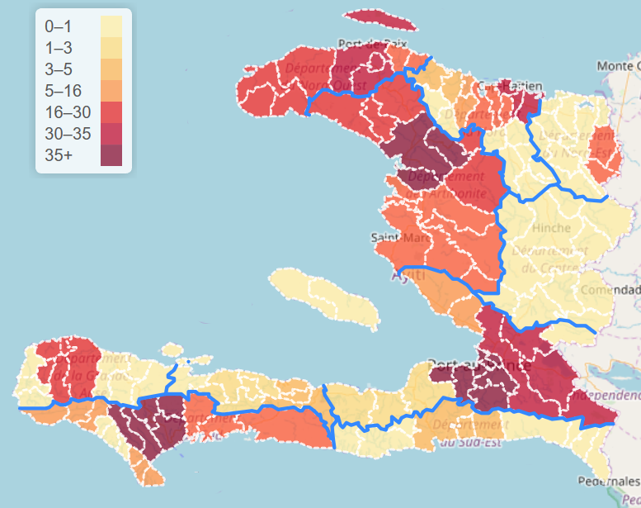

Table 10. FY22 Overview of MUSO Beneficiaries
Year | Groups | HIV-Negative Participants | Household members of Participants | HIV-Positive Participants
FY22 | 1,052 | 24,070 | 46,782 | 2,991

Of note, every MUSO cycle lasts 12 months. Member and group retention over the life of the program are strong with over 91% of the groups that completed a cycle choosing to advance to the next cycle.

There is a significant amount of money being saved which in turn increases the financial capacity of group members to respond to their basic needs, helps create more income generating activities and is useful in the response to financial emergencies or natural disasters.

Figure 8. Number of active MUSO groups

91% increase from FY19 to FY22

Table 11. Savings, Credits, Reimbursement for MUSO groups by Cycle
 |  | Cycle 1 | Cycle 2 |  | All cycle
 | Members Statut | Cycle 1 | Cycle 2 |  | All cycle | All cycles in Us (rate of 125 HTG/1 USD)
 | All Members | 60,492,525 | 47,084,846 | 18,262,458.00 | 125,839,829.2 | $1,006,718.63
Savings | PLWIH | 3,045,456 | 2,942,040 | 1,365,374.00 | 7,352,870.8 | $58,822.97
Community Fund | All Members | 2,646,481 | 365,660.00 | 2,087,283.00 | 5,099,424.0 | $40,795.39
Community Fund | PLWIH | 175,508 | 1,662,228.00 | 394,523.00 | 2,232,259.0 | $17,858.07
Credit Taken | All Members | 493,188 | 34,495,927.00 | 12,332,136.00 | 47,321,251.0 | $378,570.01
Credit Taken | PLWIH | 3,242,252 | 2,731,174.00 | 15,229,248.00 | 21,202,674.0 | $169,621.39
Amount reimbursed | All Members | 62,804,357 | 39,154,971.00 | 12,567,883.00 | 114,527,211.0 | $916,217.69
Amount reimbursed | PLWIH | 2,649,370 | 1,395,333.00 | 783,264.00 | 4,827,967.0 | $38,623.74
Maximum credit | All Members | 123,296,881 | 86,239,817.00 | 3,083,041.00 | 212,619,739.4 | $1,700,957.92
given out per cycle | PLWIH | 5,694,826 | 4,337,373.00 | 2,148,638.00 | 12,180,837.3 | $97,446.70

The MUSO model has been implemented without any complications and in general the groups can be easily maintained and scaled-up with minimal costs. The added benefit of the condensed health messages means that not only do beneficiaries achieve more financial independence, they also have accrued essential health knowledge.

Kitchen Garden Program

As an additional economic-strengthening activity for OVC caregivers, Impact Youth offers a Kitchen Garden program. The Mothers Club participants are sensitized on this activity and if accepted, an agricultural technician (Ag. Tech) visits the home to assess the possibilities of starting a garden. To avoid stigma/discrimination in the communities where the women live, the program is offered to neighbors and surrounding homes. Home gardens provide a sense of household security; physically, economically and nutritionally. The objective is for each garden owner to have enough vegetables to feed their family as well as having extra to sell so that it becomes an income generating activity. Growing fresh organic produce not only encourages the consumption of more nutritionally-rich plants and vegetables but it also empowers these women and helps them to become financially independent.

During FY22, Impact Youth trained over 3,495 individuals, of which 3,362 have established Kitchen Gardens. Of these, 23.8 % (904) are PLHIV and were sensitized and recruited through the PMTCT clubs in the Artibonite, North-West, North, and North-East regions. All Kitchen Garden beneficiaries receive health messaging and water purifying products.

Figure 9. Number of active kitchen gardens

404% increase from FY19 to FY22

Distribution of Medical and Non-Medical Products- Partnerships

Impact Youth has continued to partner up with Vitamin Angels for the distribution of Vitamin A and Albendazole to children under 5 years old, and with Operations Blessing for community distribution of Albendazole for individuals above 5 years old. Prenatal vitamins from Vitamin Angels were also given to pregnant women at some of the sites we collaborate with, regardless of HIV status. Close to 19,500 doses of Vitamin A, over 48,205 doses of albendazole, and close to 719,640 prenatal vitamins doses were distributed in FY22.
For FY22, we expanded the deworming program to the schools and community clubs, 5370 children from the schools and 4280 from the community clubs received albendazole pills.

Since 2017, during Project BEST, a grant was obtained from the Birthing Kit Foundation of Australia to supply birthing kits to HIV-infected pregnant women. The program was later expanded to include all pregnant women, regardless of status. In FY22, 6013 birthing kits were distributed to sites that Impact Youth collaborates with.

DREAMS

Impact Youth puts the empowerment of Adolescent Girls and Young Women (AGYW) at the forefront of its programming. The Impact Youth DREAMS (Determined, Resilient, Empowered, AIDS-free, Mentored, and Safe) program specifically targets AGYW in the three DREAMS designated districts, from the ages of 10 to 24 who are subject to gender inequities, in addition to poverty and cultural barriers, which render them more vulnerable to many adverse events, including Gender Based Violence (GBV) and HIV infection.

Based on the challenges that come with the ongoing socio political crisis, Impact Youth devised a strong contingency plan for DREAMS activities, which included:
- A flexible schedule at hubs with most sessions running during the weekends since chosen hub locations are schools or churches and are in some unsafe areas.
- Provision of snacks;
- Offering secondary services such as professional training, Economic strengthening activities and Parenting.

DREAMS activities include: evidence-based and developmentally appropriate interventions for adolescents; evidence-based curricula with skills-building components for parents; evidence-informed modules (healthy relationships, making healthy decisions about sex and sexual consent) integrated into already existing curricula to fill gaps; changing norms through evidenced based community interventions including Faith Based Organizations (FBOs) and communities of faith; periodic (6 month) check-ins on AGYW to ensure progress towards or completion of primary package and any needed secondary package pieces.

This fiscal year, we introduced the Transforming Masculinity (TM) component of DREAMS. We started this activity with several meetings with TEARFUND followed by a five day workshop training in November 21 for four of our staff on the TM process.
In February 2022 we started the activities with a workshop in March in some schools which focused on “My social networks" in order to determine the reference groups of the selected girls and boys, followed by a session on “THE FIVE WHYS: to determine the key social norms that need to be addressed when implementing the TM component. All these activities were necessary to choose the pilot location for TM.
The next step for this implementation was a training on the importance of ‘Gender Champions’ held from March 21st to 23rd for 17 participants which included DREAMS mentors, supervisors, social workers and community leaders. These staff have started the activities in the schools at Tabarre, Kenscoff and Petionville. Each group had to follow 6 sessions of 2 hours based on the TEARFUND curriculum. The sessions were as follows:
- Intro and underlying causes of SGBV
- Gender Roles and Norms
- Power, Status and SGBV
- Faith and SGBV
- Moving forward while reflecting on the past
- Looking to the future, striving to build a violence-free world together.

TM-Community dialogue
Supervisors who were trained as gender champions were tasked with conducting community dialogue sessions for DREAMS girls aged 18-24 and their peers in the same age group. These community-based sessions will inspire and facilitate change in gender equality, masculinities, and the role of religious beliefs, all of which are critical to preventing sexual gender-based violence (SGBV).

Table 12. TM activities
District | # Girls | # Boys | Age | Sessions
Tabarre | 15 | 16 | 18-24 | - Intro and underlying causes of SGBV  - Gender Roles and Norms  -Power, Status and SGBV  -Faith and SGBV  -Moving forward while reflecting on the past  Looking to the future, striving to build a violence-free world together
Pétion-Ville | 15 | 15 | 18-24
Kenscoff | 10 | 8 | 15-20
Total | 40 | 39
Total |  |  | 79

While continuing these activities with the youth in their communities, a training was held on April 20th-21st for 10 religious leaders and six community leaders in order to give them the information and the necessary background to enable and facilitate behavioral change on gender equity, masculinity, change in individual behavior and especially gender-based sexual violence. Based on this training, Impact Youth was able to start the activities in five churches in the Kenscoff area.
Religious leaders are male and female volunteers within communities who will inspire and facilitate change in gender equality, masculinities and the role of religious beliefs in preventing SGBV by spreading messages through churches in their communities.
Table 13. Religious leaders trained
District | # Churches | # Women | # Men
Kenscoff | 5 | 200 | 150
Total |  | 350

Table 14. DREAMS layering table
 | Aged 10-14 | Aged 15-19 | Aged 20-24
 | Intervention | Intervention | Intervention
Primary individual interventions | Social Asset Building and Community-based HIV & Violence Prevention | Social Asset Building and Community-based HIV & Violence Prevention | Social Asset Building and Community-based HIV & Violence Prevention
Primary individual interventions | HTS Screening | HTS Screening | HTS
Primary individual interventions |  | Condoms | Condoms
Secondary individual interventions | HTS | PrEP
Secondary individual interventions | Education Subsidies | Education Subsidies | Post-violence care
Secondary individual interventions | Parenting/Caregiver Programming | Parenting/Caregiver Programming | Contraceptive mix
Secondary individual interventions | Combination Socio-Economic Approaches | Combination Socio-Economic Approaches | Education subsidies (for those still in secondary school)
Secondary individual interventions | Post-Violence Care | Post-Violence Care | PrEP
Secondary individual interventions | Contraceptive Mix | Contraceptive Mix | Financial literacy
Secondary individual interventions | Condoms | HTS | Bridge to employment
Secondary individual interventions |  | Bridge to employment

Impact Youth aims to track and report on the layering of services, individual, as defined by primary and secondary packages of services, contextual, and bi-directional referrals. In Q4FY22, for the 4 different categories of AGYW_PREV being considered, in collaboration with the project funder representatives, we used the following established definitions in order to count individual AGYW.

Table 15. DREAMS Service completion
Core Package Category | Specific Service/Intervention | Definition of Completion
Social Asset Building and HIV & Violence Prevention Curriculum | CARIS DREAMS Curriculum (SGAC-Approved) | After attending 18 of 21 Caris DREAMS curriculum sessions.
Parenting / Caregiver Programming | KAP Pou Lavni (adapted from Sinovuyo) | After attending 12 out of 14 sessions, reception of certificate. Of note, Our team received the training from Clowns Without Borders, and we started serving the AGYW this Quarter.
Savings | CARIS Saving and Lending Groups (also called Mutuelle de Solidarité or MUSO), and/or Kitchen Garden program | After initiation of saving or establishment of kitchen garden.
Education | School fees and supplies | Upon payment of school fee or supplies.
Post-Violence Care | Referral to the health Center or legal system. | Seen by a professional regarding their specific case.
Community Mobilization and Norms Change | TBD | TBD
Condoms | Distribution of condoms | AGYW receive at least three condoms. Of note, all eligible AGYW who are offered Condoms (whether they accept it or not) are recorded as service completion.
HTS | Voluntary HIV testing services | AGYW is tested for HIV.
PrEP | Pre-Exposure Prophylaxis | When a referral for services is completed and confirmed.
Contraceptive mix | Access to family planning methods and services | When a referral for services is completed and confirmed.

Completing a primary package differs depending on the age group. A 10–14 year old is considered to have completed a primary package if she has completed at least 14 sessions of the DREAMS curriculum and had an HIV screening. A 15–19 year old is considered to have completed a primary package if she has completed at least 14 sessions of the DREAMS curriculum, has been screened for HIV and offered condoms. A 20–24 year old is considered to have completed a primary package if she has completed at least 14 sessions of the DREAMS curriculum, has been tested for HIV and has received condoms.

For FY22, Impact Youth’s target was to reach 18,000 AGYW who are most vulnerable to HIV infection in the 4 DREAMS designated districts. For this reporting period, a total of 18,415 active AGYW started or completed at least one DREAMS service/intervention:
- 8,145 active AGYW have fully completed the entire primary package AND at least one additional secondary service.
- 7,781 active AGYW fully completed the entire DREAMS primary package, but have not received any services beyond the primary package.
- 2,190 active AGYW fully completed at least one DREAMS service in the primary package of services but not the full primary package.
- 299 active AGYW that have started a DREAMS service/intervention but have not yet completed it.

Figure 10. AGYW_PREV Q4FY22 cumulative results vs annual target
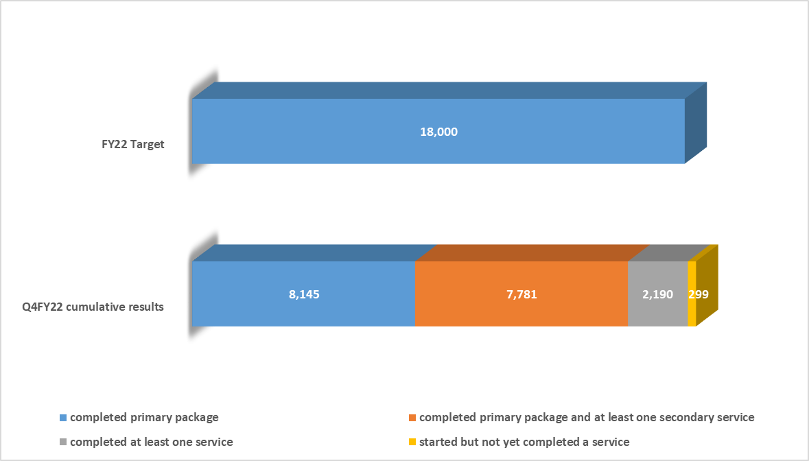

In terms of service layers, 15,926 AGYW completed the curriculum and were offered condoms. Please note that the awareness/education of using condoms is part of the Caris curriculum which the girls receive as part of the primary package. Among the 21 sessions in the curriculum, there are sessions in which AGYW are made aware of the reasons for using condoms when sexually active. Condoms are given out at the end of the condom-related sessions on a case-by-case basis.

During the individual enrollment interviews, girls are screened using the enrollment questionnaire to evaluate whether they are at high risk of acquiring HIV. Specific scores are attributed to numerous factors, including GBV risk. For the AGYW in need of HIV testing services (HTS), the lists are provided to the field team on a regular basis. For this reporting period: 1,544 AGYW were tested for HIV and 3 of them tested positive whilst follow ups have been made to place them on treatment; 479 cases of VBG have been identified with appropriate follow-up carried out; 30 AGYW received gynecological services; 4 AGYW have started a Contraceptive-Mix service; 99 AGYW have initiated PrEP; 916 beneficiaries participated in MUSO and/or Gardening programs.

For FY22, 40 DREAMS Mentors attended a training with Clowns without Borders on their Sinovouyo Curriculum. Following this initial training, the highest scoring 20 participants were chosen to become Coaches. After the evaluation phase is complete, 10 of these Coaches will be selected to become Trainers Of Trainers (TOT). There have been many delays and interruptions to the training schedule due to the country-wide insecurity but it is hoped that all trainings will be completed by the first quarter of FY23.

Table 16. DREAMS results of layering of services
 | Aged 10-14 |  | Aged 15-19 |  | Aged 20-24
 | Intervention | # Served | Intervention | # Served | Intervention | # Served
Primary Individual Interventions | Social Asset Building and Community-based HIV & Violence Prevention | 6,066 | Social Asset Building and Community-based HIV & Violence Prevention | 6,571 | Social Asset Building and Community-based HIV & Violence Prevention | 3,289
Primary Individual Interventions |  | 6,066 | Condoms & curriculum | 7,403 | Condoms & Curriculum | 3,682
Secondary Individual Interventions | Condoms & Curriculum | 6,982 | HTS | 669 | HTS | 731
Secondary Individual Interventions | HTS | 144
Secondary Individual Interventions | VBG | 40 | VBG | 290 | VBG | 149
Secondary Individual Interventions | Gynecological  services | 4 | Gynecological  services | 11 | Gynecological  services | 15
Secondary Individual Interventions | Education Subsidies | 90 | Education Subsidies | 59 | Education Subsidies | 4
Secondary Individual Interventions | Parenting/Caregiver Programming | 75 | Parenting/Caregiver Programming | 86 | Parenting/Caregiver Programming | 0
Secondary Individual Interventions | Combination Socio-Economic Approaches | 195 | Combination Socio-Economic Approaches | 372 | Combination Socio-Economic Approaches | 349
Secondary Individual Interventions | Contraceptive-Mix | 0 | Contraceptive-Mix | 1 | Contraceptive-Mix | 3
Secondary Individual Interventions | PREP | 0 | PREP | 27 | PREP | 72

Table 17. Summary of the GBV and follow up.
District | GBV type | # of cases | Types of services | HIV test | Type of Agressor
Tabarre | Sexual aggression | 2 | Psychological support |  | stranger
Saint-Marc | Physical aggression | 146 | Psychological support |  | Parent (120) | Caregiver (20) | Partner (6)
Saint-Marc | Verbal/psychological aggression | 161 | Psychological support |  | Parent (140) | Neighbor (10) | Partner (11)
Saint-Marc | Sexual aggression | 19 | Psychological support |  | Stranger (4) | Neighbor (15)
Saint-Marc | Economic aggression | 42 | Psychosocial support/reference group MUSO |  | Partner (27) | Parent (15)
Kenscoff | Sexual aggression | 3 | Psychological support |  | Neighbor
Kenscoff | Verbal/psychological aggression | 20 | Psychological support |  | Parent
Delmas | Verbal/psychological aggression | 4 | Psychological support |  | Parent
Delmas | Sexual aggression | 10 | Psychological support |  | Stranger (4) | Neighbor (6)
Desdunes | Verbal/psychological aggression | 1 | Psychological support |  | Parent
Grandes Salines | Physical aggression | 18 | Psychological support |  | Parent (13) | Caregiver (5)
Grandes Salines | Verbal/psychological aggression | 17 | Psychological support |  | Parent (15) | Neighbor (2)
Grandes Salines | Sexual aggression | 4 | Psychological support |  | Partner (3) | Stranger (1)
Grandes Salines | Economic aggression | 12 | Psychosocial support/reference group MUSO |  | Partner (6) | Parent (2) | stranger (4)
Gressier | Verbal/psychological aggression | 1 | Psychological support |  | Parent
Gressier | Sexual aggression | 4 | Psychological support |  | Neighbor (3) | Stranger (1)
Pétion-Ville | Verbal/psychological aggression | 4 | Psychological support |  | Parent
Petite Rivière | Verbal/psychological aggression | 2 | Psychological support |  | Parent
Port-au-Prince | Verbal/psychological aggression | 3 | Psychological support |  | Parent
Port-au-Prince | Sexual aggression | 4 | Psychological support |  | Neighbor
Port-au-Prince | Physical aggression | 2 | Psychological support |  | Parent
Total cases |  | 479

OVC Helpline

The free OVC helpline *4040 set up in FY20 to increase the coverage of OVC is still running and has received more than 400 calls in FY22 for the reasons stated below. It has also served to assist those who cannot receive home visits. This line is run by IY social workers day and night.

Summary of the purpose of the calls:

Sexual and reproductive health (puberty, sexuality, STIs, early pregnancy)
Psychological violence or GBV (Gender Based Violence)
Grief
Relationship advice
Economic problems
Unemployment and stress

OVC_ SERV Indicator

PEPFAR recognizes that individuals, families, and communities are being affected by HIV in ways that may hinder the medical outcomes of HIV-positive people as well as the emotional and physical development of children orphaned or made vulnerable by HIV/AIDS. A variety of services are supported through PEPFAR to mitigate these effects in order to improve health and well-being outcomes of adults and children including the developmental growth of children and the quality of life of adults and children living with and affected by HIV/AIDS.
IMPACT YOUTH offers a holistic package seeking to address the social determinants of health involved in HIV outcomes. This year we served 115,966 individuals with full disaggregation, and we surpassed our OVC_SERV target by 37%. This includes OVC_SERV direct beneficiaries and caregivers participating in our different programs; indirect beneficiaries (household members of less than 18 years of age; up to one additional caregiver per household, for a maximum total of two caregivers per household, inclusive of the direct beneficiary, if applicable). The Comprehensive package of the OVC_SERV indicator includes 102,445 beneficiaries of which 69,082 (67%) are under 18 years old.
Of note, the deterioration of the country’s socio-political crisis, the sudden increase of the shortage of fuel for most of the year has impacted our activities in all departments.
With the exorbitant increase in transportation costs, some people have had to miss club sessions despite receiving transport fees when they arrive at the club. Despite increasing the amount of transport fees given, some participants were still unable to come.
Furthermore, the rise in criminality has created a dangerous atmosphere for locals in the residential areas of Port-au- Prince and around the country. This situation prevents regular follow ups with beneficiaries residing in those areas. We are aware that the situation evolves daily and we try to adapt our plans accordingly to reflect changes and policies related to the circumstances at hand.

The results are aggregated at the IM-level by our health information system. The data is cross-referenced to ensure no duplication and each patient’s unique code is linked to each of the services that are received by the individual. When missing or inaccurate dates of birth are encountered, approximate dates are recorded in consultation with health providers familiar with the specific patients.

The following direct beneficiaries who are counted in this indicator are as follows:
- HIV positive children from 0 to 17 years of age, including members of the psychosocial Kids Clubs - Impact Youth monitors all HIV positive children in follow-up at the sites we collaborate closely with, reviewing their progress monthly. Patient home visits are made regularly (weekly to quarterly) for tracking and follow-up. Visits to the facilities are made every one or two weeks depending on the location. Of note, the HIV-positive children who follow at sites who have another OVC program (such as the UGP network) are no longer included in our OVC_SERV. We have included HIV-positive children aged 18-20 years-old who are still in secondary school and those enrolled in professional training.
- HIV-negative infants PCR-tested who are tracked by Caris until a confirmatory diagnostic test is done.
- HIV-negative OVC less than 20 years old who received fees for school tuition. Only individuals less than 18 were enrolled in our program. Individuals who are 18-20 are those who were already enrolled and who are finishing secondary school.
- HIV-positive women who are attending an Impact Youth psycho-social club.
- Household beneficiaries of Kids and Mothers Club direct beneficiaries (in Q3 and Q4 FY22) who do not participate in other programs such as MUSO, schooling or kitchen gardens. This focuses primarily on the OVC less than 18. It also can include an additional caregiver, for a maximum of two caregivers per household (where applicable).
- HIV-negative (0-5 years-old) children who are enrolled in the project’s malnutrition program.
- HIV-negative women (OVC caregivers) who are enrolled in the Kitchen Garden Program.
- HIV-negative individuals (OVC caregivers) who are enrolled in MUSO groups.
- Household members (below 18 years of age) of HIV-negative members of MUSO and
- Kitchen Garden and nutrition activities.
- Individuals 9-14 years old enrolled in schools for which teachers have been trained to share the Caris health education curriculum.
- Youth from 9-14 years-old that are a part of community clubs that receive the Caris health education curriculum.
- Adolescent girls and young women (AGYW) enrolled in Q1 and served in Q1-Q2 of FY22, as well as those enrolled in DREAMS activities within less than 12 months and served in Q1 and Q2FY22. Of note, only OVC_SERV less than 18 are reported for DREAMS under OVC_SERV; however, it is important to mention that the DREAMS program itself is supposed to target 10-24-year olds. The number reported for DREAMS under OVC SERV is therefore lower than what is reported in AGYW_PREV due to this criterion.

The table below shows the beneficiaries by category:

Table 18. OVC_SERV components results, FY22
Components | FY22 Data
Number of children with first PCRs for Q4 (EID) and number of children in active follow-up having received a service from IMPACT YOUTH in Q3 and Q4 FY22. | 2,661
Number of women on PMTCT lists who received a visit (or phone call during COVID) from IMPACT YOUTH CHWs and/or number of women having participated in IMPACT YOUTH clubs in Q4 FY22 (newly enrolled), including graduates. | 3,762
Household beneficiaries of Kids and Mothers Club direct beneficiaries (in Q3 and Q4 FY22, or just Q4 for newly enrolled) who do not participate in other programs such as MUSO, schooling or kitchen gardens. This focuses primarily on the OVC less than 18. It also can include an additional caregiver, for a maximum of two caregivers per household. | 3,154
Index testing individuals: children of PMTCT women and siblings of HIV-infected children having received a service in Q3 and Q4 FY22. | 6,204
Children screened and enrolled in the IMPACT YOUTH program for moderate malnutrition (HIV negative, as the infected children are already accounted for as children in follow-up) for the reporting period. | 29
Malnutrition program indirect beneficiaries (household members of direct beneficiaries) below 18 years old for the last quarter. This also can include a maximum of two caregivers per household. | 77
Beneficiaries enrolled in the schooling program (HIV negative, as the infected children are already accounted for as children in follow-up) in Q3 and Q4 FY22. | 3,300
Number of indirect (household) beneficiaries of DREAMS schooling beneficiaries who received an indirect service (water purifying product). This focuses primarily on the OVC less than 18. It also can include an additional caregiver, for a maximum of two caregivers per household. | 228
OVC 18-21 years old enrolled in our professional training program | 33
MUSO direct beneficiaries participating actively in MUSO groups in Q3 and Q4 FY22. Either HIV-negative or positive; the latter are not participating in other IMPACT YOUTH programs (ex: clubs, kitchen gardens), as those who are participating in other programs are counted elsewhere. This includes graduated beneficiaries. | 22,414
MUSO indirect beneficiaries, i.e. household members of direct beneficiaries who received at least one service from IMPACT YOUTH during Q3 and Q4 of FY22. This concerns indirect beneficiaries below 18, and can also include an additional caregiver, for a maximum of two caregivers per household. This includes graduated beneficiaries. | 37,897
Kitchen Garden program direct beneficiaries who were active during Q3 and Q4 of FY22 | 3,023
Kitchen Garden program indirect beneficiaries, i.e. household members of direct beneficiaries who received at least one service from IMPACT YOUTH during the Q3 and Q4 FY22. This also can include an additional caregiver, for a maximum of two caregivers per household. | 5,877
Number of children in the school networks in Q3 and Q4 FY22 who have completed the IMPACT YOUTH health curriculum and have received other services (albendazole, water purifying product) | 1,273
Number of indirect (household) beneficiaries of school networks beneficiaries who received an indirect service (water purifying product). This focuses primarily on the OVC less than 18. It also can include an additional caregiver, for a maximum of two caregivers per household. | 2,227
Number of children in the school networks we collaborate with who have received only health messages based on the IMPACT YOUTH health curricula for FY22. | 2,076
Number of children participating in IMPACT YOUTH's Community Club program, in Q3 and Q4 FY22 who have completed the IMPACT YOUTH health curriculum and have received other services (albendazole, water purifying product) | 3,458
Number of indirect (household) beneficiaries of Community Club beneficiaries who received an indirect service (water purifying product). This focuses primarily on the OVC less than 18. It also can include an additional caregiver, for a maximum of two caregivers per household. | 6,481
Number of children participating in IMPACT YOUTH's Community Club program, as well as number of community club leaders trained on health messages, and have received only the curriculum as a service for FY22 | 186
Number of AGYW (10-17 years old) or enrolled in DREAMS activities in Q4 of FY22, as well as those enrolled in Q3 and served in Q4 of FY22 | 11,140
Parents of AGYW having participated in the parenting program (SINOVOUYO Curriculum) | 218
Safe space beneficiaries who have received only the curriculum as a service in FY22 | 119
HIV screening for OVC | 129
Total | 115,966

Figure 11. OVC SERV – Number of beneficiaries served vs annual targets

OVC_HIVSTAT
The community-based activities of Impact Youth provide support to a large number of OVC, their caregivers and their community members. These activities include direct service delivery of malnutrition screening and treatment; health education in schools and community organizations via training-of-trainers; microfinance groups to support economic outcomes and meet important household needs. Support with regards to testing and counseling, as well as ensuing care and treatment is offered when indicated, depending on vulnerability to contracting HIV. All beneficiaries are screened for HIV Risk factors and those at risk are referred for testing. For this reporting period, the status of 92 % of the children in the OVC program are reported or the test is not required based on risk assessment. The OVC for which status is unknown include: OVC in the nutrition program not yet tested for HIV; children in the household of Gardening and MUSO beneficiaries for whom a test is indicated by the risk assessment tool but not yet tested; some children from the household of mothers in clubs. We will fulfill the necessary follow ups in the upcoming fiscal year.

SUCCESS STORIES

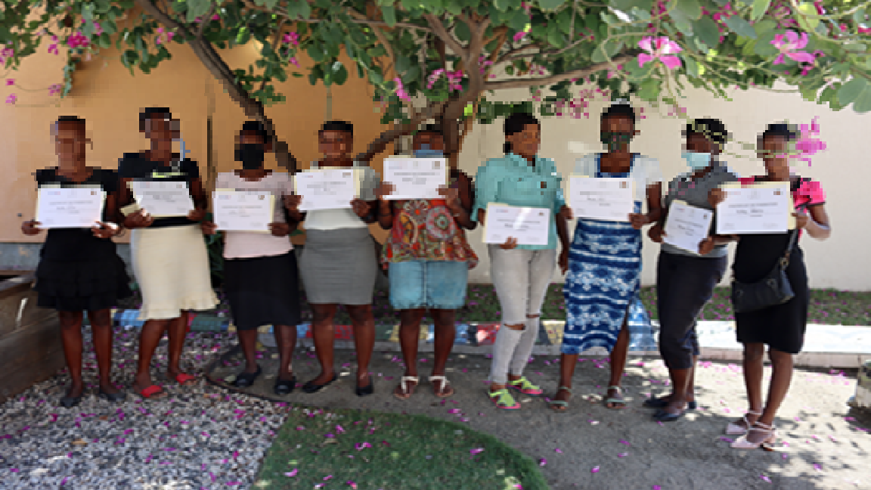
I- Empowering Haiti’s Women

Caris’s Impact Youth program uses a holistic approach in order to bring a comprehensive care package to Orphans and Vulnerable Children (OVC) and their families. All Impact Youth programs feature educational sessions as we believe that education should be at the core of development efforts in Haiti.
Women in Haiti, especially those living with HIV, constitute a great portion of the country’s illiterate population. For this reason, the pilot Literacy program was initiated in July of 2021 in order to help women from Caris Mothers Clubs to acquire skills such as reading and writing to help them to become literate and ultimately, empowered. Through our Mothers Clubs, these women were made aware of this program and 15 of them who were found to be illiterate were chosen to participate in this pilot program.
Members of our staff were trained by the Haitian “Secrétairerie d’Etat à l’Alphabétisation” with which Caris signed a Memorandum of Understanding. The length of the program was set for six months and during this time, the group of women met with our Social Workers twice every week for a 3 hour session each time.
Today we are proud to report that, on February 10th 2022, 13 out of the 15 women who participated in the pilot program have graduated.
We received many testimonials from these women thanking Caris for this initiative and recognizing the importance of this program and of their individual achievements. One woman, an HIV+ mother, mentioned that thanks to this program, she can now read a prescription and is confidently able to give her child her medication without having to go to the doctor's office for them to read the written prescription out loud to her. Others mentioned that they used to be ashamed of performing simple day to day activities like going to the bank for a cash withdrawal because they couldn’t write their names. Another beneficiary added: «Now I can help my children study, I no longer need to pay for someone to help them study because NOW I can read for myself and help my children when they need me to…THANK YOU CARIS!”

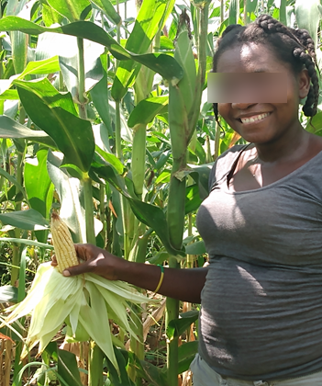
II- From the ground to the table
The IY gardening program regularly raises awareness among the various PMTCT Mothers clubs across the country. The program's Agricultural Technicians recruit women eligible to participate in the program and provide training sessions on gardening techniques for all women enrolled in PMTCT who have a space conducive to cultivation in order to set up a vegetable garden.
This is how Gerda Valcin*, 34, HIV +, mother of five children. She lived in extreme poverty and had no activity that allowed her to feed and take care of her children. After sensitization, she received a training to run her own Kitchen Garden. Once the garden was installed, Gerda was supported by an IY Agricultural Technician until the harvest. Thanks to her garden, Guerline was able to feed her children and start a small business with the money saved from the sale of surplus produce. Today she is proud to be able to produce her own vegetables herself at home because not only does she find fresh and organic produce for her children but at each harvest she also sells some in order to buy other basic necessities. "Thanks to my garden, I can feed my children, have a budget and plan other income-generating activities, thanks to the Caris Foundation" reports Gerda.
We will continue to accompany these vulnerable people by giving them new gardening practices so that they produce more vegetables in order to support their children and their families.
*Name has been changed to maintain anonymity.

CHALLENGES

This fiscal year has been faced with particular challenges, for which we had to establish mitigation measures. These include:

- Haiti has undergone a severe and prolonged socio political crisis since July 2018 which has deteriorated significantly during FY22 with high levels of insecurity and fuel shortage. This crisis has had an impact on most of our activities, especially in high-violence prone areas. Due to the security situation, many of our community activities were postponed or canceled because our teams or patients often could not reach the facilities or activity sites. However, as soon as the situation became calmer, we were able to resume activities. Mobile banking and working with CHW/mother mentors living in the areas where our beneficiaries live are among some approaches that have helped overcome these difficulties. We also reinforced our security protocols.

- Staff turnover at sites has increased. It is often only a few select staff who have access to training, key materials or e-mails. If these staff members go on leave or change jobs, there is often a delay in transition between staff members, with some loss of efficiency at the patient’s expense.

- As most health programs in Haiti, we have had issues with patient duplication, or “medical shopping”, i.e. beneficiaries seeking care in multiple sites, often with different names. Unique Identifier Codes, with biometrics or official government issued IDs verifying the authenticity of the user would help address this issue.

- Specimen transportation reduced by 17 sites which complicated the follow-up of HIV+ cases from those sites.

- The transition from ISANTE to ISANTE Plus caused delays in updating patient follow-up information as Impact Youth staff was unable to access the platform. The follow-up process to resolve this issue is ongoing.

LESSONS LEARNED / BEST PRACTICES

- Our OVC programs operate in all 10 departments, from one headquarter base and seven satellite offices strategically dispersed throughout the country. Decentralizing operations, whilst using the same models and protocols in all offices has enabled us to scale up our program quickly and in a standardized way.
- Hiring local capacity with varied expertise has been key to establishing a solid foundation for our OVC programs. A thorough understanding of the local context allowed us to develop culturally adapted plans for all the different aspects of the program.

- Staff turnover in hospitals and laboratories tends to be relatively high, and errors have arisen as a consequence, likely the result of incomplete handovers. Training, as well as refresher trainings are thus of utmost importance, to ensure maintenance of work quality.
- It was reported to us on numerous occasions that patients become non adherent to medical follow-up because of the lack of staff approachability. Trainings on stigma, discrimination and patient rights, as well as an anonymous suggestion/complaint system, should be the mainstay of any program aiming to improve ART adherence.

- Clinical sites should try as much as possible to schedule HIV-positive parents for their visit on the same day as their HIV-positive child. If this is not possible, children who are in clubs should be able to have their follow-up appointment the same day to avoid a second visit. This will help reduce LTFU of either the parent or the child.

- Strong cultural beliefs have been an impediment to uptake of health messages and adherence to treatment. It is necessary to address them as part of a holistic approach to the patient.

- HES models have been successfully implemented, maintained and able to scale-up, with minimal costs. The added benefit of short health messages means that not only do beneficiaries achieve more financial independence, they also have accrued health knowledge.

- The use of Open Data Kit sources (CommCare) has been crucial for the standardization and quality control of agent work, in addition to helping with GPS mapping. We have been able to train all our community healthcare workers on the use of these applications, with a basic android phone. This technology is of minimal cost, and scale-up potential is high.

- Centralizing data on one server has helped with workflow, as well as data quality control and analysis. Our in-house IT team has created a system of alerts based on different parameters which helped our teams follow-up on their work, such as reducing LTFU and improving viral load coverage.

- Data collection is of extreme importance; standardization through use of questionnaires and CommCare have led to a reduction of errors, as well as more thorough and accurate data uptake. It is essential to make sure that the staff responsible for collecting the data are aware of its importance, properly filling out forms and questionnaires and finding ways to convey questions and messages appropriately to get as accurate an answer as possible. There is a need for any such program to focus on improving data collection, data entry and data analysis through protocols, refresher trainings of staff, data quality controls and M&E monthly reporting on key internal indicators.

