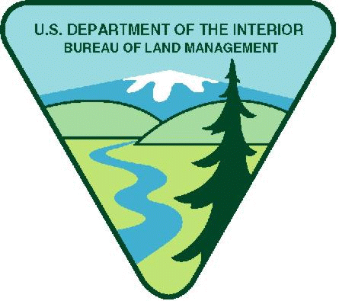
Project Title: Recreation Intern Youth Opportunity
Maximum Available Funding in FY23: $15,000
Project Background Information: Public lands of the Roseburg District, located in southwestern Oregon, contain some of the most productive forests in the world, including dense stands of Douglas-fir, hemlock, and cedar. The district is crisscrossed with streams and rivers that support sport fishing and contribute to anadromous (sea run) fish stocks vital to commercial fishing. With Interstate 5 running through the middle of the district, and east-west state highways connecting Crater Lake to the Pacific coast, the Roseburg District draws many tourists to its scenic and recreation attractions. The Bureau of Land Management's recreation resources and visitor services support strong local economies and public land conservation. As we work to enhance recreational opportunities for the American family, we strive to remain a good neighbor. This means respecting how communities use the public lands, as well as including their voices in our management decisions.
Project Objective: The objective for this internship is to provide on the ground support for the district recreation program, by working with recreation staff, partner groups, volunteers, and through interactions with the visiting public. Participate in the completion of various recreation site and trail maintenance and reconstruction projects, fire recovery projects, provide information to the public, and participate in occasional meetings and training opportunities. This position will be primarily a field going position.

Work Schedule: Generally, Monday – Friday, 8 AM to 5PM. Weekend schedules may be required at times. Start and End dates can be flexible. Tentative start dates beginning May 2023 and ending August/September, 2023.

Funding: $15,000.00

Qualification Requirements: This opportunity is suitable for youth working towards an undergraduate or graduate degree in outdoor recreation, education, or science-related disciplines. This opportunity will require time outdoors and with groups. Staff and volunteers would complete work that would require moderately strenuous physical exertion at times, such as hiking on trails while carrying tools.

Housing: The BLM cannot provide housing but may be able to assist in locating appropriate clean housing.

Vehicle Needs: Intern should have the ability to arrive at the Roseburg District Office for work. Transportation to the field would be by government vehicle with a BLM employee.

Other Project Considerations:

The youth corps organization will consider food, supplies, travel, and training requirements for the intern.

Duties: The intern will be involved with a variety of recreation maintenance and reconstruction projects, day to day operations and maintenance of recreation sites, interpretive presentation (s), BLM or other training pertaining to work to be performed, and other general park ranger duties.

BLM’s Involvement: The BLM will provide necessary project orientation and hands-on training. The BLM staff will work with the intern on a regular basis for project coordination, material needs, logistics and coordination of partner resources. The BLM will have the right to intervene by modifying the project management plan, if project is not staying on schedule, technical issues arise, etc. In addition, the BLM and recipient will meet quarterly at a minimum to discuss progress and track project outcomes; review any training needs; and then decide what direction to take in finalizing project or move to the next phase.

BLM Program Contact:

Field PO Name: Cheyne Rossbach, Assistant Field Manager Swiftwater Field Office

Field PO Phone Number: 541-579-0648

Field PO Email: crossbach@blm.gov

Applicants are encouraged to refer to the full program announcement number L23AS00444 posted on Grants.gov for all program requirements and applicable terms and conditions. Recipients selected for awards will be required to adhere to those requirements should an award be made.

