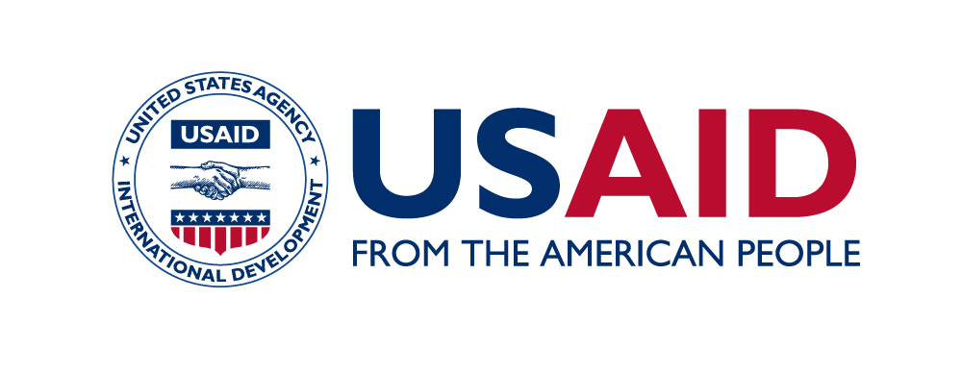
(Include partner logo)

Branding Strategy and Marking Plan
With reference to Section 320.3.3, Branding and Marking Requirements for Assistance Awards, below is the required branding strategy and marking plan:

- Program Name: USAID’s (Name) Activity

- How the materials will be positioned: USAID’s (Name) Activity will use co-branding and co-marking. This means that the program name represents both USAID and the implementing partner, and the USAID identity and implementer logo must both be visible with equal size and prominence on materials produced for program purposes. The USAID and (Partner) logos will be included on all materials.

- Desired level of visibility: (Choose Low, Medium, or High)

- Any others to be acknowledged: A host-country or ministry logo or other U.S. Government seal or logo may also be added, if applicable and approved by USAID.

BRANDING STRATEGY
With reference to Section 320.3.3, Branding and Marking Requirements for Assistance Awards, below is the required Branding Strategy:

1) Positioning

Name of the Activity: USAID’s (Name) Activity
2) Program Communications and Publicity
Program communications will be tailored to the following target groups:
Primary Audience(s): (include)
Secondary Audience(s): (include)
Since USAID is the sole funder of the activity, it will be branded as USAID’s activity in all public communications: “USAID’s (Name) Activity is made possible by the support of the American people through the United States Agency for International Development (USAID) and is implemented by (Partner).” All public communications should include the phrase “made possible by the support of the American people” to acknowledge USAID’s contribution rather than the phrase “funded by.”
In addition, the activity will promote the following main and secondary messages.
- The main message is: (include)
- The secondary messages are: (include)
If approved by the USAID Mission Director, this activity will be announced to primary and secondary audiences through a launch event and press release. Press releases and other public communication products for release by the partner will be submitted to USAID for review and approval to ensure that they are consistent with USAID’s outreach and communications policies. The activity will conclude with a closeout event to celebrate relevant achievements. The timing and release of all public information will be coordinated well in advance with the Agreement Officer’s Representative (AOR) and Development Outreach and Communications Officer (DOCO).
3) Press and Promotional Activities:
USAID is mandated to mark its foreign assistance with the USAID identity (logo) and tagline, “From the American People”. Therefore, in all USAID-funded and related activities, the activity will consistently undertake the following steps to highlight USAID’s collaboration and support:
A. TEXTUALLY: (Partner) will include references to USAID support in all printed outreach and communications materials including but not limited to reports, press releases, website content, invitations, publications, fact sheets, presentations, and promotional materials relating to the activity.
B. VERBALLY: (Partner) will ensure that USAID is publicly credited in all verbal outreach and communications activities including but not limited to speeches, press conferences, media interviews, presentations, training workshops, videos, films, public service announcements, and community meetings when referencing the activity.
C. VISUALLY: USAID’s and (Partner’s) identities will be prominently displayed on all outreach and communications materials including but not limited to reports, press releases, website content, invitations, publications, fact sheets, presentations, videos, films, public service announcements, banners, and other promotional materials. The logos displayed should be of equal size and prominence. Other logos, including a separate activity-specific logo, will not be used.
D. IN MEDIA: The USAID AOR and DOCO will be notified of each public event or workshop at least four weeks in advance. With the prior approval of the AOR and DOCO, host country and international press will be engaged at all possible opportunities. USAID will be acknowledged at all media events and in reporting on the activity. Media coverage of the work may include but is not limited to local radio, local TV, international TV, video, film, webcasts, and print (magazines, newspapers, etc.). The activity will consult with the DOCO as to whether USAID should grant interviews.
E. IN STORIES and PHOTOS: The activity will prepare at least four success stories per fiscal year using a USAID-approved story format (i.e. Medium blog, Storytelling hub, Exposure, etc.). High quality captioned digital photos will be provided for each success story and event. Noteworthy or especially interesting stories and photos will be sent to the AOR and DOCO punctually. Event photos, as feasible, will be sent on the same day as events.
F. IN SOCIAL MEDIA: The Embassy’s social media channels should be used as secondary promotional means for the activity. The activity should provide at least one Facebook updates per event or milestone. These will include text and high quality, captioned digital photos.
The activity will submit all outreach and communications materials prepared with USAID funding to the AOR for preproduction review and approval for branding and content before costs are incurred. All costs associated with branding and marking are included in the award budget.
As part of the annual work plan process, the activity will include a communications section in the work plan indicating key milestones, events, communications tools, and approaches. This will include a communications calendar that will state the proposed timing for main events. The activity will endeavor to give at least a four-week advance notice of all major public events and inform the AOR and DOC team accordingly.
4) Communication Tools
- Program brochures/fact sheets
- Program newsletter
- Success stories
- Printed PSAs, newspaper supplements, or other placements
- Advertisements about program events or activities
- Research results, studies, and evaluations
- Publications and reports
- Training manuals, workbooks, and guides
- Job aids/tools/procedures
- Professional photography
- Radio spots and/or shows
- Non-print media for SBCC
- Prepared web content for posting on the USAID website (www.usaid.gov)
- Prepared social media content for posting on the Embassy’s Facebook pages (The activity may not develop its own Facebook page.)
- Content for development blogs
- Media advisories/Press releases
- Media interviews
- Media site visits
- Press conferences
All public communications will be coordinated with the AOR and DOCO.
5) Acknowledgements
Acknowledging Host-Country Governments: All USAID’s (name) Activity materials will follow USAID branding guidelines. If during this program other major sponsors become involved, the activity will advise USAID of their involvement and request permission to include them as necessary.
Acknowledging Other Host-Country Partners: Co-branding will occur when these organizations have contributed funds to the activity. Co-branding with in-country partners may also be desirable when trying to promote local ownership and capacity building. However, when products are fully funded by USAID, Agreement Officer approval is required for any exceptions to co-branding requirements.

Marking Plan
USAID’s (name) Activity
With reference to Section 320.3.3 of ADS 320, below is the required Marking Plan for
USAID’s (Name) Activity:
Marking Plan
Table 1 below outlines the types of materials that will be produced under this activity. Any materials that are not anticipated below, but are produced under the initiative, will also be subject to similar branding guidelines and AOR approval, as appropriate.
Please note that marking is not required on items used as part of the administration of the cooperative agreement, such as stationery products, and offices supplies. The goal is to mark the activity, not the implementing partner. Thus, letterhead, name tags, business cards, office space, and equipment and supplies are not subject to branding and marking.
Every deliverable that is marked with the USAID identity will follow design guidance for color, type, and layout in the USAID Graphic Standards Manual and Partner Co-Branding Guide or such supplemental guidance as may be provided by USAID.
Disclaimer: All studies, reports, publications, websites, and all informational and promotional products not authored by USAID will contain a provision substantially as follows:
“This [study/report/audio/visual/other information/media product] is made possible by the generous support of the American people through the United States Agency for International Development (USAID). The contents of this [specify] are the responsibility of (Partner) and do not necessarily reflect the views of USAID or the United States Government.”
Table 1: Marking Plan for Materials to be Produced
Category | Type of Marking |  |  | Notes
Administrative
Stationery products (administrative business) |  | Per ADS 320, the USAID logo will not be used on stationery products intended for administrative use. Examples include letters for hiring, purchase orders, office space rental, etc. | Pertains to letterhead, envelopes, mailing labels, fax coversheets, name tags
Stationery products (program-related) |  | Stationery products that are used for program purposes will use the USAID logo (top left) and the (Partner) logo (top right). | Pertains to letters that accompany program materials, workshop invitation letters, etc.
Business cards |  | The USAID logo will not be used on business cards. (Partner) will use its own corporate business cards.
Office signs |  | Per ADS 320, the USAID logo will not be used to mark activity offices.
Activity deliverables  (e.g. work plans,  performance  monitoring plan,  financial reports, etc.) |  | Will use the USAID logo (left) and (Partner) logo (right) for internal documents.
Activity folders |  | Will be marked with the USAID logo (left) and (Partner) logo (right).
Commodities and Equipment
Commodities |  | USAID identity and (Partner) logo will be used. The design will follow guidelines for co-branding.
Equipment |  | USAID identity and (Partner) logo will be used. The design will follow guidelines for co-branding.
Technical
Technical reports, studies, analyses, briefing papers, memoranda, and policy recommendations |  | The USAID logo will appear in the top left corner of the document and the (Partner) logo at top right.
Training materials and manuals |  | The USAID logo will appear in the top or bottom left corner of the document and the (Partner) logo at top or bottom right.
CDs or DVDs |  | USAID’s and (Partner’s) identities will be used within the electronic presentation per Agency policy. The identities will also be used on the outside case containing the CD or DVD as well as on any label that may be affixed to the CD or DVD itself. USAID’s logo should be at the top left and (Partner’s) logo at top right.
PowerPoint presentations |  | The USAID logo will appear in the top left corner of the title slide and the (Partner) logo at top right. The final slide will include the USAID logo at bottom left, (Partner) logo at bottom right, and also the disclaimer language specified in Section 4 of this Marking Plan.
SBCC posters, billboards, flyers, and fact sheets |  | Posters Since these have key messages at the top. The USAID logo and (Partner) logo will be at bottom left and right, respectively.
Audio or video productions, including TV or radio PSAs |  | USAID’s and (Partner’s) identities will be used within the electronic presentation, following the USAID Graphic Standards Manual or such supplemental guidance as may be provided by USAID. The identities will also be used on the outside case containing the video/DVD as well as on any label that may be affixed to the video/DVD itself.
Brochures and Booklets |  | The title of the brochure or booklet appears at the top of the front cover. The USAID and (Partner) logos will be prominent on the front cover.
Surveys |  | The USAID identity and (Partner) logo will be prominently featured on both data collection tools and on materials produced to disseminate survey results. The design will follow guidelines for co-branding.
Government policies, strategies, plans, and guidelines (regional, national, and sub-national levels) or other materials positioned as being form the host-country government |  | The USAID identity and (Partner) logo will be printed on the inside front cover of the document. The design will follow guidelines for co-branding unless an exemption is provided for no marking.
Organizations’ policies, strategies, plans, and guidelines or materials being positioned as being from the host country partner |  | The USAID identity and (Partner) logo will be printed on the inside front cover of the document. The design will follow guidelines for co-branding unless an exemption is provided for no marking.
Promotional
Events, event signs, banners, and exhibition booths |  | The USAID logo will be visible at all events (including trainings, conferences, press conferences, seminars, briefings, exhibitions, fairs, public awareness events for SBCC purposes, workshops, etc.); located on banners and exhibition booths.  If a podium is used for an event, the USAID logo will be placed on the podium.  Bags, folders, notebooks, and pens will carry the USAID logo (left) and (Partner) logo (right).  All handouts associated with events (including invitations) will feature the USAID identity and (Partner) logo prominently.
Press releases, media advisories, press kits |  | The USAID identity (top left) and (Partner) logo (top right) will be prominently displayed and follow the guidelines for co-branding.
Mass distribution electronic email sent for program purposes (such as invitations to training events or other widely attended program related gatherings) |  | The USAID identity and (Partner) logo will be used. The design will follow guidelines for co-branding. “Alternative text” indicating support for the program from USAID and “From the American people” will be included, in case recipients view messages in plain text format or in other formats where images are not shown.

