Shoreline Protection and Water Management Facilities
Restoration on the Anahuac, McFaddin and Texas Point NWRs
Region 2, Texas Chenier Plain Refuge Complex

Notice of Funding Opportunity Number: F19AS00076

Federal Program: U.S. Department of the Interior (DOI), U.S. Fish and Wildlife Service (Service), National Wildlife Refuge System (NWRS), Region 2, Texas Chenier Plain National Wildlife Refuge Complex (NWRC).

Catalog of Federal Domestic Assistance (CFDA) Number: 15.654
Authorizing Legislation: Fish and Wildlife Conservation Act, 16 U.S.C. §§2901-2911; Fish and Wildlife Act, 16 U.S.C. 742 et seq.; Refuge Recreation Act, 16 U.S.C. §§460k-460k(4); National Wildlife Refuge System Administration Act, 16 U.S.C. §§668dd-ee; Public Lands Corps Act - Youth Conservation Corps, 16 U.S.C. §§1701-1706; Public Lands Corps Act - Public Lands Corps, 16 U.S.C. §§1721-1726; Archaeological Resources Protection Act, 16 U.S.C. §§470aa-ll; and Federal Aid for Highways-Other Highways, 23 U.S.C. §§201-204 and §206

Paperwork Reduction Act Statement: We are collecting this information in accordance with the authorizing legislation identified above. Your response is required to obtain or retain a benefit. We will use the information you provide to conduct a competitive review and select projects for funding and, if awarded, to evaluate performance. We may not conduct or sponsor and you are not required to respond to a collection of information unless it displays a currently valid Office of Management and Budget (OMB) control number. We estimate that it will take you on average about 40 hours to complete an initial application, about 3 hours to revise the terms of an award, and about 8 hours per report to prepare and submit financial and performance reports, including time to maintain records and gather information. Actual time for these activities will vary depending on program-specific requirements. You may send comments on the burden estimate or any other aspect of this information collection to the Information Collection Clearance Officer, U.S. Fish and Wildlife Service, MS BPHC, 5275 Leesburg Pike, Falls Church, VA 22041-3803.
OMB Control Number: 1018-0100 (Expiration Date: 7/31/2021)

I. Program Description
Hurricane Harvey hit the Texas coast on August 25, 2017, and stalled over the Upper Texas Coast for several days. Record rainfall and resulting flood waters impacted the water control levees and water control structures on Anahuac National Wildlife Refuge (NWR), McFaddin NWR and Texas Point NWR. Additionally, shoreline erosion occurred at Anahuac NWR along East Bay and additional erosion loss occurred on Anahuac NWR and McFaddin NWR along the Intra-Coastal Waterway. The Service will partner with Ducks Unlimited (DU) to protect the refuge shorelines and reconstruct water management infrastructure to be hardened so they are protected from future storms. Funding will be provided in support of this partnership with DU.

II. Federal Award Information
This is a single-source cooperative agreement. Funds provided to the Service were appropriated for Hurricane Harvey Recovery (PL 115-123) and this specific project has been approved by DOI under the Service’s Recovery Plan which will be applied towards this agreement to support DU with the project to protect refuge shoreline and reconstruct water management infrastructure. The Service will work with DU to acquire a feasibility study, alternatives analysis and budget estimation followed by engineering, permitting, and construction of the preferred alternative. The period of performance of this opportunity is 3 years from the original date this award is signed by the Service.

DU is a 501(c)(3) organization based out of Memphis, Tennessee that began in 1937 and is dedicated to researching, restoring and protecting waterfowl and wetland habitat and supporting waterfowl hunting and recreational opportunities. Their mission is “Ducks Unlimited conserves, restores, and manages wetlands and associated habitats for North America's waterfowl. These habitats also benefit other wildlife and people”. DU’s conservation and habitat restoration work extends across North America. They have worked on numerous projects with the Texas Coastal Refuges and adjacent Wildlife Management Areas. DU has researched the use of breakwaters for marsh erosion control and implemented the construction of these features in the Upper Texas Coast. DU is uniquely qualified to provide this level of oversight and has extensive experience implementing well designed, successful habitat restoration projects along the Texas Coast. They will be responsible for managing all aspects of this agreement along with the Service. Ducks Unlimited will be responsible for scheduling and overseeing the work described in this agreement and will provide construction oversight for the project. DU has worked to identifying shoreline protection projects along the entire Texas Coast. DU has worked for many years on engineering and development of projects on the affected refuges and recently assisted with water management facilities on Anahuac NWR. This project would be a continuation of an on-going partnership, from which DU has significant and unique experience, that will facilitate efficient-project completion.

The Service will be substantially involved in projects under the funding opportunity. In particular, the Service will be responsible for the following: 1) assist DU staff with engineering needs; 2) assist DU Staff with selecting a qualified environmental consultant for NEPA, 404 permitting, and coordination; 3) assist DU staff and the environmental firm to develop criteria for designing erosion protection plans for Refuge shoreline and repair/replacement of levees and water management facilities on Anahuac NWR, McFaddin NWR, and Texas Point NWR; 4) assist DU with selection of a qualified contractor for the construction phase of the project; and 5) provide support materials needed to help in case of problems.

III. Eligibility Information

Eligible Applicants
This is a Notice of Funding Opportunity to issue a sole-source award the recipient, DU. DU is a 501(c)(3) organization based out of Memphis, Tennessee, that began in 1937 and is dedicated to conserving wetlands and waterfowl across North America. They have conserved over 14 million acres across North America, with more than 254,500 acres of waterfowl habitat throughout Texas since 1985. The North American Waterfowl Management Plan calls for the Gulf Coast habitats of Louisiana and Texas to winter up to 15 million waterfowl, making the Gulf Coast the single-most important wintering area in North America. The Gulf Coastal Prairie is a Level 1 Priority Area for DU making it among DU’s highest priorities. The DU’s Gulf Coast Initiative number one conservation priority is protection, restoration, and enhancement of key public lands and high-quality waterfowl habitat on private lands, with the help of State and Federal partners and landowners. DU has demonstrable-project experience in working interior marshlands on NWRs. The recipient, DU, has worked on many projects in protected areas, particularly in Texas, and has a demonstrable record of success with technical assistance, design, construction oversight, and successful project completion on Federal lands. DU has designed and constructed projects of similar scale and complexity regarding water control structures, berms, levees, weirs and associated sheet piling and other retention features in similar conditions. The recipient has significant experience with design, permitting and construction oversight of hardened breakwaters on the Gulf Intracoastal Waterway (GIWW). Ducks Unlimited also has the coordination experience with Texas Parks and Wildlife Department (TPWD) and permitting experience to assure the completion of these remote and complex projects. All of the aforementioned qualifications are the criteria we used to award DU this cooperative agreement without competition.

U.S. non-profit, non-governmental organizations must provide a copy of their Section 501(c)(3) status determination letter received from the Internal Revenue Service. Federal law mandates that all entities applying for Federal financial assistance must have a valid Dun & Bradstreet Data Universal Number System (DUNS) number and have a current registration in the System for Award Management (SAM). See Title 2 of the Code of Federal Regulations (CFR), Part 25 for more information. Exemptions: The SAM registration requirement does not apply to individuals submitting an application on their own behalf and not on behalf of a company or other for-profit entity, state, local or Tribal government, academia or other type of organization.

- Cost Sharing or Matching: Cost sharing or matching is not required in the agreement.

- Other Eligibility Criteria: No other addition criteria at this time.
Unique Entity Identifier and System for Award Management (SAM.gov) Registration: This requirement does not apply to individuals applying for funds as a private citizen (i.e., unrelated to any business or nonprofit organization you may own or operate in your name) or any entity with an exception approved by the Service under 2 CFR 25.110(d). All other applicants are required to obtain a Data Universal Numbering System (DUNS) number from Dun & Bradstreet and then register in SAM.gov prior to submitting a Federal award application. Federal award recipients must continue to maintain an active SAM.gov registration with current information through the life of their Federal award(s). See the “Submission Requirements” section of this document below for more information on SAM.gov registration. The Service may not make a Federal award to an applicant that has not completed the SAM.gov registration. If an applicant selected for funding has not completed their SAM.gov registration by the time the Service is ready to make an award, the program may determine that the applicant is not qualified to receive an award. The program can use that determination as a basis for making an award to another applicant.
Prohibition on Issuing Awards to Entities that Require Certain Internal Confidentiality Agreements: Domestic (U.S.) non-Federal entities requiring their employees or contractors to sign internal confidentiality agreements or statements that prohibit, or otherwise restrict, such employees or contractors from lawfully reporting waste, fraud, or abuse to a designated investigative or law enforcement representative of a Federal department or agency authorized to receive such information are not eligible to compete for or receive a Federal award. See Pub. L. 113-235, Title VII, Division E, Section 743 for more information.
Excluded Parties: The Service conducts a review of the SAM.gov Exclusions database for all applicant entities and their key project personnel prior to award. The Service cannot award funds to entities or their key project personnel identified in the SAM.gov Exclusions database as ineligible, prohibited/restricted or otherwise excluded from receiving Federal contracts, certain subcontracts, and certain Federal assistance and benefits, as their ineligibility condition applies to this Federal program.

IV. Application Requirements
- Requesting Paper Application Package
A completed, signed and dated Application for Federal Assistance form (SF 424, SF-424A, SF-424B, SF-424C, and SF-424D). The forms may be found at the following website: (http://www.grants.gov/web/grants/forms/sf-424-family.html#sortby=1). Do not include other Federal sources of funding, requested or approved, in the total entered in the “Federal” funding box on the Application for Federal Assistance form. Enter only the amount being requested under this program in the “Federal” funding box. Include any other Federal sources of funding in the total funding entered in the “Other” box. Application Form and Content Requirements
Applicants must submit the following:
- SF-424, Application for Federal Assistance
Applicants must submit the appropriate Standard Form (SF)-424, Application for Federal Assistance. Individuals applying as a private citizen (i.e., unrelated to any business or nonprofit organization you may own or operate in your name), must complete the SF-424, Application for Federal Assistance-Individual form. All other applicants must complete the standard SF-424, Application for Federal Assistance. All of the required application forms are available on the “Packages” tab of this Funding Opportunity on Grants.gov. The SF-424, Application for Federal Assistance must be complete, and signed and dated. Please note: Enter only the amount requested from this Federal program in the “Federal” funding box on the SF-424 Application form. Include any other Federal sources of funding in the “Other” box, and provide details on those Federal source(s) and funding amount(s) in the required Budget Narrative (see the “Budget Narrative” section below).
- SF 424, Assurances
Applicants must submit the appropriate signed and dated Assurances form. Complete either the SF-424B, Assurances for Non-Construction Programs and/or the SF-424D, Assurances for Construction Programs, as applicable to your project. All of the required application forms are available on the “Packages” tab of this Funding Opportunity on Grants.gov. The SF-424 Assurances forms include a statement that some of the assurances may not be applicable to your organization and/or your project or program. Signing the required SF-424 Assurances form does not make you or your organization subject to laws that are otherwise not applicable to you or your organization. Changing, crossing out, or making notations on the form before signing has no impact on the applicability of law.
- Project Narrative: The shoreline protection and water management facilities restoration on the Texas Chenier Plain NWRs will address erosion loss and damage to water management features that occurred on refuges during Hurricane Harvey in Jefferson, Chambers and Galveston Counties, Texas.

Anahuac NWR will have a significant water control structure replaced. The project would involve the removal of the existing structure and the placement of a replacement structure. Section of levee will also need to be replaced with fill material to maintain a barrier between fresh water and salt water habitats. The water control structure will be fitted with a bridge for access and cathodic protection to assure a long life. The levees will protect more than 8,600 acres of interior wetlands from salinity caused marsh losses. Over 5 miles of levee work will be competed at Anahuac NWR to restore management capacity and protect wetlands.

Texas Point NWR needs a 1.75-mile clay levee rebuilt and re-shaped to maintain foot access to interior marshlands and maintain traditional hydrology. Significant loss of base material occurred across this entire structure and the level of the entire structure needs to be restored and maintained. Rock weirs or plugs will need to be evaluated for effectiveness and restored in locations of optimal effect. These rock plugs affect tidal amplitude and were affected by heavy flooding currents during storm runoff. Additional work on signage to restore lost boat channel marking and refuge specific signage in the area.

Impacted areas included a several miles along the GIWW and East Bay of Anahuac NWR. The embankment along McFaddin NWR currently maintains a barrier between intermediate marsh and sea water in the GIWW. These marshes are important habitat for migratory birds, fish, shellfish and other wildlife. Collectively, they represent the largest remaining contiguous intermediate marshland complex in the State of Texas. Additionally, the projects will support a healthy marsh. The buffering effects of coastal marshlands in this area help to protect strategic and economic resources in the Beaumont/Port Arthur area and elsewhere.

The projects would involve the design and construction of a hardscape structure to protect the refuge from scouring during flooding, tides, wind-driven fetch, and large boats. The structures are placed along the edge of the GIWW where they will not impede navigation. These hardened infrastructures may be placed in state waters adjacent to the shoreline. Aquatic plants colonize the area between the barriers and the shoreline, further diminishing wave energy and shoreline erosion. The Service has worked with the State and other regulatory agencies to construct many of miles of hardened infrastructure in this area. They do not typically require maintenance and several older placements have survived multiple hurricane events. This project is scalable in feet of shoreline protected. We intend to protect the most critical areas which is a total of 14.88 miles of shoreline to protect the most vulnerable sections. This would provide protection for interior roads, the visitor infrastructure, and most of the oil fields located on the refuges.

On McFaddin NWR, we proposed to repair and replace the highest priority of miles of 12.5 miles of levees and water control structure consisting of five (5) 48” culverts and associated bulkheads needs to be replaced at Wild Cow Bayou to facilitate water management on approximately 50,000 acres of the refuge lands. Access to the proposed work area will require close coordination with TPWD. Depending on condition, some repairs would include full rebuilding or re-crowning. On Texas Point NWR, one large levee would be rebuilt and re-crowned, with some interior water control weirs needing an assessment and plan to rebuild or repair them as warranted. On Anahuac NWR, the proposal would result in repairing and replace the highest priority of miles of 4.06 miles of breakwaters levees in the GIWW and East Bay. A 16-foot wide water control structure with an incorporated bridge feature will need to be replaced to facilitate water management on approximately on 1144 acres of the refuge lands. Additionally, up to 20 miles of interior levees would be repaired and rebuilt to address erosion loss and wave impacts related to inundation and storm loss. These levees allow for proper water level management of over 8,000 acres of refuge that is critical wintering waterfowl habitat.

The repaired levees and water control structures will be hardened with bulkheads, riprap and other hardened infrastructure to prevent damage from future storms. This project will plug and replace damaged water control structure. Levees will be sloped, armored, and protected to reduce impacts from storm surge and flooding. As appropriate, water control structures will be installed with bulkheads to protect them from future storms. There are no suitable alternate locations for this project. It will restore a resilient marsh system on McFaddin NWR that supports significant numbers of wintering waterfowl and shorebirds. The project is challenging, due to the inaccessible nature and remoteness of the area and requires use of specialized marsh construction equipment to move materials and equipment to the site.

All of the refuge’s various administrative buildings and the public use facilities including: roads, boat ramps, fishing piers, overlooks, trails, camping areas and restrooms will be protected by stopping the erosion along the refuge shoreline. Erosion from future storms will likely cause the loss of many of the important public use facilities and affect the ability of visitors to access popular facilities at these refuges.

Protection from erosion caused by large storm events like Hurricane Harvey is critical to protecting energy production facilities on the refuge. In places, the levee protecting the marsh has lost over 50 percent of its width due to erosion from the GIWW. This type of erosion threatens oil and gas infrastructure on the refuges; The Hill Corp Inc., Oleum, H.O.P.E Enterprises, Five Eagle Petroleum, and Torrent and Magnum operate leases on Texas Chenier Plain Refuges. They have well pads, electrical lines, storage tanks, separating facilities, and compressor facilities on the refuge in support of their production activities. They also utilize refuge roads to access their facilities. McFaddin NWR is adjacent to Big Hill Strategic Petroleum Preserve. Immediately inland, Sabine Pass, Port Arthur and Beaumont are buffered by the storm surge reduction associated with healthy marshes.

McFaddin, Texas Point and Anahuac NWR attract over 400,000 visitors from all over the world and serve as a critical economic driver for local communities. Duck hunting and fishing are big part of the of tourism use at all the affected refuges. This work will protect that tourism based economic driver while also buffering interior communities from future storm surge threats. The latest data on the economic impact of Anahuac NWR on local communities was estimated at $1.76M annually (Banking on Nature, Service 2011). This report found that for every $1 of refuge expenditures there was a result $4.50 economic effect.

McFaddin NWR
McFaddin NWR's water control structures are an essential aid in management for maintaining the health and productivity of the fresh and intermediate marshes, as well as the biodiversity of the Salt Bayou watershed. While portions of refuge marshes are tidally influenced, other areas are impounded and require water control structures. Management of these structures, which targets specific salinity levels, provides outstanding waterfowl-hunting habitat, drawing hunters from all over southeast Texas. The opportunity to fish for both saltwater and freshwater fish species on the same refuge also is a tremendous draw for anglers across the state. The protected estuaries also support the commercial fishing industry with the production of blue crab, shrimp, and many fish species.

Two of the levees to be repaired not only provide water management capability; they provide walk-in access to hunters and angler who may not own a boat. The number of visitors to the refuge has increased with improvements in habitat management capabilities. Without maintaining or repairing damaged infrastructure, the number and quality of visitor opportunities would be diminished. McFaddin NWR currently hosts over 165,000 visitors with many fishing both on the refuge and off the adjacent beach. Public waterfowl hunting can be extraordinary when managed marsh habitat conditions support large numbers of ducks and geese.

The Wild Cow Bayou Water Control Structure plays a vital role in the sustainability of the Salt Bayou Ecosystem. Our partners, Jefferson County, TPWD, National Marine Fisheries, Texas General Land Office (GLO), and COE all depend on the continued sustainability and management of our structures. All planning and associated modeling work on the Salt Bayou System Restoration Plan is based on these structures in place and remaining functional. It is important to restore the functionality of this water control structure to maintain the benefits of the significant investment on restoration of this system.

Hardened shoreline infrastructure is critical to maintaining the functional capacity of the McFaddin NWR. The busiest section of the GIWW has experienced extreme erosion rates that threaten refuge access and management. Harvey storm damage has caused additional erosion losses in these vulnerable areas. The loss of these area may expose interior marshlands to salt water and cause significant harm to interior habitats. This project will also add hardened infrastructure (12-16” granite rock) along 14.88 miles of the Gulf Intracoastal Waterway (GIWW) shoreline on McFaddin NWR. These pyramid shaped structures are constructed with a wide base and a height of approximately 1-1.5 feet above mean high tide. These hardscape structures protect shorelines by reducing wave energy from storm surge, tides, wind-driven fetch and large boats.

Texas Point NWR
This project will rebuild/reshape a 1.75-mile levee to a target elevation that provides the only pedestrian access for waterfowl hunting. Rebuilding of rock weirs will occur to enhance marsh health and improve pedestrian and boater access for hunting.

The levee side slopes will not exceed 2:1 and the levee top width will be 12 feet. Borrow material will be excavated from identified borrow areas and no more than 3 feet of additional material will be needed farther from the bank, rather than deeper into identified areas. Existing weirs will be rebuilt to pre-existing elevations to address settling and erosion. Replacement of signage will also be part of the completed project. This project addresses conservation stewardship and utilization of our natural resources by enhancing habitat that is critical to waterfowl hunters and other recreationalists.

Anahuac NWR
Water Control Structure replacement
This project replaces a critical water control structure and walkway that enables water manipulations essential to habitat maintenance for waterfowl hunting and fishing as well as access to the hunting and fishing areas for the public. The structure collapsed during the storm event, making access by the public and habitat management to support these popular activities impossible.

This project advances the missions of both the Service and the NWRS through the conservation, management, and restoration of fish, wildlife, and plants on NWR lands that were impacted by Hurricane Harvey for the continued benefit of the American people. The project also supports DOI Secretarial orders 3347 and 3356 by advancing conservation stewardship, protecting and expanding outdoor recreational opportunities, including hunting and fishing, and by improving the management of game species and their habitats on storm-impacted NWR lands. As a result, this project furthers the conservation stewardship legacy of the Service through restoration and management of infrastructure on Anahuac NWR, improving management of NWR natural resources, and maintaining and expanding quality recreational opportunities, including hunting, fishing, and wildlife viewing for members of the public who experience the refuge.

These on-the-ground improvements will improve access to waterfowl hunting, recreational fishing and wildlife observation through safe, accessible structures that can withstand increasing use by the public. Further, it addresses public safety by providing improved infrastructure that is accessible and can be utilized by all members of the public.

Levees along Oyster and Onion Bayou will be rebuilt to maintain a barrier between marshlands of the interior and open bayous, watershed and structured marsh management units on the refuge. There is limited access to fill materials at these locations and the bulk of fill materials will need to be barged in or otherwise brought to the remote locations. Additionally, a levee used for hunting access into the East Unit will be evaluated and repaired to maintain adequate access into the waterfowl hunting area of the refuge.

This project will also add hardened infrastructure (12-16” granite rock) along 4.06 miles of the GIWW shoreline on Anahuac NWR. These pyramid-shaped structures are constructed with a wide base and a height of approximately 1-1.5 feet above mean high tide. These hardscape structures protect shorelines by reducing wave energy from storm surge, tides, wind-driven fetch and large boats. The structures are placed offshore, in places that will not impede navigation and are typically located in state waters. Aquatic plants colonize the area between the barriers and shoreline, further diminishing wave energy and shoreline erosion. The Service has worked with the State and other regulatory agencies to construct hundreds of miles of hardened infrastructure. They do not typically require maintenance and several older placements have survived and protected infrastructure located behind during multiple hurricane events including Hurricane Harvey. This project is scalable to suit funding opportunities. As the attached maps show, there are multiple opportunities for breakwater projects.

Project Goals and Objectives: The Service is interested in the protection of shoreline and repair/replacement of levees and water management on Anahuac NWR, McFaddin NWR, and Texas Point NWR. This project will be completed in phases and will require coordination with other partners and agencies that have interests in these refuges and adjacent land and waters. Phases include the development of a feasibility study, alternatives analysis, engineering, and budget estimation followed by permitting and construction of structures to protect the shoreline and allow restored water management capability.

Project Activities, Methods and Timetable: The funds available for this project will allow the completion of a feasibility study, alternatives analysis, engineering, and budget estimation for the eventual permitting which is expected to take 6 months to a year, and construction of structures. These activities will require Section 7 Endangered Species Act compliance or Section 106 National Historic Preservation Act compliance. Permit applications to COE and lease application to Texas GLO are also required. Through this process, the above compliance requirements will be satisfied. Any addition of construction funds to this agreement will be accompanied by documentation of the project’s permit status at that time. The period of performance for this agreement is 3 years from the date of the award.

Stakeholder Coordination/Involvement: This project will be completed in two phases. DU will coordinate with the refuges for phase one of the project, which includes the development of feasibility study, alternatives analysis, engineering, budget estimation, and permitting which will be necessary for construction of the various structures. Coordination efforts include selecting a qualified firm for environmental compliance, working with DU engineers to develop criteria for repairing or designing shoreline protection, levees and water control structures. DU will award and administer contracts to build the projects including construction oversite. The partners will coordinate on the selection of qualified construction contractor, and frequency and nature of inspections to ensure compliance with all provisions and protection of wildlife resources.

Coordination will also be required with TPWD, Texas GLO, and COE during this project. Participation from the group will include project planning, field trips, and discussion to assist with developing of designs for this protection of shoreline and infrastructure on the refuge.

Discussions regarding the shoreline protection, which include potential design and permitting have occurred between DU, COE, GLO, Coastal Program, and the refuges have occurred on similar projects conducted in the recent past.

Project Monitoring and Evaluation: At this time, the identified funds may be applied to needed shoreline protection and levee/water management facilities repair that resulted from Hurricane Harvey in August of 2017. Oversight for this project will be provided by DU with assistance from refuge and regional facilities and engineering staff. Oversight will occur throughout the life of the project which will extend 3 years after the award of the agreement. Portions of this work will be monitored to meet COE requirements associated with 404 permitting requirements. A monitoring and evaluation plan will be included as part of the project to assure that all monitoring is addressed after the completion of construction. The standard forms required in this grant will be used for reporting by the assigned project officer.

Description of Entities Undertaking the Project: DU is a 501(c)(3) organization that began nearly in 1937 and is dedicated to conserving, restoring and managing wetlands and associated habitats for waterfowl. DU’s conservation work extends across North America. DU is well qualified to provide this level of oversight and has extensive experience implementing well-designed, successful habitat restoration projects along the Coastal Bend of Texas. DU has worked on projects on all of the affected refuges. They have engineering and construction expertise from this area of the Texas Coast. They will be responsible for managing all aspects of this agreement along with the Service. DU will be responsible for scheduling and overseeing the work described in this agreement and will provide construction oversight for the project.

Map of Project Area:

McFaddin NWR Project Areas 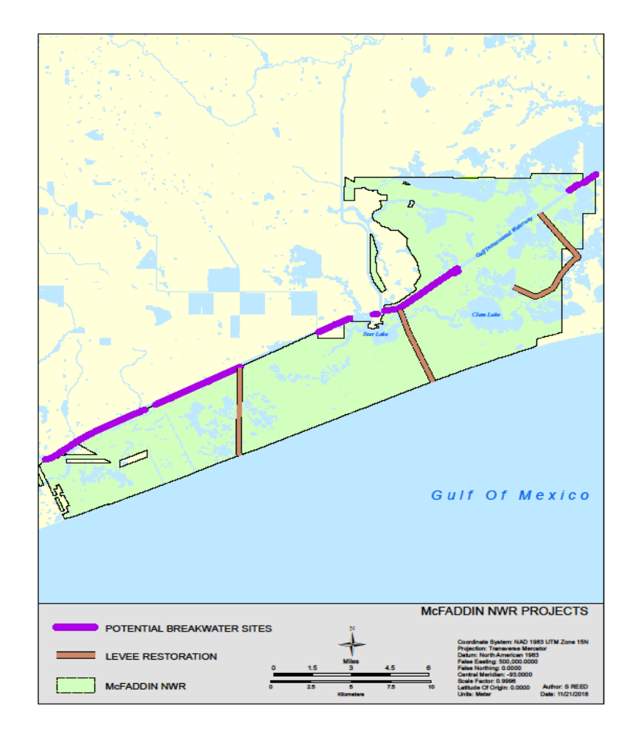
Texas Point NWR Project Area
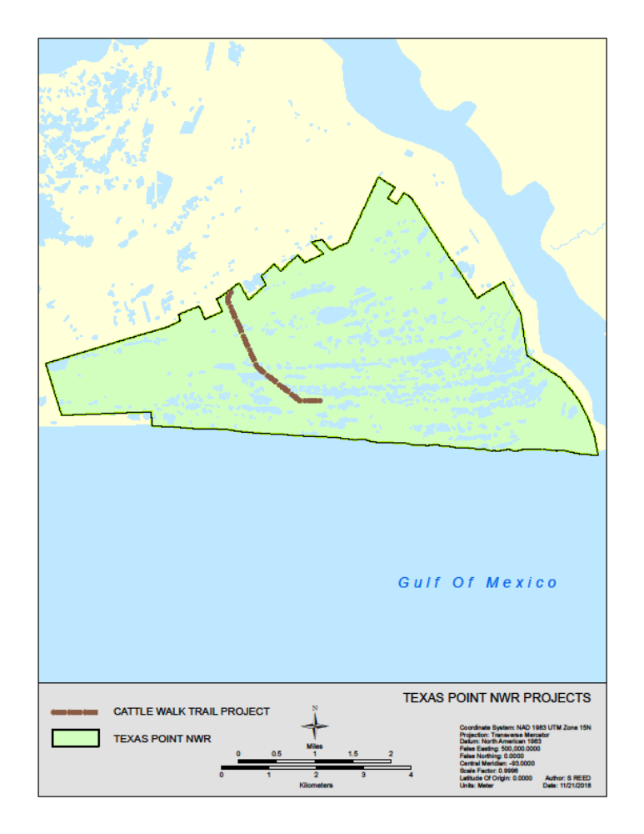

Anahuac NWR Project Areas
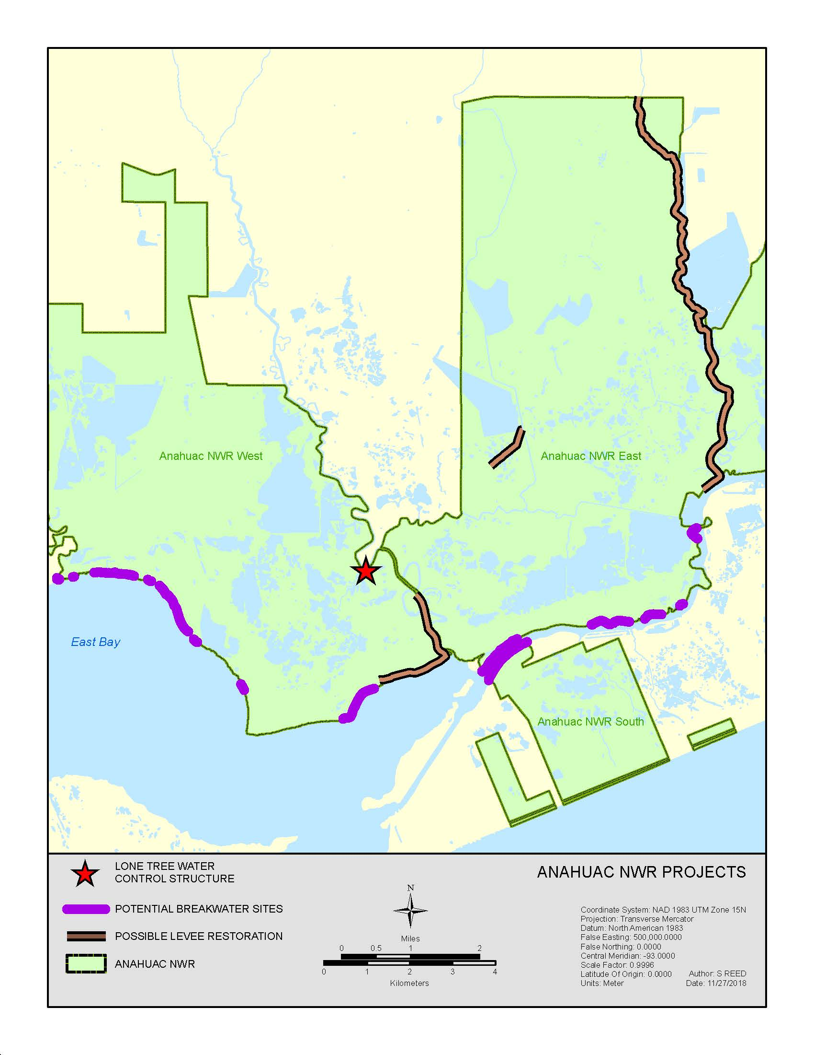

SF-424, Budget Information
Applicants must submit the appropriate SF-424 Budget Information form. Complete both the SF-424A, Budget Information for Non-Construction Programs and the SF-424C, Budget Information for Construction Programs for this project. All of the required application forms are available on the “Packages” tab of this Funding Opportunity on Grants.gov. Federal award recipients and subrecipients are subject to Federal award cost principles as detailed in the Service’s “Financial Assistance Award Terms and Conditions”. Please note: Show funds requested from this Federal program separately from any other Federal sources of funding. In the “Budget Summary” section, use the first row for funding requested from this Federal program. Use subsequent row(s) for other Federal funding. Enter each Federal program’s CFDA number(s) in the corresponding fields on the form. The CFDA number(s) for this Federal program appears on the first page of this Funding Opportunity.
- Budget Narrative
The funding will not be provided in advance to the cooperator. Under an approved agreement, the government will require the cooperator to produce a project schedule identifying critical path elements, which may include, but not limited to: surveying, design, permitting, engineering, and construction, that will allow the government to monitor and ensure reasonable and appropriate progress toward completion. Under this method, the government will also require that the cooperator submit a drawdown application for review and approval by the government prior to the drawdown of funds by the cooperator. The drawdown of funds would occur over the life of the project that is anticipated to be approximately 36 months from award.
- Indirect Costs: Individuals
Individuals applying for and receiving funds separate from a business or non-profit organization he/she may operate are not eligible to charge indirect costs to their award. If you are an individual applying for funding, do not include any indirect costs in your proposed budget and skip the next section.
- Indirect Costs: Organizations
The Federal awarding agency that provides the largest amount of direct funding to your organization is your cognizant agency for indirect costs, unless otherwise assigned by the White House Office of Management and Budget (OMB). If the Department of the Interior is your organization’s cognizant agency, the Interior Business Center will negotiate your indirect cost rate. Contact the Interior Business Center by phone 916-930-3803 or using the IBC Email Submission Form. See the IBC Website for more information.
Organizations must have an active Federal award before they can submit an indirect cost rate proposal to their cognizant agency. Failure to establish an approved rate during the award period renders all costs otherwise allocable as indirect costs unallowable under the award. Recipients must have prior written approval from the Service to use amounts budgeted for direct costs to satisfy cost-share or match requirements or to cover unallowable indirect costs. Recipients shall not shift unallowable indirect costs to another Federal award unless specifically authorized to do so by legislation.

Required Indirect Cost Statement
All organizations must include the applicable statement from the following list in their application to the Service, and attach to their application any documentation identified in the applicable statement:
We are:
- A [insert your organization type; U.S. states and local governments, please use one of the statements above or below] that has previously negotiated or currently has an approved indirect cost rate with our cognizant agency. Our indirect cost rate is [insert rate]. [Insert either: “Attached is a copy of our most recently approved but expired rate agreement. In the event an award is made, we will submit an indirect cost rate proposal to our cognizant agency within 90 calendar days after the award is made.” or “Attached is a copy of our current negotiated indirect cost rate agreement.”]
- A [insert your organization type] that has never submitted an indirect cost rate proposal to our cognizant agency. Our indirect cost rate is [insert rate]. If we receive an award, we will submit an indirect cost rate proposal to our cognizant agency within 90 calendar days after the award date.
- A [insert your organization type] that has never submitted an indirect cost rate proposal to our cognizant agency and has an indirect cost rate that is lower than 10%. Our indirect cost rate is [insert rate; must be lower than 10%]. However, if we receive an award we will not be able to meet the requirement to submit an indirect cost rate proposal to our cognizant agency within 90 calendar days after award. We request as a condition of award to charge a flat indirect cost rate of [insert rate; must be lower than 10%] against [insert a clear description of the direct cost base against which your rate is charged (e.g., salaries; salaries and fringe benefits; or modified total direct costs). However, please note that your organization cannot charge indirect costs in excess of the indirect costs that would be recovered if applied against modified total direct costs as defined in 2 CFR 200.68]. We understand that we must notify the Service in writing if we establish an approved rate with our cognizant agency at any point during the award period.
- A [insert your organization type] that has never submitted an indirect cost rate proposal to our cognizant agency and has an indirect cost rate that is 10% or higher. Our indirect cost rate is [insert your organization’s indirect rate; must be 10% or higher]. However, if we receive an award we will not be able to meet the requirement to submit an indirect cost rate proposal to our cognizant agency within 90 calendar days after award. We request as a condition of award to charge a flat de minimis indirect cost rate of 10% to be charged against modified total direct project costs as defined in 2 CFR 200.68. We understand that we must notify the Service in writing if we establish a negotiated rate with our cognizant agency at any point during the award period. We understand that additional Federal funds may not be available to support an unexpected increase in indirect costs during the project period and that such changes are subject to review, negotiation, and prior approval by the Service.
- A [insert your organization type] that will charge all costs directly.
- Conflict of Interest Disclosure
Applicants must state in their application if any actual or potential conflict of interest exists at the time of submission. Conflicts of interest include any relationship or matter that might place the recipient, including their employees and subrecipients, in a position of conflict, real or apparent, between their responsibilities under the award and any other outside interests. Conflicts of interest include direct or indirect financial interests; close personal relationships; positions of trust in outside organizations; consideration of future employment arrangements with a different organization; and decision-making authority related to the proposed project. Conflicts of interest are those circumstances real or perceived that would cause a reasonable person with knowledge of the relevant facts to question the impartiality of the applicant, or the applicant’s employees or subrecipients, in matters pertaining to the proposed project. Applicants must notify the Service in writing in their application if any employees, including subrecipient and contractor personnel, are related to, married to, or have a close personal relationship with any Federal employee in the Federal program receiving this application or who otherwise may be involved in the review and selection of their proposal. The term employee means any individual to be engaged in the performance of work pursuant to the Federal award application. Failure to disclose and resolve conflicts of interest in a manner that satisfies the Service may result in the rejection or disqualification of the application.
- Single Audit Reporting Statement
All U.S. states, local governments, federally recognized Indian tribal governments, and non-profit organizations expending $750,000 USD or more in Federal award funds in the applicant’s fiscal year must submit a Single Audit report for that year through the Federal Audit Clearinghouse’s Internet Data Entry System. U.S. state, local government, federally recognized Indian tribal government, and non-profit applicants must state if your organization was or was not required to submit a Single Audit report for the most recently closed fiscal year. If your organization was required to submit a Single Audit report for the most recently closed fiscal year, provide the EIN associated with that report and state if it is available through the Federal Audit Clearinghouse website.
- Certification Regarding Lobbying
Applicants requesting more than $100,000 in Federal funding must certify to the statements in 43 CFR Part 18, Appendix A-Certification Regarding Lobbying. If this application requests more than $100,000 in Federal funds, the Authorized Official’s signature on the appropriate SF-424, Application for Federal Assistance form also represents the entity’s certification of the statements in 43 CFR Part 18, Appendix A.
- Disclosure of Lobbying Activities
Applicants and recipients must not use any federally appropriated funds (annually appropriated or continuing appropriations) or matching funds under a Federal award to pay any person for lobbying in connection with the award. Lobbying is influencing or attempting to influence an officer or employee of any U.S. agency, a Member of the U.S. Congress, an officer or employee of the U.S. Congress, or an employee of a Member of the U.S. Congress connection with the award. Applicants and recipients must complete and submit the SF-LLL, Disclosure of Lobbying Activities if the Federal share of the proposal or award is more than $100,000 and the applicant or recipient has made or has agreed to make any payment using non-appropriated funds for lobbying in connection with the application or award. The SF-LLL form is available on the “Packages” tab of this Funding Opportunity on Grants.gov. See 43 CFR, Subpart 18.100 for more information on when additional submission of this form is required.
- Overlap or Duplication of Effort Statement
Applicants must provide a statement indicating if there is any overlap between this Federal application and any other Federal application, or funded project, in regards to activities, costs, or time commitment of key personnel. If no such overlap or duplication exists, state, “There are no overlaps or duplication between this application and any of our other Federal applications or funded projects, including in regards to activities, costs, or time commitment of key personnel”. If any such overlap exists, provide a complete description of overlaps or duplications between this proposal and any other federally funded project or application in regards to activities, costs, and time commitment of key personnel, as applicable. Provide a copy of any overlapping or duplicative proposal submitted to any other potential funding entity and identify when that proposal was submitted, to whom (entity name and program), and when you anticipate being notified of their funding decision. When overlap exists, your statement must end with “We understand that if at any time we receive funding from another source that is duplicative of the funding we are requesting from the U.S. Fish and Wildlife Service in this application, we will immediately notify the U.S. Fish and Wildlife Service point of contact identified in this Funding Opportunity in writing.”
- APPLICATION CHECKLIST
- SF-424, Application for Federal Assistance or Application for Federal Assistance-Individual
- SF-424B and D, Assurances
- Project Narrative
- SF-424A and C, Budget Information
- Budget Narrative
- Timetable
- Indirect Cost Statement and related documentation (when applicable)
- Conflict of Interest Disclosure (when applicable)
- Single Audit Reporting Statement (when applicable)
- SF-LLL, Disclosure of Lobbying Activities (when applicable)
- Overlap or Duplication of Effort Statement

Failure to provide complete information may cause delays, postponement, or rejection of the application.

V. Submission Requirements
- Unique Entity Identifier and System for Award Management (SAM.gov) Registration
These requirements do not apply to any individual applying for funds as a private citizen or any entity with an exception approved by the Federal awarding agency under 2 CFR 25.110(d). All other applicants are required to obtain a Data Universal Numbering System (DUNS) number from Dun & Bradstreet and provide that number in the application; complete SAM.gov registration before submitting an application; and continue to maintain an active SAM.gov registration with current information at all times when the entity has an active Federal award or application under consideration. There is NO COST to register with Dun & Bradstreet or SAM.gov. There are third-party vendors who will charge a fee in exchange for registering entities with Dun & Bradstreet and SAM.gov; please be aware you can register and request help for free.
- Obtain a DUNS Number
Request a DUNS Number through the Dun & Bradstreet website. The official website address is http://fedgov.dnb.com/webform. For technical difficulties, send an email to the D&B SAM Help Desk. Please ensure that you are able to receive emails from SAMHelp@dnb.com. The Grants.gov “Obtain a DUNS Number” webpage also provides detailed instructions. Once assigned a DUNS number, your organization must maintain up-to-date information with Dun & Bradstreet. Applicants must enter their DUNS number in the “Organizational DUNS” field on the SF-424, Application for Federal Assistance form.

Register with SAM
Register on the SAM.gov website. The official website address is http://www.sam.gov. The “Help” tab on the website contains User Guides and other information to assist you with registration. The Grants.gov Register with SAM” webpage also provides detailed instructions. You can also contact the supporting Federal Service Desk for help registering in SAM. Once registered in SAM, entities must renew and revalidate their SAM registration at least once every 12 months from the date previously registered. Entities are strongly encouraged to revalidate their registration as often as needed to ensure their information is up to date and reflects changes that may have been to the entity’s DUNS or IRS information. Foreign entities who want to receive payment directly to a U.S. bank account must enter and maintain valid, current banking information in SAM.
- Submission Dates and Times: Monday, December 31, 2018, by 4 p.m. MST

- Funding Restrictions: Construction is an allowable activity. There will be no reimbursement of pre-Federal award costs.

- Submission Instructions
This program encourages applicants to submit their applications online through Grants.gov. Follow these steps to apply through Grants.gov.

- Register with Grants.gov
Applicants must first register an account with Grants.gov and complete all steps of the registration process before they can apply through Grants.gov. Grants.gov registration requires the entity to create an account, create an account profile, and establish authorized profile roles, including the applicant’s authorized representative. Registration can take three to five business days or longer, if you do not complete the required steps in a timely manner.

Grants.gov Workspace Application
Grants.gov applicants apply online using Workspace. Workspace is a shared, online environment where members of a grant team may simultaneously access and edit different webforms within an application. For each funding opportunity announcement, you can create individual instances of a workspace. To apply, the applicant will create, complete, and submit a Workspace application package for this Funding Opportunity directly on Grants.gov. Grants.gov recommends submitting your application package at least 24-48 hours prior to the close date to allow time to correct any potential technical issues that may disrupt the application submission. When attaching files to the Grants.gov application, please do not assign file names longer than 20 characters, including spaces. File names longer than 20 characters will prevent your application received by Grants.gov from automatically downloading into the Service’s financial assistance management system. Applicants using slow internet, such as dial-up connections, should be aware that the transmission of the application to Grants.gov takes time. Grants.gov sends either an error message or a “successfully received” message by email to the applicant’s authorized representative once the transmission is complete. Please do not end the transmission process before receiving that message.
- Proof of Timely Submission
Grants.gov automatically generates an electronic date and time stamp in the system upon application receipt. Grants.gov sends an acknowledgement of receipt with the date and time stamp and a unique Grants.gov application tracking number to the authorized representative by email. This email from Grants.gov serves as your proof of timely submission.

VI. Application Review Information
- Criteria:

This Single Source Award is being awarded in accordance with DOI Policy 505 DM 2.14 B(2) and B(4). See Additional Information of Eligibility Section. DU has designed, constructed, and worked on NWRS property on past projects across North America. They have had great success restoring, enhancing, and establishing wetlands along the Gulf Coast. All past projects have met Service objectives while also benefiting adjacent lands.

- Review and Selection Process
This Single Source Award is being awarded in accordance with DOI Policy 505 DM 2.14 B(2) and B(4). See Additional Information of Eligibility Section. Prior to participating in any review or evaluation process, all staff and peer reviewers, evaluators, panel members, and advisors must sign and return to the program office point of contact the “Department of the Interior Conflict of Interest Certification” form. For a copy of this form, contact the Service Project Officer identified in the Agency Contacts section below.
Prior to award, the Service will review any applicant statement regarding potential overlap or duplication between the project to be funded and any other funded or proposed project in terms of activities, funding, or time commitment of key personnel. Depending on the circumstances, the Service may request modification to the application, other pending applications, or an active award, as needed to eliminate any duplication of effort, or the Service may choose not to fund the selected project.
The Service may not make a Federal award to an applicant that has not completed the SAM.gov registration. If an applicant selected for funding has not completed their SAM.gov registration by the time the Service is ready to make an award, the program may determine that the applicant is not qualified to receive an award. The program can use that determination as a basis for making an award to another applicant.
Prior to award, the Service will evaluate the risk posed by applicants as required in 2 CFR 200.205. Service programs document applicant risk evaluations using the Service’s “Financial Assistance Recipient Risk Assessment” form. Prior to approving awards for Federal funding in excess of the simplified acquisition threshold (currently $250,000), the Service is required to review and consider any information about or from the applicant found in the Federal Awardee Performance and Integrity Information System. The Service will consider this information when completing the risk review. The Service uses the results of the risk evaluation to establish monitoring plans, recipient reporting frequency requirements, and to determine if one or more of the specific award conditions in 2 CFR 200.207 should be applied the award.

VII. Federal Award Administration
- Federal Award Notices
Following review, applicants may be requested to revise the project scope and/or budget before an award is made. Successful applicants will receive written notice in the form of a notice of award document. Notices of award are typically sent to recipients by e-mail. If e-mail notification is unsuccessful, the documents will be sent by courier mail (e.g., FedEx, DHL or UPS). Award recipients are not required to sign/return the Notice of Award document. Acceptance of an award is defined as starting work, drawing down funds, or accepting the award via electronic means. Awards are based on the application submitted to and approved by the Service and are subject to the terms and conditions incorporated into the Notice of Award either by direct citation or by reference to the following: Federal regulations; program legislation or regulation; and special award terms and conditions. Recipient acceptance of a Federal award from the Service carries with it the responsibility to be aware of and comply with all terms and conditions applicable to the award. Recipients indicate their acceptance of the Federal award by starting work, drawing down funds, or accepting the award via electronic means.
- Award Terms and Conditions
See the Service’s “Financial Assistance Award Terms and Conditions” for the administrative and national policy requirements applicable to Service awards.
Institutions of Higher Education and Non-Profit Organizations
These regulations and requirements always apply as specified below:
- Administrative Requirements: 2 CFR Part 200, Subparts A through D
- Cost Principles: 2 CFR Part 200, Subpart E, except for non-profits identified in 2 CFR 200, Appendix VIII as exempt from these and therefore subject to the cost principles in 48 CFR 1, Subpart 31.2 Contracts with Commercial Organizations.
- Indirect Cost Proposals for IHEs: 2 CFR Part 200, Appendix III
- Indirect Cost Proposals for Non-Profits: 2 CFR 200, Appendix IV
- Audit Requirements for Non-Profits: 2 CFR Part 200, Subpart F
- 2 CFR Part 25, Universal Identifier and System for Award Management
- 2 CFR Part 170, Reporting Subawards and Executive Compensation
- 2 CFR Part 175, Award Term for Trafficking in Persons
- 2 CFR Part 200, Appendix XII, Award Term and Condition for Recipient Integrity and Performance Matters. Applies to awards with a total Federal share of more than $500,000.
- 2 CFR Part 1400, Nonprocurement Debarment and Suspension
- 2 CFR Part 1401, Requirements for Drug-Free Workplace
- 43 CFR 18, New Restrictions on Lobbying: Submission of an application also represents the applicant’s certification of the statements in 43 CFR Part 18, Appendix A, Certification Regarding Lobbying.
- 41 USC §4712, Enhancement of Recipient and Subrecipient Employee Whistleblower Protection. Applies to all awards over the simplified acquisition threshold (currently $250,000). This award, related subawards, and related contracts over the simplified acquisition threshold and all employees working on this award, related subawards, and related contracts over the simplified acquisition threshold are subject to the whistleblower rights and remedies established at 41 USC 4712. Recipients, their subrecipients, and their contractors awarded contracts over the simplified acquisition threshold related to this award, shall inform their employees in writing, in the predominant language of the workforce, of the employee whistleblower rights and protections under 41 USC 4712. The recipient shall insert this clause in all subawards and in contracts over the simplified acquisition threshold related to this award.
- 41 USC §6306, Prohibition on Members of Congress Making Contracts with Federal Government. No member of or delegate to Congress or Resident Commissioner shall be admitted to any share or part of this award, or to any benefit that may arise therefrom; this provision shall not be construed to extend to an award made to a corporation for the public’s general benefit.
- Section 743 of Division E, Title VII of Pub. L. 113-235, Prohibition on Issuing Financial Assistance Awards to Entities that Require Certain Internal Confidentiality Agreements. Recipients must not require their employees or contractors seeking to report fraud, waste, or abuse to sign internal confidentiality agreements or statements prohibiting or otherwise restricting such employees or contractors from lawfully reporting such waste, fraud, or abuse to a designated investigative or law enforcement representative of a federal department or agency authorized to receive such information. Recipients must notify their employees or contractors that existing internal confidentiality agreements covered by this condition are no longer in effect.
- Executive Order 13513, Federal Leadership on Reducing Text Messaging while Driving. Recipients are encouraged to adopt and enforce policies that ban text messaging while driving, including conducting initiatives of the type described in section 3(a) of the Order.

- Payments
Domestic recipients are required to register in and receive payment through the U.S. Treasury’s Automated Standard Application for Payments (ASAP), unless approved for a waiver by the Service program. Foreign recipients receiving funds to a final destination bank outside the U.S. are required to receive payment through the U.S. Treasury’s International Treasury Services (ITS) System. Foreign recipients receiving funds to a final destination bank in the U.S. are required to enter and maintain current banking details in their SAM.gov entity profile and receive payment through the Automated Clearing House network by electronic funds transfer (EFT). The Service will include recipient-specific instructions on how to request payment, including identification of any additional information required and where to submit payment requests, as applicable, in all Notices of Award.

- Reporting Requirements
The Service will include recipient-specific reporting requirements, including the required reports, reporting frequency, and report due dates in all Notices of Award, as applicable.
- Financial Reports
All recipients must use the SF-425, Federal Financial Report form for financial reporting. At a minimum, all recipients must submit a final financial report. Final reports are due no later than 90 calendar days after the award period of performance end date or termination date. For awards with periods of performance longer than 12 months, recipients are required to submit interim financial reports on the frequency established in the Notice of Award. See Service policy 516 FW 1, Monitoring Financial and Performance Reporting for Financial Assistance for more information.
- Performance Reports
Performance reports must contain a comparison of actual accomplishments with the established goals and objectives of the award; a description of reasons why established goals were not met, if appropriate; and any other pertinent information relevant to the project results. At a minimum, all recipients must submit a final performance report. Final reports are due no later than 90 calendar days after the award period of performance end date or termination date. For awards with periods of performance longer than 12 months, recipients are required to submit interim financial reports on the frequency established in the Notice of Award. See Service policy 516 FW 1, Monitoring Financial and Performance Reporting for Financial Assistance for more information.

- Significant Developments Reports
Events may occur between the scheduled performance reporting dates that have significant impact upon the supported activity. In such cases, recipients are required to notify the Service in writing as soon as the recipient becomes aware of any problems, delays, or adverse conditions that will materially impair the ability to meet the objective of the Federal award. This disclosure must include a statement of any corrective action(s) taken or contemplated, and any assistance needed to resolve the situation. The recipient should also notify the Service in writing of any favorable developments that enable meeting time schedules and objectives sooner or at less cost than anticipated or producing more or different beneficial results than originally planned.

- Real Property Reports
Recipients and subrecipients are required to submit status reports on the status of real property in which the Federal government retains an interest. The required frequency of these reports will depend on the anticipated length of the Federal interest period. The Service will include recipient-specific real property reporting requirements, including the required data elements, reporting frequency, and report due dates, as applicable.

- Conflict of Interest Disclosures
Recipients must notify the Service immediately in writing of any actual or potential conflicts of interest that arise during the life of their Federal award. Conflicts of interest include any relationship or matter that might place the recipient, including their employees and subrecipients, in a position of conflict, real or apparent, between their responsibilities under the award and any other outside interests. Conflicts of interest include direct or indirect financial interests; close personal relationships; positions of trust in outside organizations; consideration of future employment arrangements with a different organization; and decision-making authority related to the award. Conflicts of interest are those circumstances real or perceived that would cause a reasonable person with knowledge of the relevant facts to question the impartiality of the recipient or the recipients’s employees or subrecipients in matters pertaining to the award. Recipients must notify the Service in writing if any employees, including subrecipient and contractor personnel, are related to, married to, or have a close personal relationship with any Federal employee in the Federal funding program or who otherwise may have been involved in the review and selection of the award. The term employee means any individual engaged in the performance of work pursuant to the Federal award. Failure to disclose and resolve conflicts of interest in a manner that satisfies the Service may result in any of the remedies described in 2 CFR 200.338 Remedies for Noncompliance, including termination of the award.

- Other Mandatory Disclosures
The non-Federal entity or applicant for a Federal award must disclose, in a timely manner, in writing to the Federal awarding agency or pass-through entity all violations of Federal criminal law involving fraud, bribery, or gratuity violations potentially affecting the Federal award. Non-Federal entities that receive a Federal award including the term and condition outlined in 2 CFR 200, Appendix XII—Award Term and Condition for Recipient Integrity and Performance Matters are required to report certain civil, criminal, or administrative proceedings to SAM. Failure to make required disclosures can result in any of the remedies described in 2 CFR 200.338 Remedies for Noncompliance, including suspension or debarment.

VIII. Federal Awarding Agency Contact(s)
Tim Cooper, Wildlife Refuge Complex Manager
U.S. Fish and Wildlife Service, Region 2
Texas Chenier Plains NWR Complex
P.O. Box 278
Anahuac, TX 77514
Ph: 409-267-3337 x127
tim_cooper@fws.gov

