Annex E: Mapping the System
In this Annex, applicants must demonstrate that they have a strong understanding of the system in which they will be introducing their intervention. Note that applicants should use endnotes to cite their sources and an annex-specific reference list should be provided at the end of this document.
Applicants are required to identify and describe the various components of the system, including the who (e.g., key stakeholders, organizations, change agents, etc.), and the what (i.e., risk and protective factors) that influence the human trafficking problem they are seeking to address. At minimum, in this Annex, applicants are to describe the following aspects of the context in which trafficking is occurring:
- Parties in the system (e.g., victims of trafficking and those at risk and other key individuals and groups involved in the system, such as recruiters, family members, policymakers, local officials, transport workers, etc.)
- Societal-Level Factors (e.g., policies, norms, economic, corruption, etc.)
- Community-Level Factors (e.g., geographic location (rural versus urban), social cohesion, access to quality education and health care, etc.)
- Individual-Level Factors (e.g., mental and/or physical health, socioeconomic status, age, etc.)
Under the factors, please include both factors related to the risk of trafficking and protective factors that may be positive elements that prevent trafficking from occurring. Please discuss these components and how they interact to influence the identified problem. To understand the situation and the potential intervention points, it may be useful to also identify the routes and steps involved in a potential victim’s “journey” (it can be a physical journey or just a process they go through which results in a trafficking situation).
Applicants should begin to identify the evidence that underpins the systems mapping and cite specific studies and sources of information. At this proposal writing stage, applicants will likely be reliant on existing evidence. Therefore, please also highlight particular areas of the system for which there is no evidence and specify proposed methods to generate it (e.g., participatory action research, focus group discussions, key informant interviews, household surveys, etc.). Please explain how feedback will be incorporated from relevant stakeholders.
To help brainstorm, applicants may want to consider using a visual diagram(s) or other tools to identify the various components of the system. These may include, for example, a process map(s) of the potential pathways through which individuals enter trafficking, a root cause analysis (see example of a fishbone diagram below), or even a very preliminary systems map with causal loop diagrams. Any diagrams and tools used should be documented in this section.
As noted in the guidelines, at the proposal writing phase, the TIP Office recognizes that the systems mapping exercise is extremely preliminary and should be used as an opportunity to demonstrate an applicants' current understanding of the context, as well as to help identify gaps in understanding/knowledge to be addressed in Stage 1. The actual mapping tools and visuals used may be changed and refined during Stage 1.
Sample Fishbone Diagram: 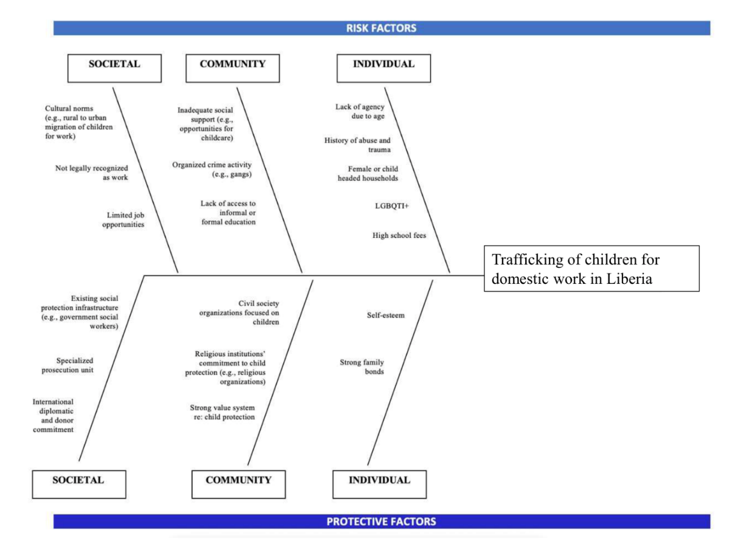
Description of the System and Diagrams

Reference List

