U.S. Department of Education
Office of Special Education & Rehabilitative Services
Office of Special Education Programs
Washington, DC 20202

FISCAL YEAR 2024
APPLICATION FOR NEW GRANTS UNDER THE
INDIVIDUALS WITH DISABILITIES EDUCATION ACT (IDEA)

EDUCATIONAL TECHNOLOGY, MEDIA, AND MATERIALS FOR INDIVIDUALS WITH DISABILITIES PROGRAM
(ALN 84.327)

APPLICATIONS FOR NEW AWARDS;
Stepping-up Technology Implementation
(ALN 84.327S)


DATED MATERIAL: OPEN IMMEDIATELY

CLOSING DATE: APRIL 30, 2024

FORM APPROVED — OMB No. 1820-0028, EXP. DATE: 07/31/2025

Contents
Applicant Letter A1
Notice Inviting Applications A6
Federal Register Notice A7
Grants.gov Submission Procedures and Tips for Applicants A45
Priority Description and Selection Criteria B1
Stepping-up Technology Implementation B2
Selection Criteria and Format for the Applications for New Awards— Stepping-up Technology Implementation (CFDA 84.327S) Competition B24
General Information on Completing an Application C1
Application Transmittal Instructions and Requirements for Intergovernmental Review D1
Appendix D5
Intergovernmental Review of Federal Programs D6
State Single Points of Contact (SPOCs) D7
Notice to All Applicants Ensuring Equitable Access and Application Forms and Instructions E1
Part I: Application for Federal Assistance (SF-424) E6
Part II: Budget Information (ED Form 524) E23
Part III: Application Narrative E28
Part IV: Assurances and Certifications E29
ED General Education Provisions Act (GEPA) 427 Form E30
Certification Regarding Lobbying….. E32
Grant Application Receipt Acknowledgement E36
Grant and Contract Funding Information E36

Paperwork Burden Statement
According to the Paperwork Reduction Act of 1995, no persons are required to respond to a collection of information unless such collection displays a valid OMB control number. The valid OMB control number for this information collection is 1820-0028. The time required to complete this information collection is estimated to average 45 hours and 40 minutes per response, including the time to review instructions, search existing data resources, gather the data needed, and complete and review the information collection. If you have any comments concerning the accuracy of the time estimate(s) or suggestions for improving this form, please write to:
U.S. Department of Education
Washington, DC 20202-4651
If you have comments or concerns regarding the status of your individual submission of this form, write directly to:
Office of Special Education Programs
U.S. Department of Education
400 Maryland Ave. SW
Washington, DC 20202

Applicant Letter

Dear Applicant:
This application packet contains information and the required forms for you to use in submitting a new application for funding under one program authorized by the Individuals with Disabilities Education Act (IDEA). This packet covers one competition under the Educational Technology, Media, and Materials for Individuals with Disabilities Program (Assistance Listing Number 84.327) program—Applications for New Awards; Educational Technology, Media, and Materials for Individuals with Disabilities Program-- Stepping-up Technology Implementation (Assistance Listing Number 84.327S).
Please take the time to review all of the applicable requirements, definitions, selection criteria, and application instructions thoroughly. An application will not be evaluated for funding if the applicant does not comply with all of the procedural rules that govern the submission of the application or if the application does not contain the information required. (EDGAR §75.216 (b) and (c)).
Please note the following:
- Grants.gov Application Submission and SAM Registration.
Applications for grants under this competition must be submitted electronically using the Grants.gov Apply site (www.Grants.gov). Please read carefully the Grants.gov Submission Procedures and Tips for Applicants document included on page A-44, which includes helpful tips about submitting electronically using the Grants.gov Apply site. Grants.gov registration involves many steps including registration on SAM (www.sam.gov) which may take approximately one week to complete but could take as many as several weeks to complete. You may begin working on your application while completing the registration process, but you cannot submit an application until all of the Registration steps are complete. Please note that once your SAM registration is active, it will take 24-48 hours for the information to be available in Grants.gov. You cannot submit an application through Grants.gov until Grants.gov has received your SAM registration information. We strongly encourage you to familiarize yourself with SAM and Grants.gov, and strongly recommend that you register and submit early.
Applicants are required to upload any narrative sections and all other attachments to your application as files in either Portable Document Format (PDF) or Microsoft Word. However, it is recommended that applicants upload files as read-only flattened PDFs.
Information on computer and operating system compatibility with Adobe and links to download the latest version of Adobe are available on Grants.gov. Please note that you must follow the Application Procedures as described in the Federal Register notice announcing this grant competition. Information (including dates and times) about how to submit your application electronically can also be found in section D of this application package, Application Transmittal Instructions and Requirements for Intergovernmental Review. Additional instructions for sending applications electronically are provided on page D-2, Application Forms and Instructions for Grants.gov Applications.

- MAXIMUM AWARD AMOUNT.
The competition included in this package has maximum award amounts. Please refer to the specific information for the priority/competition to which you are submitting an application (i.e., Section D of this package) for detailed budget information for the total grant period requested. Please be advised that for the priority in this package, the maximum award amount covers all project costs including indirect costs.

- RECOMMENDED PAGE LIMITS AND LINE SPACING OF APPLICATION NARRATIVE.
The competition included in this package limits the Application Narrative to a recommended number of double-spaced pages. This recommended page limit and double-line spacing applies to all material presented in the application narrative. This recommended double-line spacing applies to all titles, headings, footnotes, quotations, reference citations, and captions, as well as all text in charts, tables, figures, graphs, screen shots, and logic models included in the application narrative. (Please refer to the specific recommendations on page limits for the priority/competition to which you are submitting an application, Section B of this package).

- FORMAT FOR OTHER SECTIONS OF THE APPLICATION.
Additional information regarding formatting applications has been included on page C-1 of the “General Information on Completing an Application” section of this package.
Appendix A: Reviewers will be instructed to review the content of Appendix A as they do the application narrative. Reviewers will not be required to review any other appendices.
Charts, tables, figures, graphs, screen shots and logic models that provide information directly relating to the application requirements for the narrative should be the only items included in Appendix A. Appendix A should not be used for supplementary information. Please note that charts, tables, figures, graphs, screen shots, and logic models can be single-spaced when placed in an Appendix A.
Abstract: For the application Abstract, applicants should use the template located at:
https://www2.ed.gov/fund/grant/apply/osep/new-osep-grants.html

ABSOLUTE PRIORITY AND COMPETITIVE PREFERENCE PRIORITIES.
This competition includes one absolute priority and one competitive preference priority. The Department will use peer reviewers to review and score applications on the selection criteria.

Prior to the peer review, Department staff will determine if an application has met the qualifications of the absolute priority and is eligible for peer review. An application that has not met the absolute priority will not be considered for funding and may not be reviewed.

- PROTECTION OF HUMAN SUBJECTS IN RESEARCH.
The discretionary grant Application Form SF-424 requires applicants to indicate whether they plan to conduct research involving human subjects at any time during the proposed project period. The Protection of Human Subjects in Research Attachment is an integral part of the SF-424 form. It includes information that applicants need to complete the protection of human subjects item and, as appropriate, to provide additional information to the Department regarding human subjects research projects. Additional information on completing the protection of human subjects item is also available and can be accessed on the internet at:
www.ed.gov/about/offices/list/ocfo/humansub.html

- RESPONSE TO GOVERNMENT PERFORMANCE AND RESULTS ACT (GPRA)
As required by the GPRA Modernization Act of 2010, the Office of Special Education Programs (OSEP) has developed a strategic plan for measuring GPRA performance. The program included in this announcement is authorized under Part D - National Activities to Improve Education of Children with Disabilities of the Individuals with Disabilities Education Act. Projects funded under this competition are required to submit data on GPRA performance measures as directed by OSEP. See Performance Measures included in the Priority Description section of this application package. Applicants are encouraged to consider this information when preparing their applications.

- COPIES OF THE APPLICATION.
Unless you qualify for an exception in accordance with the instructions found in the Notice inviting applications, you must submit your application electronically. Therefore, you do not need to submit paper copies of the application. If you are granted an exception, current Government-wide policy requires that an original and two paper copies need to be submitted. Please note: If an application is recommended for funding and a grant award is issued, we will contact the applicant to request an electronic copy of the application in MS Word or a PDF file. The Department is moving toward an electronic grant filing system and an electronic copy of all applications that are being funded will facilitate this effort.

ADDITIONAL INFORMATION
OSEP also provides information on developing performance measures and logic models at https://www.osepideasthatwork.org/logicModel to assist you in preparing a quality application. For information about other U.S. Department of Education grant and contract opportunities, we encourage you to use the Department's grant information web page which can be accessed on the internet at http://www.ed.gov/about/offices/list/ocfo/grants/grants.html.

We appreciate your efforts to improve the provision of services for individuals with disabilities.
Sincerely,
/s/
David J. Cantrell,
OSEP Deputy Director and Acting Research to Practice Division Director

Notice Inviting Applications

Federal Register Notice
4000-01-U
DEPARTMENT OF EDUCATION
Applications for New Awards; Educational Technology, Media, and Materials for Individuals with Disabilities Program—Stepping-up Technology Implementation
AGENCY: Office of Special Education and Rehabilitative Services, Department of Education.
ACTION: Notice.
Overview Information:
Educational Technology, Media, and Materials for Individuals with Disabilities Program—Stepping-up Technology Implementation
Notice inviting applications for new awards for fiscal year (FY) 2024.
Assistance Listing Number (ALN): 84.327S.
Dates:
Applications Available: March 1, 2024.
Deadline for Transmittal of Applications: April 30, 2024.
Deadline for Intergovernmental Review: July 1, 2024.
Full Text of Announcement
I. Funding Opportunity Description
Purpose of Program:
The purposes of the Educational Technology, Media, and Materials for Individuals with Disabilities Program are to improve results for children with disabilities by (1) promoting the development, demonstration, and use of technology; (2) supporting educational activities designed to be of educational value in the classroom for children with disabilities; (3) providing support for captioning and video description that is appropriate for use in the classroom; and (4) providing accessible educational materials to children with disabilities in a timely manner.
Priority:
This competition includes one absolute priority and one competitive preference priority. In accordance with 34 CFR 75.105(b)(2)(v), the absolute priority is from allowable activities specified in sections 674(b)(2) and 681(d) of the Individuals with Disabilities Education Act (IDEA); 20 U.S.C. 1474(b)(2) and 1481(d). The competitive preference priority is from the Secretary’s Administrative Priorities for Discretionary Grant Programs published in the Federal Register on March 9, 2020 (85 FR 13640) (Administrative Priorities).
Absolute Priority:
For FY 2024 and any subsequent year in which we make awards from the list of unfunded applications from this competition, this priority is an absolute priority. Under 34 CFR 75.105(c)(3), we consider only applications that meet this priority.
This priority is:
Use of Artificial Intelligence (AI) to Meet Individual Needs of Students with Disabilities Through Learning and Assessment.
Background:
The evolution and recent developments in educational technology tools integrating AI have generated increased interest in the potential of AI to transform and support innovations in learning across educational settings for all learners, including learners with disabilities. As part of the Administration’s comprehensive strategy related to responsible innovation afforded by AI, the Department (2023) released a report that summarizes the opportunities and risks for AI in teaching and learning. Such opportunities for using AI in educational technologies include promising innovations to improve student-educator interactions, address individual learner needs and leverage learner strengths, refine feedback loops that improve learner outcomes, and support educators by reducing administrative task burden and improving practices.
Opportunities to leverage educational technology tools integrating AI to improve learning outcomes and advance equity have been noted for all learners (e.g., Chen et al., 2022; Huang et al., 2021; Zafari et al., 2022; U.S. Department of Education, 2023). Research indicates that these technologies hold promise in supporting individualized instruction and intervention and improving access in multiple areas, including communication, social, literacy, and mathematical skills (e.g., Barua et al., 2022; U.S. Department of Education, 2023). Therefore, it is critical that children with disabilities are provided appropriate levels of support in using existing and developing educational technologies integrating AI (e.g., Barua et al., 2022; Marino et al., 2023) to enhance learner outcomes.
As educational technology tools that integrate AI continue to be developed and made available, factors that support their successful implementation in educational settings need to be considered. For example, evidence-based intelligent tutoring systems have demonstrated positive outcomes for learners, but additional research is needed on how to effectively implement such systems in different settings (e.g., Phillips et al., 2020), including how best to support children with disabilities.
The role of the educator in implementing these technologies to complement ongoing instruction and intervention is critical in supporting children with disabilities (e.g., U.S. Department of Education, 2023). Several key factors that facilitate or limit successful implementation of educational technology tools in educational settings have been noted, including buy-in by and sustainability with users, alignment with existing priorities, development of materials to support fidelity of implementation, how the data are used, technology infrastructure, and data security (e.g., Evmenova et al., 2023; U.S. Department of Education, 2023).
Priority:
The purpose of this priority is to fund four cooperative agreements to establish and operate projects that achieve, at a minimum, the following expected outcomes:
(a) Improved student outcomes using an evidence-based technology-based tool or approach that integrates AI;
(b) Improved educator use and knowledge of an evidence-based technology-based tool or approach using AI to deliver effective instruction to students with disabilities;
(c) Improved educator collaboration and professional learning opportunities focusing on improving outcomes for student with disabilities using an evidence-based technology-based tool or approach using AI;
(d) Improved educator and family engagement regarding the use of an evidence-based technology-based tool or approach using AI to support student learning; and
(e) Sustained use of the evidence-based technology-based tool or approach using AI by aligning its use with existing instructional priorities and initiatives.
To be considered for funding under this priority, in the application, applicants must describe the--
(a) Evidence-based technology-based tool or approach that is ready to use at the time of the application submission. If the AI component is not yet completed, describe how this will be integrated within the first year and how it will enhance the current developed technology-based tool or approach;
(b) Outcomes of students with disabilities that will be improved by implementing the technology-based tool or approach using AI;
(c) Approach to increase educators’ use and knowledge of the technology-based tool or approach using AI to improve the outcomes of students with disabilities in an instructional setting; and
(d) Fully accessible products and resources that will help educators and families to effectively use and implement the technology-based tool or approach using AI (See for example, NIST AI Risk Management Framework-- https://nvlpubs.nist.gov/nistpubs/ai/NIST.AI.100-1.pdf--for information on managing risks across the AI lifecycle).
Note: Grantees may, but are not required to, use up to the first 12 months of the performance period and up to $200,000 of funds awarded in the first budget period for project development activities, including technology enhancement, prior to implementing the tool or approach in instructional settings. If an applicant proposes to use the first year for project development activities, then the applicant must provide sufficient justification, including the goals, objectives, and intended outcomes at the end of year one.
In addition to these programmatic requirements and application requirements, to be considered for funding under this priority, applicants must also meet the following application and administrative requirements:
(a) Demonstrate, in the narrative section of the application under “Significance,” how the proposed project will address the need for a technology-based tool or approach that integrates AI. To meet this requirement applicants must--
(1) Verify that the developed technology-based tool or approach and core components of the intervention are based on at least promising evidence;
(2) Describe how AI will be used with the identified technology-based tool or approach and describe the potential to improve student outcomes;
(3) Describe the current impact and reach of the technology-based tool or approach that is currently developed and include the population of users and,
if the applicant has received any Federal funding within the last three years related to this technology-based tool or approach, describe how the funding impacted the reach and current use;
(4) Identify how the technology-based tool or approach using AI will improve educators’ pedagogy and their capacity to deliver effective instruction for students with disabilities in PK-12 instructional settings;
(5) Identify how the technology-based tool or approach using AI will improve parent/family engagement/partnership to support student learning;
(6) Present applicable national, State, regional, or local data demonstrating the need for the identified technology-based tool or approach using AI to enhance the outcomes for students with disabilities;
(7) Identify how the proposed technology-based tool or approach using AI aligns with current policies, procedures, and practices used by educators to enhance the outcomes for students with disabilities; and
(8) Identify systemic barriers, gaps, or challenges, including challenges to using the identified technology-based tool or approach using AI.
(b) Demonstrate, in the narrative section of the application under “Quality of project services,” how the proposed project will--
(1) Ensure equal access and treatment for members of groups that have traditionally been underrepresented based on race, color, national origin, gender, age, or disability. To meet this requirement, the applicant must describe how it will--
(i) Identify the target population, including students with disabilities and their educators, that the applicant will service, the need that population has for the technology-based tool or approach, and the intended recipients for ongoing professional learning and coaching support; and
(ii) Ensure that the products and resources meet the needs of the intended recipients of this grant;
(2) Utilize a design process for the implementation approach that promotes sustainability of the technology-based tool or approach using AI beyond the life of the project;
(3) Achieve its goals, objectives, and intended outcomes. To meet this requirement, the applicant must provide measurable intended project outcomes;
(4) Be based on current research. To meet this requirement, the applicant must--
(i) Describe how the proposed project will align with current research, policies, and practices related to the benefits, services, or opportunities that are available using the technology-based tool or approach;
(ii) Describe how the proposed project will incorporate current and evidence-based research and practices, including research and practices relating to accessibility and usability, to guide the development and delivery of its products and resources; and
(iii) Document that the technology-based tool or approach to be used by the proposed project is developed, has been tested and shown to have promising evidence, and addresses, at a minimum, the following principles of universal design for learning:
(A) Multiple means of representation so that information can be delivered in more than one way (e.g., specialized software and websites, customizing display for visual or physical modalities);
(B) Multiple means of expression that allow knowledge to be exhibited through options (e.g., writing, online concept mapping, or speech-to-text programs, where appropriate); and
(C) Multiple means of engagement to stimulate interest in and motivation for learning (e.g., individual or group learning experiences or activities, learner choice); and
(5) Develop and implement products and resources that are of high quality and sufficient intensity and duration to achieve the intended outcomes of the proposed project. To address this requirement, the applicant must--
(i) Provide a plan for recruiting and selecting sites from a variety of instructional settings that include the targeted population including students with disabilities, which must include the following:
(A) Two product and resource development sites. Applicants must describe at least two proposed product and resource development sites, where the project would conduct iterative development of the products and resources intended to support the implementation of the technology-based tool or approach and produce, by the end of year two, preliminary feasibility and useability data. Applicants must include a letter in Appendix A from at least one site that indicates agreement to serve as a product and resource development site, at a minimum, in year one of the project.
(B) Three pilot sites. Pilot sites are the sites in which ongoing refinement of the developed products and resources, and the continued collection of feasibility and usability data, will occur. Applicants must describe how they would work with a minimum of three pilot sites no later than year three of the project, where the project would continue to refine the developed products and resources; collect feasibility and usability data; and demonstrate that the educational technology-based tool or approach using AI is producing the intended outcome(s) for students with disabilities.
(C) Five dissemination sites. Applicants must describe how they would work with a minimum of five dissemination sites, where the project would complete its activities, by year four of the project period, to (1) refine the products for use by educators and students, and (2) evaluate the performance of the technology-based tool or approach using AI on educators’ pedagogy and students’ outcomes. Dissemination sites would receive less implementation support from the project than development and pilot sites.
Note: A site may not serve in more than one category (i.e., development, pilot, dissemination);
(ii) Describe how the project will incorporate components from implementation science to select sites for continued use of the technology-based tool or approach using AI and support and sustain such continued use at the selected site;
(iii) Provide a plan to systematically disseminate information about the technology-based tool or approach using AI to varied audiences throughout the project period. To address this requirement the applicant must describe--
(A) The variety of dissemination strategies the project will use throughout the five years of the project to promote awareness and use of its technology-based tool or approach using AI;
(B) How the project will tailor dissemination strategies across all years of technology refinements and to ensure that, by the end of year two, the technology-based tool or approach can be accessed by, is reaching, and is used by intended recipients;
(C) Dissemination efforts that will go beyond conference presentations and articles and reach intended audiences to support implementation and scale up and increase the use of the technology-based tool or approach using AI by intended users;
(D) How the project’s dissemination plan is connected to the proposed outcomes of the project; and
(E) How the project will ensure that all digital products and all external communications are routinely evaluated for and, if necessary, remediated to meet or exceed government or industry-recognized standards for accessibility; and
(iv) Provide assurances that all products or tools developed with project funds will be open educational resources.
(c) In the narrative section of the application under “Quality of the project evaluation,” include an evaluation plan for the project as described in the following paragraphs. In designing the evaluation plan, the applicant must--
(1) Provide a logic model (as defined in 34 CFR 77.1) or conceptual framework that depicts, at a minimum, the goals, activities, project evaluation, methods, performance measures, outputs, and intended outcomes of the proposed project;
(2) Provide a plan, linked to the proposed project’s logic model or conceptual framework, for a formative evaluation of the proposed project’s activities. The plan must describe how the formative evaluation will use clear performance objectives to ensure continuous improvement in the operation of the proposed project, including objective measures of progress in implementing the project and ensuring the quality of products and resources;
(3) Describe a plan or method for assessing--
(i) The development and pilot sites’ educator training use and needs and the knowledge and availability of dedicated on-site technology training personnel;
(ii) The readiness of pilot sites to pilot or try-out the technology-based tool or approach using AI, including, at a minimum, their current infrastructure, technology or instructional alignment, available resources, and ability to build capacity;
(iii) Whether the technology-based tool or approach using AI has achieved its intended outcomes; and
(iv) The ongoing professional learning needs of educators to implement with fidelity;
(4) Describe a plan to collect formative and summative data from the professional learning to refine and evaluate the products and resources;
(5) Describe a plan or method for assessing whether dissemination efforts are increasing the knowledge and use by the intended users of the technology-based tool or approach using AI and the developed products and resources;
(6) Describe a plan to collect summative data to report on the quality, relevance, usefulness, and efficacy of the technology-based tool or approach using AI and its products and resources; and
(7) Provide an assurance that, by the end of the project period, the project will provide--
(i) Information supported by the project evaluation on the products and resources, including accessibility features, that will enable other sites to implement and sustain implementation of the technology-based tool or approach using AI;
(ii) Information in the project’s final performance report, including implementation data, on how intended users (e.g., educators, families, and students) utilized the technology-based tool or approach using AI; how the technology-based tool or approach was implemented with fidelity; and the effectiveness of the technology-based tool or approach using AI in improving outcomes for students with disabilities;
(iii) Data on how the technology-based tool or approach using AI changed educators’ practices; and
(iv) A plan for continuing to disseminate or scale up the technology-based tool or approach using AI and accompanying products beyond the sites directly involved in the project.
(d) Demonstrate, in the narrative section of the application under “Adequacy of resources and quality of project personnel,” how the--
(1) Proposed project will encourage applications for employment and project activity opportunities from persons who are members of groups that have traditionally been underrepresented based on race, color, national origin, gender, age, or disability, as appropriate;
(2) Proposed key project personnel, consultants, and subcontractors have the qualifications and experience to carry out the proposed activities and achieve the project’s intended outcomes and how the proposed project team will include qualified experts on topics such as technology, education theory, practice, research methods, and scale-up or commercialization to support sustainability and dissemination;
(3) Applicant and any key partners have adequate resources to carry out the proposed activities; and
(4) Proposed costs are reasonable in relation to the anticipated results and benefits.
(e) Demonstrate, in the narrative section of the application under “Quality of the management plan,” how--
(1) The proposed management plan will ensure that the project’s intended outcomes will be achieved on time and within budget. To address this requirement, the applicant must describe--
(i) Clearly defined responsibilities for key project personnel, consultants, and subcontractors, as applicable; and
(ii) Timelines and milestones for accomplishing the project tasks;
(2) Key project personnel and any consultants and subcontractors will be allocated and how these allocations are appropriate and adequate to achieve the project’s intended outcomes;
(3) The proposed management plan will ensure that the products and resources provided are of high quality, relevant, and useful to recipients; and
(4) The proposed project will benefit from a diversity of perspectives, including those of families, educators, researchers, and policy makers, among others, in its development and operation.
(f) Address the following application requirements. The applicant must include--
(1) In Appendix A, personnel-loading charts and timelines, as applicable, to illustrate the management plan described in the narrative;
(2) In Appendix A, the logic model or conceptual framework by which the proposed project will develop project plans and activities and achieve its intended outcomes. The logic model or conceptual framework must include a description of any underlying concepts, assumptions, expectations, beliefs, or theories, as well as the presumed relationships or linkages among these variables, and any empirical support for this framework and depict, at a minimum, the goals, activities, outputs, and intended outcomes of the proposed project; and
Note: The following websites provide more information on logic models and conceptual frameworks: https://osepideasthatwork.org/sites/default/files/2021-12/ConceptualFramework_Updated.pdf; http://www.osepideasthatwork.org/resources-grantees/program-areas/ta-ta/tad-project-logic-model-and-conceptual-framework; https://www2.ed.gov/fund/grant/about/discretionary/2023-non-regulatory-guidance-evidence.pdf; and http://ies.ed.gov/pubsearch/pubsinfo.asp?pubid=REL2015057.
(3) In the budget, attendance at the following:
(i) A one-day kick-off meeting in Washington, DC, after receipt of the award, and an annual planning meeting in Washington, DC, with the Office of Special Education Programs (OSEP) project officer and other relevant staff during each subsequent year of the project period.
Note: Within 30 days of receipt of the award, a post-award teleconference must be held between the OSEP project officer and the grantee’s project director or other authorized representative.
(ii) A three-day project directors’ conference in Washington, DC, during each year of the project period.
(iii) One annual trip, to attend Department briefings, Department-sponsored conferences, and other meetings, as requested by OSEP.
Cohort Collaboration and Support
OSEP project officers will provide coordination support among the projects. Each project funded under this priority must--
(a) Participate in monthly conference-call discussions to collaborate on implementation and project issues; and
(b) Provide annual information to OSEP using a template that captures descriptive data on project site selection and the processes for implementation and use of the technology-based tool or approach.
Under 34 CFR 75.253, the Secretary may reduce continuation awards or discontinue awards in any year of the project period for excessive carryover balances or a failure to make substantial progress. The Department intends to closely monitor unobligated balances and substantial progress under this program and may reduce or discontinue funding accordingly.
Competitive Preference Priority: For FY 2024, this priority is a competitive preference priority. Under 34 CFR 75.105(c)(2)(i), we award an additional three points to an application that meets the competitive preference priority. Applicants should indicate in the abstract if the competitive preference priority is addressed and must address the competitive preference priority in the narrative section.
This priority is:
Applications from New Potential Grantees (0 or 3 points).
(a) Under this priority, an applicant must demonstrate that the applicant has not had an active discretionary grant under the 84.327S program from which it seeks funds, including through membership in a group application submitted in accordance with 34 CFR 75.127-75.129, in the five years before the deadline date for submission of applications under the program.
(b) For the purpose of this priority, a grant or contract is active until the end of the grant’s or contract’s project or funding period, including any extensions of those periods that extend the grantee’s or contractor’s authority to obligate funds.
References:
Barua, P. D., Vicnesh, J., Gururajan, R., Oh, S. L., Palmer, E., Azizan, M. M., Kadri, N. A., & Acharya, U. R. (2022). Artificial intelligence enabled personalised assistive tools to enhance education of children with neurodevelopmental disorders--A review. International Journal of Environmental Research and Public Health, 19(3), 1192-1217. https://doi.org/10.3390/ijerph19031192.
Chen, X., Zou, D., Xie, H., Cheng, G., & Liu, C. (2022). Two decades of artificial intelligence in education: Contributors, collaborations, research topics, challenges, and future directions. Educational Technology & Society, 25(1), 28–47. http://www.jstor.org/stable/48647028.
Evmenova, A. S., Regan, K. S., Schladant, M., Hall, T. E., Buzhardt, J., Erickson, K. A., Ai, J., Sudduth, C., & Jackson, T. (2023). Stepping-up technology implementation--How does it happen? Journal of Special Education Technology, 38(1), 61-74. https://doi.org/10.1177/01626434221074357.
Huang, J., Salah, S., & Liu, Y. (2021). A review on artificial intelligence in education. Academic Journal of Interdisciplinary Studies, 10(3), 206-217. https://doi.org/10.36941/ajis-2021-0077.
Marino, M. T., Vasquez, E., Dieker, L., Basham, J., & Blackorby, J. (2023). The future of artificial intelligence in special education technology. Journal of Special Education Technology, 38(3), 404-416. https://doi.org/10.1177/01626434231165977.
Phillips, A., Pane, J. F., Reumann-Moore, R., & Shenbanjo, O. (2020). Implementing an adaptive intelligent tutoring system as an instructional supplement. Educational Technology Research and Development, 68, 1409-1437. https://doi.org/10.1007/s11423-020-09745-w.
U.S. Department of Education, Office of Educational Technology. (2023). Artificial intelligence and future of teaching and learning: Insights and recommendations. https://tech.ed.gov/ai-future-of-teaching-and-learning.
Zafari, M., Bazargani, J. S., Sadeghi-Niaraki, A. & Choi, S. M. (2022). Artificial intelligence applications in K-12 education: A systematic literature review. IEEE Access, 10, 61905-61921. https://doi.org/10.1109/ACCESS.2022.3179356.
Waiver of Proposed Rulemaking:
Under the Administrative Procedure Act (APA) (5 U.S.C. 553) the Department generally offers interested parties the opportunity to comment on proposed priorities. Section 681(d) of IDEA, however, makes the public comment requirements of the APA inapplicable to the absolute priority in this notice.
Program Authority:
20 U.S.C. 1474 and 1481.
Note: Projects will be awarded and must be operated in a manner consistent with nondiscrimination requirements contained in Federal civil rights laws.
Applicable Regulations:
(a) The Education Department General Administrative Regulations in 34 CFR parts 75, 77, 79, 81, 82, 84, 86, 97, 98, and 99.
(b) The Office of Management and Budget Guidelines to Agencies on Governmentwide Debarment and Suspension (Nonprocurement) in 2 CFR part 180, as adopted and amended as regulations of the Department in 2 CFR part 3485.
(c) The Uniform Administrative Requirements, Cost Principles, and Audit Requirements for Federal Awards in 2 CFR part 200, as adopted and amended as regulations of the Department in 2 CFR part 3474.
(d) The Administrative Priorities.
Note: The regulations in 34 CFR part 79 apply to all applicants except federally recognized Indian Tribes.
Note: The regulations in 34 CFR part 86 apply to institutions of higher education (IHEs) only.

II. Award Information
Type of Award:
Cooperative agreements.
Estimated Available Funds:
The Administration has requested $41,433,000 for the ETechM2 Program for FY 2024, of which we intend to use an estimated $1,500,000 for this competition. The actual level of funding, if any, depends on final congressional action. However, we are inviting applications to allow enough time to complete the grant process if Congress appropriates funds for this program.
Contingent upon the availability of funds and the quality of applications, we may make additional awards in FY 2025 from the list of unfunded applications from this competition.
Estimated Range of Awards:
$350,000 to $375,000 per year.
Estimated Average Size of Awards:
$375,000 per year.
Maximum Award:
We will not make an award exceeding $375,000 for a single budget period of 12 months.
Estimated Number of Awards:
4.
Note: The Department is not bound by any estimates in this notice.
Project Period:
Up to 60 months.
III. Eligibility Information
1. Eligible Applicants:
SEAs; LEAs, including public charter schools that operate as LEAs under State law; IHEs; other public agencies; private nonprofit organizations; freely associated States and outlying areas; Indian Tribes or Tribal organizations; and for-profit organizations.
2. Cost Sharing or Matching:
This competition does not require cost sharing or matching.
3. Other: General Requirements:
- a. Recipients of funding under this competition must make positive efforts to employ and advance in employment qualified individuals with disabilities (see section 606 of IDEA).
- b. Applicants for, and recipients of, funding must, with respect to the aspects of their proposed project relating to the absolute priority, involve individuals with disabilities, or parents of individuals with disabilities ages birth through 26, in planning, implementing, and evaluating the project (see section 682(a)(1)(A) of IDEA).
IV. Application and Submission Information
1. Application Submission Instructions
Applicants are required to follow the Common Instructions for Applicants to Department of Education Discretionary Grant Programs, published in the Federal Register on December 7, 2022 (87 FR 75045) and available at http://www.federalregister.gov/documents/2022/12/07/2022-26554/common-instructions-for-applicants-to-department-of-education-discretionary-grant-programs, which contain requirements and information on how to submit an application.
2. Intergovernmental Review:
This competition is subject to Executive Order 12372 and the regulations in 34 CFR part 79. Information about Intergovernmental Review of Federal Programs under Executive Order 12372 is in the application package for this competition.
3. Funding Restrictions:
We reference regulations outlining funding restrictions in the Applicable Regulations section of this notice.
4. Recommended Page Limit:
The application narrative is where you, the applicant, address the selection criteria that reviewers use to evaluate your application. We recommend that you (1) limit the application narrative to no more than 50 pages and (2) use the following standards:
• A “page” is 8.5" x 11", on one side only, with 1" margins at the top, bottom, and both sides.
• Double-space (no more than three lines per vertical inch) all text in the application narrative, including titles, headings, footnotes, quotations, reference citations, and captions, as well as all text in charts, tables, figures, graphs, and screen shots.
• Use a font that is 12 point or larger.
• Use one of the following fonts: Times New Roman, Courier, Courier New, or Arial.
The recommended page limit does not apply to the cover sheet; the budget section, including the narrative budget justification; the assurances and certifications; or the abstract (follow the guidance provided in the application package for completing the abstract), the table of contents, the list of priority requirements, the resumes, the reference list, the letters of support, image descriptions provided for accessibility, or the appendices. However, the recommended page limit does apply to all of the application narrative, including all text in charts, tables, figures, graphs, and screen shots.
V. Application Review Information
1. Selection Criteria:
The selection criteria for this competition are from 34 CFR 75.210 and are listed below:
a) Significance (15 points).
(1) The Secretary considers the significance of the proposed project.
(2) In determining the significance of the proposed project, the Secretary considers the following factors:
(i) The significance of the problem or issue to be addressed by the proposed project;
(ii) The extent to which specific gaps or weaknesses in services, infrastructure, or opportunities have been identified and will be addressed by the proposed project, including the nature and magnitude of those gaps or weaknesses;
(iii) The potential contribution of the proposed project to increased knowledge or understanding of educational problems, issues, or effective strategies; and
(iv) The potential replicability of the proposed project or strategies, including, as appropriate, the potential for implementation in a variety of settings.
(b) Quality of project services (30 points).
(1) The Secretary considers the quality of the services to be provided by the proposed project.
(2) In determining the quality of the services to be provided by the proposed project, the Secretary considers the quality and sufficiency of strategies for ensuring equal access and treatment for eligible project participants who are members of groups that have traditionally been underrepresented based on race, color, national origin, gender, age, or disability.
(3) In addition, the Secretary considers the following factors:
(i) The extent to which the services to be provided by the proposed project reflect up-to-date knowledge from research and effective practice;
(ii) The extent to which the training or professional development services to be provided by the proposed project are of sufficient quality, intensity, and duration to lead to improvements in practice among the recipients of those services;
(iii) The extent to which the services to be provided by the proposed project involve the collaboration of appropriate partners for maximizing the effectiveness of project services;
(iv) The extent to which the services to be provided by the proposed project are appropriate to the needs of the intended recipients or beneficiaries of those services; and
(v) The likely impact of the services to be provided by the proposed project on the intended recipients of those services.
(c) Quality of the project evaluation (20 points).
(1) The Secretary considers the quality of the evaluation to be conducted of the proposed project.
(2) In determining the quality of the evaluation, the Secretary considers the following factors:
(i) The extent to which the methods of evaluation are thorough, feasible, and appropriate to the goals, objectives, and outcomes of the proposed project;
(ii) The extent to which the methods of evaluation include the use of objective performance measures that are clearly related to the intended outcomes of the project and will produce quantitative and qualitative data to the extent possible;
(iii) The extent to which the methods of evaluation provide for examining the effectiveness of project implementation strategies;
(iv) The extent to which the methods of evaluation will provide performance feedback and permit periodic assessment of progress toward achieving intended outcomes; and
(v) The extent to which the evaluation plan clearly articulates the key project components, mediators, and outcomes, as well as a measurable threshold for acceptable implementation.
(d) Adequacy of resources and quality of project personnel (20 points).
(1) The Secretary considers the adequacy of resources for the proposed project and the quality of the personnel who will carry out the proposed project.
(2) In determining the quality of project personnel, the Secretary considers the extent to which the applicant encourages applications for employment from persons who are members of groups that have traditionally been underrepresented based on race, color, national origin, gender, age, or disability.
(3) In addition, the Secretary considers the following factors:
(i) The qualifications, including relevant training and experience, of key project personnel;
(ii) The qualifications, including relevant training and experience, of project consultants or subcontractors;
(iii) The adequacy of support, including facilities, equipment, supplies, and other resources, from the applicant organization or the lead applicant organization;
(iv) The relevance and demonstrated commitment of each partner in the proposed project to the implementation and success of the project; and
(v) The extent to which the costs are reasonable in relation to the objectives, design, and potential significance of the proposed project.
(e) Quality of the management plan (15 points).
(1) The Secretary considers the quality of the management plan for the proposed project.
(2) In determining the quality of the management plan for the proposed project, the Secretary considers the following factors:
(i) The adequacy of the management plan to achieve the objectives of the proposed project on time and within budget, including clearly defined responsibilities, timelines, and milestones for accomplishing project tasks;
(ii) The extent to which the time commitments of the project director and principal investigator and other key project personnel are appropriate and adequate to meet the objectives of the proposed project;
(iii) How the applicant will ensure that a diversity of perspectives are brought to bear in the operation of the proposed project, including those of parents, teachers, the business community, a variety of disciplinary and professional fields, recipients or beneficiaries of services, or others, as appropriate; and
(iv) The adequacy of procedures for ensuring feedback and continuous improvement in the operation of the proposed project.
2. Review and Selection Process:
We remind potential applicants that in reviewing applications in any discretionary grant competition, the Secretary may consider, under 34 CFR 75.217(d)(3), the past performance of the applicant in carrying out a previous award, such as the applicant’s use of funds, achievement of project objectives, and compliance with grant conditions. The Secretary may also consider whether the applicant failed to submit a timely performance report or submitted a report of unacceptable quality.
In addition, in making a competitive grant award, the Secretary requires various assurances, including those applicable to Federal civil rights laws that prohibit discrimination in programs or activities receiving Federal financial assistance from the Department (34 CFR 100.4, 104.5, 106.4, 108.8, and 110.23).
3. Additional Review and Selection Process Factors:
In the past, the Department has had difficulty finding peer reviewers for certain competitions because so many individuals who are eligible to serve as peer reviewers have conflicts of interest. The standing panel requirements under section 682(b) of IDEA also have placed additional constraints on the availability of reviewers. Therefore, the Department has determined that for some discretionary grant competitions, applications may be separated into two or more groups and ranked and selected for funding within specific groups. This procedure will make it easier for the Department to find peer reviewers by ensuring that greater numbers of individuals who are eligible to serve as reviewers for any particular group of applicants will not have conflicts of interest. It also will increase the quality, independence, and fairness of the review process, while permitting panel members to review applications under discretionary grant competitions for which they also have submitted applications.
4. Risk Assessment and Specific Conditions:
Consistent with 2 CFR 200.206, before awarding grants under this competition the Department conducts a review of the risks posed by applicants. Under 2 CFR 200.208, the Secretary may impose specific conditions, and under 2 CFR 3474.10, in appropriate circumstances, high-risk conditions on a grant if the applicant or grantee is not financially stable; has a history of unsatisfactory performance; has a financial or other management system that does not meet the standards in 2 CFR part 200, subpart D; has not fulfilled the conditions of a prior grant; or is otherwise not responsible.
5. Integrity and Performance System:
If you are selected under this competition to receive an award that over the course of the project period may exceed the simplified acquisition threshold (currently $250,000), under 2 CFR 200.206(a)(2) we must make a judgment about your integrity, business ethics, and record of performance under Federal awards--that is, the risk posed by you as an applicant--before we make an award. In doing so, we must consider any information about you that is in the integrity and performance system (currently referred to as the Federal Awardee Performance and Integrity Information System (FAPIIS)), accessible through the System for Award Management. You may review and comment on any information about yourself that a Federal agency previously entered and that is currently in FAPIIS.
Please note that, if the total value of your currently active grants, cooperative agreements, and procurement contracts from the Federal Government exceeds $10,000,000, the reporting requirements in 2 CFR part 200, Appendix XII, require you to report certain integrity information to FAPIIS semiannually. Please review the requirements in 2 CFR part 200, Appendix XII, if this grant plus all the other Federal funds you receive exceed $10,000,000.
6. In General:
In accordance with the Office of Management and Budget’s guidance located at 2 CFR part 200, all applicable Federal laws, and relevant Executive guidance, the Department will review and consider applications for funding pursuant to this notice inviting applications in accordance with--
(a) Selecting recipients most likely to be successful in delivering results based on the program objectives through an objective process of evaluating Federal award applications (2 CFR 200.205);
(b) Prohibiting the purchase of certain telecommunication and video surveillance services or equipment in alignment with section 889 of the National Defense Authorization Act of 2019 (Pub. L. No. 115—232) (2 CFR 200.216);
(c) Providing a preference, to the extent permitted by law, to maximize use of goods, products, and materials produced in the United States (2 CFR 200.322); and
(d) Terminating agreements in whole or in part to the greatest extent authorized by law if an award no longer effectuates the program goals or agency priorities (2 CFR 200.340).
VI. Award Administration Information
1. Award Notices:
If your application is successful, we notify your U.S. Representative and U.S. Senators and send you a Grant Award Notification (GAN); or we may send you an email containing a link to access an electronic version of your GAN. We may notify you informally, also.
If your application is not evaluated or not selected for funding, we notify you.
2. Administrative and National Policy Requirements:
We identify administrative and national policy requirements in the application package and reference these and other requirements in the Applicable Regulations section of this notice.
We reference the regulations outlining the terms and conditions of an award in the Applicable Regulations section of this notice and include these and other specific conditions in the GAN. The GAN also incorporates your approved application as part of your binding commitments under the grant.
3. Open Licensing Requirements:
Unless an exception applies, if you are awarded a grant under this competition, you will be required to openly license to the public grant deliverables created in whole, or in part, with Department grant funds. When the deliverable consists of modifications to pre-existing works, the license extends only to those modifications that can be separately identified and only to the extent that open licensing is permitted under the terms of any licenses or other legal restrictions on the use of pre-existing works. Additionally, a grantee that is awarded competitive grant funds must have a plan to disseminate these public grant deliverables. For additional information on the open licensing requirements please refer to 2 CFR 3474.20.
4. Reporting:
(a) If you apply for a grant under this competition, you must ensure that you have in place the necessary processes and systems to comply with the reporting requirements in 2 CFR part 170 should you receive funding under the competition. This does not apply if you have an exception under 2 CFR 170.110(b).
(b) At the end of your project period, you must submit a final performance report, including financial information, as directed by the Secretary. If you receive a multiyear award, you must submit an annual performance report that provides the most current performance and financial expenditure information as directed by the Secretary under 34 CFR 75.118. The Secretary may also require more frequent performance reports under 34 CFR 75.720(c). For specific requirements on reporting, please go to http://www.ed.gov/fund/grant/apply/appforms/appforms.html.
(c) Under 34 CFR 75.250(b), the Secretary may provide a grantee with additional funding for data collection analysis and reporting. In this case the Secretary establishes a data collection period.
5. Performance Measures:
For the purposes of Department reporting under 34 CFR 75.110, we have established a set of performance measures, including long-term measures, that are designed to yield information on various aspects of the effectiveness and quality of the ETechM2 Program. These measures are:
• Program Performance Measure 1: The percentage of ETechM2 Program products and services judged to be of high quality by an independent review panel of experts qualified to review the substantial content of the products and services.
• Program Performance Measure 2: The percentage of ETechM2 Program products and services judged to be of high relevance to improving outcomes for infants, toddlers, children, and youth with disabilities.
• Program Performance Measure 3: The percentage of ETechM2 Program products and services judged to be useful in improving results for infants, toddlers, children, and youth with disabilities.
• Program Performance Measure 4.1: The Federal cost per unit of accessible educational materials funded by the ETechM2 Program.
• Program Performance Measure 4.2: The Federal cost per unit of accessible educational materials from the National Instructional Materials Access Center funded by the ETechM2 Program.
• Program Performance Measure 4.3: The Federal cost per unit of video description funded by the ETechM2 Program.
Program Performance Measures 1, 2, and 3 apply to projects funded under this competition, and grantees are required to submit data on Program Performance Measures 1, 2, and 3 as directed by OSEP.
Grantees will be required to report information on their project’s performance in annual performance reports and additional performance data to the Department (34 CFR 75.590 and 75.591).
6. Continuation Awards:
In making a continuation award under 34 CFR 75.253, the Secretary considers, among other things: whether a grantee has made substantial progress in achieving the goals and objectives of the project; whether the grantee has expended funds in a manner that is consistent with its approved application and budget; and, if the Secretary has established performance measurement requirements, whether the grantee has made substantial progress in achieving the performance targets in the grantee’s approved application.
In making a continuation award, the Secretary also considers whether the grantee is operating in compliance with the assurances in its approved application, including those applicable to Federal civil rights laws that prohibit discrimination in programs or activities receiving Federal financial assistance from the Department (34 CFR 100.4, 104.5, 106.4, 108.8, and 110.23).
VII. Other Information
Accessible Format:
On request to the program contact person listed under FOR FURTHER INFORMATION CONTACT, individuals with disabilities can obtain this document and a copy of the application package in an accessible format. The Department will provide the requestor with an accessible format that may include Rich Text Format (RTF) or text format (txt), a thumb drive, an MP3 file, braille, large print, audiotape, or compact disc, or other accessible format.
Electronic Access to This Document:
The official version of this document is the document published in the Federal Register. You may access the official edition of the Federal Register and the Code of Federal Regulations at www.govinfo.gov. At this site you can view this document, as well as all other documents of this Department published in the Federal Register, in text or Portable Document Format (PDF). To use PDF, you must have Adobe Acrobat Reader, which is available free at the site.
You may also access documents of the Department published in the Federal Register by using the article search feature at www.federalregister.gov. Specifically, through the advanced search feature at this site, you can limit your search to documents published by the Department.
Dated: 2/28/2024
/s/
Glenna Wright-Gallo,
Assistant Secretary for Special Education and Rehabilitative Services.

IMPORTANT—PLEASE READ FIRST
U.S. Department of Education

Grants.gov Submission Procedures and
Tips for Applicants
To facilitate your use of Grants.gov, this document includes important submission procedures you need to be aware of to ensure your application is received in a timely manner and accepted by the U.S. Department of Education.
Browser Support
The latest versions of Microsoft Internet Explorer (IE), Mozilla Firefox, Google Chrome, and Apple Safari are supported for use with Grants.gov. However, these web browsers undergo frequent changes and updates, so we recommend you have the latest version when using Grants.gov. Legacy versions of these web browsers may be functional, but you may experience issues. Grants.gov no longer provides support for Microsoft Internet Explorer 9 or below.
For additional information or updates, please see the Grants.gov Browser information in the Applicant FAQs: https://www.grants.gov/applicants/applicant-faqs#browser
ATTENTION – Workspace, Adobe Forms and PDF Files
Grants.gov applicants can apply online using Workspace. Workspace is a shared, online environment where members of a grant team may simultaneously access and edit different web forms within an application. For each funding opportunity announcement (FOA), you can create individual instances of a workspace.
Below is an overview of applying on Grants.gov. For access to complete instructions on how to apply for opportunities, refer to: https://www.grants.gov/web/grants/applicants/workspace-overview.html
1) Create a Workspace: Creating a workspace allows you to complete it online and route it through your organization for review before submitting.
2) Complete a Workspace: Add participants to the workspace to work on the application together, complete all the required forms online or by downloading PDF versions, and check for errors before submission. The Workspace progress bar will display the state of your application process as you apply. As you apply using Workspace, you may click the blue question mark icon near the upper-right corner of each page to access context-sensitive help.
a. Adobe Reader: If you decide not to apply by filling out web forms you can download individual PDF forms to upload in Workspace. The individual PDF forms can be downloaded and saved to your local device storage, network drive(s), or external drives, then accessed through Adobe Reader.
NOTE: Visit the Adobe Software Compatibility page on Grants.gov to download the appropriate version of the software at:
https://www.grants.gov/web/grants/applicants/adobe-software-compatibility.html
b. Mandatory Fields in Forms: In the forms, you will note fields marked with an asterisk and a different background color. These fields are mandatory fields that must be completed to successfully submit your application.
c. Complete SF-424 Fields First: The forms are designed to fill in common required fields across other forms, such as the applicant name, address, and Unique Entity Identifier (UEI) Number. Once it is completed, the information will transfer to the other forms.
3) Submit a Workspace: An application may be submitted through workspace by clicking the Sign and Submit button on the Manage Workspace page, under the Forms tab. Grants.gov recommends submitting your application package at least 24-48 hours prior to the close date to provide you with time to correct any potential technical issues that may disrupt the application submission.
4) Track a Workspace Submission: After successfully submitting a workspace application, a Grants.gov Tracking Number (GRANTXXXXXXXX) is automatically assigned to the application. The number will be listed on the Confirmation page that is generated after submission. Using the tracking number, access the Track My Application page under the Applicants tab or the Details tab in the submitted workspace.
For additional training resources, including video tutorials, refer to https://www.grants.gov/web/grants/applicants/applicant-training.html.
Helpful Reminders
1) REGISTER EARLY – Grants.gov registration involves many steps including registration on SAM (http://www.sam.gov), which usually takes approximately 7 to 10 business days, but can take longer depending on the completeness and accuracy of the data entered into the SAM database by an applicant. You may begin working on your application while completing the registration process, but you cannot submit an application until all of the Registration steps are complete. Please note that once your SAM registration is active, it will take 24-48 hours for the information to be available in Grants.gov, and before you can submit an application through Grants.gov. For detailed information on the Registration Steps, please go to: http://www.grants.gov/web/grants/register.html. Please note that your organization will need to update its SAM registration annually.
To register in SAM.gov, click on the “Get Started” link under the “Register Your Entity…” heading in SAM.gov. Grantees, and other entities wanting to do business with the U.S. Department of Education (e.g., entities applying for a grant), that are not already registered in SAM.gov must complete the “Register Entity” registration option and NOT the “Get a Unique Entity ID” option. The “Get a Unique Entity ID” option, which is not a full registration, is only available to entities for reporting purposes. Failing to complete the “Register Entity” option may result in loss of funding, loss of applicant eligibility, and/or delays in receiving a grant award. Information about SAM is available at www.SAM.gov. To further assist you with registering in SAM or updating your existing SAM registration, see the Quick Start Guide for Grant Registrations and the Entity Registration Video at https://sam.gov/content/entity-registration.
2) SUBMIT EARLY – We strongly recommend that you do not wait until the last day to submit your application. Grants.gov will put a date/time stamp on your application and then process it after it is fully uploaded. The time it takes to upload an application will vary depending on a number of factors including the size of the application and the speed of your Internet connection, and the time it takes Grants.gov to process the application will vary as well. If Grants.gov rejects your application (see step three below), you will need to resubmit successfully to Grants.gov before 11:59:59 p.m. Eastern Time on the deadline date.
You must provide the UEI on your application that was used when you registered as an Authorized Organization Representative (AOR) on Grants.gov. This UEI is assigned to your organization in SAM at the time your organization registers in SAM. If you do not enter the UEI assigned by SAM on your application, Grants.gov will reject your application.
3) VERIFY SUBMISSION IS OK – You will want to verify that Grants.gov received your application submission on time and that it was validated successfully. To see the date/time your application was received, login to Grants.gov and click on the Track My Application link. For a successful submission, the date/time received should be earlier than 11:59:59 p.m. Eastern Time, on the deadline date, AND the application status should be: Validated, Received by Agency, or Agency Tracking Number Assigned. Once the Department of Education receives your application from Grants.gov, an Agency Tracking Number (PR/award number) will be assigned to your application and will be available for viewing on Grants.gov’s Track My Application link.
If the date/time received is later than 11:59:59 p.m. Eastern Time, on the deadline date, your application is late. If your application has a status of “Received” it is still awaiting validation by Grants.gov. Once validation is complete, the status will either change to “Validated” or “Rejected with Errors.” If the status is “Rejected with Errors,” your application has not been received successfully. Some of the reasons Grants.gov may reject an application can be found on the Grants.gov site: https://www.grants.gov/applicants/encountering-error-messages For more detailed information on troubleshooting Adobe errors, you can review the Adobe Reader Software Tip Sheet at: https://www.grants.gov/applicants/adobe-software-compatibility . If you discover your application is late or has been rejected, please see the instructions below. Note: You will receive a series of confirmations both online and via e-mail about the status of your application. Please do not rely solely on e-mail to confirm whether your application has been received timely and validated successfully.
Submission Problems – What should you do?
a) If you have problems submitting to Grants.gov before the closing date, please contact Grants.gov Customer Support at 1-800-518-4726 or email at: support@grants.goV or access the Grants.gov Self-Service Knowledge Base web portal at: https://grants- portal.psc.gov/Welcome.aspx?pt=Grants
b) The Department discourages paper applications, but if electronic submission is not possible (e.g., you do not have access to the internet), (1) you must provide a prior written notification that you intend to submit a paper application and (2) your paper application must be postmarked by the application deadline date. Your prior written notification may be submitted by email or by mail to the person listed in the FOR FURTHER INFORMATION CONTACT section of the competition Notice Inviting Applications (NIA). If you submit your notification by email, it must be received by the Department no

later than 14 calendar days before the application deadline date. If you mail your notification to the Department, it must be postmarked no later than 14 calendar days before the application deadline date. (Refer to the NIA for detailed instructions)
Helpful Hints When Working with Grants.gov
Please go to https://www.grants.gov/support for help with Grants.gov. For additional tips related to submitting grant applications, please refer to the Grants.gov Applicant FAQs found at this Grants.gov link: https://www.grants.gov/applicants/applicant-faqs as well as additional information on Workspace at https://www.grants.gov/applicants/workspace-overview .
Slow Internet Connections
When using a slow internet connection, such as a dial-up connection, to upload and submit your application, it can take significantly longer than when you are connected to the Internet with a high-speed connection, e.g., cable modem/DSL/T1. While times will vary depending upon the size of your application, it can take a few minutes to a few hours to complete your grant submission using a dial up connection. Failure to fully upload an application by the deadline date and time will result in your application being marked late in the G5 system. If you do not have access to a high-speed internet connection, you may want to consider following the instructions in the Federal Register notice to obtain an exception to the electronic submission requirement no later than 14 calendar days before the application deadline date. (See the Federal Register notice for detailed instructions and the 2022 Common Instructions.)
Attaching Files – Additional Tips
Please note the following tips related to attaching files to your application:
- When you submit your application electronically, you must upload any narrative sections and all other attachments to your application as files in either Portable Document Format (PDF) or Microsoft Word. Although applicants have the option of uploading any narrative sections and all other attachments to their application in either PDF or Microsoft Word, we recommend applicants submit all documents as read-only flattened PDFs, meaning any fillable PDF files must be saved and submitted as non-fillable PDF files and not as interactive or fillable PDF files, to better ensure applications are processed in a more timely, accurate, and efficient manner.
- Grants.gov cannot process an application that includes two or more files that have the same name within a grant submission. Therefore, each file uploaded to your application package should have a unique file name.
- When attaching files, applicants should follow the guidelines established by Grants.gov on the size and content of file names. Uploaded file names must be fewer than 50 characters,
- and, in general, applicants should not use any special characters. However, Grants.gov does allow for the following UTF-8 characters when naming your attachments: A-Z, a-z, 0-9, underscore, hyphen, space, period, parenthesis, curly braces, square brackets, ampersand, tilde, exclamation point, comma, semi colon, apostrophe, at sign, number sign, dollar sign, percent sign, plus sign, and equal sign. Applications submitted that do not comply with the Grants.gov guidelines will be rejected at Grants.gov and not forwarded to the Department.
- Applicants should limit the size of their file attachments. Documents submitted that contain graphics and/or scanned material often greatly increase the size of the file attachments and can result in difficulties opening the files. For reference, the average discretionary grant application package with all attachments is less than 5 MB. Therefore, you may want to check the total size of your package before submission.

Priority Description and
Selection Criteria

Educational Technology, Media, and Materials for Individuals with Disabilities Program--Stepping-up Technology Implementation
(ALN 84.327S)

Deadline:
April 30, 2024 (Note: Your application must be fully uploaded and submitted and must be date and time stamped by the Grants.gov system no later than 11:59:59 p.m., Washington, D.C. time, on the application deadline date.)

Absolute Priority:

Stepping-up Technology Implementation.

Background:
The evolution and recent developments in educational technology tools integrating AI have generated increased interest in the potential of AI to transform and support innovations in learning across educational settings for all learners, including learners with disabilities. As part of the Administration’s comprehensive strategy related to responsible innovation afforded by AI, the Department (2023) released a report that summarizes the opportunities and risks for AI in teaching and learning. Such opportunities for using AI in educational technologies include promising innovations to improve student-educator interactions, address individual learner needs and leverage learner strengths, refine feedback loops that improve learner outcomes, and support educators by reducing administrative task burden and improving practices.
Opportunities to leverage educational technology tools integrating AI to improve learning outcomes and advance equity have been noted for all learners (e.g., Chen et al., 2022; Huang et al., 2021; Zafari et al., 2022; U.S. Department of Education, 2023). Research indicates that these technologies hold promise in supporting individualized instruction and intervention and improving access in multiple areas, including communication, social, literacy, and mathematical skills (e.g., Barua et al., 2022; U.S. Department of Education, 2023). Therefore, it is critical that children with disabilities are provided appropriate levels of support in using existing and developing educational technologies integrating AI (e.g., Barua et al., 2022; Marino et al., 2023) to enhance learner outcomes.
As educational technology tools that integrate AI continue to be developed and made available, factors that support their successful implementation in educational settings need to be considered. For example, evidence-based intelligent tutoring systems have demonstrated positive outcomes for learners, but additional research is needed on how to effectively implement such systems in different settings (e.g., Phillips et al., 2020), including how best to support children with disabilities.
The role of the educator in implementing these technologies to complement ongoing instruction and intervention is critical in supporting children with disabilities (e.g., U.S. Department of Education, 2023). Several key factors that facilitate or limit successful implementation of educational technology tools in educational settings have been noted, including buy-in by and sustainability with users, alignment with existing priorities, development of materials to support fidelity of implementation, how the data are used, technology infrastructure, and data security (e.g., Evmenova et al., 2023; U.S. Department of Education, 2023).
Priority:
The purpose of this priority is to fund four cooperative agreements to establish and operate projects that achieve, at a minimum, the following expected outcomes:
(a) Improved student outcomes using an evidence-based technology-based tool or approach that integrates AI;
(b) Improved educator use and knowledge of an evidence-based technology-based tool or approach using AI to deliver effective instruction to students with disabilities;
(c) Improved educator collaboration and professional learning opportunities focusing on improving outcomes for student with disabilities using an evidence-based technology-based tool or approach using AI;
(d) Improved educator and family engagement regarding the use of an evidence-based technology-based tool or approach using AI to support student learning; and
(e) Sustained use of the evidence-based technology-based tool or approach using AI by aligning its use with existing instructional priorities and initiatives.
To be considered for funding under this priority, in the application, applicants must describe the--
(a) Evidence-based technology-based tool or approach that is ready to use at the time of the application submission. If the AI component is not yet completed, describe how this will be integrated within the first year and how it will enhance the current developed technology-based tool or approach;
(b) Outcomes of students with disabilities that will be improved by implementing the technology-based tool or approach using AI;
(c) Approach to increase educators’ use and knowledge of the technology-based tool or approach using AI to improve the outcomes of students with disabilities in an instructional setting; and
(d) Fully accessible products and resources that will help educators and families to effectively use and implement the technology-based tool or approach using AI (See for example, NIST AI Risk Management Framework-- https://nvlpubs.nist.gov/nistpubs/ai/NIST.AI.100-1.pdf--for information on managing risks across the AI lifecycle).
Note: Grantees may, but are not required to, use up to the first 12 months of the performance period and up to $200,000 of funds awarded in the first budget period for project development activities, including technology enhancement, prior to implementing the tool or approach in instructional settings. If an applicant proposes to use the first year for project development activities, then the applicant must provide sufficient justification, including the goals, objectives, and intended outcomes at the end of year one.
In addition to these programmatic requirements and application requirements, to be considered for funding under this priority, applicants must also meet the following application and administrative requirements:
(a) Demonstrate, in the narrative section of the application under “Significance,” how the proposed project will address the need for a technology-based tool or approach that integrates AI. To meet this requirement applicants must--
(1) Verify that the developed technology-based tool or approach and core components of the intervention are based on at least promising evidence;
(2) Describe how AI will be used with the identified technology-based tool or approach and describe the potential to improve student outcomes;
(3) Describe the current impact and reach of the technology-based tool or approach that is currently developed and include the population of users and,
if the applicant has received any Federal funding within the last three years related to this technology-based tool or approach, describe how the funding impacted the reach and current use;
(4) Identify how the technology-based tool or approach using AI will improve educators’ pedagogy and their capacity to deliver effective instruction for students with disabilities in PK-12 instructional settings;
(5) Identify how the technology-based tool or approach using AI will improve parent/family engagement/partnership to support student learning;
(6) Present applicable national, State, regional, or local data demonstrating the need for the identified technology-based tool or approach using AI to enhance the outcomes for students with disabilities;
(7) Identify how the proposed technology-based tool or approach using AI aligns with current policies, procedures, and practices used by educators to enhance the outcomes for students with disabilities; and
(8) Identify systemic barriers, gaps, or challenges, including challenges to using the identified technology-based tool or approach using AI.
(b) Demonstrate, in the narrative section of the application under “Quality of project services,” how the proposed project will--
(1) Ensure equal access and treatment for members of groups that have traditionally been underrepresented based on race, color, national origin, gender, age, or disability. To meet this requirement, the applicant must describe how it will--
(i) Identify the target population, including students with disabilities and their educators, that the applicant will service, the need that population has for the technology-based tool or approach, and the intended recipients for ongoing professional learning and coaching support; and
(ii) Ensure that the products and resources meet the needs of the intended recipients of this grant;
(2) Utilize a design process for the implementation approach that promotes sustainability of the technology-based tool or approach using AI beyond the life of the project;
(3) Achieve its goals, objectives, and intended outcomes. To meet this requirement, the applicant must provide measurable intended project outcomes;
(4) Be based on current research. To meet this requirement, the applicant must--
(i) Describe how the proposed project will align with current research, policies, and practices related to the benefits, services, or opportunities that are available using the technology-based tool or approach;
(ii) Describe how the proposed project will incorporate current and evidence-based research and practices, including research and practices relating to accessibility and usability, to guide the development and delivery of its products and resources; and
(iii) Document that the technology-based tool or approach to be used by the proposed project is developed, has been tested and shown to have promising evidence, and addresses, at a minimum, the following principles of universal design for learning:
(A) Multiple means of representation so that information can be delivered in more than one way (e.g., specialized software and websites, customizing display for visual or physical modalities);
(B) Multiple means of expression that allow knowledge to be exhibited through options (e.g., writing, online concept mapping, or speech-to-text programs, where appropriate); and
(C) Multiple means of engagement to stimulate interest in and motivation for learning (e.g., individual or group learning experiences or activities, learner choice); and
(5) Develop and implement products and resources that are of high quality and sufficient intensity and duration to achieve the intended outcomes of the proposed project. To address this requirement, the applicant must--
(i) Provide a plan for recruiting and selecting sites from a variety of instructional settings that include the targeted population including students with disabilities, which must include the following:
(A) Two product and resource development sites. Applicants must describe at least two proposed product and resource development sites, where the project would conduct iterative development of the products and resources intended to support the implementation of the technology-based tool or approach and produce, by the end of year two, preliminary feasibility and useability data. Applicants must include a letter in Appendix A from at least one site that indicates agreement to serve as a product and resource development site, at a minimum, in year one of the project.
(B) Three pilot sites. Pilot sites are the sites in which ongoing refinement of the developed products and resources, and the continued collection of feasibility and usability data, will occur. Applicants must describe how they would work with a minimum of three pilot sites no later than year three of the project, where the project would continue to refine the developed products and resources; collect feasibility and usability data; and demonstrate that the educational technology-based tool or approach using AI is producing the intended outcome(s) for students with disabilities.
(C) Five dissemination sites. Applicants must describe how they would work with a minimum of five dissemination sites, where the project would complete its activities, by year four of the project period, to (1) refine the products for use by educators and students, and (2) evaluate the performance of the technology-based tool or approach using AI on educators’ pedagogy and students’ outcomes. Dissemination sites would receive less implementation support from the project than development and pilot sites.
Note: A site may not serve in more than one category (i.e., development, pilot, dissemination);
(ii) Describe how the project will incorporate components from implementation science to select sites for continued use of the technology-based tool or approach using AI and support and sustain such continued use at the selected site;
(iii) Provide a plan to systematically disseminate information about the technology-based tool or approach using AI to varied audiences throughout the project period. To address this requirement the applicant must describe--
(A) The variety of dissemination strategies the project will use throughout the five years of the project to promote awareness and use of its technology-based tool or approach using AI;
(B) How the project will tailor dissemination strategies across all years of technology refinements and to ensure that, by the end of year two, the technology-based tool or approach can be accessed by, is reaching, and is used by intended recipients;
(C) Dissemination efforts that will go beyond conference presentations and articles and reach intended audiences to support implementation and scale up and increase the use of the technology-based tool or approach using AI by intended users;
(D) How the project’s dissemination plan is connected to the proposed outcomes of the project; and
(E) How the project will ensure that all digital products and all external communications are routinely evaluated for and, if necessary, remediated to meet or exceed government or industry-recognized standards for accessibility; and
(iv) Provide assurances that all products or tools developed with project funds will be open educational resources.
(c) In the narrative section of the application under “Quality of the project evaluation,” include an evaluation plan for the project as described in the following paragraphs. In designing the evaluation plan, the applicant must--
(1) Provide a logic model (as defined in 34 CFR 77.1) or conceptual framework that depicts, at a minimum, the goals, activities, project evaluation, methods, performance measures, outputs, and intended outcomes of the proposed project;
(2) Provide a plan, linked to the proposed project’s logic model or conceptual framework, for a formative evaluation of the proposed project’s activities. The plan must describe how the formative evaluation will use clear performance objectives to ensure continuous improvement in the operation of the proposed project, including objective measures of progress in implementing the project and ensuring the quality of products and resources;
(3) Describe a plan or method for assessing--
(i) The development and pilot sites’ educator training use and needs and the knowledge and availability of dedicated on-site technology training personnel;
(ii) The readiness of pilot sites to pilot or try-out the technology-based tool or approach using AI, including, at a minimum, their current infrastructure, technology or instructional alignment, available resources, and ability to build capacity;
(iii) Whether the technology-based tool or approach using AI has achieved its intended outcomes; and
(iv) The ongoing professional learning needs of educators to implement with fidelity;
(4) Describe a plan to collect formative and summative data from the professional learning to refine and evaluate the products and resources;
(5) Describe a plan or method for assessing whether dissemination efforts are increasing the knowledge and use by the intended users of the technology-based tool or approach using AI and the developed products and resources;
(6) Describe a plan to collect summative data to report on the quality, relevance, usefulness, and efficacy of the technology-based tool or approach using AI and its products and resources; and
(7) Provide an assurance that, by the end of the project period, the project will provide--
(i) Information supported by the project evaluation on the products and resources, including accessibility features, that will enable other sites to implement and sustain implementation of the technology-based tool or approach using AI;
(ii) Information in the project’s final performance report, including implementation data, on how intended users (e.g., educators, families, and students) utilized the technology-based tool or approach using AI; how the technology-based tool or approach was implemented with fidelity; and the effectiveness of the technology-based tool or approach using AI in improving outcomes for students with disabilities;
(iii) Data on how the technology-based tool or approach using AI changed educators’ practices; and
(iv) A plan for continuing to disseminate or scale up the technology-based tool or approach using AI and accompanying products beyond the sites directly involved in the project.
(d) Demonstrate, in the narrative section of the application under “Adequacy of resources and quality of project personnel,” how the--
(1) Proposed project will encourage applications for employment and project activity opportunities from persons who are members of groups that have traditionally been underrepresented based on race, color, national origin, gender, age, or disability, as appropriate;
(2) Proposed key project personnel, consultants, and subcontractors have the qualifications and experience to carry out the proposed activities and achieve the project’s intended outcomes and how the proposed project team will include qualified experts on topics such as technology, education theory, practice, research methods, and scale-up or commercialization to support sustainability and dissemination;
(3) Applicant and any key partners have adequate resources to carry out the proposed activities; and
(4) Proposed costs are reasonable in relation to the anticipated results and benefits.
(e) Demonstrate, in the narrative section of the application under “Quality of the management plan,” how--
(1) The proposed management plan will ensure that the project’s intended outcomes will be achieved on time and within budget. To address this requirement, the applicant must describe--
(i) Clearly defined responsibilities for key project personnel, consultants, and subcontractors, as applicable; and
(ii) Timelines and milestones for accomplishing the project tasks;
(2) Key project personnel and any consultants and subcontractors will be allocated and how these allocations are appropriate and adequate to achieve the project’s intended outcomes;
(3) The proposed management plan will ensure that the products and resources provided are of high quality, relevant, and useful to recipients; and
(4) The proposed project will benefit from a diversity of perspectives, including those of families, educators, researchers, and policy makers, among others, in its development and operation.
(f) Address the following application requirements. The applicant must include--
(1) In Appendix A, personnel-loading charts and timelines, as applicable, to illustrate the management plan described in the narrative;
(2) In Appendix A, the logic model or conceptual framework by which the proposed project will develop project plans and activities and achieve its intended outcomes. The logic model or conceptual framework must include a description of any underlying concepts, assumptions, expectations, beliefs, or theories, as well as the presumed relationships or linkages among these variables, and any empirical support for this framework and depict, at a minimum, the goals, activities, outputs, and intended outcomes of the proposed project; and
Note: The following websites provide more information on logic models and conceptual frameworks: https://osepideasthatwork.org/sites/default/files/2021-12/ConceptualFramework_Updated.pdf; http://www.osepideasthatwork.org/resources-grantees/program-areas/ta-ta/tad-project-logic-model-and-conceptual-framework; https://www2.ed.gov/fund/grant/about/discretionary/2023-non-regulatory-guidance-evidence.pdf; and http://ies.ed.gov/pubsearch/pubsinfo.asp?pubid=REL2015057.
(3) In the budget, attendance at the following:
(i) A one-day kick-off meeting in Washington, DC, after receipt of the award, and an annual planning meeting in Washington, DC, with the Office of Special Education Programs (OSEP) project officer and other relevant staff during each subsequent year of the project period.
Note: Within 30 days of receipt of the award, a post-award teleconference must be held between the OSEP project officer and the grantee’s project director or other authorized representative.
(ii) A three-day project directors’ conference in Washington, DC, during each year of the project period.
(iii) One annual trip, to attend Department briefings, Department-sponsored conferences, and other meetings, as requested by OSEP.
Cohort Collaboration and Support
OSEP project officers will provide coordination support among the projects. Each project funded under this priority must--
(a) Participate in monthly conference-call discussions to collaborate on implementation and project issues; and
(b) Provide annual information to OSEP using a template that captures descriptive data on project site selection and the processes for implementation and use of the technology-based tool or approach.
Under 34 CFR 75.253, the Secretary may reduce continuation awards or discontinue awards in any year of the project period for excessive carryover balances or a failure to make substantial progress. The Department intends to closely monitor unobligated balances and substantial progress under this program and may reduce or discontinue funding accordingly.
Competitive Preference Priority: For FY 2024, this priority is a competitive preference priority. Under 34 CFR 75.105(c)(2)(i), we award an additional three points to an application that meets the competitive preference priority. Applicants should indicate in the abstract if the competitive preference priority is addressed and must address the competitive preference priority in the narrative section.
This priority is:
Applications from New Potential Grantees (0 or 3 points).
(a) Under this priority, an applicant must demonstrate that the applicant has not had an active discretionary grant under the 84.327S program from which it seeks funds, including through membership in a group application submitted in accordance with 34 CFR 75.127-75.129, in the five years before the deadline date for submission of applications under the program.
(b) For the purpose of this priority, a grant or contract is active until the end of the grant’s or contract’s project or funding period, including any extensions of those periods that extend the grantee’s or contractor’s authority to obligate funds.

References:
Barua, P. D., Vicnesh, J., Gururajan, R., Oh, S. L., Palmer, E., Azizan, M. M., Kadri, N. A., & Acharya, U. R. (2022). Artificial intelligence enabled personalised assistive tools to enhance education of children with neurodevelopmental disorders--A review. International Journal of Environmental Research and Public Health, 19(3), 1192-1217. https://doi.org/10.3390/ijerph19031192.
Chen, X., Zou, D., Xie, H., Cheng, G., & Liu, C. (2022). Two decades of artificial intelligence in education: Contributors, collaborations, research topics, challenges, and future directions. Educational Technology & Society, 25(1), 28–47. http://www.jstor.org/stable/48647028.
Evmenova, A. S., Regan, K. S., Schladant, M., Hall, T. E., Buzhardt, J., Erickson, K. A., Ai, J., Sudduth, C., & Jackson, T. (2023). Stepping-up technology implementation--How does it happen? Journal of Special Education Technology, 38(1), 61-74. https://doi.org/10.1177/01626434221074357.
Huang, J., Salah, S., & Liu, Y. (2021). A review on artificial intelligence in education. Academic Journal of Interdisciplinary Studies, 10(3), 206-217. https://doi.org/10.36941/ajis-2021-0077.
Marino, M. T., Vasquez, E., Dieker, L., Basham, J., & Blackorby, J. (2023). The future of artificial intelligence in special education technology. Journal of Special Education Technology, 38(3), 404-416. https://doi.org/10.1177/01626434231165977.
Phillips, A., Pane, J. F., Reumann-Moore, R., & Shenbanjo, O. (2020). Implementing an adaptive intelligent tutoring system as an instructional supplement. Educational Technology Research and Development, 68, 1409-1437. https://doi.org/10.1007/s11423-020-09745-w.
U.S. Department of Education, Office of Educational Technology. (2023). Artificial intelligence and future of teaching and learning: Insights and recommendations. https://tech.ed.gov/ai-future-of-teaching-and-learning.
Zafari, M., Bazargani, J. S., Sadeghi-Niaraki, A. & Choi, S. M. (2022). Artificial intelligence applications in K-12 education: A systematic literature review. IEEE Access, 10, 61905-61921. https://doi.org/10.1109/ACCESS.2022.3179356.

Program Authority:
20 U.S.C. 1474 and 1481.

Note: Projects will be awarded and must be operated in a manner consistent with nondiscrimination requirements contained in Federal civil rights laws.

Performance Measures:
For the purposes of Department reporting under 34 CFR 75.110, we have established a set of performance measures, including long-term measures, that are designed to yield information on various aspects of the effectiveness and quality of the ETechM2 Program. These measures are:
• Program Performance Measure 1: The percentage of ETechM2 Program products and services judged to be of high quality by an independent review panel of experts qualified to review the substantial content of the products and services.
• Program Performance Measure 2: The percentage of ETechM2 Program products and services judged to be of high relevance to improving outcomes for infants, toddlers, children, and youth with disabilities.
• Program Performance Measure 3: The percentage of ETechM2 Program products and services judged to be useful in improving results for infants, toddlers, children, and youth with disabilities.
• Program Performance Measure 4.1: The Federal cost per unit of accessible educational materials funded by the ETechM2 Program.
• Program Performance Measure 4.2: The Federal cost per unit of accessible educational materials from the National Instructional Materials Access Center funded by the ETechM2 Program.
• Program Performance Measure 4.3: The Federal cost per unit of video description funded by the ETechM2 Program.
Program Performance Measures 1, 2, and 3 apply to projects funded under this competition, and grantees are required to submit data on Program Performance Measures 1, 2, and 3 as directed by OSEP.
Grantees will be required to report information on their project’s performance in annual performance reports and additional performance data to the Department (34 CFR 75.590 and 75.591).

Applications Available:
March 1, 2024.

Deadline for Transmittal of Applications:
April 30, 2024.

Deadline for Intergovernmental Review:
July 1, 2024.

Estimated Available Funds:
The Administration has requested $41,433,000 for the ETechM2 Program for FY 2024, of which we intend to use an estimated $1,500,000 for this competition. The actual level of funding, if any, depends on final congressional action. However, we are inviting applications to allow enough time to complete the grant process if Congress appropriates funds for this program.
Contingent upon the availability of funds and the quality of applications, we may make additional awards in FY 2025 from the list of unfunded applications from this competition.

Estimated Number of Awards:
4.
Note: The Department is not bound by any estimates in this notice.

Maximum Award:
We will not make an award exceeding $375,000 for a single budget period of 12 months.

Project Period:
Up to 60 months.

Recommended Page Limits:
The application narrative is where you, the applicant, address the selection criteria that reviewers use to evaluate your application. We recommend that you (1) limit the application narrative to no more than 50 pages and (2) use the following standards:
• A “page” is 8.5" x 11", on one side only, with 1" margins at the top, bottom, and both sides.
• Double-space (no more than three lines per vertical inch) all text in the application narrative, including titles, headings, footnotes, quotations, reference citations, and captions, as well as all text in charts, tables, figures, graphs, and screen shots.
• Use a font that is 12 point or larger.
• Use one of the following fonts: Times New Roman, Courier, Courier New, or Arial.
The recommended page limit does not apply to the cover sheet; the budget section, including the narrative budget justification; the assurances and certifications; or the abstract (follow the guidance provided in the application package for completing the abstract), the table of contents, the list of priority requirements, the resumes, the reference list, the letters of support, image descriptions provided for accessibility, or the appendices. However, the recommended page limit does apply to all of the application narrative, including all text in charts, tables, figures, graphs, and screen shots.

Other General Requirements:
(a) Recipients of funding under this competition must make positive efforts to employ and advance in employment qualified individuals with disabilities (see section 606 of IDEA).
(b) Applicants for, and recipients of, funding must, with respect to the aspects of their proposed project relating to the absolute priority, involve individuals with disabilities, or parents of individuals with disabilities ages birth through 26, in planning, implementing, and evaluating the project (see section 682(a)(1)(A) of IDEA).

Applicable Regulations:
(a) The Education Department General Administrative Regulations in 34 CFR parts 75, 77, 79, 81, 82, 84, 86, 97, 98, and 99. (b) The Office of Management and Budget Guidelines to Agencies on Governmentwide Debarment and Suspension (Nonprocurement) in 2 CFR part 180, as adopted and amended as regulations of the Department in 2 CFR part 3485. (c) The Uniform Administrative Requirements, Cost Principles, and Audit Requirements for Federal Awards in 2 CFR part 200, as adopted and amended as regulations of the Department in 2 CFR part 3474. (d) The Administrative Priorities.
Note: The regulations in 34 CFR part 79 apply to all applicants except federally recognized Indian Tribes.
Note: The regulations in 34 CFR part 86 apply to institutions of higher education (IHEs) only.

Eligible Applicants:
SEAs; LEAs, including public charter schools that operate as LEAs under State law; IHEs; other public agencies; private nonprofit organizations; freely associated States and outlying areas; Indian Tribes or Tribal organizations; and for-profit organizations.

Cost Sharing or Matching:
This competition does not require cost sharing or matching.

Indirect Cost Rate Information:
This program uses an unrestricted indirect cost rate. For more information regarding indirect costs, or to obtain a negotiated indirect cost rate, please see http://www2.ed.gov/about/offices/list/ocfo/intro.html.

Subgrantees:
Under 34 CFR 75.708(b) and (c), a grantee under this competition may award subgrants--to directly carry out project activities described in its application--to the following types of entities: IHEs, nonprofit organizations suitable to carry out the activities proposed in the application, and other public agencies. The grantee may award subgrants to entities it has identified in an approved application or that it selects through a competition under procedures established by the grantee, consistent with 34 CFR 75.708(b)(2).

Intergovernmental Review:
This competition is subject to Executive Order 12372 and the regulations in 34 CFR part 79. Information about Intergovernmental Review of Federal Programs under Executive Order 12372 is in the application package for this competition.

For further information about this priority contact:
Anita Vermeer, Project Officer
Research to Practice Division
Office of Special Education Programs
Telephone: (202) 987-0155.
Email: anita.vermeer@ed.gov
If you are deaf, hard of hearing, or have a speech disability and wish to access telecommunications relay services, please dial 7–1–1.

Selection Criteria and Format
for the Applications for New Awards—
Stepping-up Technology Implementation
(ALN 84.327S) COMPETITION.
Part III of the application form requires a narrative that addresses the selection criteria that will be used by reviewers in evaluating individual proposals. Applications are more likely to receive favorable reviews by panels when they are organized according to the format suggested below. This format was published in the FEDERAL REGISTER as an appendix to the program regulations, and it addresses all the selection criteria used to evaluate applications required by regulations. If you prefer to use a different format, you may wish to cross-reference the sections of your application to the selection criteria to be sure that reviewers are able to find all relevant information.

The selection criteria that will be used to evaluate applications submitted to the Educational Technology, Media, and Materials for Individuals with Disabilities Program--Stepping-up Technology Implementation (Assistance Listing Number 84.327S) competition are the selection criteria for new grants required by the EDGAR general selection criteria menu. The maximum score for all of the criteria is 100 points.
Note: This competition includes one absolute priority and one competitive preference priority. The Department will use peer reviewers to review and score applications on the selection criteria.

Prior to the peer review, Department staff will determine if an application has met the absolute priority to be eligible for peer review. An application that has not met the absolute priority will not be considered for funding and may not be reviewed.

The selection criteria for this competition are from 34 CFR 75.210 and are as follows:

a) Significance (15 points).
(1) The Secretary considers the significance of the proposed project.
(2) In determining the significance of the proposed project, the Secretary considers the following factors:
(i) The significance of the problem or issue to be addressed by the proposed project;
(ii) The extent to which specific gaps or weaknesses in services, infrastructure, or opportunities have been identified and will be addressed by the proposed project, including the nature and magnitude of those gaps or weaknesses;
(iii) The potential contribution of the proposed project to increased knowledge or understanding of educational problems, issues, or effective strategies; and
(iv) The potential replicability of the proposed project or strategies, including, as appropriate, the potential for implementation in a variety of settings.
(b) Quality of project services (30 points).
(1) The Secretary considers the quality of the services to be provided by the proposed project.
(2) In determining the quality of the services to be provided by the proposed project, the Secretary considers the quality and sufficiency of strategies for ensuring equal access and treatment for eligible project participants who are members of groups that have traditionally been underrepresented based on race, color, national origin, gender, age, or disability.
(3) In addition, the Secretary considers the following factors:
(i) The extent to which the services to be provided by the proposed project reflect up-to-date knowledge from research and effective practice;
(ii) The extent to which the training or professional development services to be provided by the proposed project are of sufficient quality, intensity, and duration to lead to improvements in practice among the recipients of those services;
(iii) The extent to which the services to be provided by the proposed project involve the collaboration of appropriate partners for maximizing the effectiveness of project services;
(iv) The extent to which the services to be provided by the proposed project are appropriate to the needs of the intended recipients or beneficiaries of those services; and
(v) The likely impact of the services to be provided by the proposed project on the intended recipients of those services.
(c) Quality of the project evaluation (20 points).
(1) The Secretary considers the quality of the evaluation to be conducted of the proposed project.
(2) In determining the quality of the evaluation, the Secretary considers the following factors:
(i) The extent to which the methods of evaluation are thorough, feasible, and appropriate to the goals, objectives, and outcomes of the proposed project;
(ii) The extent to which the methods of evaluation include the use of objective performance measures that are clearly related to the intended outcomes of the project and will produce quantitative and qualitative data to the extent possible;
(iii) The extent to which the methods of evaluation provide for examining the effectiveness of project implementation strategies;
(iv) The extent to which the methods of evaluation will provide performance feedback and permit periodic assessment of progress toward achieving intended outcomes; and
(v) The extent to which the evaluation plan clearly articulates the key project components, mediators, and outcomes, as well as a measurable threshold for acceptable implementation.
(d) Adequacy of resources and quality of project personnel (20 points).
(1) The Secretary considers the adequacy of resources for the proposed project and the quality of the personnel who will carry out the proposed project.
(2) In determining the quality of project personnel, the Secretary considers the extent to which the applicant encourages applications for employment from persons who are members of groups that have traditionally been underrepresented based on race, color, national origin, gender, age, or disability.
(3) In addition, the Secretary considers the following factors:
(i) The qualifications, including relevant training and experience, of key project personnel;
(ii) The qualifications, including relevant training and experience, of project consultants or subcontractors;
(iii) The adequacy of support, including facilities, equipment, supplies, and other resources, from the applicant organization or the lead applicant organization;
(iv) The relevance and demonstrated commitment of each partner in the proposed project to the implementation and success of the project; and
(v) The extent to which the costs are reasonable in relation to the objectives, design, and potential significance of the proposed project.
(e) Quality of the management plan (15 points).
(1) The Secretary considers the quality of the management plan for the proposed project.
(2) In determining the quality of the management plan for the proposed project, the Secretary considers the following factors:
(i) The adequacy of the management plan to achieve the objectives of the proposed project on time and within budget, including clearly defined responsibilities, timelines, and milestones for accomplishing project tasks;
(ii) The extent to which the time commitments of the project director and principal investigator and other key project personnel are appropriate and adequate to meet the objectives of the proposed project;
(iii) How the applicant will ensure that a diversity of perspectives are brought to bear in the operation of the proposed project, including those of parents, teachers, the business community, a variety of disciplinary and professional fields, recipients or beneficiaries of services, or others, as appropriate; and
(iv) The adequacy of procedures for ensuring feedback and continuous improvement in the operation of the proposed project.

General Information on
Completing an Application

General Information on Completing an Application
Potential applicants frequently direct questions to officials of the Department regarding application notices and programmatic and administrative regulations governing various direct grant programs. To assist potential applicants, the Office of Special Education Programs (OSEP) staff have assembled the following most commonly raised issues. In general, this information applies to the grant competition covered by this application package.

Extension of Deadlines
Waivers for individual applications are not granted, regardless of the circumstances. Under very extraordinary circumstances a closing date may be changed. Such changes are announced in the Federal Register.

Copies of the Application
Unless you qualify for an exception in accordance with the instructions found in the Notice inviting applications, you must submit your application electronically. Therefore, you do not need to submit paper copies of the application. If you are granted an exception, current Government- wide policy requires that an original and two paper copies need to be submitted.

Making Applications More Accessible to Reviewers Who Are Blind or Have Low Vision
Applicants are strongly encouraged to submit accessible, electronic application documents. Accessibly formatted files are equally accessible with or without assistive technologies such as screen reader software. These technologies read the documents aloud or display content from the documents in braille or in large or high contrast print, providing access to people with disabilities who cannot read standard print. If a file is not formatted in accordance with accessibility standards, applicants risk reviewers not having access to review the submitted content as intended. Applicants may wish to refer to resources about document accessibility at Section 508 Accessibility | OSEP Ideas That Work.
In the rare case that an exception has been granted for an applicant to submit a paper application, the Department will accept a copy of the application in an accessible, digital format along with the original and two print copies of the application. If there are any differences between the documents provided digitally and those provided in print, the print original is assumed to be the correct version. While strongly encouraged for the reasons described above, it is not a requirement that any copies of the application be in an accessible format.

Missed Deadlines and Submission Under Other Competitions
Should an application miss the deadline for a particular competition, it may be submitted to another competition. However, if an application is properly prepared to meet the specifications of one competition, it is extremely unlikely that it would be favorably evaluated under a different competition.

Submission to More Than One Program
Applications may be submitted to more than one Federal program if you are unsure of the most appropriate program. Each application should be prepared following the instructions for that particular program as closely as possible (which may require some reformulation). It is very helpful if each program is notified that an identical or similar application is being submitted to another program.

Help Preparing Applications
We are happy to provide general program information. Clearly it would not be appropriate for staff to participate in the actual writing of an application, but we can respond to specific questions about our application requirements and evaluation criteria, or about the announced priorities. Applicants should understand that such previous contact is not required, nor does it guarantee the success of an application.

Notification of Funding
The time required to complete the evaluation of applications is variable. Once applications have been received staff must determine the areas of expertise needed to appropriately evaluate the applications, identify and contact potential reviewers, convene peer review panels, and summarize and review the recommendations of the review panels. You can expect to receive notification within 3 to 6 months of the application closing date, depending on the number of applications received and the number of competitions with closing dates at about the same time.

Possibility of Learning the Outcome of Review Panels Prior to Official Notification
Every year we are called by a number of applicants who have legitimate reasons for needing to know the outcome of the review prior to official notification. Some applicants need to make job decisions, some need to notify a local school district, etc. Regardless of the reason, we cannot share information about the review with anyone until the Assistant Secretary has approved a slate of projects recommended for funding and Congressional notification is completed. You will be notified as quickly as possible either by telephone (if your application is recommended for funding), or by email (if your application is not successful).

Format for Applications
The application narrative should be organized to follow the exact sequence of the components in the selection criteria used to evaluate applications. (The selection criteria for the competition covered by this packet are listed following the specific competition information in section “B” of this packet. The abstract, should precede the table of contents, and application narrative. In submitting your application through Grants.gov, the abstract template should be uploaded and attached to the Abstract File. The abstract template, located at https://www2.ed.gov/fund/grant/apply/osep/new-osep-grants.html, should be completed to provide a comprehensive description of the proposed project. For the table of contents, list of priority requirements, and application narrative, you will have to upload these documents as one PDF or Microsoft Word file and attach to the Mandatory Project Narrative File. If you prefer to use a different format, you may wish to cross-reference the sections of your application to the selection criteria to be sure that reviewers are able to find all relevant information.
To aid in screening and reviewing the application, applicants should list after the table of contents, all general, special, and other requirements for the priority and corresponding page number (s) where requirements are addressed within the application. (All requirements are found in each priority description included in this application package.) Page limit recommendations do not apply to this list of priority requirements (see Application Forms and Instructions for Grants.gov Submission document for upload instructions). The format included below is an example of how you might provide this information in your application.

Page # Requirements
(a) Projects funded under this notice must make positive efforts to employ and advance in employment qualified individuals with disabilities in project activities. (See Section 606 of IDEA)

(b) Applicants and grant recipients funded under this notice must involve individuals with disabilities or parents of individuals with disabilities ages birth through 26 in planning, implementing, and evaluating the projects. (See Section 682(a)(1)(A) of IDEA)

(c) Applicant must describe steps to ensure equitable access to, and participation in, its program for students, teachers, and other program beneficiaries with special needs. (See Section 427, GEPA)

(d) Projects funded under these priorities must budget for a three-day Project Directors’ meeting in Washington, D.C. during each year of the project.

Page Limits
Please note that all applications submitted under the competition in this application package must adhere to the Part III—Application Narrative page limit requirements that are specified under each priority/competition description. Your application should provide enough information to allow the review panel to evaluate the importance and impact of the project as well as to make knowledgeable judgments about the methods you propose to use (design, subjects, sampling procedures, measures, instruments, data analysis strategies, etc.). It is often helpful to have:
- Staff Vitae: They should include each person's title and role in the proposed project and contain only information that is relevant to this proposed project's activities and/or publications. Vitae for consultants and Advisory Council members should be similarly brief.
- Instruments: Except in the case of generally available and well known instruments.
- Agreements: When the participation of an agency other than the applicant is critical to the project. This is particularly critical when an intervention will be implemented within an agency, or when subjects will be drawn from particular agencies. Letters of cooperation should be specific, indicating agreement to implement a particular intervention or to provide access to a particular group of students.
The items listed above are not included under page limits.

Making Sure Application is Assigned to the Correct Competition
Applicants should clearly indicate in Item 11 on the application (SF Form 424) the CFDA number of the program priority (e.g., 84.327S, etc.) representing the competition in which the application should be considered. If this information is not provided, your application may inadvertently be assigned and reviewed under a different competition from the one you intended.

Return of Non-Funded Applications
We do not return original copies of applications. Thus, applicants should retain at least one copy of the application. Copies of reviewer comments will be mailed to all applicants.

Proposed Staff Availability to Project
For each staff person named in the application, please provide documentation of all internal and external time commitments. In instances where a staff person is committed on a federally supported project, please provide the project name, Federal office, program title, the project federal award number, and the amount of committed time by each project year. This information (e.g., Staff: Jane Doe; Project Name: Succeeding in the General Curriculum; Federal office: Office of Special Education Programs; Program title: Educational Technology, Media, and Materials for Individuals with Disabilities; Award number: H327S240001; Time commitments: Year 1—30%; Year 2—25% and Year 3—40%) can be provided as an Appendix to the application.
In general, we will not reduce time commitments on currently funded grants from the time proposed in the original application. Therefore, we will not consider for funding any application where key staff are bid above a time commitment level that staff have available to bid. Further, the time commitments stated in newly submitted applications will not be negotiated down to permit the applicant to receive a new grant award.

Use of Person Loading Charts
It is important for applicants to include proposed time commitments for all project personnel. Also, program officials and applicants often find person loading charts useful formats for showing project personnel and their time commitments to individual activities. A person loading chart is a tabular representation of major evaluation activities by number of days spent by each key person involved in each activity, as shown in the following example.
Table: Person Loading Chart—Time in Day(s) by Person*
Activity | Time in Day(s) by Person:  Person A | Time in Day(s) by Person:  Person B | Time in Day(s) by Person:  Person C | Time in Day(s) by Person:  Person D
Library Research | 0 | 0 | 0 | 0
Hire Staff | 0 | 0 | 0 | 0
Prepare Materials | 0 | 0 | 0 | 0
Train Raters | 0 | 2 | 0 | 0
Data Collection | 0 | 0 | 0 | 0
Data Analysis | 0 | 0 | 0 | 0
Dissemination (manuscripts, etc.) | 0 | 0 | 0 | 0
*Note: All figures represent FTE for the grant year.

Allowed Travel Under These Projects
Travel is allowed if the travel specifically relates to the expressed goals of the project. Travel by students to further their education under the project's goals is also allowed. Travel to conferences is the travel item that is most likely to be questioned during negotiations. Such travel is sometimes allowed when it is for purposes of dissemination, when there will be results to be disseminated, and when it is clear that a conference presentation or workshop is an effective way of reaching a particular target group.

Funding of Approved Applications
It is often the case that the number of applications recommended for approval by the reviewers exceeds the dollars available for funding projects under a particular competition. When the panel reviews are completed for a particular competition, the individual reviewer scores and applications are ranked. The higher ranked, approved applications are funded first, and there are often lower ranked, approved applications that do not receive funding. Sometimes, one or two applications that are approved and fall next in rank order (after those projects selected for funding) are placed on hold. If dollars become available as a result of negotiations, or if a higher ranked applicant declines the award, the projects on hold may receive funding. If you receive a letter stating that you will not receive funding, then your project has neither been selected for funding nor placed on hold.

Issues Raised During Discussions Prior to Award
If your application is recommended for funding, discussions may be held prior to award to clarify technical or budget issues. These are issues that have been identified during panel and staff review. Generally, technical issues are minor issues that require clarification. Alternative approaches may be presented for your consideration, or you may be asked to provide additional information or rationale for something you have proposed to do. Sometimes, concerns are stated as "conditions". These are concerns that have been identified as so critical that the award cannot be made unless those conditions are met. Questions are also raised about the proposed budget during the discussion phase. Generally, budget issues are raised because there is inadequate justification or explanation of the particular budget item, or because the budget item does not seem critical to the successful completion of the project. A Federal project officer will present the issues to you and ask you to respond. If you do not understand the question, you should ask for clarification. In responding to discussion items, you should provide any additional information or clarification requested. You may feel that an issue was addressed in the application. It may not, however, have been explained in enough detail to make it understood by reviewers, and more information should be provided. If you are asked to make changes that you feel could seriously affect the project's success, you may provide reasons for not making the changes, or provide alternative suggestions. Similarly, if proposed budget reductions will, in your opinion, seriously affect the proposed activities, you may want to explain why and provide additional justification for the proposed expenses. Your changes, explanations and alternative suggestions will be carefully evaluated by staff. In some instances, an applicant may again be contacted for additional information. An award cannot be made until all issues have been resolved and conditions met.

Treating a Priority as Two Separate Competitions.
In the past, there have been problems in finding peer reviewers without conflicts of interest where applications are made by many entities throughout the country. The Standing Panel requirements also place additional constraints on the availability of reviewers. Therefore, The Department has determined that, for some discretionary priorities, applications may be ranked and selected for funding in two or more groups, which will ensure the availability of a much larger group of reviewers without conflicts of interest. This procedure will increase the quality, independence and fairness of the review process and will permit panel members to review applications under discretionary priorities to which they have also submitted applications.

Successful Applications and Estimated/Projected Budget Amounts in Subsequent Years
There is a maximum award amount specified for the priority/competition included in this package.

We will not make an award exceeding $375,000 for a single budget period of 12 months.

Please refer to the priority description to determine the maximum award for any one particular competition. Since the yearly budgets for multi-year projects will be negotiated at the time of the initial award, applicants must include detailed budgets for each year of their proposed project.

Requirement to Report the Results of Grant Activities
The Department shall, where appropriate, require recipients of all grants, contracts and cooperative agreements under Part D of the Individuals with Disabilities Education Act to prepare reports describing their procedures, findings, and other relevant information. The Department shall require their delivery to the Department of Education and other networks as The Department may determine appropriate. (20 U.S.C. 1482)

Difference Between a Cooperative Agreement and a Grant
A cooperative agreement is similar to a grant in that its principal purpose is to accomplish a public purpose of support or stimulation as authorized by a Federal statute. It differs from a grant in the sense that in a cooperative agreement substantial involvement is anticipated between the executive agency (in this case the Department of Education) and the recipient during the performance of the contemplated activity.

Difference Between an Absolute Priority, an Invitational Priority, and a Competitive Priority
An absolute priority is a priority that an applicant must address in order to receive an award. If an applicant does not address an absolute priority, their application will be returned as being non-responsive to the priority.
An invitational priority is a priority that reflects a particular interest of the Department, and an applicant is encouraged to address the invitational priority along with the required absolute priority. However, an applicant choosing to address an invitational priority will not receive any competitive preference over other applications.
A competitive priority is like an invitational priority in that it reflects a particular interest of the Department, and an applicant is encouraged to address the competitive priority along with the required absolute priority. A competitive priority may be handled in one of two ways:
- an application may be awarded additional points depending on how effectively it addresses the competitive priority; or
- an application that meets a competitive priority may be selected over an application of comparable merit that does not address the competitive priority. The type of competitive priority for a particular competition is always included in the Federal Register announcement.

Obtaining Copies of the Federal Register, Program Regulations and Federal Statutes
Copies of these materials can usually be found at your local library. If not, they can be obtained by writing to:
Superintendent of Documents
U.S. Government Printing Office
Washington, DC 20402
Telephone: 202-512-1800
Information about the Department's funding opportunities, including copies of application notices for discretionary grant competitions, can be viewed on the Department's grant information web page which can be accessed on the Internet at: https://www2.ed.gov/fund/grants-apply.html.
However, the official application notice for a discretionary grant competition is the notice published in the Federal Register.

Application Transmittal
Instructions and Requirements for
Intergovernmental Review

Application Transmittal Instructions
ATTENTION ELECTRONIC APPLICANTS: Please note that you must follow the Application Procedures as described in the Federal Register notice announcing the grant competition. This program requires electronic submission of applications, and specific requirements and waiver instructions can be found in the Federal Register notice.
We will reject your application if you submit it in paper format unless, as described in the Federal Register notice for this competition, you qualify for one of the exceptions to the electronic submission requirement and submit, no later than two weeks before the application deadline date, a written statement to the Department that you qualify for one of these exceptions.
If you want to apply for a grant and be considered for funding, you must meet the following deadline requirements:

Applications Submitted Electronically
Applications for grants under this program must be submitted electronically using the Government-wide Grants.gov Apply site at http://www.Grants.gov. Through this site, you will be able to download a copy of the application package, complete it offline, and then upload and submit your application. You may not submit an electronic copy of a grant application.
Your application must be fully uploaded and submitted and must be date and time stamped by the Grants.gov system no later than 11:59:59 p.m., Washington, DC time, on the application deadline date. Except as otherwise noted in Federal Register notice for this competition, we will not consider your application if it is date and time stamped by the Grants.gov system later than 11:59:59 p.m., Washington, DC time, on the application deadline date.
You should review and follow the Grants.gov Submission Procedures and Tips for Applicants for submitting an application through Grants.gov that are included in this application package to ensure that you submit your application in a timely manner to the Grants.gov system.
Please note the following:
- You must attach any narrative sections and all other attachments of your application as files in PDF or Microsoft Word. It is recommended that applicants submit all files in a read only, flattened PDF format.
- Grants.gov cannot process an application that includes two or more files that have the same name within a grant submission.
- When attaching files, applicants should limit the size of their file names. Lengthy file names could result in difficulties with opening and processing your application. We recommend your file names be less than 50 characters. The amount of time it can take to upload an application will vary depending on a variety of factors, including the size of the application and the speed of your Internet connection. Therefore, we strongly recommend that you do not wait until the application deadline date to begin the submission process through Grants.gov.
- Your electronic application must comply with any page-limit requirements described in this application package.
- If you are experiencing problems submitting your application through Grants.gov, please contact the Grants.gov Support Desk, toll free, at 1-800-518-4726. You must obtain a Grants.gov Support Desk Case Number and must keep a record of it.
According to the instructions found in the Federal Register notice, only those requesting and qualifying for an Exception to the electronic submission requirement may submit an application via mail or commercial carrier.

Submission of Paper Applications by Mail:
If you qualify for an exception to the electronic submission requirement, you may mail (through the U.S. Postal Service or a commercial carrier) your application to the Department. You must have, and include on your application, a UEI number and mail the original and two copies of your application, on or before the application deadline date, to the Department at the following address:

U.S. Department of Education
OFO/G5 Functional Application Team
Mail Stop 5C231
Attention: (Assistance Listing Number 84.327S)
400 Maryland Avenue, SW Washington, DC 20202-4260

You must show proof of mailing consisting of one of the following:

- A legibly dated U.S. Postal Service postmark.
- A legible mail receipt with the date of mailing stamped by the U.S. Postal Service.
- A dated shipping label, invoice, or receipt from a commercial carrier.
- Any other proof of mailing acceptable to the Secretary of the U.S. Department of Education.

If you mail your application through the U.S. Postal Service, the Department does not accept either of the following as proof of mailing:
(1) A private metered postmark.
(2) A mail receipt that is not dated by the U.S. Postal Service.

Note: The U.S. Postal Service does not uniformly provide a dated postmark. Before relying on this method, you should check with your local post office.
The Department will not consider applications postmarked after the application deadline date.

Note for Mail or Hand Delivery of Paper Applications:
If you mail your application to the Department—
(1) You must indicate on the envelope and in Item 11 of the SF 424 the ALN, including suffix letter, if any, of the competition under which you are submitting your application; and
(2) The G5 Functional Application Team will notify you of the Department’s receipt of your grant application. If you do not receive this notification within 15 business days from the application deadline date, you should contact the person listed in the FOR FURTHER INFORMATION CONTACT section of the competition NIA.
Applicants are reminded that they should submit their application a day or two in advance of the closing date as detailed in the Federal Register Notice. If you have any questions regarding this matter please email the Grants.gov Contact Center at support@grants.gov or call 1-800-518-4726.

Appendix

Intergovernmental Review of Federal Programs
This appendix applies to each program that is subject to the requirements of Executive Order 12372 (Intergovernmental Review of Federal Programs) and the regulations in 34 CFR part 79.
The objective of the executive order is to foster an intergovernmental partnership and to strengthen federalism by relying on state and local processes for state and local government coordination and review of proposed federal financial assistance.
Applicants must contact the appropriate State Single Point of Contact to find out about, and to comply with, the state's process under Executive Order 12372. Applicants proposing to perform activities in more than one state should immediately contact the Single Point of Contact for each of those states and follow the procedure established in each of those states under the Executive order. A listing containing the Single Point of Contact for each state is included in this appendix.
In states that have not established a process or chosen a program for review, state, areawide, regional, and local entities may submit comments directly to the Department.
Any State Process Recommendation and other comments submitted by a State Single Point of Contact and any comments from state, areawide, regional and local entities must be mailed or hand-delivered by the date indicated in the actual application notice to the following address:
The Secretary
EO 12372—CFDA 84.327S [commenter must insert number—including suffix letter, if any]
U.S. Department of Education, Room 7W301
400 Maryland Avenue, SW
Washington, DC 20202
Proof of mailing will be determined on the same basis as applications (see 34 CFR 75.102). Recommendations or comments may be hand-delivered until 4:30 p.m. (Washington, D.C. time) on the date indicated in the actual application notice.
PLEASE NOTE THAT THE ABOVE ADDRESS IS NOT THE SAME ADDRESS AS THE ONE TO WHICH THE APPLICANT SUBMITS ITS COMPLETED APPLICATION. DO NOT SEND APPLICATIONS TO THE ABOVE ADDRESS.

State Single Points of Contact (SPOCs)
Executive Order 12372, “Intergovernmental Review of Federal Programs,” was issued with the desire to foster the intergovernmental partnership and strengthen federalism by relying on State and local processes for the coordination and review of proposed Federal financial assistance and direct Federal development. The Order allows each State to designate an entity to perform this function. Below is the official list of those entities. For those States that have a home page for their designated entity, a direct link has been provided below by clicking on the State name.

States that are not listed on this page have chosen not to participate in the intergovernmental review process, and therefore do not have a SPOC. If you are located within a State that does not have a SPOC, you may send application materials directly to a Federal awarding agency.

SPOC List as of June 2023:
https://www.whitehouse.gov/wp-content/uploads/2023/06/SPOC-list-as-of-2023.pdf
Example of SPOC List:
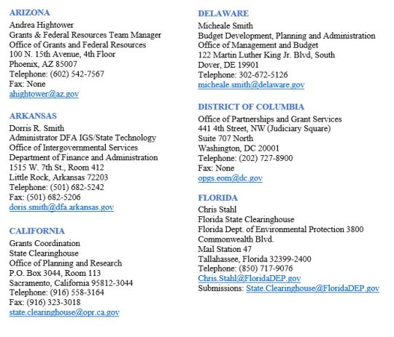
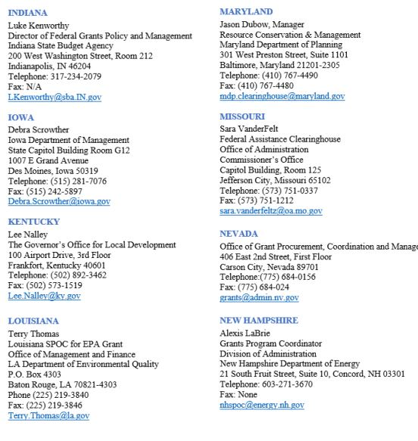
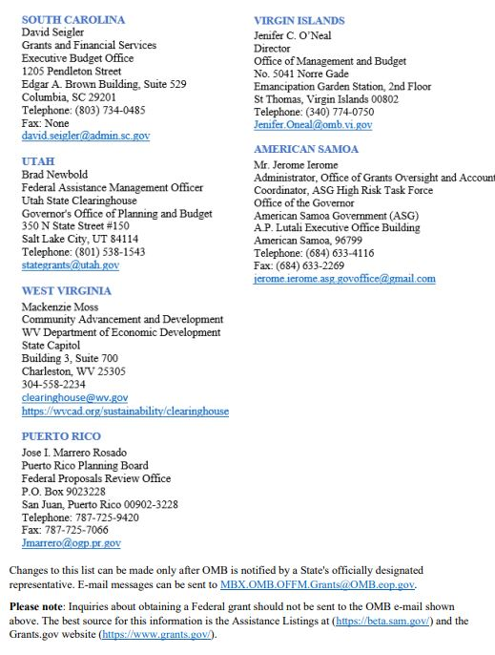

Notice to All Applicants
Ensuring Equitable Access and Application Forms and Instructions

Notice For All Applicants
NOTICE FOR ALL APPLICANTS: EQUITY FOR STUDENTS, EDUCATORS, AND OTHER PROGRAM BENEFICIARIES (OMB Control Number 1894-0005)
Form Overview:
The U.S. Department of Education (Department) has updated its standard form, NOTICE TO ALL APPLICANTS: EQUITY FOR STUDENTS, EDUCATORS, AND OTHER PROGRAM BENEFICIARIES, used by applicants seeking
Federal assistance under the Department’s grant programs to address the General Education Provisions Act (GEPA) Section 427 (20 U.S.C. 1228a) requirements effective April 3, 2023.
GEPA Section 427 requires that applicants, based on the design of their proposed grant project, the participants, and community the project proposes to serve, and local circumstances, determine the extent to which identified barriers prevent equitable access to or participation in their federal grant projects.
The updated GEPA Section 427 form is electronically integrated into the Grants.gov system, and applicants are generally no longer required to upload a separate PDF document but will electronically complete and submit the form with the application package in Grants.gov.
Form Instructions:
- Applicants may identify any barriers that may impede equitable access and participation in the proposed project or activity, including, but not limited to, barriers based on economic disadvantage, gender, race, ethnicity, color, national origin, disability, age, language, migrant status, rural status, homeless status or housing insecurity, pregnancy, parenting, or caregiving status, and sexual orientation.
- Applicants are not required to have mission statements or policies that align with equity in order to submit an application.
- Applicants may have already included some or all this required information in the narrative sections of their applications or their State Plans. In responding to this requirement, for each question, applicants may provide a cross-reference to the section(s) and page number(s) in their applications or State Plans that includes the information responsive to that question on this form or may restate that information on this form
- Applicants must respond to each question using the associated text box. Each text box allows approximately 4000 characters; therefore, if copying and pasting into the text box from another document be sure to check that everything copied.
- Applicants should use the “check for errors” button before they save the form. Applicants will receive an error message if any response is missing and will not be able to submit the application due to the missing information.
- Applicants that have already undertaken steps to address barriers must still provide an explanation and/or description of the steps already taken in each text box, as appropriate, to satisfy the GEPA Section 427 requirement.
- Applicants that believe no barriers exist must still provide an explanation and/or description to each question to validate that perception, as appropriate, to satisfy the GEPA Section 427 requirement.
Form Training:
Applicants may learn more about GEPA Section 427 and the form updates by participating in a 30-minute computer- based training titled, Ensuring Equitable Opportunities Under the GEPA Section 427, at Grants Training and Management Resources Online Grants Training Courses.

Application Forms and Instructions for Grants.gov Applications
The electronic application on Grants.gov consists of multiple mandatory forms that must be completed as well as narrative attachment forms that should be used to upload any file attachments. While there are no file size restrictions, we strongly discourage submission of very large documents. Follow the guidance provided on Grants.gov as well as the Submission Tips document located in this application instruction document for specific information on file sizes, file naming requirements, etc. NOTE: As stated in the application notice, you must upload any narrative sections and all other attachments to your application as files in either PDF or Microsoft Word. It is recommended that applicants submit all files in a read only, flattened PDF format.
Listed below are all forms that must be completed and instructions on where to upload narratives for the application

General Forms:
- Application for Federal Assistance (SF-424)
- Department of Education Budget Information for Non-Construction Programs (ED-524)
- Department of Education Supplemental for SF-424
- Evidence Form
Note: Instructions for all of the standard forms (SF-424, ED-524, and SF-424 Supplemental, etc.), will follow the forms included elsewhere in the application package.

Assurances and Certifications:
- ED GEPA 427 Form
- Grants.gov Lobbying Form (Formerly ED Form 80-0013)

Abstract:
- ED Abstract Form—(Upload and attach your PDF abstract to Abstract File). For the application Abstract, applicants should use the template located at https://www2.ed.gov/fund/grant/apply/osep/new-osep-grants.html.

Narrative Attachment Forms:
- Project Narrative Attachment Form* (Upload and attach to Mandatory Project Narrative File). Submit only one PDF document to the Mandatory Project Narrative File in the following order:
  - Table of Contents
  - List of Priority Requirements and corresponding page number(s) where requirements are addressed within the application (if applicable)
  - Project Narrative (required)

Other Narrative Attachments
(Upload and attach to Optional Project Narrative File)
Upload the attachments in the order they should appear in the application.
Suggested order:
  - Reference List
  - Appendix A (See Dear Applicant letter for description)
  - Resumes/Vitae
  - Letters
  - Supplementary Information
  - Other Appendices
*NOTE: The Project Narrative Attachment Form should include the narrative (text) that addresses each of the selection criteria, listed elsewhere in this document. The selection criteria will be used to evaluate applications submitted for this competition. The narrative has a recommended page limit (check the Page Limits section of this document for exact page limits for the competition to which you are applying). The table of contents and list of priority requirements, if applicable, do not count toward narrative page limit.
NOTE: Please do not attach any narratives, supporting files, or application components to the Standard Form (SF 424) in Part I. Although this form accepts attachments, that option should not be used.

Federal Funding Opportunity Number
The Federal Funding Opportunity Number for this program is:
ED-GRANTS-030124-001

Part I:
Application for Federal Assistance (SF-424)
NOTE: The PDF forms available in this portion of the application package instructions are for sample purposes only and cannot be submitted with your application. If you are applying for a grant, please complete and submit your application using Grants.gov Workspace. You may view the Application for Federal Assistance (SF-424) form at grants.gov/forms/forms-repository/sf-424-family.
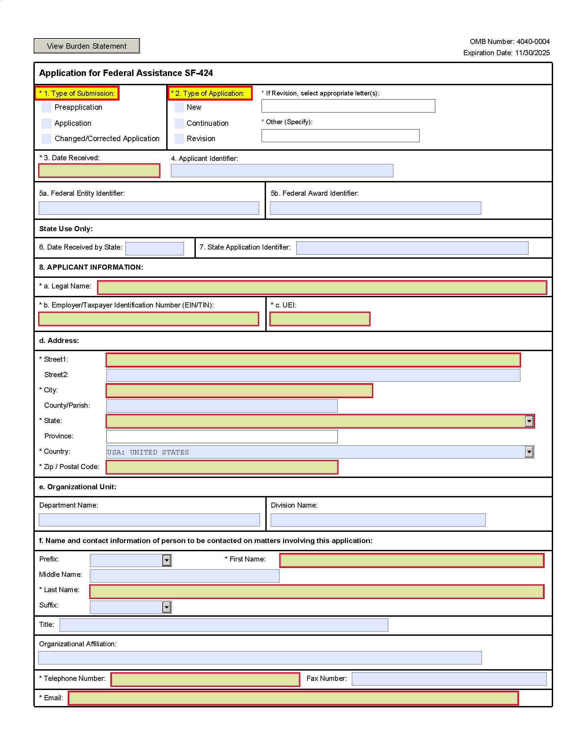

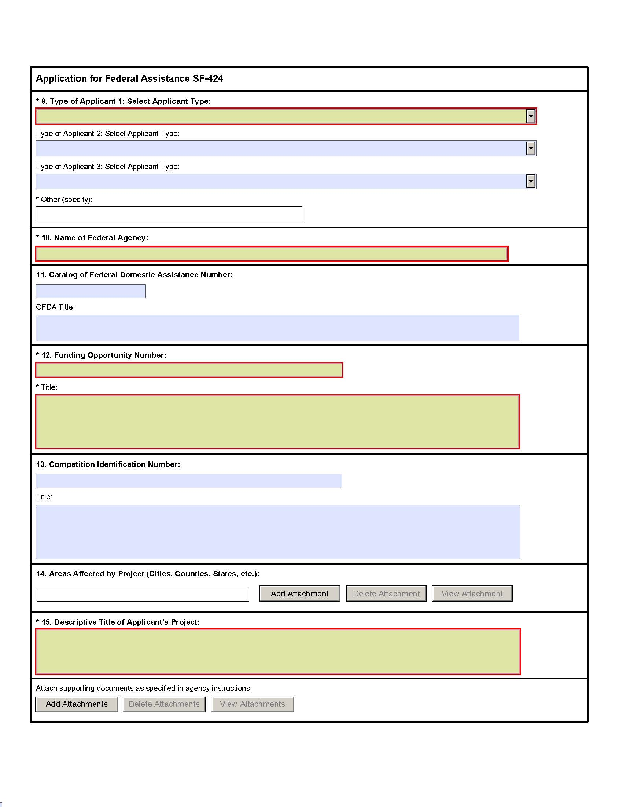

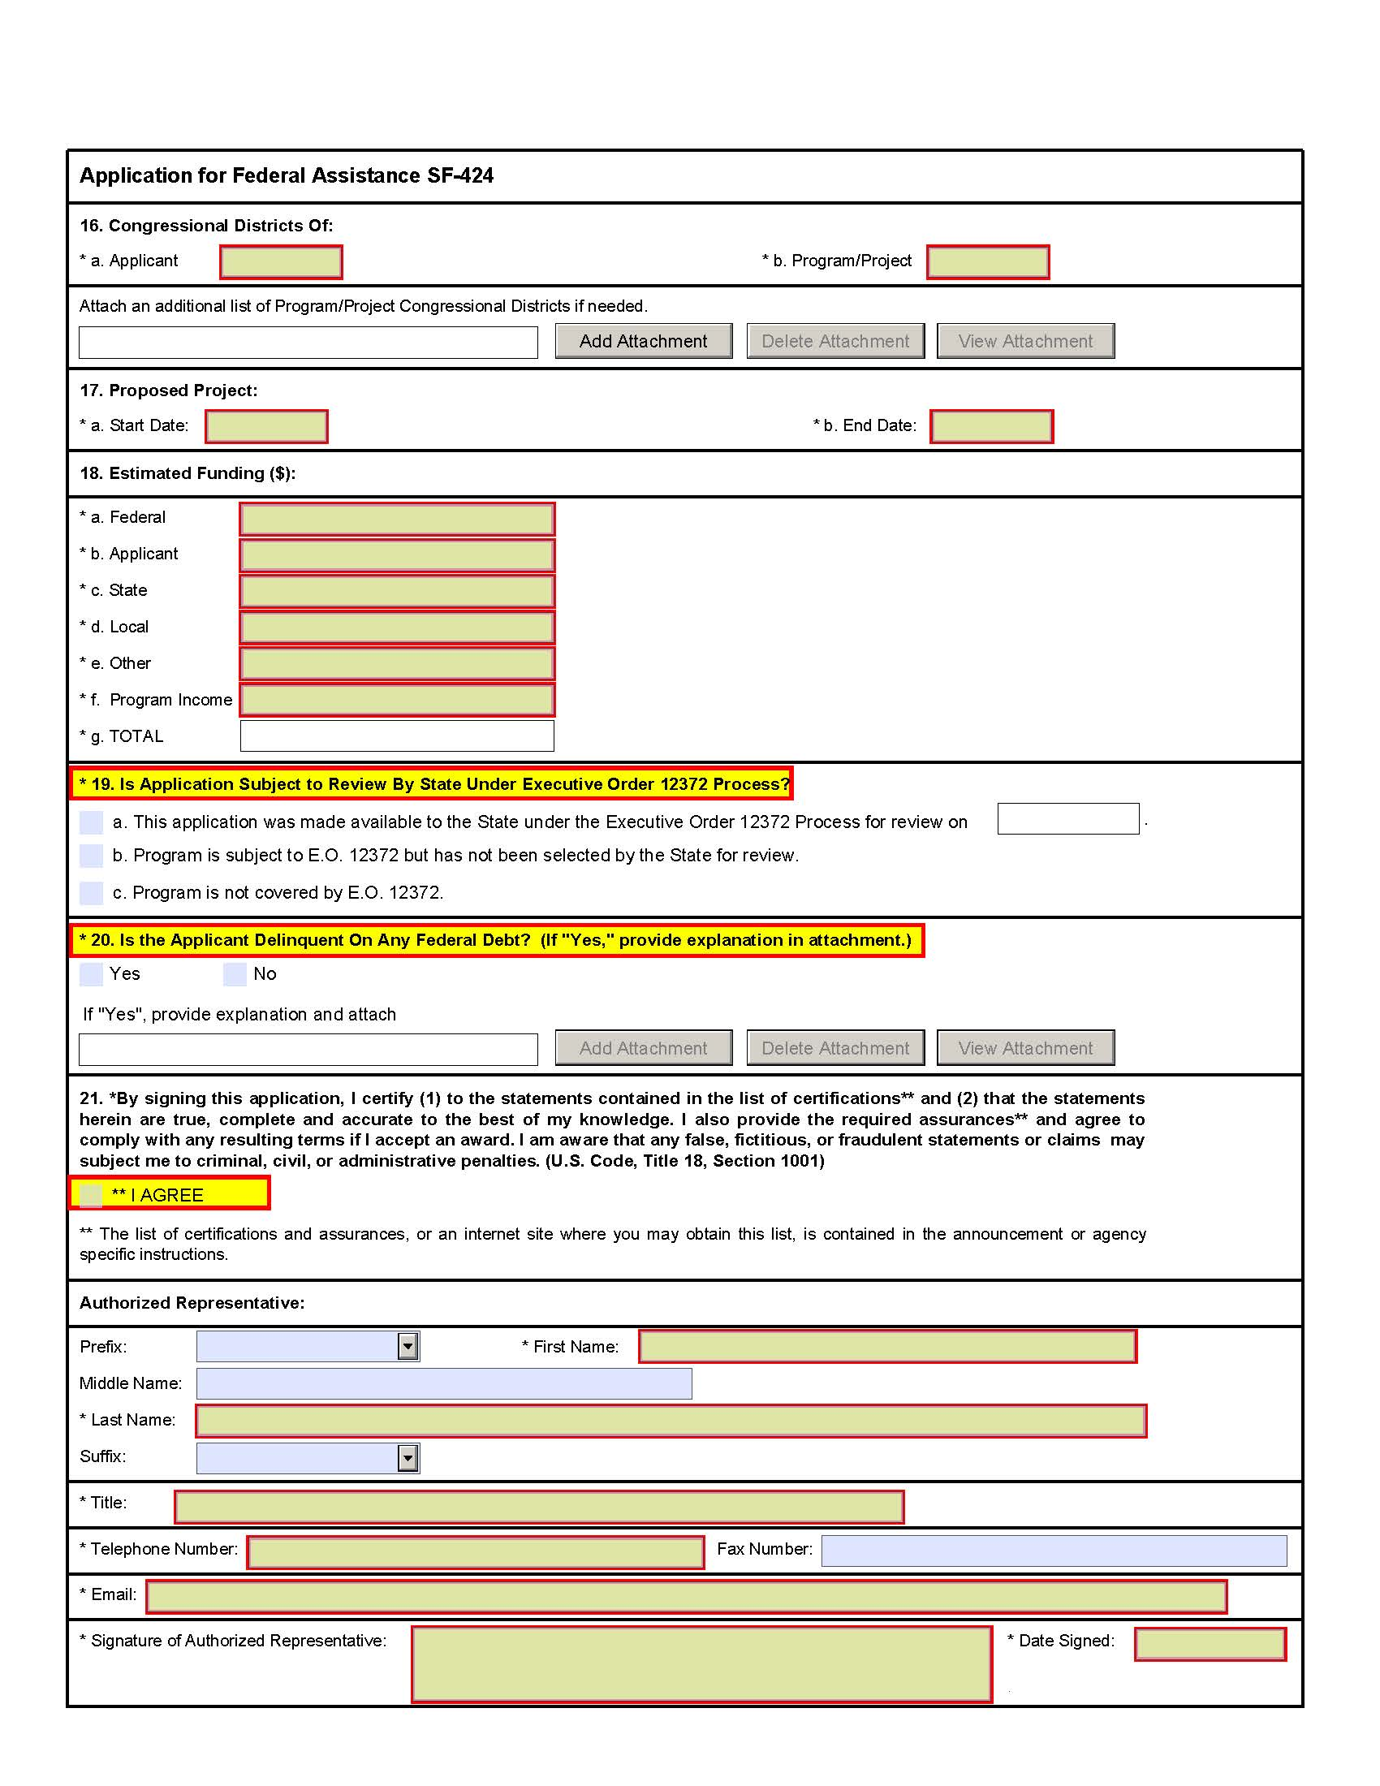

Instructions for the SF-424
This is a standard form required for use as a cover sheet for submission of pre-applications and applications and related information under discretionary programs. Some of the items are required and some are optional at the discretion of the applicant or the federal agency (agency). Required fields on the form are identified with an asterisk (*) and are also specified as “Required” in the instructions below. In addition to these instructions, applicants must consult agency instructions to determine other specific requirements.
- Type of Submission: (Required) Select one type of submission in accordance with agency instructions.
- Pre-application
- Application
- Changed/Corrected Application – Check if this submission is to change or correct a previously submitted application. Unless requested by the agency, applicants may not use this form to submit changes after the closing date.
- Type of Application: (Required) Select one type of application in accordance with agency instructions.
- New — An application that is being submitted to an agency for the first time.
- Continuation — An extension for an additional funding/budget period for a project with a projected completion date. This can include renewals.
- Revision — Any change in the federal government’s financial obligation or contingent liability from an existing obligation. If a revision, enter the appropriate letter(s). More than one may be selected. If "Other" is selected, please specify in text box provided.
- Increase Award
- Decrease Award
- Increase Duration
- Decrease Duration
- Other (specify)
- Date Received: Leave this field blank. This date will be assigned by the Federal agency.
- Applicant Identifier: Enter the entity identifier assigned buy the Federal agency, if any, or the applicant’s control number if applicable.
- a. Federal Entity Identifier: Enter the number assigned to your organization by the federal agency, if any.
- b. Federal Award Identifier: For new applications, enter NA. For a continuation or revision to an existing award, enter the previously assigned federal award identifier number. If a changed/corrected application, enter the federal identifier in accordance with agency instructions.
- Date Received by State: Leave this field blank. This date will be assigned by the state, if applicable.
- State Application Identifier: Leave this field blank. This identifier will be assigned by the state, if applicable.
- Applicant Information: Enter the following in accordance with agency instructions:
- Legal Name: (Required) Enter the legal name of applicant that will undertake the assistance activity. This is the organization that has registered with the Central Contractor Registry (CCR). Information on registering with CCR may be obtained by visiting www.Grants.gov.
- Employer/Taxpayer Number (EIN/TIN): (Required) Enter the employer or taxpayer identification number (EIN or TIN) as assigned by the Internal Revenue Service. If your organization is not in the US, enter 44-4444444.
- Organizational DUNS: (Required) Enter the organization’s DUNS or DUNS+4 number received from Dun and Bradstreet. Information on obtaining a DUNS number may be obtained by visiting www.Grants.gov.
- Address: Enter address: Street 1 (Required); city (Required); County/Parish, State (Required if country is US), Province, Country (Required), 9-digit zip/postal code (Required if country US).
- Organizational Unit: Enter the name of the primary organizational unit, department or division that will undertake the assistance activity.
- Name and contact information of person to be contacted on matters involving this application: Enter the first and last name (Required); prefix, middle name, suffix, title. Enter organizational affiliation if affiliated with an organization other than that in 7.a. Telephone number and email (Required); fax number.
- Type of Applicant: (Required) Select up to three applicant type(s) in accordance with agency instructions.
    - State Government
    - County Government
    - City or Township Government
    - Special District Government
    - Regional Organization
    - U.S. Territory or Possession
    - Independent School District
    - Public/State Controlled Institution of Higher Education
    - Indian/Native American Tribal Government (Federally Recognized)
    - Indian/Native American Tribal Government (Other than Federally Recognized)
    - Indian/Native American Tribally Designated Organization
    - Public/Indian Housing Authority
    - Nonprofit
    - Private Institution of Higher Education
    - Individual
    - For-Profit Organization (Other than Small Business)
    - Small Business
    - Hispanic-serving Institution
    - Historically Black Colleges and Universities (HBCUs)
    - Tribally Controlled Colleges and Universities (TCCUs)
    - Alaska Native and Native Hawaiian Serving Institutions
    - Non-US Entity
    - Other (specify)
- Name Of Federal Agency: (Required) Enter the name of the federal agency from which assistance is being requested with this application.
- Catalog Of Federal Domestic Assistance Number/Title:
- Enter the Catalog of Federal Domestic Assistance number and title of the program under which assistance is requested, as found in the program announcement, if applicable.
- Funding Opportunity Number/Title: (Required) Enter the Funding Opportunity Number (FON) and title of the opportunity under which assistance is requested, as found in the program announcement.
- Competition Identification Number/Title: Enter the competition identification number and title of the competition under which assistance is requested, if applicable.
- Areas Affected By Project: This data element is intended for use only by programs for which the area(s) affected are likely to be different than the place(s) of performance reported on the SF-424 Project/Performance Site Location(s) Form. Add attachment to enter additional areas, if needed.
- Descriptive Title of Applicant’s Project: (Required) Enter a brief descriptive title of the project. If appropriate, attach a map showing project location (e.g., construction or real property projects). For pre-applications, attach a summary description of the project.
- a. Congressional Districts Of: 16a. (Required) Enter the applicant’s congressional district.
- b. Enter all district(s) affected by the program or project. Enter in the format: 2 characters state abbreviation – 3 characters district number, e.g., CA-005 for California 5th district, CA-012 for California 12 district, NC-103 for North Carolina’s 103 district. If all congressional districts in a state are affected, enter “all” for the district number, e.g., MD-all for all congressional districts in Maryland. If nationwide, i.e. all districts within all states are affected, enter US-all. If the program/project is outside the US, enter 00-000. This optional data element is intended for use only by programs for which the area(s) affected are likely to be different than place(s) of performance reported on the SF-424 Project/Performance Site Location(s) Form. Attach an additional list of program/project congressional districts, if needed.
- Proposed Project Start and End Dates: (Required) Enter the proposed start date and end date of the project.
- Estimated Funding: (Required) Enter the amount requested, or to be contributed during the first funding/budget period by each contributor. Value of in-kind contributions should be included on appropriate lines, as applicable. If the action will result in a dollar change to an existing award, indicate only the amount of the change. For decreases, enclose the amounts in parentheses.
- Is Application Subject to Review by State Under Executive Order 12372 Process? (Required) Applicants should contact the State Single Point of Contact (SPOC) for Federal Executive Order 12372 to determine whether the application is subject to the State intergovernmental review process. Select the appropriate box. If “a.” is selected, enter the date the application was submitted to the State
- Is the Applicant Delinquent on any Federal Debt? (Required) Select the appropriate box. This question applies to the applicant organization, not the person who signs as the authorized representative. Categories of federal debt include; but, may not be limited to: delinquent audit disallowances, loans and taxes. If yes, include an explanation in an attachment.
- Authorized Representative: To be signed and dated by the authorized representative of the applicant organization. Enter the first and last name (Required); prefix, middle name, suffix. Enter title, telephone number, email (Required); and fax number. A copy of the governing body’s authorization for you to sign this application as the official representative must be on file in the applicant’s office. (Certain federal agencies may require that this authorization be submitted as part of the application.)

ED SF424 Supplement Form
NOTE: The PDF forms available in this portion of the application package instructions are for sample purposes only and cannot be submitted with your application. If you are applying for a grant, please complete and submit your application using Grants.gov Workspace. You may view the ED SF424 Supplement form at grants.gov/forms/forms-repository/sf-424-family.

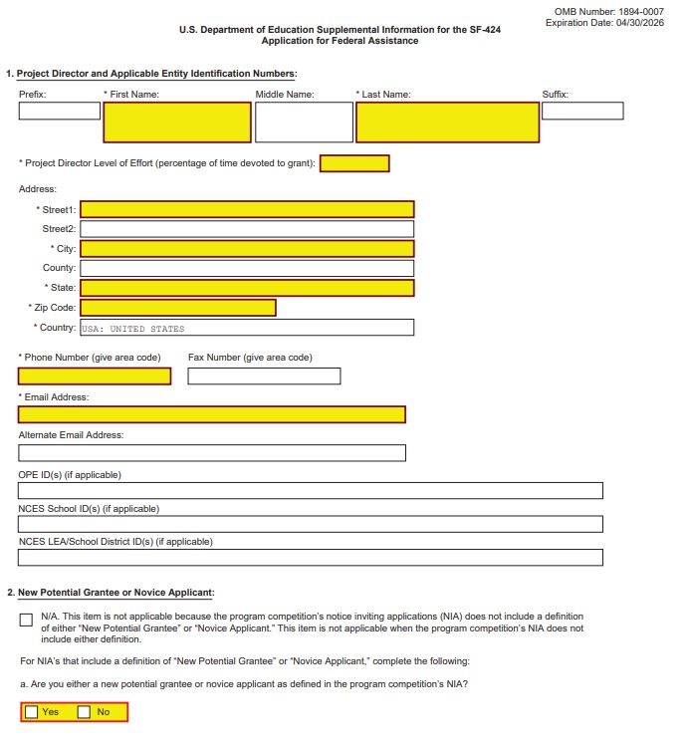
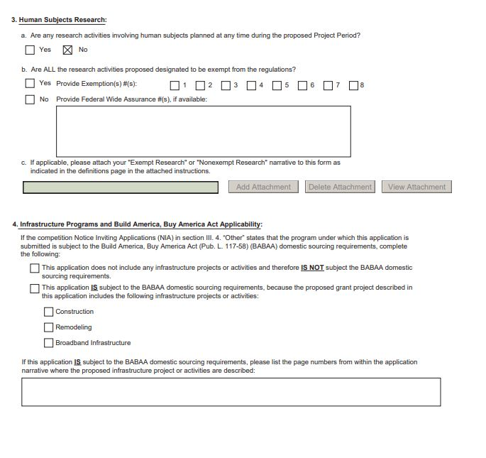

Instructions for Department of
Education Supplemental Information for SF 424 Application for Federal Assistance
1. Project Director and Applicable Entity Identification Numbers.
Name, address, telephone and fax numbers, and e-mail and alternate email addresses of the Project Director to be contacted on matters involving this application. Enter Project Director’s level of effort (the percentage of time devoted to the grant). Items marked with an asterisk (*) are mandatory. If applicable, you must enter any of the following identification numbers that apply: Office of Postsecondary Education Identification (OPE ID(s)); National Center for Education Statistics Schools Identification (NCES School ID(s)); National Center for Education Statistics Local Education Agency/School District Identification (NCES LEA/School District ID(s)). Provide the relevant number or numbers that are applicable for the institution(s), LEA(s), and school(s) that will be served by the proposed project. If you are providing multiple numbers, enter them separated by commas or semicolons. If you are applying on behalf of the entire LEA/School District, you do not need to provide the NCES School ID for each school within the LEA/School District. Search for the OPE ID code at: College Navigator - National Center for Education Statistics at https://nces.ed.gov/collegenavigator/; the NCES School ID at: https://nces.ed.gov/globallocator/; and the NCES LEA/School District ID at: https://nces.ed.gov/ccd/districtsearch/. If not applicable, enter “n/a” in the relevant field(s).
2. New Potential Grantee or Novice Applicant.
Select N/A if this item is not applicable because the program competition’s notice inviting applications (NIA) does not include a definition of either “New Potential Grantee” or “Novice Applicant.” This item is not applicable when the program competition’s NIA does not include either definition. If this item is applicable, for (a), check “Yes” if you meet the definition for new potential grantees or novice applicants specified in the program competition’s NIA and included on the attached page entitled “Definitions for U.S. Department of Education Supplemental Information for the SF-424”. By checking “Yes” the applicant certifies that it meets the new potential grantee or novice applicant requirements. Check “No” if you do not meet the definition for new potential grantees or novice applicants. For (b), if the program competition NIA is giving competitive preference points for new potential grantees or novice applicants, indicate how many points you are claiming for your application. The NIA will indicate how many are available depending on the design of the competition. Some competitions may provide more than one category of new potential grantees with differing levels of points.
3. Human Subjects Research.
(See I. A. “Definitions” in attached page entitled “Definitions for U.S. Department of Education Supplemental Information for the SF-424 form.”)
3a. If Not Human Subjects Research.
Check “No” if research activities involving human subjects are not planned at any time during the proposed project period. The remaining parts of Item 3 are then not applicable.
3a. If Human Subjects Research.
Check “Yes” if research activities involving human subjects are planned at any time during the proposed project period, either at the applicant organization or at any other performance site or collaborating institution. Check “Yes” even if the research is exempt from the regulations for the protection of human subjects. (See I. B. “Exemptions” in attached page entitled “Definitions for U.S. Department of Education Supplemental Information for the SF-424 Application for Federal Assistance.”)
3b. If Human Subjects Research is Exempt from the Human Subjects Regulations.
Check “Yes” if all the research activities proposed are designated to be exempt from the regulations. Check the exemption number(s) corresponding to one or more of the eight exemption categories (Regulation revised in 2018 and became effective in 2019) listed in I. B. “Exemptions.” In addition, follow the instructions in II. A. “Exempt Research Narrative” in the attached page entitled “Definitions for U.S. Department of Education Supplemental Information for the SF-424 Application for Federal Assistance.”
3b. If Human Subjects Research is Not Exempt from Human Subjects Regulations.
Check “No” if some or all of the planned research activities are covered (not exempt). In addition, follow the instructions in II. B. “Nonexempt Research Narrative” in the attached page entitled “Definitions for U.S. Department of Education Supplemental Information for the SF-424 Application for Federal Assistance.”
3b. Federal Wide Assurance Number.
If the applicant has an approved Federal Wide Assurance (FWA) on file with the Office for Human Research Protections (OHRP), U.S. Department of Health and Human Services, that covers the specific activity, insert the number in the space provided. (A list of current FWAs is available at: http://ohrp.cit.nih.gov/search/search.aspx?styp=bsc.) If the applicant does not have an approved assurance on file with OHRP, enter “None.” In this case, the applicant, by signature on the SF-424, is declaring that it will comply with 34 CFR part 97 and proceed to obtain the human subjects assurance upon request by the designated ED official. If the application is recommended/selected for funding, the designated ED official will request that the applicant obtain the assurance within 30 days after the specific formal request.
3c. If applicable, please attach your “Exempt Research” or “Nonexempt Research” narrative to your submission of the U.S. Department of Education Supplemental Information for the SF-424 form as instructed in item II, “Instructions for Exempt and Nonexempt Human Subjects Research Narratives” in the attached page entitled “Definitions for U.S. Department of Education Supplemental Information for the SF-424 Application for Federal Assistance.”
Note about Institutional Review Board Approval.
ED does not require certification of Institutional Review Board approval with the application. However, if an application that involves non-exempt human subjects research is recommended/selected for funding, the designated ED official will request that the applicant obtain and send the certification to ED within 30 days after the formal request. No covered human subjects research can be conducted until the study has ED clearance for protection of human subjects in research.
4 .Infrastructure Programs.
In accordance with section 70914 of the Infrastructure Investment and Jobs Act, the Build America Buy America Act (BABAA) requires that grantees funded under the U.S. Department of Education programs that allow funds to be used for infrastructure projects, i.e., construction, remodeling, and broadband infrastructure, may not use their grant funds for these infrastructure projects or activities unless they comply with the following BABAA domestic sourcing requirements:
  - All iron and steel used in the infrastructure project or activity are produced in the United States.
  - All manufactured products used in the infrastructure project or activity are produced in the United States.
  - All construction materials are manufactured in the United States.
If the NIA in section III. 4. “Other” reflects that the program under which an application is submitted is subject to the BABAA domestic sourcing requirements, select the item that applies.
Note: The BABAA domestic sourcing requirements only apply to those activities in each application grant proposal related to infrastructure (specifically, only construction, remodeling, or broadband infrastructure activities). No other projects or costs associated with other proposed grant activities are subject to the BABAA domestic sourcing requirements.
For applications with proposed infrastructure projects and activities that are subject to the BABAA domestic sourcing requirements, select the type of infrastructure activity (i.e., construction, remodeling, and/or broadband infrastructure), and identify the page numbers from within the application narrative where the infrastructure projects or activities are addressed.
Public Burden Statement:
According to the Paperwork Reduction Act of 1995, no persons are required to respond to a collection of information unless such collection displays a valid OMB control number. Public reporting burden for this collection of information is estimated to average 20 minutes per response, including time for reviewing instructions, searching existing data sources, gathering and maintaining the data needed, and completing and reviewing the collection of information. The obligation to respond to this collection is required to obtain or retain benefit (20 USC 3474 General Education Provisions Act). Send comments regarding the burden estimate or any other aspect of this collection of information, including suggestions for reducing this burden, to the U.S. Department of Education, 400 Maryland Ave., SW, Washington, DC 20210-4537 or email ICDocketMgr@ed.gov and reference the OMB Control Number 1894-0007. Note: Please do not return the completed ED SF 424 Supplemental Form to this address.

Definitions for Department of
Education Supplemental Information for the SF 424 Application for Federal Assistance

Definitions:
New Potential Grantee or Novice Applicant (See 34 CFR 75.225).
New Potential Grantee: The definition of New Potential Grantee is set in the program competition’s Notice Inviting Applications (NIA). The New Potential Grantee priority is from the Department’s Administrative Priorities for Discretionary Grant Programs published in the Federal Register March 9, 2020 (85 FR 13640). Novice Applicant: For discretionary grant programs, novice applicant means any applicant for a grant from ED that—
- Has never received a grant or subgrant under the program from which it seeks funding;
- Has never been a member of a group application, submitted in accordance with 34 CFR 75.127-75.129, that received a grant under the program from which it seeks funding; and
- Has not had an active discretionary grant from the Federal government in the five years before the deadline date for applications under the program. For the purposes of this requirement, a grant is active until the end of the grant’s project or funding period, including any extensions of those periods that extend the grantee’s authority to obligate funds.
In the case of a group application submitted in accordance with 34 CFR 75.127-75.129, a group includes only parties that meet the requirements listed above.

Protection of Human Subjects in Research
I. Definitions and Exemptions
A. Definitions.
A research activity involves human subjects if the activity is research, as defined in the Department’s regulations, and the research activity will involve use of human subjects, as defined in the regulations.
—Research
The ED Regulations for the Protection of Human Subjects, Title 34, Code of Federal Regulations, Part 97, define research as “a systematic investigation, including research development, testing and evaluation, designed to develop or contribute to generalizable knowledge.” If an activity follows a deliberate plan whose purpose is to develop or contribute to generalizable knowledge it is research. Activities which meet this definition constitute research whether or not they are conducted or supported under a program that is considered research for other purposes. For example, some demonstration and service programs may include research activities.
—Human Subject
The regulations define human subject as “a living individual about whom an investigator (whether professional or student) conducting research obtains (1) data through intervention or interaction with the individual, or (2) identifiable private information.” (1) If an activity involves obtaining information about a living person by manipulating that person or that person’s environment, as might occur when a new instructional technique is tested, or by communicating or interacting with the individual, as occurs with surveys and interviews, the definition of human subject is met. (2) If an activity involves obtaining private information about a living person in such a way that the information can be linked to that individual (the identity of the subject is or may be readily determined by the investigator or associated with the information), the definition of human subject is met. [Private information includes information about behavior that occurs in a context in which an individual can reasonably expect that no observation or recording is taking place, and information which has been provided for specific purposes by an individual and which the individual can reasonably expect will not be made public (for example, a school health record).]
B. Exemptions.
Research activities in which the only involvement of human subjects will be in one or more of the following six categories of exemptions are not covered by the regulations:
- Research conducted in established or commonly accepted educational settings, involving normal educational practices, such as (a) research on regular and special education instructional strategies, or (b) research on the effectiveness of or the comparison among instructional techniques, curricula, or classroom management methods.
- Research involving the use of educational tests (cognitive, diagnostic, aptitude, achievement), survey procedures, interview procedures or observation of public behavior, unless: (a) information obtained is recorded in such a manner that human subjects can be identified, directly or through identifiers linked to the subjects; and (b) any disclosure of the human subjects’ responses outside the research could reasonably place the subjects at risk of criminal or civil liability or be damaging to the subjects’ financial standing, employability, or reputation. If the subjects are children, exemption 2 applies only to research involving educational tests and observations of public behavior when the investigator(s) do not participate in the activities being observed. Exemption 2 does not apply if children are surveyed or interviewed or if the research involves observation of public behavior and the investigator(s) participate in the activities being observed. [Children are defined as persons who have not attained the legal age for consent to treatments or procedures involved in the research, under the applicable law or jurisdiction in which the research will be conducted.]
- Research involving the use of educational tests (cognitive, diagnostic, aptitude, achievement), survey procedures, interview procedures or observation of public behavior that is not exempt under section (2) above, if the human subjects are elected or appointed public officials or candidates for public office; or federal statute(s) require(s) without exception that the confidentiality of the personally identifiable information will be maintained throughout the research and thereafter.
- Research involving the collection or study of existing data, documents, records, pathological specimens, or diagnostic specimens, if these sources are publicly available or if the information is recorded by the investigator in a manner that subjects cannot be identified, directly or through identifiers linked to the subjects.
- Research and demonstration projects which are conducted by or subject to the approval of department or agency heads, and which are designed to study, evaluate, or otherwise examine: (a) public benefit or service programs; (b) procedures for obtaining benefits or services under those programs; (c) possible changes in or alternatives to those programs or procedures; or (d) possible changes in methods or levels of payment for benefits or services under those programs.
- Taste and food quality evaluation and consumer acceptance studies, (a) if wholesome foods without additives are consumed or (b) if a food is consumed that contains a food ingredient at or below the level and for a use found to be safe, or agricultural chemical or environmental contaminant at or below the level found to be safe, by the Food and Drug Administration or approved by the Environmental Protection Agency or the Food Safety and Inspection Service of the U.S. Department of Agriculture.
II. Instructions for Exempt and Nonexempt Human Subjects Research Narratives
If the applicant marked “Yes” for Item 3 of Department of Education Supplemental Information for SF 424, the applicant must provide a human subjects “exempt research” or “nonexempt research” narrative. Insert the narrative(s) in the space provided. If you have multiple projects and need to provide more than one narrative, be sure to label each set of responses as to the project they address.
- Exempt Research Narrative.
If you marked “Yes” for item 3 a. and designated exemption numbers(s), provide the “exempt research” narrative. The narrative must contain sufficient information about the involvement of human subjects in the proposed research to allow a determination by ED that the designated exemption(s) are appropriate. The narrative must be succinct.
- Nonexempt Research Narrative.
If you marked “No” for item 3 a. you must provide the “nonexempt research” narrative. The narrative must address the following seven points. Although no specific page limitation applies to this section of the application, be succinct.
  - Human Subjects Involvement and Characteristics: Provide a detailed description of the proposed involvement of human subjects. Describe the characteristics of the subject population, including their anticipated number, age range, and health status. Identify the criteria for inclusion or exclusion of any subpopulation. Explain the rationale for the involvement of special classes of subjects, such as children, children with disabilities, adults with disabilities, persons with mental disabilities, pregnant women, prisoners, institutionalized individuals, or others who are likely to be vulnerable
  - Sources of Materials: Identify the sources of research material obtained from individually identifiable living human subjects in the form of specimens, records, or data. Indicate whether the material or data will be obtained specifically for research purposes or whether use will be made of existing specimens, records, or data.
  - Recruitment and Informed Consent: Describe plans for the recruitment of subjects and the consent procedures to be followed. Include the circumstances under which consent will be sought and obtained, who will seek it, the nature of the information to be provided to prospective subjects, and the method of documenting consent. State if the Institutional Review Board (IRB) has authorized a modification or waiver of the elements of consent or the requirement for documentation of consent.
  - Potential Risks: Describe potential risks (physical, psychological, social, legal, or other) and assess their likelihood and seriousness. Where appropriate, describe alternative treatments and procedures that might be advantageous to the subjects.
  - Protection Against Risk: Describe the procedures for protecting against or minimizing potential risks, including risks to confidentiality, and assess their likely effectiveness. Where appropriate, discuss provisions for ensuring necessary medical or professional intervention in the event of adverse effects to the subjects. Also, where appropriate, describe the provisions for monitoring the data collected to ensure the safety of the subjects.
  - Importance of the Knowledge to be Gained: Discuss the importance of the knowledge gained or to be gained as a result of the proposed research. Discuss why the risks to subjects are reasonable in relation to the anticipated benefits to subjects and in relation to the importance of the knowledge that may reasonably be expected to result.
  - Collaborating Site(s): If research involving human subjects will take place at collaborating site(s) or other performance site(s), name the sites and briefly describe their involvement or role in the research.
Copies of the Department of Education’s Regulations for the Protection of Human Subjects, 34 CFR Part 97 and other pertinent materials on the protection of human subjects in research are available from:
Grants Policy and Oversight Staff
Office of the Chief Financial Officer
U.S. Department of Education
Washington, DC 20202-4250
Telephone: 202-245-6120
and on the U.S. Department of Education’s Protection of Human Subjects in Research Web Site:
www.ed.gov/about/offices/list/OCFO/humansub.html
NOTE: The State Applicant Identifier on the SF 424 is for State Use only. Please complete it on the OMB Standard 424 in the upper right corner of the form (if applicable).

Part II: Budget Information (ED Form 524)
NOTE: The PDF forms available in this portion of the application package instructions are for sample purposes only and cannot be submitted with your application. If you are applying for a grant, please complete and submit your application using Grants.gov Workspace. You may view the U.S. DEPARTMENT OF EDUCATION BUDGET INFORMATION NON-CONSTRUCTION PROGRAMS (ED Form 524) form at grants.gov/forms/forms-repository/sf-424-family.

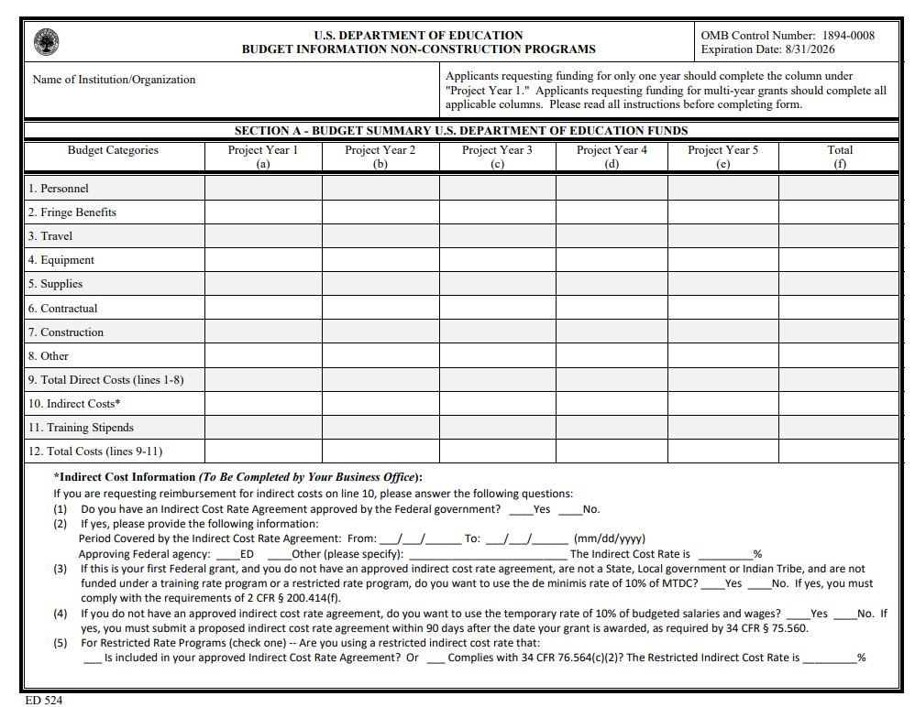
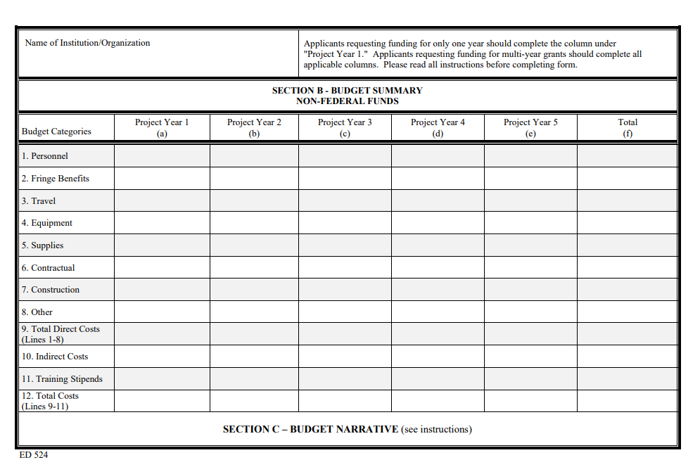

Instructions for ED Form 524

General Instructions
This form is used to apply to individual U.S. Department of Education (ED) discretionary grant programs. Unless directed otherwise, provide the same budget information for each year of the multi-year funding request. Pay attention to applicable program specific instructions, if attached. You may access the Education Department General Administrative Regulations cited within these instructions at: http://www.ed.gov/policy/fund/reg/edgarReg/edgar.html. You may access requirements from 2 CFR 200, “Uniform Administrative Requirements, Cost Principles, and Audit Requirements for Federal Awards” cited within these instructions at: https://www.federalregister.gov/articles/2013/12/26/2013- 30465/uniform-administrative-requirements-cost-principles-and audit-requirements-for-federal-awards.
You must consult with your Business Office prior to submitting this form.

Section A: Budget Summary—U.S. Department of Education Funds
All applicants must complete Section A and provide a breakdown by the applicable budget categories shown in lines 1-11.
Lines 1-11, columns (a)-(e): For each project year for which funding is requested, show the total amount requested for each applicable budget category.
Lines 1-11, column (f): Show the multi-year total for each budget category. If funding is requested for only one project year, leave this column blank.
Line 12, columns (a)-(e): Show the total budget request for each project year for which funding is requested.
Line 12, column (f): Show the total amount requested for all project years. If funding is requested for only one year, leave this space blank.
Indirect Cost Information: If you are requesting reimbursement for indirect costs on line 10, this information is to be completed by your Business Office.
(1) Indicate whether or not your organization has an Indirect Cost Rate Agreement that was approved by the Federal government. If you checked “no,” ED generally will authorize grantees to use a temporary rate of 10 percent of budgeted salaries and wages (complete (4) of this section when using the temporary rate) subject to the following limitations:
(a) The grantee must submit an indirect cost proposal to its cognizant agency within 90 days after ED issues a grant award notification; and
(b) If after the 90-day period, the grantee has not submitted an indirect cost proposal to its cognizant agency, the grantee may not charge its grant for indirect costs until it has negotiated an indirect cost rate agreement with its cognizant agency.
(2) If you checked “yes” in (1), indicate in (2) the beginning and ending dates covered by the Indirect Cost Rate Agreement. In addition, indicate whether ED or another Federal agency (Other) issued the approved agreement. If you check “Other,” specify the name of the Federal agency that issued the approved agreement.
(3): If you check “no” in (1), indicate in (3) if you want to use the de minimis rate of 10 percent of MTDC (see 2CFR § 200.68). If you use the de minimis rate, you are subject to the provisions in 2 CFR § 200.414(f). Note, you may only use the 10 percent de minimis rate if you are a first-time Federal grant recipient, and you do not have an Approved Indirect Cost Rate Agreement. You may not use the de minimis rate if you are a State, Local government, or Indian Tribe, or if your grant is funded under a training rate or restricted rate program.
(4) If you are applying for a grant under a Restricted Rate Program (34 CFR 75.563 or 76.563), indicate whether you are using a restricted indirect cost rate that is included on your approved Indirect Cost Rate Agreement or whether you are using a restricted indirect cost rate that complies with 34 CFR 76.564(c)(2). Note: State or local government agencies may not use the provision for a restricted indirect cost rate specified in 34 CFR 76.564(c)(2). Check only one response. Leave blank, if this item is not applicable.

Section B: Budget Summary —Non-Federal Funds
If you are required to provide or volunteer to provide matching funds or other non-Federal resources to the project, these should be shown for each applicable budget category on lines 1-11 of Section B.
Lines 1-11, columns (a)-(e): For each project year, for which matching funds or other contributions are provided, show the total contribution for each applicable budget category.
Lines 1-11, column (f): Show the multi-year total for each budget category. If non-Federal contributions are provided for only one year, leave this column blank.
Line 12, columns (a)-(e): Show the total matching or other contribution for each project year.
Line 12, column (f): Show the total amount to be contributed for all years of the multi-year project. If non-Federal contributions are provided for only one year, leave this space blank.

Section C: Budget Narrative
[Attach separate sheet(s)] Pay attention to applicable program specific instructions, if attached.
- Provide an itemized budget breakdown, and justification by project year, for each budget category listed in Sections A and B. For grant projects that will be divided into two or more separately budgeted major activities or sub-projects, show for each budget category of a project year the breakdown of the specific expenses attributable to each sub-project or activity.
- For non-Federal funds or resources listed in Section B that are used to meet a cost-sharing or matching requirement or provided as a voluntary cost-sharing or matching commitment, you must include:
  - The specific costs or contributions by budget category;
  - The source of the costs or contributions; and
  - In the case of third-party in-kind contributions, a description of how the value was determined for the donated or contributed goods or services.
[Please review cost sharing and matching regulations found in 2 CFR 200.306.]
- If applicable to this program, provide the rate and base on which fringe benefits are calculated.
- If you are requesting reimbursement for indirect costs on line 10, this information is to be completed by your Business Office. Specify the estimated amount of the base to which the indirect cost rate is applied and the total indirect expense. Depending on the grant program to which you are applying and/or your approved Indirect Cost Rate Agreement, some direct cost budget categories in your grant application budget may not be included in the base and multiplied by your indirect cost rate. For example, you must multiply the indirect cost rates of “Training grants" (34 CFR 75.562) and grants under programs with “Supplement not Supplant” requirements ("Restricted Rate" programs) by a “modified total direct cost” (MTDC) base (34 CFR 75.563 or 76.563). Please indicate which costs are included and which costs are excluded from the base to which the indirect cost rate is applied.
When calculating indirect costs (line 10) for "Training grants" or grants under "Restricted Rate" programs, you must refer to the information and examples on ED’s Web site at:
www.ed.gov/fund/grant/apply/appforms/appforms.html.
You may also contact (202) 377-3838 for additional information regarding calculating indirect cost rates or general indirect cost rate information.
- Provide other explanations or comments you deem necessary.

Paperwork Burden Statement
According to the Paperwork Reduction Act of 1995, no persons are required to respond to a collection of information unless such collection displays a valid OMB control number. The valid OMB control number for this information collection is 1894-0008. The time required to complete this information collection is estimated to vary from 13 to 22 hours per response, with an average of 17.5 hours per response, including the time to review instructions, search existing data sources, gather the data needed, and complete and review the information collection. If you have any comments concerning the accuracy of the time estimate(s) or suggestions for improving this form, please write to: U.S. Department of Education, Washington, D.C. 20202-4537. If you have comments or concerns regarding the status of your individual submission of this form, write directly to (insert program office), U.S. Department of Education, 400 Maryland Avenue, S.W., Washington, D.C. 20202.

Part III:
Application Narrative
This narrative section of the application requires applicants to address the selection criteria that will be used by reviewers in evaluating individual applications. Please refer to the “Selection Criteria and Format” sections in this package for the competition to which you wish to submit an application.
Also, the competition covered by this package has recommended page limitations for the application narrative. Please refer to the “Page Limits” information for the competition to which you wish to submit an application.

Part IV:
Assurances and Certifications

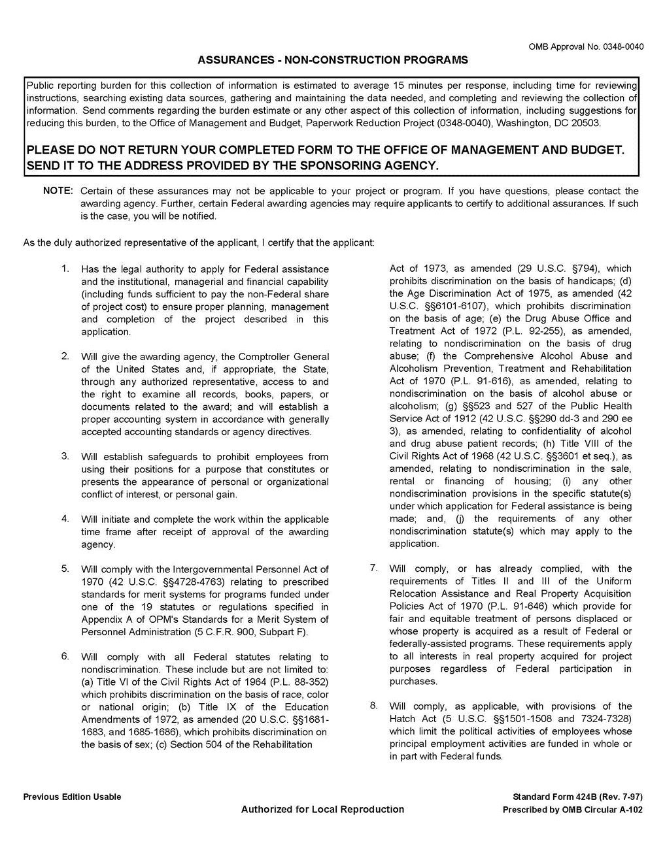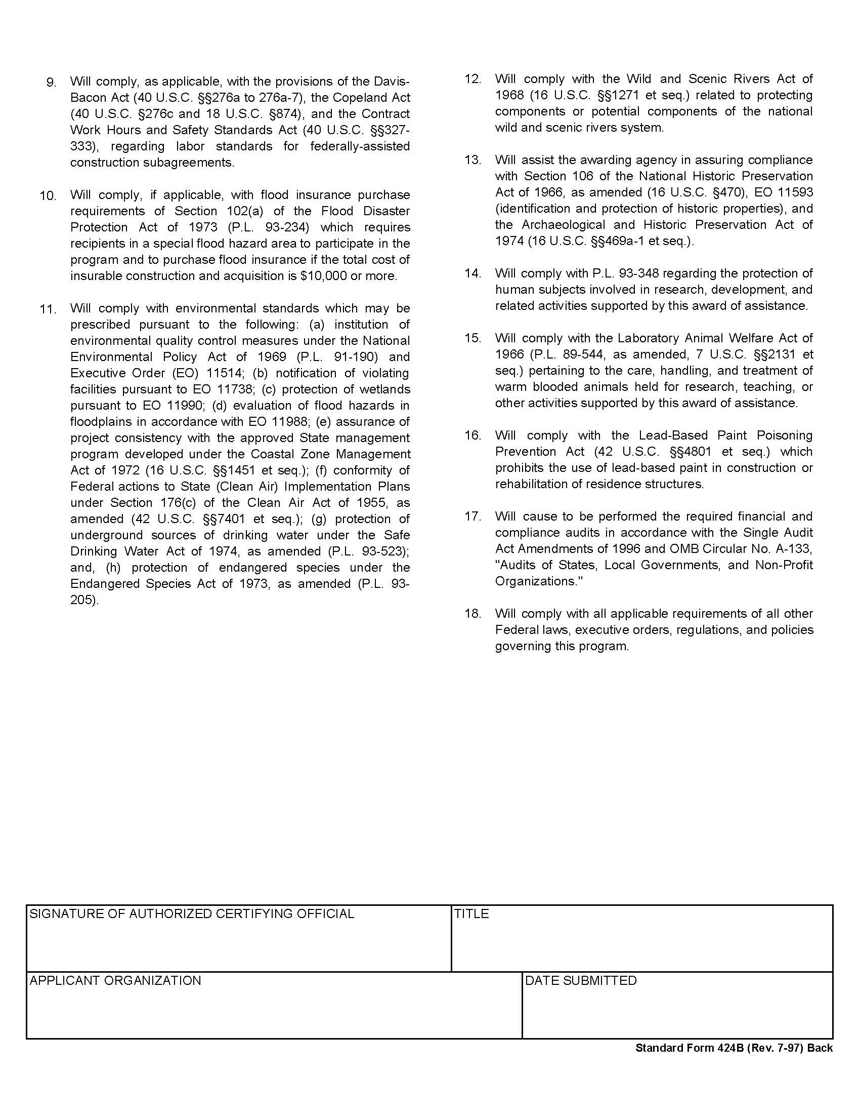


Part V: U.S. Department of Education Evidence Form

OMB Number: 1894-0001
Expiration Date: 07/31/2025

- Level of Evidence
Select the level of evidence of effectiveness for which you are applying. See the Notice Inviting Applications for the relevant definitions and requirements.
[ ] Demonstrates a Rationale [ ] Promising Evidence [ ] Moderate Evidence [ ] Strong Evidence
- Citation and Relevance
Fill in the chart below with the appropriate information about the studies that support your application.
A. Research/Citation | B. Relevant Outcome(s)/Relevant Finding(s) | C. Project Component(s)/Overlap of Populations and/or Settings
Instructions for Evidence Form
- Level of Evidence. Check the box next to the level of evidence for which you are applying. See the Notice Inviting Applications for the evidence definitions.
- Citation and Relevance. Fill in the chart for each of the studies you are submitting to meet the evidence standards. If allowable under the program you are applying for, you may add additional rows to include more than four citations. (See below for an example citation.)
  - Citation. Provide the full citation for each study or WWC publication you are using as evidence. If the study has been reviewed by the WWC, please include the rating it received, the WWC review standards version, and the URL link to the description of that finding in the WWC reviewed studies database. Include a copy of the study or a URL link to the study, if available. Note that, to provide promising, moderate, or strong evidence, you must cite either a specific recommendation from a WWC practice guide, a WWC intervention report, or a publicly available, original study of the effectiveness of a component of your proposed project on a student outcome or other relevant outcome.
  - Relevant Finding(s). Describe: 1) the project component included in the study (or WWC practice guide or intervention report) that is also a component of your proposed project, 2) the student outcome(s) or other relevant outcome(s) that are included in both the study (or WWC practice guide or intervention report) and in the logic model (theory of action) for your proposed project, and 3) the study (or WWC intervention report) finding(s) or WWC practice guide recommendations supporting a favorable relationship between a project component and a relevant outcome. Cite page and table numbers from the study (or WWC practice guide or intervention report), where applicable.
  - Overlap of Population and/or Settings. Explain how the population and/or setting in your proposed project are similar to the populations and settings included in the relevant finding(s). Cite page numbers from the study or WWC publication, where applicable.

Paperwork Burden Statement: According to the Paperwork Reduction Act of 1995, no persons are required to respond to a collection of information unless such collection displays a valid OMB control number. The valid OMB control number for this information collection is 1894-0001. The time required to complete this information collection is estimated to vary from 1 to 4 hours per response, with an average of 1.5 hours per response, including the time to review instructions, search existing data sources, gather the data needed, and complete and review the information collection. If you have any comments concerning the accuracy of the time estimate(s) or suggestions for improving this form, please write to: U.S. Department of Education, Washington, D.C. 20202-4537. If you have comments or concerns regarding the status of your individual submission of this form, write directly to the Office of Innovation and Improvement, U.S. Department of Education, 400 Maryland Avenue, S.W., Washington, D.C. 20202

EXAMPLES: For Demonstration Purposes Only (the three examples are not assumed to be cited by the same applicant)

A. Citation | B. Relevant Finding(s) | C. Overlap of Populations and Settings
Graham, S., Bruch, J., Fitzgerald, J., Friedrich, L., Furgeson, J., Greene, K., Kim, J., Lyskawa, J., Olson, C.B., & Smither Wulsin, C. (2016). Teaching secondary students to write effectively (NCEE 2017-4002). Washington, DC: National Center for Education Evaluation and Regional Assistance (NCEE), Institute of Education Sciences, U.S. Department of Education. Retrieved from the NCEE website: https://ies.ed.gov/ncee/wwc/PracticeGuide/22. This report was prepared under Version 3.0 of the WWC Handbook (p. 72). | (Table 1, p. 4) Recommendation 1 (“Explicitly teach appropriate strategies using a Model – Practice – Reflect instructional cycle”) is characterized as backed by “strong evidence.”  (Appendix D, Table D.2, pp. 70-72) Studies contributing to the “strong evidence” supporting the effectiveness of Recommendation 1 reported statistically significant and positive impacts of this practice on genre elements, organization, writing output, and overall writing quality. | (Appendix D, Table D.2, pp. 70-72) Studies contributing to the “strong evidence” supporting the effectiveness of Recommendation 1 were conducted on students in grades 6 through 12 in urban and suburban school districts in California and in the Mid-Atlantic region of the U.S. These study samples overlap with both the populations and settings proposed for the project.
U.S. Department of Education, Institute of Education Sciences, What Works Clearinghouse. (2017, February). Transition to College intervention report: Dual Enrollment Programs. Retrieved from https://ies.ed.gov/ncee/wwc/Intervention/1043. This report was prepared under Version 3.0 of the WWC Handbook (p. 1). | (Table 1, p. 2) Dual enrollment programs were found to have positive effects on students’ high school completion, general academic achievement in high school, college access and enrollment, credit accumulation in college, and degree attainment in college, and these findings were characterized by a “medium to large” extent of evidence. | (pp. 1, 19, 22) Studies contributing to the effectiveness rating of dual enrollment programs in the high school completion, general academic achievement in high school, college access and enrollment, credit accumulation in college, and degree attainment in college domains were conducted in high schools with minority students representing between 32 and 54 percent of the student population and first generation college students representing between 31 and 41 percent of the student population. These study samples overlap with both the populations and settings proposed for the project.
Bettinger, E.P., & Baker, R. (2011). The effects of student coaching in college: An evaluation of a randomized experiment in student mentoring. Stanford, CA: Stanford University School of Education. Available at https://ed.stanford.edu/sites/default/files/bettinger_baker_030711.pdf  Meets WWC Group Design Standards without Reservations under review standards 2.1 (http://ies.ed.gov/ncee/wwc/Study/72030). | The intervention in the study is a form of college mentoring called student coaching. Coaches helped with a number of issues, including prioritizing student activities and identifying barriers and ways to overcome them. Coaches were encouraged to contact their assignees by either phone, email, text messaging, or social networking sites (pp. 8-10). The proposed project for Alpha Beta Community College students will train professional staff and faculty coaches on the most effective way(s) to communicate with their mentees, suggest topics for mentors to talk to their mentees, and be aware of signals to prevent withdrawal or academic failure.  The relevant outcomes in the study are student persistence and degree completion (Table 3, p. 27), which are also included in the logic model for the proposed project.  This study found that students assigned to receive coaching and mentoring were significantly more likely than students in the comparison group to remain enrolled at their institutions (pp. 15-16, and Table 3, p. 27). | The full study sample consisted of “13,555 students across eight different higher education institutions, including two- and four-year schools and public, private not-for-profit, and proprietary colleges.” (p. 10) The number of students examined for purposes of retention varied by outcome (Table 3, p. 27). The study sample overlaps with Alpha Beta Community College in terms of both postsecondary students and postsecondary settings.

ED General Education
Provisions Act (GEPA) 427 Form
NOTE: The PDF forms available in this portion of the application package instructions are for sample purposes only and cannot be submitted with your application. If you are applying for a grant, please complete and submit your application using Grants.gov Workspace. You may view the ED General Education Provisions Act (GEPA) 427 Form at grants.gov/forms/forms-repository/sf-424-family.

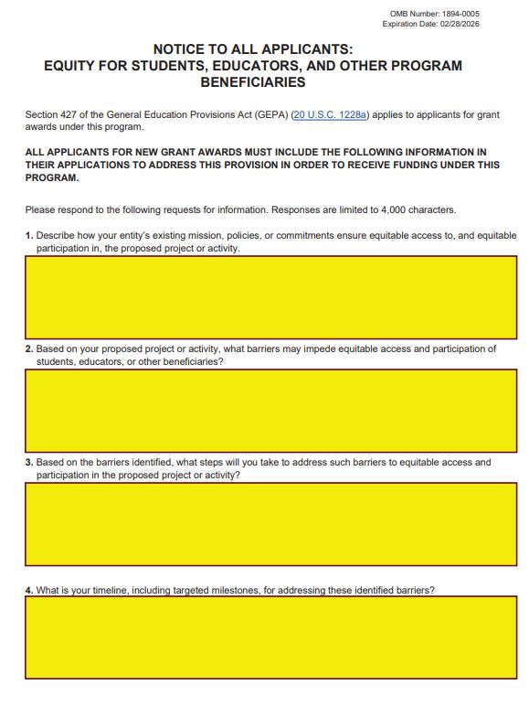

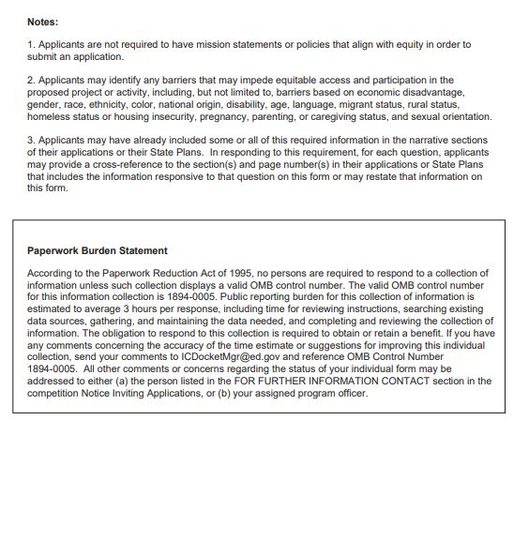

Certification Regarding Lobbying
NOTE: The PDF forms available in this portion of the application package instructions are for sample purposes only and cannot be submitted with your application. If you are applying for a grant, please complete and submit your application using Grants.gov Workspace. You may view the Grants.gov Lobbying Form at grants.gov/forms/forms-repository/sf-424-family.
.

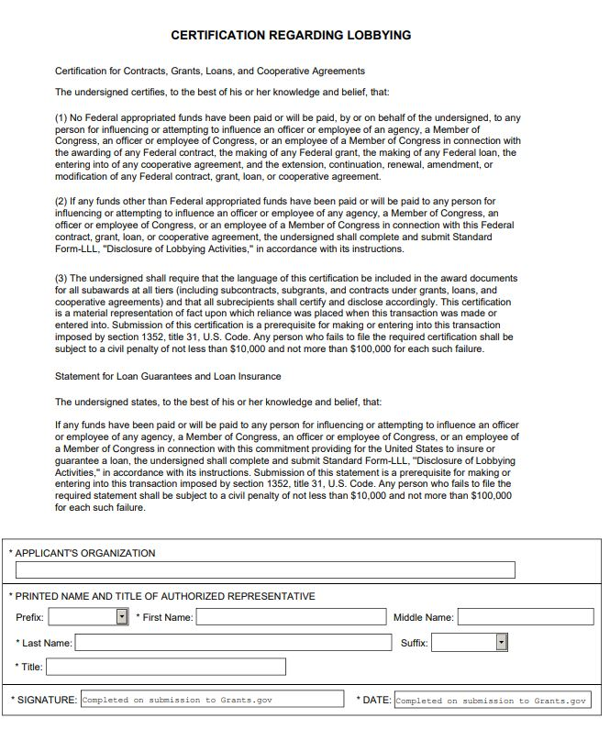

Transition from DUNS Number to Unique Entity Identifier (UEI) Fact Sheet
The Federal Government will transition from the use of the DUNS Number to the new Unique Entity Identifier (UEI) as the primary means of entity identification for Federal awards government-wide. UEIs are required in accordance with 2 CFR Part 25, and the transition from DUNS to UEI will result in the UEI being issued by the Federal Government in SAM.gov. This means entities will no longer rely on a third-party to obtain an identifier (i.e., a DUNS issued by Dun and Bradstreet). This change is meant to streamline the entity identification and validation process, making it easier and less burdensome for entities to do business with the Federal Government. Information addressing the reasons for this transition is available at Government Transition from DUNS to UEI and at Why is SAM.gov changing to SAM (UEI)?.
Starting on April 4, 2022, the Integrated Award Environment (IAE) systems (i.e., SAM.gov, FPDS, eSRS, FSRS, FAPIIS, and CPARS) will comply with the Federal Government’s requirement to end use of the DUNS Number for Federal award management. The U.S. Department of Education’s Grants Management System (G5) will also implement this transition on April 4, 2022.
Here is what you need to know to be ready for this transition:
- If your organization is currently registered in SAM.gov with either an active or inactive registration, you have already been assigned a UEI. Your UEI is viewable on your entity’s registration record in SAM.gov. To learn how to view your UEI, see this guide: How can I view my unique entity identifier (UEI)?.
- If you have an inactive registration or need to update your registration, you must ensure that your renewal or updates occur on time and as required, but this does not affect whether you have been assigned a UEI. If you have a registration, you already have a UEI. If your registration has expired, you can access instructions addressing how to renew your entity registration at: How to Renew or Update an Entity.
- From now until April 3, 2022, entities that are not already registered in SAM.gov and who wish to do business with the Federal Government must obtain and/or use a valid DUNS to register their entity in SAM.gov. On and after April 4, entities who are not registered in SAM.gov will be assigned a UEI when they register and will not need to use a DUNS for entity registration or reporting. To register in SAM.gov, click on the “Get Started” link under the “Register Your Entity…” heading in SAM.gov.
- Your organization will continue to use its DUNS for registration and reporting until April 3, 2022. After that time, your organization will no longer use the DUNS for this purpose and that number will not be maintained in any IAE systems (i.e., SAM.gov, FPDS, eSRS, FSRS, FAPIIS, and CPARS). Beginning April 4, 2022, your organization will only use the UEI in IAE systems.
- The transition to using UEIs does not impact your entity's registration expiration date or when you need to renew. Once assigned, the UEI number will never expire; however, entity registrations do expire annually and require annual renewal. Please ensure that your organization renews its registration prior to the expiration date. The expiration date is listed in your entity record in SAM.gov.
- Subrecipients under entities doing business with the Federal Government that are currently registered in SAM.gov have been assigned their UEI.
- From now until April 3, 2022, subrecipients under entities doing business with the Federal Government that are not already registered in SAM.gov must obtain and/or use a DUNS to register their entity on SAM.gov. On and after April 4, subrecipients can register in SAM.gov and will be assigned their UEI. At that time, subrecipients will no longer be able to obtain or use a DUNS for subrecipient registration or reporting.
Where to get help:
The Federal Service Desk, available at FSD.gov, is the help desk that has been established for all IAE systems. FSD.gov includes resources that address the UEI transition and these resources are available at: Help Resources. There are resources available for grantees, subrecipients, contractors, subcontractors, Federal employees who use SAM.gov, and for individuals who search for entities on SAM.gov. Two of the available resources that are particularly helpful are:
  - FAQs that are organized by how an individual uses SAM.gov based on their roles and responsibilities (UEI Transition FAQs); and
  - An interactive PDF tool that walks individuals through how they are affected by the transition, so they can be confident they have accurate information (Interactive PDF Tool – UEI Transition).
If you have questions about UEIs or the UEI transition that are not answered in the FAQs or in other resources available at FSD.gov, you may contact the FSD.gov by calling, or by choosing the “Create an Incident” or engaging in a “Live Chat.” You may also send the question directly to the General Services Administration at: entityvalidation@gsa.gov.
For other questions related to your grant, please contact your ED program contact listed in box 3 of your Grant Award Notification, or as identified in any other applicable documentation provided by ED.

Grant Application Receipt Acknowledgement
The G5 Functional Application Team will notify you of the Department’s receipt of your grant application. If you do not receive this notification within 15 business days from the application deadline date, you should contact the person listed in the FOR FURTHER INFORMATION CONTACT section of the competition NIA.

Grant and Contract Funding Information
The Department of Education provides information about grant and contract opportunities electronically in several ways:
ED Internet Home Page: www.ed.gov
Grants.gov: www.grants.gov

Applicants should note that other laws, including the Americans with Disabilities Act of 1990 (42 U.S.C. 12101 et seq.; 28 CFR part 35) and section 504 of the Rehabilitation Act of 1973, as amended (29 U.S.C. 794; 34 CFR part 104), may require that State educational agencies (SEAs) and local educational agencies (LEAs) provide captioning, video description, and other accessible educational materials to students with disabilities when these materials are necessary to provide equally integrated and equally effective access to the benefits of the educational program or activity, or as part of a “free appropriate public education” as defined in 34 CFR 104.33.
The term “artificial intelligence” or “AI” has the meaning set forth in 15 U.S.C. 9401(3): a machine-based system that can, for a given set of human-defined objectives, make predictions, recommendations, or decisions influencing real or virtual environments. Artificial intelligence systems use machine- and human-based inputs to perceive real and virtual environments; abstract such perceptions into models through analysis in an automated manner; and use model inference to formulate options for information or action.
For the purposes of this priority, projects must meet at least the definition of “promising evidence,” which means that there is evidence of the effectiveness of a key project component in improving a relevant outcome, based on a relevant finding from one of the following: (a) a practice guide prepared by the What Works Clearinghouse (WWC) reporting a “strong evidence base” or “moderate evidence base” for the corresponding practice recommendation; (b) an intervention report prepared by the WWC reporting a “positive effect” or “potentially positive effect” on a relevant outcome with no reporting of a “negative effect” or “potentially negative effect” on a relevant outcome; or (c) a single study assessed by the Department, as appropriate, that is an experimental study, a quasi-experimental design study, or a well-designed and well-implemented correlational study with statistical controls for selection bias (e.g., a study using regression methods to account for differences between a treatment group and a comparison group); and includes at least one statistically significant and positive (i.e., favorable) effect on a relevant outcome. See 34 CFR 77.1 for definitions of “project component,” “promising evidence,” “experimental study,” “moderate evidence,” “quasi-experimental design study,” “relevant outcome,” and “strong evidence.”
For the purpose of this priority, “educators” include teachers, early childhood providers, administrators, paraprofessionals, and other providers.
For the purposes of this priority, an instructional setting can be an environment that is regulated by the public school or an “early childhood education program,” as defined under the Higher Education Act of 1965, as amended, within the local educational agency (LEA) (Pub. L. 110–315, title VIII, section 801, Aug. 14, 2008, 122 Stat. 3398).
A “site” is a public school building or an “early childhood education program,” as defined under the Higher Education Act, within the local educational agency (LEA) (Pub. L. 110–315, title VIII, section 801, Aug. 14, 2008, 122 Stat. 3398).
The following website provides more information about implementation research: https://nirn.fpg.unc.edu/national-implementation-research-network.
For additional information on the open licensing requirements please refer to 2 CFR 3474.20 and this resource https://oese.ed.gov/files/2022/06/Open-Licensing-Requirement-Quick-Guide.pdf.
For the purposes of this priority, projects must meet at least the definition of “promising evidence,” which means that there is evidence of the effectiveness of a key project component in improving a relevant outcome, based on a relevant finding from one of the following: (a) a practice guide prepared by the What Works Clearinghouse (WWC) reporting a “strong evidence base” or “moderate evidence base” for the corresponding practice recommendation; (b) an intervention report prepared by the WWC reporting a “positive effect” or “potentially positive effect” on a relevant outcome with no reporting of a “negative effect” or “potentially negative effect” on a relevant outcome; or (c) a single study assessed by the Department, as appropriate, that is an experimental study, a quasi-experimental design study, or a well-designed and well-implemented correlational study with statistical controls for selection bias (e.g., a study using regression methods to account for differences between a treatment group and a comparison group); and includes at least one statistically significant and positive (i.e., favorable) effect on a relevant outcome. See 34 CFR 77.1 for definitions of “project component,” “promising evidence,” “experimental study,” “moderate evidence,” “quasi-experimental design study,” “relevant outcome,” and “strong evidence.”
For the purpose of this priority, “educators” include teachers, early childhood providers, administrators, paraprofessionals, and other providers.
For the purposes of this priority, an instructional setting can be an environment that is regulated by the public school or an “early childhood education program,” as defined under the Higher Education Act of 1965, as amended, within the local educational agency (LEA) (Pub. L. 110–315, title VIII, section 801, Aug. 14, 2008, 122 Stat. 3398).
A “site” is a public school building or an “early childhood education program,” as defined under the Higher Education Act, within the local educational agency (LEA) (Pub. L. 110–315, title VIII, section 801, Aug. 14, 2008, 122 Stat. 3398).
The following website provides more information about implementation research: https://nirn.fpg.unc.edu/national-implementation-research-network.
For additional information on the open licensing requirements please refer to 2 CFR 3474.20 and this resource https://oese.ed.gov/files/2022/06/Open-Licensing-Requirement-Quick-Guide.pdf.
SAM.gov – Or the System for Awards Management is the official site for registering to do business with the Federal Government. FPDS.gov – Or the Federal Procurement Data System is the official site for reporting contracts whose estimated value is $10K or more. eSRS.gov – Or the Electronic Subcontracting Reporting System is the official site for reporting subcontracts. FSRS.gov – Or the Federal Funding Accountability and Transparency Act Subaward Reporting System (FSRS) is the official reporting site that Federal prime awardees (i.e., prime contractors and prime grants recipients) use to capture and report subaward and executive compensation data regarding their first-tier subawards. FAPIIS.gov – Or the Federal Awardee Performance and Integrity Information System is the official site in which records are entered and searchable related to Administrative Agreements, Defective Pricing, DoD Determination of Contractor Fault, Non-Responsibility Determination, Recipient Not-Qualified Determination, Termination for Cause, Termination for Default, Termination for Material Failure to Comply, Suspension/Debarment information if the entity has any of these records, and Administrative Proceedings information. CPARS.gov – Or the Contractor Performance Assessment Reporting System is the official site in which Federal agencies can create and measure the quality and timely reporting of contractor performance information, and where contractors can review this information and provide comments.

