Arizona Fire Zone Hazardous Fuels Reduction

Notice of Funding Opportunity Number: F19AS00392

Federal Program: Department of the Interior (DOI), United States (U.S.) Fish and Wildlife Service (Service), National Wildlife Refuge (NWR), Arizona Fire District Zone

Catalog of Federal Domestic Assistance (CFDA) Number: 15.674
Authorizing Legislation: This program is authorized by the Bipartisan Budget Act of 2018, Pub. L. 115-123, Department of the Interior-Wildlife Fire Management; Consolidated Appropriations Act FY 2017 P.L. 114-113, Department of the Interior-Wildland Fire Management; and prior appropriations.

Paperwork Reduction Act Statement: We are collecting this information in accordance with the authorizing legislation identified above. Your response is required to obtain or retain a benefit. We will use the information you provide to conduct a competitive review and select projects for funding and, if awarded, to evaluate performance. We may not conduct or sponsor and you are not required to respond to a collection of information unless it displays a currently valid Office of Management and Budget (OMB) control number. We estimate that it will take you on average about 40 hours to complete an initial application, about 3 hours to revise the terms of an award, and about 8 hours per report to prepare and submit financial and performance reports, including time to maintain records and gather information. Actual time for these activities will vary depending on program-specific requirements. You may send comments on the burden estimate or any other aspect of this information collection to the Information Collection Clearance Officer, U.S. Fish and Wildlife Service, MS BPHC, 5275 Leesburg Pike, Falls Church, VA 22041-3803.

OMB Control Number: 1018-0100 (Expiration Date: 7/31/2021)

I. Program Description
The purpose of this agreement is to support hazardous fuels reduction, construction of fire breaks, clearing of roads for emergency vehicle access, and critical wildlife habitat construction/protection. All Service land in Arizona will be included in this agreement including but not limited to 1) San Bernardino NWR; 2) Leslie Canyon NWR; 3) Buenos Aires NWR; 4) Cabeza Prieta NWR; 5) Imperial NWR; 6) Kofa NWR; 7) Cibola NWR; 8) Bill Williams NWR; and 9) Havasu NWR.

Project funding will be provided by the Service’s hazardous fuels reduction (HFR) accounts, the Southern Border Initiative project (SBI) and other grants/awards depending on project location. HFR funds are used across all refuges in Arizona in areas identified as vulnerable to catastrophic wildfire damage. The SBI project includes mechanical clearing and thinning of lands near the U.S/ Mexico border. The overall goals of SBI projects are to reduce the risk of wildfire, protect critical threatened and endangered species habitat, mitigate safety risks to Service staff and Border Patrol personnel and improve access and visibility for Border Patrol operations.

The primary actions are to reduce hazardous fuels surrounding adjacent communities by mechanically removing woody debris and to chemically control invasive plant species that may exploit the openings. Mechanical treatment of large woody debris would include cutting, removal, and chipping. Invasive plant species would be controlled with herbicides followed by mechanical removal of the dead material. Planning activities include project plan development, mapping of target species, environmental compliance, contract development and administration, treatment effectiveness monitoring, and reporting. Follow-up mechanical and chemical treatments will likely be necessary for 3-5 years to achieve 100 percent control of invasive plant species.

II. Federal Award Information
This program uses a cooperative agreement as the financial assistance instrument. Refuge staff will participate in planning and ensuring compliance for projects under this funding opportunity. The Service will be substantially involved in projects under this funding opportunity. In particular, the Service will be responsible for the following: 1) identifying project areas; 2) project design and specifications, quality control, and reporting; 3) completing any necessary compliance activities required for a given project under the National Environmental Policy Act (NEPA), Federal Endangered Species Act, California Endangered Species Act, and National Historic Preservation Act; 4) ensuring that pesticide use proposals are submitted and approved for any use of herbicides on Service-owned lands; 5) acquisition of any herbicide utilized on the project; and 6) coordinating activities with other Federal and State partners.

The Recipient, Arizona Department of Forestry and Fire Management (AZDFFM), will be responsible for mechanical treatment of large woody debris including cutting, removing, and chipping. Based on funding and needs, hazardous fuels treatment plans may include, but are not limited to: 1) removal of identified hazardous fuels; 2) herbicide treatments of non-preferred vegetation; 3) digging or mowing fire containment lines; 4) piling brush; 5) improving existing trails/access/interpretive sites; and 6) planting or other habitat restoration activities.

Other projects that may be undertaken through this funding opportunity include, but are not limited to: 1) fencing projects; 2) assistance with water catchment development and rehabilitation; 3) non-BAR habitat restoration and enhancement; 4) herbicide applications; 5) facilities, building, or equipment maintenance; 6) landscaping; and 7) visitor facility enhancement.

This cooperative agreement may cover up to a 5-year period contingent on the availability of funds. Funding levels will vary on an annual basis for the life of the agreement. Existing projects are eligible for renewal or supplementation within the 5 years of this agreement. Intra-Service Section 7 consultations and other NEPA clearance documents will be completed on an as-needed basis for this program.

III. Eligibility Information

Eligible Applicants
This Single Source Award is being awarded in accordance with DOI Policy 505 DM 2.14 B(4) Unique Qualifications: The Recipient, AZDFFM, has a great deal of expertise in forest rehabilitation, other habitat enhancement projects, and refuge facilities and infrastructure. In addition, AZDFFM has fire crews headquartered in close proximity to many of the refuges which are able to devote a large number of individuals to meet the objectives of any project in a cost-efficient manner. This crew is also self-sufficient with trained sawyers and herbicide applicators. AZDFFM is a local partner, familiar with the refuges, fuel type, and mission. In addition, AZDFFM crews have the resources and internal capacity to maintain scheduling flexibility to respond to project needs on short notice. Their proximity to the project site, cost efficiency, proven quality of work, flexible availability, expertise, and their long-standing track record with the Service justifies a single-source award to AZDFFM.

Cost Sharing or Matching: No cost sharing or matching is required.

Other Eligibility Criteria
Federal law mandates that all entities applying for Federal financial assistance must have a valid Dun & Bradstreet Data Universal Number System (DUNS) number and have a current registration in the System for Award Management (SAM). See Title 2 of the Code of Federal Regulations (CFR), Part 25 for more information. Exemptions: The SAM registration requirement does not apply to individuals submitting an application on their own behalf and not on behalf of a company or other for-profit entity, state, local or Tribal government, academia or other type of organization.

Unique Entity Identifier and System for Award Management (SAM.gov) Registration: This requirement does not apply to individuals applying for funds as a private citizen (i.e., unrelated to any business or nonprofit organization you may own or operate in your name) or any entity with an exception approved by the Service under 2 CFR 25.110(d). All other applicants are required to obtain a Data Universal Numbering System (DUNS) number from Dun & Bradstreet and then register in SAM.gov prior to submitting a Federal award application. Federal award recipients must continue to maintain an active SAM.gov registration with current information through the life of their Federal award(s). See the “Submission Requirements” section of this document below for more information on SAM.gov registration. The Service may not make a Federal award to an applicant that has not completed the SAM.gov registration. If an applicant selected for funding has not completed their SAM.gov registration by the time the Service is ready to make an award, the program may determine that the applicant is not qualified to receive an award. The program can use that determination as a basis for making an award to another applicant.

Prohibition on Issuing Awards to Entities that Require Certain Internal Confidentiality Agreements: Domestic (U.S.) non-Federal entities requiring their employees or contractors to sign internal confidentiality agreements or statements that prohibit, or otherwise restrict, such employees or contractors from lawfully reporting waste, fraud, or abuse to a designated investigative or law enforcement representative of a Federal department or agency authorized to receive such information are not eligible to compete for or receive a Federal award. See Pub. L. 113-235, Title VII, Division E, Section 743 for more information.

Excluded Parties: The Service conducts a review of the SAM.gov Exclusions database for all applicant entities and their key project personnel prior to award. The Service cannot award funds to entities or their key project personnel identified in the SAM.gov Exclusions database as ineligible, prohibited/restricted or otherwise excluded from receiving Federal contracts, certain subcontracts, and certain Federal assistance and benefits, as their ineligibility condition applies to this Federal program.

IV. Application Requirements

Requesting Paper Application Package
Download the Application Package linked to this Funding Opportunity on www.grants.gov to begin the application process. Downloading and saving the Application Package to your computer makes the required government-wide standard forms fillable and printable. Completed applications must be submitted electronically through www.grants.gov.

Application Form and Content Requirements
Applicants must submit the following (failure to provide complete information may cause delays, postponement, or rejection of the application):

SF-424, Application for Federal Assistance
Applicants must submit Standard Form (SF)-424, Application for Federal Assistance, SF-424, Application for Federal Assistance. All of the required application forms are available on the “Packages” tab of this Funding Opportunity on www.grants.gov. The SF-424, Application for Federal Assistance must be complete, and signed and dated. Please note: Enter only the amount requested from this Federal program in the “Federal” funding box on the SF-424 Application form. Include any other Federal sources of funding in the “Other” box, and provide details on those Federal source(s) and funding amount(s) in the required Budget Narrative (see the “Budget Narrative” section below).

Applicants must submit the appropriate signed and dated Assurances form. Complete the SF-424B, Assurances for Non-Construction Programsfor your project. All of the required application forms are available on the “Packages” tab of this Funding Opportunity on www.grants.gov. The SF-424 Assurances forms include a statement that some of the assurances may not be applicable to your organization and/or your project or program. Signing the required SF-424 Assurances form does not make you or your organization subject to laws that are otherwise not applicable to you or your organization. Changing, crossing out, or making notations on the form before signing has no impact on the applicability of law.

Project Narrative

- Project Title: Arizona Fire Zone Hazardous Fuel Reduction Cooperative Agreement

- Statement of Need: The Service’s NWR’s in Arizona often need to undertake projects with less staff and volunteers than needed. A cooperative agreement with AZDFFM will allow the Service to accomplish labor-intensive projects such as fencing and other maintenance, invasive species removal, or habitat restoration quickly and efficiently.

- Project Goals and Objectives: The overarching goal of this program is to provide assistance to Service lands in Arizona in accomplishing a variety of projects in an efficient manner. Initial project objectives will be to assist Buenos Aires NWR with hazardous fuels reductions along the international border with Mexico. Additional future projects may include: 1) assistance with water catchment development and rehabilitation; 2) non-HFR habitat restoration and enhancement; 3) herbicide applications; 4) facilities, building, or equipment maintenance; 5) landscaping; and 6) and visitor facility enhancement.

- Project Activities, Methods and Timetable: This funding opportunity will include assistance with implementation of HFR plans. HFR plans involve activities and treatments for lands, wildlife habitats, and infrastructure vulnerable to catastrophic fire damage on Service lands in Arizona. Mitigation of accumulated fuels on refuge lands protects valuable habitat as well as assists with reducing impacts of fires to partners and stakeholders

In addition, this program may include fencing projects, assistance with water catchment development and rehabilitation, non-HFR habitat restoration and enhancement, herbicide applications, facilities, building, or equipment maintenance, landscaping, and visitor facility enhancement.

This opportunity may require labor-intensive work in harsh environmental conditions. Summer temperatures can reach well over 100 degrees and there is high potential to encounter venomous reptiles, stinging insects, and thorny plants.

Progress will be evaluated on an annual basis. Annual project objectives will be developed in order to monitor progress and accountability. All agreed upon projects will be complete by September 30, 2024.

- Stakeholder Coordination/Involvement: Partners on this program may include the Arizona Game and Fish Department, U.S. Army Yuma Proving Ground, U.S. Customs and Border Patrol, U.S. Forest Service, U.S. Bureau of Indian Affairs, U.S. Bureau of Land Management, U.S. Bureau of Reclamation, Tribal governments, private landowners, non-government organizations, and others. Coordination with partners will be the responsibility of the Service.

- Project Monitoring and Evaluation: Monitoring and evaluation for this program will be ongoing for the life of the agreement. The Service will coordinate activities under this agreement, most of which will fall in the activity categories outlined above. AZDFFM will assist the Service with completing projects and the success of each activity will be evaluated by both AZDFFM and the Service on an ongoing basis.

- Description of Entities Undertaking the Project: The Service will be the lead for projects under this agreement. The Service will work with the recipient and coordinate all activities under this agreement and all reporting to the Complex Manager’s (Project Officer’s) below.

Key personnel leading this project include project leader’s (complex Managers) from each complex in Arizona as well as managers from the Arizona Fire zone. The three project leaders are responsible for management of FWS lands in Arizona. The Project leaders come from a variety of backgrounds with vast knowledge and experience in the management of FWS lands. The two personnel with the Arizona Fire Zone based at the Buenos Aires NWR are Nathan Barrett Fire Management Officer and Louis Prevatke Fire Management Specialist. As this agreement will be heavily focused on HFR work the fire zone will be key in the planning and implementation of projects on all refuges.

Nathan Barrett Louis J. Prevatke
nathan_barrett@fws.gov louis_prevatke@fws.gov
Fire Management Officer Fire Management Specialist
520-993-0229 928-581-6011

Elaine Johnson Bill Radke
elaine_johnson@fws.gov bill_radke@fws.gov
Project Officer Project Leader
928-345-4917 520-508-7180

Jeff Howland
Jeff_howland@fws.gov
Project Leader
928-667-4144

- Key personnel for AZDFFM will consist of administrative personnel, program managers, fire management officials, and the state forester. Program managers and administrators will help to develop and implement the agreement as well as address administrative needs throughout the agreement. The state forester will be the approving official for the state and will have the ultimate decision authority for the agreement.

Lehi Vizcaino Bryon Kimball
lvizcaino@dffm.az.gov bkimball@dffm.az.gov
AFMO Planning and Preparedness Officer
602-653-9142 602-771-2211

John Richardson David Tenney
jrichardson@dffm.az.gov dtenney@dffm.az.gov
Acting Forestry Programs Administrator State Forester
602-771-1420 602-771-1400

SF-424, Budget Information
Applicants must submit the SF-424 Budget Information form. Complete the SF-424A, Budget Information for Non-Construction Programs for your project. All of the required application forms are available on the “Packages” tab of this Funding Opportunity on Grants.gov. Federal award recipients and subrecipients are subject to Federal award cost principles as detailed in the Service’s “Financial Assistance Award Terms and Conditions”. Please note: Show funds requested from this Federal program separately from any other Federal sources of funding. In the “Budget Summary” section, use the first row for funding requested from this Federal program. Use subsequent row(s) for other Federal funding. Enter each Federal program’s CFDA number(s) in the corresponding fields on the form. The CFDA number(s) for this Federal program appears on the first page of this Funding Opportunity.

Budget Narrative
Describe and justify requested budget items and costs. Detail how the SF-424 Budget Information, Object Class Category totals were determined. For personnel salary costs, include the baseline salary figures and the estimates of time. Describe any item of cost that requires prior approval under the Federal cost principles. See 2 CFR 200.407 “Prior written approval (prior approval)” for more information. If equipment purchased previously with Federal funds is available for the project, provide a list of that equipment and identify the Federal funding source.

Indirect Costs: Individuals
Individuals applying for and receiving funds separate from a business or non-profit organization he/she may operate are not eligible to charge indirect costs to their award. If you are an individual applying for funding, do not include any indirect costs in your proposed budget and skip the next section.

Indirect Costs: Organizations
The Federal awarding agency that provides the largest amount of direct funding to your organization is your cognizant agency for indirect costs, unless otherwise assigned by the White House Office of Management and Budget (OMB). If the Department of the Interior is your organization’s cognizant agency, the Interior Business Center will negotiate your indirect cost rate. Contact the Interior Business Center by phone 916-930-3803 or using the IBC Email Submission Form. See the IBC Website for more information.
Organizations must have an active Federal award before they can submit an indirect cost rate proposal to their cognizant agency. Failure to establish an approved rate during the award period renders all costs otherwise allocable as indirect costs unallowable under the award. Recipients must have prior written approval from the Service to use amounts budgeted for direct costs to satisfy cost-share or match requirements or to cover unallowable indirect costs. Recipients shall not shift unallowable indirect costs to another Federal award unless specifically authorized to do so by legislation.

Required Indirect Cost Statement
All organizations must include the applicable statement from the following list in their application to the Service, and attach to their application any documentation identified in the applicable statement:
We are:
- A U.S. state or local government entity receiving more than $35 million in direct Federal funding each year with an indirect cost rate of [insert rate]. We submit our indirect cost rate proposals to our cognizant agency. Attached is a copy of our most recently approved rate agreement/certification.
- A U.S. state or local government entity receiving less than $35 million in direct Federal funding with an indirect cost rate of [insert rate]. We have prepared and will retain for audit an indirect cost rate proposal and related documentation.

- A [insert your organization type] that has never submitted an indirect cost rate proposal to our cognizant agency. Our indirect cost rate is [insert rate]. If we receive an award, we will submit an indirect cost rate proposal to our cognizant agency within 90 calendar days after the award date.
- A [insert your organization type] that has never submitted an indirect cost rate proposal to our cognizant agency and has an indirect cost rate that is lower than 10%. Our indirect cost rate is [insert rate; must be lower than 10%]. However, if we receive an award we will not be able to meet the requirement to submit an indirect cost rate proposal to our cognizant agency within 90 calendar days after award. We request as a condition of award to charge a flat indirect cost rate of [insert rate; must be lower than 10%] against [insert a clear description of the direct cost base against which your rate is charged (e.g., salaries; salaries and fringe benefits; or modified total direct costs). However, please note that your organization cannot charge indirect costs in excess of the indirect costs that would be recovered if applied against modified total direct costs as defined in 2 CFR 200.68]. We understand that we must notify the Service in writing if we establish an approved rate with our cognizant agency at any point during the award period.
- A [insert your organization type] that has never submitted an indirect cost rate proposal to our cognizant agency and has an indirect cost rate that is 10% or higher. Our indirect cost rate is [insert your organization’s indirect rate; must be 10% or higher]. However, if we receive an award we will not be able to meet the requirement to submit an indirect cost rate proposal to our cognizant agency within 90 calendar days after award. We request as a condition of award to charge a flat de minimis indirect cost rate of 10% to be charged against modified total direct project costs as defined in 2 CFR 200.68. We understand that we must notify the Service in writing if we establish a negotiated rate with our cognizant agency at any point during the award period. We understand that additional Federal funds may not be available to support an unexpected increase in indirect costs during the project period and that such changes are subject to review, negotiation, and prior approval by the Service.
- A [insert your organization type] that will charge all costs directly.

Conflict of Interest Disclosure
Applicants must state in their application if any actual or potential conflict of interest exists at the time of submission. Conflicts of interest include any relationship or matter that might place the recipient, including their employees and subrecipients, in a position of conflict, real or apparent, between their responsibilities under the award and any other outside interests. Conflicts of interest include direct or indirect financial interests; close personal relationships; positions of trust in outside organizations; consideration of future employment arrangements with a different organization; and decision-making authority related to the proposed project. Conflicts of interest are those circumstances real or perceived that would cause a reasonable person with knowledge of the relevant facts to question the impartiality of the applicant, or the applicant’s employees or subrecipients, in matters pertaining to the proposed project. Applicants may not solicit, obtain, or use non-public information that may be of competitive interest to the entity, including information regarding the funding opportunity, evaluation, award, or administration of an award to the entity. Applicants must notify the Service in writing in their application if any employees, including subrecipient and contractor personnel, are related to, married to, or have a close personal relationship with any Federal employee in the Federal program receiving this application or who otherwise may be involved in the review and selection of their proposal. The term employee means any individual to be engaged in the performance of work pursuant to the Federal award application. Applicants may not have a former Federal employee as a key project official, or in any other substantial role for the proposed project, whose participation puts them out of compliance with the legal authorities addressing post-Government employment restrictions. See the U.S. Office of Government Ethic’s website at https://oge.gov/ for more information on these restrictions. The Service will examine each conflict of interest disclosure based on its particular facts and the nature of the proposed project and will determine whether a significant potential conflict exists. If it does, the Service may work with the applicant determine an appropriate resolution. Failure to disclose and resolve conflicts of interest in a manner that satisfies the Service may result in the rejection or disqualification of the application.

Single Audit Reporting Statement
All U.S. states, local governments, federally recognized Indian tribal governments, and non-profit organizations expending $750,000 USD or more in Federal award funds in the applicant’s fiscal year must submit a Single Audit report for that year through the Federal Audit Clearinghouse’s Internet Data Entry System. U.S. state, local government, federally recognized Indian tribal government, and non-profit applicants must state if your organization was or was not required to submit a Single Audit report for the most recently closed fiscal year. If your organization was required to submit a Single Audit report for the most recently closed fiscal year, provide the EIN associated with that report and state if it is available through the Federal Audit Clearinghouse website.

Certification Regarding Lobbying
Applicants requesting more than $100,000 in Federal funding must certify to the statements in 43 CFR Part 18, Appendix A-Certification Regarding Lobbying. If this application requests more than $100,000 in Federal funds, the Authorized Official’s signature on the appropriate SF-424, Application for Federal Assistance form also represents the entity’s certification of the statements in 43 CFR Part 18, Appendix A.

Disclosure of Lobbying Activities
Applicants and recipients must not use any federally appropriated funds (annually appropriated or continuing appropriations) or matching funds under a Federal award to pay any person for lobbying in connection with the award. Lobbying is influencing or attempting to influence an officer or employee of any U.S. agency, a Member of the U.S. Congress, an officer or employee of the U.S. Congress, or an employee of a Member of the U.S. Congress connection with the award. Applicants and recipients must complete and submit the SF-LLL, Disclosure of Lobbying Activities if the Federal share of the proposal or award is more than $100,000 and the applicant or recipient has made or has agreed to make any payment using non-appropriated funds for lobbying in connection with the application or award. The SF-LLL form is available on the “Packages” tab of this Funding Opportunity on Grants.gov. See 43 CFR, Subpart 18.100 for more information on when additional submission of this form is required.

Overlap or Duplication of Effort Statement
Applicants must provide a statement indicating if there is any overlap between this Federal application and any other Federal application, or funded project, in regards to activities, costs, or time commitment of key personnel. If no such overlap or duplication exists, state, “There are no overlaps or duplication between this application and any of our other Federal applications or funded projects, including in regards to activities, costs, or time commitment of key personnel”. If any such overlap exists, provide a complete description of overlaps or duplications between this proposal and any other federally funded project or application in regards to activities, costs, and time commitment of key personnel, as applicable. Provide a copy of any overlapping or duplicative proposal submitted to any other potential funding entity and identify when that proposal was submitted, to whom (entity name and program), and when you anticipate being notified of their funding decision. When overlap exists, your statement must end with “We understand that if at any time we receive funding from another source that is duplicative of the funding we are requesting from the U.S. Fish and Wildlife Service in this application, we will immediately notify the U.S. Fish and Wildlife Service point of contact identified in this Funding Opportunity in writing.”

APPLICATION CHECKLIST
- SF-424, Application for Federal Assistance or Application for Federal Assistance-Individual
- SF-424B, Assurances
- Project Narrative
- SF-424A, Budget Information
- Budget Narrative
- Indirect Cost Statement and related documentation (when applicable)
- Conflict of Interest Disclosure (when applicable)
- Single Audit Reporting Statement (when applicable)
- SF-LLL, Disclosure of Lobbying Activities (when applicable)
- Overlap or Duplication of Effort Statement

Failure to provide complete information may cause delays, postponement, or rejection of the application.

V. Submission Requirements

Unique Entity Identifier and System for Award Management (SAM.gov) Registration
These requirements do not apply to any individual applying for funds as a private citizen or any entity with an exception approved by the Federal awarding agency under 2 CFR 25.110(d). All other applicants are required to obtain a Data Universal Numbering System (DUNS) number from Dun & Bradstreet and provide that number in the application; complete SAM.gov registration before submitting an application; and continue to maintain an active SAM.gov registration with current information at all times when the entity has an active Federal award or application under consideration. There is NO COST to register with Dun & Bradstreet or SAM.gov. There are third-party vendors who will charge a fee in exchange for registering entities with Dun & Bradstreet and SAM.gov; please be aware you can register and request help for free.

Obtain a DUNS Number
Request a DUNS Number through the Dun & Bradstreet website. The official website address is http://fedgov.dnb.com/webform. For technical difficulties, send an email to the D&B SAM Help Desk. Please ensure that you are able to receive emails from SAMHelp@dnb.com. The Grants.gov “Obtain a DUNS Number” webpage also provides detailed instructions. Once assigned a DUNS number, your organization must maintain up-to-date information with Dun & Bradstreet. Applicants must enter their DUNS number in the “Organizational DUNS” field on the SF-424, Application for Federal Assistance form.

Register with SAM
Register on the SAM.gov website. The official website address is http://www.sam.gov. The “Help” tab on the website contains User Guides and other information to assist you with registration. The Grants.gov Register with SAM” webpage also provides detailed instructions. You can also contact the supporting Federal Service Desk for help registering in SAM. Once registered in SAM, entities must renew and revalidate their SAM registration at least once every 12 months from the date previously registered. Entities are strongly encouraged to revalidate their registration as often as needed to ensure their information is up to date and reflects changes that may have been to the entity’s DUNS or IRS information. Foreign entities who want to receive payment directly to a U.S. bank account must enter and maintain valid, current banking information in SAM.

Submission Dates and Times: September 17, 2019, by 4 p.m. MDT, via www.grants.gov.

Intergovernmental Review
Prior to application submission, U.S. state and local government applicants should visit the OMB Office of Federal Financial Management website and view the “State Point of Contact (SPOC) List” to determine whether their application is subject to the state intergovernmental review process under Executive Order (E.O.) 12372 “Intergovernmental Review of Federal Programs.” States not on the list do not participate in the intergovernmental review process, and therefore do not have a SPOC. If you are located within a State that does not have a SPOC, you may send application materials directly to a Federal awarding agency. If your state is on the list, contact the designated entity for more information on the state’s prior review requirements for Federal assistance applications.

Funding Restrictions
No construction, foreign travel, equipment purchases, or pre-federal award costs will be allowed under this funding opportunity.

Submission Instructions
This program requires applicants to submit their applications online through Grants.gov. Follow these steps to apply through Grants.gov.

Register with Grants.gov
Applicants must first register an account with Grants.gov and complete all steps of the registration process before they can apply through Grants.gov. Grants.gov registration requires the entity to create an account, create an account profile, and establish authorized profile roles, including the applicant’s authorized representative. Registration can take three to five business days or longer, if you do not complete the required steps in a timely manner.

Grants.gov Workspace Application
Grants.gov applicants apply online using Workspace. Workspace is a shared, online environment where members of a grant team may simultaneously access and edit different webforms within an application. For each funding opportunity announcement, you can create individual instances of a workspace. To apply, the applicant will create, complete, and submit a Workspace application package for this Funding Opportunity directly on Grants.gov. Grants.gov recommends submitting your application package at least 24-48 hours prior to the close date to allow time to correct any potential technical issues that may disrupt the application submission. When attaching files to the Grants.gov application, please do not assign file names longer than 20 characters, including spaces. File names longer than 20 characters will prevent your application received by Grants.gov from automatically downloading into the Service’s financial assistance management system. Applicants using slow internet, such as dial-up connections, should be aware that the transmission of the application to Grants.gov takes time. Grants.gov sends either an error message or a “successfully received” message by email to the applicant’s authorized representative once the transmission is complete. Please do not end the transmission process before receiving that message.

Proof of Timely Submission
Grants.gov automatically generates an electronic date and time stamp in the system upon application receipt. Grants.gov sends an acknowledgement of receipt with the date and time stamp and a unique Grants.gov application tracking number to the authorized representative by email. This email from Grants.gov serves as your proof of timely submission.

VI. Application Review Information

Criteria
This Single Source Award is being awarded in accordance with DOI Policy 505 DM 2.14 B(4). See Additional Information under the Eligibility Section.

Review and Selection Process
This Single Source Award is being awarded in accordance with DOI Policy 505 DM 2.14 B(4). See Additional Information under the Eligibility Section.
Prior to award, the Service will review any applicant statement regarding potential overlap or duplication between the project to be funded and any other funded or proposed project in terms of activities, funding, or time commitment of key personnel. Depending on the circumstances, the Service may request modification to the application, other pending applications, or an active award, as needed to eliminate any duplication of effort, or the Service may choose not to fund the selected project.
The Service may not make a Federal award to an applicant that has not completed the SAM.gov registration. If an applicant selected for funding has not completed their SAM.gov registration by the time the Service is ready to make an award, the program may determine that the applicant is not qualified to receive an award. The program can use that determination as a basis for making an award to another applicant.

Prior to award, the Service will evaluate the risk posed by applicants as required in 2 CFR 200.205. Service programs document applicant risk evaluations using the Service’s “Financial Assistance Recipient Risk Assessment” form. Prior to approving awards for Federal funding in excess of the simplified acquisition threshold (currently $250,000), the Service is required to review and consider any information about or from the applicant found in the Federal Awardee Performance and Integrity Information System. The Service will consider this information when completing the risk review. The Service uses the results of the risk evaluation to establish monitoring plans, recipient reporting frequency requirements, and to determine if one or more of the specific award conditions in 2 CFR 200.207 should be applied the award.

VII. Federal Award Administration

Federal Award Notices
Following review, applicants may be requested to revise the project scope and/or budget before an award is made. Successful applicants will receive written notice in the form of a notice of award document. Notices of award are typically sent to recipients by e-mail. If e-mail notification is unsuccessful, the documents will be sent by courier mail (e.g., FedEx, DHL or UPS). Award recipients are not required to sign/return the Notice of Award document. Acceptance of an award is defined as starting work, drawing down funds, or accepting the award via electronic means. Awards are based on the application submitted to and approved by the Service and are subject to the terms and conditions incorporated into the Notice of Award either by direct citation or by reference to the following: Federal regulations; program legislation or regulation; and special award terms and conditions. Recipient acceptance of a Federal award from the Service carries with it the responsibility to be aware of and comply with all terms and conditions applicable to the award. Recipients indicate their acceptance of the Federal award by starting work, drawing down funds, or accepting the award via electronic means.

Award Terms and Conditions
See the Service’s “Financial Assistance Award Terms and Conditions” for the administrative and national policy requirements applicable to Service awards. The “Department of the Interior (DOI) Award Provisions” attached to this Funding Opportunity also apply to Service awards (Attachment A). Acceptance of a financial assistance award (i.e., grant or cooperative agreement) from the Service carries with it the responsibility to be aware of and comply with the terms and conditions applicable to the award. Acceptance is defined as the start of work, drawing down funds, or accepting the award via electronic means. Awards are based on the application submitted to and approved by the Service and are subject to the terms and conditions incorporated into the notice of award either by direct citation or by reference to the following: Federal regulations; program legislation or regulation; and special award terms and conditions. The Federal regulations applicable to Service awards are available on the Internet at http://www.fws.gov/grants/. If you do not have access to the Internet and require a full text copy of the award terms and conditions, contact the Service point of contact identified in the Agency Contacts section below.

Payments
Domestic recipients are required to register in and receive payment through the U.S. Treasury’s Automated Standard Application for Payments (ASAP), unless approved for a waiver by the Service program. Foreign recipients receiving funds to a final destination bank outside the U.S. are required to receive payment through the U.S. Treasury’s International Treasury Services (ITS) System. Foreign recipients receiving funds to a final destination bank in the U.S. are required to enter and maintain current banking details in their SAM.gov entity profile and receive payment through the Automated Clearing House network by electronic funds transfer (EFT). The Service will include recipient-specific instructions on how to request payment, including identification of any additional information required and where to submit payment requests, as applicable, in all Notices of Award.

Reporting Requirements
The Service will include recipient-specific reporting requirements, including the required reports, reporting frequency, and report due dates in all Notices of Award, as applicable.

Financial Reports
All recipients must use the SF-425, Federal Financial Report form for financial reporting. At a minimum, all recipients must submit a final financial report. Final reports are due no later than 90 calendar days after the award period of performance end date or termination date. Interim financial reports and performance reports may be required. Interim reports will be required no more frequently than quarterly, and no less frequently than annually. A final financial report and a final performance report will be required and are due within 90 calendar days of the end date of the award. Performance reports must contain: 1) a comparison of actual accomplishments with the goals and objectives of the award as detailed in the approved scope of work; 2) a description of reasons why established goals were not met, if appropriate; and 3) any other pertinent information relevant to the project results. See Service policy 516 FW 1, Monitoring Financial and Performance Reporting for Financial Assistance for more information.

Performance Reports
At a minimum, all recipients must submit a final performance report. Final reports are due no later than 90 calendar days after the award period of performance end date or termination date. For awards with periods of performance longer than 12 months, recipients are required to submit interim financial reports on the frequency established in the Notice of Award. See Service policy 516 FW 1, Monitoring Financial and Performance Reporting for Financial Assistance for more information.

Significant Developments Reports
Events may occur between the scheduled performance reporting dates that have significant impact upon the supported activity. In such cases, recipients are required to notify the Service in writing as soon as the recipient becomes aware of any problems, delays, or adverse conditions that will materially impair the ability to meet the objective of the Federal award. This disclosure must include a statement of any corrective action(s) taken or contemplated, and any assistance needed to resolve the situation. The recipient should also notify the Service in writing of any favorable developments that enable meeting time schedules and objectives sooner or at less cost than anticipated or producing more or different beneficial results than originally planned.

Real Property Reports
Recipients and subrecipients are required to submit status reports on the status of real property in which the Federal government retains an interest. The required frequency of these reports will depend on the anticipated length of the Federal interest period. The Service will include recipient-specific real property reporting requirements, including the required data elements, reporting frequency, and report due dates, as applicable.

Conflict of Interest Disclosures
Recipients must notify the Service immediately in writing of any conflict of interest that arise during the life of their Federal award, including those reported to them by any subrecipient under the award. Recipients must notify the Service in writing if any employees, including subrecipient and contractor personnel, are related to, married to, or have a close personal relationship with any Federal employee in the Federal funding program or who otherwise may have been involved in the review and selection of the award. The term employee means any individual engaged in the performance of work pursuant to the Federal award. Recipients may not have a former Federal employee as a key project official, or in any other substantial role related to their award, whose participation put them out of compliance with the legal authorities addressing post-Government employment restrictions. See the U.S. Office of Government Ethics website at https://oge.gov/ for more information on these restrictions. The Service will examine each conflict of interest disclosure based on its particular facts and the nature of the project and will determine if a significant potential conflict exists. If it does, the Service will work with the recipient to determine an appropriate resolution. Failure to disclose and resolve conflicts of interest in a manner that satisfies the Service may result in any of the remedies described in 2 CFR 200.338 Remedies for Noncompliance, including termination of the award.

Other Mandatory Disclosures
The non-Federal entity or applicant for a Federal award must disclose, in a timely manner, in writing to the Federal awarding agency or pass-through entity all violations of Federal criminal law involving fraud, bribery, or gratuity violations potentially affecting the Federal award. Non-Federal entities that receive a Federal award including the term and condition outlined in 2 CFR 200, Appendix XII—Award Term and Condition for Recipient Integrity and Performance Matters are required to report certain civil, criminal, or administrative proceedings to SAM. Failure to make required disclosures can result in any of the remedies described in 2 CFR 200.338 Remedies for Noncompliance, including suspension or debarment.

VIII. Federal Awarding Agency Contact(s)
Nathan Barrett
Nathan_Barrett@fws.gov
Fire Management Officer
Arizona Fire Zone US FWS
520.993.0229

Louis J. Prevatke
Louis_Prevatke@fws.gov
Fire Management Specialist
Arizona Fire Zone.
Sasabe, AZ.
928-581-6011

Map of Project Area: Location of refuges within the state of Arizona.
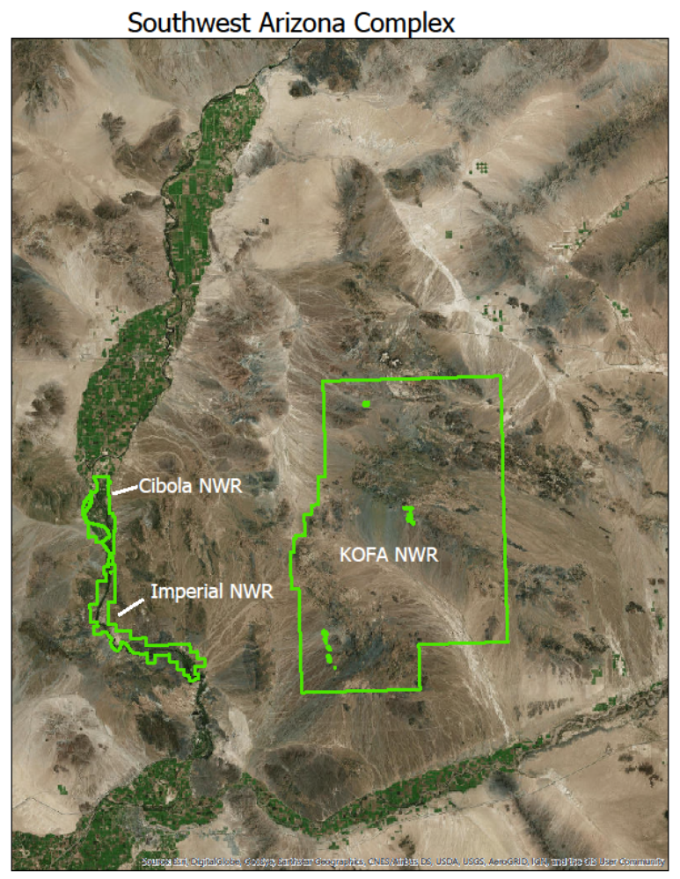

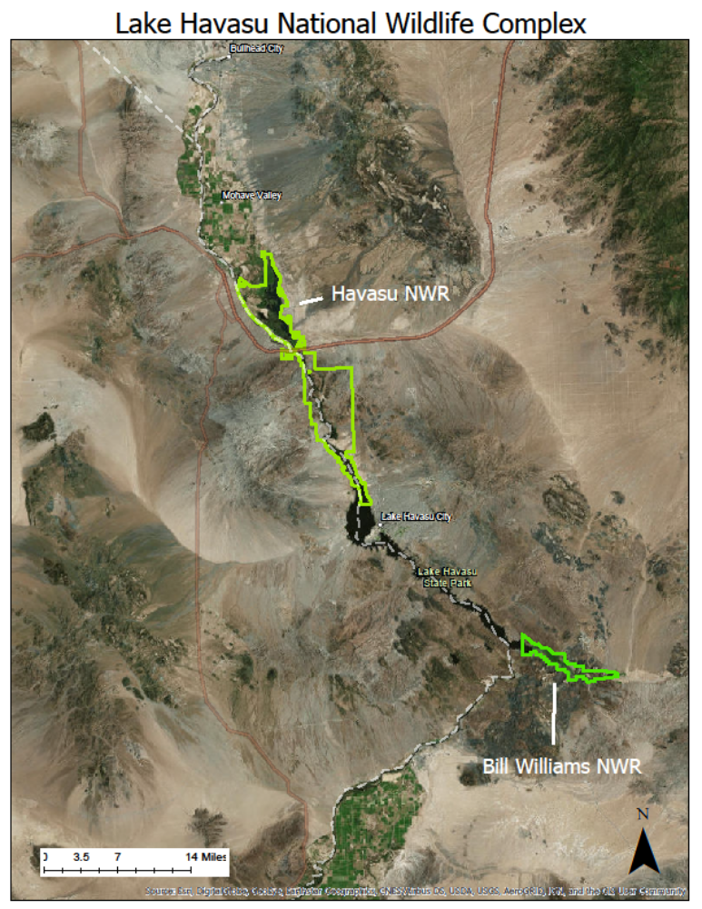

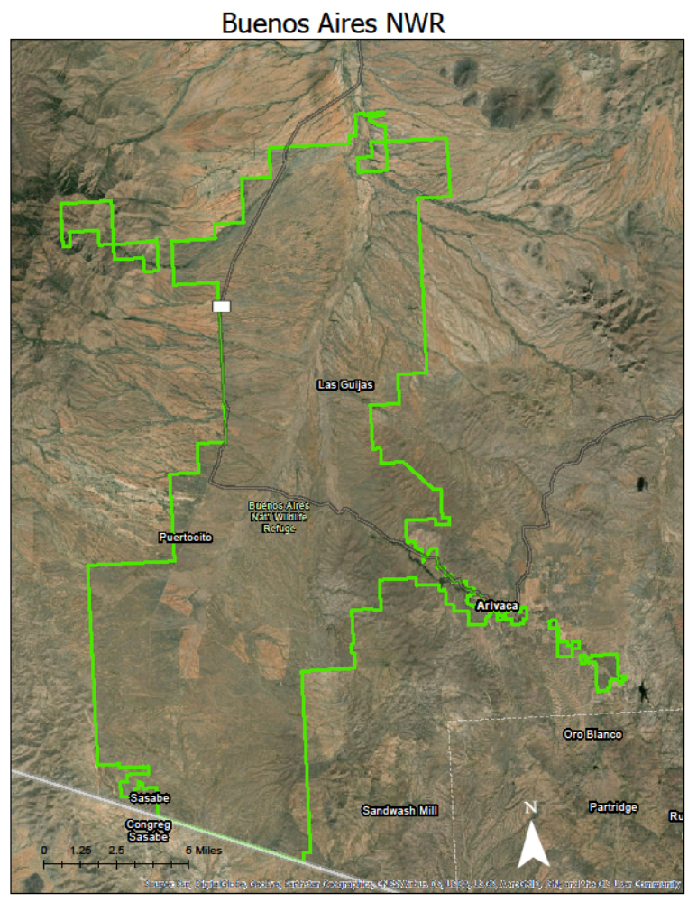

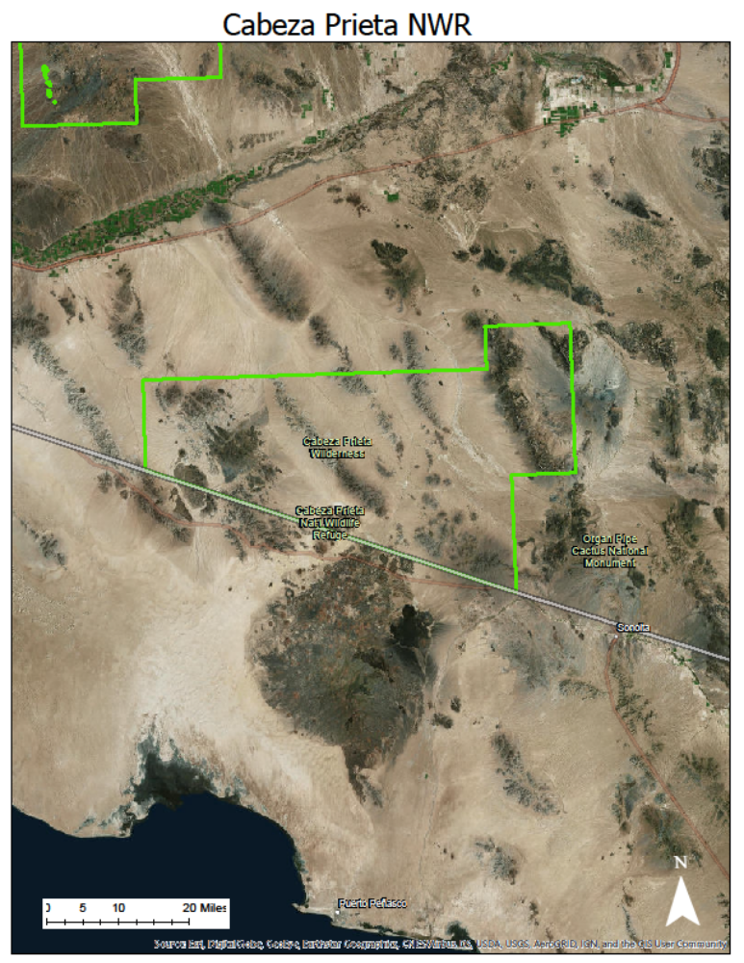

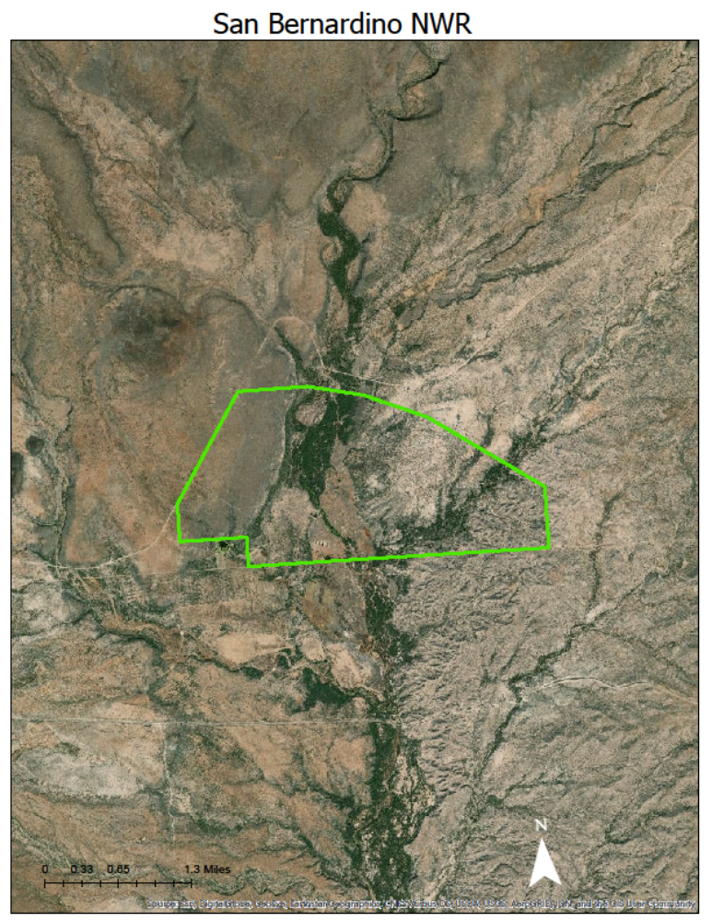

Attachment A: DOI Award Provisions
I. Conflicts of Interest
(a) Applicability.
(1) This section intends to ensure that non-Federal entities and their employees take appropriate steps to avoid conflicts of interest in their responsibilities under or with respect to Federal financial assistance agreements.
(2) In the procurement of supplies, equipment, construction, and services by recipients and by subrecipients, the conflict of interest provisions in 2 CFR 200.318 apply.
(b) Requirements.
(1) Non-Federal entities must avoid prohibited conflicts of interest, including any significant financial interests that could cause a reasonable person to question the recipient's ability to provide impartial, technically sound, and objective performance under or with respect to a Federal financial assistance agreement.
(2) In addition to any other prohibitions that may apply with respect to conflicts of interest, no key official of an actual or proposed recipient or subrecipient, who is substantially involved in the proposal or project, may have been a former Federal employee who, within the last one (1) year, participated personally and substantially in the evaluation, award, or administration of an award with respect to that recipient or subrecipient or in development of the requirement leading to the funding announcement.
(3) No actual or prospective recipient or subrecipient may solicit, obtain, or use non-public information regarding the evaluation, award, or administration of an award to that recipient or subrecipient or the development of a Federal financial assistance opportunity that may be of competitive interest to that recipient or subrecipient.
(c) Notification.
(1) Non-Federal entities, including applicants for financial assistance awards, must disclose in writing any conflict of interest to the DOI awarding agency or pass-through entity in accordance with 2 CFR 200.112, Conflicts of lnterest.
(2) Recipients must establish internal controls that include, at a minimum, procedures to identify, disclose, and mitigate or eliminate identified conflicts of interest. The recipient is responsible for notifying the Financial Assistance Officer in writing of any conflicts of interest that may arise during the life of the award, including those that have been reported by subrecipients.
(d) Restrictions on Lobbying. Non-Federal entities are strictly prohibited from using funds under this grant or cooperative agreement for lobbying activities and must provide the required certifications and disclosures pursuant to 4 3 CFR Part 18 and 31 USC 13 52.
(e) Review Procedures. The Financial Assistance Officer will examine each conflict of interest disclosure on the basis of its particular facts and the nature of the proposed grant or cooperative agreement, and will determine whether a significant potential conflict exists and, if it does, develop an appropriate means for resolving it.
(f) Enforcement. Failure to resolve conflicts of interest in a manner that satisfies the Government may be cause for termination of the award. Failure to make required disclosures may result in any of the remedies described in 2 CFR 200.338, Remedies for Noncompliance, including suspension or debarment (see also 2 CFR Part 180).
II. Data Availability
(a) Applicability. The Department of the Interior is committed to basing its decisions on the best available science and providing the American people with enough information to thoughtfully and substantively evaluate the data, methodology, and analysis used by the Department to inform its decisions.
(b) Use of Data. The regulations at 2 CFR 200.315 apply to data produced under a Federal award, including the provision that the Federal Government has the right to obtain, reproduce, publish, or otherwise use the data produced under a Federal award as well as authorize others to receive, reproduce, publish, or otherwise use such data for Federal purposes.
(c) Availability of Data. The recipient shall make the data produced under this award and any subaward(s) available to the Government for public release, consistent with applicable law, to allow meaningful third party evaluation and reproduction of the following:
(1) The scientific data relied upon;
(2) The analysis relied upon; and
(3) The methodology, including models, used to gather and analyze data.

