I. Funding Opportunity Description
Missile Defense Agency (MDA) Science, Technology, Engineering, and Mathematics (STEM)
The MDA STEM goal is to increase the awareness of K-12 and college students to Science, Technology, Engineering, and Mathematics, in order to enhance the number of U.S. scientists and engineers capable of solving future Missile Defense challenges in the Government, industry, and academia.

MDA STEM is further guided by the following objectives.
- Increase the number of high school graduates capable of declaring a college major in a science, technology, engineering, or mathematics (STEM) field.
- Inspire K-12 and college students about career paths and the activities of scientists and engineers.
- Investigate real-life, practical uses for applied math and science in K-12 grade classrooms to further degree declarations; and career and life interest in STEM.
- Present the importance of STEM career opportunities to school personnel, parents, and supporting institutions.

Boosting Engineering, Science, and Technology (BEST) Robotics, Inc.
Boosting Engineering, Science and Technology (BEST) Robotics, Inc. (www.bestinc.org) is a non-profit, volunteer-based organization whose mission is to inspire students to pursue careers in engineering, science, technology, and math through participation in a sports-like, science-and engineering-based robotics competition.

BEST's mission is to engage, inspire and excite students to pursue STEM majors and STEM careers through the vehicle of an after-school robotics program and competition. BEST values access and diversity and encourages participation of all students and schools by providing a free program supported through the fundraising and mentoring efforts of a large higher education and industry volunteer corps.

BEST Robotics Inc. point of contact: Rosemary Mendel, Executive Director, rosemary.mendel@bestinc.org, (469) 630-2525.

The purpose of this announcement is to allow Official BEST Robotics Inc. Local Competition Hubs the opportunity to obtain financial support for providing direct teacher professional development to teachers within their first three (3) years of being a team teacher for a BEST Robotics team. Teacher professional development ensures general STEM training for teachers and ensures a successful experience during their local BEST Robotics season, advancing the awareness of and engagement in STEM with K-12 teachers and students.

II. Awards
The MDA will award no more than $160,000.00 through this grant opportunity in FY17. The number of awards is not predetermined. Each hub’s individual grant award will vary, but will not exceed $5,321.40, including the 5% administrative supplement. Estimated cost per teacher attendee should not exceed $506.80 and must be compliant with the local travel and lodging per diem. A HEA will submit one proposal, for up to 10 team teachers. Individual teachers should not submit proposals; all proposals should be submitted by a HEA/BEST hub.

III. Eligibility Information
Official BEST Robotics Inc. Local Competition Hubs (only) may submit proposals. Local Competition Hubs must be approved by BEST Robotics Inc.’s National Headquarters and managed by a Higher Education Agency (HEA) - junior college or four-year college/university. BEST Robotics Regional and World Competition hubs and hubs not managed by an HEA are excluded from applying to this grant opportunity. Teachers identified by their hub for training must be full-time employees of the public school system.

Local Competition Hubs awarded an MDA STEM BEST Robotics Grant in Fiscal Years 2013, 2014, 2015, and / or 2016, may apply for funding through this grant only if both of the following statements are true about the hub’s previous grant performance:
- Projected team registration goals and hub growth proposed in the grant proposals were attained.
- Post-award reporting requirements, receivable deadlines and content, were met.

Official BEST Robotics Inc. Local Competition Hubs submitting proposals must have a Data Universal Numbering System (DUNS) number. A DUNS number is a nine-digit number established and assigned by Dun and Bradstreet, Inc. (D&B) to uniquely identify business entities. A DUNS number may be obtained from D&B by telephone (866-705-5711) or website (http://fedgov.dnb.com/webform).

Official BEST Robotics Inc. Local Competition Hubs submitting proposals and awarded grants must also have current information in the System for Award Management (SAM). If awarded a grant, SAM information must remain current until final payment is received, unless exempted from the requirement under 2 CFR 25.110. Additional information about registration procedures may be obtained by telephone (866-606-8220) or web site (https://www.sam.gov).

Official BEST Robotics Inc. Local Competition Hubs submitting proposals must have a Wide Area Work Flow (WAWF) e-Business Suite (https://wawf.eb.mil/) account for, as a minimum, Invoice, Receipt, Acceptance, and Property Transfer (iRAPT) usage. WAWF accounts must remain current until all grant agreement payments and reporting are complete. College/University signing authority for the grant agreement, if awarded, must have working knowledge and access to WAWF. Additional information about WAWF accounts and instructions may be obtained by telephone (866-618-5988) or web site (www.dla.mil). When viewing www.dla.mil, select “Business Operations” on the top navigation bar, and “Wide Area Workflow” from the list of options.

IV. Application and Submission Information

**Please refer to VIII. Form Assistance for help in completing the grants.gov required forms. **

Application forms and instructions are available at Grants.gov. To access these materials, go to http://www.grants.gov, select “Apply for Grants,” and then follow the instructions.

This grant opportunity may fund up to ten (10) BEST Robotics team teachers and the materials needed for their training. While other teachers may participate in the training offered by the local hub, this grant will not reimburse or financially support the costs of training any additional teachers, new or veteran. Total requested funds should reflect the number of new BEST Robotics team teachers to be trained, up to 10; materials required to train the identified teachers, up to 10; and, if applicable, identified teachers’ travel and lodging costs. Meals and/or refreshments offered during the professional development session(s) training will not be provided or reimbursed by or through this grant. An administrative supplement for the processing the grant award and providing reporting requirements will be included at a flat, absolute rate of 5% of cost. The administrative supplement should not be included in the total amount of requested funds in the grant proposal.

Proposals may only request support for developing and providing teacher professional development, provided by and at the local hub competition site, within a month before or after the day of the kick-off for the 2017 BEST Robotics competition season. Teacher professional development must include all of the following:
- Training for the BEST Robotics teams’ teachers within the hub’s assigned BEST Robotics region;
- Awarding at least one continuing education credit (CEU) for participating teachers;
- Instruction in at least three STEM areas, such as programming languages, computer-aided design (CAD), and robotics;
- Learning materials for each team teacher to retain, for classroom learning; and
- Sessions totaling at least four hours but no more than eight hours.

If the training will be held the day before kick-off, funding may include travel (mileage), lodging, and materials, within Fiscal Year 2017 per diem rates. If teacher professional development for team teachers will be held kick-off day, funding may include travel (mileage) and training materials. Teachers and their schools must be identified in the proposal.
Funding will include exact reimbursement for costs:
- Up to and not exceeding the amounts below;
- Per teacher; and
- For no more than two days, including travel time.

Item | Total Maximum  Cost, if professional development is the same day as Kick-off | Total Maximum Cost for Two Days, if training occurs the day before kick-off | Additional Restrictions and Limits
Materials | $200 | $200 | Per new lead teacher participant
Lodging | $ 0.00 | Check per diem rates | Lodging should be for no more than one night.
Travel (mileage) | $ 64.80 (at $0.54 per mile for 120 miles) | $ 64.80 (at $0.54 per mile for 120 miles) | - Privately-owned vehicle  - Mileage only  - First and last day (combined);  - To training site from point of origin (school site/home), if lodging is required.

**Please refer to VIII. Form Assistance for help in completing the grants.gov required forms. **

In addition to information requested in the grants.gov standard form instructions, your proposal must include the following as attachments.
- Attachment Name: Hub Information and Funding
A document listing the counties in the hub’s service region, the number of middle schools and high schools participating, and the projected number of teams for 2017. Include the hub’s requested amount of funding.
- Attachment Name: Training Information
A document with all the training information including:
  - Location
  - Date
  - Number of learning modules
  - Time allotted for each module
  - Brief description of learning objectives/modules
  - Brief description of learners’ assessments
  - Itemized list of training materials
  - Cost per unit (teacher)
  - Vendor
- Attachment Name: Support Letter 1
A signed support letter on official letterhead (internal) from physical site’s senior leadership, such as the University President or Vice-President.
- Attachment Name: Post-Award Agreement
A signed letter of acknowledgement and agreement from the Hub Director on official college/university letterhead to provide MDA STEM with required post-award reporting. The letter should include MDA BEST Robotics Teacher Professional Development Survey, demographic information, information briefs, videos, and/or photographs.
- Attachment Name: SAM Certification
A certification that SAM information is current.
- Attachment Name: WAWF Certification
A certification that a WAWF account is current.

Grant award recipients must be able to independently accomplish all required hub tasks, without any involvement or additional funding from MDA.

Items 1 – 6 should total no more than six (6) attachments. Items 1 – 6 will be submitted on grants.gov on the Attachments Form. Please use the appropriate attachment names. The SF424 (R&R), Key Contact(s), and Project/Performance Site Location(s) will remain and be submitted separate from items 1 – 6.

If the HEA is involved in lobbying, you must complete and submit a SF-LLL (Disclosure of Lobbying Activities).

Applications are due no later than June 30, 2017, at 5:00 p.m. CDT, via Grants.gov.

**Please refer to VIII. Form Assistance for help in completing the grants.gov required forms. **
V. Grant Application Review Information
MDA will evaluate proposals based upon the following areas – efficiency and commitment.
- Efficiency
  - Section IV. Application and Submission Information
    - Is it evident by the amount, type, and description of the training objectives and modules provided that the hub will be effectively using the funds to train the proposed teachers?
    - Is it evident by the proposed training and material information that the hub will provide relevant and effective training to the proposed teachers?
  - Proposal Data: Section IV, Item 2
  - Proposal Evaluative Weight: Seventy percent (70%)
- Commitment
  - Section IV. Application and Submission Information
    - Is it evident by the information provided that the proposed teachers and schools are committed to participating in the BEST Robotics competition?
  - Proposal Data: Section IV, Items 3 and 4
  - Proposal Evaluative Weight: Thirty percent (30%)

A single grant award for any hub will not exceed $5068.00, plus the 5% administrative processing fee. Evaluations of proposals may result in funding levels lower than the proposed amount(s).

VI. Award Administration Information
- Award Notices
Successful proposers will receive a separate notice (award/acceptance letter or e-mail) stating that an application has been selected. The notification letter or e-mail must not be regarded as an authorization to commit or expend funds. The Government is not obligated to provide any funding for this award until a Government Grants Officer and the appropriate official from the selected entity sign the grant document.

- Reporting
On or before November 10, 2017 awarded hubs must collect from each teacher for which the grant was awarded, a completed Missile Defense Agency BEST Robotics Teacher Professional Development Survey. Surveys should be submitted collectively to MDA STEM.

Post-award should be submitted electronically to MDA STEM Program Director at stemoutreach@mda.mil, with the e-mail subject as “MDA STEM Outreach BEST Robotics Grant Hub HEA LHTPD 2017 – “ followed by college/university name and grant number.

- Invoicing
The MDA BEST Robotics grant is limited to teacher professional development offered by local BEST Robotics hubs, managed by HEAs only. HEAs must have separate receipts, expense documents, and/or invoices for items reimbursable through the grant from those that will not. Also invoices must be separated by category - travel, lodging, and meals. Receipts are required for every/all invoiced items. Reimbursements will not be paid for any item without a receipt except for mileage and food. Mileage reimbursements require map direction documents specifying the distance from the lodging to the workshop site and/or the place of origin (school site/home) to the lodging site, as applicable.
In addition to the above, grant recipient hubs shall submit a request for payment in WAWF for an amount which:
- Is not exceeding the amount identified in the grant agreement;
- Is documented by the invoice(s);
- Occurs after MDA STEM Program Director has received a copy of all receipts and invoices;
- Occurs after deliverables, outlined in Section VI. Post-Award Reporting, are received by MDA STEM Program Director and Grants Officer Technical Representative, MDA STEM;
- Occurs after hub receives an approval e-mail for deliverables from MDA STEM Program Director and Grants Officer Technical Representative, STEM; and
- Occurs between November 22, 2017 and December 21, 2017.

Requests for payments shall be submitted directly in WAWF, as a cost voucher. A completed SF 270 form with the college/university invoice(s) for travel and lodging (if applicable) must be submitted as attachments to the cost voucher.

The Office of Naval Research (ONR) will serve as the administrative office (Grant Agreement, Block 6). ONR will approve the voucher and supporting documents. Visit the ONR web site (http://www.onr.navy.mil/) for more information on electronic payments for grants.
After ONR approves the voucher and supporting documents, ONR will forward the information to the Defense Finance and Accounting Service (DFAS) for payment. DFAS is the payment office (Grant Agreement, Block 12).

Both ONR and DFAS are completely separate entities from MDA. Awarded hubs must:
- Include MDA in all communications with ONR regarding payments;
- Include MDA in all communications with DFAS, if applicable;
- Forward to MDA e-mail confirmations regarding invoice submissions (whether rejected or approved) from ONR; and
- Provide to MDA a copy of all invoice documents and supporting receipts.

- Agency Contacts
Direct your questions about the grant application process to:
- Willis Brice, Grants and Contracting Officer, (256) 450-4790, willis.brice@mda.mil; or
- Mitch Shelton, Grants Specialist, (256) 450-4680, mitchell.shelton@mda.mil.

Direct your questions about the grant implementation or post-award documentation to:
- Patricia Gore, PhD, Program Lead, STEM, (256) 450-4000, stemoutreach@mda.mil; or
- Amber Horton, STEM, (256) 450-4000, stemoutreach@mda.mil.

- Form Assistance
All forms below are for sample purposes and are not for submission.
- SF424 (R&R) – This is a required grants.gov form; no special directions are required.
- Key Contacts Form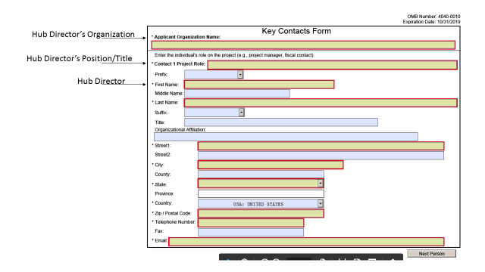

- Project/Performance Site Location(s)
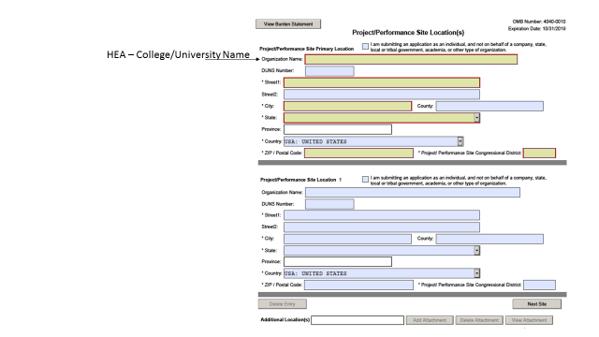
- Attachments Form
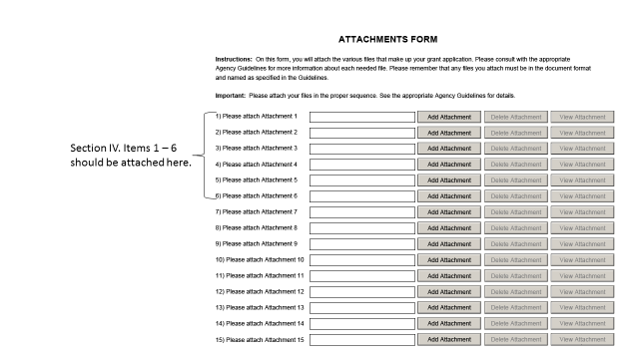
- SF – LLL – This is an optional form, only to be filled out if the HEA applying for this grant is involved in lobbying.

