I. Funding Opportunity Description
Missile Defense Agency (MDA) Science, Technology, Engineering, and Mathematics (STEM)
The MDA STEM goal is to increase the awareness of K-12 and college students to Science, Technology, Engineering, and Mathematics, in order to enhance the number of U.S. scientists and engineers capable of solving future missile defense challenges in the Government, industry, and academia.

MDA STEM is further guided by the following objectives.
- Increase the number of high school graduates capable of declaring a college major in a science, technology, engineering, or mathematics (STEM) field.
- Inspire K-12 and college students about career paths and the activities of scientists and engineers.
- Investigate real-life, practical uses for applied math and science in K-12 grade classrooms to further degree declarations; and career and life interest in STEM.
- Present the importance of STEM career opportunities to school personnel, parents, and supporting institutions.

Boosting Engineering, Science, and Technology (BEST) Robotics, Inc.
Boosting Engineering, Science and Technology (BEST) Robotics, Inc. (www.bestinc.org) is a non-profit, volunteer-based organization whose mission is to inspire students to pursue careers in engineering, science, technology, and math through participation in a sports-like, science-and engineering-based robotics competition.

BEST's mission is to engage, inspire and excite students to pursue STEM majors and STEM careers through the vehicle of an after-school robotics program and competition. BEST values access and diversity and encourages participation of all students and schools by providing a free program supported through the fundraising and mentoring efforts of a large higher education and industry volunteer corps.

BEST Robotics Inc. point of contact: Rosemary Mendel, Executive Director, rosemary.mendel@bestinc.org, (469) 630-2525.

The purpose of this announcement is to offer support for local school systems, hereafter referred to as Local Education Agencies (LEAs), and their experienced BEST Robotics team teachers for the opportunity to attend BEST national teacher professional development training. Teacher professional development ensures general STEM training for teachers and a successful experience during their local BEST Robotics season, advancing the awareness of and engagement in STEM with K-12 teachers and students.

II. Awards
The MDA will award no more than $75,000.00 through this grant opportunity in FY17 to a LEA. The number of awards is not predetermined. A LEA will submit one proposal, for up to 5 team teachers. Individual teachers should not submit proposals; all proposals should be submitted by a LEA. Each LEA’s grant award will vary, but will not exceed $14,190.75, including the 5% administrative supplement. Estimates for individual teacher amounts are limited to $2,703 and must be compliant with the local travel, lodging, and meal per diem.

III. Eligibility Information
This MDA grant offers the opportunity for financial support for public local school systems to provide professional development for up to five (5) veteran BEST Robotics team lead teachers, at the national BEST Robotics Inc. summer training session. Teachers identified by their district for training must: (1) be full-time employees of the public LEA submitting the application and (2) have at least one year experience with BEST Robotics, as the team teacher for a competing team.

LEAs submitting proposals must have a Data Universal Numbering System (DUNS) number. A DUNS number is a nine-digit number established and assigned by Dun and Bradstreet, Inc. (D&B) to uniquely identify business entities. A DUNS number may be obtained from D&B by telephone (866-705-5711) or website (http://fedgov.dnb.com/webform).

LEAs submitting proposals and awarded grants must also have current information in the System for Award Management (SAM). If awarded a grant, SAM information must remain current until final payment is received, unless exempted from the requirement under 2 CFR 25.110. Additional information about registration procedures may be obtained by telephone (866-606-8220) or web site (https://www.sam.gov).

LEAs submitting proposals must have a Wide Area Work Flow (WAWF) e-Business Suite (https://wawf.eb.mil/) account for, as a minimum, Invoice, Receipt, Acceptance, and Property Transfer (iRAPT) usage. WAWF accounts must remain current until all grant agreement payments and reporting are complete. School system/district signing authority for the grant agreement, if awarded, must have working knowledge and access to WAWF. Additional information about WAWF accounts and instructions may be obtained by telephone (866-618-5988) or web site (www.dla.mil). When viewing www.dla.mil, select “Business Operations” on the top navigation bar and then select “Wide Area Workflow” from the list of options.

IV. Application and Submission Information

**Please refer to VIII. Form Assistance for help in completing the grants.gov required forms. **

Application forms and instructions are available at Grants.gov. To access these materials, go to http://www.grants.gov, select “Apply for Grants”, and then follow the instructions.

A LEA will submit one proposal, for up to five (5) teachers. Proposals must identify teachers, their schools, and first year as a team teacher for a BEST Robotics team. No more than one proposal may be submitted by a LEA. No more than five (5) teachers may be identified in a proposal. No more than five (5) schools and their related BEST Robotics teams may be identified in the proposal. An administrative supplement for the processing the grant award and providing reporting requirements will be included at a flat, absolute rate of 5% of cost. The administrative supplement should not be included in the total amount of requested funds in the grant proposal.

Proposal submissions for this announcement may only request support for teacher professional development offered and provided by BEST Inc. National Headquarters. The national BEST Robotics Inc. summer training will provide teacher professional development in STEM areas, including computer programming, with up to five (5) continuing education credits.
Funding will include travel, lodging, and meals within General Services Administration’s (GSA) Fiscal Year 2017 per diem rates. Funding will include exact reimbursement for costs: (1) up to and not exceeding the amounts below; (2) per teacher; and (3) for no more than five (5) days, including travel time.

Funding Item | Maximum Cost for up to 5 Days | Additional Restrictions and Limits
Professional Development Workshop Fee | $500 | Flat, one-time fee. No daily amount
Lodging | TBD | Not to exceed local per diem rate for up to 4 nights
Meals | TBD | First and last day (combined), not to exceed 75% of the local per diem rate
Meals | TBD | Days 2 – 4 only, not to exceed the local per diem rate
Travel (Airplane) | $600.00 | Special seating and upgrades will not be reimbursed
Travel (Mileage) | $226.80 (at $0.54 per mile for 420 miles) | Privately-owned vehicle  - Mileage only  - To training site, from lodging site only; leisure time is not included  - Carpooling is required for all vehicle travel, for systems/districts with more than one teacher attending training.  - To and from the airport in NOT included
Travel (Car) | $365.00 (at $73.00 per day) | Rental  - Economy Class only  - Includes gas allowance per day  - Includes rental car fees per day  - Vehicle rental must comply with ceilings set by GSA for the selected rental car company.

LEAs are expected to pay all costs for each teacher for their lodging, travel, and workshop training fees, in lieu of individual teachers’ payment responsibilities. These costs include those which may or may not be supplemented or included in the grant award. Grant-awarded LEAs will be reimbursed by the grant for the identified teachers (only).

**Please refer to VIII. Form Assistance for help in completing the grants.gov required forms. **

In addition to information requested in the grants.gov standard form instructions, your proposal must include the following as attachments.
- Attachment Name: Teacher and Funding Information
A document with the funding and team teacher/trainee information (up to 5) including:
  - Team Teacher/Trainee’s name
  - School
  - First year as BEST team teacher
  - Full-time status
  - Lodging
  - Food
  - Travel
  - Total amount of funding for all Teachers
- Attachment Name: Support Letter 1
A signed support letter on official letterhead (internal) from Local Education Agency’s (LEA’s) superintendent.
- Attachment Name: Support Letter 2
A signed support letter on official letterhead (external) from local BEST Robotics hub verifying all teachers identified in the grant have participated as team teacher during the previous year.
- Attachment Name: Post-Award Agreement
A signed letter of acknowledgement and agreement from the Hub Director on official college/university letterhead to provide MDA STEM with required post-award reporting. The letter should include MDA BEST Robotics Teacher Professional Development Survey, demographic information, information briefs, videos, and/or photographs.
- Attachment Name: SAM Certification
A certification that SAM information is current.
- Attachment Name: WAWF Certification
A certification that a WAWF account is current.

Grant award recipients must be able to independently accomplish all required hub tasks, without any involvement or additional funding from MDA.

Items 1 – 6 should total no more than six (6) attachments. Items 1 – 6 will be submitted on grants.gov on the Attachments Form. Please use the appropriate attachment names. The SF424 (R&R), Key Contact(s), and Project/Performance Site Location(s) will remain and be submitted separate from items 1 – 6.

If the HEA is involved in lobbying, you must complete and submit a SF-LLL (Disclosure of Lobbying Activities).

Applications are due no later than June 30, 2017, at 5:00 p.m. CDT, via Grants.gov.

**Please refer to VIII. Form Assistance for help in completing the grants.gov required forms. **

V. Grant Application Review Information
MDA will evaluate proposals based upon the following areas – efficiency, involvement, and support.
- Efficiency
  - Section IV. Application and Submission Information
    - Is it evident by the amount, type, and description of expenses that the LEA will effectively use the proposed funds?
  - Proposal Data: Section IV, Item 1
  - Proposal Evaluative Weight: 33.3%
- Involvement
  - Section IV. Application and Submission Information
    - Is it evident by the information provided that the proposed teacher(s) have prior involvement in BEST Robotics?
  - Proposal Data: Section IV, Item 3
  - Proposal Evaluative Weight: 33.3%
- Support
  - Section IV. Application and Submission Information
    - Is it evident by the information provided that the proposed teacher(s) and schools have support from the LEA?
  - Proposal Data: Section IV, Item 2
  - Proposal Evaluative Weight: 33.3%

Evaluation of proposals may result in funding levels lower than the proposed amount(s).

      - Award Administration Information
- Award Notices
Successful proposers will receive a separate notice (award/acceptance letter or e-mail) stating that an application has been selected. The notification letter or e-mail must not be regarded as an authorization to commit or expend funds. The Government is not obligated to providing any funding for this award until a Government Grants Officer and the appropriate official from the selected entity sign the grant document.

- Reporting
On or before November 10, 2017 grant award system/district must (collectively) submit the MDA BEST Robotics Teacher Professional Development Survey for each lead teacher participant supported by the grant.

Post-award reporting (completed surveys) should be submitted electronically to MDA STEM Program Director, at stemoutreach@mda.mil, with the e-mail subject as “MDA STEM Outreach BEST Robotics Grant LEA NTPD 2017 – “ followed by LEA name and grant number.

On or before November 10, 2017, grant-awarded LEAs must submit the documentation above to complete post-award grant reporting requirements.

- Invoicing
The MDA BEST Robotics grant is limited to teacher professional development offered by BEST Robotics Inc. National Headquarters. LEAs must have separate receipts, expense documents, and/or invoices for items reimbursable through the grant from those that will not. Receipts for and from food purchases are not needed. Also invoices must be separated by category - travel, lodging, and meals. Receipts are required for every/all invoiced items. Reimbursements will not be paid for any item without a receipt except for mileage and food. Mileage reimbursements require map direction documents specifying the distance from the lodging to the workshop site and/or the place of origin (school site/home) to the lodging site, as applicable.

In addition to the above, grant recipient LEAs shall submit a request for payment in WAWF for an amount which:
- Is not exceeding the amount identified in the grant agreement;
- Is documented by the invoice(s);
- Occurs after MDA STEM Program Director receives a copy of all receipts and invoices;
- Occurs after deliverables, outlined in Section VI. Post-Award Reporting, are received by MDA STEM Program Director and Grants Officer Technical Representative; and
- Occurs after hub receives an approval e-mail for deliverables from MDA STEM Program Director and Grants Officer Technical Representative.
- Occurs between November 22, 2017 and December 21, 2017

Requests for payments shall be submitted directly in WAWF, as a cost voucher. A completed SF 270 form with the system/district invoice(s) for travel, lodging, and meals must be submitted as attachments to the cost voucher.

The Office of Naval Research (ONR) will serve as the administrative office (Grant Agreement, Block 6). ONR will approve the voucher and supporting documents. Visit the ONR web site (http://www.onr.navy.mil/) for more information on electronic payments for grants.

After the ONR approves the voucher and supporting documents, the ONR will forward the information to the Defense Finance and Accounting Service (DFAS) for payment. DFAS is the payment office (Grant Agreement, Block 12).

Both ONR and DFAS are completely separate entities from the MDA. Awarded hubs must:
- Include the MDA in all e-mail communications with ONR regarding payments;
- Include the MDA in all communications with DFAS, if applicable; and
- Forward to the MDA e-mail confirmations regarding invoice submissions (whether rejected or approved) from ONR.
- Provide to MDA a copy of all invoice documents and supporting receipts.

- Agency Contacts
Questions about the grant application process should be directed to:
- Willis Brice, Grants and Contracting Officer, (256) 450-4790, willis.brice@mda.mil; or
- Mitch Shelton, Grants Specialist, (256) 450-4680, mitchell.shelton@mda.mil.

Questions about the grant implementation or post-award documentation should be directed to:
- Patricia Gore, MDA STEM Program Director, (256) 450-4000, stemoutreach@mda.mil; or
- Amber Horton, STEM, (256) 450-4000, stemoutreach@mda.mil.
- Form Assistance
All forms below are for sample purposes and are not for submission.
- SF424 (R&R) – This is a required grants.gov form; no special directions are required.
- Key Contacts Form – Please fill in the form with Hub Director information. Once that has been completed, click “Next Person” button at the bottom of the form. Then fill in the form with the LEA point of contact information.
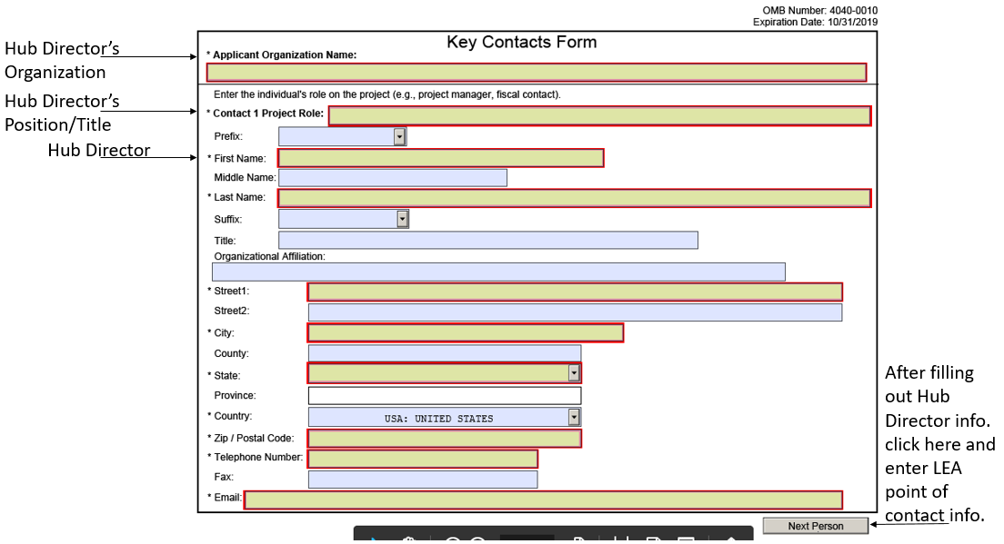

- Project/Performance Site Location(s)
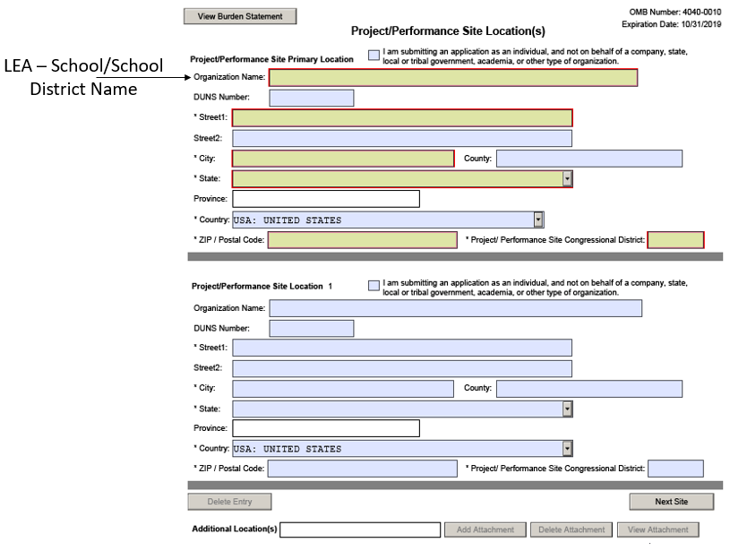

- Attachments Form
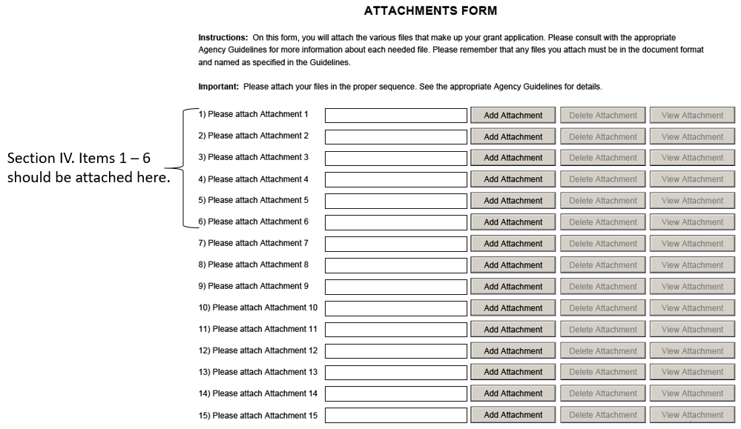

- SF – LLL – This is an optional form, only to be filled out if the HEA applying for this grant is involved in lobbying.

