# **Performance Monitoring Plan (PMP)** ***How-To Guide: Performance Indicators***

*This How-To Guide is designed to help CT/P grant applicants and grantees work with CT-P program managers (PMs) to develop PMPs.* [*18 FAM 301.4-3*](https://fam.state.gov/FAM/18FAM/18FAM030104.html) *requires every program to create a PMP to outline how program implementation will be measured and monitored.* ***This guidance focuses on performance indicators, a key component of all PMPs.***

# **Performance Monitoring Plan (PMP) Components**

| [PMP Component](https://fam.state.gov/FAM/18FAM/18FAM030104.html) | Explanation | Examples/Context |
| --- | --- | --- |
| Activity | An action or process undertaken over a specific period of time by an organization. Activities convert inputs (resources) to products or services in order to achieve outputs and outcomes.  Note: Only include those activities in the PMP that directly/demonstrably lead to an output or outcome (i.e., do *not* include inputs or interim steps). | * Trainings * Meetings * Provision of equipment |
| Performance Indicator Type:   * Output-Level Indicators * Outcome-Level Indicators | Select whether the indicator is an output- or outcome-level indicator:   * **Output-Level:** Measure what was *delivered*immediately and directly from a program’s activities. Typically measured as services or products *(PMP must include at least two per outcome).* * **Outcome-Level:** Measure what was *achieved*based on a program’s outputs. Typically measured as a degree of change in knowledge, behavior, performance; changed conditions. Track higher-level results *(PMP must include at least one per outcome).* | * **Output-Level:** Number of people trained; number of trainings conducted, mentoring sessions held; equipment provided, assembled, etc.      * **Outcome-Level:** % change in knowledge gained/applied; # of SOPs or policies developed/improved, investigations conducted, cases processed, KSTs identified. |
| Performance Indicator | Performance indicators are used to monitor progress and measure actual results against expected results. They can be measured quantitatively (e.g., numeric value, percentages, etc.).  Remember that indicators should be “SMART”: Specific, Measurable, Achievable, Relevant, Time-Bound (see Annex I below).  Note: Grantees must use at least three relevant CT Indicators (see Annex II below). They can also develop/use **customized** indicators as needed. Grantees/PMs should select a blend of the aforementioned indicator types that they believe most effectively measure the effects of their programs. | * *Illustrative**Custom Indicator (outcome-level):* % change in knowledge of training participants in how to work with law enforcement on terrorism-related cases. * *Illustrative Custom Indicator (outcome-level):* % of terrorism-related cases brought to court in country X by CT-trained prosecutors in accordance with international standards. * *Illustrative Custom Indicator (outcome-level):* % of trained personnel using standard operating procedures to conduct proper fraudulent visa detection. * *Illustrative CT Indicator (output-level):*  *CT 0.1:* Number of participants (disaggregated by type of activity, subject matter, etc.). * *Illustrative CT Indicator (output-level):*  CT 1.3.5: Number of pieces of equipment maintained in good standing |
| Indicator Definition | Defines how the indicator will be reliably measured throughout the life of the program. | * **How:** Explain how the indicator will measure the expected change. * **Why:** Explain why it’s needed (i.e., how it will be used to monitor program progress). |
| Disaggregation | Disaggregation involves sub-dividing of data to create additional units of analysis, such as geography or sex, for a specific indicator. For example, if the indicator is "number of individuals trained," then this is disaggregated by female and male. | * Location * Organization * Age * Sex |
| Data Source | Specifies how data to measure your performance indicators will be collected.  Data can be collected directly by implementing partners, PMs, or from credible secondary sources; regardless, PMs should verify that data can easily, reliably and credibly be collected from each source. | **Primary Data (collected by program):**   * Interviews and focus groups * Pre- and post-tests * Surveys * Site visits and direct observations * Meeting minutes and attendance sheets   **Secondary Data (from credible outside sources):**   * Government or police records * UN or NGO reports |
| Reporting Frequency | The timing for reporting results and setting targets; ideally, indicators should be updated no less than quarterly to coincide with Quarterly Report deadlines.  However, not all data collection methods or indicators may allow for this. If you are unable to collect data quarterly, make note of it in the PMP. | * Monthly, quarterly, annually, every other year, etc. * On specific dates (MM/YYYY) * On the last day of each training * Upon delivery of equipment |
| Responsible POC | The person(s) who will ensure data is collected and delivered complete and on time. | * *Field-based:* Course instructor, Mentor, Resident Legal Advisor * *DC/Non-Field:* Implementing Partner PM * CT PM is also responsible. |
| Unit of Measure | What is the indicator measuring? | * Number * Percentage * Date |
| Initial Baseline | Data that are collected before or at the start of a program and provide a basis for planning and/or assessing subsequent progress and impact. | * For a new program, baselines are usually *"zero”* unless they are a direct continuation of the same activities from a previous iteration of the program. * Baselines for continuing programs (e.g., through cost amendments, subsequent phases of a program) would include previous program figures (e.g., # of individuals previously trained or supported). * If a program conducts a baseline using a needs assessment, or a gap analysis, then the baselines, indicators and targets would be updated with those figures once the study or assessment is completed. |
| Final Target | Targets are the value of what we expect to achieve for each indicator for each quarter and the entire year. They should be ambitious but achievable. Targets should be disaggregated for specific indicators. For those indicators with disaggregations, include disaggregated targets as well. | Factors influencing development of targets can include:   * Baseline data * Program length and funding * Number of PMs and implementing partners * Historical trends and stakeholder expectations * Research findings |

# **Performance Monitoring Plan: Definitions Table**

* Include at least one outcome-level indicator and two output-level indicators for each program outcome.[1]
* Robust PMPs should contain both qualitative & quantitative performance indicators that capture outputs and, more importantly, outcomes.
* All ‘people’-related data must be disaggregated by demographic categories relevant to your program – e.g., organization, location, sex (see examples in the “Sample Program/Template below).
* Note: If an award is made, grantees will have another opportunity to revise and change the final PMP.

|  |  |  |  |  |  |  |  |  |  |
| --- | --- | --- | --- | --- | --- | --- | --- | --- | --- |
| **Activities** | **Performance Indicator Type** | **Performance Indicator** | **Indicator Definition, Disaggregation** | **Data Source** | **Data Collection** | | **Unit of Measure** | **Initial Baseline** | **Final Target** |
| **Reporting Frequency** | **Responsible POC(s)** |
| *Outcome 1: List each CT program outcome (from the NOFO) here.* | | | | | | | | | |
| List activities.  (Note: Only include activities in the PMP that directly & demonstrably lead to an output or outcome - i.e., do not include inputs or interim steps). | State Indicator Type (output- or outcome-level) | Add performance indicator.  Indicators are used to monitor progress and measure actual results against expected results. Implementing partners should include CT indicators (see Annex II below) wherever applicable. | Defines how the indicator will be reliably measured throughout the life of the program. Ensure you explain: **1) How** the indicator will measure the expected change; and **2)** **Why** indicator is needed (i.e., how it will be used to monitor program progress).  **Disaggregation:** Sub-dividing of data to enable additional levels of analysis for comparative purposes. (e.g., location, organizational unit, sex) as needed | **Source**: Where will the data come from?  What tool(s) will be used to collect it? | Timing, frequency or schedule for reporting. | Who is responsible at the partner organization for data collection, analysis, and reporting? | What is the indicator measuring – e.g., number, percentage, date. | Data that are collected before or at the start of a program and provide a basis for planning and/or assessing subsequent progress and impact. | Define targets for each indicator to report against actual progress. |

# **Performance Monitoring Plan: Sample CT Program/Template**

The following is an illustrative example of a CT program’s PMP intended to provide additional guidance to applicants in preparing their proposals’ PMPs. Applicants should therefore view this as a reference tool rather than as a substitute for developing their own PMP indicators/components, which should demonstrate their ability to effectively measure the results from their proposed program activities while accounting for the program’s operating environment.

| **Activity** | **Performance Indicator Type** | **Performance Indicator** | **Indicator Definition, Disaggregation** | **Data Source** | **Data Collection** | | **Unit of Measure** | **Initial Baseline (POP start)** | **Final Target**  **(POP end)** |
| --- | --- | --- | --- | --- | --- | --- | --- | --- | --- |
| **Reporting Frequency** | **Responsible POC** |
| ***Outcome 1[2]:*** *Country X’s prosecutors improve their capacity to handle terrorism-related cases.* | | | | | | | | | |
| **1.1:** “Support through Trial Advocacy” Training provided to Country X’s prosecutors | Output-Level | **Indicator 1.1.1: #** of prosecutors who complete “Support through Trial Advocacy” Trainings. | **How:** Calculate # who completed entire training. **Why:** Demonstrates # of prosecutors who have potential to improve their capacity to handle terrorism-related cases. **Disaggregation:** Female/Male | Attendance records | Quarterly | “X” Partner | Number | 0 | 40 |
| **Indicator 1.1.1a:** Disaggregation (female) | -- | Attendance records | Quarterly | “X” Partner | Number | 0 | 20 |
| **Indicator 1.1.1b:** Disaggregation (male) | -- | Attendance records | Quarterly | “X” Partner | Number | 0 | 20 |
| Outcome-Level | **Indicator 1.1.2:** % change in knowledge of training participants in how to work with law enforcement on terrorism-related cases. | **How: \***Numerator: # of members demonstrating improved knowledge (post-test score – pre-test score) on working with law enforcement on CT cases; **Denominator: Total # of members who completed trainings. **Why:** Demonstrates extent of members’ improved knowledge from training in how to work with law enforcement. **Disaggregation:** Female/Male | Pre- and Post-tests | Quarterly | “X” Partner | Percentage | 0 | 80%  (32*/40**) |
| **Indicator 1.1.2a:** Disaggregation (female) | -- | Pre- and Post-tests | Quarterly | “X” Partner | Percentage | 0 | 80%  (16*/40**) |
| **Indicator 1.1.2b:** Disaggregation (male) | -- | Pre- and Post-tests | Quarterly | “X” Partner | Percentage | 0 | 80%  (16*/40**) |
| Outcome-Level | **Indicator 1.1.3:** # of terrorism-related cases brought to court in Country X by CT-trained prosecutors in accordance with international standards. | **How:** Calculate # of terrorism-related cases brought to court in Country X by CT-trained prosecutors in accordance with international standards. **Why:** Demonstrates link between support to prosecutors & key step toward improved prosecution of terrorism-related cases. **Disaggregation:** N/A | Gov’t records | Quarterly | “X” Partner | Number | 0 | 20 |
| ***Outcome 2:*** | | | | | | | | | |
|  |  | **Indicator 2.1:** |  |  |  |  |  |  |  |
|  |  | **Indicator 2.2:** |  |  |  |  |  |  |  |
|  |  | **Indicator 2.3:** |  |  |  |  |  |  |  |
| ***Outcome 3:*** | | | | | | | | | |
|  |  | **Indicator 3.1:** |  |  |  |  |  |  |  |
|  |  | **Indicator 3.2:** |  |  |  |  |  |  |  |
|  |  | **Indicator 3.3:** |  |  |  |  |  |  |  |

**ANNEX I: Explaining “SMART” Indicators**

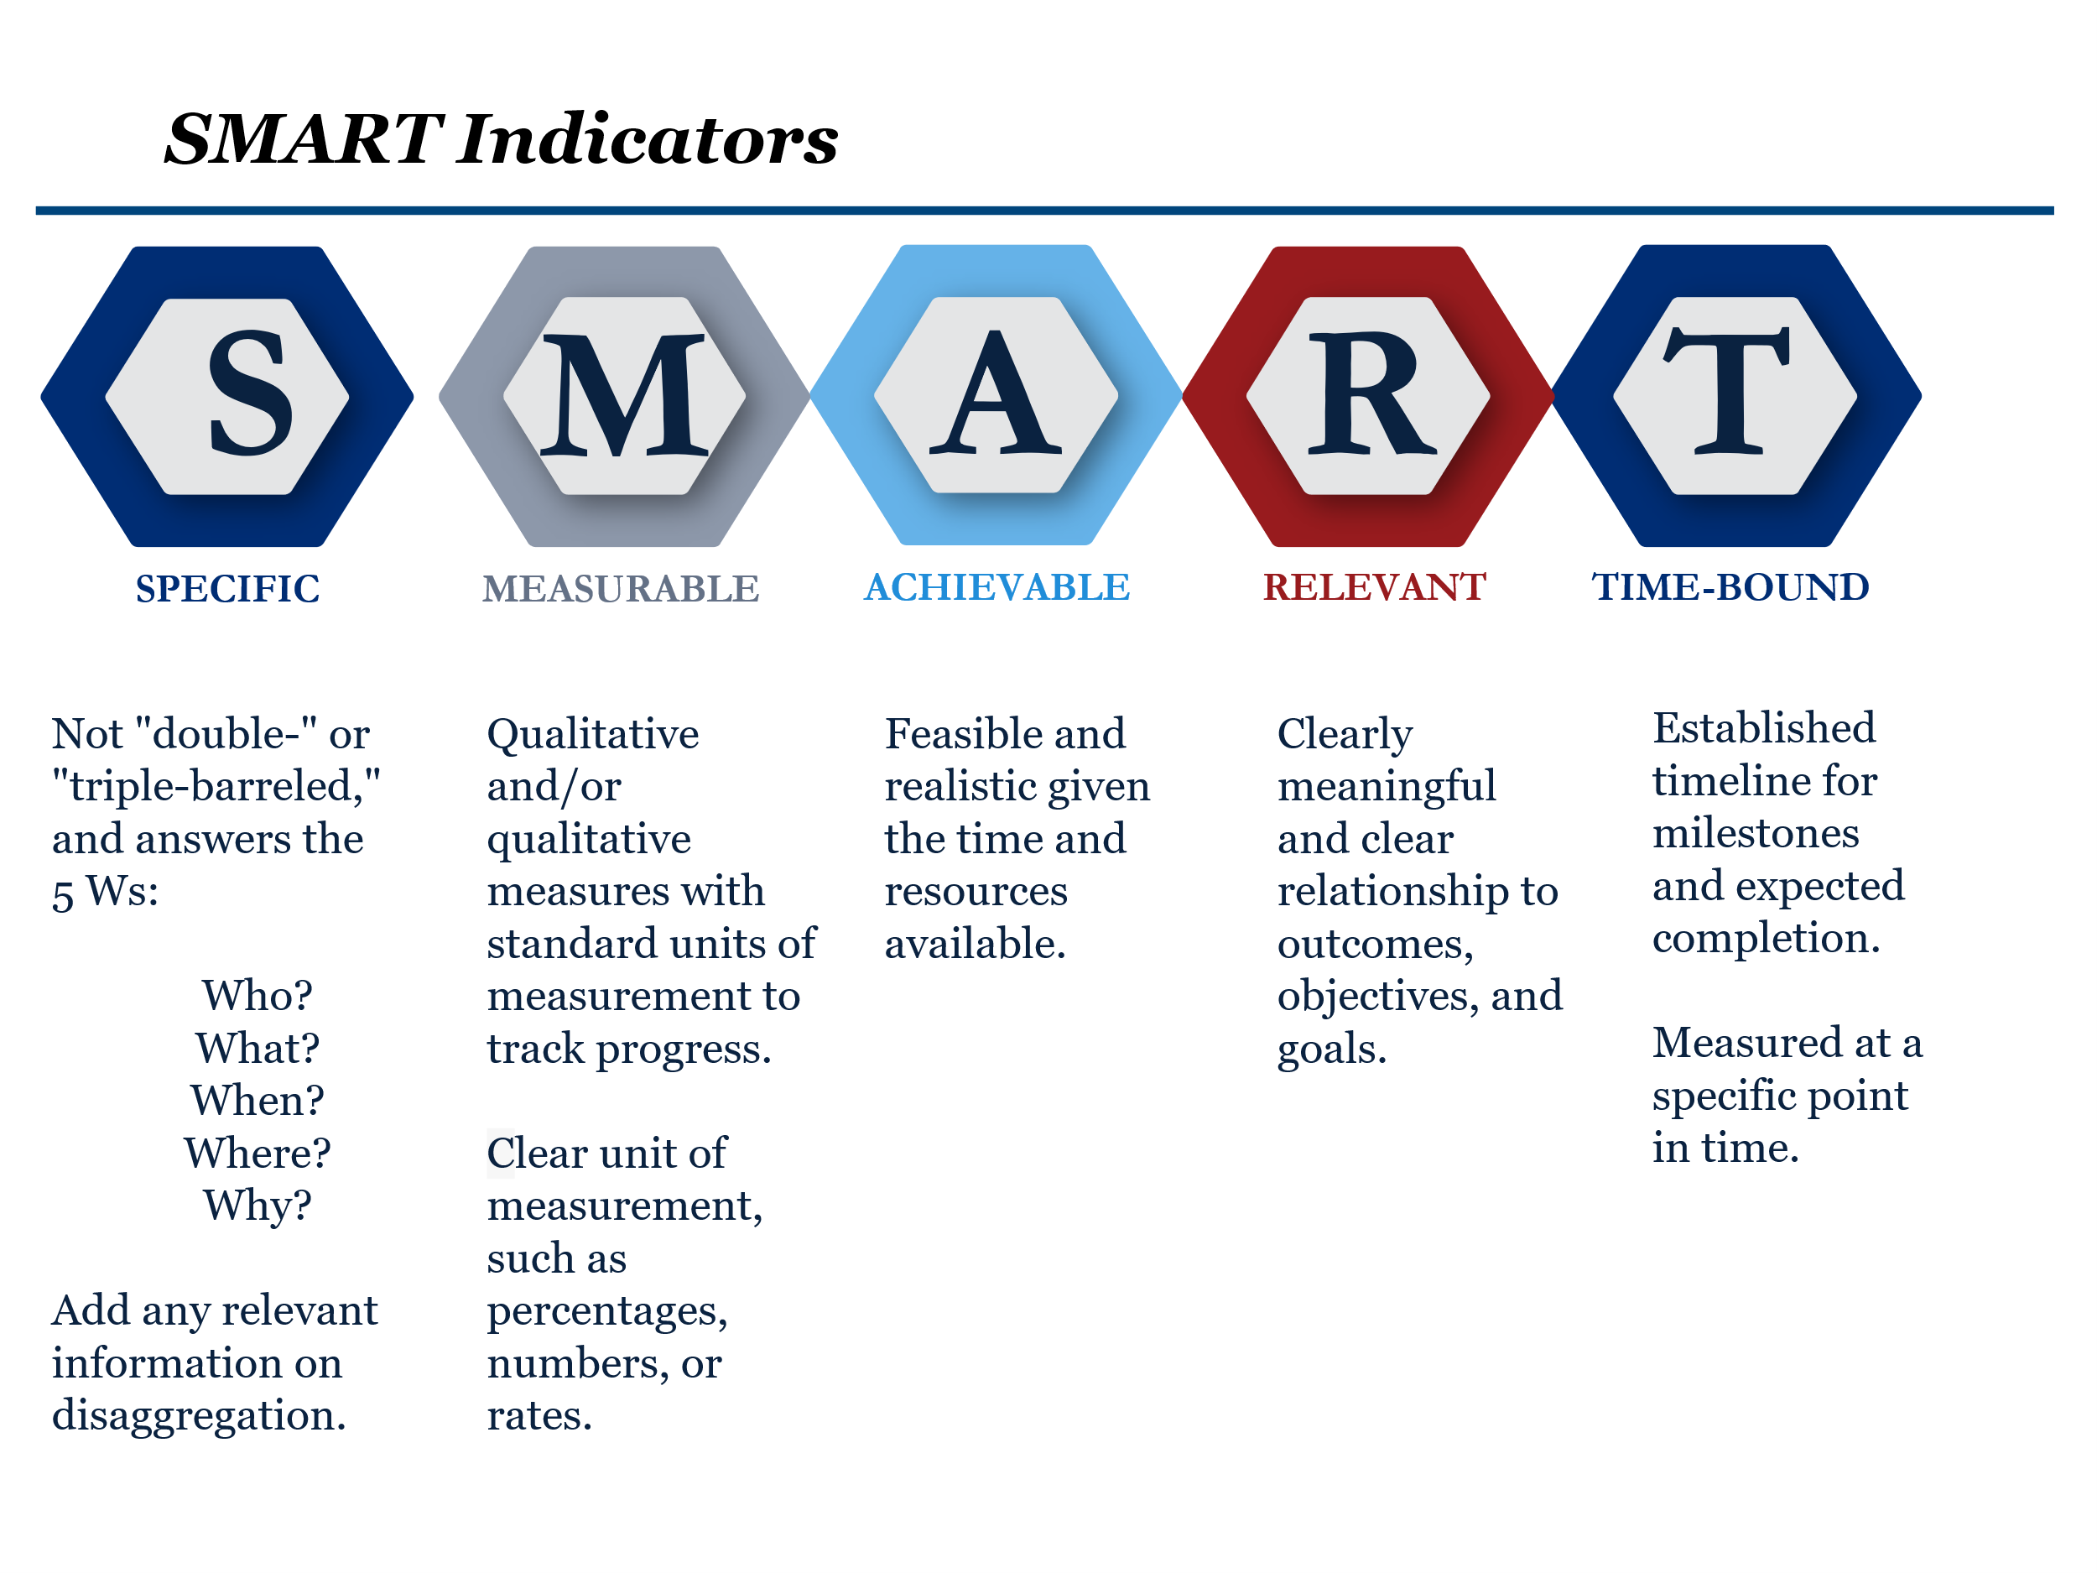

**ANNEX II: CT Indicators**

Applicants must include at least three CT indicators, including preferably at least one outcome-level indicator, along with appropriate disaggregations, from the list below.

| **Category** | **CT Indicators** | **Performance Indicator Type**  **(Output or Outcome)** |
| --- | --- | --- |
| Training & Equipment | CT 0.1 Number of participants trained.  *Disaggregate wherever relevant by:*   CT 0.1.a: Subject Matter – counterterrorism finance, cyber security, rule of law, investigations   CT 0.1.b: Participant type – mentees, TOTs   CT 0.1.c: Organization/profession – justice/judiciary (prosecutors/investigators), law enforcement, security sector  CT 0.1.d: Sex – Female or Male | Output |
| Events/Workshops | CT 0.2 Number of training events completed.   *Disaggregate wherever relevant by:*   CT 0.2.a: Type of activity – Training, meetings, TOT sessions, mentorship sessions, symposia | Output |
| Equipment | CT.0.6 Number of pieces of equipment(s) provided. | Output |
| Course Materials | CT 0.7 Number of course materials developed. | Output |
| Border Security | CT 1.1.1.2 Number of ports of entry (i.e., airports, border crossings, water ports) for which the State Department provides counter terrorism screening support. | Output |
|  |  |  |
| Cases/Investigations | CT 2.1.2.3: Number of terrorism finance related investigations referred for prosecution. | Outcome |
| Cases/Investigations | CT 2.1.2.5: Number of convictions in terrorism-finance related prosecutions. | Outcome |
| Cases/  Investigations | CT 2.2.1.1: Number of terrorism-related investigations prosecuted. | Outcome |
| Cases/Adjudications/  Investigations | CT 2.2.1.2: Number of convictions in terrorism-related prosecutions. | Outcome |
| Knowledge and Utility | CT.1.3.4 Number of partnerships established across various actors (law enforcement, prosecutors, investigators, intelligence unit, etc.) on counterterrorism investigations. | Outcome |
| Knowledge and Utility | CT.1.3.3 Number of participants that report using trainings in their functions/roles/job to perform job-related tasks. | Outcome |
| Collaboration | CT.1.3.2 Number of partner nations that incorporate skills and knowledge from CT-funded courses into their own training curriculum. | Outcome |
| Use of equipment | CT 1.3.4 Number of participants that report frequently using investigation equipment as part of their jobs. | Outcome |
| Use of equipment | CT 1.3.5 Number of pieces of equipment maintained in good standing. | Outcome |

1. “Outcomes” were formerly “objectives”
2. “Outcomes” were former “objectives”