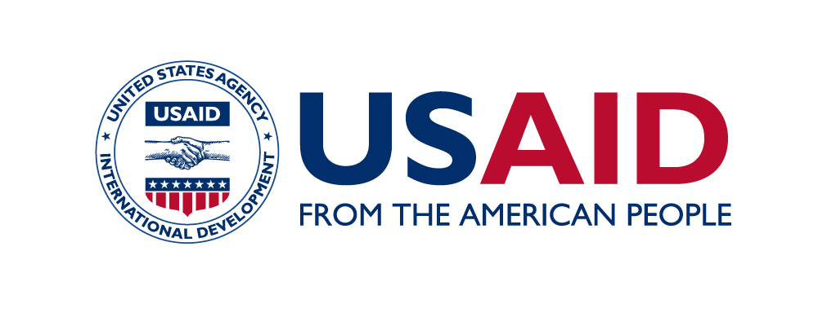

USAID Basic Education Program

Year 2 Annual Report – October 1, 2020 – September 30, 2021

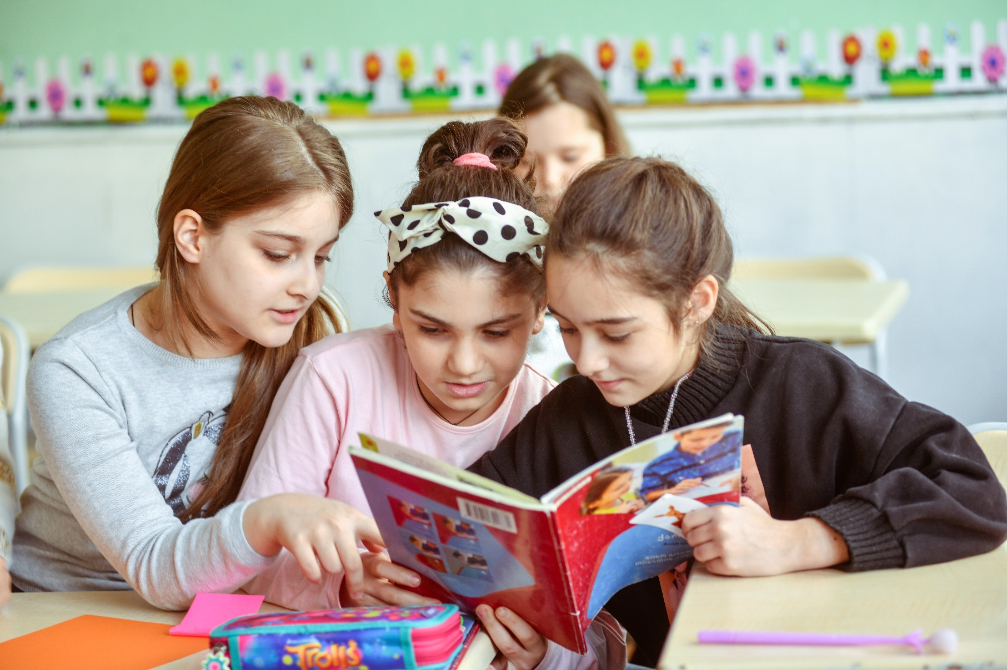

Submission Date: October 26, 2021

This document was produced for review by the United States Agency for International Development. It was prepared by RTI International for the USAID Basic Education Program.

Cover photo ty RTI staff taken by RTI staff at Tbilisi Public School #23; parental permission obtained.
USAID|Georgia
Basic Education Program

Y2 Annual Report

October 1, 2020 – September 30, 2021

Program Period of Performance: January 6, 2020–January 5, 2024
Agreement Number: 72011420CA00001

Prepared for USAID|Georgia
USAID|Georgia
Basic Education Program

Annual Report

Year 2, October 1, 2020 – September 30, 2021

Program Period of Performance: January 6, 2020–January 5, 2024
Agreement Number: 72011420CA00001

Prepared for USAID|Georgia

United States Agency for International Development
ATTN: Medea Kakachia, Agreement Officer’s Representative
29 Georgian-American Friendship Avenue
Didi Dighomi, Tbilisi 0131, Georgia

Prepared by RTI International
3040 Cornwallis Road Post Office Box 12194
Research Triangle Park, NC 27709-2194

RTI International is a registered trademark and a trade name of Research Triangle Institute.
TABLE OF CONTENTS

INTRODUCTION 4
Program Description 4
ACTIVITY IMPLEMENTATION PROGRESS 4
Progress Narrative 4
Y2 Implementation Successes 5
Technical Activities 5
Activity Progress 8
Objective 1: Current primary grade teachers and administrators implement student-centered curricula 8
Outcome 1.1: Teachers and administrators currently in-service are trained and mentored by in-service training providers 9
Outcome 1.2: Contemporary learning resources and materials are accessible 19
Outcome 1.3: Classroom instruction is informed by continuous assessment of students 21
Outcome 1.4: Reading and math practice is established outside school hours 22
Objective 2: Future teachers acquire student-centered teaching skills and future administrators acquire relevant instructional leadership skills 24
Outcome 2.1. University curricula are reformed to reflect student-centered learning ………………………………………………………………………24
Outcome 2.2 University faculty is trained to educate future teachers in student-centered methodologies 24
Outcome 2.3 Future teachers have better opportunities for school-based practice and research at universities 25
Objective 3: Educational policies are developed with the use of data and evidence 26
Outcome 3.1. Policy Working Group is informed with data and evidence 26
Program Implementation Challenges 28
Annual Monitoring, Evaluation, and Learning Plan (AMELP) Update 29
INTEGRATION OF CROSSCUTTING ISSUES and USAID FORWARD PRIORITIES 36
Gender Equality, Female Empowerment, and Social Inclusion 36
Sustainability Mechanisms 36
PPP Impacts 38
Parental Engagement 41
Communications 42
Management and ADMINISTRATIVE UpdatES 44
Staffing 44
Short-Term Technical Assistance (STTA) 44
Grants 45
LESSONs LEARNED 46
Annex A: University Self-Assessment 47
Annex B: PRINCIPALS’ ENGAGEMENT Survey Results 49
ANNEX C: LMS ANALYTICS 53
ANNEX D: RESULTS OF SURVEY OF 21st Century Workforce skills 56
ANNEX E: REGIONAL TEACHER RECOGNITION WINNERS 57

INTRODUCTION

Program Description
The USAID Basic Education Program is funded by the United States Agency for International Development (USAID) and implemented by RTI International in partnership with the University of Georgia, seven regional universities, Child, Family, and Society (CFS) and the Center for Civil Integration and Inter-ethnic Relations (CCIIR). Through direct collaboration with the Georgian Ministry of Education and Science (MOES), the Program seeks to implement sustainable student-centered reform in primary grades. As a system-wide reform, the Program will impact all stakeholders in the primary education sector in Georgia, including primary grade students and their families, teachers and administrators, universities, local organizations, and the Ministry.
The USAID Basic Education Program aims to institutionalize student-centered instruction through a far-reaching systemic reform of pre-service and in-service teacher professional development and use of research and data to inform policy and classroom practice. This goal will be achieved by accomplishing three objectives:
(1) current teachers and administrators implement student-centered curricula
(2) future teachers acquire student-centered teaching skills and future administrators acquire relevant instructional leadership skills
(3) educational policies are developed with the use of data and evidence
In April 2021, USAID awarded the Program additional funding to assess the early grade reading and mathematics skills of Grade 2 and Grade 6 students as part of the ongoing efforts to improve the performance of all Georgian primary students. Assessing Georgian, Azeri, and Armenian mother tongue, and Georgian as a Second Language (GSL) proficiencies represents an unprecedented initiative that will provide rich data about the reading and mathematics skills of all Georgian students.
Upon receipt of the modification to fund the national assessment, the Program moved quickly to plan for the administration of the baseline assessment in September 2021. However, by September, it became apparent that the MOES could not guarantee that all schools would open by October 4, necessitating the postponement of the baseline to May 2022. Following USAID’s approval to postpone the assessment, the Program stopped all assessment activities until Spring 2022.
At the end of the Program, the Georgian education system will have the capacity to sustain nation-wide reforms grounded in student-centered instruction. This reform will produce measurable improvements in reading and math learning outcomes as well as the critical thinking and problem-solving skills for all girls and boys in Georgia, including those with different learning needs and those whose mother tongue is not Georgian.

ACTIVITY IMPLEMENTATION PROGRESS

Progress Narrative
The global pandemic loomed large over all the Program activities. Pandemic precautions necessitated the continuation of online teacher/principal trainings and stakeholder meetings. No longer considered a seismic shift as it had been Y1, online meetings and trainings quickly became the acceptable norm.
Despite pandemic challenges, the Program accomplished all Y2 deliverables except implementation of Next Generation Camps precluded by pandemic restrictions. Training of trainers, lead teachers, and principals continued throughout Y2, focusing on student-centered learning, critical thinking, formative assessments, differentiated instruction, and remediation to support not only teaching of Georgian students but also teaching of ethnic minority students and students with special learning needs. In support of the ongoing training of trainers and teachers, the Program launched the Learning Management System (LMS) to house all TPDC-approved courses, training, and instructional resources. To understand the challenges faced by teachers and trainers, the Program surveyed IT capacity, principals’ engagement, and gender awareness to collect data on the status of the teaching environment in the primary schools and partner universities. University grantees provided a description of the university’s pre-service degree program to inform future activities. Universities, led by Ilia State University, which is a Program grantee, conducted mini-research projects in partnership with local schools and presented the results at the Program Institute in July. The Program also aggressively engaged the private sector through Business Leaders’ Roundtables, the “Read for 15” campaign to celebrate International Literacy Day, the vaccination promotion campaign, and the grant with the Gudavadze-Patarkatsishvili Foundation (GPF) to conduct Regional Teacher Recognition awards.
On April 1, USAID modified the Program’s agreement to provide additional funding to conduct a national assessment of the early grade reading and mathematics skills of Grade 2 and Grade 6 students. Although the Program began item development workshops immediately, assessment activities stopped when the baseline assessment was postponed until Spring 2022.
The numerous training and instructional videos and materials produced and placed on the Program’s LMS ensure the sustainability of resources developed throughout the year. With strong support from the Ministry and the expectation that schools will re-open, the Program is well positioned to continue successful implementation of activities in Year 3.

Y2 Implementation Successes

Technical Activities
Stakeholder Activities
- Memo of Understanding between RTI and TPDC signed in virtual ceremony on January 28
Training of the Trainers (Georgian and Ethnic Minority)
February 2021
- Program staff delivered the second TOT to 114 university and NGO trainers, February 9-25, 2021
- CFS presented a two-hour segment on inclusive education during the TOT organized by the Program on February 11
- Two TOTs conducted for eight ethnic minority math trainers (four Armenian and four Azeri); one in January based on the Sep 2020 TOT and one in March based on the Feb 2021 TOT
- CCIIR trained eight ethnic minority reading trainers (four Armenian and four Azeri); one in November based on the Sep 2020 TOT and one in April based on the Feb 2021 TOT
- CCIIR prepared trainers to conduct a principals’ workshop to provide guidance on selecting proactive teachers
September 2021
- University primary trainers had a 94% TOT participation rate while reserved trainers had a 96% rate. CCIIR had an 80% participation rate, CFS had a 70% rate, and ethnic minority math trainers had a 94% rate. The training is ongoing.
Training – Georgian Lead Teachers and Principals
Fall 2020
- 5313 of 5619 Lead Teachers (95%) trained virtually by university trainers from October 25 to December 24
- 1943 of 2075 Principals (94%) attended workshops conducted by university trainers from October 25 to December 27
Spring 2021
- 5,482 of 5,565 (98.5%) Lead Teachers trained by university trainers, March – June 2021
Training for Ethnic Minority Teachers and Principals
Fall 2020
- CCIIR trained 1329 of 1,349 (98%) reading teachers in ethnic minority schools.
Spring 2021
- 1,219 of the 1,278 ethnic minority math teachers trained on first teacher training
- 1,172 of the 1,281 ethnic minority math teachers participated in the second teacher training
- CCIIR trained 1,280 ethnic minority reading teachers and 238 proactive teachers
- CCIIR conducted workshops for principals
- CFS completed a six-hour, self-paced online course for special education teachers in Georgian, Azeri, and Armenian
TLCs/Online Coaching Sessions
- 3,446 coaching sessions conducted by university grantees for Lead Teachers
- 4,452 Lead Teachers conducted 8,844 TLC meetings
- At the request of USAID, the reading team presented the webinar “School and Family: Contributors to Literacy for All Children” on May 25
Learning Management System
- Piloted the Georgian interface of the LMS with four trainers from two universities among 78 teachers.
- The offline (local) version of the diagnostic assessment tool, originally created by the USAID Georgia Primary Education Project (G-PriEd) and posted on kargiskola.ge, was finalized and stored on EMIS el.ge under “Projects”, with the link uploaded on the Program’s LMS under “Student Centered Instruction Resources/Assessment”
- First self-paced, online course, based on inclusive education content developed by CFS, made available to general primary education teachers on the LMS
- LMS introduced to Lead Teachers and ethnic minority teachers, who, in turn, introduced to their peers
- At the end of Y2, 12,704 users had registered on the LMS site
Grantees and Subcontractor Activities
- Y1 grant activities implemented by all university grantees and subcontractor UG successfully completed
- Partner universities submitted degree program assessment, IT capacity survey, principals’ engagement survey, and gender attitudinal survey
- An online platform created to share all training materials and videos of TOT conducted in February and September 2021 with universities
- Online platform for Year 2 was created for partners to share reports, webinars, and videos
- Three external networked learning community meetings conducted with representatives from partner universities
- Program Facebook page created to facilitate effective communication among members of the external networked learning community
- A total of 29 internal networked community meetings conducted among the 8 universities
- Using Facebook or TEAMS, all universities created networks for teachers and principals to continue effective communication among schools’ representatives and universities
- The Program conducted the Year 2 grants signing online ceremony with university partners on Jan 25, followed by orientation on Feb 4
- CCIIR and CFS signed Year 1 grant extensions on Feb 9; Year 2 follow on grants signed on Mar 4
- Y3 follow-on grants approved by USAID on Sep 21; grants will be signed on Oct. 1
Gender
- 7005 Georgian general and special education teachers, and Azeri and Armenian teachers responded to the Program’s online gender attitudes survey
- Training module on gender equi4ty developed, supplemented with videos
Private Sector Engagement
- Grant agreement with the Gudavadze-Patarkatsishvili Foundation signed
- Nine participants from eight companies attended the first Business Leaders’ Roundtable
- Program activities presented to the American Chamber of Commerce
- Business Leaders Round Tables conducted in Imereti, Samegrelo, and Adjara regions
- Private Sector companies surveyed on 21st Century workforce skills
- Seven books were filmed for the Book Buddies activity for G1-4 and posted on Program’s YouTube channel; six of the seven books also filmed in Georgian Sign Language
- The Program’s “Read for 15” campaign in celebration of International Literacy Day reached 6,311 people through the Program’s Facebook page
- The Program conducted a Facebook awareness campaign to advocate for COVID-19 vaccinations.
Program Institute/Action Research
- Action Research space on Google drive created for universities to post research documents and to elicit feedback from Ilia State
- Universities, led by Ilia State, completed the mini-Action Research projects, and presented at the July 9 Program Institute
GSL
- Ilia State University conducted meetings on Georgian as a second language (GSL) for universities interested in starting a GSL program
- Georgian-as-a-second-language space created on Google drive for universities to receive feedback from Ilia’s GSL expert Tinatin Kighuradze
Assessment
- USAID provided additional funding in Modification 2 to conduct a national assessment
- Program specialists convened item development workshops with online support from home office assessment specialists
- GORBI selected through a competitive procurement process as the data collection company
- School closures due to the pandemic necessitated delaying the baseline until May 2022
- MOES provided approval to conduct the assessment and approved the postponement

Activity Progress

Objective 1: Current primary grade teachers and administrators implement student-centered curricula
Despite pandemic restrictions precluding face-to-face training, the USAID Basic Education Program, university partners, and CCIIR delivered quality online training on schedule to trainers, teachers, and principals throughout Y2.

Outcome 1.1: Teachers and administrators currently in-service are trained and mentored by in-service training providers
University trainers conducted online training for principals and lead teachers following the Y1 Sep 2020 and Y2 Feb 2021 TOTs. University trainers will begin training lead teachers following the Sep 2021 TOT in October.
1.1.1 TOT on student-centered methodology, with a focus on reading, math, problem solving and critical thinking
Feb 2021
Following the first TOT in the last quarter of Y1, the Literacy and Numeracy teams began planning for the Feb 2021 TOT. The 18-hour, online TOT focused on critical thinking, problem solving, and differentiated instruction, divided equally between the two subject areas. Training for the ethnic minority trainers mirrored the content of the TOT for Georgian teachers of math and reading.
The virtual training, delivered six evenings throughout February, included lectures, live discussions, and video clips to illustrate strategies and activities. Ilia State University conducted a session on RESULT, a program in which faculty and student teachers conduct research together, and CFS presented on addressing the special needs of students.
The average number of trainers who participated was 110 (96% attendance rate).
Table 1. Feb 2021 TOT Attendance
Partner University / NGO | Participants |  |  | Attendance by TOT days
Partner University / NGO | Lead Trainers | Reserve Trainers | Total Participants | Day 1 Feb 9 | Day 2  Feb 11 | Day 3  Feb 16 | Day 4  Feb 18 | Day 5  Feb 23 | Day 6  Feb 25
Batumi State University | 14 |  | 14 | 14 | 14 | 14 | 14 | 14 | 14
Zugdidi State University | 11 |  | 11 | 11 | 11 | 11 | 11 | 11 | 11
Telavi State University | 8 | 1 | 9 | 9 | 9 | 9 | 9 | 9 | 9
Ilia State University | 11 |  | 11 | 11 | 11 | 10 | 10 | 11 | 11
Samtskhe-Javakheti State University | 9 | 1 | 10 | 10 | 10 | 9 | 10 | 10 | 10
University of Georgia | 18 |  | 18 | 18 | 16 | 18 | 16 | 16 | 18
Sokhumi State University | 4 | 3 | 7 | 6 | 6 | 7 | 7 | 7 | 7
Kutaisi State University | 16 | 2 | 18 | 17 | 17 | 18 | 18 | 18 | 18
CCIIR | 5 |  | 5 | 4 | 4 | 5 | 5 | 5 | 4
CFS | 3 |  | 3 | 0 | 1 | 3 | 3 | 2 | 2
Program Math Trainers | 8 |  | 8 | 8 | 8 | 8 | 7 | 8 | 7
Total | 107 | 7 | 114 | 108 | 107 | 112 | 110 | 111 | 111

On the last training evening, thirty-three university trainers, who also serve as teachers, took a test to provide the results to TPDC for professional development recognition. As specified in the MOU, teachers must score 70% or above for successful course completion. Thirty-one of the thirty-three trainers passed the test.
Sep 2021
Beginning Sep 22, 2021, the Program offered the second Y2 TOT to the trainers, focusing on remediation, formative assessment, and the multi-tiered systems of support model for inclusive education. At the end of Y2 in September, university trainers had a 94% participation rate while reserved trainers had a 96% rate. CCIIR had an 80% participation rate, CFS had a 70% rate, and ethnic minority math trainers had a 94% rate. The overall attendance rate of the 113 invited participants was 87%, primarily due to lack of participation from the NGO trainers. Four of the six sessions were conducted in September. Teacher training will follow the completion of the TOT in October.
Table 2. Fall 2021 TOT Attendance
Partner University / NGO | Invited Participants |  | Day 1 – Sep 22 Attendance |  | Day 2 – Sep 24 Attendance |  | Day 3 – Sep 29 Attendance |  | Day 4 – Sep 30 Attendance
Partner University / NGO | Lead Trainers | Reserved Trainers | Lead Trainers | Reserved Trainers | Lead Trainers | Reserved Trainers | Lead Trainers | Reserved Trainers | Lead Trainers | Reserved Trainers
Batumi State | 10 |  | 10 |  | 10 |  | 10 |  | 10
Zugdidi State | 11 |  | 9 |  | 11 |  | 9 |  | 11
Telavi State | 9 |  | 9 |  | 9 |  | 8 |  | 9
Ilia State | 11 |  | 11 |  | 11 |  | 10 |  | 11
Samtskhe-Javakheti State | 10 | 2 | 9 | 2 | 9 | 2 | 9 | 2 | 9 | 2
University of Georgia | 18 |  | 18 |  | 18 |  | 18 |  | 16
Sokhumi State | 4 | 3 | 4 | 2 | 4 | 3 | 4 | 3 | 4 | 3
Kutaisi State | 15 | 2 | 13 | 2 | 11 | 2 | 13 | 2 | 14 | 2
University Total | 88 | 7 | 83 | 6 | 83 | 7 | 81 | 7 | 84 | 7
CCIIR | 5 |  | 5 |  | 5 |  | 5 |  | 1
CFS | 5 |  | 2 |  | 3 |  | 4 |  | 5
Program Math Trainers | 8 |  | 8 |  | 8 |  | 7 |  | 7

1.1.2 Support for teacher training institutions to revise and institutionalize new curricula and learning resources.
Pre-service degree programs. As a part of the first grant agreement with the universities, each completed a self-assessment of their 300-credit or 60-credit pre-service programs. (Annex A) The purpose of the assessment was for universities to reflect on their program in consideration of their recent experiences in the schools and for Program staff to identify the areas requiring potential support to improve the current pre-service teacher programs. Analysis of each university’s self-assessment of their 300-credit or 60-credit pre-service programs revealed that the programs were heavy in theoretical pedagogy with little or no emphasis on primary education. However, most universities reported that they were pleased with their programs, finding little reason to change.
To motivate universities to reflect more seriously on the content of the 300-credit programs, the Program Institute provided an opportunity to present to all partner universities with a model master’s level degree program, focused on primary education, which incorporated three guiding principles: (1) student teachers increase their classroom-based practice steadily over time; (2) faculty shift from “lecturing” to modelling effective student-centered instruction; and (3) student teachers should be trained as action-researchers, who through reflective practice, learn from real-time assessment, respond to diverse student needs, improve their practice, and share their professional development with peers. The goal of the Program Institute session, conducted July 8-9, was for universities to identify potential curricular changes in current pre-service programs. In Y3, the Program will engage an international consultant to assist universities in revising or developing their programs.
Georgian-as-a-second-language course. Ilia University delivered a session during the Feb TOT on establishing a Georgian-as-a-Second-Language (GSL) course as part of the pre-service degree program. Ilia followed up with interested universities in a series of meetings. Batumi University and the University of Georgia do not have GSL programs, but both were interested in starting one. Sokhumi and Samtskhe-Javakheti had GSL programs which needed to be updated.
Tinatin Kighuradze, Associate Professor of Georgian as a Second Language at Ilia State University, worked with the interested universities on the GSL programs. Ilia also conferred with CCIIR in the development of the training materials. Ilia conducted a total of five meetings and uploaded all documents to the Google drive.
Part of the process included Ilia comparing its program to the MOES regulatory documents regarding GSL. Ilia discovered that graduates of the university’s GSL course would be certified to teach not only Georgian in non-Georgian schools but would also be able to teach Georgian to any foreigners. The comparison confirmed that all regulatory compliances were met through the inclusion of the following topics:
- Formation of a positive learning environment
- Planning and conducting the learning process
- Evaluating the learning process
- Continuing professional development
The analysis also resulted in several recommendations such as including courses that provided stress sustainable development and an internship program. Ilia will consider implementing the recommendations during the coming year.
The initiative marked the first time universities discussed having a quality GSL program. Batumi and UG eventually stopped meeting with Ilia as developing a GSL course did not fit within the universities’ accreditation plan; however, Sokhumi and Samtskhe-Javakheti continued to work with Ilia to update their programs.
1.1.3 Program partners deliver face-to-face training to Lead Teachers.
Fall 2020
The first quarter of Y2 focused predominantly on the training for lead teachers and principals. The universities partners communicated with the assigned schools in their region through the Educational Resource Centers which became actively involved in the online training management process. The universities’ program managers and their trainers also contacted school principals and lead teachers directly.
Prior to the online training day, universities sent the schools the training video prepared by the university to upload to the selected training platform. All universities created teachers and principals’ groups in TEAMS and added the Program’s university collaboration coordinator for monitoring purposes. Program specialists monitored several training sessions to assess efficacy of training efforts.
The universities offered two days of online training, for a total of six hours (three hours per day). Partners offered an additional three hours of make-up training to all participants who were unable to attend the main training. Additionally, the universities uploaded the training video which each university created on the social network group used for communication with teachers.
Following the training sessions, universities sent training reports using a template provided by the Program’s University Collaboration Coordinator. All partners attached attendance sheets downloaded from MS Teams. Each university continued to communicate with lead teachers and principals in the groups created for this purpose to build a strong network among universities and schools in the region.
During the Fall 2020 training cycle, university partners trained a total of 5,313 (94%) lead teachers and 1943 (94%) principals, as indicated in Table 1. CCIIR trained a total of 1329 (98%) teachers in ethnic minority schools.
Table 3. University partners’ training of lead teachers and principals
University/NGO | Lead Teachers |  | Principals
University/NGO | Projected | Actual | Projected | Actual
University of Georgia | 1209 | 985 | 405 | 335
Ilia State University, Tbilisi | 447 | 428 | 249 | 208
Sokhumi University, Tbilisi | 258 | 256 | 86 | 78
Batumi State University | 978 | 919 | 326 | 314
Samtskhe-Javakheti State University | 309 | 308 | 201 | 201
Kutaisi State University | 1119 | 1118 | 373 | 372
Telavi State University | 546 | 546 | 184 | 184
Zugdidi State Teaching University | 753 | 753 | 251 | 251
University subtotal | 5619 | 5313 | 2075 | 1943
Center for Civil Integration and Inter-ethnic Relations (CCIIR) | 1349 | 1329
CCIIR subtotal | 1349 | 1329
Total | 6968 | 6642 | 2075 | 1943
The teacher training content focused on student-centered teaching, inclusive education, and the NSM unit template. Additional sessions provided information about the Program, TLCs, and Lead Teachers’ roles and responsibilities. Due to the unexpected rapid transition to virtual training, Program specialists filmed many of the sessions to assist universities in adapting to online training. Although each university could tailor the training sessions to reflect their training styles, many universities opted to use the filmed sessions provided by the Program. The table below details the session resources.
Table 4: Filmed Training Resources Used by Universities for Teacher Training
PRESENTER | TOPIC | # of UNIVERSITIES THAT USED THE FILM
Welcome Speeches | Welcome speeches made by officials (the Program's video) | 7
CFS | Inclusive Education | 7
CFS | Recommendations for effective involvement of students with ADHD | 3
Nika Silagadze, MOES | New School Model | 5
Tamar Jakeli, MOES | Pedagogical Principals of NSM | 5
Gia Nozadze | Constructivism | 5
Giorgi Chauchidze | Formative Assessment | 4
Tamar Chanturia | Differentiation, Remediation | 5
Paata Papava | Critical thinking and Problem solving in the Primary Grades | 2
Gia Nozadze | Overview of Math Matrix Structure and Components | 5
Paata Papava | Overview of the Georgian Language and Literature Matrix Structure and Components | 5
Gia Nozadze | Appendixes to Math Unit | 2
Tamar Chanturia | Appendixes to the Georgian Language and Literature Unit | 3
Giorgi Chauchidze | Sample Unit in Georgian Language and Literature. Miamiti Ghamura (Naïve bat) | 2
Natia Kobadze | Sample Unit in Math, III grade, "Numbers" | 2
Gia Nozadze | Guided Practice in Math Unit development | 3
Giorgi Chauchidze | The Georgian Language and Literature Unit Development | 3
Tamar Chanturia | TLC (for teachers' training) | 7
Principal training. Principal training agendas and content primarily followed the Program-developed videos and materials. Only Ilia State University used its own materials in addition to Program resources. Topics included information about the Program, the principal as an instructional leader, NSM, TLCs, formative assessments, inclusive education, and parental engagement. Principals attended only this training during Y2.
Table 5. Filmed Training Resources Used by Universities for Principals’ Training
PRESENTER | TOPIC | # of UNIVERSITIES THAT USED THE FILM
Welcome Speeches | Welcome speeches made by officials | 7
Niko Silagadze, MOES | NSM | 6
Nancy Parks | Principal as an Instructional Leader | 6
Tata Chanturia | TLCs | 6
Nancy Parks | Formative Assessments | 6
Nancy Parks | Inclusive Education | 5
Nika Chachkhiani | Parental and Private Sector Engagement | 6

Spring 2021
Following the February TOT, university trainers and CCIIR began to prepare for the online teacher training. Partner universities submitted plans to Program specialists for approval. By the end of March, teacher training began, ending in June 2021.
The partners provided training reports which included all necessary information about partner’s training activities. They are uploaded in the space designated for universities: https://sites.google.com/view/bepreport/report.
The training participation was an average 97%, which exceeded the Fall 2020 94% rate.
Table 6. University partners’ training of lead teachers, Spring 2021
University | Region | Lead Teachers
University | Region | Projected | Actual
University of Georgia | Tbilisi | 639 | 637
University of Georgia | Racha-Letchknumi and Kvemo Svaneti | 122 | 120
University of Georgia | Shida Kartli | 390 | 390
Sukhumi State University | Mtskheta-Mtianeti | 258 | 258
Telavi Iakob Gogebashvili State University | Kakheti | 546 | 545
Ilia State University | Kvemo Kartli | 447 | 416
Samtskhe Javakheti State University | Samtskhe-Javakheti | 309 | 309
Kutaisi State University | Imereti | 1119 | 1105
Zugdidi Shota Meskhi State University | Samegrelo-Zemo Svaneti | 757 | 757
Batumi Shota Rustaveli State University | Guria | 285 | 273
Batumi Shota Rustaveli State University | Adjara | 693 | 672
Ethnic Minority Math and Reading Teachers | Kvemo Kartli, Samtskhe-Javakheti, Tbilisi, Kakheti | 1782 | 1636
TOTAL |  | 7347 | 7118
University partners continued to communicate with assigned schools through the Educational Resource Centers which were actively involved in the online training management process. The universities’ program managers and their trainers also contacted school principals and Lead Teachers directly. All universities created teachers and principals’ groups in TEAMS and added the Program’s university collaboration coordinator for monitoring purposes.
The training reports submitted to the Program included information about the Lead Teachers who took the final test. Due to technical problems in some regions and villages, particularly the mountainous regions, some teachers were unable to take the final test. These teachers were given an extra day for testing. 4,364 lead teachers (80% of lead teachers trained) eventually passed the test.
The table below represents the number of teachers who met the training requirements successfully. The Program provided the statistics to TPDC to ensure teachers received credit for their participation in the training.
Table 7: Success rate of Lead Teachers who took the final test
Organization | Region | Actual Number of Teachers | Number of Teachers Trained | Number of Teachers Who Succeeded | Number of Teachers Who Failed | Number of Teachers ineligible to take test*
University of Georgia | Tbilisi | 639 | 637 | 528 | 26 | 82
University of Georgia | Racha-Letchknumi and Kvemo Svaneti | 122 | 120 | 71 | 14 | 36
University of Georgia | Shida Kartli | 390 | 390 | 270 | 30 | 90
Sukhumi State University | Mtskheta-Mtianeti | 258 | 258 | 258 | 0 | 0
Telavi Iakob Gogebashvili State University | Kakheti | 546 | 545 | 447 | 70 | 28
Ilia State University | Kvemo Kartli | 447 | 416 | 317 | 67 | 32
Samtskhe Javakheti State University | Samtskhe-Javakheti | 309 | 309 | 298 | 0 | 11
Kutaisi State University | Imereti | 1119 | 1105 | 865 | 140 | 100
Zugdidi Shota Meskhi State University | Samegrelo-Zemo Svaneti | 757 | 757 | 586 | 120 | 51
Batumi Shota Rustaveli State University | Guria | 285 | 273 | 242 | 20 | 11
Batumi Shota Rustaveli State University | Adjara | 693 | 672 | 482 | 137 | 53
Total |  | 5,565 | 5,482 | 4364 | 624 | 494
*Teachers who missed more than 20% of the sessions and did not attend make-up sessions
1.1.4 Lead teachers mentor their peers through Teacher Learning Circles
During the TOTs, the lead teachers received guidance on establishing, facilitating, and reporting TLC meetings. Trainers received guidance on identifying key conversation topics during the TLC observations, facilitating reflection and feedback, and using coaching techniques during conversations with the Lead Teachers. Program specialists also conducted an additional webinar for trainers on the specific aspects of online coaching and provided a TLC reporting template.
During this year of limited face-to-face engagement, trainers communicated with lead teachers by phone, social networks (a Facebook group created especially for teachers by region), TEAMS, etc. All schools provided reports on TLC activities to the partner university coordinators. Details of TLC meetings during Y2 are provided below.
Table 8: TLCs conducted in Y2
Organization | Region | Actual Number of Lead Teachers | Number of  Individual Lead Teachers Who Conducted a TLC | Total Number of TLC Meetings | Total Number of Individual Teachers Participating in TLCs
University of Georgia | Tbilisi | 639 | 424 | 885 | 1935
University of Georgia | Racha-Letchknumi and Kvemo Svaneti | 122 | 72 | 162 | 227
University of Georgia | Shida Kartli | 390 | 275 | 645 | 1044
Sukhumi State University | Mtskheta-Mtianeti | 258 | 262 | 2352 | 637
Telavi Iakob Gogebashvili State University | Kakheti | 546 | 534 | 3162 | 1365
Ilia State University | Kvemo Kartli | 447 | 348 | 656 | 1338
Samtskhe Javakheti State University | Samtskhe-Javakheti | 309 | 288 | 554 | 650
Kutaisi State University | Imereti | 1119 | 698 | 1304 | 1828
Zugdidi Shota Meskhi State University | Samegrelo-Zemo Svaneti | 757 | 735 | 2107 | 1783
Batumi Shota Rustaveli State University | Guria | 285 | 267 | 421 | 575
Batumi Shota Rustaveli State University | Adjara | 693 | 652 | 1131 | 1408
Total |  | 5,565 | 4,555 | 13,379 | 12,790
*Total number of teachers participating in TLC meetings shows the individual number of teachers; a teacher might teach both subjects and attend both TLC meeting at a school but here a teacher is counted once.
During TLC meetings, Lead Teachers introduced topics of their trainings and encouraged their colleagues to use the new materials and approaches in their classroom. Based on the reports of the partner universities, the chart shows the popular topics of TLC meetings.
Table 9: Jan – May 2021 TLC Topics
TLC Topic | Number of TLCs Conducted on this Topic
Critical Thinking and Problem Solving | 1945
Differentiation | 1261
Inclusive Education | 892
Math Topics | 823
Other (Program introduction, etc.) | 817
NSM Complex Tasks | 718
LMS Portal | 676
Reading Topics | 382
Thematic Unit | 382
Student Centered Education | 321
Constructivism | 241
Matrix | 184
TLCs | 177
Remediation | 25

To provide sustainable materials as part of the TLC curriculum, the Program conducted an online lottery among universities to identify the training topic which the university would prepare as a session for uploading to the LMS system, accessible by all TLCs.

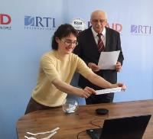
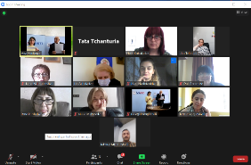
Screenshot of lottery participation; Natia Kobadze drawing the topic for the university named by Gia Nozadze
The following topics were assigned to each university:
Table 10: TLC topics assigned to partner universities
Topic | University
Overview of Student-Centered Instruction in Literacy and Numeracy | Batumi University
Guided practice in developing Math sample units and Math content-based units with Supplemental Resource Kits | Zugdidi University
Guided practice in developing Literacy sample units and Literacy CB Units with Supplemental Resource Kits | Sokhumi University
Inclusive education strategies and activities in language and math model unit | University of Georgia
Introduction to critical thinking and problem solving; critical thinking and problem solving in math standards and math teaching practice | Samtskhe-Javakheti University
Introduction to critical thinking and problem solving; critical thinking and problem solving in GLL Standards and GLL teaching practice | Kutaisi University
Introduction to differentiated instruction; differentiated instruction in Math teaching/learning practice | Telavi University
Introduction to differentiated instruction; differentiated instruction in GLL teaching/learning practice | Ilia University

Universities finalized the topics in September 2021. Program specialists will review and universities will finalize the topics in Y3. The final versions will be posted on the LMS as illustrative TLC curriculum content.
1.1.5 Program partners deliver online/offline training to remaining teachers
University partners offered an additional three hours of make-up training to all participants who were unable to attend the main training. In addition to the make-up training, the universities offered online webinars, conducted on the Microsoft TEAMS platform, for Lead Teachers and principals. The topics of the two-hour webinars were different for each university, i.e., "Creative Methods of Problem-Solving," and “Preparation for the Test” (which would enable them to get TPDC training credit.) Sokhumi State University conducted additional webinars for its assigned teachers and principals to improve their ICT skills and assist them to use the TEAMS platform easily.
1.1.6 Program partners deliver training in special education and mother tongue instruction
CCIIR. Following the Sep-Oct TOT, CCIIR conducted a four-day TOT, November 10-13, for four Azeri and four Armenian trainers on student-centered instruction. CCIIR conducted training for the teachers of ethnic minority students November 16 - December 25. CCIIR delivered training to 1,329 (98%) teachers. (646 teachers from 114 Azeri schools and 683 teachers from 129 Armenian schools.)
Using the model proposed by the Program, CCIIR conducted online training using MS Teams platform. The trainings included two make-up sessions organized in late December for 31 Azeri teachers to ensure maximum teacher participation. The total number of the trainees represented 98% of the target teacher population. CCIIR’s training efforts were covered by local media: https://nor.ge/?p=160153&fbclid=IwAR22j2vQ4fELC8bbtNohQv279OgZJgWkeaKST_dvBCwrE3ZRB3CGuWM2YgM
April 15-16, CCIIR delivered a two-day training for ethnic minority trainers on problem-solving and critical thinking, differentiated instruction and inclusive education for ethnic minority students. All eight trainers attended the two days of training. CCIIR also conducted a workshop for ethnic minority principals to present the “Agents of Change” model that CCIIR felt was needed to effect change in teaching instruction. CCIIR requested that principals nominate the proactive teachers who could be change agents.
Throughout Spring 2021, CCIIR conducted second phase of trainings for teachers. In total, 1,280 out of 1,349 ethnic minority teachers (95% of average participation rate) attended the trainings. In May, CCIIR trained 238 proactive teachers, nominated by principals, who comprise a cadre of agents of change.
Training for ethnic minority math trainers and teachers. The Program’s Math team delivered two online TOTs in 2021 for eight Ethnic Minority Math trainers (4 Armenian and 4 Azeri trainers). The team uploaded all necessary training materials for trainers on a specially created site on TEAMS. Both TOTs included preliminary readings and home assignments for trainees. On the last training evening, eight math trainers took a test to provide the results to TPDC for recognition as part of their professional development.
Following the TOT, the Ethnic Minority math trainers delivered online training, which mirrored the topics introduced in the TOT, to 1173 teachers in Jan 2021. (The training was delayed until all materials could be translated.) The Program engaged two Armenian and two Azeri assistants to liaise with the assigned schools through the Educational Resource Centers, which became actively involved in the online training management process. They also contacted school principals and teachers directly to increase participation and teacher motivation.
April 1, the Program conducted a two-hour LMS session for eight math and reading trainers, recruited by the Program (math) and CCIIR (reading). Based on the feedback from the trainees, the Program revised the LMS session guide and shared with trainers.
April 7, 2021, trainers delivered the second training course to the primary math teachers of ethnic minority students. According to the plan, 52 groups (Armenian 24 and Azerbaijani 28) completed the training course on May 8, 2021. In total 1219 out 1278 invited teachers actually participated in the training. The average participation rate was 95%.
Table 11. Participants in ethnic minority training in April 2021
 | Invited |  | Participated |  | Total Participants | Participation Rate
 | Female | Male | Female | Male
Azeri | 573 | 139 | 519 | 125 | 644 (of 712) | 90%
Armenian | 527 | 39 | 540 | 35 | 575 (of 566) | +100%

CFS Inclusivity training. CFS had no training in Y2; however, the NGO did develop course modules. The self-paced course for general education teachers is divided into eight 45-minute sessions and covers topics such as the foundation of inclusive education and its development history; content and procedures for teaching students with special needs; and creation of equal conditions for all students at school and during lesson activities. CFS requested and was granted a one-month extension to finalize the course due to the public transportation ban related to the pandemic which precluded travel for the Azeri and Armenian language translators from the Kvemo Kartli region to record at the studio location in Tbilisi. Once completed, the course was uploaded to the LMS in June 2021. CFS, with the Program support, worked with the partner universities to encourage mainstream teachers in primary grades to complete the course. CFS also developed a similar course for special education teachers which was posted on the LMS in May. The Program, through its partners, encouraged Lead Teachers, special education teachers, and other teachers to take the courses in their respective language in summer or during the next academic year.
1.1.7 Partners provide individualized coaching to the Lead Teachers and administrators after training
Most university trainers had only rudimentary knowledge and experience in conducting school visits. During the February TOT, the Program introduced its approach and model of observing TLC meetings and delivering feedback sessions with Lead Teachers.
After completing the training and testing process, each university trainer began coaching the Lead Teachers with up to four people from each school. The coaching process consisted of three stages: pre-meeting with the lead teacher to assist in preparing agenda for TLC meeting, directly monitoring the meeting, and the feedback session. The chart below represents number of online TLC observations and number of coaching sessions delivered to Lead Teachers.
Table 12: Number of TLC sessions and observations in Y2
Organization | Region | Total Number of TLCs for Q3 | Total Number of Online TLC Observations | Total Number of Online Coaching Sessions
University of Georgia | Tbilisi | 964 | 284 | 299
University of Georgia | Racha-Letchknumi and Kvemo Svaneti | 157 | 49 | 56
University of Georgia | Shida Kartli | 726 | 205 | 226
Sukhumi State University | Mtskheta-Mtianeti | 932 | 255 | 255
Telavi Iakob Gogebashvili State University | Kakheti | 1341 | 454 | 454
Ilia State University | Kvemo Kartli | 491 | 303 | 303
Samtskhe Javakheti State University | Samtskhe-Javakheti | 351 | 249 | 227
Kutaisi State University | Imereti | 1766 | 625 | 607
Zugdidi Shota Meskhi State University | Samegrelo-Zemo Svaneti | 1297 | 422 | 362
Batumi Shota Rustaveli State University | Guria | 213 | 199 | 199
Batumi Shota Rustaveli State University | Adjara | 606 | 458 | 458
Total |  | 8,844 | 3,503 | 3,446

Coaching principals. In April, university trainers conducted individual half-hour online consultations with each principal of a Georgian school and 100 principals from non-Georgian instruction schools. Consultations were conducted using TEAMS and Zoom platforms or telephone communication. Topics included principal leadership and TLC meetings.
UG conducted a Principals’ Workshop in April, in which 353 principals participated. The main topics were Instructional Leadership and TLCs. Based on the feedback from the principals, the majority felt that TLCs offered a new avenue of communication within schools.
The chart below represents the number of principals per region and the number of online coaching sessions conducted.
Table 13: Coaching sessions for principals
Partner University | Region | Total # of Principals | Coaching Conducted
University of Georgia | Tbilisi | 175 | 87
University of Georgia | Racha-Letchknumi and Kvemo Svaneti | 67 | 49
University of Georgia | Shida Kartli | 163 | 104
Sukhumi State University | Mtskheta-Mtianeti | 86 | 82
Telavi Iakob Gogebashvili State University | Kakheti | 184 | 184
Ilia State University | Kvemo Kartli | 249 | 249
Samtskhe Javakheti State University | Samtskhe-Javakheti | 201 | 201
Kutaisi State University | Imereti | 373 | 371
Zugdidi Shota Meskhi State University | Samegrelo-Zemo Svaneti | 251 | 251
Batumi Shota Rustaveli State University | Guria | 97 | 97
Batumi Shota Rustaveli State University | Adjara | 229 | 229
 |  | 2,075 | 1,904

According to the reports from universities, many principals were reluctant to be engaged in Program activities. The Program sent a survey to university trainers in June to collect feedback from the trainers on their experiences with principals. Forty-five trainers who work with approximately 1,125 principals responded. Overall, the experiences were positive, but the trainers provided valuable insights on ways the Program can better meet the needs of principals. Complete survey results and comments are in Annex B.

Outcome 1.2: Contemporary learning resources and materials are accessible
1.2.1. Map and adapt existing classroom instructional resources for the new curricula
UG completed mapping all the resources from the website www.kargiskola.ge and www.inclusion.ge. The mapping was the first step in the process. UG now works with Program staff to categorize each activity, determining which activities should remain and gaps which need to be filled. This is an ongoing process.
On April 21-22 and May 22, the literacy team conducted a writers’ workshop with guided practice sessions on drafting and reviewing decodable readers and other supplementary resources for reading instruction. On May 25 workshop participants presented their draft versions of readers and received feedback from peers and facilitators. Following the workshop, participants from CCIIR and CFS continued developing readers and activity cards and received feedback from the program. Development of instructional materials will continue until the end of September.
Thirteen videos from the G-PriEd library of instructional videos were shortened and uploaded to the LMS. The following videos were edited in collaboration with UG:

Table 14: G-PriEd videos edited
 | Title | Grade Level
Math Videos
1 | Use of math activity cards | G1-6
2 | Figures with equal area - A constructivist method of teaching | G5
3 | The method of differentiated instruction - Cubing | G 1-6
4 | Differentiated Math activity – Bar charts | G5
5 | Strategy for differentiated instruction - From Concrete to Abstract | G3
6 | Formative assessment activity - "Traffic lights" | G1-6
Reading Videos
1 | Read Aloud and Shared Reading | G1
2 | Combine Split Text | G1
3 | Language Experience Approach | G1
4 | Word Bingo | G1-2
5 | Animal House (for remediation and differentiation) G1 | G1-3
6 | Super Speed (for remediation and differentiation) | G1-3
7 | Conducting School Visits and Effective Coaching | G1-6

1.2.2 Improve usability of online resources and adapt them for mobile and offline use. By the end of Y2, the Program’s Learning Management System (LMS) was fully operational. The launch in February was preceded by Moodle customizations made by the LMS consultants beginning in October and the piloting in December.
The LMS was customized in close collaboration with the EMIS, which provided its cloud server at https://chemiskola.emis.ge/. The Program also signed an MOU with EMIS to house the diagnostic assessment offline version on El.ge (a sub-domain of EMIS) which was designed as the e-library of instructional resources developed by the Ministry, its agencies, schools, local and international organizations, such as RTI. With EMIS’s assistance, load and stress testing of the platform was completed. The Program Moodle consultants configured the server back-ups (both of the database and website), which now happens automatically on daily basis.
The current structure of the LMS includes eight major categories:

- Courses
- Math Instruction
- Language Instruction
- Student-centered Instruction
- Teacher Learning Circles
- Special Education Teachers
- Principals
- Extracurricular activities

The category “Courses” offers TPDC-acknowledged and certified self-paced courses and the library of recorded video resources and webinars on topics, offered by the Program in student-centered instruction. Currently there is one such course fully launched, and two in the testing phase. Other categories, such as “Resources for math and native language teachers” are organized by grades (1-6), skills and topics. Other categories are organized by topics. The LMS has a 4-lingual interface, including English, Georgian, Armenian, and Azeri. The interface internal strings were translated and/or revised into all three languages and submitted to the central Moodle development team. These uploads were introduced to the online version and the mobile version of the platform.
Resources are organized by three languages – Georgian, Armenian, and Azeri. The “search” capability within the repositories is functional both for the desktop and mobile clients, i.e., clients who use a web-browser or mobile application
The summary of current resources’ upload and availability on the LMS is presented in the Table 15 below.
Table 15. LMS Resources
Language | Courses | Math | Native language | Student Centered Instruction | TLC | Special ed | Principals | Extra-curricular | Total
Georgian | 3 | 315 | 501 | 18 | 5 | 0 | 0 | 4 | 839
Armenian | 1 | 308 | 323 | 14 | 0 | 0 | 0 | 0 | 645
Azeri | 1 | 329 | 320 | 14 | 0 | 0 | 0 | 0 | 663
Total | 5 | 952 | 1,144 | 46 | 5 | 0 | 0 | 4 | 2,147
Resource development and upload is a process, which will continue throughout the life of the Program. Program staff, universities, CFS and CCIIR provide the materials to be uploaded.
Major tasks implemented during the year include platform integration with Microsoft (MS) Teams and Office 365 (Teams of the MOES). The platform application has also been published in MS Teams and is accessible to eligible users only (primary teachers of language and math, special education teachers, and principals). This integration enabled the Program to facilitate the registration/authorization process for the users. The Program prepared and uploaded 3 tutorials (instructional videos) on registration, navigation, and TLC space management. To ensure easier use of the LMS in consideration of teachers’ limited access to computers and predominate use of smartphones, the Program launched an Android version of the LMS, which is available in Google Play console.
Starting from March 2021, the LMS is being administered by a part-time LMS Administrator, who received intensive training from the LMS consultants. In addition to the platform maintenance and help-desk support, the LMS Administrator is constructing self-paced courses with the content provided by the Program and the Program partners.
The analytics of LMS use are detailed in Annex C.

Outcome 1.3: Classroom instruction is informed by continuous assessment of students
1.3.1. Carry out TOT on continuous classroom assessment
Program Specialists included formative assessments during all TOTs. Consequently, all units which the universities developed include formative assessments. The Program addressed formative assessments specifically in the Sep 2021 TOT. Topics included:
- Student assessment system in Georgian National Curriculum
- Definition of Formative assessment
- Purpose and description of Formative assessment
- Organizing and delivering Formative assessments
- Formative assessment activities and tools (including catalog of activities and two episodes from G-PriEd videos)
- Using data from student observations to inform reading and math instruction
- Adjusting teaching based on Formative assessment
1.3.2. Develop formative assessment curriculum for Teacher Learning Circles
The Program is developing a self-paced course on formative assessments which teachers can take, either independently or during TLC meetings, to earn professional development recognition from TPDC. The course is currently being translated.
1.3.3. Adapt continuous assessment resources for offline use.
The Program, with USAID approval, has created an offline (local) version of a diagnostic assessment software, previously created by the USAID G-PriEd Project and available online on kargiskola.ge. This instrument can be used as a diagnostic tool, as well as a formative and summative instrument. The Program developed a local version to offer teachers an easy-to-manipulate application, which would not require internet connectivity and could be accessed on a desk or laptop while retaining all its functionality. Functionality includes test generation by subject, grade and purpose, class logbook, data entry and analysis and data archive for future reference to compare progress over time. The Program closely collaborated with EMIS, which provided a temporary access to the application code, and engaged a former developer of the original G-PriEd online tool. When the local version was designed, it was housed on EMIS’ el.ge together with the video and text tutorial. The downloadable local version of the diagnostics assessment can be found in the “Resources for Student-Centered Instruction” category under the sub-category “Formative Assessment”. Alternatively, a teacher can download it straight from el.ge (https://el.ge/projects/usaid-sabaziso-ganatlebis-programa).
To support reading teaching of students in ethnic minority schools, as well as to help overcome the challenges with online teaching and learning caused by COVID-19 in all schools, the Program also decided to create a mobile application version of the G-PriEd online writing resource called “Write a Story”. The application is tri-lingual and is available on Google Play Market under the name “Write Something”| „დაწერე რამე“ https://play.google.com/store/apps/details?id=com.basiceducationprogram . During the design stage, the reading team reviewed the original application, revised the textual info, visuals, and the bank of items, which were provided to the developer to fill the app with the data.

Outcome 1.4: Reading and math practice is established outside school hours
Activities in 1.4 were modified as the Program waited for the MOES to resume after-school activities.
1.4.1. Implement Project: Next Generation camps.
This activity was on hold throughout the year until the implementers can meet directly with students. Until that time, the Program continues to gauge private sector interest.
1.4.2 Promote community and private sector engagement in Book Buddies
Although Book Buddies as described in the work plan could not be offered this year due to COVID-19 restrictions that precluded after-school activities, the Program developed a sustainable online version of Book Buddies which could be used by teachers or parents. The Program identified well-known Georgian personalities to be filmed reading a leveled supplementary book from the G-PriEd book collection. May - June, the Program recorded six Book Buddies videos. Actor and musician Nugzar Kvashali read three first grade books; well-known artist Zaliko Sulakauri, read a book to the third graders; and the world champion in para-fencing Irma Khetsuriani read two books to the second graders, one of which was read using an electronic format to promote the use of electronic resources and devices. In September Rusudan Bolkvadze, a well-known Georgian actress, read a book for fourth graders, which is currently being edited. The videos were recorded at the University of Georgia.
In addition, the Program, in cooperation with CFS, engaged Lamara Japoshvili, a Georgian sign interpreter to sign the six books which were recorded first. The videos adhere to the Universal Design for Learning guidelines.
Table 16: Book Buddies videos
Grade | Book Title | Reader | Profession | Sign Language
1 | Clown Jajo | Nugzar Kvashali | Actor & Musician | X
1 | Lizard Khako | Nugzar Kvashali | Actor & Musician | X
1 | Woodpecker Koka | Nugzar Kvashali | Actor & Musician | X
2 | Gabutuli - Gaputuli | Irma Khetsuriani | Para-Fencing | X
2 | Cyclops and Glasses | Irma Khetsuriani | Para-Fencing | X
3 | Backwards Boy | Zaliko Sulakauri | Artist | X
4 | Umbrella | Rusudan Bolkvadze | Actress
The Program continues discussions with well-known community members, in order to record more Book Buddies videos for upper grades. In total, the Program developed 13 videos based on 7 books.
1.4.3. Conduct training on remediation in reading and math
The Program included remediation activities and tips in the teacher resource kits. The Program also produced a video focused on remediation, which the Program included in Fall 2021 training sessions.
The Fall 2021 TOT focused on remediation. Topics for remediation included:
- Overview of remediation
- Discussing the reading and math video episodes on remediation
- Identifying students for remediation and grouping appropriately
- Informing the parties (parents, students, school administration)
- Case analysis
- Planning and organizing remedial lessons in reading and math
The Program’s model for remediation aims at step-by-step implementation and user-friendly tools for diagnostics and progress monitoring. Through training and coaching, Lead Teachers will acquire the optimized framework for starting the remediation process based on observation and formative assessments, selected reading, and math remediation activities, as well as links to instructional materials on the Program’s LMS.

Objective 2: Future teachers acquire student-centered teaching skills and future administrators acquire relevant instructional leadership skills

Outcome 2.1. University curricula are reformed to reflect student-centered learning
In a self-assessment survey (Annex A), conducted by the Program in December 2020, most universities reported that they were pleased with their pre-service degree programs, finding little reason to change. The tortuous bureaucracy involved in obtaining MOES certification to add a course to the Program of Studies as well as the lack of understanding of the importance of offering courses that lead to primary education specialization may have contributed to the reluctance to change existing programs. Program specialists, concerned with the lack of primary education topics, decided to provide a model for a primary education degree program during the Program Institute in July.
During the Program Institute, the COP presented a model primary education pre-service program which incorporated three guiding principles: (1) student teachers need to steadily increase their classroom-based practice over time; (2) faculty need to shift from “lecturing” to modelling effective student-centered instruction; and (3) student teachers should be trained as action-researchers, who through reflective practice, learn from real-time assessment, respond to diverse student needs, improve their practice, and share their professional development with peers. The Program provided the participants with outlines of model programs.
In August, as university grantees were selecting elective tasks to complete for the Y3 grants, all grantees requested assistance in either developing a new course or revising a current course to reflect primary education topics. The Program will pursue this initiative in Y3.

Outcome 2.2 University faculty is trained to educate future teachers in student-centered methodologies
Teacher training efforts focused on trainings conducted by university trainers. The majority of university trainers who participate in Program trainings are from the university faculty. Out of the 98 university trainers, 63 are faculty, and 35 are from outside the university. These faculty members will be instrumental in advocating for change in the pre-service programs. Many of the trainers that are from outside the university formerly worked as trainers on the USAID G-PriEd project.
Table 17: University Faculty who are also trainers
Partner University / NGO | Faculty Members | External Trainers
Batumi State University | 6 | 4
Zugdidi State University | 6 | 5
Telavi State University | 4 | 5
Ilia State University | 8 | 3
Samtskhe-Javakheti State University | 7 | 5
University of Georgia | 9 | 9
Sokhumi State University | 7
Kutaisi State University | 12 | 5
Total for Universities | 59 | 36

The Program regularly conducted meetings of the external networking community to address primary education topics. One meeting was facilitated by the Program and two meetings by Ilia State University and Samtskhe-Javakheti State University. Both university coordinators facilitated the discussion among all universities’ representatives. Assigning the facilitator's role to each university motivated the partners to be actively involved in establishing and maintaining communication with other universities.
Universities focused on offering meetings of their internal networked communities to provide an opportunity for pre-service faculty to discuss relevant primary education topics. Each university conducted at least two meetings, bringing the total to 29 conducted among the eight universities (Table X). Based on university reports, pre-service students, and teachers from assigned schools attended the internal meetings as well.
Table 18: Number of Internal Networking Meetings
University | # of meetings
University of Georgia | 4
Ilia State University, Tbilisi | 2
Sokhumi University, Tbilisi | 5
Batumi State University | 2
Samtskhe-Javakheti State University | 3
Kutaisi State University | 5
Telavi State University | 4
Zugdidi State Teaching University | 4
Total # of Meetings | 29
UG expanded the topics during its meetings to include the needs of Georgian schools. According to the information provided by the UG program coordinator, the experience gained in the framework of this activity will be used in the developing the 300-credit Program.

Outcome 2.3 Future teachers have better opportunities for school-based practice and research at universities
Due to the pandemic impacting school openings during the 2020-2021 academic year, the Program was able to introduce only a mini-research project in Y2. The purpose of the mini-project was to take universities through the steps of action research in preparation for the year-long activity during the 2021-2022 academic year. Ilia State University led the mini-action research activity with experts Sofiko Lobzhanidze, Program Manager and Head of the School of Education, and Professor Giorgi Gakheladze, who is also a Program trainer.
During the Feb TOT, Ilia State University introduced the mini-research project that universities could conduct in cooperation with local schools in the remaining months of the 2020-2021 academic year. Recommended research topics included gender equity and inclusivity issues. After presenting at the Feb TOT, Ilia State University conducted three meetings with partner universities to guide the mini-action research projects. Ilia also created the Action Research space on Google drive for universities to post research documents and to elicit feedback from Ilia State.
Universities presented the results from the mini-research project at the Program Institute in July. For many of the universities, the research linked universities for the first time with teachers in schools. The in-school experiences increased the universities’ understanding of the practices and challenges in Georgian public schools.
Table 19: Research topics of each university
MINI-ACTION RESEARCH TOPICS
University | Topics
Ilia State University | Adapting NSM complex tasks for students with intellectual disabilities
University of Georgia | How to Increase the role of formative assessment / feedback in Students' Independent Homework
Sokhumi State University | How to Improve a Collaborative Classroom Environment regularly using Student’ peer-to-peer assessment in Grade IV
Telavi State University | - Using graphic organizers as a teaching and formative assessment tool to facilitate comprehensive reading in third grade  - Developing special needs student's concentration in distance learning at the elementary level (I-IV grade)
Samtskhe-Javakheti State University | How to Improve the reading skills of G3 students with speech impairment based on modifying a complex assignment (New School Model / Solo Taxonomy)
Zugdidi State University | Effective use of formative assessment in the teaching of Georgian language and literature in the 5th grade to improve the quality of complex assignments completion.
Kutaisi State University | How to increase parental participation in formative assessment
Batumi State University | How to improve the classroom learning environment  Adaptation of first graders to pandemic conditions.
The experience in action research helps to prepare the universities to become quality teacher training institutions that can be utilized by the Ministry. The research, limited this year due to coronavirus restrictions, will be expanded next year to the full academic calendar.

Objective 3: Educational policies are developed with the use of data and evidence
Although the MOES does not have a Policy Working Group, Program specialists participated in various committees organized by the MOES.

Outcome 3.1. Policy Working Group is informed with data and evidence
The Education and Science Committee of the Parliament of Georgia invited the Program’s Teaching and Learning Director and the Literacy specialist to participate in the advisory group for general education. One of the first topics of discussion was the impact of the COVID-19 pandemic on the general education system. Discussions and subsequent research will be supported by the USAID Georgia Good Governance Initiative (GGI).
The Program’s Teaching and Learning Director also participated in in the Supporting public administration reform conference in Tsinandali, August 6-7. Participants discussed general education challenges to improve the MOES strategic plan. The MOES is working on a 2022-2032 strategy document with the involvement of local and international experts within the framework of the EU Public Administration Reform Project. In order to analyze the problems in the general education system, as part of working on the strategy, workshops are planned with various target groups, including local and international organizations working in the education sector. The Program’s Teaching and Learning Director will participate in these meetings. The Program’s specialist also participated in six meetings of the Commission for the Development of a New Concept and Action Plan for Teacher Professional Development organized by the MOES.
The Program believes strongly that it is imperative for Program specialists to participate in these meetings to provide input reflective of best practices.
3.1.1 Coordinate activities under objectives 1 and 2
Two activities implemented by the Program provided the opportunity to synchronize in-school activities with pre-service activities.
1. The training that trainers offer to teachers provides an opportunity for the universities to understand the capacity of primary teachers to offer quality, age-appropriate instruction.
2. The mini-action research project linked universities with teachers to enhance understanding between both groups
The Program strongly encourages university grantees to engage with local schools to increase understanding of the issues teachers and principals face. The universities have also said that the Program has provided a rare opportunity for universities to collaborate with one another.
3.1.2 Provide training and support to Policy Working Group on interpreting education data
When the latest Trends in International Math and Sciences Study (TIMSS) results were posted in 2020, the scores showed that Georgian students had significantly improved their math scores, particularly in the regions, as compared to the TIMSS results four years ago. Students scored 40 points higher in math, which is a statistically significant improvement. To identify the reasons for the improvement, NAEC contacted the Program’s Teaching/Learning Director Gia Nozadze to provide the NAEC research team with details about G-PriEd math activities. NAEC’s hypothesis was that the G-PriEd math activities were the most influential contributors to the increased scores as there were no other primary level efforts implemented during the period. After the Program’s Teaching and Learning Director provided NAEC with all of G-PriEd’s math activities, resources, and strategies, NAEC concluded that G-PriEd’s math interventions improved student math competencies more than any other activities, such as teacher certification state exams or the new textbooks approved by the Ministry.
The NAEC team plans to research this hypothesis. NAEC will request access to G-PriEd’s information about schools and regions covered by G-PriEd and impact assessment data. NAEC believes that they will be able to show that G-PriEd strategies and approaches were effective, and that the MOES must incorporate the same approaches into its planned reforms.
The significance for the USAID Basic Education Program is that the same approaches and strategies employed by G-PriEd are being introduced to all primary math teachers during Program training sessions. Although the Program does not have direct contact with the teachers as G-PriEd had, the partner universities’ efforts could result in similar improvements.
3.1.3 Provide training and support to the Policy Working Group on generating brief, user-friendly research-based policy reports.
In Y2, the Program did not collect data that would result in policy briefs. After the Y3 National-Level Assessment Dissemination Workshop, an RTI policy expert will develop a policy brief that synthesizes the discussions and implications for policy recommendations based on the results of the Spring 2022 baseline assessments.
3.1.4 Support the Policy Working Group to communicate with external stakeholders
Following the Y3 baseline assessment and with MOES consent, the Program will share assessment results with all regions, MOES agencies, Program partner universities, NGOs, and the donor community to discuss implications.
3.1.5 Conduct national assessment of G2 and G6 students’ reading and math skills
In April 2021, USAID awarded the Program additional funding to assess the early grade reading and mathematics skills of Grade 2 and Grade 6 students as part of the ongoing efforts to improve the performance of all Georgian primary students. Assessing Georgian, Azeri, and Armenian mother tongue, and Georgian as a Second Language (GSL) proficiencies represents an unprecedented initiative that will provide rich data about the reading and mathematics skills of all Georgian students. The assessment will be administered in 300 public primary schools located throughout Georgia. The baseline assessment will be conducted in May 2022, the midterm in May 2023, and the final assessment in May 2025.
Initially, the Program planned to administer the baseline in September 2021. Program specialists immediately conducted item development workshops. Concurrent with the workshops, the Program issued an RFP for a data collection company. The Program identified GORBI as the Georgian company to collect data. The Program also procured electronic tablets for assessment administration.
In June, the MOES provided approval to conduct the assessment. The deputy minister expressed an interest in the assessment results and pledged support in all assessment aspects. Everything was going as planned until August 2021 when the MOES announced that schools would be online until October. This announcement necessitated postponing the baseline until May 2022.

Program Implementation Challenges
- Restrictions in response to the coronavirus pandemic (COVID-19) continued in Y2. For example, the shutdown of public transportation due to the pandemic caused logistical issues in recording the self-paced video sessions for CFS. Online schools necessitated that training be online as well. Overall, all Georgians were growing weary of the pandemic restrictions.
- The situation with the school principals is dire. Principals have no approved standards or principal exams which precludes them from advancing their status. Technically, they are only “acting” principals which further demoralizes them. Understandably, principals lack the motivation to become instructional leaders in their schools.
- Ethnic minority teachers face a similar situation as the principals. As they do not have the opportunity to change their professional status, they have little incentive to participate in Program trainings.
- Universities lack the initiative to become teacher training institutions. Without government support for a voucher scheme that would allow teachers to take a course at the university, the universities have no incentive for offering training courses.
- Poor IT skills among teachers and sporadic or lack of internet connectivity hindered online training and access to the LMS. Despite webinars focused on increasing the teachers’ skills, many teachers struggled to access Program resources. While most schools have connectivity, at varying degrees of speed, many teachers lack internet access in their homes which hindered participation in online training.
- University grantees had much difficulty in completing the System Award Management (SAM) registration required of all grantees. Program staff spent an excessive amount of time explaining the system to the universities.
- During Y2, the MOES did not allow after school activities for students. Because of this restriction, Next Generation Camps are on hold until the next academic year.

Annual Monitoring, Evaluation, and Learning Plan (AMELP) Update
No. | Indicator | Indicator type | Definition of Indicator | Reporting Frequency | Data Sources and Collection Method | Disaggregation |  | Y2 (2020-2021) |  | Target Rationale | Critical assumptions and risks
 |  |  |  |  |  |  | Baseline | Target | Actual | Target Rationale | Critical assumptions and risks
 |  |  |  |  |  |  | Y1 |  |  | Target Rationale | Critical assumptions and risks
USAID Basic Education Program GOAL: Institutionalize student-centered reading and math instruction through a far-reaching systemic reform of pre-service and in-service teacher professional development and use of research and data to inform policy and classroom practice
IR 1: Current primary grade teachers and administrators implement student-centered curricula
1 | Number of learners in primary schools or equivalent non-school based settings reached with USG education assistance | USAID ES 1-3 | A learner is a grade 1-6 student, who is enrolled in public schools benefitting from USG education assistance. Each learner is counted once for the year being reported. | Annually | MOESCS EMIS | Student Sex, grade level, Language of Instruction, region |  | 215,000 | 249,494 | 75% of the total 286,775 students in grades 1-6 enrolled in the EMIS database. 75% of students are directly linked to 75% of teachers the Program can realistically reach over LOP | Target updated annually based on MOES EMIS records
Note for the indicator #1: The Program targets teachers as primary recipients of USG assistance and does not target learners directly. Therefore, the number of learners reported here is proportionate to the number of teachers reached by the Program (ref. Indicator #2) and represents 87% or 249,494 students.
2 | Number of primary or secondary educators who complete professional development activities with USG assistance | USAID ES 1-6 | Educators are teachers of mother tongue and math in primary classes of the targeted public schools receiving in-person or online training and other capacity development support Completing professional development activities means that an individual has met the completion requirements of a structured training, coaching, or mentoring program as defined by the program offered. An individual is counted once for the year being reported. | Annually | University Partners’ Training Reports | Sex, Subject area, Language of Instruction, Region |  | 18,800 | 19,908 | Since the program is designed to reach to all teachers not directly, but through trained teacher-facilitators, the program expects to target up to 75% of the 23,000 teachers, including ethnic minority and special education teachers. | Target updated annually based on MOES EMIS records
Note for the indicator #2: Throughout Y2, the Program directly and through its partner universities and NGOs trained 5,482 Lead Teachers from Georgian schools, 1,636 of math and native language teachers from ethnic minority schools. Through the trained lead teachers, the Program reached 12,790 general education teachers, who participated in the TLC meetings. Thus, the total number of educators who completed professional development activities is 19,908 (87%). Among these teachers, 16,592 are female and 3,316 are male.
3 | Number of special education teachers who complete professional development activities with USG assistance | Custom indicator | Educators are teachers of special education in primary classes teachers who complete special education training. Completing professional development activities means that an individual has met the completion requirements of a structured training, coaching, or mentoring program as defined by the program offered. An individual is counted once for the year being reported. | Quarterly | CFS Training Reports | Sex, Region |  | 1,300 | 62 | Since the program is designed to reach to all teachers not directly, but through trained teacher-facilitator or online, the program expects to target up to 75% of 1,850 special education teachers | Target updated annually based on MOES EMIS records
Note for the indicator #3: The Program partner NGO, CFS created two self-paced online courses: one for general education teachers and the other for special education teachers. The courses are in Georgian, Azeri, and Armenian. The course for general teachers in Georgian language is already uploaded on the LMS by the Program. As of the end of Y2, the number of teachers, who registered on the course is 62. The low engagement of teachers is determined by the fact that the course was launched in late Sept 2021.
4 | Number of primary or secondary textbooks and other teaching and learning materials (TLMs) that are inclusively representative provided with USG assistance | USAID ES 1- 49 | Textbooks and other teaching and learning materials (TLMs) include reading and math modules, teacher manuals, reading materials, training courses, supplementary reading books, manuals and guides for coaches and teacher trainers and reference material in electronic formats and/or media format. TLMs are counted only once, in its final stage of USG support. | Annually | USAID Basic Education Program Reports | Subject, Grade level, Language of instruction, General Education teachers, Special Education Teachers | 0 | 8 | 284 | The Program aims to create 6 reading and 6 math modules (one/grade level) for a total of 12 TGUIs (in reading and math in each of the three languages (Georgian, Armenian, Azeri), or a total of 36 TGUIs over the LOP. | Modules, which follow the NSM competency-based template, will be completed in coordination with university partners, NGOs, and teachers
Note for the indicator #4: The Program has significantly overreached the original target. The number of resources created by the Program include those developed by the Program technical team, the Program partner Universities and NGOs. The resources include graded thematic units in reading and math in one or three languages, revised video resources, trainings manuals, resources for students with special needs, readers, activity cards, Book Buddy videos and similar types of instructional resources and methodological manuals.
5 | Number of Schools implementing after-school activities (Next Generation Camps, Book Buddies, others) | Custom indicator | School is a public entity receiving USG assistance. After-school activities are programs building students’ problem-solving and critical thinking skills. Private sector companies and/or pre-service university students are engaged to support these activities. Each school is counted once for the year being reported. | Annually | University Partners’ Site Visit Reports | Region |  | 100 | 0 | By the end of the program, 500 schools will offer camps | Pre-service teachers, led by university trainers, will implement after school activities
Note for the indicator #5: After school activities were on hold due to COVID-19 restrictions and online schooling. The MOES did not allow after school activities for students; therefore, Next Generation Camps and Book Buddies were put on hold until Year 3. The Program found a creative way to offer Book Buddies, but with the MOES’ restriction on after-school activities, Next Generation Camps are on hold until the next academic year.
6 | Number of private sector companies that provide financial or in-kind support to Program activities | Custom indicator | Private sector companies are business entities that provide either financial or in-kind support. Support can include sponsorships of activities or in-kind contributions (staff time, provision of supplies, printing of instructional resources, etc.). | Annually | USAID Basic Education Program reports | Companies, Region | 0 | 10 | 11 | A total of 50 companies | Each company will provide financial support to Program activities
Note for the indicator #6: Two private companies provided in-kind support (tablets) for Regional Teacher Recognition awards. Four prominent Georgians contributed their time to participate in the Book Buddy video recording activity. Five female professionals participated in the Gender Equity video recordings.
7 | Number of educators, education administrators and officials accessing online resource portal | Custom indicator | Educators are in-service teachers of math, mother tongue (Georgian, Azeri and Armenian) and special education, principals, and Program partners’ (universities and NGOs) trainers, who are registered on the Program’s online platform and access its content on a regular basis to use online or download resources created by the Program. Each educator is counted once for the year being reported. | Annually | USAID Basic Education Program reports | Sex, Subject area, Language of instruction, Mainstream/Special Education teacher | 0 | 18,500 | 12,702 | The program will reach teachers indirectly through trained teacher facilitators and online modules, the program expects to target up to 75% of all school-level educators | Poor internet connectivity, limited or no access to IT equipment and lack of IT skills may limit the number of teachers who access the portal
Note for the indicator #7: The Program launched LMS in February 2021. By September 30, 2021, there are 12,702 users registered on the LMS. Among them 7,512 are primary teachers, 181 special ed teachers, 3,526 lead teachers, 282 principals, 121 trainers, 13 training providers, and 1,067 unspecified users. Among the registered users 11,188 are female and 447 male, 1,067 users did not indicate their sex.
8 | Number of education administrators and officials who complete professional development activities with USG assistance | USAID ES 1-12 | Education administrators and officials are school principals. Completing professional development activities mean that an individual has met the completion requirements of a structured training, coaching, or mentoring program as defined by the program offered. Educators who benefit from services or training delivered by other trainees as part of a deliberate service delivery strategy (e.g., cascade training) are counted. An individual is counted once for the year being reported. | Annually | University Partners’ Training Reports | Sex, Subject area, Grade Level, Region | 0 | 1,556 | 1,951 | 75% of the 2,075 principals will participate in the face-to-face trainings planned for Year 2 and will regularly access the program online platform in Years 3 and 4 | Poor internet connectivity, limited or no access to IT equipment and lack of IT skills may limit the number of administrators who access the portal
Note for the indicator #8: In Y2, partner university trainers conducted 2 principal trainings: one in Oct-Dec 2020 and the other in March-Sept 2021. 1,951 (95%) of 2,075 total principals participated in either one or both trainings. From this number 638 are male and 1,313 female principals.
IR 2: Future teachers acquire student-centered teaching skills and future administrators acquire relevant instructional leadership skills
9 | Number of host country higher education institutions receiving capacity development support with USG assistance | USAID ES 2-1 | Host country higher education institutions are the Program partner state universities. Capacity development support is comprised of a range of activities, interventions, processes, and approaches that may include, but are not limited to institutional partnerships, professional development, training, and coaching. An institution is counted once for the year being reported. | Annually | USAID Basic Education Program records | Type (public/ private), Region | 0 | 8 | 8 | 8 Universities will participate in the Program | Target will be updated annually
Note for the indicator #9: The Program engaged eight educational institutions as partner organizations. Seven out of eight are state universities and one is the private university. These universities are in different regions of Georgia: Adjara (Shota Rustaveli Batumi State University), Samegrelo (Shota Meskhia Zugdidi Teaching University), Imereti (Akaki Tsereteli State University in Kutaisi), Samtskhe-Javakheti (Samtskhe-Javakheti State University), Kakheti (Iakob Gogebashvili State University), Tbilisi (Sokhumi State University, Ilia State University and University of Georgia). In addition to building the capacity of universities in provision of teacher training and school-based capacity development, the Program supported its partners in establishing internal and external networks, engaging private sector, reviewing their teacher preparation courses/programs' curriculum.
10 | Number of individuals affiliated with higher education institutions receiving capacity development support with USG assistance | USAID ES 2-52 | Individuals affiliated with higher education institutions are partner university faculty members and trainers. Capacity development support is not a single event such as a training or a workshop. It is sustained and may be comprised of a range of activities, interventions, processes, and approaches that may include, but are not limited to professional development, training, coaching, technical assistance, etc. An individual is counted once for the year being reported. | Annual | USAID Basic Education Program records, Partner University reports | Sex, Type (public/Private), Region, Faculty/trainer | 0 | 90 | 98 | 8 Universities will participate in the Program | Faculty members and trainers will be counted. Target will be updated annually
Note for the indicator #10: The Program partners with eight higher education institutions - seven state and one private universities. During Year 2, the partner universities were primarily engaged in teacher training delivery. Their cadre of trainers included faculty members and recruited trainers. While the Program defined the number of required trainers per university, partners decided to recruit more trainers as reserve. Among 98 reported trainers 19 are male and 79 are female, 63 are faculty members and 35 are recruited. S. During Y2 the trainers received intensive trainings from the Program.
IR 3: Educational policies are developed with the use of data and evidence
11 | Number of policies in effective reading/math skills development advocated and passed with USG assistance | Custom indicator | Policies are documented decisions made on or following the meetings with the MOESCS supporting early grade reading and math instruction, and may include strategies, decrees, or regulations. | Annually | USAID Basic Education Program records | Policies | 0 | 0 | 0 | 0 | Data collected by Program will inform policy decision
Cross-Cutting Issues: Gender Equity and Inclusivity Considerations
12 | Percent of teachers who demonstrate increased awareness of gender equity issues in teaching practice | Custom indicator | Teachers are in-service general education teachers, ethnic minority, and special needs teachers. Demonstrate increased awareness means that teachers are gender aware in their teaching practices. | Annual | Survey compiled by RTI specialists | Sex, Grade level Region | 0 | 20% | 63% |  | Y2 will be considered as the baseline
Note for the indicator #12: During November 2020 - March 2021 the Program conducted a baseline online gender survey of the sample of 7,005 Georgian and ethnic minority schoolteachers. The analysis of the survey data shows that from the surveyed teachers an average 63% of teachers demonstrate awareness and progressive view of gender equity issues in teaching practice. This is the average of 65% of Georgian, 66% of Armenian and 57% of Azeri teachers.

INTEGRATION OF CROSSCUTTING ISSUES and USAID FORWARD PRIORITIES

Gender Equality, Female Empowerment, and Social Inclusion
To assess teachers’ attitudes of gender equity, the Program, through its eight university partners, surveyed Grade 1-6 reading/language arts and math teachers in Georgia’s eleven regions November 2020-January 2021 to determine their attitudes toward gender roles and status. The survey, translated into Georgia, included 36 statements (six statements in six general categories) to which the teachers could respond with “agree,” “disagree,” or “no response.” Indicators from each of the categories were randomly distributed within the survey. Within each category, indicators represented either progressive views of gender equity or traditional views.
Among the Georgian teachers, 229 males and 5,269 females responded. Among the Armenian teachers, 29 male and 786 females responded; among the Azeri teachers, 95 male and 597 females responded. A total of 7005 teachers responded to the online survey, exceeding the 5,600-sample needed for a 99% confidence level with +/- 1.5 confidence level.
Overall, the ethnic minority teachers had the highest percentage of traditional views and the lowest percentage of progressive views. Among the regions, Guria had low numbers regarding gender equity. The Program needs to focus on these language groups and regions; however, none of the regions had ideal numbers. Traditional gender roles and views persist and will be difficult to overcome.
Baseline results will be compared to the results from the attitudes’ survey administered in the final Program year. The Program submitted the Gender Survey Report to USAID with the Quarter 2 report.
Using the results of the gender survey administered in Y2Q1, the Program developed a course in gender equity, compliant with TPDC guidelines, to be posted on the LMS. Two videos were recorded at the UG studio to include in the module. One video dealt with the global discrepancy in pay between men and women and the other video addressed the issue of gender stereotypes in professional roles. The purpose of the videos was to demonstrate how gender stereotypes permeate society and influence interactions, even among students in the primary classroom. The module will be posted early in Y3.

Sustainability Mechanisms
The Program continued regular engagement of all Ministry stakeholders, particularly the New School Model department, TPDC, and the EMIS department, throughout the year. The Program used virtual meetings to obtain their feedback and agreement on Program activities, as well as their agreement to use the EMIS servers to host the LMS. These engagement efforts support the USAID Journey to Self-reliance initiative by building the capacity of the MOES to plan activities and seek solutions to challenges.
Since the Program LMS is housed by EMIS, it is accessible by the basic education math and language teachers, special education teachers, and principals. Throughout the year, EMIS technical staff readily provided ad-hoc support to resolve sudden shut-down issues, to provide extra EMIS e-mail accounts to the Program, upgrade versions of the LMS, cover domain hosting fees, and support the steadily increasing number of users. The Program goal now is to increase the number of users.
The MOU between RTI and TPDC provides a detailed description of all school-level activities which can potentially count towards teacher professional development, as described in the list below.
- TOT course for Georgian trainers in student-centered instruction methods and Teacher Learning Circle management
- TOT course for ethnic minority trainers in reading student-centered instruction methods
- TOT course for ethnic minority trainers in math student-centered instruction methods
- A training course for Lead Teachers in Georgian schools, delivered by the Program University partners
- A training course for math teachers in ethnic minority schools, delivered by the Program
- A training course for reading teachers in ethnic minority schools, delivered by CCIIR
- A training for proactive teachers from ethnic minority schools in TLC facilitation, delivered by CCIIR
- A self-paced course in inclusive education for general education primary grade teachers in Georgian and ethnic minority languages, designed by CFS
In May, the Program requested and TPDC agreed to modify the MOU by revising the existing training descriptions and adding new descriptions. The Program will continue to work closely with the NSM team and TPDC to ensure that teacher participation in Program activities motivates a teacher to either to stay in the profession or enhance the professional status. In early Y3, the Program will initiate the second modification to the MOU for the 2021-2022 academic year.
IT Capacity. During January, the Program surveyed universities to assess their IT capacities to deliver online training, to monitor training, and to access the LMS. Results of the survey are provided in the table below.
Table 20. Partner Universities’ IT Capacities Survey
Question | Number of Universities Responding  (Out of 8)
Question | Poor | Emerging | Good | Exceptional
The university’s ability to access the Program’s online resources |  |  | 3 | 5
University’s use of an online digital resource library for students |  |  | 3 | 5
The university’s use of Facebook or other social media to engage students |  | 1 |  | 7
The university’s use of networked learning communities among faculty |  | 1 | 3 | 4
University’s capacity to offer online courses |  |  | 4 | 4
Popularity of online courses among students |  |  | 4 | 4
University’s capacity to manage the online training program, i.e., attendance statistics, assignments, scores |  |  | 4 | 4
University’s frequency in using online surveys or questionnaires to collect feedback from students or faculty |  | 1 | 2 | 5
University’s capacity to offer students connectivity while on campus |  |  | 2 | 6
University’s capacity to film videos for online training and seminars |  | 2 | 2 | 4

The Program used the survey results to assist universities with building their IT capacities. While the Program cannot assist with hardware, Program specialists offered guidance in accessing online programs that facilitate course deliveries.

PPP Impacts
American Chamber of Commerce. In October, the Program became a member of the American Chamber of Commerce (AmCham). The PPP/Grant Manager presented an overview of the Program to AmCham’s Education Committee on October 29. The USAID Basic Education Program, as well as the Education Committee meeting details, were featured in the December issue of Investor.ge magazine. The Program plans to utilize AmCham’s private sector network for the New Generation Camps and Book Buddies activities.
In March, the PPP/Grants Manager reached out to AmCham to request support with dissemination of a private sector survey among its members. Survey results identified the 21st Century skills required by a workforce (Annex D: Survey of Workforce Skills).
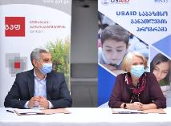
Gudavadze-Patarkatsishvili Foundation grant. On November 11, the Program signed a grant agreement with the Gudavadze-Patarkatsishvili Foundation, a well-known advocate of strong education activities. Collaboration with the Foundation focused on raising public awareness and respect for the teaching profession through regional advertising campaigns and competitions to recognize top-performing teachers in three target regions: Imereti, Kvemo Kartli, and Kakheti.
Zurab Kervalishvili, GPF, and Nancy Parks, Basic Education Program, signing the grant agreement
In January, the Program initiated the Regional Teacher Recognition Awards competition in three regions supported by GPF. University trainers disseminated information among schools on the award categories, selection indicators, required documentation, and timeline. University trainers collected the nomination packages at the end of April. A jury comprised of Program, GPF, and MOES representatives selected the winners in mid-May.
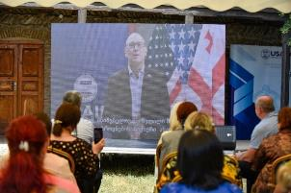
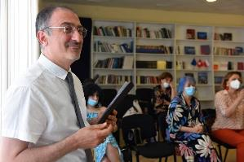
The Program conducted regional recognition ceremonies throughout Georgia. Each ceremony received significant local media coverage.
USAID Mission Director Peter Wiebler providing opening remarks at the ceremony in Shida Kartli
Paata Papava, who served as emcee of all events, in Kutaisi
Under the GPF grant, each winning teacher received an electronic tablet. The University of Georgia provided tablets for the winners from its regions of responsibility: Tbilisi, Racha Lechkhumi, and Shida Kartli. The winning teachers will be featured in an advertising campaign, sponsored by GPF, that promotes teaching as a profession and focuses on the importance of children having outstanding teachers in the foundational years of their education. The campaign will begin in Y3. The current grant period with GPF will end in Dec 2021. Future cooperation has not been discussed.
To ensure all primary teachers in Georgia had an opportunity to be recognized, the Program sponsored the competition in the eight remaining regions. Twenty-four reading and math teachers from eight remining regions were recognized during the ceremonies. GlobalPharm and University of Georgia sponsored tablets for the Racha-Lechkhumi-Kvemo Svaneti, Tbilisi and Samtskhe-Javakheti winners.
The ceremonies proved to be inspirational and rewarding, confirming the impact that recognizing outstanding teachers regionally had. Speakers included the USAID Mission Director’s taped remarks, mayors of the cities, Education Resource Center principals, and
university grantee trainers. Winners of the Regional Teacher Awards are listed in Annex E.
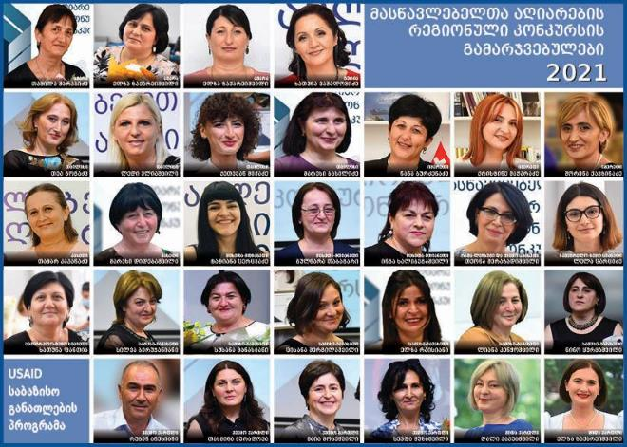
All 31 winners of the regional teacher awards

Business Leaders’ Roundtable. On December 22, the Program organized its first Business Leaders Round Table. Eight Tbilisi-based companies and USAID representatives participated in the online meeting. The main topic of discussion was private sector insights into the soft skills needed in the Georgian workforce. The companies shared their thoughts on the skills the education system needs to begin teaching from an early (primary) stage.
Table 21: Private Sector Participants in Business Leaders Round Table
Company Name | Business Profile | Representative | Position
Finca Bank | Banking | Mariam Esebua | Head of Marketing
Agro Import LLC | Logistics | Giorgi Sturua | Founder, CEO
Letterato | Education | Tamar Razmadze | Founder, Director
Crystal | Microfinance | Archil Bakuradze | Executive Chairman
Georgian Progress Group | Consulting & Event Management | Mikhail Samkaradze | Executive Director
DIO | Window & Door Technologies | Tamaz Daushvili | General Director
ROY Group | Consulting | Simon Ormotsadze | Chairman
Kings Georgia | Education | Giorgi Chalaganidze | Head of Marketing

Regional Business Leaders’ Round Tables were also held in Imereti, Samegrelo-Zemo Svaneti, and Adjara regions. Ten private sector companies attended the meetings. During the meetings, private sector representatives and the Program’s staff discussed challenges that employers are facing with their workforce, particularly the skills that the employees should be equipped with when applying for jobs. Companies listed the following common skills gaps:

- Basic Computer Skills
- Ability to adapt to new environment
- Poor math and reading skills
- Sense of responsibility
- Analytical thinking
- Disconnect between education system and labor market
- Leadership skills
- Low productivity of workforce
- Lack of motivation
- Communication skills
- Financial literacy and entrepreneurial skills
- Problem solving skills

While many of these skills require serious focus in the upper grades, primary teachers can lay a solid foundation in work habits, critical thinking, and problem solving.
Private Sector Engagement. The Program has engaged over twenty private sector companies which have expressed an interest in supporting education activities.
Table 22. Private Sector Companies
 | Location | Company Name | Business Type | Contact Name | Position
1 | Tbilisi | TBSC | Consulting | Paul Clark | President
2 | Tbilisi | Smartex | IT | Tengiz Lashkhi | Executive Director
3 | Tbilisi | Georgian Progress Group | Management Consulting | Misha Samkharadze | Executive Director
4 | Tbilisi | Finca Bank | Banking | Mariam Esebua | Head of Marketing
5 | Tbilisi | Agro Import LLC | Logistics | Giorgi Sturua | Founder, CEO
6 | Tbilisi | Letterato | Education | Tamar Razmadze | Founder, Director
7 | Tbilisi | Crystal | Microfinance | Archil Bakuradze | Executive Chairman
8 | Tbilisi | DIO | Window Technologies | Tamaz Daushvili | General Director
9 | Tbilisi | ROY Group | Consulting | Simon Ormotsadze | Chairman
10 | Tbilisi | Kings Georgia | Education | Giorgi Chalaganidze | Head of Marketing
11 | Samegrelo | EVROFOOD, SPAR | Retail | Giorgi Narmania | Founder
12 | Samegrelo | Keksia | Agrobusiness | Mari Kodua | Owner
13 | Samegrelo | Agrohouse | Agrobusiness | Maia Mikava | Owner
14 | Adjara | Progress Schools | Education | Nino Chikvaishvili | Founder
15 | Adjara | Anagi | Construction | Nino Jashi | Sales Officer
16 | Adjara | Basis Bank | Banking and Finance | Tamta Nutsubidze | Manager
17 | Kakheti | Tamar Mikeladze | Artizan Products | Tamar Mikeladze | Owner
18 | Kakheti | Alali | Juice Factory | Gocha Ghvinephadze | Owner
19 | Kakheti | Gocha Ghaghashvili | Cheese Production | Gocha Ghaghashvili | Owner
20 | Kakheti | Iuri Mikelashvili | Wine Cellar | Iuri Mikelashvili | Owner
21 | Kakheti | Giorgi Latsabidze | Berry Production | Giorgi Latsabidze | Owner
22 | Samtskhe-Javakheti | GLOBALPHARM | Pharmaceutical | Anton Obolashvili | Founder
23 | Samtskhe-Javakheti | Nail Story | Saloon | Natia Lomidze | Founder
24 | Samtskhe-Javakheti | Eikon Development | Construction | Gia Petashvili | Director

Parental Engagement
At the request of USAID, the reading team presented a webinar on May 25 for teachers and parents entitled “School and Family: Contributors to Literacy for All Children.” The topic dealt with how to make reading an entertaining and useful process for children and how to help primary students become good readers.
During the webinar, facilitators shared selected activities that work well both in the classroom and family environments. These included read-aloud activities, shared reading activities, classroom readers’ club and the Write Something application. By end of June, the webinar had accumulated over 7.5K views and many positive comments.
“Read for 15” campaign. The celebrated International Literacy Day with a “Read for 15” activity. On Sep 8, between 1 and 1:15 PM, the Program’s reading specialist went online to ask everyone to stop whatever they were doing to read any type of reading material for 15 minutes. Participants sent “selfies” of themselves reading. The activity garnered a significant public response by reaching 6,311 people, shared 539 times, and having approximately 1,000 photos posted. The overwhelming postive response has prompted the Program to make “Reading for 15” an annual event.
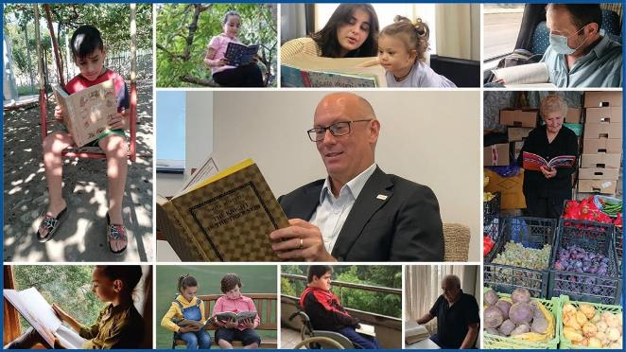
Collage of "Reading for 15" participants posted on the Program's Facebook page.
Table 23: “Read for 15” statistics
Reach | Likes | Comments | Shares | Link Clicks | Photos received
6,311 | 2394 | 804 | 539 | 5011 | 1000+

Vaccination Advocacy Campaign. The Program used its Facebook page to promote the COVID-19 vaccine. Program staff, trainers, and award-winning teachers posted photos and testimonials in support of vaccinations for all Georgians, particularly teachers. The theme was “Spread knowledge, not the virus,” which the Program posted on a frame for people to use to post their advocacy of the vaccination.
People willingly posted their photos in the frame to show support for the vaccination campaign.
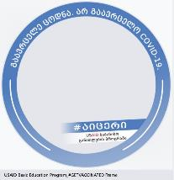
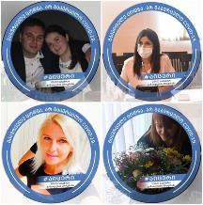
Frame with theme for people to use when they posted their photos on Facebook
Examples of posted photos

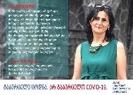
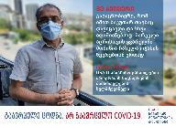
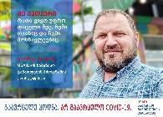
The Program also used quotes from Program staff and teachers to promote vaccinations.

Communications
During Y2 The Program’s Communications launched the following campaigns to reach more people, build an audience and engage visitors on the Program’s Facebook page.
- #გაიცანითპარტნიორები (Meet our partners): 8 partner universities and 2 NGOs were introduced to the audience highlighting their role, scope of work and activities in the framework of the Program.
- #მასწავლებლისსამახსოვრო (Notes for teachers): 5 posters with significant quotations were published on our Facebook page. In total they were shared by 221 visitors
- During the campaign #მასწავლებელთააღიარებისკონკურსი (Teacher Recognition Award) 52 Facebook posts were published. The Program created Google site – space where detailed information about the Teacher Recognition Competition is published in Georgian, Azeri, and Armenian languages. Quotations from Jury members, interviews with them, 10 featured videos of award-winning teachers were posted on the Facebook page and YouTube Channel. Playlist “The Regional Teacher Recognition Award” was created on the Program’s YouTube channel https://www.youtube.com/watch?v=4yqyAeo8I5s&list=PLHz1R9entLOYtSnzTMD1Zek3Rln4NHWbN The videos have 80,000 views in total. The awarding ceremonies from Kakheti, Imereti, Shida Kartli, Kutaisi and Tbilisi were livestreamed on the Program’s Facebook page so that the visitors could watch the ceremony in real time.
- #წიგნისმეგობრები (Book Buddies): Book Buddies’ videos produced by the program were posted on the Facebook page. They have up to 10,000 views in total. To increase visibility of the Program’s activities a playlist “Book Buddies” was created on the Program’s YouTube channel https://www.youtube.com/watch?v=9FOmzsxStwI&list=PLHz1R9entLOY6uxU3XOYJBcqg7eqh_NYn
- 6 instructional videos filmed by the Program were posted on the Facebook page. The videos have more than 33,000 views in total.
- In total, the Program posted 195 times on the Program’s Facebook page https://www.facebook.com/USAIDEDU . The Program’s Facebook page was promoted by sending a brief description and the link to more than 12,000 active users of LMS. The content was also shared to the different thematic groups and pages on Facebook. The numbers reached by each post, followers and likes dramatically increased throughout the last year.
Table 24: Number of people reached in Y2
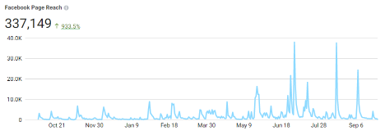
Table 25: Total Facebook page followers in Y2

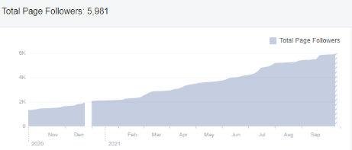
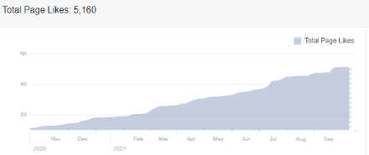
Table 26: Total likes of the Facebook page in Y2

- The Program engaged mass media to promote the Regional Teacher Recognition Competition and communicate the Program’s goals and upcoming activities to the broader public. The stories about the events and winners were aired / published by the leading media outlets of the country:
Table 27: Y2 Media
# | Media | Source
1 | Information Agency Interpressnews | https://www.interpressnews.ge
2 | TV and Radio Broadcaster IMEDI | https://TVIMEDI
3 | E-newspaper TOPNEWS | http://topnews.com.ge/
4 | TV Broadcaster Mega TV | https://www.facebook.com/MEGATV
5 | TV Broadcaster Rioni TV | http://rionitv.com
6 | E-newspaper Region Kvira | http://region.kvira.ge
7 | E-newspaper TOPNEWS | http://topnews.com.ge
8 | TV Broadcaster Mega TV | https://megatv.ge
9 | TV and Radio Public Broadcaster | https://1tv.ge
0 | TV and Radio Public Broadcaster | https://1tv.ge/news/
11 | E-newspaper Edu.aris.ge | https://edu.aris.ge/news/
12 | TV and Radio Broadcaster IMEDI | https://www.IMEDITV
13 | TV Broadcaster EURONEWSGEORGIA | https://www.EURONEWSGEORGIA
14 | TV Broadcaster TV9 | https://tv9news.ge/
15 | Information Agency IPRESS | https://ipress.ge/new/usaid
16 | E-newspaper SKNEWS | https://sknews.ge
17 | TV and Radio Broadcaster IMEDI | https://www.TVIMEDI
18 | E-newspaper ETALONI | https://www.etaloni.ge
19 | E-newspaper AKHALIGANATLEBA | https://akhaliganatleba.ge/

Management and ADMINISTRATIVE UpdatES

Staffing
Lasha Gatchava joined the Program as the Finance/Administration Manager on October 1.

Short-Term Technical Assistance (STTA)
- Giorgi Chauchidze (April 2020 – August 2021), who in collaboration with the Literacy Team, works with CCIIR on development of instructional and training resources
- Lasha Kokilashvili and Ilia Mestvirishvili (September 2020 – September 2021), Moodle Administrators, continue to work on the LMS development, with the focus on training the newly recruited LMS Administrator for the gradual hand-over of LMS related tasks
- Giorgi Molodinashvili (August 2020 – September 2021), Video Production Manager, continues to support the Program to design, produce and finalize various video products
- The Program engaged the company Mrgsoft Ltd with Giorgi Kupatadze as the representative, to develop the offline diagnostic assessment.
- Four Armenian math trainers, four Azeri math trainers, two Armenian training assistants and two Azeri training assistants were engaged starting from January 15 to provide a 4-day (24 -hour) Teams-based online training to approximately 570 Armenian and 710 Azeri teachers during February – May 2021 period
- Salome Charkviani (February – September 2021) was contracted as a short-term Inclusive Education Specialist to work with CFS and provide technical assistance to CFS and the Program on inclusive education component
- Giorgi Zhvania (March 2020 – February 2022) was contracted as a part-time Learning Management System Administrator to provide technical support to the LMS and LMS users, upload content, and design Moodle-compatible online courses
- In April, Nino Chubinidze joined the Program on April 17 as the part-time Assessment Coordinator and will be on board to coordinate field assessment activities and liaise with RTI home office and local stakeholders.

Grants
Universities: By the end of December 2020, all university grantees had successfully completed the Year 1 grant deliverables while the University of Georgia continued to implement its subcontract on schedule. The Program received USAID approval in January 2021 for the follow-on grant agreements with university partners. The follow-on (Y2) grants were signed with the universities on January 27 during an online ceremony, followed by an orientation meeting on Feb 4. August 26, Program specialists met with CFS, CCIIR, and the seven university grantees to review the tasks for the next follow-on grants which were approved by USAID on Sep 21, 2021. The Program expects the follow-on grants to be signed in October 2021.
CCIIR. The Program granted CCIIR an extension of the first rant to complete development of supplementary readers. During the extension period, CCIIR submitted new supplementary materials (11 books in Armenian and 11 books in Azeri). The submission completed the Y1 deliverables. The follow-on grant for Y2 was signed on March 4. By Sep 2021, CCIIR had completed all activities. During the grant period the Program met with the CCIIR to discuss the delay in producing materials and meeting deliverable timelines. The pace of deliverable submission increased but the Program still had concerns over the NGO’s ability to meet grant obligations. Despite the numerous challenges with CCIIR, a follow-on grant was issued on Oct. 1, 2021.
CFS. CFS requested a no-cost extension of its first grant to complete dubbing videos in Azeri and Armenian. The process was delayed due to pandemic travel restrictions which prevented the Azeri and Armenian speakers from traveling to Tbilisi for taping. The Year 2 follow-on grant was signed on Mar 4. The Y3 follow on was approved on Sep 21 and will be singed on Oct. 1.
One significant challenge with the grants program is the system for awards management (SAM) registration. SAM registration is required for all grantees who receive U.S. government awards above $25,000. Two NGOs and two universities have been registered. The Program will continue working with remaining universities to complete the registration process in July-August period, in time for awarding the Year 3 grants. The process requires an English speaker with knowledge of university financial systems to complete the registration. Some of the grantees spent months trying to complete the registration.

LESSONs LEARNED
Lessons learned from Y2 include the following:
- Program staff must avoid assuming the capacity of universities and NGOs is sufficient for activity implementation. The universities and NGOs require simple tools and specific guidance, provided by the Program, to facilitate their training programs. Some of the institutions and organizations have limited experience implementing grants with such a broad scope. Additional consultation meetings with university representatives were effective in correcting misunderstandings.
- Challenges resulting from COVID-19 restrictions continue. The Program must remain flexible to adapt to sudden changes in travel within and outside Tbilisi.
- The NSM team has not finalized the template for reading teachers to use to develop instructional units. Therefore, the Program will postpone revisions to the completed units until the template has been finalized. Trying to keep pace with the NSM changes is frustrating to both the Program and university partners.
- The ethnic minority trainers require additional training to understand all concepts to be introduced to the teachers.
- While the number of LMS users has been steadily growing from 86 in December 2020, to 7,786 on March 31, and to 12,704 by September 30, the Program needs to promote it more vigorously.
- Implementation of effective coaching in schools is heavily dependent on preparation of trainers in three key areas: selecting the best combination of coaching and mentoring modes based on individual needs of the Lead Teacher, making the session as useful as possible for practical application to TLC meetings and classroom work, running the sessions effectively in a synchronous online format. Providing useful support in all these areas helps build the confidence of both trainers and teachers.

Annex A: University Self-Assessment
Results of the university self-assessments universities are below. Only seven universities responded to the indicators as the University of Georgia does not have the degree programs. The numbers in each column represent the number of universities that claim to offer the course.

Our pre-service program (300 or 60 credit program) contains the following content in the courses designed specifically to prepare pre-service teachers to teach at the primary level.
Item # | Indicator | YES |  |  | NO
Item # | Indicator | 300- credit | 60- credit |  | 300- credit | 60- credit
General Curriculum Design
1 | Instructional design of primary curriculum | 5 | 1 |  | 3 | 3
2 | How children learn to read: basic reading skills | 7 | 1 |  |  | 3
3 | How children learn to do math: basic math skills | 7 | 3 |  |  | 1
4 | How to emphasize STEM (Science, Technology, Engineering, and Math) subjects in the primary classroom | 7 | 2 |  |  | 2
5 | Promoting gender equity in the primary classroom | 2 |  |  | 5 | 4
6 | Applying different teaching strategies to help students acquire life skills | 5 | 1 |  | 2 | 3
Student-centered learning
7 | Fundamentals of student-centered learning in primary education | 7 | 3 |  |  | 1
8 | Characteristics of the age-related differences in learning among primary students | 7 | 3 |  |  | 1
9 | Designing learning activities considering age-related differences | 5 | 1 |  | 2 | 3
10 | Ensuring problem solving and critical thinking activities are included in classroom instruction | 4 | 1 |  | 3 | 3
11 | Supporting different learning styles: Differentiated instruction and remediation for primary students | 6 | 2 |  | 1 | 2
12 | Integrating a wide range of resources into the teaching activity to engage students in their own learning process and to help them know themselves and others | 2 |  |  | 5 | 4
Assessments
13 | Differences among formative, diagnostic, and summative assessments | 6 | 3 |  | 1 | 1
14 | Delivering effective feedback to students following assessment | 6 | 3 |  | 1 | 1
Classroom Management
15 | Creating a Productive Classroom: Classroom management in the primary classroom | 7 | 3 |  |  | 1
16 | Applying different communication techniques to foster collaborative learning | 5 | 1 |  | 2 | 3
Inclusive Education, Georgian as a Second Language, Mother Tongue Instruction
17 | Inclusive education for students with disabilities | 7 | 3 |  |  | 1
18 | Reaching marginalized students | 2 |  |  | 5 | 3
19 | Mother tongue instruction for ethnic minority students |  |  |  | 7 | 4
20 | Georgian-as-a-second-language instruction | 1 | 1 |  | 6 | 3
21 | Fundamentals of bilingual instruction | 1 |  |  | 6 | 4
Parental Engagement
22 | Productively engaging parents of primary students | 4 | 1 |  | 3 | 2
Technology
23 | Technology for learning and teaching in the primary classroom | 7 | 2 |  |  | 2
University Program
24 | The university offers action research in which professors and pre-service teachers jointly research topics. | 7 |  |  |  | 4
25 | The university pre-service program offers opportunities for the pre-service teachers to practice their skills in schools. | 6 | 3 |  | 1 | 1
26 | The university pre-service program facilitates communities of practice in which all participants can acquire new knowledge and at the same time shape their understanding of primary education in Georgia. | 4 | 2 |  | 3 | 1

Annex B: PRINCIPALS’ ENGAGEMENT Survey Results
This questionnaire was completed in by 45 trainers who worked with principals.

- How would you characterize the participation of the principals in your assigned schools?
- All principals in my assigned schools were very enthusiastic about the Program
- Most of the principals in my assigned schools were enthusiastic, but some principals did not participate
- Many of the principals in my assigned schools allowed us to conduct activities but were not eager to participate in any principal activities
- Very few of the principals in my assigned schools participated in activities
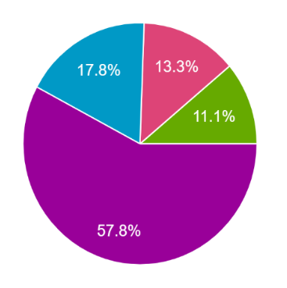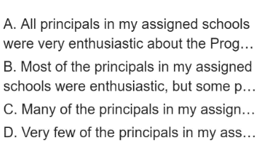

Comments:
- It would be good for the principals to have training at this stage as well.
- There is a lot of interest in the project, the motivation of the principals is high.
- Part of the principals, at first, found it difficult to comprehend how important these trainings were to their schools, but gradually became convinced of the validity of our training, and today we thank the USAID Basic Education Program and our team for such an opportunity.
- For example, teachers attended training sessions, principals were interested, some were not interested at all.
- All principals expressed a willingness to engage in program activities, were aware of the program objectives and were willing to assist the TLC in providing resources for the workshops. In addition, some principals attended the online meetings asked questions, and participated in activities.
- They liked the activities we offered, tried their best to make their teachers work in teacher training groups.

- What was the main reason that principals did not want to participate in the activities designed specifically for them?
- Not relevant to their job
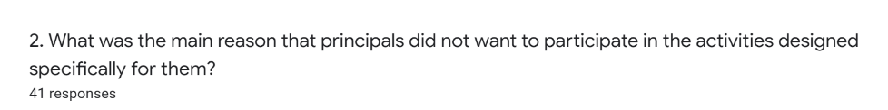
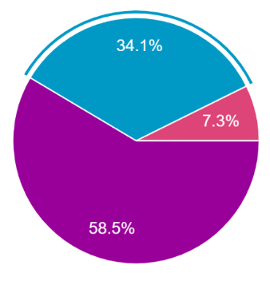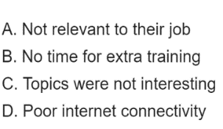
- No time for extra training
- Topics were not interesting
- Poor internet connectivity

Comments:
  - The problem was the weak Internet and the competencies required for online communications by some of the principals.
  - The main problem was lack of the time.
- At first, they thought it was just a "New School Model", so they thought it would be the same training as the Ministry of Education and Science.

- What did the principals enjoy most about the activities?
- Participation in the training sessions
- Online coaching visits
- Formation of Teacher Learning Circles
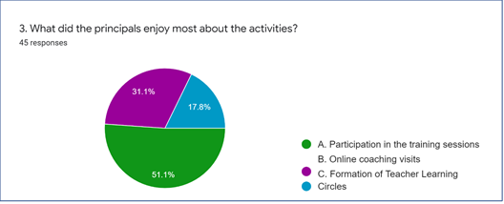

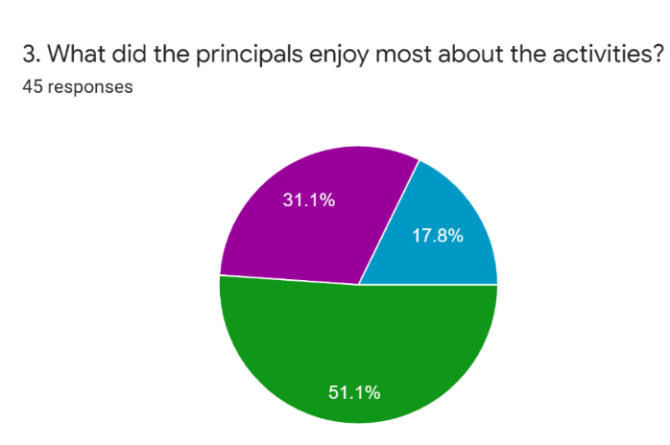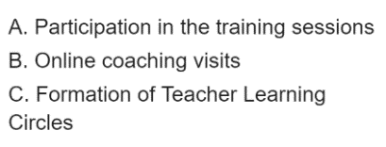

Comments:
- Principals requested the group meetings for sharing experience and discussion.
- Formation of TLC was the most supported by the principals.
- Most of the principals were interested in both training sessions and participation in coaching online visits.
- Particularly interesting and fascinating was the fact that throughout our training, the leading teachers in the school were constantly meeting and discussing training issues, planning various meetings and activities.

What suggestions did any of the principals make to improve the program?
Suggestions the principals made:
- Minority principals requested to take into consideration weak internet, their low IT skills, and bad knowledge of the state language.
- Many of them demand improvement of internet connection frequency, equipping schools with technological resources and only then declare readiness for news (as some principals say, some schools have only one personal computer, no internet, teachers do not have technological skills).
- Some principals requested face-to-face training because of lack of IT skills.
- Principals requested more coaching.
- Principals recommended to add new topics for their training.
- Principals recommended to keep the same trainers for training and coaching as well to make teachers feel comfortable in communication with university representative.
- Principals requested to includes all activities for teachers conducted by the program in MOU with TPDC to keep chance to recognize them.
- Principals were willing to conduct similar trainings frequently.
- Principals requested more resources and materials in Armenian and Azeri.
- Some principals requested narrative text of whole training.
- Principals asked to have more hours during the training on complex task, inclusive education.
- Principals recommended to university to conduct research-based conference or seminar.
- Principals liked private sector engagement in the school life.
- Principals recommended to invite businessmen to school and talking about successful careers - this will increase students' motivation, conversations about literature and art, it would be good if a "reading hour" is set and any famous businessman reads his favorite book to students at school, etc. Business involvement will have the other side as well. If necessary, the business will have the opportunity to provide financial support to a particular school in terms of training resources, stadium, or any specific problem.
- It would be best for all elementary school teachers to be able to get involved in our program. Some expressed the desire that the process would be much more beneficial in the face-to-face training. We have had cases when an offer to sign a memorandum of cooperation came directly from the school.
- Principals requested all primary grade teachers to be trained by the Universities.
- The involvement of ERSs is important for the sustainability and continuation of all activities at school.
- It is an important to have close cooperation between university and school.
- Principals requested more information about TLC.
- Principals prefer to receive a package of the training topics and select the most interesting theme for them. Principals do not have a lot of time for whole training, and it would be good to have an opportunity to decide undependably which training they will attend.
- Several principals requested to attend the teachers training.
- Principals recommended to provide an even more specific and diverse methodology to help develop critical thinking, as well as developmental assessment methods and tools.
- I would mainly emphasize six categories of schools:
  - The schoolteachers involved in the new school model have been very busy with a lot of training and our assignments.
  - Even for those schoolteachers who were not involved in the new school model, it was relatively difficult to work on thematic units.
  - In small contingent schools, working groups were either not available by subject, or due to a shortage of teachers, work was done between two teachers.
  - The schools involved in G-PriEd noted that these issues are familiar and uninteresting to them.
  - Special Schools noted that more if it would be tailored to their needs would be better.
  - Mountain schools had difficulty attending training due to internet problems.
- Principals want their work in this program to be reflected in compulsory hours just as they have been in the case of leaders, as some of them are also teachers and they also need to collect compulsory hours to maintain status.

ANNEX C: LMS ANALYTICS
Total users
Primary Teacher | 7512 | 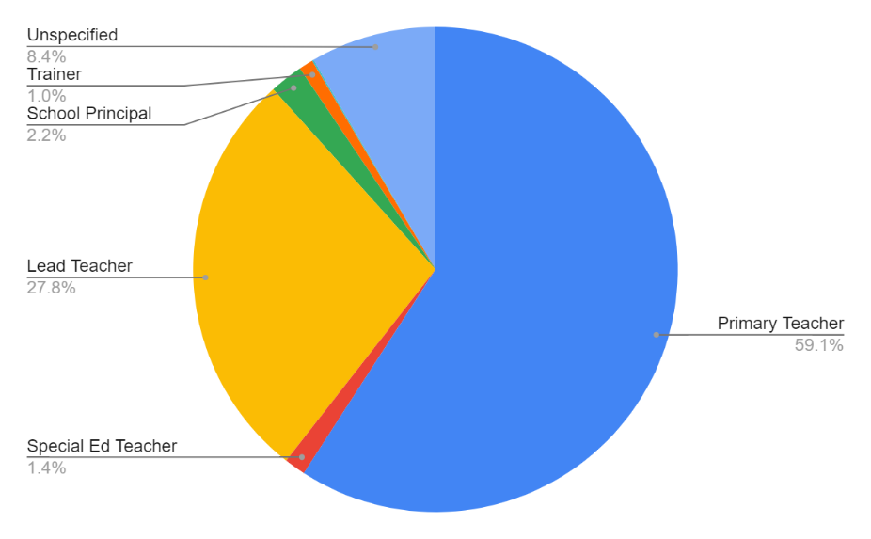
Special Ed Teacher | 181
Lead Teacher | 3526
School Principal | 282
Trainer | 121
Training-Provider | 13
Unspecified | 1067
Total Users | 12702

User distribution by Regions
Adjara | 1023 | 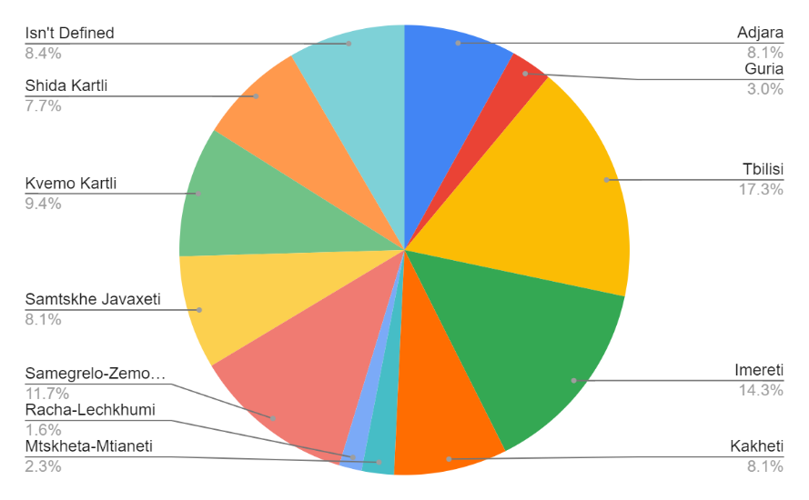
Guria | 380
Tbilisi | 2193
Imereti | 1815
Kakheti | 1034
Mtskheta-Mtianeti | 295
Racha-Lechkhumi | 207
Samegrelo-Zemo Svaneti | 1487
Samtskhe Javakheti | 1035
Kvemo Kartli | 1194
Shida Kartli | 972
Isn't Defined | 1067

User distribution by Gender
Female | 11188 | 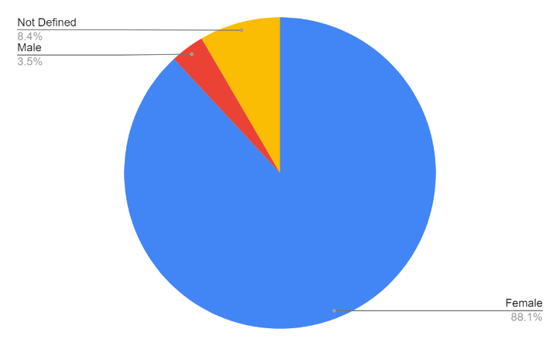
Male | 447
Not Defined | 1067
Activities by users
Red | Non-editing teacher stands for the Trainers of partner Universities and NGOs
Blue | Student stands for primary education Teachers
Orange | Undefined Users are those, who did not specify their role, when creating a profile during the registration process

This chart shows number of users from the three major categories, who have used the LMS between July 11 and beginning of October 2021. The chart demonstrates the impact of the summer vacation period on the level of users’ engagement.
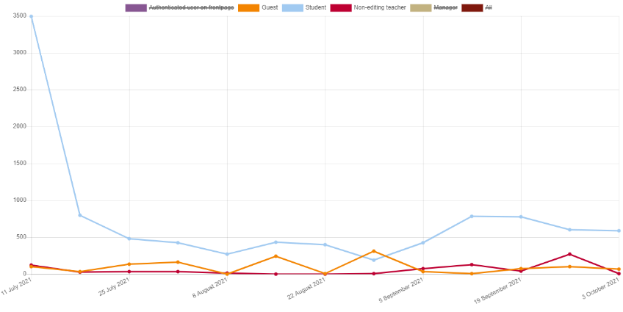

TLC meetings organized by Lead Teachers by regions and Universities between February and June 2021
Imereti by Kutaisi University | 1066 | 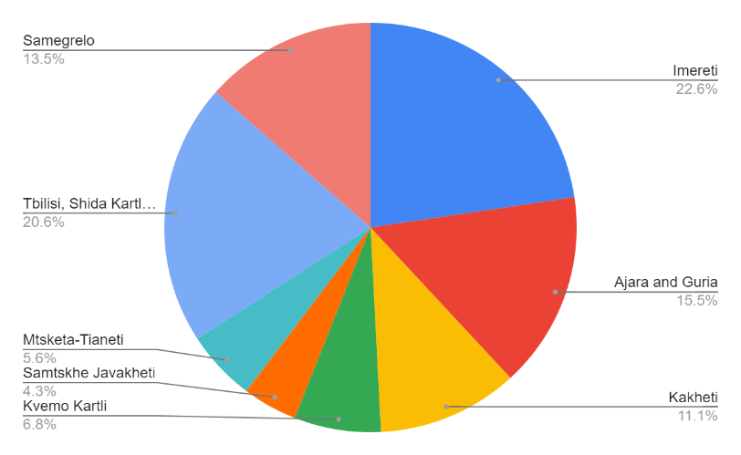
Ajara and Guria by Batumi University | 730
Kakheti by Telavi University | 521
Kvemo Kartli by Ilia University | 320
Samtskhe Javakheti by Samtskhe-Javakheti University | 202
Mtskheta-Tianeti by Sokhumi University | 263
Tbilisi, Shida Kartli, Racha-Lechkhumi by University of Georgia | 972
Samegrelo by Zugdidi University | 636

Number of resources viewed and/or downloaded in category “Resources for Math Teachers”
Math, grade 3, Georgian | 12887
Math, grade 2, Georgian | 12769
Math, grade 1, Georgian | 10187
Math, grade 5, Georgian | 6679
Math, grade 4, Georgian | 6568
Math, grade 6, Georgian | 4511
Math, grade 3, Azeri | 2059
Math, grade 1, Armenian | 1004

Number of resources viewed and/or downloaded in category “Resources for Reading Teachers”
Reading, grade 2, Georgian | 14690
Reading, grade 3, Georgian | 11953
Reading, grade 1, Georgian | 10822
Reading, grade 4, Georgian | 9864
Reading, grade 5, Georgian | 6537
Reading, grade 6, Georgian | 5912
Reading, grade 1, Armenian | 1210
Reading, grade 2, Armenian | 825

Number of resources viewed and/or downloaded in category “Resources for Student-Centered Instruction”
Thematic Unit development | 3705
Teacher Learning Circle facilitation | 2915
Differentiation | 1692
Assessment | 1510

ANNEX D: RESULTS OF SURVEY OF 21st Century Workforce skills

Company |  |  | Sector Participation | %
1 | Soko |  | Agriculture | 26.3 %
2 | LLC Gela |  | Banking | 10.5%
3 | Tsereteli University |  | Construction | 0%
4 | VTB Bank Georgia |  | Hospitality/ Restaurants | 21.1%
5 | LTD Twenty First Century |  | Sales | 15.8%
6 | PMAG Cluster |  | Technology | 15.8%
7 | Hotel Like |  | Tourism | 5.3%
8 | LTD Eurofood |  | Other | 15.8%
9 | I.E. Tamar Mikeladze
10 | Winery Aguna
11 | LTD Achinebuli
12 | Basis Bank
13 | Abkhazian Trade Association
14 | LTD Family Medical Center
15 | LTD Atelier Mia
16 | LTD Health Center Abkhazia
17 | Social Enterprise Dadari
18 | Clinic Health

SURVEY RESULTS
 | Indicator | Very important | Somewhat Important | Not Too Important | Not important at all
Which of the following skills do you consider important when hiring someone?
1 | The ability and willingness to learn new skills | 63.20% | 36.80%
2 | Critical thinking and problem-solving skills | 78.90% | 21.10%
3 | Collaboration and teamwork skills | 57.90% | 36.80% | 5.30%
4 | Ability to meet deadlines | 52.60% | 36.80% | 10.60%
5 | Interpersonal communication | 63.20% | 31.60% | 5.20%
6 | Ability to analyze and synthesize information | 63.20% | 31.60% | 5.20%
7 | Subject matter expertise in the sector | 42.10% | 36.80% | 21.10%
8 | Ability to develop and implement a strategic plan | 15.80% | 52.60% | 26.30% | 5.30%
9 | Strong skills in business processes | 10.50% | 63.20% | 26.30%
10 | Project management | 15.80% | 47.40% | 31.60% | 5.20%
11 | Social media and online communication skills | 21.10% | 36.80% | 36.80% | 5.30%
12 | Strong IT skills, including expertise in Word, Excel, PowerPoint, and online communications such as MS TEAMS or ZOOM | 31.60% | 47.40% | 15.80% | 5.20%
13 | Strong mathematical skills | 10.50% | 63.20% | 26.30%
14 | Strong organizational skills | 21.10% | 52.60% | 26.30%
Most Important Overall Hiring and Promotion Skills
15 | Past work experience | 21.10% | 52.60% | 26.30%
16 | Formal education and the degree they have | 26.30% | 47.40% | 26.30%
17 | Experience in managing people | 21.00% | 63.20% | 15.80%
18 | Communication skills | 68.40% | 31.60%

ANNEX E: REGIONAL TEACHER RECOGNITION WINNERS
Event Location | Region | N | Teacher Name | Category | Language | School
Kutaisi | Guria | 1 | Khatuna Vashakmadze | Math | Geo | Chokhatauri, V. Qvabghi School
Kutaisi | Guria | 2 | Mzia Adadze | Reading | Geo | Chokhatauri, V. Qvabghi School
Kutaisi | Adjara | 1 | Elza Zakareishvili | Reading | Geo | Batumi N1 School
Kutaisi | Adjara | 2 | Tamila Sharabidze | Math | Geo | Batumi N1 School
Kutaisi | Racha-Lechkhumi-Kvemo Svaneti | 1 | Teona Sherazadashvili | Reading | Geo | Oni School
Kutaisi | Samegrelo Zemo-Svaneti | 1 | Lela Tsartsidze | New Reading | Geo | V. Ieli School
Kutaisi | Samegrelo Zemo-Svaneti | 2 | Khatuna Pantia | Reading | Geo | Zugdidi N2 School
Tbilisi | Kvemo Kartli | 1 | Sevda Muzashvili | Reading | Aze | Bolnisi, V. Darbazi School
Tbilisi | Kvemo Kartli | 2 | Takhmina Muradova | Math | Aze | Dmanisi, V. Amamlo School
Tbilisi | Kvemo Kartli | 3 | Maia Moseshvili | Reading | Geo | V. Kazreti School
Tbilisi | Kvemo Kartli | 4 | Ruben Anesiani | Reading | Arm | Tsalka, V. Ozni School
Tbilisi | Tbilisi | 1 | Ledi Eliashvili | Math | Geo | Tbilisi N71 School
Tbilisi | Tbilisi | 2 | Tea Gogadze | New Math | Geo | Tbilisi N90 School
Tbilisi | Tbilisi | 3 | Ketevan Mikadze | New Reading | Geo | Tbilisi N106 School
Tbilisi | Tbilisi | 4 | Marekhi Basiladze | Reading | Geo | Tbilisi N151 School
Tbilisi | Mtskheta-Mtianeti | 1 | Tatiana Tsertsvadze | New Reading | Geo | Mtskheta N1 School
Tbilisi | Mtskheta-Mtianeti | 2 | Inga Khalibegashvili | Reading | Geo | V. Tserovani N3 School
Tbilisi | Mtskheta-Mtianeti | 3 | Gulnara Tabagari | Math | Geo | Mtskheta N1 School
Tbilisi | Samtskhe-Javakheti | 1 | Silva Berudjanian | Reading | Arm | Akhalkalaki, V. Baraleti School
Tbilisi | Samtskhe-Javakheti | 2 | Elza Raisiani | New Reading | Arm | Akhaltsikhe, V. Tchvinti School
Tbilisi | Samtskhe-Javakheti | 3 | Susana Manasian | Math | Arm | Akhaltsikhe, N3 School
Tbilisi | Samtskhe-Javakheti | 4 | Liana Kenchoshvili | Math | Geo | Akhaltsikhe N1 School
Tbilisi | Samtskhe-Javakheti | 5 | Nino Kurmashvili | Reading | Geo | Akhaltsikhe N1 School
Tbilisi | Samtskhe-Javakheti | 6 | Tsisana Shergilashvili | New Reading | Geo | Akhalkalaki N3 School
Kakheti, Busheti | Kakheti | 1 | Marekhi Didebashvili | Reading | Geo | Sagarejo, v. Gombori School
Kakheti, Busheti | Kakheti | 2 | Tamar Kapanadze | Math | Geo | Akhmeta Public School
Gori | Shida Kartli | 1 | Lia Metivishvili | Reading | Geo | Khashuri N7 School
Gori | Shida Kartli | 2 | Dali Papuashvili | Math | Geo | Gori, v. Akhaldaba School
Kutaisi | Imereti | 1 | Shorena Kavzinadze | Math | Geo | Khoni N3 School
Kutaisi | Imereti | 2 | Nana Burdzenidze | Reading | Geo | Chiatura N4 School
Kutaisi | Imereti | 3 | Kristine Macharadze | New Math | Geo | Kutaisi N33 School

At any given time, back-ups are available only for the last seven days.

