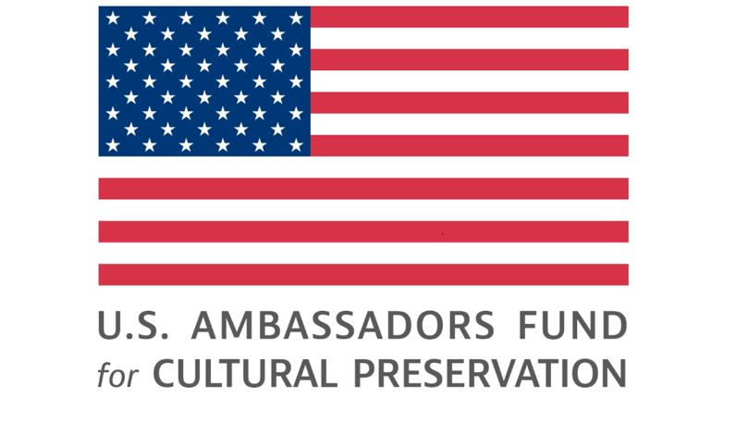

CPAIG 2024
Concept Note Form - Template

Please make sure that you fill all parts of the below form.

PART A – PROJECT BASICS

Project Basic Information
Title of the Project:
CPAIG focus area and category:

AFCP Focus Areas: Cultural Sites, Cultural Objects & Collections, Forms of Traditional Cultural Expression.
Anticipated Project Length (in months):

Applicants may propose project periods of up to 36 months
Location/site:

Ownership status of the object or site:

Please note AFCP does not support preservation or purchase of privately or commercially owned cultural objects, collections, or real property.

Project Cost Estimate (amount requested from CPAIG) in U.S. dollars:

PART B – PROJECT IMPLEMENTER INFORMATION

Project Implementer Information
Organization name:
Organization type:

Address information:
Name, title, and contact information of project director:

Applicant Unique Entity Identifier (UEI) number, NCAGE Code, SAM Registration (Optional for Round I):  Guidelines to help with applying for a UEI, NCAGE and registering with SAM.gov can be found on our website | UEI Number:  NCAGE Code:  SAM Registration: □ YES □ No □ In progress*
*Please note that UEI number, NCAGE Code and SAM registration are required for every organization applying for a U.S. Federal Government grant. But the process may take several weeks. If you haven’t got the numbers and finalized the registration already, for the concept note phase, initiation of these processes will be enough. So please fill in the above status information accordingly.

PART C – PROJECT LOCATION
Project Location
Project site:
City or vicinity:

Brief description of location:

PART D - OFFICIAL PERMISSIONS
Proof of Official Permission to undertake the project (If applicable) | Please list the official permissions you have

PART E – SCOPE OF WORK

Please summarize the project scope of work addressing the following points:
1) cultural property protection activities and goals, 2) related host country or community goals (i.e., what they hope to gain from the project beyond protecting cultural property and how these goals will be achieved), and 3) anticipated strategic outreach activities to build awareness and engage communities and stakeholders. (max. 3000 characters with space)

PART F – PROJECT VISUALS
Please attach 5 to 10 high-quality images (JPEG, PNG, or PDF only) that convey the nature and condition of the site, object, or form of expression and, in the case of a site or object, show the urgency or need for the proposed project (collapsing wall, water damage, worn fabric, broken handle, etc.).

Please list below the names of the visuals you will attach on your email.

PART x – RATIONALE
Please explain why it’s in the interests of the U.S. government to fund the project, specifically:
1) how the project relates to specific National Security Strategy plans, Integrated Country Strategy goals, existing bilateral cultural property agreements or Joint Action Plans (if applicable), emergency import restrictions, or any other U.S. foreign policy objectives (1,000 characters maximum).
2) the projected public diplomacy benefits of the project (1,000 characters maximum).

