U.S. Department of Energy
Office of Fossil Energy and Carbon Management
National Energy Technology Laboratory

Request for Information (RFI) TEMPLATE
DE-FOA-0003075

Title: Facilitating a Domestic Critical Minerals Future: Carbon Ore, Rare Earth, and Critical Minerals (CORE-CM) Initiative

Issue Date: May 17, 2023

Due Date: July 17, 2023

Program Area: Office of Fossil Energy and Carbon Management (FECM)/National Energy Technology Lab (NETL); U.S. Department of Energy (DOE)

This Request for Information (RFI) template is provided as a guide to enable easy answering of the RFI. Although we would appreciate thorough and thoughtful answers to every question, please answer as many or as few questions as you are able to. All input is valuable and helpful, regardless of length.

Company/institution name
Company/institution contact
Respondent’s contact information

QUESTION 1
Q1. | Does continuing with the basin model approach for CORE-CM make the most sense for understanding CM potential for all unconventional and secondary feedstocks or does it make more sense to switch to a regional approach and why?
A1.

Figure 3: Blank Map of the United States, including Hawaii and Puerto Rico
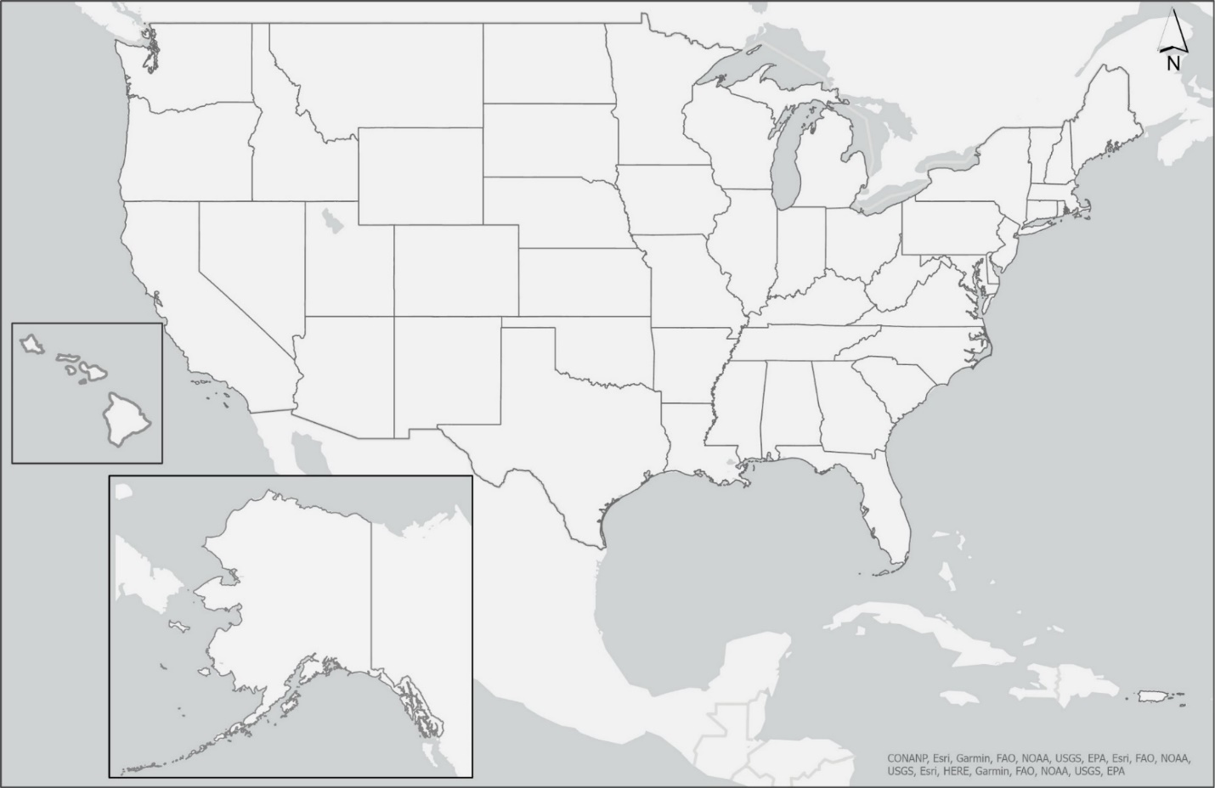
QUESTION 2
Q2a | Do you see public access to data that is non-proprietary and was produced using federal support/funding as a security issue and why?
A2a
Q2b | Would restriction of access to such data inhibit research and innovation of the scientific community and why?
A2b
Q2c | What is an appropriate period of time between collection of data and making it publicly accessible and why?
A2c
Q2d | Would access to such data be necessary for critical mineral cradle-to-grave traceability, and how would it help (e.g., more easily tracing the origin of CM material from feedstock through end-product and recycling/reuse)?
A2d
Q2e | What benefit is there to having standards that can be referenced not only CORE-CM awardees and other government agencies, but the wider CM community for the collection of critical mineral data (e.g., work being done under the 2020 Action Plan, or standards developed within the International Organization for Standardization (ISO))?
A2e

QUESTION 3
Q3a | What has been your experience so far when engaging with waste site owners considering the possibility of redevelopment of their site?
A3a
Q3b | Who should take on these challenges involved with redevelopment of these sites (e.g., private industry, local, state, or federal governments)?
A3b
Q3c | In your experience, what kind of assistance would be needed from regulators and the government to make redevelopment feasible? Is a ‘good Samaritan’ law sufficient here?
A3c
Q3d | Can you provide case studies from your previous experience in similar land use redevelopment?
A3d

QUESTION 4
Q4a | What hurdles associated with the permitting process have you experienced, or do you foresee?
A4a
Q4b | Please elaborate if you foresee gaining permits for “older” (e.g., pre-Surface Mining Control and Reclamation Act (SMCRA) of 1977) sites as more challenging compared to “newer” (e.g., post-SMCRA) sites or currently active mining operations?
A4b
Q4c | What permitting variation do you anticipate for operations that occur on state or federal land versus private land, or for sites that are at different stages in the remediation/reclamation process?
A4c

QUESTION 5
Q5a | Does this phased approach make the most sense for approaching redevelopment of a CM supply chain in the United States? What do you like or not like about it?
A5a
Q5b | Is there any area that needs more focus and/or additional research?
A5b
Q5c | Are there any components missing from this approach?
A5c
Q5d | Do certain areas need to be fully completed prior to moving on to future phases?
A5d

QUESTION 6
Q6a | If you were to lay out a “roadmap/storyboard” on the necessary steps (permitting, availability of financing, characterization required, etc.) for the development of a CM supply chain, what are the steps you would take?
A6a
Q6b | What other additional criteria are required as part of this roadmap (e.g., workplan, market transformation plan, team and resources, financial, regional economic benefits, quality jobs, environmental justice, diversity, equity, inclusion) and do you foresee certain obstacles?
A6b

QUESTION 7
Q7a | Do you support or see value in the development of a critical minerals and materials “matchmaker”?
A7a
Q7b | Do you know of such systems already in place?
A7b
Q7c | Do you have suggestions on how to design such a system?
A7c

QUESTION 8
Q8 | What regional factors should be included as part of the broader implementation of the CORE-CM Initiative?
A8

Questions Specific to the Community:
QUESTION 9: For the following question consider that the resources of interest (as defined in the list on page 3) may occur on or in proximity to Tribal land and sacred sites, or in proximity to coal mining communities
Q9a | Is there interest in repurposing these resources for both economic and environmental benefit? If not, why?
A9b
Q9b | If so, what level of communication and cooperation is expected from groups involved with the study of these resources?
A9b
Q9c | What types of outreach and engagement strategies are needed to make sure these stakeholders are involved during each phase, and are there best practices for equitably and meaningfully engaging stakeholders?
A9c
Q9d | What issues or challenges do you predict may arise when attempting to study these resources and ultimately develop them?
A9d
Q9e | Are there any current problems your community is facing with regards to legacy waste materials?
A9e

Question 10
Q10a | In what ways, if any, do you anticipate the CORE-CM Initiative could impact the workforce in your community?
A10a
Q10b | What activities and engagement would make the CORE-CM Initiative successful and sustainable in terms of workforce development; worker recruitment; improved diversity, equity, and inclusion across the workforce; and the creation of good union jobs?
A10b
Q10c | What tools should the CORE-CM Initiative utilize to meet the goals of providing opportunities for workers displaced from fossil industries and other industrial or resource-based industries in decline?
A10c
Q10d | What tools should be utilized to ensure good-paying and secure work opportunities for local residents in the construction and long-term operations of projects, especially in disadvantaged communities and in communities that have experienced or will experience job losses due to economic transition?
A10d

Question 11
Q11a | What information do communities, Tribal or State governments, or other stakeholders need to engage with DOE on the CORE-CM Initiative?
A11a
Q11b | What benefits or opportunities could encourage local, State, and Tribal governments to consider engaging with DOE on the CORE-CM Initiative?
A11b
Q11c | How should DOE better engage local, State, and Tribal communities to establish reasonable expectations and plans concerning the CORE-CM Initiative?
A11c

Question 12
Q12a | How can the CORE-CM Initiative ensure community-based stakeholders/organizations are engaged and included in the planning, decision making, and implementation process (e.g., including community-based organizations on the program/project/activity team)?
A12a
Q12b | What barriers exist, if any, for deeper economic and other engagement with communities impacted by CORE-CM Initiative project?
A12b

Question 13
Q13a | Please give input on how the Justice40 policy priorities can be achieved through the CORE-CM Initiative to ensure that 40% of the overall benefits of projects will flow to disadvantaged communities (DACs) and maximize implementation co-benefits.
A13a
Q13b | With concrete example(s), how will regional economic growth and its benefit be shared with underserved populations.
A13b
Q13c | What equity, energy, and environmental justice concerns or priorities are most relevant for the CORE-CM Initiative and how can these concerns or priorities be addressed?
A13c
Q13d | How are adverse impacts currently measured or monitored, and which materials/processes/components result in the largest environmental impact and what opportunities exist to minimize impacts?
A13d
Q13e | Describe possible human health, environmental or ecological considerations, both positive and negative (e.g., are there any air quality impacts, sensitive ecosystems, National Environmental Policy Act (NEPA) issues, environmental justice communities, other considerations) in connection with implementation of this provision.
A13e

Question 14
Q14 | Do you have additional thoughts or comments you have regarding the content above, the CORE-CM Initiative, or topics that may have been missed or glossed over?
A14

