

UNITED STATES
DEPARTMENT OF THE INTERIOR

NATIONAL PARK SERVICE

Survey Bat Community Composition at Hopewell Culture NHP Post White-Nose Syndrome

Authority: 16 USC §1a-2(j), 16 USC §5933 and the 1998 NPS Omnibus Act

Funding Opportunity Announcement
P14AS00114

CFDA No. 15.945
CFDA Title: Cooperative Research and Training Programs – Resources of the National Park System

ISSUE DATE: May 29, 2014

CLOSING DATE & TIME
June 6, 2014, 3:00 p.m., Eastern Daylight Time

NPS Grants Officer Contact Information:
Brian Straka, Agreements Officer
North Administrative Service Unit
Great Smoky Mountains National Park
Phone: 865.436.1217 Fax: 865.436.1220
Brian_Straka@nps.gov

SECTION I. Funding Opportunity Description

A. Project Objectives:
Hopewell Culture National Historical Park (HOCU) is located in south central Ohio and is 1,200 acres in size. Bat communities in all five of HOCU’s units were inventoried in 2004 before the emergence of white-nose syndrome (WNS). The 2004 survey listed seven species as “Present” (Big Brown Bat, Eastern Red Bat, Little Brown Bat, Northern Long-eared Bat, Evening Bat, Eastern Pipistrelle), two species as “Probably Present” (Silver-haired Bat, Indiana Bat) and three species as “Unconfirmed” (Eastern Small-footed Bat, Rafinesque's Big Eared Bat, Mexican Freetail). The primary purpose of this project is to identify the bat species present in the parks post-WNS. The secondary purpose is to conduct public education and outreach via a special public event that will include a night-time interpretive program along with a display at the park’s Visitor Center. Completion of this study will help the park in the Section 7 consultation process with the USFWS, a process which the park is legally tasked to undertake in connection with the Northern Long-eared Bat’s (NLEB) Candidate Species status. In addition it will help guide management actions such as tree removal. Survey results will be published in a Technical Report.

- The primary objective is to document 90% of the bat species expected to occur at the park.
- A quantitative assessment of species relative abundance.
- Determination of reproductive success for observed species.
- Document ancillary habitat data (climate, vegetation type).
- Collection of voucher specimens for observed species according to NPS standards.

B. Project Tasks:

Location: The inventory will include all park units: Mound City Group, Hopeton Earthworks, Hopewell Mound Group, Seip Earthworks, and High Bank Works (Figure 2-Figure 6). All units contain a mixture of vegetation types including agricultural fields, forests, lawn, restored native grassland, riparian corridors and old agricultural/hay fields.

Subunit | Size (approx.) | Strata
Mound City Group | 130 ac | Woods, Scioto River, agricultural, lawn
Hopeton Earthworks | 308 ac | Agricultural, restored native grassland, wood lot, intermittent stream, old field
Hopewell Mound Group | 313 ac | Woods, Sulfur Lick Creek, North Fork Paint Creek, 1/3-acre pond, hay field, old pasture
High Bank Works | 170 ac | Riparian woods, Scioto River, old field, restored native grassland, hay field
Seip Works | 150 ac | Riparian woods, old hay field, Paint Creek
Total | 1070 ac

- Mound City Group is located at 16062 State Route 104, Chillicothe. This site contains five buildings, one mile of trails, and 0.74 mile of road. The entire unit contains 130 acres, with 30 acres actively mowed, 45 acres mowed periodically for hay, 45 acres of early succession mixed mesophytic forest with the rest being developed area. The Scioto River borders the eastern edge of the unit.

- Hopeton Earthworks (Hopeton) is located at the 1100 block of Hopeton Road, Chillicothe. This is one of the largest parcels encompassing approximately 308 acres. A portion of the area, 140 acres, is used for active farming of winter wheat and soybeans. Sixty two acres are restored native grasslands. Another 26 acres is composed of a black walnut grove and an early succession mixed deciduous open forest with an intermittent stream flowing through (Dry Run Creek). The remaining acres are fallow fields or pastures. Currently there is an active gravel mining operation located on the western edge of the property. The Scioto River runs along the western side of the gravel mining operation, with Hopeton on the eastern side of the operation.

- Hopewell Mound Group is located at 4731 Sulfur Lick Road, Chillicothe. An unnamed tributary runs alongside the northern boundary of this 313-acre site, with the North Fork of Paint Creek bordering the southeastern edge and Sulfur Lick Creek bordering the eastern edge. Currently the property is mainly composed of 170 acres of pasture, most of which is shortly mowed. The northern portion of the property includes 37 acres of semi-mature mixed mesophytic forest with a 1/3-acre impoundment located on the eastern edge within these woods.

- Seip Earthworks is located on US 50 near Paint Valley High School, Bainbridge. The southern border of this 150-acre site lies alongside Paint Creek. The majority of the site is a fallow field community. Paint Creek is bordered by a 3-acre wooded riparian corridor.

- High Bank Works is located at the end of County Road 900, off US 35 south of Chillicothe. Approximately half of this 170-acre site is an old alfalfa field and the other half is a restored native grassland. The Scioto River borders the western edge of this property, where a 25-acre mature riparian woodland exists.

Methodology:

- Survey methods
Since the 2004 survey recorded NLEB in all units except Mound City Group, and since there is the potential for Indiana Bats, survey guidelines will follow those set forth by the USFWS for 2014. Bats will be surveyed in all five park units. According to the above guidelines one survey site per unit should suffice. Actual locations shall be determined by the PI’s expert opinion with the possibility of returning to the 2004 locations noted in Table 2 and in Figures 2-6. The PI is responsible for recording any new survey location using GPS and entering them into the database. Mist-nets will be the primary survey method, but acoustic detectors will be placed in these same areas. Qualitative and quantitative analyses for species identifications will be performed on all recorded call sequences. For 2014 the USFWS defined netting season as June 1 - August 15 as these dates delineate acceptable limits for documenting the presence of summer populations of Indiana Bats and NLEB, especially maternity colonies. Habitat assessment forms will be completed using the format of the USFWS 2014 guidelines. Netted female NLEB or Indiana Bats will be banded, fitted with a radio transmitter and followed to the roost. A recording of the hand-release event will be taken for reference.

- Timing
June 25-July 18 shall be the targeted field survey period. If weather conditions delay the survey an extension will be granted. A draft of the final report will be available for NPS review by September 15th. Final report is due by October 15th. Any changes to said schedule must be coordinated with park staff.

- Personnel
The park biologist will work with the PI during the survey and at least one park biological technician will be available as well. The purpose of this is to reduce the cost of the cooperative agreement and to provide training for park personnel for future in-house surveys.

- Acoustic Survey
The PI will use the acoustic survey equipment provided by the park. All acoustic files will be processed with identification to the genus level as a minimum and species level when possible. Auto ID is acceptable as long as it undergoes QA/QC by the PI. The park will provide Bat Call ID (BCID) software with one license.

- Qualitative Assessment of Species Relative Abundance
Each species will be qualitatively placed in one of four or more abundance categories following those in the 2004 survey. Relative abundance asseessments will be based on acoustic surveys and mist nets.

- Determination of Reproductive Success
Basic biological data will be collected for all bats captured including species, sex, age (adult or juvenile), weight and reproductive condition. All animals will be released at the site of capture. An acoustic file for each hand-released bat will be generated and annotated to designate is as a hand-release sequence.

- Biotic and Abiotic Data Collection
Habitat assessment forms using the format of the 2014 USFWS Indiana Bat guidelines will be completed. The PI may add attributes to the form, if appropriate. Databases utilized by the PI must provide for geospatial data.

- Voucher Specimen Collection
Inventory method is to capture and release all specimens. Only photographic vouchers will be taken unless death occurs in the handling process, in which case skin and skull vouchers will be taken. A digital camera will be used and all photographs will be electronic. The PI is responsible for voucher specimen preparation. All vouchers must be catalogued and labeled with appropriate metadata. Bat specimens collected will be stored in the park’s natural history collection in coordination with the park curator.

- Negative Results
In addition to all encounters all efforts with negative results must be recorded, and summarized in field forms (hard copy or electronic) and the final report.

Data Management and Reporting: All inventory results will be recorded on field forms or a digital logger that clearly describes the spatial, temporal and methodological aspects of the survey. Efforts, results and ancillary data must be clearly cross-referenced with locational data. At minimum, analyses will include a description of diversity, in terms of observed and estimated species richness and distribution and abundance at sampling units and any larger spatial categories. A comparison with the 2004 survey results shall be included and will provide usuful information as to the possible effects of WNS. Required products include raw data in field forms and databases, geospatial information, acoustic monitoring files, final report, and associated metadata. All these will be in printed and electronic formats as described below.

General Formats
Data and reports must be provided in both digital and printed report format, according the Deliverables and Timeline section, below.
- Text documents (including final report): MS Word.
- Databases: MS Access or ArcView Geodatabase.
- Geospatial data: GPS data and associated ArcView shape files complying with FGDC standards (see www.fgdc.gov).
- Acoustic survey files: Original zero-cross format.
- Storage media: CD, thumb drive or, where otherwise allowed for, transfer over the Internet.
- Operating system: Windows, version 7.
- Units of measurement: metric.

Data Verification
Principal Investigator is responsible for checking all data for correspondence between field forms and databases as well as the QA/QC of genus and species identification from acoustic files. NPS shall randomly test 10 percent of all records and requires that less than 3 percent contain transcription or other errors.

Geospatial Data
- Digital geospatial data shall be referenced by UTMs (NAD83 Zone 17N)
- GPS must provide a minimum of 10m accuracy.

Principal Investigator Obligations
- The U.S. Fish and Wildlife Service maintains a list of permittees for Indiana bat surveys in Ohio (attached). A Principal Investigator (PI) from this list will be sought out for this project.
- The PI and all field personnel directly handling bats must have a current rabies vaccination.
- Prior to the start of the project the PI will coordinate the project with Jennifer Norris of ODNR (jennifer.norris@dnr.state.oh.us) and aquire the state and site-specific permits. A USFWS permit will be obtained by contacting Angela Boyer (angela_boyer@fws.gov) of the USFWS Field Office in Columbus.
- The PI will apply for a NPS study permit via the Research Permit and Reporting System prior to the commencement of fieldwork and collecting. The internet site, https://irma.nps.gov/rprs/Investigator/Index, provides for on line permit requests.
- The PI will need an Animal Welfare Act (IACUC) permit. The PI may obtain this permit through the academic institution with which he/she is affiliated. A permit may also be obtained through the NPS IACUC submission/approval process (http://nature.nps.gov/biology/iacuc/).
- The PI shall be responsible for the scientific credibility and validity of the material delivered.
- Fieldwork will be conducted in a manner that is consistent with conservation ethics.
- The PI will finalize the timing and methods to be employed during the project to the park biologist at a mandatory pre-work meeting or conference call.
- The PI shall furnish all supervision, supplies, equipment (apart from detector and BCID software), tools, material and transportation to the park. Once in the park a park vehicle may be used. Field assistants will be supplied by the park (biologist and biological technicians). The park will provide the best available renditions of park areas, habitats and features, in appropriate GIS formats.
- All data collected by the PI and or their representatives related to the occurrence and distribution of any federal or state listed threatened, endangered, or sensitive species or their habitat will be maintained in strict confidence. Such information will be made available only to the NPS according to the terms and conditions of this project unless written permission to release the sensitive information to non-NPS groups or individuals is obtained in writing.
- Collecting voucher specimens of state or federal rare, threatened or endangered species shall be avoided. Photography should be used to document such species and their habitats.
- Surface rocks and logs may be manipulated, but soil disturbance such as from digging must be avoided to protect archeological resources.
- If historic or prehistoric artifacts are observed they are to be avoided and reported to the park archeologist in a timely manner.
- All reports and material collected as a result of the study will become the property of the United States Government, including but not limited to geospatial data, digital photographs, acoustical files, biological specimens, and data resulting from field surveys.

Final approval of products will not be given until NPS completes reviews at park and other levels such as the Heartland I&M Network and/or regional Wildlife Biologist. The PI will respond to reviews with revisions and or additions to the Draft Final Report in a Final Report. The NPS will have 30 days to make comments on the Final Report/products. Final payment is made after the Final Report is submitted and approved.
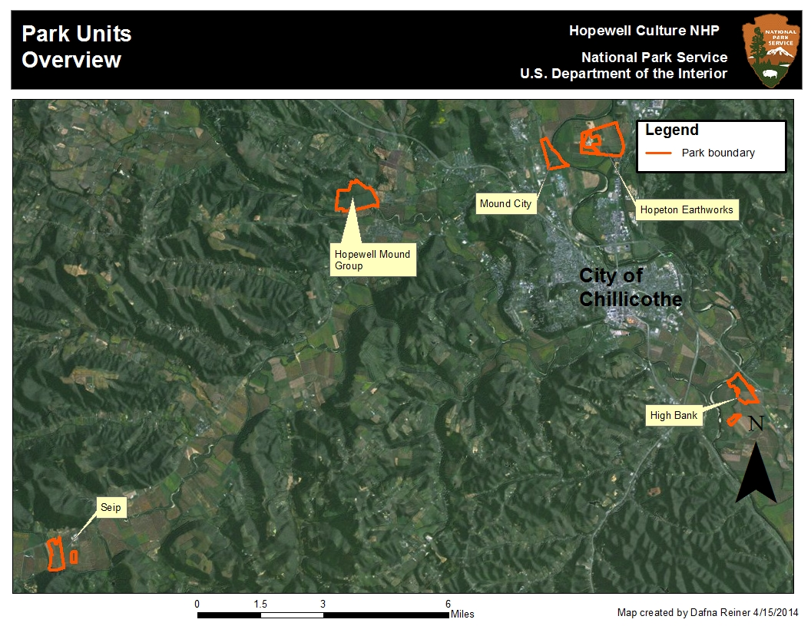
Figure 1. Location of units at Hopewell Culture National Historical Park.

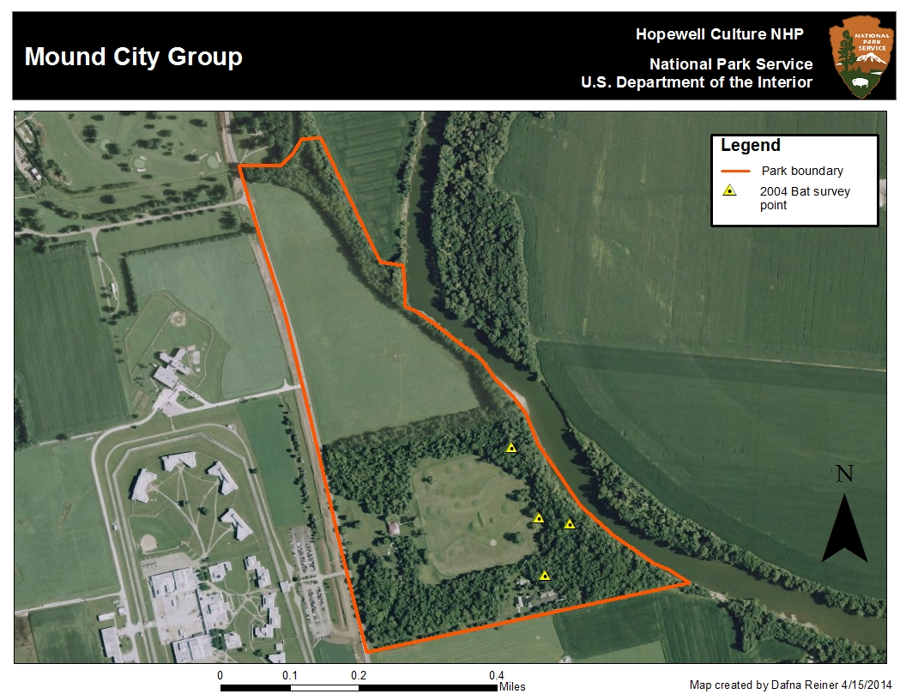
Figure 2. Mound City Group showing 2004 bat survey points
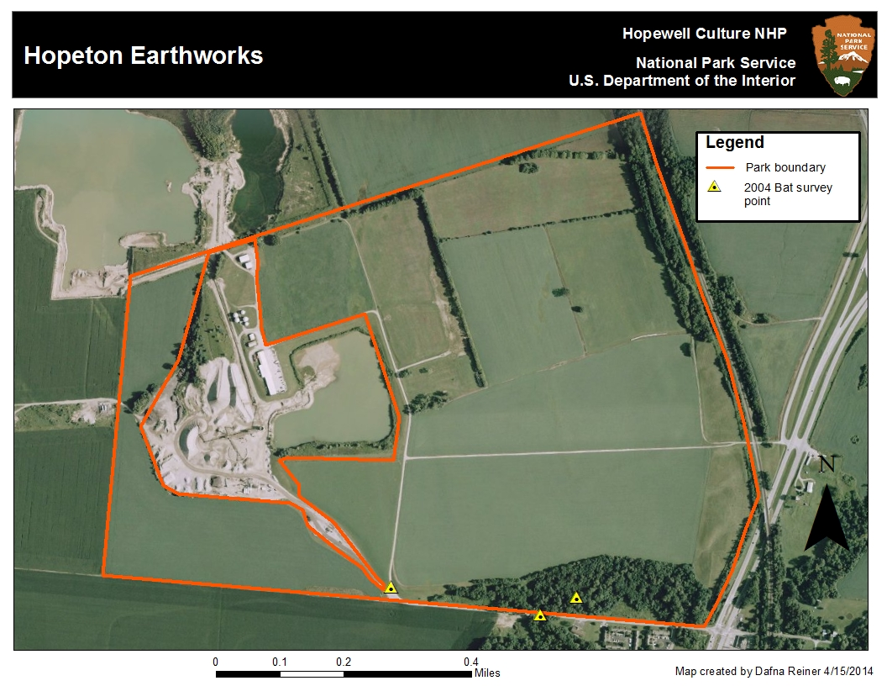
Figure 3. Hopeton Earthworks showing 2004 bat survey points

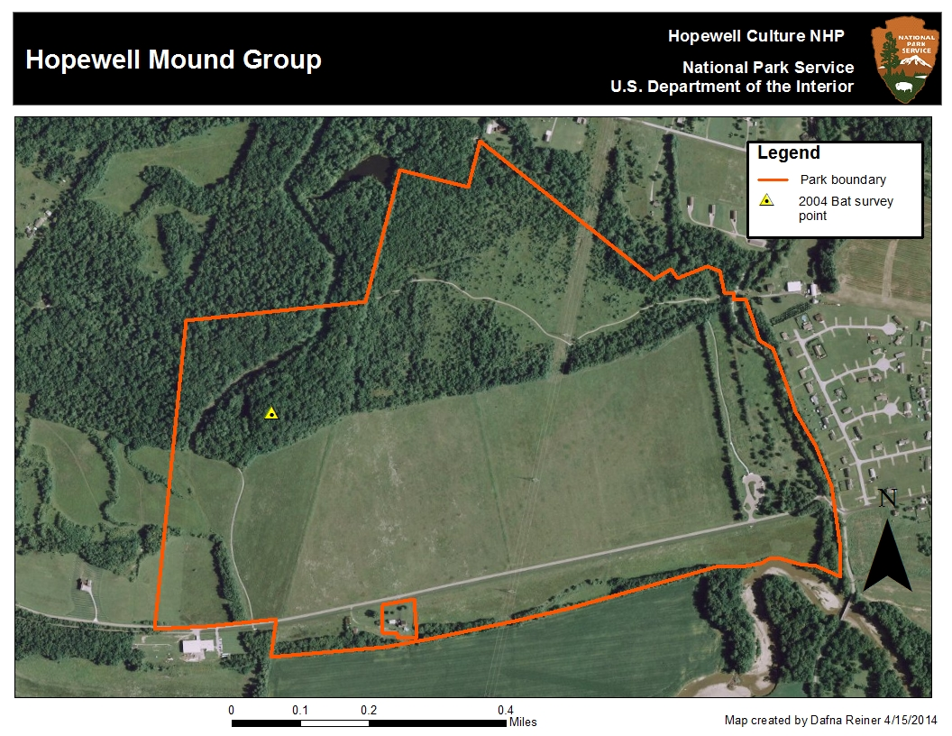
Figure 4. Hopewell Mound Group showing 2004 bat survey points.
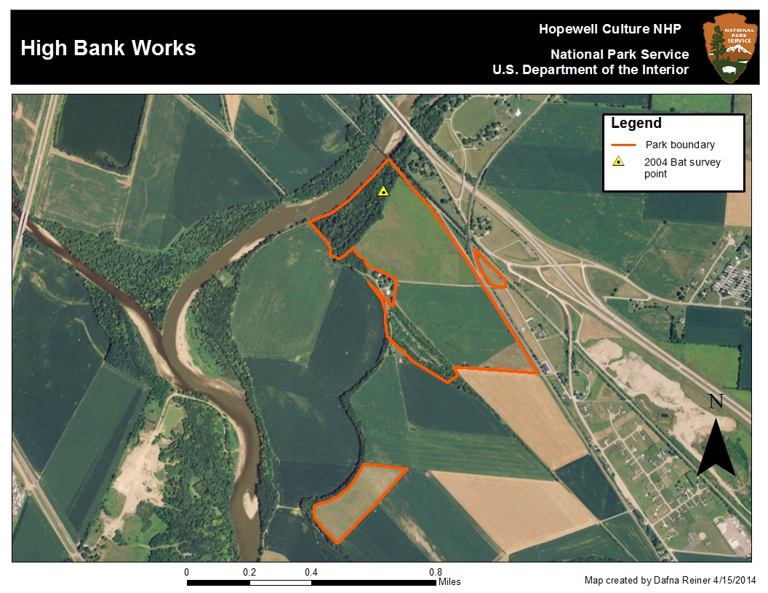
Figure 5. High Bank Works showing 2004 bat survey points.

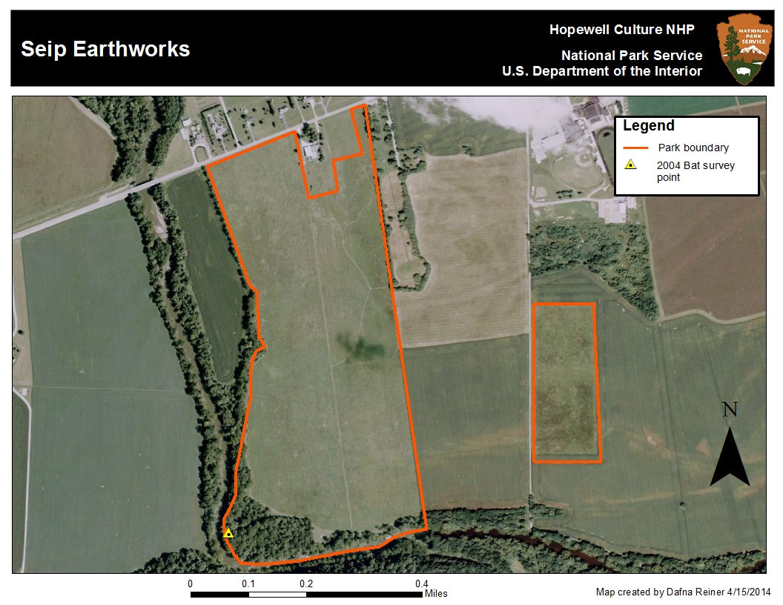
Figure 6.Seip Earthworks showing 2004 bat survey points.

Table 1. List of bat species expected to occur at Hopewell Culture NHP.
Scientific Name | Common Name
Eptesicus fuscus | Big Brown Bat
Lasionycteris noctivagans | Silver-haired Bat
Lasiurus borealis | Red Bat
Lasiurus cinereus | Hoary Bat
Myotis lucifugus | Little Brown Bat
Myotis septentrionalis | Northern Long-eared Bat
Myotis sodalist | Indiana Bat
Nycticeius humeralis | Evening Bat
Pipistrellus subflavus | Tri-colored bat

Table 2. Coordinates of the 2004 survey sites (NAD 83 Zone 17N)

Survey Point | Habitat | Easting | Northing
1 | Riparian Edge | 327503 | 4360469
2 | Forest Trail | 327440 | 4360632
3 | Small Forest Trail | 327575 | 4360454
4 | Small forest trail | 327518 | 4360334
5 | Riparian corridor | 334350 | 4352133
6 | Riparian corridor | 307880 | 4344796
7 | Pond/forest | 319181 | 4359121
8 | Creekbed | 329428 | 4360713
9 | Creekbed | 329519 | 4360757
10 | Stream bed | 329051 | 4360781

C. Project Products:

Draft of Final Report due by 15 September 2015
- Will follow NPS Natural Resource Publications Management (NRPM) format (http://www.nature.nps.gov/publications/nrpm/index.cfm).
- Will describe features in the study area, including their locations and attributes.
- Will include summaries of counts, estimates of abundance and frequencies of occurrence.
- Maps that delineate spatial aspects of inventories,
- Will include PI’s judgment regarding influences of WNS, habitat, vegetation management and weather conditions during the study that may have affected the survey.
- Will provide a technical assessment of taxa that were accounted for in the study, including observed species richness and estimates as to the proportion of species that were detected in each project area during the study.
- Will include lists of species that were thought to have been “missed” for any reason, are unlikely, but may occur within the park and those species likely to been effected by WNS. Conclusions must emphasize results of the inventory with greater weight than any results of background research, such as preexisting lists that may have been consulted.

Other Deliverables
- Databases, including GPS data,
- GIS data (digital, and illustrated in Final Report as appropriate), complying with FGDC standards,
- Acoustic survey files, including noise files, annotated with genus and species (if possible) ID,
- raw data forms (hard copy),
- voucher specimen data (if collected) and vouchers, fully processed according to NPS specifications,

D. Project Schedule:
Period of performance shall be from June 2, 2014 to October 31, 2014.

E. Furnished Property / Other Considerations:

References:

U.S. Fish and Wildlife Service. 2014. Rangewide Indiana Bat Summer Survery Guidelines Jan. 13, 2014. Website
http://www.fws.gov/midwest/endangered/mammals/inba/surveys/pdf/2014IBatSummerSurveyGuidelines13Jan2014.pdf
[Accessed 16 Apr. 2014]
Jones, C., W.J. McShea, M.J. Conroy and T.H. Kunz. 1996. Chapter 8: Capturing mammals. In: D.E. Wilson, F.R. Cole, J.D. Nichols, R. Rudran and M.S. Foster (eds.). Measuring and monitoring biological diversity: standard methods for mammals. Smithsonian Institution Press, Washington.

Kunz, T.H., D.W. Thomas, G.C. Richards, C.R. Tidemann, E.D. Pierson, and P.A. Racey. 1996. Chapter 7: Observational techniques for bats. In: D.E. Wilson, F.R. Cole, J.D. Nichols, R. Rudran and M.S. Foster (eds.). Measuring and monitoring biological diversity: standard methods for mammals. Smithsonian Institution Press, Washington

F. National Park Service Project Contact:

Project Leader :Dafna Reiner, Biologist, (740) 774-1126, Dafna_Reiner@nps.gov

ATR: Bret Ruby, (740) 774-1126, Bret_J_Ruby@nps.gov, 16062 State Rt 104, Chillicothe, OH 45601

SECTION II. AWARD INFORMATION
- Expected Number of Awards: One (1)
- Estimated Total Program Funding: $27,296
- Award Ceiling:

D. Assistance Instrument: Southern Appalachian Mountains Cooperative Ecosystem Studies Unit Cooperative Agreement

SECTION III. ELIGIBILITY INFORMATION

A. Eligible Applicants: Members organizations / universities of the Southern Appalachian Mountains Cooperative Ecosystems Studies Unit (SA-CESU)
B. Cost Sharing or Matching: $0.00

SECTION IV. APPLICATION AND SUBMISSION INFORMATION

A. Address to Request Application Package:
This announcement contains all information, instruction and attachments necessary to submit an application through Grants.gov.

B. Content and Form of Application:
The application package shall consist of all the required SF-424 Standard Forms shown below AND Proposal Submission Format (Attachment A) and Budget (Attachment B) narrative.

1. Required Standard Forms:

SF Forms to Submit | SF-424 Family of Forms
Application | Form SF-424, Application for Federal Assistance http://cesu.utk.edu/documents/nps_documents_only/NPS_SF-424.pdf  (Some fields in this form have been already been filled in with NPS information.)
Budget Information | Form SF-424A, Budget Information - Non-Construction Programs  http://cesu.utk.edu/documents/project_templates/SF-424_A.pdf
Assurances | Form SF-424B, Assurances - Non-Construction Programs  http://cesu.utk.edu/documents/project_templates/SF-424_B.pdf

SF-424 forms should be completed and signed by the appropriate grants officer. This is often the Office of Sponsored Programs at Universities. PDF format is preferred.

Assistance with any of the SF-424 forms can be requested of the SA-CESU NPS Coordinator (Ray Albright at 865 974-8443 or ray_albright@nps.gov)

2. Proposal Submission.

Proposal Submission Format (Attachment A) can be used as an example when submitting your proposal. The proposal technical text must be no longer than 10 pages, no smaller than font size 11, and have 1-inch margins. The 10-page limit includes all text, figures, references, and vitae. (The Budget, Attachment B, is not included in the 10-page limit.)

Communication with the National Park Service Project Contact (see Section I.F. above) is encouraged during the development of the proposal. The intent of a cooperative project is for all parties to ‘build the project together’. The SA-CESU NPS Coordinator is also available for consultation regarding the proposal.

The proposal text should include the following:

  - Purpose and Objectives– (Attachment A, Section I) - (a) Describe why the project is needed by the National Park Service; (b) Describe the project’s objectives.

  - Technical Approach – (Attachment A, Section II) - Describe how you propose to conduct and achieve the project in accordance with the project objectives. The project design must contain enough detail to show the development of the project and the relationship between the objectives, tasks, and milestones. The work plan must be clear, suitable, and feasible with respect to the following; (a) Describe the techniques, procedures, and methodologies to be used; (b) Describe data collection, analysis, and means of relationship interpretation; (c) Describe expected results or outcomes; and (d) Describe the procedures for evaluating project efficacy, including fixed performance indices with probabilities for obtaining them.

  - Qualifications, Experience, and Past Performance – (Attachment A, Section III) - Describe who will carry out the project activities. List all project personnel, including consultants. Describe their responsibilities and the amount of time each will dedicate to the project. Briefly describe how their experience and qualifications are appropriate to successfully achieve the stated objectives.

3. Project Budget

Submit a detailed budget breakdown (Attachment B). The project budget should follow the budget categories in SF-424 A page A1.

The budget can be in page form or spreadsheet form (preferred). Page form is provided in Attachment B.

The budget should contain the following (as applicable, not all projects will have all budget categories):

- Salaries and Wages. Include all employees and their titles working on the project.

- Fringe Benefits. Show rates/amounts.

- Travel and Per Diem. For each trip, indicate the number of persons traveling, the total days they will be in travel status, and the total subsistence and transportation costs for that trip.

- Equipment. List each item of tangible, nonexpendable personal property having a useful life of more than one year and an acquisition cost of $5,000 or more per unit.

- Supplies and Materials. Include consumable supplies and materials to be used in the project. Supplies can be listed as categories such as ‘field supplies ‘or ‘lab supplies’.

- Contractual. Show procurement contracts (rentals, licenses, insurance, subscriptions, cell phone contracts) and sub-contracts / consultant agreements.

- Construction. (omit this budget category since SA-CESU projects do not involve construction)

- Other Costs. This should include the cost of duplication and printing, postage and other services not previously listed.

- Total Modified Direct Charges. This is the sum of all costs in a. through h. Exclude costs for scholarships, tuition, rental of non-university space, and sub-contract costs in excess of $25,000 should not be assessed more than $25,000. (See 2 CFR 220, Appendix A.)

- Indirect Charges. The Southern Appalachian Mountains Cooperative Ecosystems Studies Unit (SA-CESU) has a negotiated indirect cost rate of no more than 17.5% on Modified Total Direct Costs.

Be aware that graduate student tuition, equipment and rental of non-university owned space are excluded from Total Direct Charges and result in Modified Total Direct Costs. Indirect costs should be charged against the Modified Total Direct Costs.

- TOTALS. Sum of i. and j. above.

C. Submission Dates and Times:

All responses will be required to be submitted electronically through grants.gov. The application package should consist of:
- The proposal
- The Budget
- The family of SF-424 forms.
- An optional cover letter of submission

The electronic submission into Grants.gov is due by April 22, 2012 @ 11:59 p.m. Eastern Daylight Time. An application package received after the closing date and time will not be considered for award. If it is determined that an application package will not be considered due to lateness, you will be so notified immediately.

D. Submission Instructions and Information:

All Funding Opportunities Announcements (FOA) and Notice of Intents (NOI) are posted to Grants.Gov, www.grants.gov. Please access this website and download the FOA and NOI by using the Funding Opportunity Announcement Number supplied by the NPS grants officer. The ten character FOA number starts with a ‘P’.

When you are ready to submit your proposal there are two options for submittal. Grants.gov does not easily convey application packages at this time, so two alternate options are offered.

The preferred option is to utilize FedConnect (www.fedconnect.net). Your sponsored programs office should already have an account registration in FedConnect. If not, the registration is simple and free but does require a DUNS number.

Within FedConnect search by Agency or by Reference Number using the Funding Opportunity Announcement number.

- For an Agency search, use DOI – NPS (note DOI space hyphen space NPS). The search will not work unless you type it in exactly this way. Many announcements will appear. Find the Funding Opportunity Announcement by either the Title or the ‘Reference Number’. Click on the title to bring up the announcement.

- Searching by Funding Opportunity Announcement number, as a reference number, is the easiest way to find the announcement. Click on the title to bring up the announcement.

Once at the announcement or ‘opportunity’ page, click on ‘Register to Receive Notifications’. This displays a side panel box. Click ‘Create’ and a data entry page is displayed. Proceed with submitting the proposal with the budget, the SF-424 forms and a cover letter (optional). Once complete, click ‘Submit to Agency’. The NPS grants officer will be notified by FedConnect to receive your submitted package of documents.

The second option for submittal is to e-mail the proposal with budget, family of SF-424 forms and the cover letter (optional) directly to the NPS grants officer using the contact information shown on the cover of the FOA.

Late Submissions, Modifications, and Withdrawals of Application and/or Proposal - Any application package received after the exact time specified for receipt will not be considered in the original selection process unless the application is received before award is made and it is determined by NPS that the late receipt was due to mishandling by the Government. Any modification of an application or quotation is subject to the same conditions stated above.

E. Intergovernmental Review:

This funding opportunity is not subject to Executive Order (EO) 12372, “Intergovernmental Review of Federal Programs”.

F. Funding Restrictions:

A CESU task agreement issued under the Southern Appalachian Mountains CESU Cooperative Agreement by the NPS, signed by the NPS, obligates NPS funds. Costs incurred prior to receipt of a signed CESU task agreement may not be reimbursed. Once the CESU task agreement has been signed by the NPS, the recipient may incur costs as specified in their proposed and approved budget submittal. Funding for the first year does not guarantee funding in subsequent years. A new set of SF-424 forms must be submitted for subsequent years.

SECTION V. Award Administration Information

A. Award Notices:

Project work cannot begin before a fully executed copy of the CESU task agreement is approved, signed and awarded by the NPS. The date of the award is the effective date that the project can start.

B. Administrative and National Policy Requirements:

1. Office of Management and Budget (OMB) Circulars

By accepting Federal assistance, your organization agrees to abide by the applicable OMB Circulars in the expenditure of Federal funds and performance under this program. http://www.whitehouse.gov/omb/circulars/

2 CFR Part 220 (OMB Circular A-21) - Cost Principles for Educational Institutions

2 CFR Part 225 (OMB Circular A-87) - Cost Principles for State, Local and Indian Tribal Governments

2 CFR Part 230 (OMB Circular A-122) - Cost Principles for Non-Profit Organizations

2 CFR Part 215 (OMB Circular A-110) - Uniform Administrative Requirements for Grants and Other Agreements with Institutions of Higher Education, Hospitals and Other Non-Profit Organizations

OMB Circular A-133, "Audits of States, Local Governments, and Non-Profit Organizations."

2. Standard Award Terms and Conditions

This agreement incorporates the Standard Award Terms and Conditions found at the following Department of the Interior website as if they were given here: http://www.doi.gov/pam/programs/financial_assistance/resources.cfm

Prohibition on Text Messaging and Using Electronic Equipment Supplied by the Government while Driving. This executive order introduces a Federal Government-wide prohibition on the use of text messaging while driving on official business or while using Government-supplied equipment, driving company-owned or rented vehicles or GOV, or while driving POV when on official Government business or when performing any work for or on behalf of the Government.

Acceptance of a Federal Financial Assistance award from the Department of the Interior (DOI) carries with it the responsibility to be aware of and comply with the terms and conditions of award. Acceptance is defined as the start of work, drawing down funds, or accepting the award via electronic means. Awards are based on the application submitted to, and as approved by DOI and are subject to the terms and conditions incorporated either directly or by reference in the following:

- Program legislation/regulations.
- Special terms and conditions.
- Code of Federal Regulations/Regulatory Requirements, as applicable (Contact your program officer with any questions regarding the applicability of the following):

2 CFR Part 175 Trafficking Victims Protection Act of 2000

43 CFR 12(A) Administrative and Audit Requirements and Cost Principles for Assistance Programs

43 CFR 12(E) Buy American Requirements for Assistance Programs

43 CFR 12(C) Uniform Administrative Requirements for Grants and Cooperative Agreements to State and Local

43 CFR 12(F) Uniform Administrative Requirements for Grants and Cooperative Agreements with Institutions of Higher Education, Hospitals, other Non-Profit and Commercial Organizations

43 CFR 43 Government wide Requirements for a Drug-Free Workplace

43 CFR 42 Government wide Debarment and Suspension (Nonprocurement)

43 CFR 18 New Restrictions on Lobbying

3. Compliance with Buy American Act:

a. Notice: Pursuant to sec. 307 of the Omnibus Consolidated Appropriations Act of 1997, Public Law 104-208, 110 Stat. 3009, please be advised of the following:

In the case of any equipment or product that may be authorized to be purchased with financial assistance provided using funds made available in this act, it is the sense of the Congress that entities receiving the assistance should, in expending the assistance, purchase only American-made equipment and products.

b. Recipient agrees to follow the requirements in 43 CFR Part 12, Subpart E, Buy American Requirements for Assistance Programs.

4. Opposition to Any Legislation - In accordance with the Department of the Interior, Environment, and Related Agencies Act, 2006, Title IV, Section 402, No part of any appropriation contained in this Act shall be available for any activity or the publication or distribution of literature that in any way tends to promote public support or opposition to any legislative proposal on which Congressional action is not complete other than to communicate to Members of Congress as described in 18 U.S.C. 1913.

5. Endorsements - Recipient shall not publicize or otherwise circulate, promotional material (such as advertisements, sales brochures, press releases, speeches, still and motion pictures, articles, manuscripts or other publications) which states or implies governmental, Departmental, bureau, or government employee endorsement of a product, service, or position which the recipient represents. No release of information relating to this award may state or imply that the Government approves of the recipient’s work products, or considers the recipient’s work product to be superior to other products or services.

All information submitted for publication or other public releases of information regarding this project shall carry the following disclaimer:

The views and conclusions contained in this document are those of the authors and should not be interpreted as representing the opinions or policies of the U.S. Government. Mention of trade names or commercial products does not constitute their endorsement by the U.S. Government.

Recipient must obtain prior Government approval for any public information releases concerning this award which refer to the Department of the Interior or any bureau or employee (by name or title). The specific text, layout photographs, etc. of the proposed release must be submitted with the request for approval.

A recipient further agrees to include this provision in a subaward to and subrecipient, except for a subaward to a State government, a local government, or to a federally recognized Indian tribal government.

6. Retention and Access Requirements for Records - All recipient financial and programmatic records, supporting documents, statistical records, and other grants-related records shall be maintained and available for access in accordance with 43 CFR Subpart C, Section 12.82 for State, local and Indian tribal governments or Subpart F, Section 12.953 for institutions of higher education, hospitals, other non-profit and all other organizations.

7. Increasing Seat Belt Use - Recipients of grants/cooperative agreements and/or sub-awards are encouraged to adopt and enforce on-the-job seat belt use policies and programs for their employees when operating company-owned, rented, or personally owned vehicles. These measures include, but are not limited to, conducting education, awareness, and other appropriate programs for their employees about the importance of wearing seat belts and the consequences of not wearing them.

8. Special Terms and Conditions.

a. Order of Precedence - Any inconsistency in the agreement shall be resolved by giving precedence in the following order: (a) Any national policy requirements and administrative management standards; (b) 43 CFR Part 12; (c) requirements of the applicable OMB Circulars and Treasury regulations; (d) special terms and conditions; and (e) all agreement sections, documents, exhibits, and attachments; (f) and the recipient’s project proposal.

b. Amendments - The agreement may be amended by written agreement signed by both the recipient’s Authorized Representative and the NPS AO. Administrative changes (i.e. NPS AO name change, etc.) which do not change the project management plan, NTE amount, etc. or otherwise affect the recipient may be signed unilaterally by the NPS AO. Additionally, a unilateral amendment may be utilized if it should become necessary to suspend or terminate the agreement in accordance with 43 CFR, Subpart C, Section 12.83 for State, local and Indian tribal governments or Subpart F, Section 12.961 for institutions of higher education, hospitals, other non-profit and all other organizations.

All other changes shall be made by means of a bilateral amendment to the agreement. No oral statement made by any person, or written statement by any person other than the NPS AO, shall be allowed in any manner or degree to amend or otherwise effect the terms of the agreement.

All requests for amendment of the agreement shall be made in writing, provide a full description of the reason for the request, and be sent to the attention of the NPS AO. Any request for project extension shall be made at least 30 days prior to the expiration date of the agreement or the expiration date of any extension period that may have been previously granted. Any determination to extend the period of performance or to provide follow-on funding for continuation of a project is solely at the discretion of the NPS.

c. Budget and Program Plan Revision - The budget plan is the financial expression of the project or program as approved during the award process. Recipients are required to report deviations from budget and program plans and request prior approval for budget and program plan revisions. Recipients are not required to request prior approval for deviations among approved direct cost categories when the cumulative amount of the transfer is less than 10 percent of that cost category. However, the recipient must report any deviation to the NPS AO and Program Officer (PO).

d. Audit Requirements - Non-Federal entities that expend $500,000 or more during a year in Federal awards shall have a single or program-specific audit conducted for that year in accordance with the Single Audit Act Amendments of 1996 (31 U.S.C. 7501-7507) and revised OMB Circular A-133, which is available at http://www.whitehouse.gov/omb/grants/grants_circulars.html.
Federal awards are defined as Federal financial assistance and Federal cost-reimbursement contracts that non-Federal entities receive directly from Federal awarding agencies or indirectly from pass-through entities. They do not include procurement contracts, under grants or contracts, used to buy goods or services from vendors. Non-Federal entities that expend less than $500,000 for a fiscal year in Federal awards are exempt from Federal audit requirements for that year, except as noted in A-133, §_215(a), but records must be available for review or audit by appropriate officials of the Federal agency, pass-through entity, and General Accounting Office (GAO).

Audits shall be made by an independent auditor in accordance with generally accepted government auditing standards covering financial audits. Additional audit requirements applicable to this agreement are found at 43 CFR 12.66 or 43 CFR 12.926, as applicable. General guidance on the single audit process is included in a pamphlet titled, Highlights of the Single Audit Process" which is available on the internet at http://www.dot.gov/ost/m60/grant/sincontact.html. Additional information on single audits is available from the Federal Audit Clearinghouse at http://harvester.census.gov/sac/ .

e. Metric Conversion - All performance and final reports, other reports, or publications, produced under this agreement, shall employ the metric system of measurements to the maximum extent practicable. Both metric and inch-pound units (dual units) may be used if necessary during and transition period(s). However, the recipient may use non-metric measurements to the extent the recipient has supporting documentation that the use of metric measurements is impracticable or is likely to cause significant inefficiencies or loss of markets to the recipient, such as when foreign competitors are producing competing products in non-metric units.

f. Officials Not to Benefit - No member of or delegate to Congress, or resident commissioner, shall be admitted to any share of this agreement, or to any benefit arising from it. However, this clause does not apply to this agreement to the extent that this agreement is made with a corporation’s general benefit.

g. Deposit of Publications - In addition to any requirements listed in the Project Management Plan, two (2) copies of each applicable publication produced under this agreement shall be sent to the Natural Resources Library with a transmittal that identifies the sender and the publication, and states that the publication is intended for deposit in the Natural Resources Library. Publications shall be sent to the following address:

U.S. Department of the Interior
Natural Resources Library
Interior Service Center
Gifts and Exchanges Section
1849 C Street, N.W.
Washington, D.C. 20240

h. Reimbursable Costs and Limitations:

The recipient shall not incur costs or obligate funds for any purpose pertaining to operation of the program or activities beyond the expiration date stated in the agreement. The only costs which are authorized for a period of up to 90 days following the award expiration date are those strictly associated with closeout activities for preparation of the final report.

The NPS's financial participation is limited. The NPS will only fund up to its share of those amounts requested in the project proposal and as are subsequently approved and funded in the agreement. The recipient shall not be obligated to continue performance under the agreement or to incur costs in excess of the costs set forth in the proposal and subsequent agreement. However, if the recipient chooses to expend funds in excess of the approved project budget, the recipient will be responsible to fund the excess without funding participation by the NPS.

i. Inspection - The NPS has the right to inspect and evaluate the work performed or being performed under this agreement, and the premises where the work is being performed, at all reasonable times and in a manner that will not unduly delay the work. If NPS performs inspection or evaluation on the premises of the recipient or a subrecipient, the recipient shall furnish and shall require sub-recipients to furnish all reasonable facilities and assistance for the safe and convenient performance of these duties.

- Copyrights:

1. For recipients subject to the administrative standards set forth in OMB Circular A-110, the following copyright provision, as implemented by 43 CFR 12.936(a), shall apply:

“The recipient may copyright any work that is subject to copyright and was developed, or for which ownership was purchased, under an award. The Federal awarding agency(ies) reserves a royalty-free, nonexclusive and irrevocable right to reproduce, publish, or otherwise use the work for Federal purposes, and to authorize others to do so.”

2. For recipients subject to the administrative standards set forth in OMB Circular A-102 and the Grants Management Common Rule, the following copyright provision, as implemented by 43 CFR 12.74, shall apply:

“The Federal awarding agency reserves a royalty-free, nonexclusive, and irrevocable license to reproduce, publish or otherwise use, and to authorize others to use, for Federal Government purposes:
(a) The copyright in any work developed under a grant, subgrant, or contract under a grant or subgrant; and
(b) Any rights of copyright to which a grantee, subgrantee or a contractor purchases ownership with grant support.”

- Rights to Data - For recipients subject to the administrative standards set forth in OMB Circular A-110, the following provision, as implemented by 43 CFR 12.936(c), shall apply:

"The Federal Government has the right to:
(1) Obtain, reproduce, publish or otherwise use the data first produced under an award; and
(2) Authorize others to receive, reproduce, publish, or otherwise use such data for Federal purposes.”

l. Procurement Procedures - It is a national policy to place a fair share of purchases with minority business firms. The Department of the Interior is strongly committed to the objectives of this policy and encourages all recipients of its grants and cooperative agreements to take affirmative steps to ensure such fairness. Positive efforts shall be made by recipients to utilize small businesses, minority-owned firms, and women's business enterprises, whenever possible. Recipients of Federal awards shall take all of the following steps to further this goal:

1. Ensure that small businesses, minority-owned firms, and women's business enterprises are used to the fullest extent practicable.

2. Make information on forthcoming opportunities available and arrange time frames for purchases and contracts to encourage and facilitate participation by small businesses, minority-owned firms, and women's business enterprises.

3. Consider in the contract process whether firms competing for larger contracts intend to subcontract with small businesses, minority-owned firms, and women's business enterprises.

4. Encourage contracting with consortiums of small businesses, minority-owned firms and women's business enterprises when a contract is too large for one of these firms to handle individually.

5. Use the services and assistance, as appropriate, of such organizations as the Small Business Development Agency in the solicitation and utilization of small business, minority-owned firms and women's business enterprises.

9. Central Contractor Registration (CCR) - Prior to award the Recipient shall register and maintain their own information with Dun & Bradstreet and the Central Contractor Registration System.

Obtain a valid Dun & Bradstreet Number (D&B) from Dun & Bradstreet @ http://www.dnb.com/or by calling them at 800-333-0505.

Register at SAM, https://www.sam.gov/index.html#1

10. Payments:

a. Financial Management Service’s (FMS), Automated Standard Application for Payment (ASAP) System. If recipient is registered in ASAP payments will be made through that system.

Payments will be made by the United States Department of Treasury, FMS, ASAP system. ASAP is a recipient-initiated, on-line payment and information system for Financial Assistance Agreements that is recipient initiated. The recipient will request federal funds that are due directly from the Federal Reserve Bank on a reimbursable basis.

The ASAP Requestor ID, furnished by the Department of Treasury, will be used to access the account to request reimbursement payments. The NPS NPS AO will create an ASAP Account ID unique to this agreement. The first nine characters will be the agreement number. The remaining three characters will identify NPS funding line items. Drawdown of funds will be taken from specific lines on this agreement. An amendment will be stamped to indicate the appropriate line number for the drawdown.

11. Property Management and Disposition - Any NPS property used or other property acquired under this agreement, including intangible property such as copyrights and patents shall be governed by the provisions of 43 CFR, Subpart C, Section 12.71 through 12.72 for State, local and Indian tribal governments or Subpart F, Section 12.930 through 12.937 for institutions of higher education, hospitals, other non-profit and all other organizations. The NPS assumes no liability for any actions or activities conducted under this agreement except to the extent that recourse or remedies are provided by Congress under the Federal Tort Claims Act [28 U.S.C. 1346(b), 2401(b), 2671 - 2680, as amended by P.L. 89-506, 80 Stat. 306]".

C. Reporting:

1. For ASAP Recipients: - Federal Financial Reports: Reports of expenditures are required as documentation of the financial status of awards according to the official accounting records of the recipient’s organization. The recipient shall submit a completed original and one copy of the quarterly FFR, the SF 425, Federal Financial Report (Short Form), (Down load the form at: http://www.whitehouse.gov/OMB/grants/grants_forms.html to report the status of funds for this agreement. In addition include separately, detailed information of costs, by budget categories that reflects the approved SF 424A, Budget Information. The quarterly report(s) shall be sent to the NPS AO and are due 30 calendar days after the end of the quarterly reporting period. The recipient will report program outlays and program income on a cash basis.

An original and one copy of the final FFR is due to the NPS AO no later than 90 calendar days after the expiration or termination of this agreement.

Recipients who are placed on agency review, shall submit an original and one completed copy of the SF 425, Federal Financial Report (Short Form), (Down load the form at: http://www.whitehouse.gov/OMB/grants/grants_forms.html to report the status of funds for each payment requested before reimbursement payments are made. In addition include separately, detailed information of costs, by budget categories that reflects the approved SF 424A, Budget Information. This does not relieve the recipient of the quarterly FFR requirement unless reimbursement is only requested on a quarterly basis.

The NPS AO may review the report for patterns of cash expenditures, including accelerated or delayed drawdowns, and to assess whether performance or financial management problems exist. Before submitting FFRs to the NPS AO, grantees must ensure that the information submitted is accurate, complete, and consistent with the grantee’s accounting system. The recipient’s Authorized Certifying Official’s signature on the FFR certifies that the information in the FFR is correct and complete and that all outlays and obligations are for the purposes set forth in agreement documents, and represents a claim to the Federal government. Filing a false claim may result in the imposition of civil or criminal penalties.

2. Performance Reports - Recipient shall submit an annual performance report(s) to the NPS AO within 30 days after the end of the fiscal year. The performance report must be prepared in accordance with 43 CFR, Subpart C, Section 12.80 for State, local and Indian tribal governments or Subpart F, Section 12.951 for institutions of higher education, hospitals, other non-profit and all other organizations. The performance report shall include a narrative summary both of completed activities and activities in progress, a calculation of percent of completed work based on work identified in the Project Management Plan, the reason for slippage if objectives or milestones are not met, a prediction of future activities and how they will be accomplished, and a discussion of issues and problems which may impact the ability to complete the work on time. Recommendations to overcome problems shall also be provided.

In lieu of the fourth quarter performance report an annual program performance report shall be submitted at the end of each year of the agreement. An original shall be submitted to the NPS AO no later than 90 days following the end of each year of the agreement. Copies of this report may be required to be included with any application for continuing support of the agreement

An original of the final program performance report shall be submitted no later than 90 days following the expiration or termination of the agreement.

3. Non-compliance - Failure to comply with the reporting requirements contained in this agreement may be considered a material non-compliance with the terms and conditions of the award. Non-compliance may result in withholding of future payments, suspension or termination of the agreement, recovery of funds paid under the agreement, and withholding of future awards.

D. DEFINITIONS:.

1. Agreement – The CESU Task Agreement under the Southern Appalachian Mountain CESU Cooperative Agreement

2. Agreements Officer (NPS AO) - The NPS's Agreements Officer. The NPS AO is the only individual authorized to obligate funds, award, modify or terminate an agreement.

3. Agreements Technical Representative (ATR) - The NPS employee designated for the purpose of administering the technical aspect of an agreement. The ATR is authorized to clarify technical requirements, and to review and approve work which is clearly within the scope of the work specified in an agreement. The ATR is not authorized to issue changes or in any other way modify an agreement.

4. The National Park Service (NPS) - May also be referred to as the Service.

5. The Code of Federal Regulations (CFR) – General and permanent regulations issued by Executive departments and agencies of the Federal Government.

6. Fiscal Year (FY) - The Federal fiscal year which extends from October 1 of one year through September 30 of the following year.

7. Not-to-Exceed (NTE) Amount - The maximum Federal funding amount.

8. The Office of Management and Budget (OMB) – Largest component of the Executive Office of the President. OMB reports directly to the President and helps a wide range of executive departments and agencies across the Federal Government to implement the commitments and priorities of the President.

9. Project Manager/Principal Investigator - The recipient's Project Manager/Principal Investigator.

10. Responsible Official: The recipient's Responsible Official - The responsible official is the individual who is authorized to act for the recipient’s organization and commit the recipient to compliance with the terms and conditions of this agreement.

E. Financial Support.

1. An agreement shall be funded each FY based on the availability of NPS funding. The recipient hereby releases the NPS from all liability due to failure of Congress to appropriate funds for the agreement.

2. Funds obligated but not expended in one FY can be carried forward and expended in the subsequent FY.

3. The dollar amount represents the estimated not-to-exceed (NTE) amount for which the NPS will be responsible under the terms of the agreement. The NPS shall not be obligated to pay for nor shall the recipient be obligated to perform any effort that will require the expenditure of Federal funds above the NTE amount.

4. Program income for the agreement shall be in accordance with 43 CFR, Subpart F, Section 12.924.

-- END OF PROGRAM ANNOUNCEMENT –

ATTACHMENT A

PROPOSAL SUBMISSION FORMAT

Please read the announcement carefully before completing this information.

SECTION I. PURPOSE AND OBJECTIVES

A. Describe why the project is needed by the National Park Service
B. Describe the project’s objectives.

SECTION II. TECHNICAL APPROACH

Describe how you propose to conduct and achieve the project in accordance with the project objectives. The project design must contain enough detail to show the development of the project and the relationship between the objectives, tasks, and milestones. The work plan must be clear, suitable, and feasible with respect to the following;
(a) Describe the techniques, procedures, and methodologies to be used;
(b) Describe data collection, analysis, and means of relationship interpretation;
(c) Describe expected results or outcomes; and
(d) Describe the procedures for evaluating project efficacy, including fixed performance indices with probabilities for obtaining them.

Section iii. QUALIFICATIONS, EXPERIENCE, PAST PERFORMANCE

Describe who will carry out the project activities. List all project personnel, including consultants. Describe their responsibilities and the amount of time each will dedicate to the project. Briefly describe how their experience and qualifications are appropriate to successfully achieve the stated objectives.

ATTACHMENT B

section iv. Budget
This is a suggested format for a proposal’s budget. The budget tables match the categories identified on the SF-424A form, Budget Information.

Each table should be repeated for each federal fiscal year of the duration of the project.

A. Salaries and Wages. Provide the names and/or titles of key project personnel.
Name/Title of Position | Pay Rate per Pay Period | Pay Period (Hr, Wk, Yr) | No. of Pay Periods | Minus any matching, donated or in kind pay | Total
 | $ |  |  | $ | $
 | $ |  |  | $ | $
 | $ |  |  | $ | $
 | $ |  |  | $ | $
 | $ |  |  | $ | $
Subtotal |  |  |  |  | $

Special Note: Graduate student scholarship / tuition costs are not Direct Costs and must not be used to calculate the Indirect Cost. (See 2 CFR 220, Appendix A.G.2.). Include graduate student names and roles in above table, but exclude the scholarship / tuition costs from Direct Costs.

B. Fringe Benefits. If more than one rate is used, list each rate and the wage or salary base.
Name/Title of Position | Fringe Benefit % | Fringe Benefit Cost | Minus any matching, donated or in kind pay | Total Fringe Benefit Cost per Position
 |  | $ | $ | $
 |  | $ | $ | $
 |  | $ | $ | $
 |  | $ | $ | $
Subtotal |  |  |  | $

C. Travel and Per Diem. For each trip, indicate the number of persons traveling, the total days they will be in travel status, and the total subsistence and transportation costs for that trip. Per diem rates shall not exceed maximum Federal rates as listed by GSA.
From/To | No. of People | No. of Travel Days | Per diem (lodging and meals) per person per day | Total per diem (lodging and meals) for this trip | Transportation costs (airfare and mileage) per person | Total transportation costs (airfare and mileage) for this trip | Minus any matching, donated or in kind pay | Total Cost Per Trip
 |  |  | $ | $ | $ | $ | $ | $
 |  |  | $ | $ | $ | $ | $ | $
 |  |  | $ | $ | $ | $ | $ | $
 |  |  | $ | $ | $ | $ | $ | $
 |  |  | $ | $ | $ | $ | $ | $
 |  |  | $ | $ | $ | $ | $ | $
 |  |  | $ | $ | $ | $ | $ | $
 |  |  | $ | $ | $ | $ | $ | $
Subtotal |  |  |  |  |  |  |  | $

D. Equipment. List each item of tangible, nonexpendable, personal property having a useful life of more than one year and an acquisition cost of $5,000 or more per unit.
Item | # of units | Cost per unit ($) | Total Cost Per Item | Justification (write brief reason for each piece of equipment)
 |  | $ | $
 |  | $ | $
 |  | $ | $
 |  | $ | $
 |  | $ | $
 |  | $ | $
Subtotal |  |  | $

E. Supplies. List individually or use categories such as ‘field supplies’, ‘office supplies’, etc. If a single item is over $500, then list separately. (Do not include rent, publication costs, shipping costs, or other service type procurements.)
Item or Category | No. of units | Cost per unit ($) | Total Cost Per Item | Justification (write brief reason for supplies)
 |  | $ | $
 |  | $ | $
 |  | $ | $
 |  | $ | $
 |  | $ | $
 |  | $ | $
Subtotal |  |  | $

Two types of contracts are possible: procurement contract and/or sub-contract agreement.
Fill in the contractual agreement which is applicable to the project.

Procurement Contract: the product is being acquired from an organization/company and is generally available in the same condition, format or state to other purchasers (not created new for the project but can be assembled from existing inventory for the project, such as satellite images of a park.)

Procurement Contract examples: Rentals, software license, insurance, subscriptions, cell phone contracts.

Sub-contract / Consultant: the product is specifically created for the project by an individual or organization, and there may be an additional overhead cost involved.

Sub-contract / Consultant Examples: University faculty at another university as co-PI, GIS product, retired federal worker providing advice, or any other professional and/or technical services.

F. Contractual. See note above.
Type of Contract (Procurement, Sub-Contract) | Name of Contract Recipient | Product(s) from Contract | Indirect Costs (if applicable) | Total Cost Per Contract
 |  |  | $ | $
 |  |  | $ | $
 |  |  | $ | $
 |  |  | $ | $
Subtotal |  |  |  | $

G. Construction Costs. Do not include into proposal budget. CESU projects do not include construction costs.

H. Other Costs. Include the costs of publication, printing, shipping and other non-supply, non-contract type of services. Can use categories as ‘Printing’.
Item or Category | No. of Units | Cost Per Unit | Basis of Cost Per Unit Computation | Total Cost Per Item
 |  | $ |  | $
 |  | $ |  | $
 |  | $ |  | $
 |  | $ |  | $
 |  | $ |  | $
Subtotal |  |  |  | $

Budget Justification. Provide any additional justification or clarification of the budget items.

BUDGET SUMMARY: display budget per budget category and per fiscal year (FY)

Budget Item | FY 1 | FY 2 | Total Project Costs
A. Personnel (Salary & Wages) | $ | $ | $
B. Fringe Benefits | $ | $ | $
C. Travel | $ | $ | $
D. Equipment | $ | $ | $
E. Supplies | $ | $ | $
E. Contractual | $ | $ | $
(Procurement Subtotal) | $ | $ | $
(Sub-contract Subtotal) | $ | $ | $
G. Construction | -- | -- | --
H. Other | $ | $ | $
Total Direct Charges (1) | $ | $ | $
Excluded Schl /Tuition (2) | $ | $ | $
Excluded Equipment | $ | $ | $
Excluded Contractual | $ | $ | $
Modified Total Direct Costs (3) | $ | $ | $
CESU 17.5% Indirect Costs (4) | $ | $ | $
TOTAL Per FY | $ | $
PROJECT TOTAL |  |  | $
(1) Total Direct Charges. This is the sum of all costs in A. through H.
(2) Exclude costs for scholarships, tuition, rental of non-university space, and sub-contract costs in excess of $25,000 should not be assessed more than $25,000. (See 2 CFR 220, Appendix A.)
(3) Modified Total Direct Costs. Subtract excluded costs from Total Direct Charges.
(4) The Southern Appalachian Mountains Cooperative Ecosystems Studies Unit (SA-CESU) has a negotiated indirect cost rate of no more than 17.5% on Modified Total Direct Costs.

