

UNITED STATES
DEPARTMENT OF THE INTERIOR

NATIONAL PARK SERVICE

NOTICE OF INTENT TO AWARD

This Notice of Intent to Award is not a request for applications. This announcement is to provide public notice of the National Park Service’s intention to fund the following federal financial assistance project without full and open competition since full and open competition is not required for federal financial assistance projects (31 USC 6301(3); DOI 505 DM 2.2 & 2.13)

ABSTRACT
Funding Announcement | P14AS00114
Project Title | Survey Bat Community Composition at Hopewell Culture NHP Post White-Nose Syndrome
Recipient | Tennessee Technological University
Principle Investigator / Program Manager | Brian D. Carver, Ph.D. Assistant Professor of Biology, Tennessee Technological University, bcarver@tntech.edu
Total Anticipated Award Amount | $27,296
Cost Share | N/A
New Award or Continuation? | New Award
Anticipated Period of Performance | June 25, 2014 to October 15, 2015
Anticipated Length of Agreement | About 16 months
Award Instrument | Southern Appalachian Mountains CESU Cooperative/Task Agreement
Statutory Authority | 16 USC §1a-2(j), 16 USC §5933 and the 1998 NPS Omnibus Act
CFDA # and Title | 15.945 -- Cooperative Research and Training Programs – Resources of the National Park System (CESU)
Single Source Justification Criteria Cited | (5) Emergencies
NPS Point of Contact

PROJECT OVERVIEW

A. Project Objectives:
Hopewell Culture National Historical Park (HOCU) is located in south central Ohio and is 1,200 acres in size. Bat communities in all five of HOCU’s units were inventoried in 2004 before the emergence of white-nose syndrome (WNS). The 2004 survey listed seven species as “Present” (Big Brown Bat, Eastern Red Bat, Little Brown Bat, Northern Long-eared Bat, Evening Bat, Eastern Pipistrelle), two species as “Probably Present” (Silver-haired Bat, Indiana Bat) and three species as “Unconfirmed” (Eastern Small-footed Bat, Rafinesque's Big Eared Bat, Mexican Freetail). The primary purpose of this project is to identify the bat species present in the parks post-WNS. The secondary purpose is to conduct public education and outreach via a special public event that will include a night-time interpretive program along with a display at the park’s Visitor Center. Completion of this study will help the park in the Section 7 consultation process with the USFWS, a process which the park is legally tasked to undertake in connection with the Northern Long-eared Bat’s (NLEB) Candidate Species status. In addition it will help guide management actions such as tree removal. Survey results will be published in a Technical Report.

- The primary objective is to document 90% of the bat species expected to occur at the park.
- A quantitative assessment of species relative abundance.
- Determination of reproductive success for observed species.
- Document ancillary habitat data (climate, vegetation type).
- Collection of voucher specimens for observed species according to NPS standards.

B. Project Tasks:

Location: The inventory will include all park units: Mound City Group, Hopeton Earthworks, Hopewell Mound Group, Seip Earthworks, and High Bank Works (Figure 2-Figure 6). All units contain a mixture of vegetation types including agricultural fields, forests, lawn, restored native grassland, riparian corridors and old agricultural/hay fields.

Subunit | Size (approx.) | Strata
Mound City Group | 130 ac | Woods, Scioto River, agricultural, lawn
Hopeton Earthworks | 308 ac | Agricultural, restored native grassland, wood lot, intermittent stream, old field
Hopewell Mound Group | 313 ac | Woods, Sulfur Lick Creek, North Fork Paint Creek, 1/3-acre pond, hay field, old pasture
High Bank Works | 170 ac | Riparian woods, Scioto River, old field, restored native grassland, hay field
Seip Works | 150 ac | Riparian woods, old hay field, Paint Creek
Total | 1070 ac

- Mound City Group is located at 16062 State Route 104, Chillicothe. This site contains five buildings, one mile of trails, and 0.74 mile of road. The entire unit contains 130 acres, with 30 acres actively mowed, 45 acres mowed periodically for hay, 45 acres of early succession mixed mesophytic forest with the rest being developed area. The Scioto River borders the eastern edge of the unit.
- Hopeton Earthworks (Hopeton) is located at the 1100 block of Hopeton Road, Chillicothe. This is one of the largest parcels encompassing approximately 308 acres. A portion of the area, 140 acres, is used for active farming of winter wheat and soybeans. Sixty two acres are restored native grasslands. Another 26 acres is composed of a black walnut grove and an early succession mixed deciduous open forest with an intermittent stream flowing through (Dry Run Creek). The remaining acres are fallow fields or pastures. Currently there is an active gravel mining operation located on the western edge of the property. The Scioto River runs along the western side of the gravel mining operation, with Hopeton on the eastern side of the operation.
- Hopewell Mound Group is located at 4731 Sulfur Lick Road, Chillicothe. An unnamed tributary runs alongside the northern boundary of this 313-acre site, with the North Fork of Paint Creek bordering the southeastern edge and Sulfur Lick Creek bordering the eastern edge. Currently the property is mainly composed of 170 acres of pasture, most of which is shortly mowed. The northern portion of the property includes 37 acres of semi-mature mixed mesophytic forest with a 1/3-acre impoundment located on the eastern edge within these woods.
- Seip Earthworks is located on US 50 near Paint Valley High School, Bainbridge. The southern border of this 150-acre site lies alongside Paint Creek. The majority of the site is a fallow field community. Paint Creek is bordered by a 3-acre wooded riparian corridor.
- High Bank Works is located at the end of County Road 900, off US 35 south of Chillicothe. Approximately half of this 170-acre site is an old alfalfa field and the other half is a restored native grassland. The Scioto River borders the western edge of this property, where a 25-acre mature riparian woodland exists.

Methodology:

- Survey methods
Since the 2004 survey recorded NLEB in all units except Mound City Group, and since there is the potential for Indiana Bats, survey guidelines will follow those set forth by the USFWS for 2014. Bats will be surveyed in all five park units. According to the above guidelines one survey site per unit should suffice. Actual locations shall be determined by the PI’s expert opinion with the possibility of returning to the 2004 locations noted in Table 2 and in Figures 2-6. The PI is responsible for recording any new survey location using GPS and entering them into the database. Mist-nets will be the primary survey method, but acoustic detectors will be placed in these same areas. Qualitative and quantitative analyses for species identifications will be performed on all recorded call sequences. For 2014 the USFWS defined netting season as June 1 - August 15 as these dates delineate acceptable limits for documenting the presence of summer populations of Indiana Bats and NLEB, especially maternity colonies. Habitat assessment forms will be completed using the format of the USFWS 2014 guidelines. Netted female NLEB or Indiana Bats will be banded, fitted with a radio transmitter and followed to the roost. A recording of the hand-release event will be taken for reference.

- Timing
June 25-July 18 shall be the targeted field survey period. If weather conditions delay the survey an extension will be granted. A draft of the final report will be available for NPS review by September 15th. Final report is due by October 15th. Any changes to said schedule must be coordinated with park staff.

- Personnel
The park biologist will work with the PI during the survey and at least one park biological technician will be available as well. The purpose of this is to reduce the cost of the cooperative agreement and to provide training for park personnel for future in-house surveys.

- Acoustic Survey
The PI will use the acoustic survey equipment provided by the park. All acoustic files will be processed with identification to the genus level as a minimum and species level when possible. Auto ID is acceptable as long as it undergoes QA/QC by the PI. The park will provide Bat Call ID (BCID) software with one license.

- Qualitative Assessment of Species Relative Abundance
Each species will be qualitatively placed in one of four or more abundance categories following those in the 2004 survey. Relative abundance asseessments will be based on acoustic surveys and mist nets.

- Determination of Reproductive Success
Basic biological data will be collected for all bats captured including species, sex, age (adult or juvenile), weight and reproductive condition. All animals will be released at the site of capture. An acoustic file for each hand-released bat will be generated and annotated to designate is as a hand-release sequence.

- Biotic and Abiotic Data Collection
Habitat assessment forms using the format of the 2014 USFWS Indiana Bat guidelines will be completed. The PI may add attributes to the form, if appropriate. Databases utilized by the PI must provide for geospatial data.

- Voucher Specimen Collection
Inventory method is to capture and release all specimens. Only photographic vouchers will be taken unless death occurs in the handling process, in which case skin and skull vouchers will be taken. A digital camera will be used and all photographs will be electronic. The PI is responsible for voucher specimen preparation. All vouchers must be catalogued and labeled with appropriate metadata. Bat specimens collected will be stored in the park’s natural history collection in coordination with the park curator.

- Negative Results
In addition to all encounters all efforts with negative results must be recorded, and summarized in field forms (hard copy or electronic) and the final report.

Data Management and Reporting: All inventory results will be recorded on field forms or a digital logger that clearly describes the spatial, temporal and methodological aspects of the survey. Efforts, results and ancillary data must be clearly cross-referenced with locational data. At minimum, analyses will include a description of diversity, in terms of observed and estimated species richness and distribution and abundance at sampling units and any larger spatial categories. A comparison with the 2004 survey results shall be included and will provide usuful information as to the possible effects of WNS. Required products include raw data in field forms and databases, geospatial information, acoustic monitoring files, final report, and associated metadata. All these will be in printed and electronic formats as described below.

General Formats
Data and reports must be provided in both digital and printed report format, according to the Deliverables and Timeline section, below.
- Text documents (including final report): MS Word.
- Databases: MS Access or ArcView Geodatabase.
- Geospatial data: GPS data and associated ArcView shape files complying with FGDC standards (see www.fgdc.gov).
- Acoustic survey files: Original zero-cross format.
- Storage media: CD, thumb drive or, where otherwise allowed for, transfer over the Internet.
- Operating system: Windows, version 7.
- Units of measurement: metric.

Data Verification
Principal Investigator is responsible for checking all data for correspondence between field forms and databases as well as the QA/QC of genus and species identification from acoustic files. NPS shall randomly test 10 percent of all records and requires that less than 3 percent contain transcription or other errors.

Geospatial Data
- Digital geospatial data shall be referenced by UTMs (NAD83 Zone 17N)
- GPS must provide a minimum of 10m accuracy.

Principal Investigator Obligations
- The U.S. Fish and Wildlife Service maintains a list of permittees for Indiana bat surveys in Ohio (attached). A Principal Investigator (PI) from this list will be sought out for this project.
- The PI and all field personnel directly handling bats must have a current rabies vaccination.
- Prior to the start of the project the PI will coordinate the project with Jennifer Norris of ODNR (jennifer.norris@dnr.state.oh.us) and aquire the state and site-specific permits. A USFWS permit will be obtained by contacting Angela Boyer (angela_boyer@fws.gov) of the USFWS Field Office in Columbus.
- The PI will apply for a NPS study permit via the Research Permit and Reporting System prior to the commencement of fieldwork and collecting. The internet site, https://irma.nps.gov/rprs/Investigator/Index, provides for on line permit requests.
- The PI will need an Animal Welfare Act (IACUC) permit. The PI may obtain this permit through the academic institution with which he/she is affiliated. A permit may also be obtained through the NPS IACUC submission/approval process (http://nature.nps.gov/biology/iacuc/).
- The PI shall be responsible for the scientific credibility and validity of the material delivered.
- Fieldwork will be conducted in a manner that is consistent with conservation ethics.
- The PI will finalize the timing and methods to be employed during the project to the park biologist at a mandatory pre-work meeting or conference call.
- The PI shall furnish all supervision, supplies, equipment (apart from detector and BCID software), tools, material and transportation to the park. Once in the park a park vehicle may be used. Field assistants will be supplied by the park (biologist and biological technicians). The park will provide the best available renditions of park areas, habitats and features, in appropriate GIS formats.
- All data collected by the PI and or their representatives related to the occurrence and distribution of any federal or state listed threatened, endangered, or sensitive species or their habitat will be maintained in strict confidence. Such information will be made available only to the NPS according to the terms and conditions of this project unless written permission to release the sensitive information to non-NPS groups or individuals is obtained in writing.
- Collecting voucher specimens of state or federal rare, threatened or endangered species shall be avoided. Photography should be used to document such species and their habitats.
- Surface rocks and logs may be manipulated, but soil disturbance such as from digging must be avoided to protect archeological resources.
- If historic or prehistoric artifacts are observed they are to be avoided and reported to the park archeologist in a timely manner.
- All reports and material collected as a result of the study will become the property of the United States Government, including but not limited to geospatial data, digital photographs, acoustical files, biological specimens, and data resulting from field surveys.

Final approval of products will not be given until NPS completes reviews at park and other levels such as the Heartland I&M Network and/or regional Wildlife Biologist. The PI will respond to reviews with revisions and or additions to the Draft Final Report in a Final Report. The NPS will have 30 days to make comments on the Final Report/products. Final payment is made after the Final Report is submitted and approved.
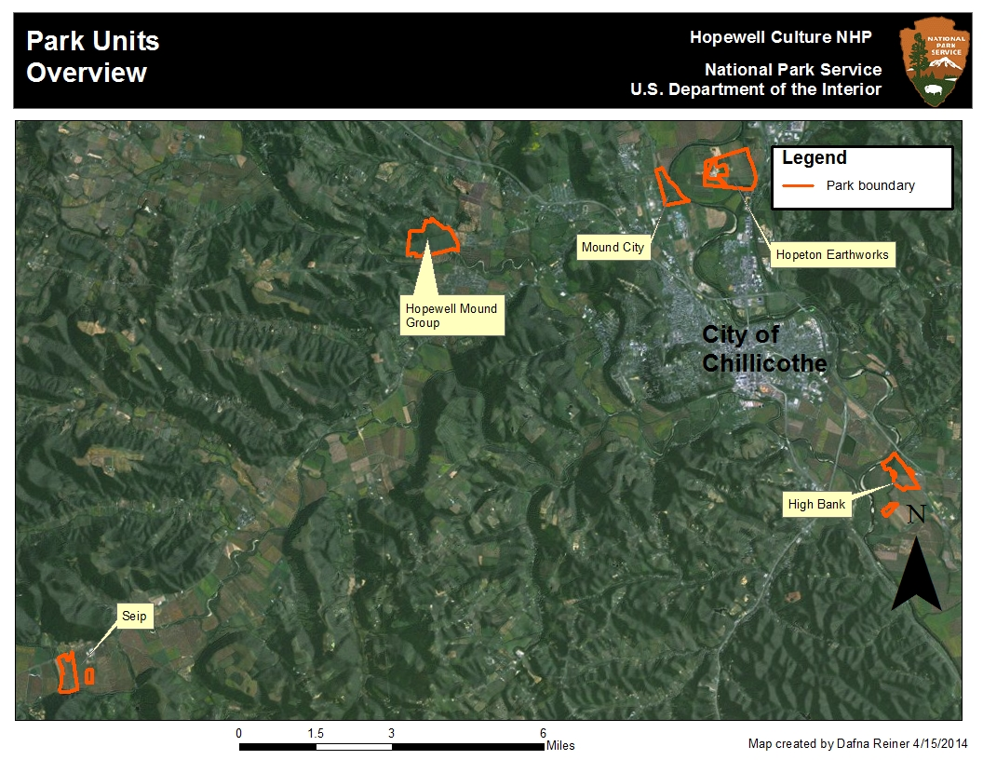
Figure 1. Location of units at Hopewell Culture National Historical Park.

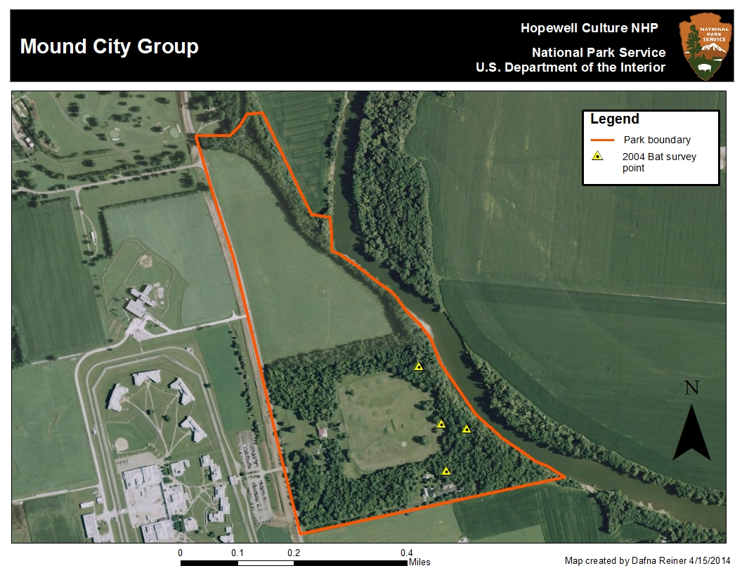
Figure 2. Mound City Group showing 2004 bat survey points
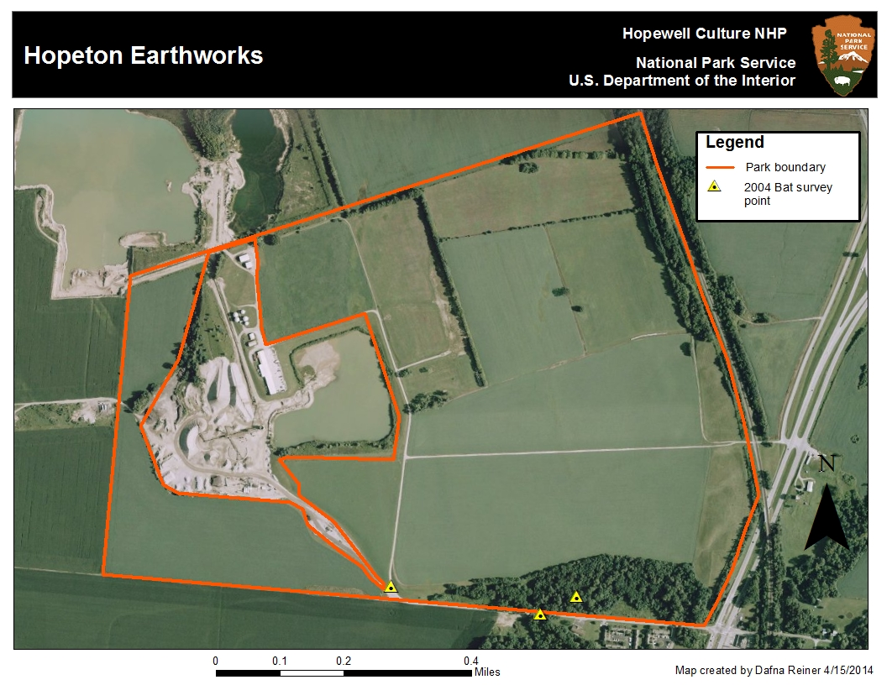
Figure 3. Hopeton Earthworks showing 2004 bat survey points
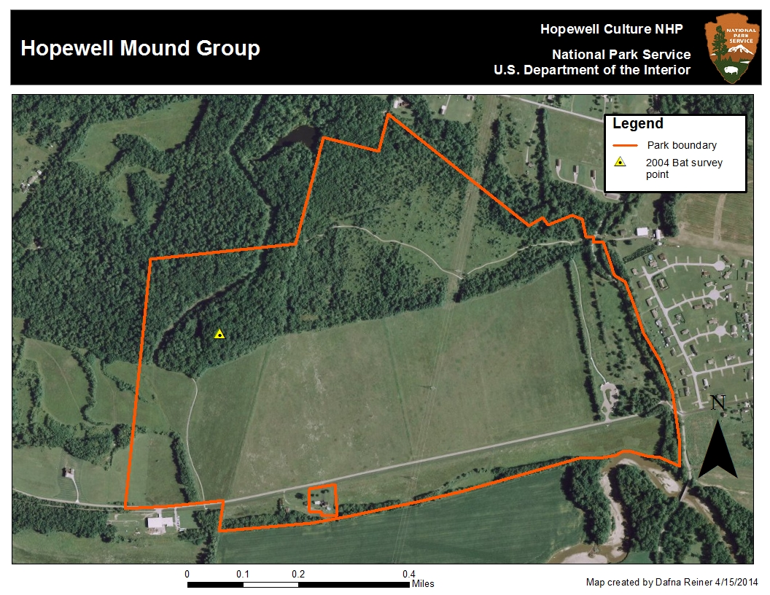
Figure 4. Hopewell Mound Group showing 2004 bat survey points.
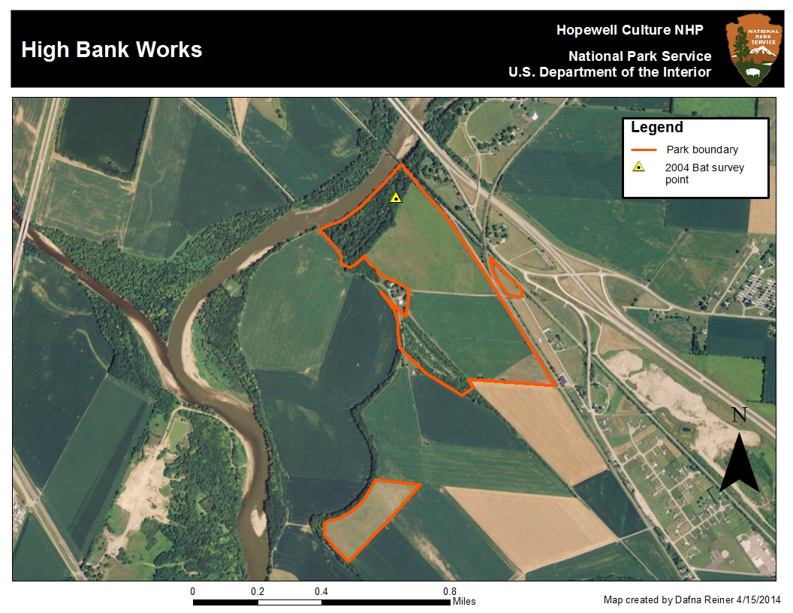
Figure 5. High Bank Works showing 2004 bat survey points.

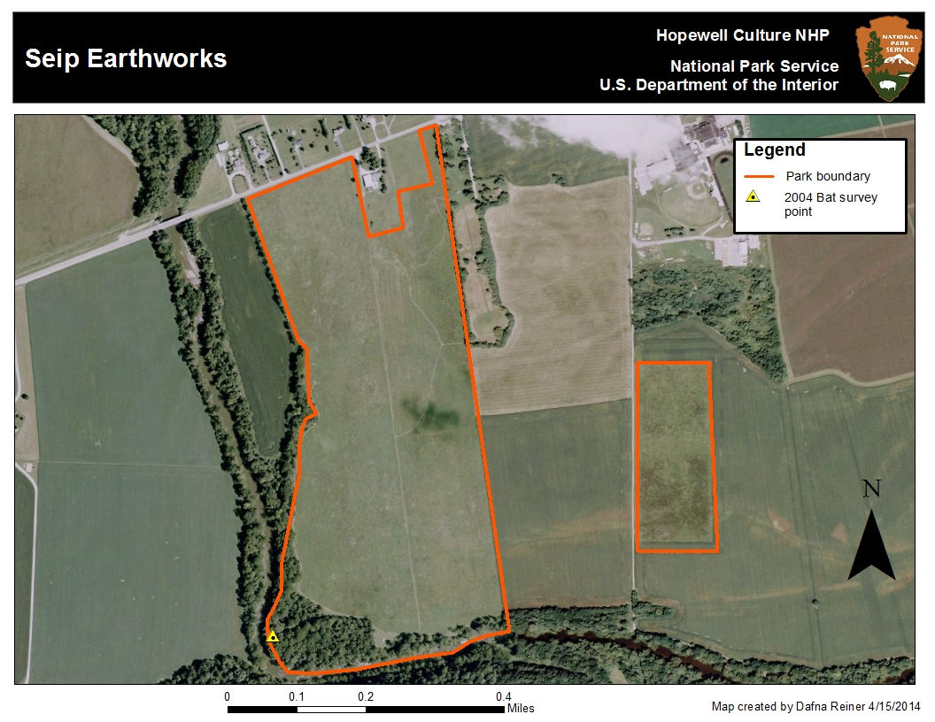
Figure 6.Seip Earthworks showing 2004 bat survey points.

Table 1. List of bat species expected to occur at Hopewell Culture NHP.
Scientific Name | Common Name
Eptesicus fuscus | Big Brown Bat
Lasionycteris noctivagans | Silver-haired Bat
Lasiurus borealis | Red Bat
Lasiurus cinereus | Hoary Bat
Myotis lucifugus | Little Brown Bat
Myotis septentrionalis | Northern Long-eared Bat
Myotis sodalist | Indiana Bat
Nycticeius humeralis | Evening Bat
Pipistrellus subflavus | Tri-colored bat

Table 2. Coordinates of the 2004 survey sites (NAD 83 Zone 17N)

Survey Point | Habitat | Easting | Northing
1 | Riparian Edge | 327503 | 4360469
2 | Forest Trail | 327440 | 4360632
3 | Small Forest Trail | 327575 | 4360454
4 | Small forest trail | 327518 | 4360334
5 | Riparian corridor | 334350 | 4352133
6 | Riparian corridor | 307880 | 4344796
7 | Pond/forest | 319181 | 4359121
8 | Creekbed | 329428 | 4360713
9 | Creekbed | 329519 | 4360757
10 | Stream bed | 329051 | 4360781

C. Project Products:

Draft of Final Report due by 15 September 2015
- Will follow NPS Natural Resource Publications Management (NRPM) format (http://www.nature.nps.gov/publications/nrpm/index.cfm).
- Will describe features in the study area, including their locations and attributes.
- Will include summaries of counts, estimates of abundance and frequencies of occurrence.
- Maps that delineate spatial aspects of inventories,
- Will include PI’s judgment regarding influences of WNS, habitat, vegetation management and weather conditions during the study that may have affected the survey.
- Will provide a technical assessment of taxa that were accounted for in the study, including observed species richness and estimates as to the proportion of species that were detected in each project area during the study.
- Will include lists of species that were thought to have been “missed” for any reason, are unlikely, but may occur within the park and those species likely to been effected by WNS. Conclusions must emphasize results of the inventory with greater weight than any results of background research, such as preexisting lists that may have been consulted.

Other Deliverables
- Databases, including GPS data,
- GIS data (digital, and illustrated in Final Report as appropriate), complying with FGDC standards,
- Acoustic survey files, including noise files, annotated with genus and species (if possible) ID,
- raw data forms (hard copy),
- voucher specimen data (if collected) and vouchers, fully processed according to NPS specifications,

D. Project Schedule:
Period of performance shall be from June 25, 2014 to October 15, 2015

E. Furnished Property / Other Considerations:

References:

U.S. Fish and Wildlife Service. 2014. Rangewide Indiana Bat Summer Survery Guidelines Jan. 13, 2014. Website
http://www.fws.gov/midwest/endangered/mammals/inba/surveys/pdf/2014IBatSummerSurveyGuidelines13Jan2014.pdf
[Accessed 16 Apr. 2014]
Jones, C., W.J. McShea, M.J. Conroy and T.H. Kunz. 1996. Chapter 8: Capturing mammals. In: D.E. Wilson, F.R. Cole, J.D. Nichols, R. Rudran and M.S. Foster (eds.). Measuring and monitoring biological diversity: standard methods for mammals. Smithsonian Institution Press, Washington.

Kunz, T.H., D.W. Thomas, G.C. Richards, C.R. Tidemann, E.D. Pierson, and P.A. Racey. 1996. Chapter 7: Observational techniques for bats. In: D.E. Wilson, F.R. Cole, J.D. Nichols, R. Rudran and M.S. Foster (eds.). Measuring and monitoring biological diversity: standard methods for mammals. Smithsonian Institution Press, Washington

SINGLE-SOURCE JUSTIFICATION

DEPARTMENT OF THE INTERIOR
SINGLE SOURCE POLICY REQUIREMENTS
Department of the Interior Policy (505 DM 2) recognizes competition is not required for a federal financial assistance award and at the same time requires a written justification which explains why competition is not practicable for a single-source award. The justification must address one or more of the following criteria as well as discussion of the program legislative history, unique capabilities of the proposed recipient, and cost-sharing contribution offered by the proposed recipient, as applicable.

505 DM 2.14 stipulates that a single-source federal financial assistance award must satisfy one or more of the following criteria:

- Unsolicited Proposal – The proposed award is the result of an unsolicited assistance application which represents a unique or innovative idea, method, or approach which is not the subject of a current or planned contract or assistance award, but which is deemed advantageous to the program objectives;

- Continuation – The activity to be funded is necessary to the satisfactory completion of, or is a continuation of an activity presently being funded, and for which competition would have a significant adverse effect on the continuity or completion of the activity;

- Legislative intent – The language in the applicable authorizing legislation or legislative history clearly indicates Congress’ intent to restrict the award to a particular recipient of purpose;

- Unique Qualifications – The applicant is uniquely qualified to perform the activity based upon a variety of demonstrable factors such as location, property ownership, voluntary support capacity, cost-sharing ability if applicable, technical expertise, or other such unique qualifications;

- Emergencies – Program/award where there is insufficient time available (due to a compelling and unusual urgency, or substantial danger to health or safety) for adequate competitive procedures to be followed.

The National Park Service and Tennessee Technological University as members of the Southern Appalachian Mountains Cooperative Ecosystem Studies Unit (SA-CESU) network are under a Cooperative Agreement which allows Tennessee Technological University to participate in specific tasks under task agreements with the National Park Service.

The National Park Service intends to award a task agreement to Tennessee Technological University based on the following:

(5) Emergencies - Due to the very late notice of funding and the fact that the U.S. Fish and Wildlife Service restricts mist-netting season for Indiana Bats and Northern Long Eared Bats to the period between June 1-August 15 an emergency sole-source award is requested. A quick start of this project would ensure that it is completed in FY14. A delay may cause the project to carry-over into the spring of FY15 increasing the costs. The U.S. Fish and Wildlife Service (FWS) publishes a list of permittees for Indiana Bat surveys in the state of Ohio. Only those on the list are authorized to survey for this federally listed species as well as Northern Long Eared Bat (NLEB) which has been declared a candidate species. Since the park lies within Indiana Bat’s range and since NLEB have been documented in four out of five of the park’s units a permittee from the list must be sought. All the permittees who are associated with a university were contacted. Several were not available to do the survey and several were non-responsive. Dr. Carver responded in a timely manner and indicated his interest and availability to conduct the study.

