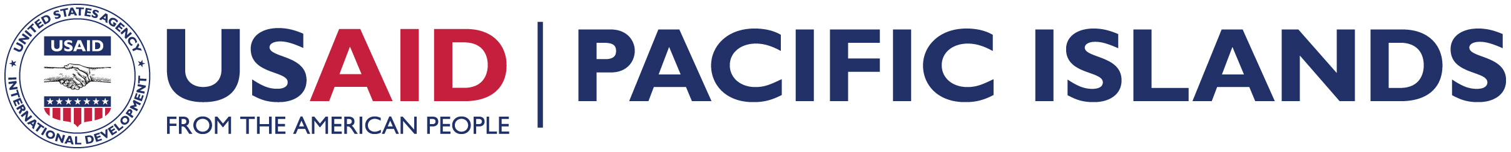

Amendment #: Two (2) to Solicitation Number 492-12-000029 “HIV/AIDS Services for MARPS in PNG Program”

Amendment Issuance Date: June 26, 2012

The RFA closing date of July 17th remains the same.

Applicants should consider the following as supplemental information to the RFA:

REVISIONS/CLARIFICATIONS:

1. In amendment one (1) the RFA closing date is listed as July 11th. That is incorrect. The original RFA closing date was July 17th. That remains the same. To be considered for award, for this RFA, applications are due July 17th at 2:00 p.m. (local Manila time).

2. In amendment one (1) the posting date of the amendment was actually June 18th, not June 15th as stated in the amendment.

3. The RFA number in amendment one is corrected to 492-12-000029.

3A. Section III.B(i) of the RFP (page 43) refers to “Letters of Commitment from Recipients, if any and key personnel”. Could USAID please clarify what “Recipient” means in this context?

3Q. Replace “recipient” with “sub-awardee whose budget exceeds 5% of the amount of the total proposed agreement budget.”

END OF REVISIONS/CLARIFICATIONS FOR AMENDMENT 2

