U.S. Department of the Interior
National Park Service

Financial Assistance
Notice of Funding Opportunity (NOFO)



Program Title | Hurricanes Harvey, Irma, and Maria Emergency Supplemental Historic Preservation Fund Grant Program
Notice of Funding Opportunity Number: | P18AS00242
Announcement Type: | Initial
CFDA Number: | 15.957

Issue Date: | June 14, 2018
Application Due Date: | August 15, 2018 | Time AM/PM Zone | 11:59 PM Eastern

Agency Contact Information |  | Questions and Requests
Name | Megan J. Brown | Name | STLPG Staff
Address | State, Tribal, Local, Plans & Grants Division  National Park Service  1849 C Street, NW  Mail Stop 7360  Washington, DC 20240 | Address | State, Tribal, Local, Plans & Grants Division  National Park Service  1849 C Street, NW  Mail Stop 7360  Washington, DC 20240
Phone | 202-354-2020 | Phone | 202-354-2020
Email | preservation_grants_info@nps.gov | Email | preservation_grants_info@nps.gov

Table of Contents

Section A: Program Description 3
Section B: Federal Award Information 4
Section C: Eligibility Information 6
1. Eligible Applicants 6
2. Cost Sharing or Matching 6
Section D: Application and Submission Information 7
1. Address to Request Application Package 7
2. Contents and Form of Application Submission 7
3. Unique entity identifier and System for Award Management (SAM) 8
4. Submission Dates and Times 9
5. Intergovernmental Review 9
6. Funding Restrictions 9
7. Other Submission Requirements 9
Section E: Application Review Information 12
Section F: Federal Award Administration Information 13
1. Federal Award Notices 13
2. Administrative and National Policy Requirements 13
3. Reporting 14
Section G: Federal Awarding Agency Contacts 17
Section H: Other Information: 18
Appendix A – Forms Instructions 20

Section A: Program Description

Federal Agency Name: Department of the Interior, National Park Service

Funding Opportunity Title: Hurricanes Harvey, Irma, and Maria Emergency Supplemental Historic Preservation Fund Grant Program – Competitive Grants

Funding Opportunity Number: P18AS00242

Catalog of Federal Domestic Assistance (CFDA) Number: 15.957

Legislative Authority:
- 54 USC 301 et seq. (National Historic Preservation Act)
- 54 U.S.C. 302907

Bipartisan Budget Act of 2018, enacted as Public Law 115-123

Federal Regulations: 2 C.F.R. § 200, 2 C.F.R. § 1402

Program Background Information and Objectives:

Public Law 115-123 appropriated $50 million from the Historic Preservation Fund (HPF) for historic preservation projects providing relief to damages in areas that have received a major disaster declaration pursuant to the Robert T. Stafford Disaster Relief and Emergency Assistance Act (42 USC 5121 et seq.) as a result of Hurricanes Harvey, Irma, and Maria which occurred in 2017.

Department of the Interior Priorities:
This program supports the following Department of the Interior (DOI) priorities:
- Striking a regulatory balance: Reduce the administrative and regulatory burden imposed on U.S. industry and the public;
- Ensuring sovereignty means something: Support tribal self-determination, self-governance, and sovereignty;
- Restoring trust with local communities: Expand the lines of communication with Governors, state natural resource offices, Fish and Wildlife offices, water authorities, county commissioners, Tribes, and local communities; and
- Modernizing our Infrastructure: Remove impediments to infrastructure development and facilitate private sector efforts to construct infrastructure projects serving American needs.

Section B: Federal Award Information

Anticipated Federal Funding:
Approximately $1 million will be awarded based on competitive criteria to the following eligible Tribal Historic Preservation Offices: Catawba Indian Nation of South Carolina, Chitimacha and Coushatta Tribes of Louisiana, and Seminole Tribe of Florida.

Opportunity Number: P18AS00242

Non-Federal Entity Cost Share:
No matching share is required for this program.

Estimated Number of Agreements to be Awarded:
An estimated 4 grants will be awarded based on competitive criteria. Each grantee may then subgrant a portion of the funds to eligible recipients.

Estimated Amount of Funding Available Per Award: $500,000
The amount of funding available per award for this Notice of Funding Opportunity (NOFO) will be determined as part of the application review process based on applications received and funding made available through appropriations.

Anticipated Start Date:
Start date for work under these awards is estimated at October 1, 2018.

Anticipated Term of the Agreement: October 1, 2018 to September 30, 2023.Agreement terms for funded projects are generally five years, depending on the negotiated project statement of work. Agreements are not effective until fully executed with signature from the NPS Financial Assistance Awarding Officer (FAAO).

Grant Agreement - A legal instrument of financial assistance between The National Park Service and a non-Federal entity that, consistent with 31 U.S.C. § 6302, 6304:

(1) Is used to enter into a relationship the principal purpose of which is to transfer anything of value from the Federal awarding agency to the non-Federal entity to carry out a public purpose authorized by a law of the United States (see 31 U.S.C. § 6101(3)); and not to acquire property or services for the Federal awarding agency’s direct benefit or use;

(2) Is distinguished from a cooperative agreement in that it does not provide for substantial involvement between the Federal awarding agency or pass-through entity and the non-Federal entity in carrying out the activity contemplated by the Federal award.

Substantial Involvement:
No substantial involvement on the part of the National Park Service (NPS) is anticipated.

Other Information:
- Applications for renewal or supplementation of existing projects are not eligible.

- Projects funded under this program constitute “undertakings” as defined by Section 106 of the National Historic Preservation Act, as amended (54 U.S.C. 306108). Accordingly, after the grant is awarded, the National Park Service will work with the grantee to complete the consultation process prior to receiving funds from their grant account. Depending on the project, additional federal reviews may be required under other laws including but not limited to, the Archaeological Resources Protection Act of 1979 (ARPA), the National Environmental Policy Act (NEPA), and Native American Graves Protection and Repatriation Act (NAGPRA).

- Based on an assessment of applicants’ risk, NPS may require additional training or reporting.

- Project funds (including subgrants) that are not obligated by December 31, 2018, may be recaptured by the NPS and reallocated to other eligible projects.

Section C: Eligibility Information

Application Due Date: August 15, 2018, 11:59pm, Eastern
An applicant's failure to meet an eligibility criterion by the time of the application deadline will result in the application being excluded from consideration. This includes but is not limited to late and incomplete application packages.

Eligible Applicants
- Eligible competitive applicants are:
  - Catawba Indian Nation
  - Chitimacha Tribe of Louisiana
  - Coushatta Tribe of Louisiana
  - Seminole Tribe of Florida

2. Cost Sharing or Matching
There is no matching share requirement for this program.

- Other
Eligible activities include:
- Recovery of historic resources in areas that received a major disaster declaration pursuant to the Robert T. Stafford Disaster Relief and Emergency Assistance Act (42 U.S.C. 5121 et seq.).
- Projects under the eligible program areas as defined by the National Historic Preservation Act.
- Administration costs necessary to complete and administer the program.
- Necessary compliance activities required by 54 USC 306108 (commonly known as Section 106) of the National Historic Preservation Act related to the consequences of Hurricanes Harvey, Irma, and Maria.
- Recovery and repair of properties
  - Eligible properties include historic districts, buildings, sites, structures and objects listed or considered eligible for listing in the National Register of Historic Places by the Tribal Historic Preservation Officer.
  - Eligible properties that receive funding must complete and submit a nomination as part of the project.
  - All work must meet the Secretary of the Interior’s Standards and Guidelines for Archeology and Historic Preservation.
  - All projects receiving repair assistance must enter into a preservation agreement/covenant/easement.
- Survey and Inventory of historic resources to determine eligibility, degree of damage, and provide preparedness for future disasters.
- Projects must substantially mitigate the threat and include steps to mitigate future damage.

Section D: Application and Submission Information

1. Address to Request Application Package
The Application Package contains several mandatory forms, which must be submitted with your proposal, forms include:
- SF-424 (Application for Financial Assistance)
- SF-424A (Budget Information for Non-Construction Programs)
- SF-424B (Assurance for Non-Construction Programs)
- SF-424C (Budget Information for Non-Construction Programs)
- SF-424D (Assurance for Construction Programs)
- SF-LLL (Disclosure of Lobbying Activities), if anticipated award is over $100,000
- Attachments Form
- Project Description Worksheet
- Indirect Cost Rate (if applicable)

2. Contents and Form of Application Submission
You must complete the mandatory forms and any applicable optional forms, in accordance with the instructions below, as required by this NOFO. Do not include any proprietary or personally identifiable information (PII). A complete application should include:
- Standard Form 424 (SF 424) – Application for Federal Assistance
  - Complete this form as much as possible with all applicable information. Please note: You must provide your ZIP Code + 4. Your DUNS and Bradstreet Number (DUNS) must match the DUNS Number under your SAM.gov record.

- Standard Form 424A and 424C – Budget Information
  - Please follow the instructions for filling out the SF-424a which are provided in Appendix A of this Notice of Funding Opportunity.
  - The project budget shall include detailed information on all cost categories and must clearly identify all project costs. Unit costs shall be provided for all budget items including the cost of work to be provided by contractors or sub-recipients. In addition, applicants shall include a narrative description of the items included in the project budget, including the value of in-kind contributions of goods and services provided to complete the project when cost share is identified to be included (reference section C of this announcement). Cost categories can include, but are not limited to, those costs items included on the SF424A and SF424C.
- Standard Form 424B and D - Assurances
  - By downloading these forms on the “Manage Workspace” page, these forms will be marked as “passed” and will be considered completed and marked as “Read Only”. You do not need to re-upload them on the attachments form.
- Standard Form LLL - Disclosure of Lobbying Activities
In accordance with 43 C.F.R. § 18 and 31 U.S.C. § 1352 this form must be completed and signed if the amount of the Federal award is anticipated to exceed $100,000.00.
- Attachments Form
  - The Attachments Form is where the required indirect cost rate, project description worksheet, and any other relevant documents are attached as part of the grant application.

- Indirect Cost Rate Agreement, if applicable
- If your proposed budget includes indirect costs, the rate as proposed must meet the requirements of 2 CFR Part 200, Section 200.414 and 2 CFR Part 200, Appendix III through Appendix VII as applicable. A negotiated indirect cost rate agreement must be provided with your proposal.
- If your proposed budget includes indirect costs, please submit either:
  - Your organization’s Approved Indirect Cost Rate Agreement, or
  - DeMinimis Indirect Cost Rate Certification. If selecting use of 10% de minimis rate because of no prior negotiated indirect cost rate a De Minimis Indirect Cost Rate Certification must be submitted. Proposals that fail to document their indirect costs will have those costs disallowed.
- Indirect and direct administrative costs may not exceed 25% of the total project budget as defined in 54 USC 301 et seq.

- Project Description Worksheet
  - The project description worksheet is where you input your project narrative. The project description worksheet must be uploaded via the attachments form in Workspace.

If selected for award, NPS reserves the right to request additional or clarifying information for any reason deemed necessary, including, but not limited to:
(a) Other budget information
(b) Financial capability
(c) Evaluation of risk
(d) Name and phone number of the Designated Responsible Employee for complying with national policies prohibiting discrimination (See 43 C.F.R. § 17)

3. Unique entity identifier and System for Award Management (SAM)
Each applicant (unless exempt under 2 CFR §25.110) is required to:
(a) Be registered in SAM.gov;
(b) Provide a valid unique entity identifier in its application (currently a DUNS number);
(c) Continue to maintain an active SAM registration with current information at all times during which it has an active Federal award or an application or plan under consideration by a Federal awarding agency.

Registration processes for SAM can be found at https://www.sam.gov

A financial assistance agreement will not be made with a non-Federal entity until the non-Federal entity has complied with all applicable unique entity identifier and SAM requirements. If a non-Federal entity has not fully complied with the requirements by the time that an agreement is ready for award, a determination may be made that the applicant is not qualified to receive a Federal award. That determination may be used as a basis for making a Federal award to another applicant.

In addition, in order to submit an application through Grants.gov an applicant must have an active SAM registration and register for submission permissions through the Grants.gov website. Utilize the following link to guide you through this process: http://www.grants.gov/web/grants/applicants/organization-registration.html

4. Submission Dates and Times
Applicants are held responsible for their proposals being submitted to the National Park Service. Applications must be received by August 15, 2018, 11:59 pm EST. Applicants are encouraged to submit the application well before the deadline.

Application preparation time may take several weeks, so please start the application process as soon as possible. Applications received after the deadline will not be reviewed or considered for award. If it is determined that a proposal was not considered due to lateness, the applicant will be notified during the selection process.

5. Intergovernmental Review
This funding opportunity is not subject to Executive Order (EO) 12372 “Intergovernmental Review of Federal Programs.” Applicants subject to EO 12372 must contact their State’s Single Point of Contact (SPOC) to find out about and comply with the State’s process. The names and addresses of the SPOC’s are listed in the OMB’s home page at: http://www.whitehouse.gov/omb/grants_spoc/

6. Funding Restrictions
Costs incurred by the applicant prior to the start date of the period of performance of a signed Federal award are only allowable with written approval by a Financial Assistance Awarding Officer and may only be counted toward their cost share requirement.

7. Other Submission Requirements
Applications must be submitted through Grants.gov to the National Park Service by August 15, 2018, 11:59pm EST. Applications not received by the deadline will NOT be considered.

After you submit your application you should receive three emails from grants.gov.
- The first email will be a confirmation that you have submitted your application.
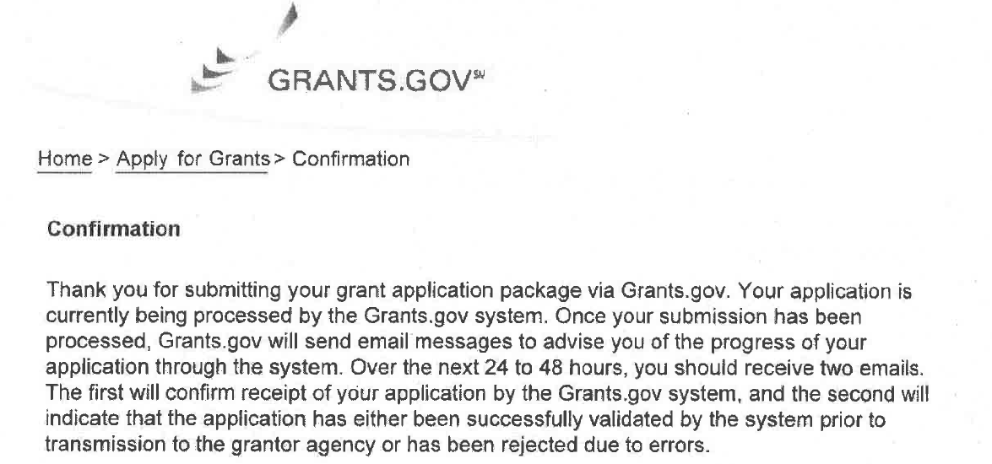

- The second email will confirm receipt of your application by the grants.gov system.
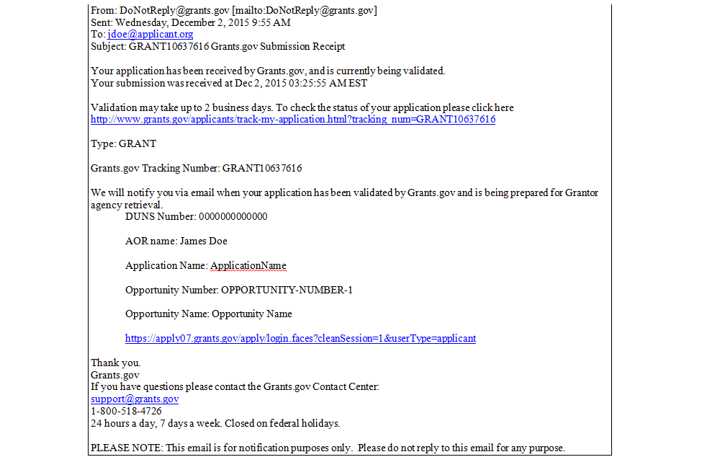

- The third will indicate that the application has either been successfully validated by the system or rejected due to errors. If your application is rejected due to errors, please contact grants.gov immediately. Your application must be validated in order for your application to be forwarded to NPS and be considered for funding.

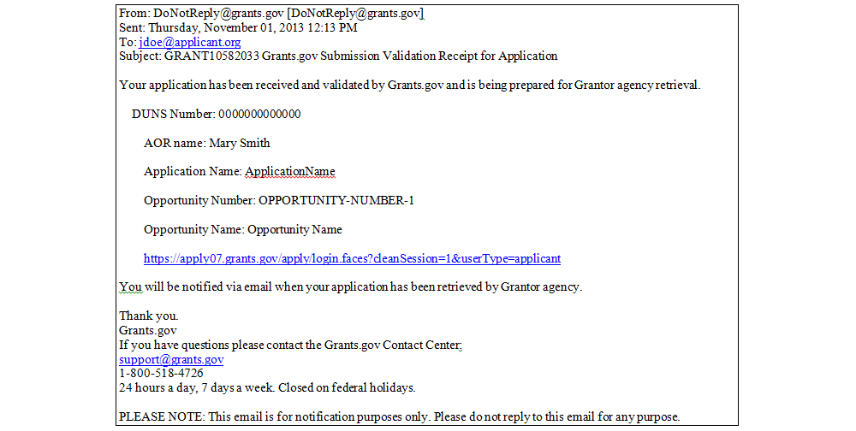

In the event the applicant experiences difficulties in completing their application, please contact: preservation_grants_info@nps.gov or 202-354-2020. Technical issues with Grants.gov should be resolved by calling 1-800-518-4726 or visiting their online help desk. Document any issues with submission carefully.

START THIS PROCESS EARLY DON’T DELAY!

Section E: Application Review Information

1. Criteria for Competitive Awards
NPS will evaluate and consider only those applications that separately address each of the merit review criteria. Each applicant is required to provide a detailed project description, in accordance with section D.2., of the following criteria elements.

Criterion 1
 | Weight 25%
Need | Describe how historic cultural resources have been damaged by one of the named storms and then needs that are associated with recovery. Include how documentation of damage will be gathered to establish in-house or subgrant project eligibility.  If your proposal includes funding for temporary or contractual staff, explain and justify the need for additional staff, the scope of work to be performed, and the relationship between this work and storm-related damage.  Note: if your proposal includes plans to undertake sub-grant projects or to manage preservation grants in-house, projects must be closely monitors to ensure other assistance from other Federal, state, local, or private sources (including insurance claims) is not funding the same work.

Criterion 2
 | Weight 25%
Threat | Describe how historic cultural resources are threatened or endangered as a result of the named storms. Your response must document the urgent preservation and/or conservation need. Priority will be given to physically damaged properties in need of repair.

Criterion 3
 | Weight 25%
Mitigation of the Threat | Describe how funded projects, either undertaken as subgrants or in-house, will substantially mitigate the threats identified in criterion 2 and how grant funding will be used to mitigate future damage.  Describe anticipated products and results.

Criterion 4
 | Weight 25%
Department of the Interior Priorities | Discuss how your project advances the following Department of the Interior Priorities:  - Striking a regulatory balance: Reduce the administrative and regulatory burden imposed on U.S. industry and the public;  - Ensuring sovereignty means something: Support tribal self-determination, self-governance, and sovereignty;  - Restoring trust with local communities: Expand the lines of communication with Governors, state natural resource offices, Fish and Wildlife offices, water authorities, county commissioners, Tribes, and local communities; and  - Modernizing our Infrastructure: Remove impediments to infrastructure development and facilitate private sector efforts to construct infrastructure projects serving American needs.

2. Review and Selection Process
NPS personnel, and in some cases independent Federal reviewers, will review all proposals. All proposals for funding will be considered using the criteria outlined above. A summary of the review panel comments may be provided to the applicant if requested once awards are announced.

a. Initial Review
Prior to conducting the comprehensive merit review, an initial review will be performed to determine whether: (1) the applicant is eligible for an award; (2) the information required by the NOFO has been submitted; (3) all mandatory requirements of the NOFO are satisfied; and (4) the proposed project is responsive to the program objectives of the NOFO (program determination). If an applicant fails to meet the requirements or objectives of the NOFO, or does not provide sufficient information for review, the applicant will be considered non-responsive and eliminated from further review.

b. Comprehensive Merit Review
All applications that satisfactorily pass the initial review will be eligible for the Comprehensive Merit Review.

Each criteria element will be scored 25 point scale:

Description
Criterion1 | Criterion 2 | Criterion 3 |  | Criterion 4
25 | 25 | 25 |  | 25 | Superior
20 | 20 | 20 |  | 20 | Good
14 | 14 | 14 |  | 14 | Satisfactory
10 | 10 | 10 |  | 10 | Marginal
6 | 6 | 6 |  | 6 | Poor
0 | 0 | 0 |  | 0 | Not Acceptable

The scoring of each criterion must be based on the strengths and weaknesses of the application narrative. To assist in assigning an appropriate score, the following will be used as a guideline:

Rating | Descriptive Statement
Superior | Applicant fully addresses all aspects of the criterion, convincingly demonstrates that it will meet the Government's performance requirements, and demonstrates no weaknesses.
Good | Applicant fully addresses all aspects of the criterion, convincingly demonstrates a likelihood of meeting the Government's requirements, and demonstrates only a few minor weaknesses.
Satisfactory | Applicant addresses all aspects of the criterion and demonstrates the ability to meet the Government's performance requirements. The Application contains weaknesses and/or a number of minor weaknesses.
Marginal | Applicant addresses all aspects of the criterion and demonstrates the ability to meet the Government's performance requirements. The Application contains significant weaknesses and/or significant minor weaknesses.
Poor | The likelihood of successfully meeting the Government's requirements. Significant weaknesses are demonstrated and clearly outweigh any strength presented.
Not Acceptable | Applicant does not address all aspects of the criterion and the information presented indicates a strong likelihood of failure to meet the Government's requirements.

c. Selection
The Selection Official may consider the merit review recommendation, program policy factors, and the amount of funds available to select applications for funding. All proposals for funding will be considered using the criteria outlined above. A summary of the review panel comments may be provided to the applicant if requested.

d. Discussions and Award
The Government may enter into discussions with a selected applicant for any reason deemed necessary, including, but not limited to: (1) only a portion of the application is selected for award; (2) the Government needs additional information to determine that the applicant is capable of complying with the requirements of DOI Financial Assistance Regulations, and/or (3) additional specific terms and conditions are required. Failure to satisfactorily resolve the issues identified by the Government may preclude award to the applicant.

3. Evaluation of Applicant Risk
In accordance with 2 C.F.R. § 200.205, applications selected for funding will be subject to a pre-award risk assessment which may include a review of information contained within the applicant’s proposal, past audits, Federal Awardee Performance and Integrity Information System (FAPIIS), and/or past performance on previous Federal financial assistance awards. Negative information that leads to an applicant being designated as “Medium Risk” or “High Risk” may result in specific conditions, as identified in 2 C.F.R. § 200.207, being incorporated into the final award.

Section F: Federal Award Administration Information

1. Federal Award Notices
Upon being selected for the award, successful applicants will receive a notification of the selection of their application for funding. NPS will notify the applicant selected for award by Fall 2018. A notice of selection is not an authorization to begin performance on an agreement. This notice will detail the next steps in the awarding process. Once all clearances and reviews have been conducted, a grant agreement will be sent for signature.

Work cannot begin before the non-Federal entity receives a fully executed copy of the grant agreement which contains the signature of the Financial Assistance Awarding Officer. Any pre-award costs incurred prior to the receipt of a signed agreement or written notice signed by a Financial Assistance Awarding Officer authorizing pre-award costs, is at the applicant’s own risk. A signed grant agreement signed by a Financial Assistance Awarding Officer is the only authorizing document to begin performance.

Organizations whose applications have not been selected will be advised as promptly as possible.

2. Administrative and National Policy Requirements

a. Code of Federal Regulations (CFR)
By accepting Federal financial assistance, the non-Federal entity agrees to abide by the applicable Federal regulations in the expenditure of Federal funds and performance under this program: 2 C.F.R. Part 200 - Uniform Administrative Requirements, Cost Principles, and Audit Requirements For Federal Awards

b. Standard Award Terms and Conditions
Acceptance of a Federal financial assistance award from the Department of the Interior carries with it the responsibility to be aware of and comply with the terms and conditions of the award. Acceptance is defined as the start of work, drawing down funds, or accepting the award via electronic means. Awards are based on the application submitted to, and as approved by the Financial Assistance Awarding Officer. All financial assistance awards are subject to the terms and conditions incorporated either directly or by reference in the award document. Code of Federal Regulations/Regulatory Requirements, as applicable, are listed within Appendix B of this announcement (Contact the Financial Assistance Awarding Officer with any questions regarding the applicability of any terms and conditions).
- 2 C.F.R. Part 175 - Trafficking Victims Protection Act of 2000
- 2 C.F.R. Parts 182 & 1401 - Government-wide Requirements for a Drug-Free Workplace
- 2 C.F.R. Parts 180 & 1400 - Government-wide Debarment and Suspension (Non-procurement)
- 43 CFR. 18 - Restrictions on Lobbying

c. Order of Precedence
Any inconsistency in the agreement shall be resolved by giving precedence in the following order: (a) Any national policy requirements and administrative management standards; (b)
2 C.F.R. Part 200, in its entirety; (c) requirements of the applicable OMB Circulars and Treasury regulations; (d) special terms and conditions; (e) all agreement sections, documents, exhibits, and attachments; (f) and the non-Federal Entity’s project proposal.

d. Modifications
The agreement may be modified by written agreement signed by both the non-Federal entity’s Authorized Representative and the Financial Assistance Awarding Officer. Administrative changes (i.e. Financial Assistance Awarding Officer name change, etc.) which do not change the statement of work, agreement amount, etc., or otherwise affect the non-Federal entity may be signed unilaterally by the Financial Assistance Awarding Officer. Additionally, a unilateral modification may be utilized if it should become necessary to impose remedies for non- compliance, suspension or termination of the agreement in accordance with 2 CFR 200, Section 200.338 – 200.342.

All other changes shall be made by means of a bilateral modification to the agreement. No oral statement made by any person, or written statement by any person other than the NPS Financial Assistance Awarding Officer shall be allowed in any manner or degree to modify or otherwise effect the terms of the agreement.

e. Payments
All applicants must be registered in the System for Awards Management (SAM) prior to award under this NOFO. Instructions for registering for SAM are located at http://www.sam.gov/portal/public/SAM. All applicants must maintain an active SAM registration with current information at all times while they have an active Federal award or an application under consideration.

All applicants must also be registered with, and willing to process all payments through, the Department of the Treasury Automated Standard Application for Payments (ASAP) system. All non-Federal entities with active NPS financial assistance agreements must be enrolled in ASAP under the appropriate Agency Location Code(s) (ALC) and the Data Universal Number System (DUNS) Number prior to the award of funds. If a non-Federal has multiple DUNS numbers they must separately enroll within ASAP for each unique DUNS Number and/or Agency. Note that if your entity is currently enrolled in the ASAP system with an agency other than NPS, you must enroll specifically with NPS in order to process payments.

f. Funding Restrictions
All funding is contingent upon the availability and appropriation of funds by the United States Congress.

g. Cost Principles:
Costs must be allowable in accordance with the applicable Federal cost principles referenced in 2 CFR Part 200, Subpart E – Cost Principles.

h. Pre-award Costs:
Must comply with 2 CFR Part 200.458 and requires written approval from the Financial Assistance Awarding Officer.

3. Reporting

a. Financial Status Reports:
A report of expenditures is required as documentation of the financial status of awards according to the official accounting records of the non-Federal entity. The financial information will be reported by completing and submitting the Federal Financial Report (FFR), SF425. At a minimum, financial reports will be required quarterly and shall be submitted within 30 calendar days after the end of the reporting period. The Financial Assistance Awarding Officer may designate a reporting schedule requiring more frequent reporting based on the assessment of risk. The reporting requirements will be defined within the grant agreement. A final FFR shall be submitted no more than 90 calendar days after the end date of the agreement.

The FFR can be downloaded at:
http://www.whitehouse.gov/omb/grants/standard_forms/ffr.pdf

The NPS Financial Assistance Awarding Officer will review the report for patterns of cash expenditures and assess whether performance or financial management problems exist. Before submitting the FFR to the NPS Financial Assistance Awarding Officer, the non-Federal entity must ensure that the information submitted is accurate, complete, and consistent with the non-Federal entity’s accounting system. The non-Federal entity’s Authorized Certifying Official’s signature on the FFR certifies that the information in the FFR is correct and complete and that all outlays and obligations are for the purposes set forth in the agreement documents, and represents a claim to the Federal Government. Filing a false claim may result in the imposition of civil or criminal penalties.

b. Performance Reports:
A report of performance is required as documentation of performance towards the accomplishments of the Federal award and detailing project activity and participant profile information. At a minimum, performance reports will be required quarterly and shall be submitted within 30 calendar days after the end of the reporting period. The Financial Assistance Awarding Officer may designate a reporting schedule requiring more frequent reporting based on the assessment of risk. The reporting requirements will be defined within the grant agreement. A final performance report shall be submitted no more than 90 calendar days after the end date of the agreement.

In accordance with 2 C.F.R. 200 § 200.328, the performance reports shall contain brief information on:

(1) A comparison of actual accomplishments to the objectives of the Federal award established for the period. Where the accomplishments of the Federal award can be quantified, a computation of the cost (for example, related to units of accomplishment) may be required if that information will be useful. Where performance trend data and analysis would be informative to the Federal awarding agency program, the Federal awarding agency should include this as a performance reporting requirement;
(2) The reasons why established goals were not met, if appropriate; and
(3) Additional pertinent information including, when appropriate, analysis and explanation of cost overruns or high unit costs.

Before submitting the performance report to the NPS Financial Assistance Awarding Officer, the non-Federal entity must ensure that the information submitted is accurate, complete, and consistent with the non-Federal entity’s Federal financial report. Filing false information may result in the imposition of civil or criminal penalties.

c. Non-Compliance:
Failure to comply with the reporting requirements contained in an agreement may be considered a material non-compliance with the terms and conditions of the award. Non-compliance may result in withholding of future payments, suspension or termination of the agreement, recovery of funds paid under the agreement, and the withholding of future awards. The specific information regarding type, frequency and means of submission of post-Federal award reporting requirements will be contained in the award document.

4. Reporting Matters Related to Recipient Integrity and Performance:
If the total value of your currently active grants, cooperative agreements, and procurement contracts from all Federal awarding agencies exceeds $10,000,000 for any period of time during the period of performance of this Federal award, then you as the recipient during that period of time must maintain the currency of information reported to the System for Award Management (SAM) that is made available in the designated integrity and performance system (currently the Federal Awardee Performance and Integrity Information System (FAPIIS)) about civil, criminal, or administrative proceedings in accordance with Appendix XII to 2 C.F.R. 200.

Section G: Federal Awarding Agency Contacts

Agency Contact Information:

Name: | Megan Brown, Chief, State, Tribal, Local, Plans & Grants Division
Address: | National Park Service, 1849 C Street, NW, MS 7360, Washington, DC 20240
Phone: | 202-354-2020
E-mail: | preservation_grants_info@nps.gov

Questions and Requests pertaining to this Notice of Funding Opportunity shall be submitted to:

Name: | State, Tribal, Local, Plans & Grants Staff
Address: | National Park Service, 1849 C Street, NW, MS 7360, Washington, DC 20240
Phone: | 202-354-2020
E-mail: | preservation_grants_info@nps.gov

Section H: Other Information:

- Program Information
Public Law 115-123 appropriated $50 million from the Historic Preservation Fund (HPF) for historic preservation projects providing relief to damages in areas that have received a major disaster declaration pursuant to the Robert T. Stafford Disaster Relief and Emergency Assistance Act (42 USC 5121 et seq.) as a result of Hurricanes Harvey, Irma, and Maria which occurred in 2017.
General program information is available at the State, Tribal, Local, Plans & Grants Division website at www.nps.gov/disaster

2. Proprietary and Personally Identifiable Information

a. Notice of Potential Disclosure under Freedom of Information Act
Applicants should be advised that identifying information regarding all applicants, including applicant names and/or points of contact, may be subject to public disclosure under the Freedom of Information Act, whether or not such applicants are selected for negotiation of award. Applicants must identify any proprietary information within their applications.

b. Personally Identifiable Information
In responding to this NOFO, applicants must ensure that Protected Personally Identifiable Information (PII) is not included in the following documents: Project Abstract, Project Narrative, Biographical Sketches, Budget or Budget Justification. These documents will be used by the Merit Review Committee in the review process to evaluate each application. PII is defined by the Office of Management and Budget (OMB) as:

Any information about an individual maintained by an agency, including but not limited to, education, financial transactions, medical history, and criminal or employment history and information that can be used to distinguish or trace an individual’s identity, such as their name, social security number, date and place of birth, mother’s maiden name, biometric records, etc., including any other personal information that is linked or linkable to an individual. This definition of PII can be further defined as: (1) Public PII and (2) Protected PII.

Public PII:
PII found in public sources such as telephone books, public websites, business cards, university listing, etc. Public PII includes first and last name, address, work telephone number, email address, home telephone number, and general education credentials.

Protected PII:
PII that requires enhanced protection. This information includes data that if compromised could cause harm to an individual such as identity theft.

3. Routine Notices to Applicants

a. Modification or Changes to the Notice of Funding Opportunity
Notices of any modifications to this NOFO will be posted on Grants.gov. You can receive an email when a modification or an announcement message is posted. When you download the application at Grants.gov; you can also register to receive notifications of changes through Grants.gov.

b. Government Right to Reject or Negotiate
NPS reserves the right, without qualification, to reject any or all applications received in response to this announcement and to select any application, in whole or in part, as a basis for negotiation and/or award.

c. Evaluation and Administration by Non-Federal Personnel
In conducting the merit review evaluation, the Government may seek the advice of qualified non-Federal personnel as reviewers. The Government may also use non-Federal personnel to conduct routine, nondiscretionary administrative activities. The applicant, by submitting its application, consents to the use of non-Federal reviewers/administrators. Non-Federal reviewers must sign conflict of interest and non-disclosure agreements prior to reviewing an application. Non-Federal personnel conducting administrative activities must sign a nondisclosure agreement.

d. Notice of Right to Conduct a Review of Financial Capability
NPS reserves the right to conduct an independent third party review of financial capability for applicants that are selected for negotiation of award (including personal credit information of principal(s) of a small business if there is insufficient information to determine financial capability of the organization).

Appendix A – Forms Instructions

Many of the application forms are included as interactive forms on the Grants.gov application website. Indirect Cost Rate Agreements and any other documents that are not the SF-424 series need to be uploaded through the “Attachments Form” which can be found in the Application Package.

SF-424 (Application for Financial Assistance)
You will find instructions on how to fill out the SF-424 on Grants.gov. You must provide your ZIP Code + 4 and your DUNS Number must exactly match your SAM.gov registration

SF-424A (Non-Construction Budget)

SHPO/THPO-Specific Instructions for the SF-424A (Non-Construction Budget Form)
Sections A, B, and C provide budget estimates for the entire grant award. All applications must contain a breakdown by the object class categories shown in lines a. – k. of Section B. The amounts appearing on the Budget Form must agree with the amounts appearing on the SF-424.

SECTION A - Budget Summary
1.e. Enter the total Federal share request to be approved in the Grant Award. The amount entered in 1.e. will equal the amount in Item 15a. on the SF-424.
SECTION B - Budget Categories
For each column, total the amounts entered on lines 6.i. and 6.j. and enter the total on line 6.k.
The total of Column 1 (Administrative), Column 2 (Internal Operating/Staff), and Column 3 (External Subgrants and Contracts) will equal the amount shown in Item 15.f. of the SF-424.
Total columns 1 through 3 across and enter the figures in column 5. The figure in column 5, line 6.k. will equal the amount entered in Section A.1.g.
SECTION B – Administrative and Operating Cost Instructions
In order to establish the amount of administrative costs applied in support of operational HPF activities, administrative costs must be listed separately in Section B, column (1) of the SF-424A Budget Form. Section B, column (2) must list operational costs for activities.
Administrative costs: Allowable, reasonable, and allocable costs related to the overall management of activities directly related to finance (accounting, auditing, budgeting, contracting), general administrative salaries and wages (grant administration, personnel, property management, equal opportunity) and other “overhead” functions (general legal services, general liability insurance, depreciation on buildings and equipment, etc.) not directly attributable to specific program areas identified in the grant agreement. All administrative costs reported must be absolutely necessary for project and/or program implementation, such as the cost items identified in the final grant agreement or items otherwise approved in writing by the NPS Awarding Officer (AO). Administrative costs plus any indirect costs charged to the grant may not exceed 25% of the overall project budget (Federal and matching share).

Operating Costs. The costs applied to specific Program Area activities described in Historic Preservation Fund Grant Manual Chapter 6. Operating programs and projects are those that directly contribute to the accomplishments of the SHPO responsibilities. The following are examples of operating costs:
o Personnel and nonpersonnel costs allocable to specific program areas.
o Payment to any trainees (such as work-study participants) including salaries, wages, and employer's share of fringe benefits.
- Administration or management directly linked to program areas; these costs are included under the appropriate program area.

SECTION C
8.b. Enter any nonfederal share supplied by the grantee.
8.d. Enter any nonfederal share supplied by other sources (including other State agencies) for the HPF grant

Notes:
Program Income (see Historic Preservation Fund Grant Manual Chapter 16) to be approved by NPS as nonfederal share must be shown in line 7 under Section B. If such Program Income is not listed, written NPS prior approval must be sought by the grantee through submission of a subsequent letter.

SECTION F – Other Budget Information
21. Direct Charges: Attach, if applicable, a list of proposed equipment to be purchased and the cost of each item. Equipment exceeding a cost of $5,000 per item must be listed. Equipment costing more than $5,000 not listed as part of the grant application will require a separate letter from the grantee and written NPS approval prior to purchase. If you enter expenses for equipment having an acquisition cost greater than or equal to $5,000, you will need to report on this equipment using the appropriate SF-428 family form.
22. Indirect Charges: Provide the date of approval for the most recent Federally-approved Indirect Cost Rate. Attach a copy of the document from the cognizant Federal Agency that approved the Rate.
23. Administrative Costs: Provide the percent of Administrative Costs; must be less than or equal to 25%. To calculate, compute: Administrative Costs (Section B, Column 1, line 6.k.) plus the State or Tribe's indirect costs (Section B, column 5, line 6.j.). This should not exceed 25 percent of total program costs (Section B, Column 5, line 6.k.).

Note:
Costs requiring prior NPS approval (see Chapter 13, Section C) should be listed in an attachment to Section F of the SF-424A Budget Form. If such costs are not listed, written NPS prior approval must be sought by the grantee through submission of a subsequent letter or amendment request.

SF-424B (Non-Construction Assurances)
By downloading this form on the “Manage Workspace” page, this form will be marked as “passed” and will be considered completed and marked as “Read Only”. You do not need to re-upload it on the attachments form.

SF-424C (Budget for Construction Programs)
The project budget shall include detailed information on all cost categories and must clearly identify all project costs. Unit costs shall be provided for all budget items including the cost of work to be provided by contractors or sub-recipients. In addition, applicants shall include a narrative description of the items included in the project budget, including the value of in-kind contributions of goods and services provided to complete the project when cost share is identified to be included (reference section C of this announcement).
SF-424D (Assurances for Construction Programs)
By downloading this form on the “Manage Workspace” page, this form will be marked as “passed” and will be considered completed and marked as “Read Only”. You do not need to re-upload it on the attachments form
Standard Form LLL (Disclosure of Lobbying Activities)
In accordance with 43 C.F.R. § 18 and 31 U.S.C. § 1352 this form must be completed and signed if the amount of the Federal award is anticipated to exceed $100,000.00. If lobbying activities do not apply, enter “NA” as needed.

If you need assistance in completing the attachment forms, please contact NPS at: 202-354-2020 preservation_grants_info@nps.gov. If you are having problems with Grants.gov or their SF-424 document series, please contact them directly at 1-800-518-4726.

