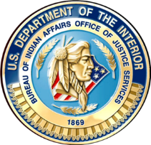
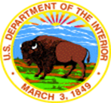
Bureau of Indian Affairs
Office of Justice Services
Indian Highway Safety Program

BIA IHSP FY 2019 Lifesavers Conference Grant Opportunity

This grant opportunity is intended for Tribal personnel who are not currently funded by the Bureau of Indian (BIA), Office of Justice Services (OJS), Indian Highway Safety Program (IHSP). The BIA IHSP is offering a limited number of grants, to federally recognized tribes, to cover registration fees and travel expense for attendance to the Lifesavers National Conference, March 31- April 2, 2019, in Louisville, Kentucky. If your tribe is awarded a grant the tribe will be reimbursed for actual registration fees and travel expenses, not to exceed the federal travel regulations, upon completion.
Funding provided to the attendee on behalf of the tribe is managed and dispersed under all applicable grant and federal travel regulations.
The deadline for proposals is close of business, March 1, 2019. All grant applications received will be evaluated and selections will be made based on information provided by applicants. Ensure the application has the most accurate complete information available.
Applicants should submit their application as soon as possible to get the best rates for registration and lodging.
Personnel actively working in these fields are eligible to attend:
- Adult and/or Child Occupant Protection Programs
- Tribal Criminal Justice
- Tribal Law Enforcement
- Tribal Injury Prevention Programs
- Tribal Traffic Safety Planning Programs
Proposals should be sent by e-mail to: ojs_indian_highway_safety@bia.gov
or by mail to:

Bureau of Indian Affairs
Office of Justice Services
Indian Highway Safety Program
1001 Indian School Road NW, Suite 251
Albuquerque, New Mexico 87104

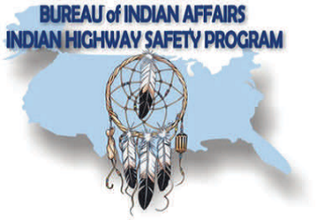
The BIA Indian Highway Safety Staff are available, Monday - Friday from 8:00 am - 5:00 pm MST, to answer questions at (505)563-3764.

