Application and Supplemental Form Instructions
For instructions on Registering for Grants.gov click here.
For instructions on completing the FTA required Supplemental Form, click here. To download the Supplemental Form for the opportunity you are applying for, click here. NOTE: If you do not attach the correct Supplemental Form or there are required fields missing in the Supplemental Form, FTA will mark your submission as invalid and it will not be reviewed by FTA. Please be sure to follow these instructions closely.
Submitting an Application - Individual Applicant Account
In the following screenshots, the asterisk and arrow are your visual indicators of where to click based on the instructions above the screenshot.
On the Grants.gov home page, click the Find Grant Opportunities link on the left hand navigation menu
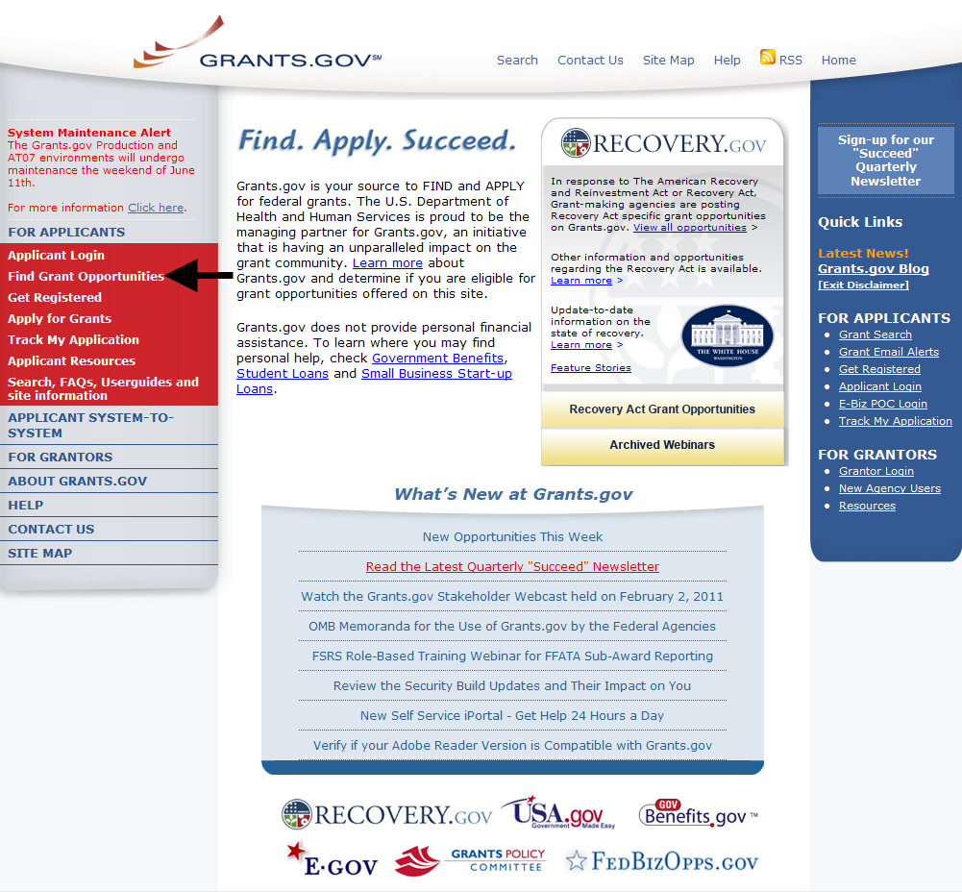

The Find Grants Opportunity screen is displayed. You can search for grant opportunities by clicking on the Basic Search link (arrow) or the Browse by Agency link (asterisk).
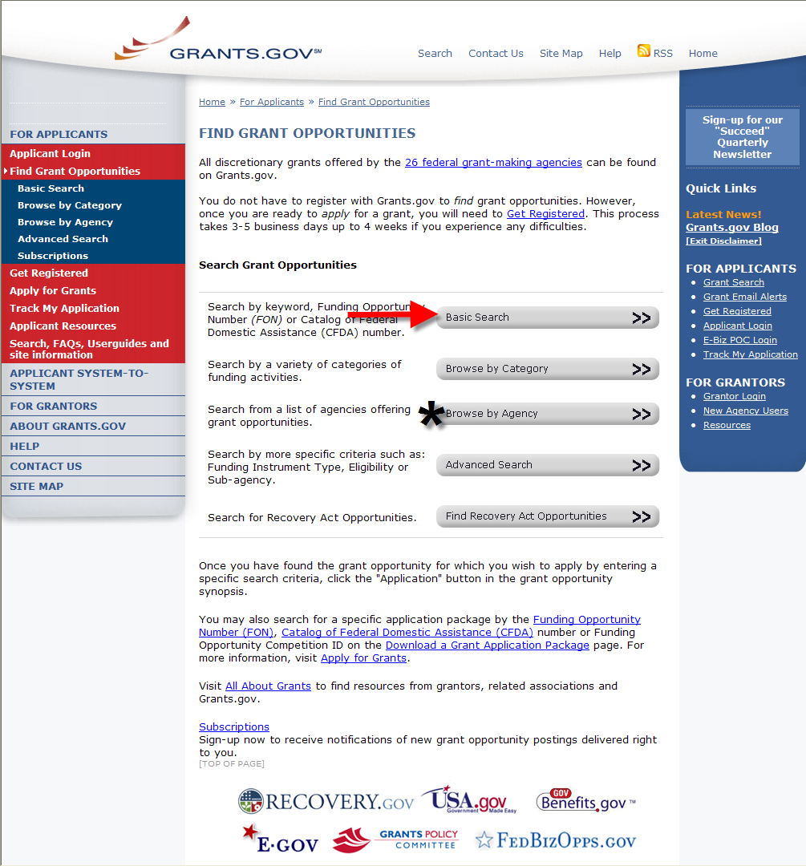

If doing a Basic Search enter a keyword(s), a Funding Opportunity number or a CFDA number then click Search.
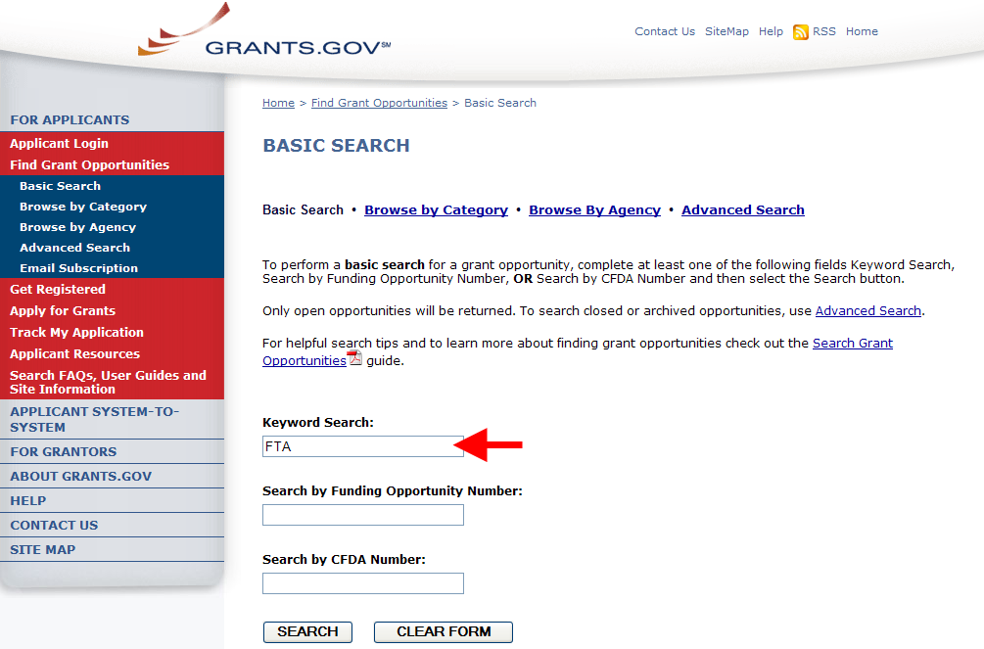

If searching by Agency, scroll down and click on Department of Transportation. Note: There is no separate entry for FTA.
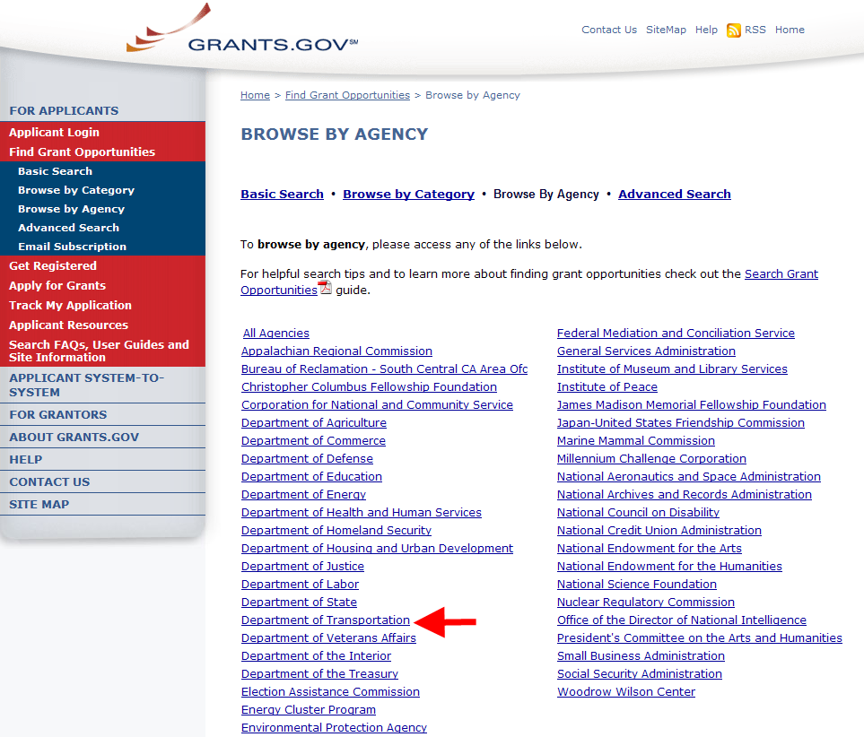

The Search Results page is displayed. All the available opportunities are displayed. Note: You will see more funding opportunities under the Department of Transportation that do not belong to FTA.
To view an opportunity, click on the name link (see the arrow) from the Opportunity Title column.
Note: The remaining screen shots are of data from the Grants.gov test environment. Locate the Grant Opportunity of interest.
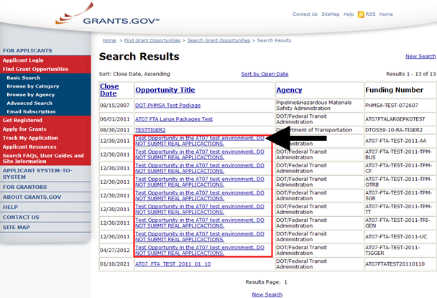

This page displays details about the opportunity. To apply for this opportunity click the Application link at the top right corner.
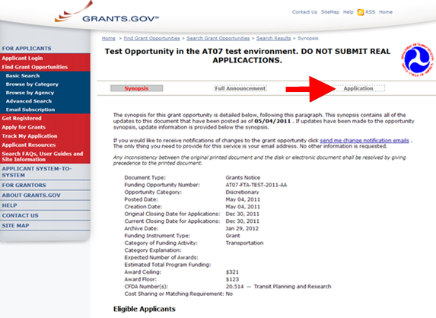

The Selected Grant Applications for Download screen is opened in a new window browser. In the table at the end of the page, click the download link located in the Instructions and Application column.
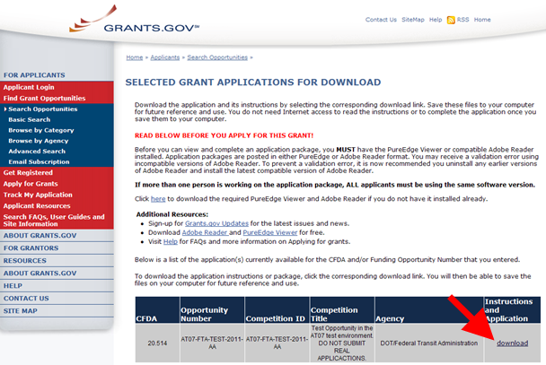

The Download Opportunity Instructions and Application screen is displayed. To download the SF424 application click link number 2. Download Application Package.
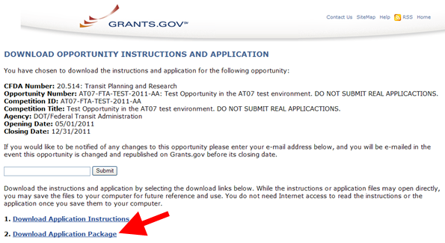

The SF424 is opened as a PDF file.
In the two blue boxes below the Application Filing Name, you must move the SF424 Mandatory Form and the Attachments from the Mandatory Documents to the Mandatory Documents for Submission. Simply highlight each of the forms, then click the Move Form to Complete button (see the arrow).
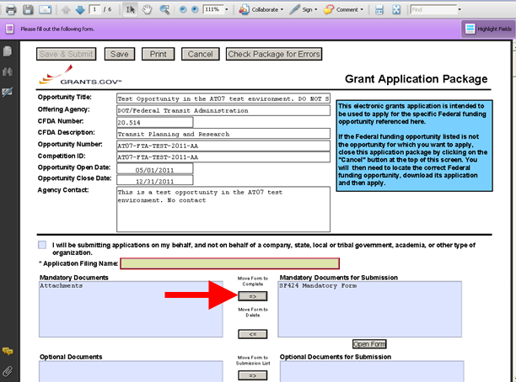

The Attachments Form you just moved over to the Mandatory Documents for Submission box is located at the end of the SF424. You MUST attach the corresponding Supplemental Form (a.k.a. applicant profile) or your proposal will not be accepted by FTA. For example, if you are applying for a Grant Opportunity for Alternatives Analysis, you must attach the Alternatives Analysis Supplemental form in the Attachments Form section of the SF424 Form. If you do not attach the correct Supplemental form, FTA will mark your submission as invalid and your proposal will not be reviewed by FTA.
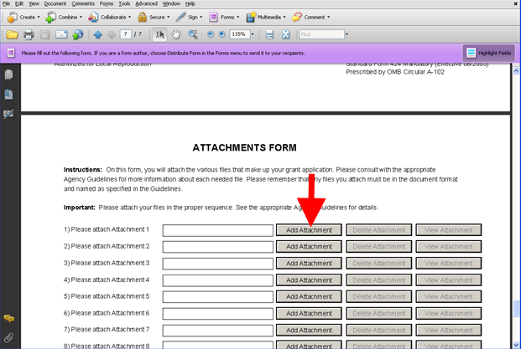
Important tips about Supplemental Forms
- All fields on a supplemental form must be filled out, unless instructed otherwise. Leaving fields blank will mark your submission as invalid.
- Use the Validate Form button located at the top right hand corner of the supplemental form to make sure no required fields were left blank.
- The sum of the Budget Line items listed in the Supplemental form must match the Estimated Funding amount in the SF 424 form. If these amounts to not match, DGS will mark the submission as invalid. Note: Some supplemental forms do not have a matching field. In those cases, it is okay to leave the Match field on the SF424 blank.
SF424 – Section 14. Estimated Funding.
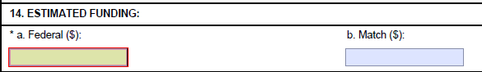
- If you print out and scan the supplemental form and upload it to Grants.gov, the form is no longer in the original electronic format. FTA’s systems will not be able to read the data from the form and it will not be accepted or available for review by FTA.
- To add multiple projects to a supplemental form, click on the Add Project button. Note: If the supplemental form has multiple projects, the sum of the Budget Line items must match the Estimated Funding amount (Federal) on the SF 424 Form. If they do not match, the submission will be marked invalid.
- For the Project Calculations in the TIGGER Supplemental form, please refer to the instructions on the form on how to use the calculator sheets.

Download the Applicable Supplemental Form
Please ensure you download and use applicable Supplemental Form for the opportunity you are applying for. The following table provides links to the web pages on the FTA Public Website where the Supplemental Form can be downloaded:
Program | Link to Program Specific Webpage where the Supplemental Form is located
Alternatives Analysis | http://www.fta.dot.gov/alternativesanalysis
Bus Livability (and State of Good Repair) | http://www.fta.dot.gov/bus
Clean Fuels | http://www.fta.dot.gov/cleanfuels
Over the Road Bus (OTRB) | http://www.fta.dot.gov/otrb
Transit Investments for Greenhouse Gas and Energy Reduction (TIGGER) | http://www.fta.dot.gov/TIGGER
Tribal Transit | http://www.fta.dot.gov/tribaltransit

