STATEMENT OF OBJECTIVES (SOO)
NATURAL RESOURCES SUPPORT ACTIVITIES
EDWARDS AFB (EAFB), CALIFORNIA
Article III (D) of the Applicable Cooperative Ecosystems Studies Unit (CESU)

1. PURPOSE
1.1. The Edwards AFB (EAFB) environmental program ensures military mission activities are conducted in compliance with all applicable environmental laws, regulations and policies with cooperation and assistance from the Air Force Civil Engineer Center’s (AFCEC) Installation Support Section (ISS). Article I B of the master agreement states the objectives of the CESU are to: provide research, technical assistance and education to federal land management, environmental and research agencies and their potential partners; develop a program of research, technical assistance and education that involves the biological, physical, social sciences needed to address resource issues and interdisciplinary problem-solving at multiple scales and in an ecosystem context at the local, regional, and national level; and place special emphasis on the working collaboration among federal agencies and universities and their related partner institutions.
1.2. The objectives of the work to be performed under this task order are to conduct natural resource tasks on the federal lands belonging to Edwards Air Force Base (AFB), and to prepare reports detailing the results of this work for submission to the USACE Project Manager (PM), AFCEC Edwards Installation Support Section (ISS) POC, and Edwards Natural Resource POC.
2. AUTHORITY
Authority to enter into a Cooperative Agreements (CA) for the work: Section 670c-1, Title 16 United States Code, Sikes Act.
2.1. In agreement with the above stated goals, the NFE agrees to provide the necessary personnel, equipment, and materials required to implement, in part, the EAFB responsibilities pursuant to the Endangered Species Act (16 USC 1531 et seq.), the Sikes Act Improvement Act, the Migratory Bird Treaty Act (16 USC 1361 et seq.), the National Environmental Policy Act (42 U.S.C. 4321 et seq.), and applicable implementing regulations, such as Air Force Manual 32-7003, Environmental Conservation; Grant and Cooperative Agreements Act of 1977 (31 U.S.C. § 6301 et seq.), all CESU projects must carry out a public purpose of support or stimulation, instead of acquiring goods or services for the exclusive direct benefit of the United States Government. Examples of carrying out a public purpose may include, but are not limited to, the following:
- Project results are made available to a wide audience (including nonfederal entities)
- Project results/outputs add to the scientific literature/knowledge base, with applicability and utility beyond the scope of the project footprint/study area
- Academic and other nonfederal partner institutions (and their personnel) gain professional experience, increase knowledge, and develop skills and abilities
- Students benefit from direct interaction with federal scientists, program and technical staff, and field unit managers
2.2. In accordance with section 6305 – Using cooperative agreements of the Federal Grant and Cooperative Agreements Act of 1977 (31 U.S.C. § 6301 et seq.), substantial involvement is expected between the Department of Defense and the recipient when carrying out the activity contemplated by the cooperative agreement. The DoD agrees to participate at a national level in support of the CESU program as accepted in the Master MOU for the establishment and continuation of the CESU program Article II 1-4 and Article VI 1-7.
The installation further (hence DoD) agrees to provide substantial involvement as directed under the appropriate master agreement to include, but not limited to, the following:
- EAFB and AFCEC Edwards ISS are involved in development of study methodology, data gathering, analysis, and/or report writing
- EAFB and AFCEC Edwards ISS are active participates and collaborates in carrying out the project plan of work, reviews and approves activities, helps train or select project staff or trainees
- EAFB and AFCEC Edwards ISS incurs in-kind or direct expenditures in carrying out the activities specified in the project agreement. Examples include, but are not limited to, the following:
  - Providing staff time to work on the project
3. DESCRIPTION OF OBJECTIVES
Conduct tasks in accordance with this Statement of Objectives (SOO), as prioritized by AFCEC Edwards ISS and the respective base Natural Resources Manager (NRM). Only work aligned with the original AF ACES programming and approved by the USACE Grants Officer Technical Representative (GOTR) should be completed as part of this task order (TO).
Task provisions and coordination is as follows:
Travel: Provide transportation and fuel for all NFE staff to get to and from all field sites. Retain current proof of insurance and current registration for all modes of transportation.
Coordination: Coordinate concurrently with the Base NRM, AFCEC Edwards ISS and USACE PM. All work schedules shall be approved by the AFCEC and be consistent with the Project Schedule & Work Plan approved by the Base NRM. Schedule changes can be made; trade-off decisions will be jointly made by the USACE PM, Base NRM and AFCEC Edwards ISS and align with the Sikes Act compliant INRMP and original ACES programming. Any changes in scope or cost must be approved by the USACE Grants Officer. All coordination with state and federal regulators will be by the Base NRM or AFCEC Edwards ISS only.
Project Management: Within 30 days of award of this task order, the NFE will schedule an initial project kick off meeting with all parties involved (Edwards AFB, AFCEC/Edwards ISS, USACE, etc) to develop a project work schedule to implement the SOO. All deliverables/tasks will be submitted within the required timeframes as identified.
Access: Access to Edwards AFB is restricted. General base access requires sponsorship by a Government civilian employee, and should be coordinated at least two weeks prior to the visit. Long-term base access will require additional security clearances and access processing. Access to the Air Force Research Laboratory (AFRL), the Precision Impact Range Area (PIRA), the airfield, and other restricted facilities on EAFB may require additional security clearances and training. Access to some areas may be limited by ongoing military activities such that personnel access is limited to weekends or brief periods of a few hours. Access procedures are described in further detail in the most recent version of the Edwards AFB Contractor Access Request Procedures Template.
Photography Use: Photography at Edwards AFB is restricted, requiring an authorization letter that must be in the photographer’s possession at all times. Cell phone photos are not allowed. Any photos/reports released to the public must be reviewed and authorized by Public Affairs. A non-disclosure agreement (NDA) is required for use of photographs for data analysis and report preparation prior to authorization by public affairs for release of photos/reports to the public. Biological Security Measure: The NFE shall follow applicable Biological Security Best Management Practices identified in the most recent version of the Edwards Air Force Base Invasive Species Management Plan.
Environmental Awareness Training: All NFE project personnel working on Edwards AFB shall attend desert tortoise awareness training prior to commencing work or visiting the work site.
Biological Security Measure: The NFE shall follow applicable Biological Security Best Management Practices identified in the most recent version of the Edwards Air Force Base Invasive Species Management Plan.

Table 1.
Task | Title | Section | Options
Task 1 | Mgt, Wetlands / Floodplains | 3.1 | Base Plus Four Option Years
Task 2 | Mgt Species, T&E | 3.2 | Base Year Only
Task 3 | Mgt, Habitat | 3.3 | Base Year Only
Task 4 | Mgt, Species | 3.4 | Optional (Base Year / OY1)

Base Year Cost Ceiling:
Task 1: $131,563.00
Task 2: $520,352.00
Task 3: $363,636.00
Task 4: $191,780.00

3.1 TASK 1: FSPMA5322915 Mgt, Wetlands Floodplains: Maintain existing levees/roads at Piute Ponds Complex
3.1.1 Background:
The upland and wetland area (excluding Rosamond Dry Lake) of the Piute Ponds Complex encompasses approximately 7,840 acres. Of the 7,840 acres, approximately 1,365 acres of ponds, wetlands, wet meadows, and clay pans are in an area where the water flow/levels can be managed to some degree (reference: PPC Levee/Roads Maintenance Figures). The primary source of water is effluent from the Los Angeles County District 14 Wastewater Treatment Plant (D14). Other seasonally flooded wetlands exist outside of this Water Management Area fed exclusively from natural surface water as it flows to the lakebed.

Numerous levees/roads are inaccessible or unsafe for use throughout the year due to deteriorated levee/road surface conditions. Access is required year-round for PPC infrastructure maintenance, habitat management, and public recreational access. This project is identified in the Edwards AFB Integrated Natural Resources Management Plan (INRMP). It helps accomplish: Project 7.4.1 Maintain Waterfowl Hunting opportunities at Piute Ponds Complex. Project 13.2. Implement management activities described in the Piute Ponds Complex Management Plan.

3.1.2 Objectives:
The primary objective of this project is to maintain existing levees/roads at the Piute Ponds Complex to allow year-round use by vehicles/equipment/recreationalists. The Non-Federal Entity (NFE) will establish procedures and provide services and equipment to implement the following at the Piute Ponds Complex: 1) Each year, maintain PPC levees/roads requiring up to approximately 16,365 cubic yards of subbase and road base/gravel from Edwards AFB recycled concrete stockpiles. The NFE will provide support to levees/roads of Levee/Road Condition-1 and then to levees/roads of Levee/Road Condition-2. The Natural Resource Manager will approve the priority selection of levees/roads to be maintained each year.

Existing levee/road surfaces should be covered with concrete aggregate subbase and road base/gravel and compacted. Finished top surface will be tapered from levee/road center to levee/road shoulder to allow for proper water runoff. Existing levee/road surfaces average between 16 to 25 feet in width. Depending on the Levee/Road Condition of the levees/roads (See Attachment 1: PPC Levee/Road Maintenance Figures 20220524), they will require one of the three applications: 1) Approximately 2.1 miles of dirt levee/roads require: Concrete aggregate subbase (9,493 cubic yards) of approximately 10 - 12 inches in size placed on the existing dirt levee/road surface to a depth of approximately 18 inches and to the approximate width of the existing dirt levee/road surface. Additional concrete aggregate subbase (6,329 cubic yards) of approximately 3 – 6 inches in size will be placed on top of the 10 – 12 inches in size subbase to a depth of approximately 12 inches. Additional road base/gravel (4,749 cubic yards) of ¾ inch minus material will be placed on top of the concrete aggregate subbase of approximately 3 – 6 inches in size to a depth of approximately 6 – 8 inches. 2) Approximately 10.8 miles of dirt levee/roads will require: Concrete aggregate subbase (35,005 cubic yards) of approximately 3 – 6 inches in size will be placed on the existing dirt levee/road surface to a depth of approximately 12 inches. Additional road base/gravel (26,255 cubic yards) of ¾ inch minus material will be placed on top of the concrete aggregate subbase of approximately 3 – 6 inches in size to a depth of approximately 6 – 8 inches. 3) Approximately 4.6 miles of dirt levee/roads will require: Road base/gravel (13,464 cubic yards) of ¾ inch minus material placed on the existing dirt levee/road surface to a depth of approximately 6 – 8 inches.

Concrete aggregate subbase and road base/gravel is recycled material created from demolished runway concrete and a subsequent concrete crushing operation on EAFB. The stockpiled material has been chemically tested and found environmentally suitable for use on this project (Otie. 2019). The concrete aggregate subbase and road base/gravel will be loaded and hauled from recycled concrete stockpiles on EAFB located off of Missile Road to the Piute Ponds Complex via Jones Road, Lancaster Boulevard, East Avenue E and Shuttle Road. The recycled concrete aggregate subbase and road base/gravel from EAFB stockpiled recycled materials will be provided at no cost for this project. The Non-Federal Entity (NFE) is responsible for the cost of loading, transporting, and spreading of EAFB stockpiled recycled materials. One-way travel distance from stockpiles to PPC is approximately 24 miles. Ten miles are on paved Edwards AFB roads, ten miles on public paved roads, and 2 miles on Edwards AFB unpaved roads. Reference: Otie. 2019. Final Project Completion Report, Environmental Restoration Support, Edwards Air Force Base, Kern County, California. July.

3.1.3 Deliverables:
Reports: Edwards AFB requires use of the approved work plan template, standard report covers, and Standard Form 298 - Report Documentation Page. Reports shall generally be free of typos, grammatical errors, formatting inconsistencies and incorrectly labeled tables and figures. The reports shall provide proper citations for all documents referenced. It is requested that draft reports contain line numbering for ease of Government comment. Government and NFE comments shall be provided in a comment matrix provided by the Government. Project GIS Data shall be submitted along with draft and final reports. Final work plans, final technical reports, and final GIS data deliverables shall be submitted only after the NFE has addressed all Government comments satisfactorily.

Work Plan: The NFE shall submit a separate draft and final work plan describing in narrative format the plan of action for the accomplishment of the project tasks. The plan shall follow the Edwards AFB Work Plan Template. The NFE shall provide a proposed comprehensive timeline for completion of the required work element activities and submittals. Updated project schedules will be provided by the NFE when the schedule changes, regardless of whom is responsible for causing the change in schedule. Updated schedules shall be submitted within seven (7) calendar days of any documented change in project schedule.

Technical Report: The NFE shall submit a separate draft and final technical report describing in narrative format the accomplishments of the project tasks including pertinent maps, figures, tables, photographs. The report format shall follow that of a scientific publication and include the following section heading: Introduction, Methods, Results, Discussion and Literature Cited, as well as original data sheets and/or copies thereof, laboratory reports, and other appendices as appropriate. Update as-built drawings of Piute Ponds Complex as required for work performed.

GIS Data: The NFE shall comply with all requirements in the most recent version of the Edwards Air Force Base Standards for Geographic Environmental Support Section 412 CEG/CEVA. This document provides all details required for a successful GIS delivery. A preliminary technical consultation with 412 CEG/CEVA GIS staff shall be accomplished after the Post Award Kick-Off Meeting and prior to the start of all data collection for this project.

Weekly Status Report: The NFE shall provide to the Edwards AFB NRM weekly status report via email when performing on-base project activities. Report shall include activities accomplished, activity planned for the upcoming week, issues, and updated timelines for completion of work.

Monthly Status Report: The NFE shall provide a brief monthly project status report to the Edwards AFB NRM that describes amount of work completed to date, work completed in the past month, upcoming work schedules, potential problems, and unresolved issues.

Press Release: The NFE shall prepare an editable press release for the general public. The press release shall identify the project as a 412 CEG/CEVA Natural Resource project, what the project’s objective is, where the project is located on base, when the project will be implemented, how it will be implemented. The press release shall be no longer than approximately 200 words. Write the narrative to the 9th grade level. Provide an editable electronic copy of: 1) Beginning of project press release. 2) End of project results press release.

Deliverables Schedule: Submit deliverables as listed below, or as otherwise specified in the NFE’s proposal. Deliverable schedule must be within the period of performance of the agreement. The NFE may propose an alternate schedule, but should not reduce the opportunities for and duration of Government review periods.

Description | When Due | Format
Work Plan Draft | Notice to Proceed (NTP)+ 60 days | Microsoft Word editable: Electronic only (e-mail attachment, or file transfer)
Work Plan Comment Response | 30 days after receipt of Government comments | Microsoft Word editable: Electronic only - comment matrix and work plan revision with track changes (e-mail attachment, or file transfer)
Work Plan Final | 21 days after Government approval of NFE’s response to all Government comments | PDF: Electronic only (e-mail attachment or file transfer)
Weekly Status Report | Friday prior to upcoming field work week | Email
Monthly Status Report | Within 14 days after end of each month | Microsoft Word editable: Electronic only (e-mail attachment, or file transfer)
Draft Technical Report | To be determined by NFE | Microsoft Word editable: Electronic only (e-mail attachment, or file transfer)
GIS Draft Technical Report Deliverables | Submit with Draft Technical Report | Per EAFB GIS Standards: Electronic (e-mail attachment, or file transfer)
Technical Report Comment Response | 30 days after receipt of Government comments | Microsoft Word editable: Electronic only - comment matrix and technical report revision with track changes (e-mail attachment, or file transfer)
Final Technical Report | 21 days after Government approval of NFE’s response to all Government comments | PDF: Electronic (e-mail attachment or file transfer); 2 hard copies spiral or comb-bound, each with a CD containing the full document and all references.
GIS Final Technical Report Deliverables | Submit with Final Technical Report | Per EAFB GIS Standards Electronic (e-mail attachment, or file transfer) and CD
Press Release Initial | Submit with Work Plan Draft | Microsoft Word editable: Electronic only (e-mail attachment)
Press Release  Results | Submit with Final Technical Report | Microsoft Word editable: Electronic only (e-mail attachment)

3.1.4 Project Period of Performance:
Base Period of Performance: 18 months. 3 months administrative period to complete on-boarding of employees and/or subcontractors, 12-month technical period for conducting fieldwork, 3 months administrative for completion of reports only with no new work.
Option Years: Four (4) option years will be available. The efforts produced in Option Periods 1, 2, 3, and 4 will be similar to the amount of effort produced in the Base Period.
Option Year Period of Performance: 18 months. Overlap in PoPs is strictly administrative and includes on-boarding of employees and/or subcontracts before start of work and completing of reports after completion of fieldwork.

3.2 TASK 2: FSPMA53227119 Mgt Species T&E: Restoration of disturbed areas on Edwards AFB
3.2.1 Background:
Edwards AFB encompasses approximately 308,180 acres in the Antelope Valley in southern California. The installation lies in the western Mojave Desert. On Edwards AFB, the historic vegetative cover, for the most part, has not changed over the years. The main plant communities are still present within the base; however, once disturbed, habitat can take decades to centuries to fully recover without assistance. Various habitat restoration attempts have been made over the years following disturbances but a formal standard evaluation of success has not been a common practice. This project will commence with a literature search followed by field data collection, analysis, and reporting.
3.2.2 Objectives:
The primary objective of this project is to evaluate previous restoration practices for effectiveness and success. The project shall look over existing documents and GIS data of previous restoration projects, revisit restored areas, collect field data metrics of habitat recovery compared to adjacent comparable sites, and evaluate various restoration techniques for effectiveness in habitat recovery/improved habitat value. This project is identified in the Edwards AFB Integrated Natural Resources Management Plan (INRMP). It helps accomplish Goal 4: Maintain and enhance quality and quantity of habitat.
The Non-Federal Entity (NFE) will establish procedures, and provide services and equipment to implement the following tasks. Review existing data and reports for management actions related to the restoration of disturbed areas on Edwards AFB and the implementation of Edwards AFB Road Closure Plan. Based off the available information, develop a statistically valid protocol to evaluate the success of the management efforts in achieving habitat recovery through various restoration actions across the base. Additionally, the NFE shall revisit roads recommended for closure in the Edwards AFB Road Closure Plan and determine 1) which of the roads recommended for closure were closed, 2) which actions were the most effective in closing the roads, 3) of those actions that successfully closed the road, which were the most effective in recovering the habitat, 4) which roads need further action for closure and/or habitat recovery, and 5) if there are additional roads that should be evaluated for closure. Perform field data collection based on the protocols developed to determine the success of management actions in recovering key habitat features such as native species diversity, native plant cover, and lack of new disturbance. Analyze field data to generate statistically relevant results of whether management actions, and which actions, had a positive impact on habitat recovery and protection of natural resources. Generate report discussing results, which actions were most effective in recovering habitat and/or meeting management goals, and make management recommendations for future actions based on those findings.
3.2.3 Deliverables:
Reports: Edwards AFB requires use of the approved work plan template, standard report covers, and Standard Form 298 - Report Documentation Page. Reports shall generally be free of typos, grammatical errors, formatting inconsistencies and incorrectly labeled tables and figures. The reports shall provide proper citations for all documents referenced. It is requested that draft reports contain line numbering for ease of Government comment. Government and NFE comments shall be provided in a comment matrix provided by the Government. Project GIS Data shall be submitted along with draft and final reports. Final work plans, final technical reports, and final GIS data deliverables shall be submitted only after the NFE has addressed all Government comments satisfactorily.

Work Plan: The NFE shall submit a separate draft and final work plan describing in narrative format the plan of action for the accomplishment of the project tasks. The plan shall follow the Edwards AFB Work Plan Template. The NFE shall provide a proposed comprehensive timeline for completion of the required work element activities and submittals. Updated project schedules will be provided by the NFE when the schedule changes, regardless of whom is responsible for causing the change in schedule. Updated schedules shall be submitted within seven (7) calendar days of any documented change in project schedule.

Technical Report: The NFE shall submit a separate draft and final technical report describing in narrative format the accomplishments of the project tasks including pertinent maps, figures, tables, photographs. The report format shall follow that of a scientific publication and include the following section heading: Introduction, Methods, Results, Discussion and Literature Cited, as well as original data sheets and/or copies thereof, laboratory reports, and other appendices as appropriate.

GIS Data: The NFE shall comply with all requirements in the most recent version of the Edwards Air Force Base Standards for Geographic Environmental Support Section 412 CEG/CEVA. This document provides all details required for a successful GIS delivery. A preliminary technical consultation with 412 CEG/CEVA GIS staff shall be accomplished after the Post Award Kick-Off Meeting and prior to the start of all data collection for this project.

Weekly Status Report: The NFE shall provide to the Edwards AFB NRM weekly status report via email when performing on-base project activities. Report shall include activities accomplished, activity planned for the upcoming week, issues, and updated timelines for completion of work.

Monthly Status Report: The NFE shall provide a brief monthly project status report to the Edwards AFB NRM that describes amount of work completed to date, work completed in the past month, upcoming work schedules, potential problems, and unresolved issues.

Press Release: The NFE shall prepare an editable press release for the general public. The press release shall identify the project as a 412 CEG/CEVA Natural Resource project, what the project’s objective is, where the project is located on base, when the project will be implemented, how it will be implemented. The press release shall be no longer than approximately 200 words. Write the narrative to the 9th grade level. Provide an editable electronic copy of: 1) Beginning of project press release. 2) End of project results press release.

Deliverables Schedule: Submit deliverables as listed below, or as otherwise specified in the NFE’s proposal. Deliverable schedule must be within the period of performance of the contract. The NFE may propose an alternate schedule, but should not reduce the opportunities for and duration of Government review periods.

Description | When Due | Format
Work Plan Draft | Notice to Proceed (NTP)+ 60 days | Microsoft Word editable: Electronic only (e-mail attachment, or file transfer)
Work Plan Comment Response | 30 days after receipt of Government comments | Microsoft Word editable: Electronic only - comment matrix and work plan revision with track changes (e-mail attachment, or file transfer)
Work Plan Final | 21 days after Government approval of NFE’s response to all Government comments | PDF: Electronic only (e-mail attachment or file transfer)
Weekly Status Report | Friday prior to upcoming field work week | Email
Monthly Status Reports | Within 14 days after end of each month | Microsoft Word editable: Electronic only (e-mail attachment, or file transfer)
Draft Technical Report | To be determined by NFE | Microsoft Word editable: Electronic only (e-mail attachment, or file transfer)
GIS Draft Technical Report Deliverables | Submit with Draft Technical Report | Per EAFB GIS Standards: Electronic (e-mail attachment, or file transfer)
Technical Report Comment Response | 30 days after receipt of Government comments | Microsoft Word editable: Electronic only - comment matrix and technical report revision with track changes (e-mail attachment, or file transfer)
Final Technical Report | 21 days after Government approval of NFE’s response to all Government comments | PDF: Electronic (e-mail attachment or file transfer); 2 hard copies spiral or comb-bound, each with a CD containing the full document and all references.
GIS Final Technical Report Deliverables | Submit with Final Technical Report | Per EAFB GIS Standards Electronic (e-mail attachment, or file transfer) and CD
Press Release Initial | Submit with Work Plan Draft | Microsoft Word editable: Electronic only (e-mail attachment)
Press Release  Results | Submit with Final Technical Report | Microsoft Word editable: Electronic only (e-mail attachment)

3.2.4 Project Period of Performance:
The period of performance for this task will be 18-months from date of award.

3.3 TASK 3: FSPMA53226119 Mgt, Habitat: Environmental Assessment of Edwards AFB INRMP
3.3.1 Background:
Pursuant to the National Environmental Policy Act of 1969, an Environmental Assessment (EA) documented the impacts of how Edwards AFB planned to implement the 2014 Edwards Air Force Base Integrated Natural Resources Management Plan. A five-year revision of the Edwards AFB INRMP was prepared in 2020 for Edwards AFB as required by the Sikes Act Improvement Act of 1997 and AFMAN 32-7003, Environmental Conservation.
Edwards AFB recommends some changes in the approach to natural resources management in the Edwards Air Force Base Integrated Natural Resources Management Plan 2020-2025 and in its associated plans that were subsequently updated. The management activities in the most current Edwards AFB INRMP and its associated plans need to be assessed in light of the Environmental Assessment for the Integrated Natural Resources Management Plan for Edwards Air Force Base, California, 2015.
Natural resource surveys and inventories from projects identified in the Edwards AFB INRMP and implemented to meet various goals and objectives in the Edwards AFB INRMP have provided new information regarding natural and cultural resources on base. This includes new information about floodplains, non-jurisdictional wetlands, flora, fauna, natural habitats, invasive species, and cultural resources that shall be considered when assessing planned natural resource management activities described in the most current Edwards AFB INRMP and associated plans.
An Environmental Assessment Work Plan has been developed that details the methodology, document deliverables, delivery schedules, and document quality standards to be used in accomplishing this EA.
3.3.2 Objectives:
The primary objective of this project is to complete an Environmental Assessment (EA) to support management actions associated with implementing the most current Integrated Natural Resources Management Plan (INRMP) for Edwards Air Force Base (AFB) in accordance with National Environmental Protection Act (NEPA) requirements. The INRMP is a component plan of the Edwards Air Force Base Installation Development Plan. The INRMP is comprised of associated plans including the Integrated Cultural Resources Management Plan, the Invasive Species Management Plan, the Piute Ponds Complex Management Plan, the Branch Memorial Park Management Plan, the Wildland Fire Management Plan, the Bird/Aircraft Strike Hazard Plan, and the Integrated Pest Management Plan that also need to be included in the environmental assessment.
- The Non-Federal Entity (NFE) shall develop an Environmental Assessment (EA) to support management actions described in the most current Edwards AFB INRMP revision/update and its associated plans in accordance with NEPA requirements. Edwards AFB is seeking the NFE to prepare an EA and associated Finding of No Significant Impact (FONSI), if appropriate, to ensure potential impacts to the environment from the considered alternatives are fully analyzed and avoided or minimized to the extent possible, per the above regulations.

- Some parts of the Edwards AFB are within a floodplain. As such, a Finding of No Practicable Alternative (FONPA) will also be necessary in accordance with Executive Order 11988, Floodplain Management, and AFMAN 32-7003, Environmental Conservation.

- This EA will include an objective analysis of the positive and negative impacts of alternative management scenarios and support the selected management measures that comprise the INRMP. The EA will comply fully with the procedural mandates of NEPA as established by the underlying statute, as well as the implementing guidance published by the Council on Environmental Quality (CEQ) and 32 CFR 651. The EA will be fully integrated into the most current INRMP. The NFE shall assess this EA and determine whether the most current INRMP also complies fully with the procedural mandates of NEPA, CEQ, and 32 CFR 651. The Contractor will prepare a new fully integrated EA if the previous NEPA document is not sufficient.

- This requires the NFE to: Fully develop the “Purpose and Need” and Description of Proposed Action and Alternatives (DOPAA), collect and review existing background material and identify potential data gaps, describe unavoidable adverse effects and mitigation, publish notice of NEPA scoping in local papers and develop press releases, and conduct Agency coordination

- The NFE shall use the most current USAF EA Template and EA Template Instruction Document to complete the EA.

3.3.3 Deliverables:
Work Plan, Technical Report, GIS Data, Weekly Status Report, Monthly Status Report, Press Release. DOPAA (Draft and Final), Internal Draft EA, Preliminary Draft EA and Draft Notice of Availability (NOA), Draft EA and Draft NOA, Preliminary Final EA, Preliminary Draft FONSI/FONPA, Final EA, Draft FONSI/FONPA, NOA, Administrative Record.

Reports: The NFE shall use the most current USAF EA Template and EA Template Instruction Document to complete the EA.

Work Plan: An Environmental Assessment Work Plan has been developed that details the methodology to be used in accomplishing this EA. Updated project schedules will be provided by the NFE when the schedule changes, regardless of whom is responsible for causing the change in schedule. Updated schedules shall be submitted within seven (7) calendar days of any documented change in project schedule.

GIS Data: The NFE shall comply with all requirements in the most recent version of the Edwards Air Force Base Standards for Geographic Environmental Support Section 412 CEG/CEVA. This document provides all details required for a successful GIS delivery. A preliminary technical consultation with 412 CEG/CEVA GIS staff shall be accomplished after the Post Award Kick-Off Meeting and prior to the start of all data collection for this project.

Weekly Status Report: The NFE shall provide to the Edwards AFB NRM weekly status report via email when performing on-base project activities. Report shall include activities accomplished, activity planned for the upcoming week, issues, and updated timelines for completion of work.

Monthly Status Report: The NFE shall provide a brief monthly project status report to the Edwards AFB NRM that describes amount of work completed to date, work completed in the past month, upcoming work schedules, potential problems, and unresolved issues.

Press Release: The NFE shall prepare an editable press release for the general public. The press release shall identify the project as a 412 CEG/CEVA Natural Resource project, what the project’s objective is, where the project is located on base, when the project will be implemented, how it will be implemented. The press release shall be no longer than approximately 200 words. Write the narrative to the 9th grade level. Provide an editable electronic copy of: 1) Beginning of project press release. 2) End of project results press release.

Deliverables Schedule: Submit deliverables as listed in the EA Work Plan.

3.3.4 Period of Performance
The period of performance for this task will be 18-months from date of award.

3.4 TASK 4: FSPMA53226120 Mgt, Species: Natural Resource Inventories of EAFB Geographically Separated Units
3.4.1 Background:
Edwards AFB encompasses approximately 308,180 acres in the Antelope Valley in southern California. An additional nine leased GSUs totaling approximately 108 acres are known to exist outside of the installation boundary. Four GSUs are located within a few miles of the installation. Two GSUs are located approximately 50 and 100 miles west of the installation. Three GSUs are located in Nevada northeast of Nellis AFB. Natural resource details for all of these GSUs are not documented. General habitat descriptions are detailed in the EAFB Wildland Fire Management Plan (WFMP) for six of the known GSUs.
3.4.2 Objectives:
The primary objective of this project is to provide baseline natural resource inventories of Edwards AFB (EAFB) Geographically Separated Units (GSUs) (See Table 3).
The Non-Federal Entity (NFE) will establish procedures, and provide services and equipment to implement the following tasks: 1) Review existing real estate documents and GIS data of leased GSUs, determine status of real estate instruments including existence of any additional GSUs, briefly describe the site infrastructure, and identify land and infrastructure management responsibilities of EAFB identified in the real estate instrument. 2) Perform site visits of up to ten GSUs and record the significant natural resource characteristics of each site and adjacent land including: flora, fauna, geology, hydrology, habitat type, natural disturbances. Expectation is that no more than one day would be spent at most field sites collecting data visually. 3) Determine natural resource concerns of the lessor such as species of interest and habitat management activities. 4) Provide a Species of Interest list similar to EAFB INRMP Species of Interest list for each GSU. 5) Document by photography natural resource site conditions of each GSU.
Table 3: Edwards AFB Geographically Separated Units (GSUs)
Installation / Geographically Separated Unit | Main Use/ Mission | Acreage | Addressed in INRMP or WFMP | Describe Natural Resource Implications
Annex A-10 | Test & Evaluation | 9 | WFMP | None
Annex A-11 | Test & Evaluation | 27 | WFMP | None
Annex T-6 | Test & Evaluation | 8 | WFMP | None
Boron NEXRAD Annex | Test & Evaluation | 6 | WFMP | None
Egan Range Microwave Relay Annex Site 1 | Test & Evaluation | 3 | WFMP | None
Ely Radio Relay Annex Site 1 | Test & Evaluation | 50 | WFMP | None
McPherson Peak Microwave Relay Annex | Test & Evaluation | 1 | WFMP | None
Mount Pinos Radio Relay Annex Site 1 | Test & Evaluation | 1 | WFMP | None
Worthington Mountain Microwave Relay Annex | Test & Evaluation | 3 | WFMP | None

Boron NEXRAD Annex (BNA)
According to Ecological Subregions, BNA is located in the High Desert Plains and Hills Subsection of the Mojave Desert Section, within the American Semidesert and Desert Province. It is comprised of 0.5 acres in San Bernardino County, California, about 7 miles north of EAFB. The nearest town is Boron, California. Access to BNA from Boron is by taking California State Highway 58 east, turning left (north) on U.S. Highway 395, turning right (east) on an unnamed dirt road, and turning left (north) into the GSU. BNA is bordered by open desert on all sides. Fire management responsibility falls back on the appropriate county and federal resources.

Edwards Missile Tracking Annex A-10 (EMTAA-10)
According to Ecological Subregions, EMTAA-10 is located in the High Desert Plains and Hills Subsection of the Mojave Desert Section, within the American Semidesert and Desert Province. It is comprised of 5.3 acres in San Bernardino County, California, about 6 miles south of EAFB. The nearest town is Helendale, California. Access to EMTAA-10 from Helendale is by taking Shadow Mountain Road west, turning right (north) on an unnamed dirt road, turning left (northwest) on another unnamed dirt road, and continuing into the GSU. EMTAA-10 is bordered by mountainous desert terrain on all sides. Fire management responsibility falls back on the appropriate county and federal resources.

Edwards Missile Tracking Annex A-11 (EMTAA-11)
According to Ecological Subregions, EMTAA-11 is located in the High Desert Plains and Hills Subsection of the Mojave Desert Section, within the American Semidesert and Desert Province. It is comprised of 5.1 acres in Los Angeles County, California, about 4 miles south of EAFB. The nearest town is Lake Los Angeles, California. Access to EMTAA-11 from Lake Los Angeles is by taking 170th Street East to the north, turning right (east) on East Avenue J, turning left (north) on 200th Street East, turning right (east) on East Avenue E, continuing east on East Avenue D8, turning left (north) on 230th Street East, turning right (east) on an unnamed dirt road, turning right (south) on the third unnamed dirt road to the right, and continuing into the GSU. EMTAA-11 is bordered by open desert on all sides. Fire management responsibility falls back on the appropriate county and federal resources.

Edwards Missile Tracking Annex T-6 – West (EMTAT-6)
According to Ecological Subregions, EMTAT-6 is located in the High Desert Plains and Hills Subsection of the Mojave Desert Section, within the American Semidesert and Desert Province. It is comprised of 5.2 acres in Los Angeles County, California, about 0.3 miles south of EAFB. The nearest town is Lake Los Angeles, California. Access to EMTAT-6 from Lake Los Angeles is through EAFB itself. EMTAT-6 is bordered by open desert on all side. Fire management responsibility falls back on the appropriate county and federal resources.

McPherson Peak Microwave Relay Annex (MPMRA)
According to Ecological Subregions, MPMRA is located in the Interior Santa Lucia Range Subsection of the Central California Coast Ranges Section, within the California Coastal Range Open Woodland - Shrub - Coniferous Forest - Meadow Province. It is comprised of 40.2 acres in Santa Barbara County, California, about 95 miles west of EAFB. The nearest town is New Cuyama, California. Access to MPMRA from New Cuyama is by taking various forest roads to reach the summit of McPherson Peak, the location of the GSU. MPMRA is bordered by forests on all sides. Fire management responsibility falls back on the appropriate county and federal resources.

Mount Pinos Radio Relay Annex (MPRRA)
According to Ecological Subregions, MPRRA is located in the Northern Transverse Ranges Subsection of the Southern California Mountain and Valley Section, within the California Coastal Range Open Woodland - Shrub - Coniferous Forest - Meadow Province. It is comprised of 10.4 acres in Ventura County, California, about 58 miles west of EAFB. The nearest town is Pinon Pines Estates, California. Access to MPRRA from Pinon Pines Estates is by taking Cuddy Valley Road west and continuing on Mount Pinos Road until reaching the summit of Mount Pinos, the location of the GSU. MPRRA is bordered by forest on all sides. Fire management responsibility falls back on the appropriate county and federal resources.

Egan Range Microwave Relay Annex Site 1
The subject property consists of 2.5 acres located at an elevation of 6,400 above mean sea level in the Egan Range, approximately 12 miles south of Lund, Nevada and 2 miles east of Highway 38. The subject property is located in a remote area of Nevada and can be accessed via a dirt road with an entrance gate on the east side of Highway 38, located about 2 miles south of the Nye and White Pine Counties borders. Figure 1 shows the geographic location of the property. The site is located in Section 32, Township 10 North, Range 62 East of the Mount Diablo Baseline Meridian, Nye County, Nevada (Figure 2). Figure 3 shows the layout of the site facilities.

The subject property is located in a remote region of the Egan Range in Nye County, Nevada, at 38°41’4.9” North Latitude, 115°1’45.1” West Longitude, at an elevation of 6,931 feet, and is located within the United States Geological Survey (USGS) 7.5-minute Moorman Spring Quadrangle. The land surface slopes to the west and local geology is characterized by granitic bedrock overlain by a thin mantle of unconsolidated sediments.

Ely Radio Relay Annex Site 1
The Ely Radio Relay Annex (North Peak, South Peak, and the Saddle) is located on top of Kimberly Mountain, which is approximately 12 miles northwest of Ely, Nevada, 9.5 miles west of Highway 50, at an elevation of 9,238 feet. Figure 1 shows the location of Ely, Nevada within the state. The site is located in Section 27, Township 17 North, Range 61 East of the Mount Diablo Baseline and Meridian, White Pine County, Nevada (Figure 2). Maps of the South and North Peak facilities depict the layout of the area (Figures 3 and 4). A map of the Saddle was not available.
An additional 0.5 acre parcel of land controlled by Edwards AFB, known as Snowcat Shed, is approximately 9 miles northeast of the Ely Radio Relay Annex, 0.25 mile west of Highway 50, and adjacent to the access road. This shed reportedly houses equipment such as snowplows for road maintenance. The site is located in Section 20, Township 17 North, Range 62 East of the Mount Diablo Baseline and Meridian, White Pine County, Nevada.

A dirt road that provides access to the Ely Radio Relay Annex and Snowcat Shed is approximately 9.5 miles in length. The road passes through Sections 17, 19, 20, 25, 27, 30, and 36 as it goes from Highway 50 to the Ely Radio Relay Annex within the Mount Diablo Baseline and Meridian, White Pine County, Nevada.

The Ely Radio Relay Annex consists of four general areas as described below. The first three areas are located at the top of Kimberly Mountain. The fourth area is located at the base of Kimberly Mountain.
- South Peak: South Peak consists of the Main Relay Site (10 acres) including Building 1 (main building), a radar site, a concrete vault, a radio tower, a concrete pad, a 125–foot tower and concrete pad, Building 2 (diesel generator shed building), outdoor electrical transformer area, concrete support structures, a concrete vault, three propane above-ground storage tanks, Building 3 (a metal building-diesel generator shed) and a concrete pad.
- North Peak: North Peak Relay Site (2.5 acres) consists of a cinder block building, tall tower, AF relay station, and other non-AF users (see Section 3.6 for list of current users). These buildings were not assessed.
- Saddle: The Saddle is located between South Peak and North Peak and consists of a cinder block structure, a shed, and a small antenna. These buildings were not assessed.
- Snowcat Shed: The Snowcat Shed area (0.5 acres) contains a metal storage building that houses equipment for roadway maintenance activities. This area is located at the base of Kimberly Mountain. This building was not assessed.

Worthington Mountain Microwave Relay Annex
The subject property is located in a remote area of the Worthington Mountains in Lincoln County, Nevada, on top of an unnamed mountain, which is approximately 22 miles north of Rachel, Nevada and 150 miles southwest of Ely, Nevada. The subject property consists of 2.5 acres located at an elevation of 6,098 feet (+/- 20 feet). Future use of the property by the BLM is unknown. The site is located in Section 14, Township I North, Range 56 East of the Mount Diablo Baseline Meridian, Lincoln County, Nevada. A dirt road provides access to the property and is approximately 40 miles in length (40 miles west of Hwy 318).

In a letter dated 18 April 1961, the United States Army Corps of Engineers (USACE) requested authorization from the BLM to use this land for a microwave relay site on behalf of Edwards AFB. The BLM approved this request on 21 April 1961. The approval was for 2.5 acres and an associated access road subject to 44 LD 513 (Department of Interior 1916), a blanket land decision, and serial number Nev-057479 was assigned. The site was one of three intermediate relay sites that linked the Shoshone Radio Site to the Ely Radio Site for flight test data transmission purposes.

3.4.3 Deliverables
Reports: Edwards AFB requires use of the approved work plan template, standard report covers, and Standard Form 298 - Report Documentation Page. Reports shall generally be free of typos, grammatical errors, formatting inconsistencies and incorrectly labeled tables and figures. The reports shall provide proper citations for all documents referenced. It is requested that draft reports contain line numbering for ease of Government comment. Government and NFE comments shall be provided in a comment matrix provided by the Government. Project GIS Data shall be submitted along with draft and final reports. Final work plans, final technical reports, and final GIS data deliverables shall be submitted only after the NFE has addressed all Government comments satisfactorily.

Work Plan: The NFE shall submit a separate draft and final work plan describing in narrative format the plan of action for the accomplishment of the project tasks. The plan shall follow the Edwards AFB Work Plan Template. The NFE shall provide a proposed comprehensive timeline for completion of the required work element activities and submittals. Updated project schedules will be provided by the NFE when the schedule changes, regardless of whom is responsible for causing the change in schedule. Updated schedules shall be submitted within seven (7) calendar days of any documented change in project schedule.

Technical Report: The NFE shall submit a separate draft and final technical report describing in narrative format the accomplishments of the project tasks including pertinent maps, figures, tables, photographs. The report format shall follow that of a scientific publication and include the following section heading: Introduction, Methods, Results, Discussion and Literature Cited, as well as original data sheets and/or copies thereof, laboratory reports, and other appendices as appropriate.

GIS Data: The NFE shall comply with all requirements in the most recent version of the Edwards Air Force Base Standards for Geographic Environmental Support Section 412 CEG/CEVA. This document provides all details required for a successful GIS delivery. A preliminary technical consultation with 412 CEG/CEVA GIS staff shall be accomplished after the Post Award Kick-Off Meeting and prior to the start of all data collection for this project.

Weekly Status Report: The NFE shall provide to the Edwards AFB NRM weekly status report via email when performing on-base project activities. Report shall include activities accomplished, activity planned for the upcoming week, issues, and updated timelines for completion of work.

Monthly Status Report: The NFE shall provide a brief monthly project status report to the Edwards AFB NRM that describes amount of work completed to date, work completed in the past month, upcoming work schedules, potential problems, and unresolved issues.

Deliverables Schedule: Submit deliverables as listed below, or as otherwise specified in the NFE’s proposal. Deliverable schedule must be within the period of performance of the contract. The NFE may propose an alternate schedule, but should not reduce the opportunities for and duration of Government review periods.

Description | When Due | Format
Work Plan Draft | Notice to Proceed (NTP)+ 60 days | Microsoft Word editable: Electronic only (e-mail attachment, or file transfer)
Work Plan Comment Response | 30 days after receipt of Government comments | Microsoft Word editable: Electronic only - comment matrix and work plan revision with track changes (e-mail attachment, or file transfer)
Work Plan Final | 21 days after Government approval of NFE’s response to all Government comments | PDF: Electronic only (e-mail attachment or file transfer)
Weekly Status Report | Friday prior to upcoming field work week | Email
Monthly Status Reports | Within 14 days after end of each month | Microsoft Word editable: Electronic only (e-mail attachment, or file transfer)
Draft Technical Report | To be determined by NFE | Microsoft Word editable: Electronic only (e-mail attachment, or file transfer)
GIS Draft Technical Report Deliverables | Submit with Draft Technical Report | Per EAFB GIS Standards: Electronic (e-mail attachment, or file transfer)
Technical Report Comment Response | 30 days after receipt of Government comments | Microsoft Word editable: Electronic only - comment matrix and technical report revision with track changes (e-mail attachment, or file transfer)
Final Technical Report | 21 days after Government approval of NFE’s response to all Government comments | PDF: Electronic (e-mail attachment or file transfer); 2 hard copies spiral or comb-bound, each with a CD containing the full document and all references.
GIS Final Technical Report Deliverables | Submit with Final Technical Report | Per EAFB GIS Standards Electronic (e-mail attachment, or file transfer) and CD

3.3.4 Period of Performance
The period of performance for this task will be 18-months from date of award.

Option Years: This project is currently unfunded and therefore should be proposed as an option for both the base year (FY22) and Option Year 1 (FY23). The level of effort is identical in both optional periods. If not funded in the base year then it would be awarded in Option Period 1.
4. QUALIFICATIONS / PERMITS
The NFE should meet the minimum qualifications necessary to perform tasks described in the project work statement. The principal investigator should have experience directing the efforts of the project team. NFE personnel shall have the technical experience, the field implementation experience, any required state and federal certifications, and any required state or federal handling or application permits likely to be used in this project. The NFE shall ensure that project activities, project reports, and project data are professionally executed with minimal errors.
5. GOVERNMENT FURNISHED MATERIALS OR PROPERTY
The NFE will furnish all labor, materials, equipment, supplies, technical expertise, and supervision needed to perform all objectives.
6. OPTIONS:
Refer to Sections 3.1-3.4 for task specific options.
7. PERIOD OF PERFORMANCE
Refer to Sections 3.1-3.4 for task specific period of performance.
8. COORDINATION
USACE POC:
David Leptien
Cell: 402-889-5570
david.b.leptien@usace.army.mil

AFCEC POC:
Daniel F. Garcia
Edwards ISS at Vandenberg AFB
Office: 805-606-9834
daniel.garcia.23@us.af.mil

9. AGREEMENT REQUIRED DELIVERABLES
In addition to the below, refer to Sections 3.1 – 3.4 for task specific deliverables.
9.1 A kickoff meeting, arranged by the Cooperator and including the installation POC and USACE Project Manager, shall be held via telephone or virtually within 30 days of the award and prior to September 30th of the Award year.

9.2 Progress Reports - One (1) typed letter report describing progress on the project. The report shall be due within 10 days of the end of each 3-month period (quarterly) and shall be transmitted via electronic mail, facsimile, or regular mail no later than the 10th calendar day following the end of the reporting period. Invoices for partial payment shall be submitted to coincide with receipt of the quarterly progress reports. No partial payment will be approved unless the government has received all progress reports which are due.

9.2 Annual Inventory –Federally owned property - an annual inventory listing Federal property (to include description of the property, a serial number or other identification number) that is in the custody of the recipient; Copies to be sent to USACE – SWF and EAFB.

9.3 Annual Inventory – Required under 2CFR for Grants and Cooperative Agreements - Acquired Property purchased with funding from award - property records must be maintained that includes description of the property, serial number or other identification number, source of funding, who holds title, acquisition date, cost of property, percentage of Federal participation in project costs, location, use and condition of property, and ultimate disposition including date of disposal and sale price. A physical inventory must be taken, and results reconciled every two years. Copies of the inventory to be sent annually to USACE – SWF and EAFB

9.4 Annual Report per 2CFR. One (1) paper copy of a annual report should be submitted no later than one month before end of each year. At a minimum, the report shall contain an introduction section, and one section for each Task identified in your proposal. For each Task, the report shall summarize work accomplished for the Task. EAFB staff will review and provide comments, if any, within fifteen (15) calendar days after receipt.

9.5 Draft Final Project Report. One (1) paper copy of a draft final report should be submitted no later than one month before end of the project. At a minimum, the report shall contain an introduction section, and one section for each Task identified in your proposal. For each Task, the report shall summarize work accomplished for the Task. EAFB staff will review and provide comments, if any, within fifteen (15) calendar days after receipt. Must provide an electronic copy to the USACE POC at the time this document is submitted to the Installation POC.

9.6 Final Project Report. One (1) paper copy of the final report, incorporating EAFB review comments on the draft, if any, shall be submitted no later than fifteen (15) days after receipt of the EAFB comments. Additionally, one (1) copy of the final report shall be submitted in a MSWord file(s), on digital media. Must provide an electronic copy to the USACE POC at the time this document is submitted to the Installation POC.

10.0 ADMINISTRATIVE

This cooperative agreement may be administered through CESU only upon mutual agreement and official authorization by both parties of the acceptance of the application of the CESU Network IDC rate (17.5%).

Any resulting cooperative agreement will be subject to and recipient/cooperator shall comply with 2 CFR 200.313 “Equipment”, 200.314 “Supplies”, and 200.315 “Intangible Property” which includes use of research data.
Invoices and Closeout Documents. Per the standard Terms of Agreement and in accordance with 2CFR, SF270s and closeout documents are required deliverables for all projects. The recipient shall submit a SF270 with other required documentation to SWF[1]CESU-INVOICE@usace.army.mil at minimum on a quarterly. Closeout documents are due 90 after the end of projects. The documents for closeout include the following: 1. Final SF 270 2. Final SF 425 3. SF 428 with attachment B (C and S when applicable) 4. DD Form 882 5. Final report (See 2 CFR 200.328) 6. Cover Form SF 298

PPC Levee/Road Maintenance Figures 20220524
Attachments 1-4
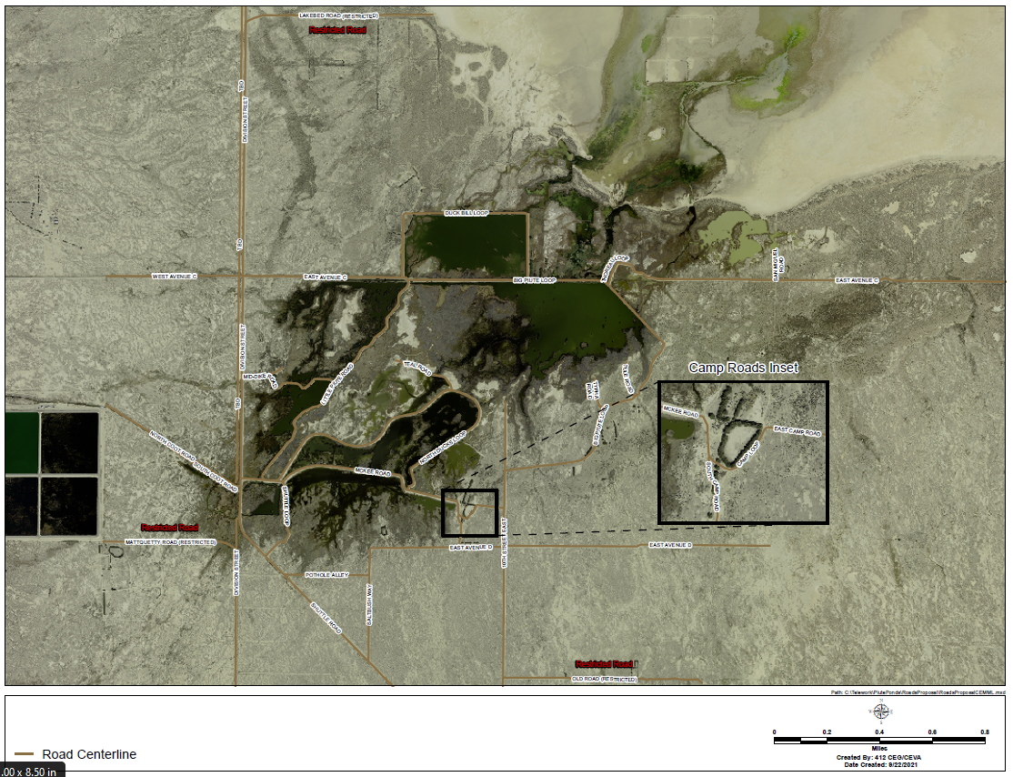
Attachment 1: PPC Levee/Road Maintenance

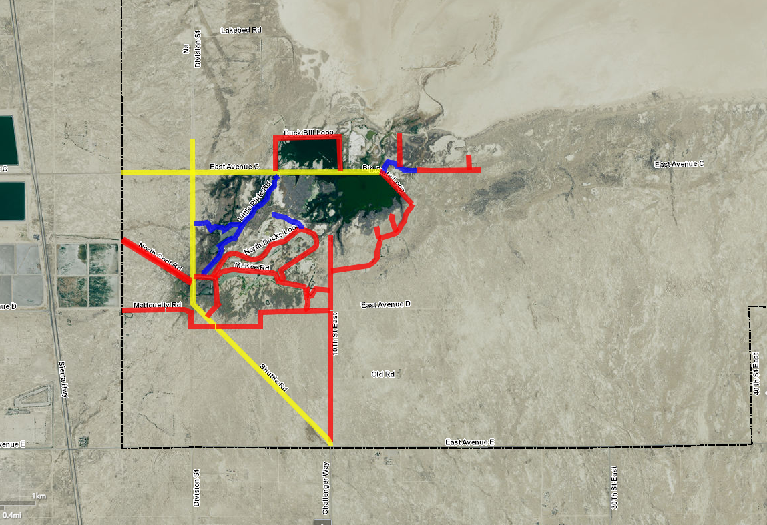
Attachment 2: Levee/Road Condition: 1-Blue, 2-Red, 3-Yellow

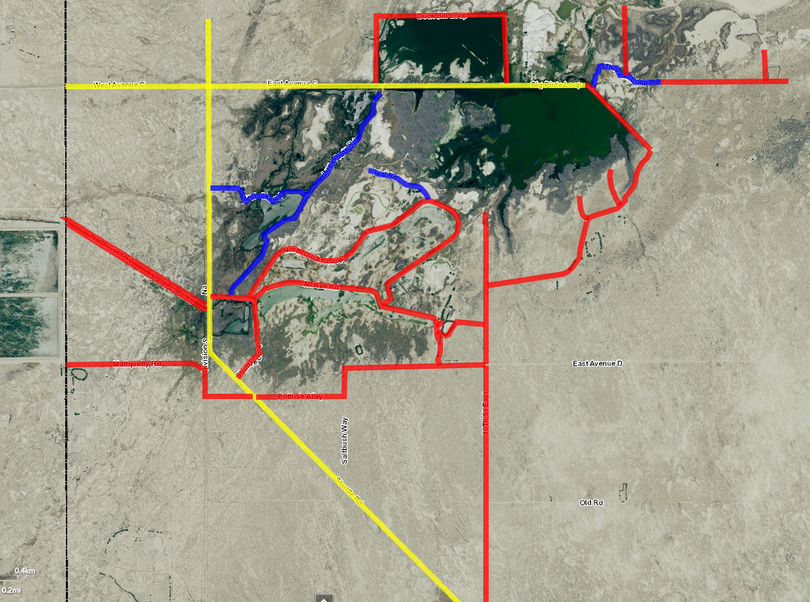
Attachment 3: Levee/Road Condition: 1-Blue, 2-Red, 3-Yellow

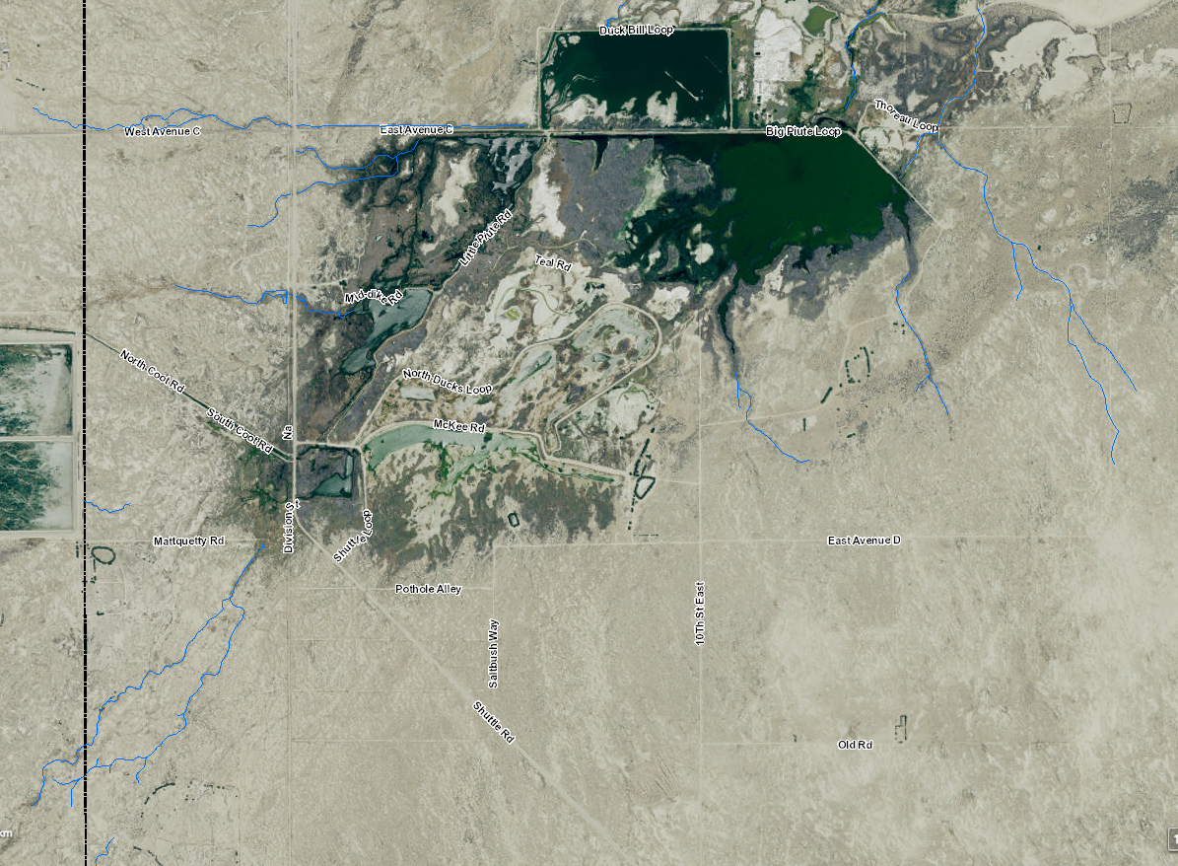
Attachment 4: Watercourses (shown in blue)

Table 2
PPC Levee/Road Conditions
Levee/Road Condition – Name Miles Linear Feet Cubic Yards
3 – Shuttle Road 1.5 7904 4391
2 – Duck Bill Loop 1.0 5280 5476
3 – East Avenue C (Div) 0.7 3686 2048
2 – East Avenue C (Tho) 0.4 1914 1985
1 – Thoreau Road 0.4 1914 3686
2 - San Miguel Road 0.1 531 551
2 – Big Piute Loop E/S 1.2 6403 6640
2 – 10th Street East 1.6 8275 8581
2 – Camp Loop 0.1 531 551
2 – East Camp Road 0.1 531 551
2 – South Camp Road 0.2 954 989
2 – McKee Road 0.7 3686 4778
2 – East Avenue D 0.5 2645 2743
2 – Saltbush Way 0.1 531 551
2 – Pothole Alley 0.5 2645 2743
2 – Shuttle Loop 0.5 2645 2743
2 – North Ducks Loop 1.4 7410 9606
1 – Teal Road 0.3 1340 2581
1 – Little Piute Road 1.0 5280 10169
1 – Mid Dike Road 0.4 2146 4133
2 - North Coot Road 0.6 3164 3281
2 – South Coot Road 0.6 3164 3281
3 – Big Piute Loop N 0.7 3686 2048
3 – Division 1.2 6315 3508
2 - West Avenue C 0.5 2645 1469
2 - Thoreau/Lakebed 0.3 1340 1390
2 - Mattquetty Road 0.6 3164 3281
2 - Tule 0.2 954 989
2 - Typha 0.1 531 551

