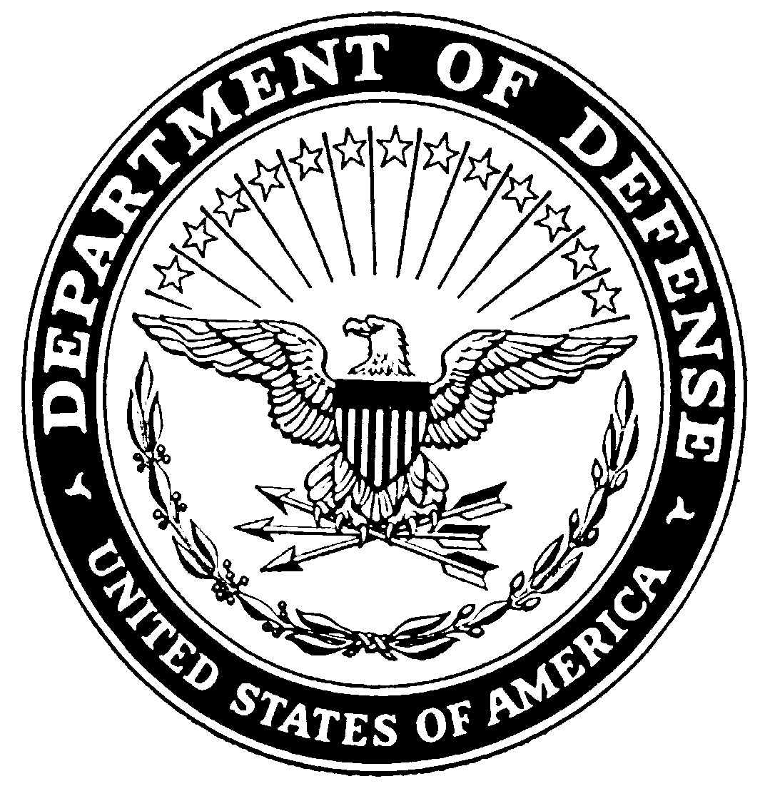
DEPARTMENT OF THE ARMY

FORT WORTH DISTRICT, CORPS OF ENGINEERS
P.O. BOX 17300
FORT WORTH, TX 76102-0300

24 JUNE 2022

REQUEST FOR STATEMENT OF INTEREST
Number W9126G-22-2-SOI-4124

Applicants must be a member in one of the Cooperative Ecosystem Studies Units (CESU):
Colorado Plateau / Californian CESU Regions

Project Title: Natural Resources Support at Edwards AFB, CA
Responses to this Request for Statements of Interest will be used to identify potential investigators for this project. Approximately $1,207,331.00 is expected to be available to support this project for the base year if all options are exercised. Additional funding may be available for additional tasks and/or follow on work in subsequent fiscal years to the successful Recipient/Awardee.

Background:
Provide Habitat, Wetlands and Species Support to Edwards AFB, CA.

Type of Award:

In accordance with section 6305 – Using cooperative agreements of the Federal Grant and
Cooperative Agreements Act of 1977 (31 U.S.C. § 6301 et seq.), all CESU projects must
carry out a public purpose of support or stimulation, instead of acquiring goods or services
for the exclusive direct benefit of the United States Government.

In accordance with section 6305 – Using cooperative agreements of the Federal Grant and
Cooperative Agreements Act of 1977 (31 U.S.C. § 6301 et seq.), substantial involvement is
expected between the federal partner and the nonfederal partner when carrying out the
activities specified in the project agreement. The exact nature of the government’s involvement will be defined in the statement of objectives, issued with a request for full proposal.

As a result, it is anticipated that a cooperative agreement through the CESU program will be awarded. Such awards may be administered through a CESU only upon mutual agreement and official authorization by both parties of the acceptance of the application of the CESU Network IDC rate (17.5%).

NOTE: Must be a non-federal partner in the Cooperative Ecosystem Studies Units (CESU) Program to be qualified for considiration.

Brief Description of Anticipated Work:
This research focuses on the following objectives:

“See Attached Statement of Objectives”

NOTE: At this time we are only requesting that you demonstrate available qualifications and skills for performing similar or same type of work. You will be evaluated for request for a proposal based on skills and qualifications demonstrated in your SOI.

Period of Performance. The base year of agreement will extend 18 months from date of award. There will be four 18 month option years based on availability of funding. Please refer to attached SOO for additional task specific period of performance details.

Materials Requested for Statement of Interest/Qualifications:
Please provide the following via e-mail attachments (Maximum length: 2 pages, single-spaced 12 pt. font).

- Name, Organization, Cage Code, Duns number, and Contact Information (Email)
2. Brief Statement of Qualifications (including):
a. Biographical Sketch,
b. Relevant past projects and clients with brief descriptions of these projects,
c. Staff, faculty or students available to work on this project and their areas of expertise,
d. Any brief description of capabilities to successfully complete the project you may wish to add (e.g. equipment, laboratory facilities, greenhouse facilities, field facilities, etc.).

Note: A full study proposal and proposed budget are NOT requested at this time.
Review of Statements Received: All statements of interest received will be evaluated by a board comprised of one or more people at the receiving installation or activity, who will determine which statement(s) best meet the program objectives. Based on a review of the Statements of Interest received, an investigator or investigators will be invited to prepare a full study proposal. Statements will be evaluated based on the investigator’s specific experience and capabilities in areas related to the study requirements.

Please send responses or direct questions to:

Audria Gill
Grants Specialist
USACE, Fort Worth District
Email: audria.j.gill@usace.army.mil
Office: 817-886-1925

David Leptien
Project Manager
USACE, RPEC
Email: david.b.leptien@usace.army.mil
Office: 850-218-4097

Timeline for Review of Statements of Interest: RSOI’s required to be posted on www.Grants.gov for 30 days, prior to the Government making a decision and requesting full proposals. Responses are due by 5:00 P.M., Central Time, on 17 August 2022.

[End of RSOI]

