Information Collection: 0584-0512
Expiration date: 3/31/2029

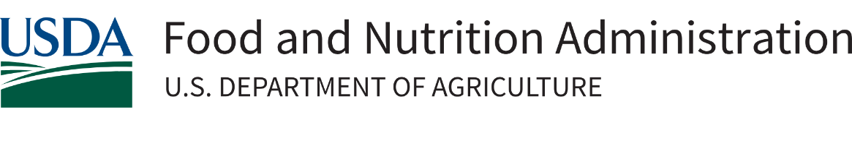

Supplemental Nutrition Assistance Program

Healthy Fluid Milk Incentives – Cooperative Agreement

Fiscal Year 2026 Request for Applications (RFA)
Assistance Listing Number (ALN): 10.530

Release Date: | June 16, 2026
Application Due Date: | July 16, 2026; 11:59 pm, Eastern Daylight Time (EDT)
Anticipated Award Date: | September 2026

This information is being collected to assist the Food and Nutrition Administration in evaluating applications for the Healthy Fluid Milk Incentive Grant. This is a voluntary collection and FNA uses the information to rank and fund applicants for the Healthy Fluid Milk Incentive Grant. This collection does not request any personally identifiable information under the Privacy Act of 1974. According to the Paperwork Reduction Act of 1995, an agency may not conduct or sponsor, and a person is not required to respond to, a collection of information unless it displays a valid OMB control number. The valid OMB control number for this information collection is 0584-0512. The time required to complete this information collection is estimated to average 50 hours per response, including the time for reviewing instructions, searching existing data sources, gathering and maintaining the data needed, and completing and reviewing the collection of information. Send comments regarding this burden estimate of any other aspect of this collection of information, including suggestions for reducing this burden, to: U.S. Department of Agriculture, Food and Nutrition Administration, Office of Policy Support, 1320 Braddock Place, 5th Floor, Alexandria, VA 22314 ATTN: PRA (0584-0512). Do not return the completed form to this address.
Application Checklist

This Application Checklist provides applicants with a list of the required actions and documents that must be completed. However, FNA expects that applicants will read the entire RFA prior to the submission of their application and comply with all requirements outlined in the solicitation. The Application Checklist is for applicant use only and should not be submitted as part of the Application Package.

Complete the following at least four weeks prior to submission:
- Obtain a Unique Entity Identifier (UEI) number;
- Register the UEI number in the System for Award Management (SAM); and,
- Register in Grants.gov.

When preparing your application, ensure:
- Application format and narrative meet the requirements included in Section 6 – Application Submission Information. This includes page limits, priorities outlined in Section 5 – Application Review Information, and all necessary attachments.

When preparing your budget, ensure the following information is included:
- All key staff proposed to be paid by this grant.
- The percentage of time the Project Director will devote to the project in full-time equivalents (FTEs).
- Your organization’s fringe benefit rate and amount, as well as the basis for the computation.
- The type of fringe benefits to be covered with Federal funds.
- Itemized travel expenses (including type of travel), travel justification, and basis for lodging estimate.
- Types of equipment and supplies, justifications, and estimates, ensuring that the budget is in line with the project description.
- Information for all contracts and justification for any sole-source contracts
- Justification, description, and an itemized list of all consultant services.
- Indirect cost information. Provide either a copy of a Negotiated Indirect Cost Rate Agreement (NICRA) or if no agreement exists, the applicant may charge up to 15% de minimis. If an applicant is requesting the de minimis rate or indirect costs are not required, please state this in the budget narrative.

When submitting your application, ensure you have submitted the following:
- SF-424 – Application for Federal Assistance (fillable PDF in Grants.gov)
- SF-424A – Budget Information and Instruction Form (fillable PDF in Grants.gov)
- SF-424B – Assurances for Non-Construction Programs (fillable PDF in Grants.gov)
- SF-LLL – Disclosure of Lobbying Activities
- FNS-906 – Grant Program Accounting System & Financial Capability Questionnaire (fillable PDF in Grants.gov).
- Negotiated Indirect Cost Rate Agreement (PDF - Upload using the “Add Attachments” button under SF-424 item #15).
- Resumes of key staff.
- Letters of support/commitment from key staff and partners.
- Proposal Narrative.
- Budget Narrative.
- A line-item budget in a spreadsheet format (e.g. Microsoft Excel).
- All non-profit organizations must include their 501(c)(3) determination letter issued by the Internal Revenue Service (IRS).
- A signed letter of commitment to work closely and cooperatively with FNA and its other partners in support of the grant objectives. To demonstrate that the applicant and its partners possess strong capability to work together and successfully fulfill the obligations of this agreement in a timely, efficient, and effective manner, applicants are required to provide supportive documentation in their proposal. Letters of support must be submitted with the application through Grants.gov. Please note that letters submitted via email will not be considered.
- Signed letters of commitment from each retailer banner or location that will participate in the project.
- Additional attachments as required.

Table of Contents
1. Program Description and Objectives 6
Executive Summary 6
Program Description 6
Key Objectives 7
Project Design 7
Cooperative Agreement 16
2. Federal Award Information 17
Allowable Costs 18
Unallowable Costs 19
3. Eligibility Information 20
Eligible Applicants 20
Ineligible Applicants 21
Cost Sharing or Matching Considerations 21
Pre-Award Screening Requirements 21
Acknowledgement of USDA Support 21
4. Application Content Information 21
Content and Form of Application Submission 21
Special Instructions: 22
Cover Sheet 22
Table of Contents 22
Application Project Summary 22
Project Narrative 22
Activities/Indicators Tracker 24
Application Budget Narrative 24
Indirect Cost Rate 25
Required Grant Application Forms 25
5. Application Review Information 26
Review Criteria 26
Project Design (35 points) 26
Implementation and Monitoring (15 points) 26
Sustainability (10 points) 27
Budget Appropriateness and Economic Efficiency (25 points) 27
Staff Capability and Management (15 points) 27
FY26 Funding Priorities (Bonus Points) (up to 15 points) 28
FY2026 Agency Priorities 28
Review and Selection Process 29
6. Application Submission Information 29
Submission Date 29
Preparing for Electronic Application Submission through Grants.gov 30
How to Submit an Application via Grants.gov 30
Grants.gov Receipt Requirements and Proof of Timely Submission 31
Funding Restrictions 31
7. Federal Award Administration Information 32
Federal Award Notice 32
Administrative and National Policy Requirements 32
Confidentiality of an Application 32
Conflict of Interest and Confidentiality of the Review Process 33
Administrative Regulations 33
Code of Federal Regulations and Other Government Requirements 36
Reporting Requirements 36
Financial Reports 36
Performance Progress Reports (PPR) 36
8. Federal Awarding Agency Contacts 37
9. Other Information 37
Debriefing Requests 37
Appendix 38
RFA Budget Narrative Checklist 38
FNS-908 Performance Progress Report (PPR) 40

1. Program Description and Objectives

Executive Summary
The USDA’s Food and Nutrition Administration (FNA) works to nourish those in need through financially sound programs that promote health and work, as well as champion the productivity of American agriculture. FNA requests applications for the Healthy Fluid Milk Incentives (HFMI) Cooperative Agreement Project for Fiscal Year (FY) 2026. The goal of these grants is to increase the purchase of fluid milk among low-income consumers participating in the Supplemental Nutrition Assistance Program (SNAP) by providing incentives at the point of purchase. In line with the United States Department of Agriculture’s (USDA) strategic goals to provide Americans with access to healthier food systems to build healthier families, the HFMI project both develops and implements modernized systems, as well as strengthens existing strategies to encourage healthy choices, healthy outcomes, and healthy families.

Congress appropriated $4,000,000 to FNA for FY 2026 funding of this project. Government agencies (State, local, territory, or tribal agencies) and non-profit organizations are eligible to apply for this funding. The anticipated period of performance for this project is from September 2026 to September 2029.

Program Description
FNA supports low-income households in accessing a nutritious diet by providing benefits through SNAP. SNAP is the Nation’s largest nutrition assistance program and served an average of 42.1 million participants per month in Federal FY 2025. FNA also authorizes and oversees retailers that accept SNAP benefits, and in FY 2025 about 250,000 retailers were approved to do so.

Section 4208 of the Agricultural Improvement Act of 2018 (P.L. 115-334), as amended, authorizes USDA, on a competitive basis, to enter into cooperative agreements with governmental entities or nonprofit organizations to carry out HFMI projects. The Continuing Appropriations, Agriculture, Legislative Branch, Military Construction and Veterans Affairs, and Extensions Act, 2026, (P.L. 119-37) provides $4,000,000 for HFMI for FY 2026.

The primary purpose of the HFMI project is to develop and test effective methods to increase the purchase and consumption of qualifying fluid milk by SNAP households. To achieve this goal, the project provides SNAP participants with an incentive at the point of purchase at authorized retailer locations.

“Qualifying fluid milk” includes all varieties of pasteurized cow’s milk that (1) is without flavoring or sweeteners, (2) is consistent with the most recent dietary recommendations, (3) is packaged in liquid form, and (4) contains vitamins A and D at levels consistent with the Food and Drug Administration, State, and local standards for fluid milk. Per the updated Dietary Guidelines for Americans, healthy fluid milk includes full-fat (whole), reduced-fat (2%), low-fat (1%) and non-fat (skim) milk. Additionally, through this project, FNA aims to identify new strategies and strengthen existing ones to promote healthy choices, improve health outcomes, and support healthy families.

In line with USDA’s strategic goal to put farmers first and FNA’s mission to increase food security, FNA will give priority to projects that partner directly with dairy farmers who sell qualifying fluid milk, and projects that target SNAP households in high food insecure areas. Applicants who incorporate the priority areas, partnerships, or both into their project design will receive bonus points to their score. See Section 5 – Application Review Information - FY26 Funding Priorities, for more details.

Key Objectives
Below is a list of the required Program Objectives. As noted in Section 4, within the “Activities/Indicators Tracker,” proposed activities should be clearly aligned to these objectives and their associated activities and indicators.

If awarded, the grantee must use the FNS-908 Performance Progress Report to report on progress towards activities aligned with the required objective(s).

At minimum, proposals must include all the objectives identified below.

# | Required Objectives
1. | Increase the purchase and consumption of qualifying fluid milk by SNAP households by providing a financial incentive at the point of purchase using Electronic Benefit Transfer (EBT) integration or automatic discounts.
2. | Partner with selected SNAP-authorized retailer(s) to operate the point of purchase incentive solution in compliance with all relevant SNAP regulations and requirements.
3. | Communicate and promote HFMI incentive availability and information to SNAP households.
4. | Provide training and technical support to participating SNAP-authorized retailers in administering the incentives.
5. | Facilitate participation in the HFMI evaluation through data collection and sharing.
6. | Provide education on the nutritional value of cow’s milk in accordance with the latest Dietary Guidelines for Americans. Also explain how this information relates to the availability of HFMI incentives at the participating locations.

Project Design
The grantee(s), and its partners (e.g., including retailers, and optionally other community partners), must develop and operate the projects to provide incentives for the purchase of fluid milk at the point of purchase. Grant funds must be used to fund new projects.

Below are the required design parameters.

- Target Foods

HFMI is intended to increase the purchase and consumption of healthy fluid milk by SNAP households. Qualifying fluid milk under HFMI is defined as all varieties of pasteurized cow’s milk, including lactose-free, that is:

- Without flavoring or sweeteners,
- Packaged in liquid form,
- Consistent with the Food and Drug Administration, State, and local standards for fluid milk Vitamin A and D levels, and
- Consistent with the Dietary Guidelines for Americans, 2025-2030. Per the updated Dietary Guidelines for Americans, healthy fluid milk includes full-fat (whole), reduced-fat (2%), low-fat (1%) and non-fat (skim) milk.

- Incentive Models

Applicants must propose one of the following models in their application:

Model 1 (Automatic Discount):

Fluid milk is eligible for an immediate point-of-purchase discount.
SNAP households must purchase qualifying fluid milk, as defined in parameter number one, using their SNAP benefits to receive an automatic discount or specified dollar-off incentive at the time of the qualifying purchase.

- An automatic discount incentive does not require a subsequent purchase for the discount to apply; it is applied immediately at the point-of-purchase.

Model 2 (EBT Integration):

Fluid milk incentives are provided directly to eligible SNAP households through their EBT accounts. SNAP households must purchase qualifying fluid milk (defined in parameter one) using their SNAP benefits to receive a set amount or percentage of the qualifying purchase back into their EBT account (i.e., EBT Integration) to be used on a subsequent shopping trip for the purchase of any SNAP eligible item at any SNAP-authorized store.

This model is based on the SNAP Electronic Healthy Incentives Project (eHIP) which allows the incentive amount to be redeemed subsequently in the same manner as any SNAP EBT transaction for any SNAP-eligible food. SNAP eHIP is an FNA grant that was awarded in June 2023.

Applicants may also propose limiting the use of earned incentives for the purchase of additional healthy fluid milk or dairy food items if the applicant or applicant’s State partner has that capability.

For Model 2, if the HFMI applicant is not a State agency responsible for administering SNAP, then the HFMI applicant will need to establish a partnership with a State that has or is in the process of developing the EBT-integrated infrastructure to implement this model within the project’s period of operation. Requirements for a letter of commitment demonstrating partnership with a State are outlined in parameter 8. Due to current EBT system limitations, States that have already implemented EBT-integrated incentives and whose incentives are active will not be able to operate HFMI via EBT in parallel.

Prior to applying for this grant, applicants must verify with selected partnering retailers, their third-party processor (TPP), and any additional partners that their proposed solution is viable and that the associated costs are acceptable.

Model 3 Coupon (only in special cases and in tandem with Model 1 or Model 2):

FNA may review and consider proposals that utilize a coupon model, provided that the applicant can demonstrate it is the most efficient or familiar method for both the retailer and the target community. For instance, if the proposed partner retailers have already implemented and operated a successful incentive program within the community, such as the Gus Schumacher Nutrition Incentive Program (GusNIP), this may serve as evidence supporting the coupon model’s viability. Applicants proposing coupon models need to fully describe them in their application. Once the project is awarded, the proposed model cannot be altered. Additionally, the coupon model cannot serve as the primary model for the project. Therefore, the project’s main model must either be Model 1 (Automatic Discount) or Model 2 (EBT Integration).

Alternative incentive models not specified in this solicitation are not allowed, even if the retailer later determines that the proposed solution is not practicable.

Incentives must be offered to every SNAP household shopping at the partnering retailer locations.

Applicants may propose implementing different models and/or discount levels at participating stores. If an applicant elects to implement different models and/or discount levels, proposals must include a: 1) justification, and 2) confirmation from the retailer(s) confirming the feasibility of programing different incentive scenarios into their point of sale (POS) system, and a 3) management plan explaining how the grantee plans to manage communication and promotional activities for varying incentive models.

- Incentives Amounts

Applicants must indicate the following:
- Whether the incentives will be a percentage-off discount, dollar-off discount, or a dollar-for-dollar match;
- The incentive dollar amount or percentage that will be discounted;
- The maximum incentive amount, if any, that a household may earn per transaction/day/week/month, etc.;
- When the incentive will be available for redemption (i.e., immediately, next day, within 24 hours, etc.); and
- The expiration date for all non-automatic discount incentives. An expiration date is required for all non-automatic discount incentives and cannot be less than 30 days.

- Site Selection

Proposed project site(s) may include State or sub-State areas, such as county, community, or group of contiguous communities, and/or Tribal Lands.

Priority will be given to applicants who target communities in priority areas, listed under Section 5 – Application Review Information - FY26 Funding Priorities, and project areas that have not yet been targeted in prior HFMI initiatives.

- Retailer Selection

Applicants must establish partnerships with SNAP-authorized retailers located in the project site(s) and must submit a letter of commitment from each partnering retailer as part of the application package.

Selected grantee(s) will be required to provide the retailer’s FNA authorization numbers in a secured format within two weeks of award. Applicants should confirm that selected retailers are authorized to accept SNAP benefits.

Ideally, project site(s) would include some combination of supermarket chains, independent retailer grocers of all sizes, and convenience stores. Also, the SNAP-authorized retailer partners should offer a range of qualifying fluid milk.

Applicants must indicate the number of retailers they plan to partner with. They must also provide a detailed justification explaining the likelihood that grant funds designated for the incentives will be redeemed by SNAP households at each retailer over the project period.

Indicate whether the selected retailers offer other incentives (e.g., fruits and vegetables incentives) and whether the other incentives are operating under a GusNIP or an FNA-approved incentive waiver.

If a grantee wishes to add additional retailer banners and locations that were not included in the initial proposal, the grantee will be required to submit a written request to FNA, including justification, store name(s), addresses, and FNA numbers. If the grantee is partnering with a new retailer banner or location, the grantee will be required to attach a letter of commitment from each retailer banner or location.

Ineligible retailers: Retailers that are not eligible to participate in an incentive project under this grant include:
- Retailers that are not authorized to accept SNAP benefits.
- SNAP-authorized retailers that do not typically sell qualifying foods to households, such as bakeries or meat/seafood specialty stores.
- Wholesalers, restaurants, and meal services, such as drug/alcohol treatment programs, battered women’s shelters, communal dining facilities, group living arrangements, homeless meal providers, meal delivery services, and senior and other residential centers.

Funding System Software Upgrades for Retailers in Priority Areas: Applicants may propose using grants funds to make software updates that enable the provision and/or redemption of HFMI incentives for independent retailers that sell sufficient quantities of qualifying fluid milk and are located in the priority areas listed in Section 5 – Application Review Information - FY26 Funding Priorities. These updates may include changes needed to display information about earned incentives on SNAP receipts. Grant funds may not be used for retailers to purchase hardware, such as the POS devices. See Section 2 – Federal Award Information - Unallowable Costs.

- Incentive Delivery Mechanism

FNA is seeking applicants who, in collaboration with their partners, choose an incentive delivery method(s), that either 1) places incentives into a SNAP household’s EBT account through integration with State EBT systems, or 2) provides households with an automatic discount at the point of purchase, as described under Section 1 – Program Description and Objectives – Project Design.

Applicants must describe the incentive delivery method(s) in high-level detail, including any proposed system enhancements.

Retailers with integrated electronic cash register (IECR) systems that include scanners and POS interfaces will need to reprogram their systems to identify targeted foods, calculate and transmit the value of the incentive, and print resulting incentive values on the SNAP EBT card receipt. Retailers operating standalone (side-by-side) POS terminals must visually identify target foods, create a separate subtotal for these items, and manually enter this value into the system.
Retailers may not have the technical enhancements to allow their POS systems to support automatic discounts. The grantee must maintain records of the value of the incentive discounts given.

- Household Earnings Information

Proposals should include how the retailer will notify households of 1) the incentive amount or discount earned 2) the remaining accumulated value of incentives, and 3) the expiration date for unused incentives.

Proposals for the EBT Integration model (Model 2 above) projects must:
- Specify that incentives will be assigned a hierarchy level that maintains first in, first out redemption of benefits;
- Specify that the Automated Response Unit (ARU) will report incentive transactions and balances just like other transactions when the callers choose to hear recent transactions or request a two-month statement by mail; and
- At point of purchase Include the printed incentive values and the expiration date on the SNAP EBT card receipt.

Proposals using the Automatic Discount model (Model 1 above) should include the discounted amount on the printed receipt. Please also include the feasibility and any limitations for including this on the receipt for each partnering retailer.

Technical assistance from FNA will be available to the grantee on their project as needed (if awarded).

- Letters of Commitment

Applicants proposing the Automatic Discount model (Model 1 above) or Coupon model (Model 3 above) must submit letters of commitment from each retailer banner or location that will participate in the project.

At a minimum, the letters of commitment from retailer banners or locations must include the following as applicable to each partner:
- Confirmation that the proposed solution is viable and that costs are acceptable, including retailer costs associated with:
  - Recognizing qualifying foods and totaling their value;
  - Applying an automatic discount, if applicable;
  - Printing the incentive value and expiration date on the receipt, if applicable; and
  - Meeting reporting and accounting requirements.

- Confirmation that the selected retailer(s) systems can provide data that reflects SNAP EBT transactions separate from other EBT transactions (i.e., TANF, WIC, etc.) to meet the reporting and accounting requirements.

- A description explaining partnering retailers’ Third-Party Processor (TPP) provider, the type of POS system the retailer uses, any changes that will be made to the POS system, and documentation that shows the retailer has discussed the needed changes and cost with their service providers.
- Retailers with IECR systems: Confirmation that the selected retailer(s) can program their systems to offer incentives or the commitment to upgrade their systems to offer incentives using the proposed project design.
- Retailers with side-by-side POS terminals: Confirmation that the selected retailer(s) has 1) a process in place to identify qualifying milk purchases at the point of purchase, and 2) a system to offer and track incentives using the proposed project design.

Applicants proposing the EBT Integration model (Model 2 above) must submit letters of commitment from:

- Each retailer banner or location that will participate in the project;
- Each SNAP State agency where the project will operate (if applicant is not the SNAP State agency); and
- Each State’s EBT contractor for the proposed EBT system changes.

Letters of commitment for EBT Integration models must also include confirmation from the applicable partner that the EBT and/or retailer system is able to:
- Validate participating HFMI stores;
- Properly calculate and post incentives earned;
- Identify incentives separately from SNAP transactions in order to debit and post incentives, and for back-end accounting and tracking purposes;
- Transmit the information in the authorization request to the EBT system in a manner compliant with current American National Standard Institute (ANSI) message standard X9.58, modified as necessary to transmit HFMI data in a standard manner for all retailers participating in the project (this will require collaboration with FNA, participating integrated retailers and their TPPs, and standalone terminal providers);
- Generate appropriate approval messages to retailers;
- Print incentive values earned on EBT receipts;
- Apply a cap to the monthly amount of incentive that can be earned by any one household;
- Remove incentive amounts from the available balance after the expiration date;
- Ensure that SNAP households no longer receiving SNAP benefits are not continuing to earn incentives;
- Continue to verify the retailer’s FNA authorization number, account number, and PIN, and ensure the account status is active and has sufficient funds; and
- Meet the reporting and accounting requirements.

- Retailer Training and Technical Support Plan

Applicants must provide a plan for training cashiers and other on-site staff of participating retailers (also known as firms) on the mechanics, requirements, and limitations of HFMI. The proposal must describe the process for addressing and resolving any technical, policy or operational issues that may arise at retailer locations during project implementation and ongoing operations. It must also explain how that process will be communicated to participating retailers.

A detailed description of the resolution process should include information on the organizations/partners responsible for such activities, including hours of availability and expected response timeframes.

- Communication/Outreach Promotion

Applicants must include a detailed plan in their proposals for communicating information about and promoting HFMI incentives to SNAP households.

The grantee must ensure the following is communicated to SNAP households:
- Availability of incentives and the conditions for receiving the incentives;
- Which qualifying fluid milk purchases earn incentives and which foods may be purchased with earned incentives;
- Location of participating retailers;
- Cap amounts (purchase/daily/weekly/monthly), if applicable, and how to track the amount of incentives earned;
- How to use the incentives earned;
- The expiration date of the incentives earned; and
- How to find out more about HFMI.

Examples of State SNAP agency promotional activities include:
- Providing HFMI promotional materials at local SNAP offices;
- Playing promotional videos at local SNAP offices;
- Creating promotional materials for social media accounts; or
- Partnering with the State agency to send promotional materials through direct mail to SNAP recipients in the participating retailer’s area. State agencies may not provide outside entities with a list of SNAP recipients’ mailing addresses, even under a memorandum of understanding.

- Nutrition Education Component

Incentives are available to all SNAP households, regardless of whether the SNAP client is aware of the HFMI program. To further encourage positive behavioral change and increase the purchase and consumption of healthy milk options through HFMI, FNA requires the incorporation of a nutrition education component. Proposals should include a description of planned activities and any potential partnerships or collaborations to meet this requirement.

As a reminder, all proposals must clearly describe any planned partnerships or collaborations (e.g., increased collaboration with SNAP-implementing agencies and other stakeholder programming). Applicants must include a signed letter of commitment to work closely and cooperatively with FNA and its other partners in support of the grant objectives.

- Data Collection and Evaluation

FNA will conduct an outcome evaluation using data provided by the grantee. FNA will develop and monitor indicators of progress towards objectives by examining HFMI project activities in terms of (1) the project’s administrative costs, (2) the number of incentives or discounts issued, and (3) sales of fluid milk by tender type. Data should be reported separately by retailer outlets (e.g., individual store/market locations). The grantee may not change the amount of the incentive or discount provided by an individual retailer outlet without FNA approval.

The grantee is required to have a Data Use Agreement with each retailer that guarantees each retailer will be able to do the following:

- Identify and account for any SNAP funds used for the incentive program and for administrative costs separately from any other funding that may be used to support this project; and
- Breakout SNAP grant funding spent on administrative costs versus incentives to SNAP participants.

Data Use Agreements shall also guarantee that each retailer will provide the following required data elements related to incentive issuance and sales, at a minimum:
- Amount of incentives issued to SNAP participants, in dollars and number of transactions; and
- Sales of qualifying fluid milk by tender type. Sales completed with non-SNAP EBT tenders may be aggregated and do not need to be broken out by tender type.

The grantee will be required to submit this data to FNA monthly.

All data elements related to incentive issuance and sales shall be aggregated at the weekly level, with a week defined as Sunday to Saturday. Each week shall be presented as a row in a cumulative spreadsheet. The updated spreadsheet shall be shared with FNA by the first Wednesday of each month. These submissions shall include any information on unusual circumstances affecting sales data for any retailer (e.g., natural disaster, systems outage, broken dairy case, supply chain issues, special milk/ dairy promotion unrelated to this project, etc.) as well as the week(s) each circumstance occurred. Applicants may propose collecting and providing other data elements, e.g., the number of unique SNAP participants earning incentives or discounts. If applicable, applicants shall describe the feasibility of this data collection.

To assist FNA in examining the impact of the incentive program, the grantee is required to obtain either (1) historical data from participating retailer outlets or (2) current data from comparison retailer outlets. Historical data refers to data from at least 3 months preceding incentive program implementation and include SNAP EBT and all other sales of fluid milk by tender type. Comparison retailer outlets refer to stores (not participating in the incentive program) that are similar to participating outlets in terms of SNAP EBT sales volume, geographic location, and other characteristics. Applicants shall propose a strategy for selecting and obtaining data for comparison retailer outlets.

Along with providing data for the outcome evaluation to FNA, the grantee shall conduct a process evaluation to understand implementation of the incentive program. Applicants shall propose an approach to evaluate: 1) store staff training, 2) promotion and marketing activities, and 3) other aspects of implementation. Any data collection activities that involve human subjects must be approved by the grantee’s Institutional Review Board. Time required to receive such approval shall be built into the proposed timeline.

Proposals should discuss any opportunities and challenges with the data collection requirements and how they will be addressed. Proposals should also describe any previous process evaluation experience with SNAP participants, food retailers, or nutrition incentive programs. The proposal should demonstrate the capacity and willingness to comply with the data collection and evaluation requirements.

- Key Timeframes

The period of performance for the FY 2026 SNAP HFMI Cooperative Agreement will not exceed 4 and a half years. The grantee will be expected to launch the project in a fully operational form within 18 months of executing a signed cooperative agreement. During this 18-month period, the grantee will be expected to make and test all administrative and accounting systems adjustments to set HFMI up for operations. Once launched, the project operations may last for the remainder of the grant’s period of performance. The grantee will be responsible for the monthly collection and reporting of specified incentive issuance and redemption data for the entire period of performance.

First-time HFMI grantees will be required to participate in biweekly conference calls with FNA during the initial implementation. Thereafter, all current grantees will be required to participate in conference calls as needed to report on project progress/status to FNA. Formal progress and financial reports are due quarterly.

- Proposed Project Enhancements
In addition to meeting the basic requirements of this RFA, applicants are encouraged to include in their proposal enhancements that exceed the project requirements. Enhancements may be submitted in the application if these do not detract from or interfere with the goals, rigor, and integrity of the project, or contradict the project design requirements. Such enhancements may include, but are not limited to, partnership with other entities which offer additional, or matching, funding, or nutrition education. Any enhancements should be presented separately from the core proposal in the application and should include an accompanying budget proposal that is separate from the core proposal budget.

The enhancement section will not be scored separately, but it may contribute to the scores of relevant sections and influence selection decisions.

Cooperative Agreement
This grant will be awarded in the form of a cooperative agreement. This agreement is a legal instrument reflecting a relationship between the Federal government and the grantee. Substantial involvement is expected between the Federal government and the grantee when carrying out the activity in the agreement. Cooperative agreements are subject to the same administrative requirements as grants.

Project Roles and Responsibilities

FNA will provide direction and technical assistance to the grantee. FNA will approve major aspects of the project before implementation in a manner and timeframe mutually agreed upon by both the grantee and FNA. FNA will establish a funding mechanism consistent with the terms of the cooperative agreement and provide the grantee with detailed directions regarding the process for claiming and accounting for HFMI funds. FNA will evaluate quarterly progress reports and financial reports to ensure objectives, terms, and conditions of the agreement are met. FNA will participate in periodic collaborative meetings with the grantee to discuss project updates.

The grantee holds primary responsibility for project planning, implementation, and operations in cooperation with retailers and other partners as designated by the grantee. FNA encourages consultation and partnering with agencies who have experience teaching SNAP households how to make healthy meals and how to stretch their SNAP dollars. The grantee shall:

- Select/hire personnel with appropriate credentials to manage and operate the project;
- Delegate responsibilities to retailers and other partners as appropriate;
- Recruit and train retailers in all relevant aspects of HFMI and oversee their activities to ensure project integrity and effectiveness, including:
  - Amending the retailer’s point-of-sales service provider agreements, as needed, to support system and procedural changes at participating retailers;
  - Developing a plan for the tracking and use of incentives that ensure project integrity;
  - Developing memoranda of understanding with participating retailers that have the capability to identify HFMI target foods and understand their responsibilities to meet milestones of the HFMI management plan;
  - Informing and educating SNAP recipients on HFMI incentives and how to use them;
  - Collecting, recording, and reporting required data; and
  - Providing necessary support, resources, and oversight.
- Seek FNA approval to add additional retailer banners and locations that were not included in the initial proposal. The grantee will be required to submit a written request to FNA, including justification, store name(s), addresses, and FNA numbers. If the grantee is partnering with a new retailer banner or location, the grantee must provide a letter of commitment from each retailer banner or location;
- Train other partners, as applicable, on the requirements and limitations of HFMI to ensure compliance;
- Maintain records on project costs;
- Seek FNA approval on post-award requirements such as the management plan, budget plan, training plans, EBT contractor’s design and implementation plan (if applicable), and retailer accountability plans that are submitted in preliminary form in the application;
- Seek FNA approval before disseminating data, reports, project summaries or related publications about the HFMI grant;
- Meet specific obligations and approval points that will be further delineated by FNA in terms of the cooperative agreement between FNA and the grantee;
- Submit timely progress reports, financial reports, and data reports during the project. At the end of the project, the grantee must submit a final progress report and a final financial report;
- Participate in periodic collaborative meetings during the project, as well as orientation and close-out meetings with FNA; and
- Account for HFMI funds separately from SNAP administrative funds (i.e., SNAP State agencies), any other grant award funds, or funds provided by any other partner, and establish financial and management reporting and controls to ensure that HFMI funds are used as required.

2. Federal Award Information
The following information is intended to provide applicants with information to help make informed decisions about proposal submissions.

- Total amount of funding expected to award: $4,000,000
- Anticipated number of awards: 1
- Minimum award amount (award floor): $1.00
- Maximum award amount (award ceiling): $4,000,000
- Anticipated award announcement date: September 2026
- Anticipated period of performance (start and end date of the award): September 2026 – September 30, 2029
- Application due date: July 16, 2026 (11:59 PM, Eastern Daylight Time (EDT))

Please note:
- Grant awards are subject to the availability of funding and/or appropriation of funds, and FNA reserves the right not to make awards.
- Applications and all proposed activities must comply with applicable laws, regulations, and executive orders. FNA reserves the right to exclude from consideration any applications proposing activities in contradiction of these requirements.

FNA reserves the right to use this solicitation and results of this competition to award additional grants in the next fiscal year should additional funds be made available.

Allowable Costs

Incentives
Funds provided under HFMI must primarily provide financial incentives at the point of purchase to encourage SNAP recipients to purchase more fluid milk. As a result, the Agency will give priority to applicants who propose to spend at least 65% (with a minimum of 50%) of the total requested grant funds on incentives.

If an applicant proposes to integrate healthy fluid milk incentives into a State’s EBT system that has or is currently in the process of implementing EBT Integration for incentives, grant funds may be used to pay for EBT system software upgrades required to incorporate HFMI into the existing EBT processing system(s).

Funds may provide necessary retailer system software changes or upgrades for independent partnering retailers located in one of the targeted priority areas for the purpose of providing and/or redeeming HFMI incentive under this grant.

Promotional Items
The purchase of promotional items is allowed if they are directly related to the grant proposal’s objective, and the need must be clearly described in the application. Any cost associated with such promotions must be reasonable in comparison to the grant funding.

Promotional activities must be limited to factual statements and HFMI grantees must generally avoid emotional appeals in their promotional activities. Promotional activities funded with Federal and/or match funds:

- Must present factual statements intended to inform, not to persuade;
- May include locational information about retailers (i.e., the address of retailers participating in the grantee's project);
- May also specify that retailers accept SNAP and EBT (this includes appropriate logo use as outlined in the SNAP Logo Guidance; and
- May include information describing the mechanics of the grantee's project (e.g., spend $1 on milk and earn $1 to spend on other dairy products).
The following example would be considered an allowable promotional expense:

“Thanks to the Healthy Fluid Milk Incentive program, when you use your SNAP benefits to purchase any qualifying cow’s milk at any of the retailers listed below, you will receive 50% off.”

Costs that are indirect in nature and included in entities’ indirect cost pool fall under the indirect cost rate.

Equipment and Supplies
Expenditures for equipment (i.e., items of personal property having a useful life of more than one year and a cost of $10,000 or more) are allowable expenses with prior approval by FNA. FNA reserves the right to approve/disapprove these expenditures based on needs as expressed by the proposed project. Supplies do not require a separate specific prior approval outside of the budget/proposal approval process.

All costs proposed in the budget and detailed in the budget narrative must be allowable, reasonable, necessary, and allocable. Refer to 2 CFR Part 200 Subpart E – Cost Principles for a detailed description of all allowable and unallowable costs.

A complete listing of selected items of costs is located at 2 CFR 200.420 – 200.476.

Unallowable Costs
Funds awarded under this grant may not be used for any purpose that limits the use of benefits provided under the Act. Similarly, funds awarded may not be used for the purpose of providing access to ineligible items under the Act. Examples include, but are not limited to, giveaways of alcohol, tobacco, firearms, and lottery tickets.

Under no circumstances may HFMI grantees engage in any activities intended to persuade or recruit individuals to apply for SNAP benefits. The use of Federal funds to employ personnel tasked with enrolling individuals in SNAP is strictly prohibited (no supplanting).

Regardless of format, the following example would be an unallowable expense:
"Sign up to receive SNAP benefits and then you can also get 50% off a gallon of milk at Main Street Grocers! Drinking milk will keep you and your family healthy and happy, so come on down on the corner of Maple and Elm Streets!"

Funds awarded under this grant may not be used for the purchase of hardware equipment, including POS devices, for partnering retailers. All equipment costs require prior written approval.

Entertainment: Costs of entertainment, including amusement, diversion, and social activities and any associated costs (such as mascot costumes, promotional items, etc.) are unallowable unless there is a programmatic purpose and prior approval is granted by FNA.

A complete list of selected items of costs is located at 2 CFR 200.420 – 200.476.

All costs proposed in the budget and detailed in the budget narrative must be allowable, reasonable, necessary, and allocable. Refer to 2 CFR Part 200 Subpart E – Cost Principles for a detailed description of all allowable and unallowable costs.

Non-Supplantation
Grants must be used to supplement, not supplant, non-Federal funds that would otherwise be available for expenditure on incentive program activities. Grant funds must be used to fund new projects. They may not be used to replace State or local funds that would, in the absence of Federal aid, be available or forthcoming for incentive programs.

3. Eligibility Information

Eligible Applicants
Entities that do not meet the eligibility definitions will be deemed ineligible and removed from competition without further consideration. The following are eligible entities, which are described in more detail below:
- Governmental entities (State, local, territory, or tribal agencies)
- All non-profit organizations must include their 501(c)(3) determination letter issued by the Internal Revenue Service (IRS).

A government entity is a State, local, territory, or tribal agency. A nonprofit entity is any organization or institution with IRS 501(c) status or accredited institutions of higher education, where no part of the net earnings benefit any private shareholder or individual. All applicant organizations must be domestic entities and shall be owned, operated, and located within the 50 United States, the District of Columbia, Guam, or the United States Virgin Islands. All applicants must demonstrate in their application that they are a domestic entity and either a government agency or a 501(c) non-profit organization. Each eligible applicant may only submit one application in response to this grant solicitation. Suspended or debarred organizations are ineligible to apply.

FNA will prioritize applicants who possess the following qualifications:

- have experience in: (i) working to reduce food insecurity in the community, including food distribution, improving access to services, or coordinating services and programs; or (ii) familiarity with SNAP;
- have demonstrated competency to implement a project, provide fiscal accountability, collect data, and prepare reports and other necessary documentation; and
- possess a demonstrated willingness to share information with researchers, evaluators, practitioners, and other interested parties, and have a plan for disseminating results to stakeholders.

Partners and Collaborators: Applicants are encouraged to seek and create partnerships with 1) public or private, non-profit or for-profit entities, and/or other appropriate professionals; 2) community-based organizations; and 3) local government entities; and/or partnering entities for the purposes of providing additional resources and strengthening under-resourced communities. Only the applicant, not partners and collaborations, must meet these requirements for grant eligibility. The grantee may collaborate with organizations not eligible to apply for this grant, provided such organizations are necessary for the successful completion of the project.

Note: In cases where an applicant is deemed nonresponsive for failing to submit required elements or documents associated with this RFA, they will be considered ineligible and removed from consideration.

IN ADDITION: Those applicants who fail to submit any required documents or forms will be deemed NONRESPONSIVE and therefore will be INELIGIBLE to participate in the competition and removed from further consideration.

Ineligible Applicants
- International (non-U.S. or non-U.S. territories) entities are not eligible to apply.

Cost Sharing or Matching Considerations
There are no cost sharing or matching requirements for this program. However, FNA supports collaboration among local, State, regional, or national partnerships that leverage assets to most effectively reach the goals associated with this solicitation.

Pre-Award Screening Requirements
In reviewing applications in any discretionary grant competition, prior to making a Federal award, Federal awarding agencies, in accordance with 2 CFR 200.206, are required to review information available through any OMB-designated repositories of government-wide eligibility qualifications or financial integrity information. Additionally, Federal awarding agencies are required to have a framework in place for evaluating the risks posed by applicants before they receive Federal awards. The FNA review of risk posed by applicants will be based on the following:
- SAM.gov, the System for Award Management, the Official U.S. Government system that consolidated the capabilities of CCR/FedReg, ORCA, EPLS, and FAPIIS.
- FNA Risk Assessment Questionnaire (FNS-906)
  - Applicants must complete the Grant Program Accounting System & Financial Capability Questionnaire that allows FNA to evaluate aspects of the applicant’s financial stability, quality of management systems, and history of performance, reports, and findings from audits. The questionnaire contains a number of questions that may be an indicator of potential risk.

The evaluation of the information obtained from the designated systems and the risk assessment questionnaire may result in FNA imposing special conditions or additional oversight requirements that correspond to the degree of risk assessed.

Acknowledgement of USDA Support
- As required in 2 CFR 415.2, grant recipients must have an acknowledgement of the USDA awarding agency support placed on any information dissemination products with any Federal financial assistance support, including those which report the results of, or describe, a Federal financial assistance-supported activity. Grant recipients may be asked to host USDA officials for a site visit during the course of their grant award. All costs associated with the site visit will be paid for by USDA and are not expected to be included in grant budgets.

4. Application Content Information

Content and Form of Application Submission
FNA strongly encourages eligible applicants interested in applying to this program to adhere to the following applicant format. The proposed project plan should be presented on 8 ½” x 11” white paper with at least 1-inch margins on the top and bottom. All pages should be single-spaced in 12-point font. The project description with relevant information should be captured on no more than 35 pages, not including the cover sheet, table of content, resumes, letter(s) of commitment, endorsement letter(s), budget narrative(s), appendices, and required forms. All pages, excluding form pages, must be numbered.

Special Instructions:
- Late application submission will not be considered in this competition. FNA will not consider additions or revisions to applications unless they are submitted via Grants.gov by the deadline. No additions or revisions will be accepted after the deadline.
- Letters of support must be submitted with the application through Grants.gov. Letters submitted via email will not be considered.
- Applications submitted without the required supporting documents, forms, certification will not be considered.
- Applications missing a written proposal or budget narrative will not be considered and deemed nonresponsive and removed from further consideration.
- FNA reserves the right to request clarification on any application submitted in response to this solicitation.
- Applications not submitted via Grants.gov will not be considered.
- If multiple application packages are submitted through Grants.gov by the same applicant in response to this solicitation, FNA will accept the latest application package successfully submitted. All other packages submitted by the applicant will be removed from this competition.

Cover Sheet
The cover page should include, at a minimum:
- Applicant’s name and mailing address;
- Primary contact’s name, job title, mailing address, phone number and e-mail address; and
- Grant program title and subprogram title (if applicable)

Table of Contents
The Table of Contents should include relevant sections, subsections and associated page numbers.

Application Project Summary
The application should clearly describe the proposed project activities and anticipated outcomes that would result if the proposal were to be funded.

Project Narrative
The project narrative should clearly identify 1) what the applicant is proposing and 2) how it will implement the solution, 3) the expected results and/or benefits of the proposed solution, and 4) how the posed solution will meet the RFA program scope and objectives.

Project Methodology
The proposed project methodology should describe the 1) project design, 2) specific methodology needs, 3) procedures, 4) timetables, 5) monitoring/oversight, 6) the organization’s project staffing, 4) any partnerships involved and 5) retailers that will participate in the project.

Please include responses to this section as a clear and discrete section of your proposal. In this section do not reference other sections or charts located elsewhere in your proposal.
Incentive Design. Please include the following information in this section:
    - The products eligible to be purchased to trigger receipt of incentives at the point of purchase (See Section 1 – Program Description and Objectives – Project Design – Target Foods);
    - The products eligible to be received at the point of incentive redemption (See Section 1 – Program Description and Objectives – Project Design – Target Foods);
    - The incentive levels (e.g., ratio of SNAP benefits spent to incentive earned; maximum incentive dollar amount that can be earned per day);
    - The financial instrument used for incentive delivery (e.g., automatic discount or EBT);
    - The method for reimbursing retailers for redeemed incentives;
    - Any methods, if applicable, that will be used to track SNAP households’ project participation (e.g., a store loyalty card issued to each participant);
    - Indicate if nutrition education or other interventions will be combined with the incentive; and
    - List where the project and sub-grantee projects will operate.

Project Site. Describe the community(ies) in which the project will operate in detail, including:
- Community characteristics: a detailed description of the locality for the project; its boundaries, whether it is rural or urban, located in a priority area, and any other relevant characteristics.
- Retailer characteristics, including store types and locations.

Priority Areas. To qualify for the FY 2026 Funding Priority bonus points described in Section 5 – Application Review Information - FY26 Funding Priorities, applicants must specifically indicate the retailer’s location, how the applicant will identify the priority areas, and how the partnering retailer(s) will educate those areas on the incentive program.

Retailer Recruitment.
- Provide the retailer names and street addresses.
- Include a justification for the number of selected retailers.

Selected grantee(s) will be required to provide the retailer’s FNA authorization number in a secured format within 2 weeks of award. FNA will remind the selected grantee(s) of this requirement via email and will also follow up with selected grantee (s). All applicants should confirm that selected retailers are authorized through the retailer locator map.

Communication/Incentive Promotion. Include a plan for notifying SNAP households in the project area about the HFMI incentives and describe any incentive promotion activities. After award the applicant must submit the final communication/promotion plan to FNA.

Outlines of Training Plans. Provide a general outline of separate customized plans to train SNAP participants and the participating retailers and all partners who would be involved in the project. The plan should provide general timeframes for the training. After award the applicant must submit final training plans to FNA.

Data Collection. Describe procedures and duties associated with data collection, including how partners will work with FNA to meet evaluation needs. Specifically:
- How the applicant will collect the data elements described in Data Collection and Evaluation;
- The entities/individuals involved in the data collection;
- Plans for obtaining test data files from retailers prior to the start of implementation to ensure shared understanding of the data in each field;
- How quality assurance will be completed before submitting data files to FNA; and
- How work will be coordinated with FNA to troubleshoot to resolve issues and refine procedures as needed.

Activities/Indicators Tracker
Proposed Activities and indicators measuring success must be mapped to Program Objectives (as described in Section 1 – Program Description and Objectives) in the below format (note that additional Activities/Indicators can be added as needed). While proposals may contain more objectives, each application proposal must include all six objectives listed under the subsection “Key Objectives,” within Section 1 – Program Description and Objectives.

Note: Indicators are defined as any metric you anticipate can be tracked during the grant’s period of performance. Common examples include Number of People Attended, Number of People Impacted, Number of Conferences Delivered, Number of Materials Created, Number of Trainings, Number of People Trained.

Example
Objective # | - Increase the purchase and consumption of qualifying fluid milk by SNAP households by providing a financial incentive at the point of purchase using Electronic Benefit Transfer (EBT) integration or automatic discounts.
Activity | Provide automatic discount at the point of purchase for SNAP households purchasing qualifying milk at [Retailer A]
Indicator(s) | Number of milk sales
Activity | Measuring households’ nutrition knowledge, attitudes, and behaviors
Indicator(s) | Number of SNAP households impacted

Objective #
Activity
Indicator(s)

Objective #
Activity
Indicator(s)

Application Budget Narrative
The budget narrative, formatted as a table, should correspond with the proposed project narrative and application budget. If the budget narrative is not formatted as a spreadsheet (e.g. Microsoft Excel), then it must be accompanied by a spreadsheet with all costs listed and which aligns to the categories on the SF-424. The narrative must justify and support the bona fide needs of the budget’s direct cost. The budget and budget narrative must be in line with the proposed project description. If the budget includes indirect costs, the applicant must provide a copy of its most recently approved Federal indirect cost rate agreement or clearly state if the de minimis rate is being requested. Budget categories in this table must match those listed on the SF-424A form. The budget table must be formatted to fit on an 8.5 x 11-inch page, with a font no smaller than 11-point. All funding requests must be in whole dollars.

Note that if a discrepancy exists between the total funding request (submitted on SF-424, SF-424A, and budget or budget narrative) within the application package in response to this solicitation, FNA will only consider and evaluate the estimated funding request contained on the SF-424.

Indirect Cost Rate
A current Negotiated Indirect Cost Rate Agreement (NICRA), negotiated with a cognizant Federal agency, should be used to charge indirect costs. Indirect costs may not exceed the negotiated rate. If a NICRA is used, the percentage and base should be indicated in the budget narrative and a copy of the agreement must be submitted with your application. If the applicant does not have a current Federal negotiated indirect cost rate (including provisional rate) they may elect to charge a de minimis rate of up to 15 percent of modified total direct costs (MTDC). In this instance, the applicant must indicate they are requesting the de minimis rate. An applicant may elect not to charge indirect costs and instead use all grant funds for direct costs. If indirect costs are not charged, the phrase “none requested” should be stated in the budget narrative. For questions related to the indirect cost rate, please work with the Grant Officer as noted in Section 8 of this RFA.

Applicants which are nonprofit institutions will be subject to a limit on indirect costs under this cooperative agreement. For purposes of this limitation, the indirect cost limitation applies to cooperative agreements with Institutions of Higher Education (IHE) and other nonprofit organizations as defined in 2 CFR Part 200. Recipients may charge the lesser of their:

- Current NICRA or de minimis rate of 15% of MTDC; or
- 10% of the total direct costs (TDC).

Required Grant Application Forms
The required Grants.gov forms may be previewed at Grants.gov/web/grants/forms/forms-repository.html. These forms are part of the Grants.gov Workspace application.

- Non-Construction Grant Projects Forms: SF-424 Family
  - Application and Instruction for Federal Assistance (SF-424)
  - Budget Information and Instructions (SF-424A)
  - Assurance-Non-Construction Programs (SF-424B)
- Disclosure of Lobbying Activities (SF LLL)
  - Indicate on your form whether your organization intends to conduct lobbying activities. If you organization does not intend to lobby, write “Not Applicable” in boxes required to be completed.
- FNS-906 (Grant Program Accounting System and Financial Capability Questionnaire)
- Additional Required Information
  - Unique Entity Identifier (UEI) number. Please see below for further information
  - SAM registration. Please see below for further information.

5. Application Review Information

Review Criteria
FNA will pre-screen all applications to ensure the applicants are eligible entities. FNA will not approve any waivers from Program regulations for any projects submitted in response to this solicitation.

The review committee will evaluate proposals against the criteria below. The project narrative sections include a point value to indicate the importance of each section; however, reviewers will be evaluating proposals based on all sections regardless of whether point values are provided.

The following selection criteria will be used to evaluate applications for this RFA.

Project Design (35 points)
- The proposal includes and describes the overall approach and the general strategies that will be used to provide incentives for the purchase and consumption of qualifying fluid milk by SNAP households, including but not limited a description of various incentive option(s) proposed and how each is intended to increase purchase and consumption of qualifying fluid milk;
- The proposal clearly outlines that the chosen project design(s) will either 1) deliver HFMI incentives as an automatic discount at the point of purchase or 2) implement the project through integration with State (EBT) systems to automatically deposit earned HFMI incentives onto SNAP households EBT cards;
- The proposal clearly describes the point-of-purchase solution to be used to implement incentive program options, including but not limited to:
    - Any changes to systems or POS equipment necessary; and
    - A description of the formal agreement between the grantee and the retailer(s) that clearly describes the relationship between the two entities and the responsibilities and obligations of each;
- The proposal describes the overall approach and the general techniques that will be used to support the training of retailers and communication with SNAP households, and
- The proposal clearly describes reporting methodologies and timeframes for incentive tracking and risks and issues monitoring.

Implementation and Monitoring (15 points)
- The proposal includes a Work Breakdown Structure outlining the incentive options with at least three levels of tasks. The breakdown should provide sufficient description and definition for tracking the completion of events, task duration, and the interrelationships between tasks based on a logical and efficient sequence of tasks designed to accomplish the project;
- The proposal includes a communication plan for communicating internally with FNA and externally with retailers and project stakeholders; and
- The proposal includes sample report templates for summarizing the purchases of fluid milk.

Sustainability (10 points)
- The proposal describes how the project can be replicated and scaled.

Budget Appropriateness and Economic Efficiency (25 points)
- The proposal includes:
    - A line-item budget in a spreadsheet format (e.g. Microsoft Excel);
    - A narrative that demonstrates how funds will be spent, by whom and for what purpose. The narrative should provide enough detail for reviewers to easily understand how costs were determined and how they relate to the objectives of the project. There should be adequate justification for budget costs based on current industry costs/standards;
    - A copy of the approved negotiated indirect cost rate agreement must be attached if indirect costs are shown as a budget expense to the project; and
    - If applicable, the budget must show how the costs are going to be allocated for the proposed incentive options. It should demonstrate that this grant is only going to fund approved costs;
- The proposal is cost effective; it must demonstrate that the anticipated results are commensurate with the cost of the project;
- The Agency will give priority to applicants who propose to spend at least 65% (with a minimum of 50%) of the total requested grant funds on incentives.
- Proposals that include hiring a consultant or contracting the work must provide the following information:
    - Consultant’s name and description of service;
    - Itemized list of all direct costs and fees;
    - Salaries, the number of personnel, and their position title;
    - Specialty and specialized qualifications as appropriate to the salary;
    - Labor cost (e.g., estimated number of hours per hourly rate);
    - All expenses and fees directly related to the proposed services to be rendered to the project; and
    - Applications that require a bid for contractual or consultant services must provide a narrative explaining the requirements and provide a reasonable estimate of the Contractual and Consultant Costs.

Staff Capability and Management (15 points)
- The proposal must clearly outline that the applicants:
(1) have experience in:
    - (i) efforts to reduce food insecurity in the community, including food distribution, improving access to services, or coordinating services and programs; or
    - (ii) familiarity with SNAP.
(2) demonstrated competency to implement a project, provide fiscal accountability, collect data, and prepare reports and other necessary documentation; and
(3) possess a demonstrated willingness to share information with researchers, evaluators, practitioners, and other interested parties, including a plan for disseminating results to stakeholders;
- The proposal identifies the project director/manager and other key staff. The proposal includes resumes that demonstrate that the proposed staff has the appropriate technical and experiential backgrounds for their proposed roles. If the applicant is unable to identify the project director/manager or key staff, it must include, in the application package, job descriptions for the vacant positions. Applicants should address their contingency, or back-up plans in the event of key staff departures;
- The proposal outlines the amount of time and effort the project director or manager, key staff, and, if applicable, partnering organizations, will contribute to the project;
- The proposal demonstrates that effective and consistent oversight by qualified project managers will be implemented throughout the project, and that effective communication will exist within the applicant’s organization
- The proposal includes an organization chart of the proposed project; and
- Applicants should address their contingency, or back-up plans in the event of key staff departures.

Total Points Available (without Bonus Points): 100

FY26 Funding Priorities (Bonus Points) (up to 15 points)

FY2026 Agency Priorities
In line with USDA’s strategic goal to put farmers first and FNA’s mission to increase food security, for those applications submitted in response to this RFA FNA will give priority to projects that:
- Partner directly with dairy farmers who sell qualifying fluid milk
  - and/or with farmers’ markets that sell qualifying fluid milk; and/or
- Target SNAP households likely to be in high food insecure areas (i.e. priority areas) such as:
- Tribal Nations or surrounding tribal communities,
- Rural communities, and/or
- Persistent Poverty Counties; and/or
- Low-income and Low-access census tracts.

FNA will award a maximum of 15 bonus points to projects meeting the FY 2026 Agency priorities (as described above and stipulated below in the scoring criteria). These bonus points will be added to the Evaluation Factors and Criteria score.

Bonus Points will be evaluated and scored as follows (applicants will either be awarded 0, 5, 10, or 15 total bonus points based on the level of meeting the criteria below):

5 points
- Direct partnership with one dairy farmer who sells qualifying fluid milk, or with one farmers’ market that sells qualifying fluid milk (one total partnership);
AND/OR
- Up to 50% of overall selected retailer locations target one or more of the priority areas.

10 points
- Direct partnership with one to two dairy farmers who sell qualifying fluid milk, and/or with one to two farmers’ markets that sell qualifying fluid milk (minimum of two partnerships, maximum of four partnerships);
AND/OR
- More than 50%, but less than 75% of overall selected retailer locations target one or more of the priority areas.

15 points
- Direct partnership with three or more dairy farmers who sell qualifying fluid milk, and/or with three or more farmers’ markets that sell qualifying fluid milk (minimum of three partnerships)
AND/OR
- Over 75% of overall selected retailer locations target one or more of the priority areas.

Total Points Available (with Bonus Points): 115

Review and Selection Process
Following the initial screening process, FNA will assemble a panel group to review and determine the technical merits of each application. The panel will evaluate the proposals based on how well they address the required application components and array the applications from highest to lowest score. The panel members will recommend applications for consideration for a grant award based on the evaluation scoring. FNA may request information from the applicant not clearly addressed in their proposal. The Selecting Official reserves the right to accept the panel’s recommendation or to select an application for funding out of order to meet agency priorities or geographical representation. FNA reserves the right to use this solicitation and results of this competition to award additional grants in the next fiscal year should additional funds be made available.

6. Application Submission Information

Submission Date
Complete grant applications must be uploaded to Grants.gov by 11:59 PM EDT on the due date listed on the cover page (TBD, 2026).

- Applications must be submitted via Grants.gov. Mailed, emailed, or hand-delivered application packages will not be accepted. For further instructions, see the “Preparing for Electronic Application Submission through Grants.gov” below.
- Late or incomplete applications will not be considered.
- FNA will not consider additions or revisions to applications unless they are submitted via Grants.gov by the deadline. No additions or revisions will be accepted after the deadline.
- If multiple application packages are submitted through Grants.gov by the same applicant in response to this solicitation, FNA will accept the latest application package successfully submitted. All other packages submitted by the applicant will be removed from this competition.
- Those applicants who fail to submit any required documents or forms will be deemed NONRESPONSIVE and therefore will be INELIGIBLE to participate in the competition and removed from further consideration.

FNA strongly encourages applicants to begin the registration process at least four weeks before the due date and to submit applications to Grants.gov at least one week before the deadline to allow time to troubleshoot any issues should they arise. Please note that upon submission, Grants.gov may send multiple confirmation notices. Applicants should ensure receipt of confirmation that the application was accepted.
FNA will not accept applications outside of Grants.gov. Applicants experiencing difficulty submitting applications through Grants.gov should contact applicant support via the toll-free number 1-800-518-4726 and email at Support@Grants.gov. This service is available 24/7.

Preparing for Electronic Application Submission through Grants.gov
Applicants must register with Grants.gov and SAM.gov in order to submit an application to FNA via Grants.gov as required.

In order to submit an application, you must:

- Obtain a UEI number

What is a Unique Entity Identifier (UEI)?
A UEI is a unique number assigned to all entities (public and private companies, individuals, institutions, or organizations) who register to do business with the federal government. For more information, visit https://sam.gov/entity-registration.

Note: Entities can register in SAM.gov and will be assigned their “SAM UEI.” For additional information on the UEI process, please visit SAM.gov.

2. Register in the System for Award Management (SAM)

- On April 4, 2022, the UEI used across the Federal government changed from the DUNS number to the UEI (generated by SAM.gov).
- SAM combines federal procurement systems and the Catalog of Federal Domestic Assistance into one system. Visit SAM.gov for additional information.
- To register, you must have your organization’s UEI, the organization’s Tax ID Number (TIN), and taxpayer name (as it appears on the last tax return). It may take up to 5 to 7 business days or more to register and/or complete the migration of permissions and/or the renewal of an entity record.
- All applicants must have current SAM status at the time of application submission and throughout the duration of a Federal Award in accordance with 2 CFR Part 25.
- FNA strongly encourages applicants to begin this process at least 3 weeks before the due date of the grant solicitation.

3. Create a Grants.gov Account

The next step in the registration process is to create an account with Grants.gov. Applicants must know their organization’s Unique Entity Identifier (UEI) to complete this process. For more detailed instruction about creating a profile on Grants.gov, visit Grants.gov/web/grants/applicants/registration.html.

How to Submit an Application via Grants.gov
Applicants must apply online using Workspace. Workspace is a shared, online environment where members of a grant team may simultaneously access and edit different web forms within an application. For each funding opportunity announcement or RFA, you can create individual instances of a workspace.

For additional training resources, including video tutorials, visit Grants.gov/web/grants/applicants/applicant-training.html.

Applicant Support: Grants.gov provides applicants 24/7 support (except Federal holidays) via the toll-free number 1-800-518-4726 and email at support@grants.gov. If you are experiencing difficulties with your submission, it is best to contact Grants.gov support and get a ticket number. The Support Center ticket number will assist the Center with tracking your issue.

For programmatic and financial-related questions regarding this specific grant opportunity, please contact the Grant Officer noted in Section 8 – Federal Awarding Agency Contacts of this RFA.

Grants.gov Receipt Requirements and Proof of Timely Submission
All applications must be received by 11:59 PM EDT on the due date listed on the cover page, as detailed in Section 6 – Application Submission Information - Submission Date. Proof of timely submission is automatically recorded by Grants.gov. An electronic date/time stamp is generated within the system when the application is successfully received by Grants.gov. The applicant Authorized Organization Representative (AOR) will receive an acknowledgement of receipt and a tracking number (e.g., GRANTXXXXXXXX) from Grants.gov with the successful transmission of their application. Applicant AORs will also receive the official date/time stamp and a Grants.gov tracking number in an email serving as proof of their timely submission.

When FNA successfully retrieves the application from Grants.gov and acknowledges the download of submissions, Grants.gov will provide an electronic acknowledgement of receipt of the application to the email address of the applicant with the AOR role. Again, proof of timely submission shall be the official date and time that Grants.gov receives your application. Applications received by Grants.gov after the established due date for the program will be considered late and will not be considered for FNA funding.

Applicants using slow internet, such as dial-up connections, should be aware that transmission could take some time before Grants.gov receives your application. Again, Grants.gov will provide either an error or a successfully received transmission in the form of an email sent to the applicant with the AOR role. The Grants.gov Support Center reports that some applicants end the transmission because they think that nothing is occurring during the transmission process. Please be patient and give the system time to process the application.

File attachment names longer than approximately 50 characters can cause problems processing packages. Please limit file attachment names. Also, do not use any special characters (This includes periods (.) and spacing followed by a dash in the file. To separate words in naming a file, use underscore

Funding Restrictions
Funds provided under HFMI must primarily provide financial incentives at the point of purchase to encourage SNAP recipients to purchase more qualifying fluid milk. As a result, a minimum of 50% of total Federal grant funds must be budgeted to and spent on incentives.

Only applicants proposing to integrate healthy fluid milk incentives into a State’s EBT systems (i.e., Incentive Model 2 - EBT Integration), may request funds to integrate the issuance and redemption of SNAP incentives into existing EBT processing systems.

Funds may only be used for necessary retailer system changes if the partnering retailer(s) is located in one of the targeted priority areas.

Pre-award costs will not be permitted for this cooperative agreement.

7. Federal Award Administration Information

Federal Award Notice
The Government is not obligated to make any award as a result of this RFA. Unless an applicant receives a signed award document with terms and conditions, any contact from a FNA Grants or Program Officer should not be considered as a notice of a grant award. No pre-award or pre-agreement costs incurred prior to the effective start date are allowed unless approved and stated on FNA’s signed award document (FNS-529). Only the recognized FNA authorized signature can bind the USDA, Food and Nutrition Administration to the expenditure of funds related to an award’s approved budget.

Administrative and National Policy Requirements

Confidentiality of an Application
When an application results in an award, it becomes a part of the record of FNA transactions, available to the public upon specific request. Information that the Secretary determines to be of a confidential, privileged, or proprietary nature will be held in confidence to the extent permitted by law. Therefore, any information that the applicant wishes to have considered as confidential, privileged, or proprietary should be clearly marked within the application. Any application that does not result in an award will be not released to the public. An application may be withdrawn at any time prior to the final action thereon.

Safeguarding Personally Identifiable Information
“Personally identifiable information” means information that can be used to distinguish or trace an individual’s identity, either alone or when combined with other information that is linked or linkable to a specific individual (OMB Circular A-130, Managing Information as a Strategic Resource).

Applicants submitting applications in response to this RFA must recognize that confidentiality of Personally Identifiable Information (PII) and other sensitive data is of paramount importance to the USDA Food and Nutrition Administration. All federal and non-federal employees (e.g., contractors, affiliates, or partners) working for or on behalf of FNA are required to acknowledge understanding of their responsibilities and accountability for using and protecting PII in accordance with applicable law, regulation, and policy [e.g., the Privacy Act of 1974; Office of Management and Budget (OMB) Memorandum, M-17-12, Preparing for and Responding to a Breach of Personally Identifiable Information; OMB Circular A-130, Managing Information as a Strategic Resource (this is a non-exhaustive list of requirements in this area)].

By submitting an application in response to this RFA, applicants are assuring that all data exchanges conducted throughout the application submission and pre-award process (and during the performance of the grant, if awarded) will be conducted in a manner consistent with applicable Federal laws, regulations, and policies. By submitting a grant application, applicants agree to take all necessary steps to protect PII, including the following: (1) ensuring that PII and sensitive data developed, obtained or otherwise associated with UDSA FNA funded grants is securely transmitted; (2) ensuring that PII is not transmitted to unauthorized users, and that PII and other sensitive data is not submitted via email; (3) data is transmitted via FNA approved file sharing services or encrypted mobile media storage devices; and (4) ensuring that PII is encrypted and password protected both in transit and at rest.

Conflict of Interest and Confidentiality of the Review Process
The agency requires all panel reviewers to sign a conflict of interest and confidentiality form to prevent any actual or perceived conflicts of interest that may affect the application review and evaluation process. Names of applicants, including States and tribal governments, submitting an application will be kept confidential, except to those involved in the review process, to the extent permitted by law. In addition, the identities of the reviewers will remain confidential throughout the entire process. Therefore, the names of the reviewers will not be released to applicants.

Administrative Regulations
Federal Tax Liabilities Restrictions
None of the funds made available by this or any other Act may be used to enter into a contract, memorandum of understanding, or cooperative agreement with, make a grant to, or provide a loan or loan guarantee to, any corporation that has any unpaid Federal tax liability that has been assessed, for which all judicial and administrative remedies have been exhausted or have lapsed, and that is not being paid in a timely manner pursuant to an agreement with the authority responsible for collecting the tax liability, where the awarding agency is aware of the unpaid tax liability, unless a Federal agency has considered suspension or debarment of the corporation and has made a determination that this further action is not necessary to protect the interests of the Government.

Felony Crime Conviction Restrictions
None of the funds made available by this or any other Act may be used to enter into a contract, memorandum of understanding, or cooperative agreement with, make a grant to, or provide a loan or loan guarantee to, any corporation that was convicted of a felony criminal violation under any Federal law within the preceding 24 months, where the awarding agency is aware of the conviction, unless a Federal agency has considered suspension or debarment of the corporation and has made a determination that this further action is not necessary to protect the interests of the Government.

Debarment and Suspension 2 CFR Part 180 and 2 CFR Part 417
A recipient chosen for an award shall comply with the non-procurement debarment and suspension common rule implementing Executive Orders (E.O.) 12549 and 12689, “Debarment and Suspension,” codified at 2 CFR Part 180 and 2 CFR Part 417. This common rule restricts sub-awards and contracts with certain parties that are debarred, suspended or otherwise excluded from or ineligible for participation in Federal assistance programs or activities. The approved grant recipient will be required to ensure that all sub-contractors and sub-grantees are neither excluded nor disqualified under the suspension and debarment rules prior to approving a sub-grant award by checking the System for Award Management (SAM) at SAM.gov.

Universal Identifier and Central Contractor Registration 2 CFR Part 25
Requirement for System for Award Management. Unless you are exempted from this requirement under 2 CFR 25.110, you as the recipient must maintain current information in the SAM. This includes information on your immediate and highest-level owner and subsidiaries, as well as on all of your predecessors that have been awarded a Federal contract or Federal financial assistance within the last three years, if applicable, until you submit the final financial report required under this Federal award or receive the final payment, whichever is later. This requires that you review and update the information at least annually after the initial registration, and more frequently if required by changes in your information or another Federal award term.

Requirement for Unique Entity Identifier: If you are authorized to make subawards under this Federal award, you:
- Must notify potential subrecipients that no entity (see definition in paragraph C of this award term) may receive a subaward from you until the entity has provided its Unique Entity Identifier to you.
- May not make a subaward to an entity unless the entity has provided its Unique Entity Identifier to you. Subrecipients are not required to obtain an active SAM registration but must obtain a Unique Entity Identifier.

Reporting Sub-award and Executive Compensation Information 2 CFR Part 170
The Federal Funding Accountability and Transparency Act (FFATA) of 2006 (Public Law 109–282), as amended by Section 6202 of Public Law 110–252, requires primary grantees of Federal grants and cooperative agreements to report information on sub-grantee obligations and executive compensation. FFATA promotes open government by enhancing the Federal Government’s accountability for its stewardship of public resources. This is accomplished by making Government information, particularly information on Federal spending, accessible to the general public.

Primary grantees, including State agencies, are required to report actions taken on or after October 1, 2010, that obligate $30,000 or more in Federal grant funds to first-tier sub-grantees. This information must be reported in the Government-wide FFATA Sub-Award Reporting System (FSRS), now part of SAM.gov. In order to access FSRS a current SAM registration is required. A primary grantee and first-tier sub-grantees must also report total compensation for each of its five most-highly compensated executives. Every primary and first-tier grantee must obtain a UEI prior to being eligible to receive a grant or sub-grant award. Additional information will be provided to grant recipients upon award.

Duncan Hunter National Defense Authorization Act of Fiscal Year 2009, Public Law 110-417
Section 872 of this Act requires the development and maintenance of a Federal Government information system that contains specific information on the integrity and performance of covered Federal agency contractors and grantees. The Federal Awardee Performance and Integrity Information System (FAPIIS) is designed to address these requirements. FAPIIS contains integrity and performance information from the Contractor Performance Assessment Reporting System, information from SAM.gov, and suspension and debarment information from the SAM. FNA will review and consider any information about the applicant reflected in FAPIIS when making a judgment about whether an applicant is qualified to receive an award.

Freedom of Information Act (FOIA) Requests
The Freedom of Information ACT (FOIA), 5 U.S.C. 552, provides individuals with a right to access records in the possession of the Federal Government. The Government may withhold information pursuant to the nine exemptions and the three exclusions contained in the Act.

Application packages submitted in response to this grant solicitation may be subject to FOIA by requests by interested parties. In response to these requests, FNA will comply with all applicable laws and regulations, including departmental regulations.

FNA will forward a Business Submitter Notice to the requested applicant’s point-of-contact. Applicants will need to review requested materials and submit and submit any recommendations within 10 days from the date of FNA notification. FNA will redact Personally Identifiable Information (PII).

For additional information on the Freedom of Information (FOIA) process, please contact the FNA Freedom of Information Act officer at FOIA@usda.gov.

USDA Non-Discrimination Statement
In accordance with Federal civil rights law and U.S. Department of Agriculture (USDA) civil rights regulations and policies, the USDA, its Agencies, offices, and employees, and institutions participating in or administering USDA programs are prohibited from discriminating based on race, color, national origin, religion, sex, disability, age, marital status, family/parental status, income derived from a public assistance program, political beliefs, or reprisal or retaliation for prior civil rights activity, in any program or activity conducted or funded by USDA (not all bases apply to all programs). Remedies and complaint filing deadlines vary by program or incident.

Persons with disabilities who require alternative means of communication for program information (e.g., Braille, large print, audiotape, American Sign Language, etc.) should contact the responsible Agency or USDA's TARGET Center at (202) 720-2600 (voice and TTY) or contact USDA through the Federal Relay Service at (800) 877-8339. Additionally, program information may be made available in languages other than English.

To file a program discrimination complaint, complete the USDA Program Discrimination Complaint Form, AD-3027, found online at How to File a Program Discrimination Complaint and at any USDA office or write a letter addressed to USDA and provide in the letter all of the information requested in the form. To request a copy of the complaint form, call (866) 632-9992. Submit your completed form or letter to USDA by: (1) mail: U.S. Department of Agriculture, Office of the Assistant Secretary for Civil Rights, 1400 Independence Avenue, SW, Washington, D.C. 20250-9410; (2) fax: (202) 690-7442; or (3) email: program.intake@usda.gov.

USDA is an equal opportunity provider, employer, and lender.

Privacy Policy
The USDA Food and Nutrition Administration does not collect any personal identifiable information without explicit consent. To view USDA’s Privacy Policy, visit: usda.gov/privacy-policy.

Code of Federal Regulations and Other Government Requirements
This grant will be awarded and administered in accordance with the following regulations 2 Code of Federal Regulations (CFR), Subtitle A, Chapter II. Any Federal laws, regulations, or USDA directives released after this RFA is posted will be implemented as instructed.

Government-wide Regulations
- 2 CFR Part 25: “Universal Identifier and System for Award Management”
- 2 CFR Part 170: “Reporting Sub-award and Executive Compensation Information”
- 2 CFR Part 175: “Award Term for Trafficking in Persons”
- 2 CFR Part 180: “OMB Guidelines to Agencies on Government-wide Debarment and Suspension (Non-Procurement)”
- 2 CFR Part 200: “Uniform Administrative Requirements, Cost Principles, and Audit Requirements for Federal Awards”
- 2 CFR Part 400: USDA’s implementing regulation of 2 CFR Part 200 “Uniform Administrative Requirements, Cost Principles, and Audit Requirements for Federal Awards”
- 2 CFR Part 415: USDA “General Program Administrative Regulations”
- 2 CFR Part 416: USDA “General Program Administrative Regulations for Grants and Cooperative Agreements to State and Local Governments”
- 2 CFR Part 417: USDA “Non-Procurement Debarment and Suspension”
- 2 CFR Part 418 USDA “New Restrictions on Lobbying
- 2 CFR Part 421: USDA “Requirements for Drug-Free Workplace (Financial Assistance)”
- 7 CRR Part 16: “Equal Opportunity for Religious Organizations”
- 41 U.S.C. Section 22 “Interest of Member of Congress”
- Freedom of Information Act (FOIA). Public access to Federal Financial Assistance records shall not be limited, except when such records must be kept confidential and would have been excepted from disclosure pursuant to the “Freedom of Information” regulation (5 U.S.C. 552)

General Terms and Conditions (T&Cs) of FNA grant awards may be obtained electronically in advance of an award. For a copy of T&Cs, please contact the Grant Officer noted in the Agency Contacts (Section 8 – Federal Awarding Agency Contacts, of this RFA.)

Reporting Requirements

Financial Reports
The award recipient will be required to enter the SF-425 (Federal Financial Report) into the FNA Food Program Reporting System (FPRS) on a quarterly basis. In order to access FPRS, the grant recipient must obtain login.gov and USDA e-Authentication, verify their identity, and submit an FNS-674 form, which will be provided by the Grant Officer to access FPRS. A final Financial Status report is due 120 days after the termination date. For additional information on FPRS, visit fprs.fns.usda.gov.

Performance Progress Reports (PPR)
The grantee will be required to submit progress reports to FNA 30 days following the end of each quarter using the FNS-908 PPR form that will be sent to the grantee at the time of award or the initial orientation. The reports should cover the preceding period of activity. A final report identifying the accomplishments and results of the project will be due 120 days after the end date of the award.

Final Progress Report. A final FNS-908 PPR identifying the accomplishments and results of the project will be due 120 days after the end date of the award. This report will be composed of a short Executive Summary and the following:
- A project description including a concise summary of the major accomplishments, the difficulties encountered, and the solutions developed to resolve the difficulties; and
- A discussion of the project results and lessons learned.

The final report should be sent in the form of an attachment to the FNS-908, not to exceed 25 pages.

Copies of any deliverables, media or publicity releases/articles and links to materials on websites also should be included or papers resulting from the grant should be attached to the final report. All products should include an acknowledgement of the source of funding. The Federal awarding agency reserves a royalty-free, non-exclusive, and irrevocable license to reproduce, publish or otherwise use, and to authorize others to use, for Federal Government purposes, the copyright in any work developed under a grant, sub-grant, or contract under a grant or sub-grant or any rights of copyright to which a grantee, sub-grantee, or a contractor purchases ownership with grant support.

Please note: The FNS-908 PPR form specific to this opportunity will be sent to the grantee at the time of award or the initial orientation. Use of the FNS-908 PPR form for progress reports is required. Previous grantees that have not submitted reports timely may be evaluated as high risk. All activities reported on the FNS-908 must align with the required objective(s) from the “Key Objectives” Section above.

The recipient will be responsible for managing and monitoring the progress of the grant project activities and performance. The grant terms and conditions will indicate the reporting schedule for submitting project performance/progress reports to FNA. Any additional reporting
requirements will be identified in the award terms and conditions, including results of the grant project.

8. Federal Awarding Agency Contacts
For questions regarding this solicitation, please contact the Grant Officer.

Carla Garcia
Grant Officer, Grants and Fiscal Policy Division
U.S. Department of Agriculture, FNA
Email: Carla.Garcia@usda.gov

9. Other Information

Debriefing Requests
Non-selected applicants may request a debriefing to discuss the strengths and weaknesses of submitted proposals. This information may be useful when preparing future grant proposals. Additional information on debriefing requests will be forwarded to non-selected applicants. FNA reserves the right to provide this debriefing orally or in written format.

Appendix

RFA Budget Narrative Checklist
FOR GRANT APPLICANT USE ONLY. DO NOT RETURN THIS FORM WITH THE APPLICATION.

This checklist will assist you in completing the budget narrative portion of the application. Please review the checklist to ensure the items below are addressed in the budget narrative.

NOTE: The budget and budget narrative, as well as forms SF-424 and SF-424A must be in line with the proposal project description (statement of work) bona fide need. FNA reserves the right to request information not clearly addressed. All funding requests must be in whole dollars.

If a discrepancy exists between the total funding request (submitted on SF-424, SF-424A, and budget or budget narrative) within the application package in response to this solicitation, FNA will only consider and evaluate the estimated funding request contained on the SF-424.

ITEM | YES | NO
Personnel
Did you include all key employees paid for by this grant under this heading?
Are employees of the applicant’s organization identified by name and position title?
Did you reflect percentage of time the Project Director will devote to the project in full-time equivalents (FTE)?
Fringe Benefits
Did you include your organization’s fringe benefit amount along with the basis for the computation?
Did you list the type of fringe benefits to be covered with Federal funds?
Travel
Are travel expenses itemized? For example, origination/destination points, number and purpose of trips, number of staff traveling, mode of transportation and cost of each trip.
Are the Attendee Objectives and travel justifications included in the narrative?
Is the basis for the lodging estimates identified in the budget? For example, include excerpt from travel regulations.
Equipment
Is the need for the equipment justified in the narrative?
Are the types of equipment, unit costs, and the number of items to be purchased listed in the budget?
Is the basis for the cost per item or other basis of computation stated in the budget?
Supplies
Are the types of supplies, unit costs, and the number of items to be purchased reflected in the budget?
Is the basis for the costs per item or other basis of computation stated?
Contractual: (FNA reserves the right to request information on all contractual awards and associated costs after the contract is awarded.)
Has the bona fide need been clearly identified in the project description to justify the cost for a contract or sub-grant expense(s) shown on the budget?
A justification for all Sole-source contracts must be provided in the budget narrative prior to approving this identified cost.
Other
Consultant Services –
Has the bona fide need been clearly identified in the project description to justify the cost shown on the budget? The following information must be provided in the justification: description of service, the consultant’s name and an itemized list of all direct cost and fees, number of personnel including the position title (specialty and specialized qualifications as appropriate to the costs), number of estimated hours and hourly wages per hour, and all expenses and fees directly related to the proposed services to be rendered to the project.
For all other line items listed under the “Other” heading –
List all items to be covered within “Other” along with the methodology on how the applicant derived the costs to be charged to the program.
Indirect Costs
Has the applicant obtained a Negotiated Indirect Cost Rate Agreement (NICRA) from a cognizant Federal Agency? If yes, a copy of the most recent and signed negotiated rate agreement must be provided along with the application.
2 CFR 200.14 (f) De minimis rate; Recipients and subrecipients that do not have a current Federal negotiated indirect cost rate (including provisional rate) may elect to charge a de minimis rate of up to 15 percent of modified total direct costs (MTDC).

FNS-908 Performance Progress Report (PPR)
FOR REFERENCE ONLY.

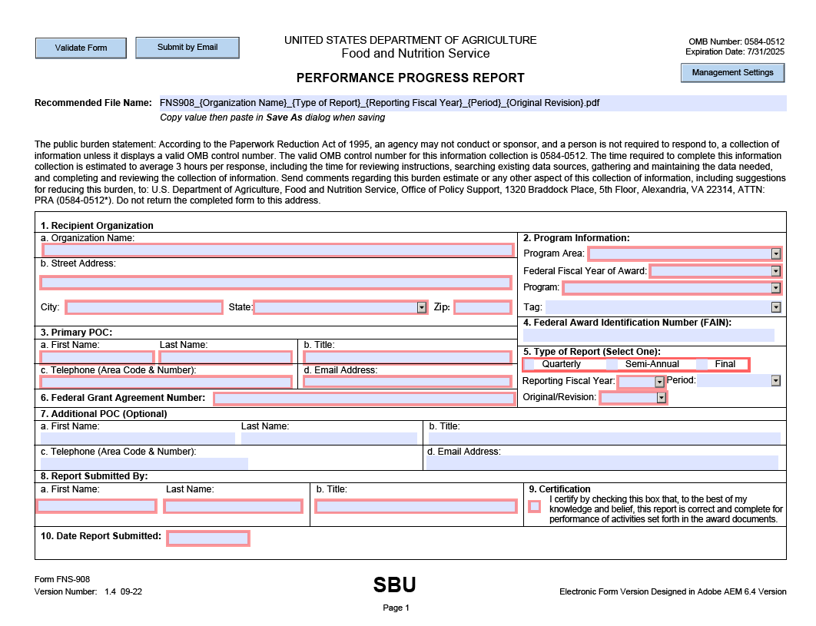

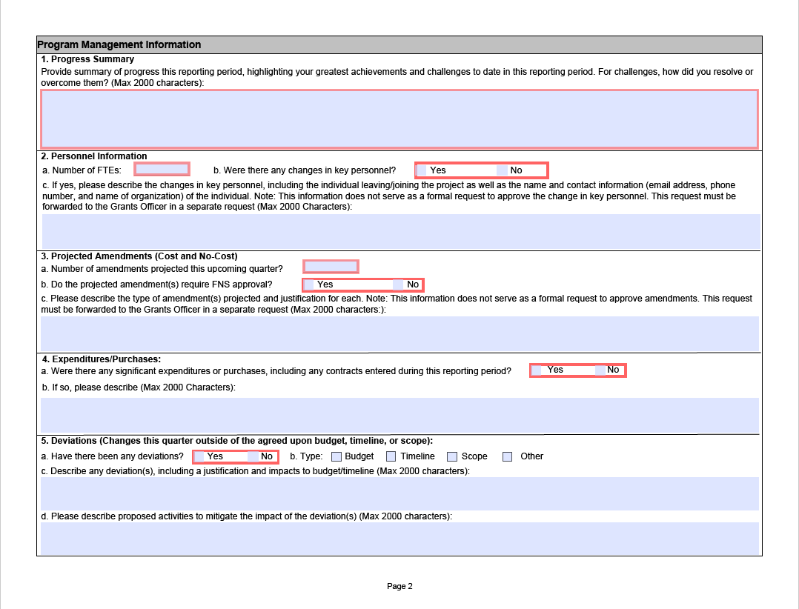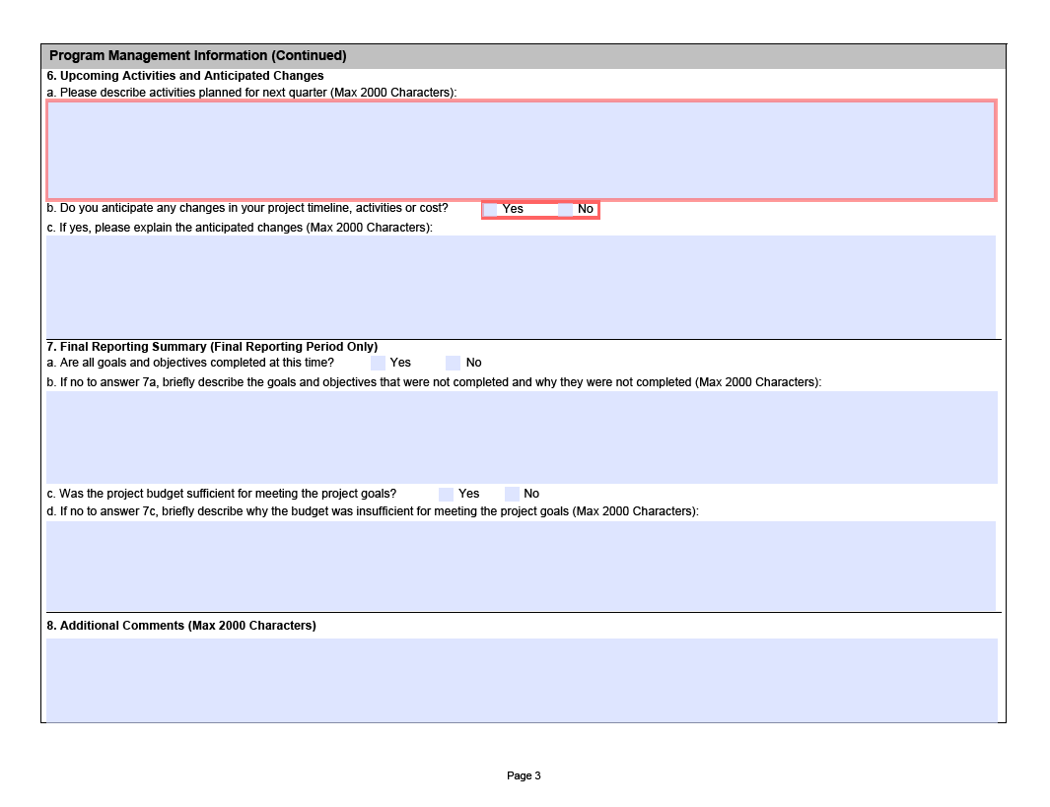
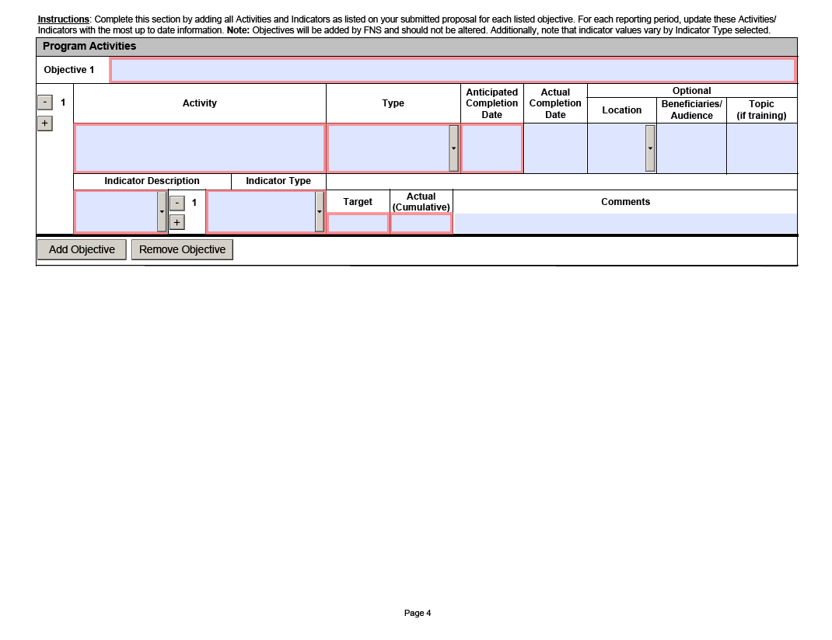

WIC EBT sales should be included with “other tenders”, distinguished from SNAP EBT sales.

