Request for Statements of Interest
Funding Opportunity Announcement

Federal Awarding Agency:
U.S. Army Corps of Engineers,
Engineer Research and Development Center
3909 Halls Ferry Road
Vicksburg, MS 39180-6199

Funding Opportunity No: W81EWF-20-SOI-0016

CFDA No: 12.630
Statutory Authority: 10 USC 2358

Project Title: Interior Least Tern Monitoring on the McClellan Kerr Arkansas River Navigation System in the Little Rock Corps District

Announcement Type: Initial announcement
Issue Date: 23 April 2020

Statement of Interest/Qualifications Due Date: 22 May 2020

Full Application Package Due Date, if Invited: 12 June 2020

Estimated Award Ceiling: $100K

Estimated Total Program Funding (optional): $58K
Expected Number of Awards: 1

REQUEST FOR STATEMENT OF INTEREST
GULF COAST & GREAT RIVERS CESU

Project Title: Interior Least Tern Monitoring on the McClellan Kerr Arkansas River Navigation System in the Little Rock Corps District

Section I: Funding Opportunity Description

Background
Least terns (Sternula antillarum) are fish-eating birds that nest in a variety of open habitats on rivers and coasts (Thompson et al. 1997). The interior population of the Least Tern (ILT) is defined as all Least Terns nesting >50 miles from the Gulf of Mexico on rivers of the Great Plains and in the Lower Mississippi Valley (USFWS 1985, 1990). Most individuals of this population nest on sandbars with little to no vegetation that are located on large rivers, primarily the Mississippi, Red, Arkansas, Canadian, Missouri, and Platte (Lott 2006).
ILT was listed as endangered by the United States Fish and Wildlife Service (USFWS)in 1985 due to concerns about breeding habitat loss and degradation associated with water resource development projects, which affect a large proportion of this population (USFWS 1985). Large multi-purpose dams, engineered navigation systems, bank stabilization projects, and wells or canals that remove water for irrigated agriculture affect ILT nesting habitat across much of their range (USFWS 1990). Many of the large dams and navigation systems in the range of ILT are operated by USACE (U. S. Army Corps of Engineers 1999, 2002, 2003, 2004a, 2004b, 2005) as detailed in the incidental take statement of the 2016 PBO in accordance with the Endangered Species Act (ESA) (USFWS 2016). Historically, sandbar nesting habitat on many rivers throughout the range of ILT has been lost or strongly degraded due to channel responses to large dam placement or channelization for navigation (Friedman et al. 1998, Funk and Robinson 1974, Williams 1978, Stinnett et al. 1988, Tommelleri 1984, and Knoll 2006). In addition to this initial (and in some cases, ongoing) pulse of habitat loss during channel adjustment to large-scale river engineering, multi-purpose dam operations continue to have direct effects on ILT reproductive success (e.g., nest and chick mortality due to flooding) that are strongest directly below 8 large multi-purpose dams on the Arkansas, Red, Canadian, and Missouri Rivers (USFWS 2003, 2005a). For this project all efforts will be concentrated on the Arkansas River between Fort Smith and the Mississippi River. In addition to the Arkansas River, least terns have been documented nesting on rooftops within the Arkansas River Valley. These are flat rooftops, fully or partially covered with small river rock or pea gravel, at least superficially resembling riverine, island/sandbar nesting habitat of Least Terns (Forys and Borboen-Abrams 2006). These sites are also monitored with the appropriate permissions.

Brief Description of Anticipated Work

It was determined that traditional navigation and hydroelectric operations on the Arkansas River from Oklahoma to Arkansas has had detrimental effects on the ILT population. Once we understood how our actions were impacting the ILT bird population we needed to ascertain through research how badly as well as exploring different conservation measures that would stabilize and support the remaining birds.
Field work includes conducting breeding season, nest monitoring and inventory as well as habitat assessments of the interior least terns. The research will cover monitoring at least 12 river colony locations and 3-5 rooftop colonies within the Arkansas River Valley from downstream of Wilbur D. Mills Dam at river mile (RM) 10 to roughly RM 285 of the MKARNS in Arkansas.

Research Goal: Evaluating how habitat management activities the Corps has implemented over time, are impacting relative abundance and reproductive success of terns on the Arkansas portion of the Arkansas River. This research will assist the Corps in identifying what type of activity, or combination of activities provide the most benefit terns and appropriate locations/sand bars on which to implement these activities.
Description of Objectives
1. Monitoring and data collection through surveys and inventories

(a) Conduct surveys and inventories annually to assess population status of ILT (adults, chicks and fledgling) on the Arkansas River in Arkansas including reservoirs, river reaches between reservoirs, and at locations adjacent to the river.

(b)Monitor all nesting sites (to include roof tops) to evaluate seasonal productivity and document causes and number of mortality and injury to eggs, chicks, fledglings, and adults on the Arkansas River in Arkansas including reservoirs, river reaches between reservoirs, and at locations adjacent to the river.

2. Implement new conservation practices to curb the species decline and encourage the population to rebound.

(a) Conducting habitat assessments and creating new habitats where necessary, post signs at nesting sites with high human use, sites used by boaters, ATV's or other ORV's, sites with history of human disturbance, boat ramps, eliminating land bridges etc., in an effort to educate and reduce predation.

3. Preparation of an annual report

(a) The report will include number of adults, nests, chicks, and fledglings per breeding pair at each nesting site, location (as measured with a global positioning system) in latitude and longitude of each nesting site, evidence of land bridging, if applicable, possible causes of nest failure (e.g., flooding, predation, human disturbance), and elevation of nests and freeboard representing the highest and lowest nests at each nesting site. Analysis of information for created/enhanced nesting habitat USACE is maintaining to benefit nesting ILT will be reported separately from natural nesting habitat and will be referenced using a naming scheme agreed upon by USFWS and USACE. The report also will include analysis of data, interpretation of results, and management recommendations the USACE may implement to maintain these sites as suitable nesting habitat for least terns.

QUALIFICATIONS
Successful applicants should have expert knowledge and work experience in the Upper Mississippi River System (UMRS) floodplain ecosystem, particularly the impounded section of the UMRS, riverfront and floodplain forest communities, and the community dynamics of large river terrestrial systems. Applicants should have prior experience with inventory and monitoring of vegetation features within these systems including mapping, data collection and statistical analysis. Applicants will also be required to submit three (3) monthly status reports and one (1) annual report each year of the cooperative agreement to provide updates on the implementation of the project.

Eligible applicants will hold all necessary state, federal, county, and municipal permits consistent with applicable laws and regulations before commencing work under this agreement and provide numbers of current Arkansas state scientific collection and section 10(a)(1)(A) recovery permits as part of their application package. They also will have at least three years of experience conducting least tern or shore bird surveys and monitoring nesting sites on the Arkansas River in Arkansas using methods and protocols approved by the U.S Fish and Wildlife Service.

Skills & requirements desired:
- Knowledge of/experience with wildlife research study design
- Knowledge of comprehensive literature review techniques
- Ability to write clearly and concisely, synthesizing any studies that have been conducted, and create comprehensive bibliographic citations
- Experience working with federal agencies
- Must have a valid section 10(a) (1) (A) recovery permit.

Educational and experiential background desired:
- Knowledge of shorebird species, behavior and migration patterns, and natural history
- Knowledge of study design and research techniques
- Ability to understand technical publications, discern the difference between primary and secondary sources in research, and judge the rigor and scientific merit of research publications
- Experience in conducting research

Period of Performance
Field work is anticipated to take place July 15, 2020, through September 30, 2020. Reports will be due by 15 May 2021 or earlier.

Site Locations:
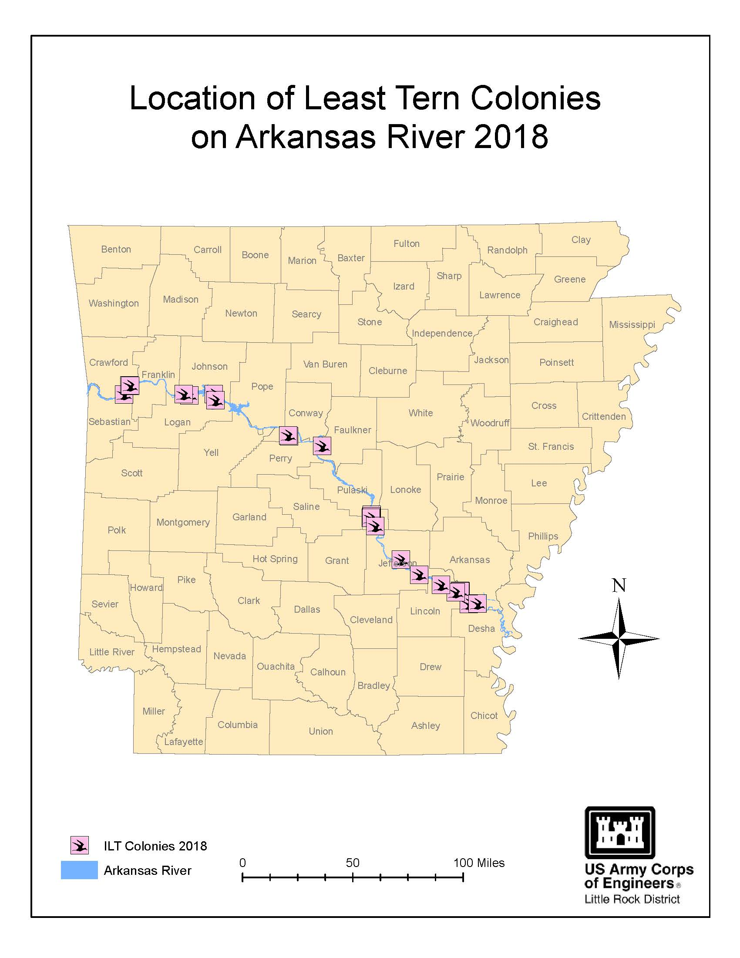
Public Purpose/ Benefit includes but are not limited to:
- Birds including the interior least terns are vital environmental indicators, telling us about the health of our ecosystems thus, conservation of the bird species and protection of their habitat improves biodiversity and ultimately the ecological health of the local watersheds in our communities. Determination of population status and trends for the species at local and regional levels, will more adequately reflect habitat and ecosystem quality than does simple presence or absence of bird species. These species are sensitive to changes in diverse habitats and can tell us about the impacts; both good and bad occurring in watersheds that encompasses the Arkansas River. A healthy watershed provides clean and increased volumes of water for recreation, supports thriving populations of wildlife valued by the public, and strengthens sensitive wildlife and plant species’ ability to survive.

- Project results and output will be shared through a variety of strategies to increase public awareness, knowledge and support for conservation and natural resources stewardship of the species habitat wherever they exist.

- Project results are made available to a wide audience including nonfederal entities.

- Project results/outputs will add to the scientific literature/knowledge base, with applicability and utility beyond the scope of the project study area and external to USACE.

Section II: Award Information

Responses to this Request for Statements of Interest will be used to identify potential investigators for this project and studies to be sponsored by the SWL District. Approximately $58,000 is available to support this project for one (1) year. Additional funding may be available for follow on work in subsequent years up to 4 years at $80,000 per year for a total of $378,000 over 5 years.

Government Participation
The Little Rock District anticipates it will provide substantial involvement through the life of the project: (1) provide access to study sites and participate in the development of study and sampling requirements; (2) participate in site visits as appropriate; (3) general close monitoring or operational involvement during performance period under the award. The District will also participate in technical meetings and final report preparation. The District will insure distribution of data for public, other resource managers, and academic use.

Section III: Eligibility Information

1. Eligible Applicants – This opportunity is restricted to non-federal partners of the Great Rivers or Gulf Coast Cooperative Ecosystems Studies Units (CESU).

2. Cost Sharing
This action will be 100% funded by USACE.

FOR CONTRACTING USE ONLY

Section IV: Application and Submission Information – Two Phase Process

Phase I: Submission of a Statement of Interest/Qualifications.

- Materials Requested for Statement of Interest/Qualifications:
  - Please provide the following via e-mail attachment to: Amanda.Andrews@usace.army.mil
(Maximum length: 2 pages, single-spaced 12 pt. font).

1. Name, Organization and Contact Information

2. Brief Statement of Qualifications (including):
      - Biographical Sketch,
      - Relevant past projects and clients with brief descriptions of these projects,
      - Staff, faculty or students available to work on this project and their areas of expertise,
      - Any brief description of capabilities to successfully complete the project you may wish to add (e.g. equipment, laboratory facilities, greenhouse facilities, field facilities, etc.).

Note: A proposed budget is NOT requested at this time.

The administrative point of contact is Amanda Andrews, 601-634-5249; Amanda.Andrews@usace.army.mil

- Statement of Interest/Qualifications shall be submitted NO LATER THAN 22 May 2020 1300 Central Time

Based on a review of the Statements of Interest received, an investigator or investigators will be invited to move to Phase II which is to prepare a full study proposal. Statements will be evaluated based on the investigator’s specific experience and capabilities in areas related to the study requirements.

Phase II: Submission of a complete application package to include a full technical proposal including budget, if invited.

- Address to Request Application Package
The complete funding opportunity announcement, application forms, and instructions are available for download at Grants.gov.

The administrative point of contact is Amanda Andrews, 601-634-5249; Amanda.Andrews@usace.army.mil

- Content and Form of Application Submission
All mandatory forms and any applicable optional forms must be completed in accordance with the instructions on the forms and the additional instructions below.
  - SF 424 R&R - Application for Federal Assistance
  - Full Technical Proposal – Discussion of the nature and scope of the research and technical approach. Additional information on prior work in this area, descriptions of available equipment, data and facilities, and resumes of personnel who will be participating in this effort should also be included.
  - Cost Proposal/Budget – Clear, concise, and accurate cost proposals reflect the offeror’s financial plan for accomplishing the effort contained in the technical proposal. As part of its cost proposal, the offeror shall submit cost element breakdowns in sufficient detail so that a reasonableness determination can be made. The SF 424 Research & Related Budget Form can be used as a guide. The cost breakdown should include the following, if applicable:
- Direct Labor: Direct labor should be detailed by level of effort (i.e. numbers of hours, etc.) of each labor category and the applicable labor rate. The source of labor rates shall be identified and verified. If rates are estimated, please provide the historical based used and clearly identify all escalation applied to derive the proposed rates.
- Fringe Benefit Rates: The source of fringe benefit rate shall be identified and verified.
- Travel: Travel costs must include a purpose and breakdown per trip to include destination, number of travelers, and duration.
- Materials/Equipment: List all material/equipment items by type and kind with associated costs and advise if the costs are based on vendor quotes and/or engineering estimates; provide copies of vendor quotes and/or catalog pricing data.
- Subrecipient costs: Submit all subrecipient proposals and analyses. Provide the method of selection used to determine the subrecipient.
- Tuition: Provide details and verification for any tuition amounts proposed.
- Indirect Costs: Currently the negotiated indirect rate for awards through the CESU is 17.5%.
- Any other proposed costs: The source should be identified and verified.

- Application package shall be submitted NO LATER THAN 12 June 2020 1300 Central Time.

- Submission Instructions
Applications may be submitted by mail, e-mail, or Grants.gov. Choose ONE of the following submission methods:
  - Mail one unbound copy of your complete proposal to:
US Army Corps of Engineers, Engineer Research and Development Center
Attn: Amanda Andrews
3909 Halls Ferry Road
Vicksburg, MS 39180-6199

  - E-mail:
Format all documents to print on Letter (8 ½ x 11”) paper. E-mail proposal to Amanda.Andrews@usace.army.mil

  - Grants.gov: https://www.grants.gov/:
Applicants are not required to submit proposals through Grants.gov. However, if applications are submitted via the internet, applicants are responsible for ensuring that their Grants.gov proposal submission is received in its entirety.

All applicants choosing to use Grants.gov to submit proposals must be registered and have and account with Grants.gov. It may take up to three weeks to complete Grants.gov registration. For more information on registration, go to https://www.grants.gov/web/grants/applicants.html.

Section V: Application Review Information

- Peer or Scientific Review Criteria: In accordance with DoDGARs 22.315(c), an impartial peer review will be conducted. Subject to funding availability, all proposals will be reviewed using the criteria listed below (technical and cost/price). All proposals will be evaluated under the following two criteria which are of descending importance.

a. Technical (items i. and ii. are of equal importance):
i. Technical merits of proposed R&D.
ii. Potential relationship of proposed R&D to DoD missions.

b. Cost/Price: Overall realism of the proposed costs will be evaluated.

2. Review and Selection Process
a. Categories: Based on the Peer or Scientific Review, proposals will be categorized as Selectable or Not Selectable (see definitions below). The selection of the source for award will be based on the Peer or Scientific Review, as well as importance to agency programs and funding availability.

- Selectable: Proposals are recommended for acceptance if sufficient funding is available.

ii. Not Selectable: Even if sufficient funding existed, the proposal should not be funded.

Note: The Government reserves the right to award some, all, or none of proposals. When the Government elects to award only a part of a proposal, the selected part may be categorized as Selectable, though the proposal as a whole may not merit such a categorization.

b. No other criteria will be used.

c. Prior to award of a potentially successful offer, the Grants Officer will make a determination regarding price reasonableness.

Section VI: Award Administration Information
- Award Notices
Written notice of award will be given in conjunction with issuance of a cooperative agreement signed by a Grants Officer. The cooperative agreement will contain the effective date of the agreement, the period of performance, funding information, and all terms and conditions. The recipient is required to sign and return the document before work under the agreement commences. Work described in this announcement SHALL NOT begin without prior authorization from a Grants Officer.

- Administrative Requirements
The cooperative agreement issued as a result of this announcement is subject to the administrative requirements in 2 CFR Subtitle A; 2 CFR Subtitle B, Ch. XI, Part 1103; and 32 CFR Subchapter C, except Parts 32 and 33.

- Reporting
See 2 CFR Sections 200.327 for financial reporting requirements,
200.328 for performance reporting requirements, and 200.329 for real property reporting requirements.

Section VII: Agency Contact
Amanda Andrews, Contract Specialist
US Army Corps of Engineers, Engineer Research and Development Center
3909 Halls Ferry Road
Vicksburg, MS 39180-6199
Amanda.Andrews@usace.army.mil
601-634-5249

