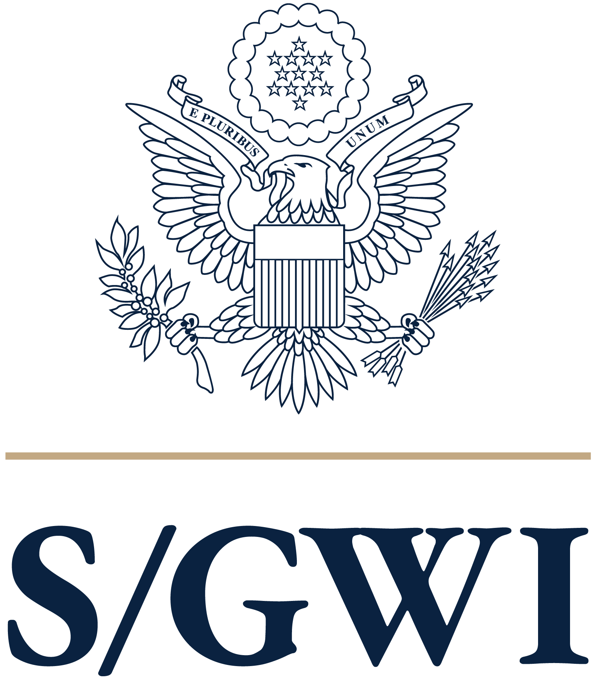

The Secretary’s Office of
Global Women’s Issues

Department of State

Gender Analysis Template

What are the relevant gender gaps?

Gender analysis is a tool for exploring the gaps in power, resources, and opportunities among women, men, girls, boys, and other gender identities in a given context, and how this interacts with proposed work. Gender analysis is most effective when used in the early stages of program/policy/activity conception to inform design, and it should be reviewed consistently throughout the implementation of the proposed intervention. This simple process can be conducted by anyone – whether they work in policy, programs, or public diplomacy, to ensure activities reach all members of a community equitably.

Steps of Gender Analysis

Gather Data and Reports: Conduct research to understand gender in the context of the country/region which you wish to work in. The “Information Sources” section below directs you to helpful resources. If findings from civil society consultations exist, these insights could also be helpful in this stage.

Meet and Analyze: After reviewing the relevant research, meet with colleagues and team members to analyze the findings using the second column of the table below. Including a diversity of colleagues across portfolios may be helpful in ensuring comprehensive responses. After completing each of the boxes, ask, “What are the relevant gender gaps and opportunities?” If the same gaps and opportunities appear in multiple domains, that may indicate that these are significant factors that should be addressed.

Create Next Steps and Incorporate: Work with your team to plan next steps to address gaps and opportunities. Activities may be geared toward policy, programs, and/or public diplomacy. Incorporate these steps into a plan of action.

Information Sources
- USG:
  - Department of State Reports
    - Country Reports on Human Rights Practices (DRL)
    - Trafficking in Persons Reports (J/TIP)
    - International Religious Freedom Reports (J/IRF)
  - USAID Gender Assessments/Analysis
    - Contact your USAID colleagues or S/GWI MEL Team (sgwi_mel_team@state.gov)
- Research from organizations, governments, and/or other stakeholders, for example:
  - Women, Business and the Law Reports (World Bank Group)
  - Women, Peace, and Security Index (Georgetown Institute for Women, Peace and Security)
  - Global Gender Gap Report (World Economic Forum)
You may see the same gender gaps appearing in multiple domains, which may highlight the most relevant gaps for your work. Examining the Domains of Analysis and Cross-Cutting Questions can help you develop your Design and Implementation for programs, policy, and public diplomacy.

Analysis Template
Domain of Analysis​​ | Relevant information and/or research to YOUR Strategic Objectives​​ | Create Next Steps: ​ 1) Policy, 2) Programs, 3) Public Diplomacy​
Laws, Policies, Regulations, and Institutional Practices​​
Are all genders treated equitably in legislation, policies, and institutions? Are there any laws or policies that address inequities or discrimination? How could these impact your project or activity?​​​​
Cultural Norms and Beliefs
What does this society expect of different genders? How will this shape the way our work impacts women, men, girls, boys, and non-conforming genders? Do gender norms or expectations facilitate or impede engagement with the USG?
Gender Roles, Responsibilities, & Time Use (includes paid and unpaid work, i.e. elder and childcare)
Who does what? How does gender affect roles, inside and outside the home, and change the way people are affected by the challenges at hand? How might this impact their participation in our policy engagement, diplomacy, or programs?
Access to and Control over Assets and Resources (includes income, employment, and land)
How do gender norms affect control over and capacity to use resources and assets? Examples include access and control over income, education, healthcare, social services, technology, and information.
Patterns of Power and Decision-making​ (includes structural barriers & leadership norms)​​
Who influences or exercises control over decision-making? Why? Consider decisions over material, human, intellectual, or financial resources and sexual and reproductive health. Are there any risks associated with disrupting these decision-making patterns, even if someone requests it? If so, how will you mitigate or respond to those risks?
Cross-Cutting Questions | Relevant information and/or research to YOUR Strategic Objectives​​ | Create Next Steps: ​ 1) Policy, 2) Programs, 3) Public Diplomacy​
Collaboration: What do local women, girls, and gender experts; marginalized peoples; and communities think? How have/will you partner with them and mitigate potential risks from their involvement?
Gender-Based Violence: How does gender-based violence impact our work and the communities with which we engage?​​ |  | .​​
Intersectionality: What other aspects of identity should be considered?​ (Age, religion, sexual orientation, race, ethnicity, tribe, wealth, education, disability, marital or relationship status, class, etc.) ​
How do we respectfully analyze these complexities?

The Secretary’s Office of Global Women’s Issues (S/GWI) has created this gender analysis sample for use by Department of State bureaus and offices. S/GWI thanks USAID and DRL for their contributions to the development of the Department of State gender analysis template. USAID provided best practices and examples for this gender analysis template. DRL shared experiences and tools (including the Country Reports on Human Rights Practices) to make this template as concise as possible. Additional resources to assist with your gender analysis are available from S/GWI’s internal website.

When we say "opportunities" we are not promoting a gender exploitative approach nor instrumentalizing women for other ends.
Disclaimer: External research, literature, and/or publications do not represent the opinion of the Secretary’s Office of Global Women’s Issues; the Department of State; and/or the U.S. Government
We use “all genders” as an all-encompassing term referencing women, men, girls, boys, and non-conforming genders. Additionally communities or countries may have other contextually different breakdowns that may be important to consider, such as "youth," "children," "elders," "Kinnar," "fa'afafine," or others. Our list is not meant to limit your analysis, but rather to be a helpful reminder to ask yourself “who’s missing?” Consulting with stakeholders, per cross-cutting question 1, is important to help you localize this question. ​
DRL has been developing Department capacity to analyze population identity for the past ten years and can provide relevant information and expertise here.​
See https://usdos.sharepoint.com/sites/SES/sgwi/SitePages/Gender-Integration-Resources.aspx for tools, resources, and more examples.

