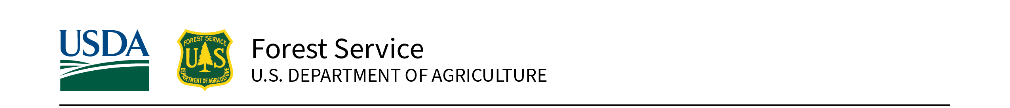
Eastern Region State, Private, and Tribal Forestry | August 23, 2023

2023 USDA Forest Service Great Lakes Restoration Initiative
Cooperative Weed Management Areas
Request for Applications
Due by 5 PM Central/ 6 PM Eastern, October 23rd, 2023
Contents
Background and Purpose 3
Eligibility 3
Projects Not Eligible 4
Program Area Information for CWMAs 4
Criteria for GLRI CWMA Project Selection 4
Minimum Requirements 4
Recommended for Applicants 5
Evaluation Criteria (100 points total) 5
Purpose and need (25%) 5
Technically sound and sustainable scope of work (25%) 6
Measurable results/outcomes expected (30%) 6
Partnerships and knowledge sharing (20%) 7
Important Considerations for Funding Recipients 7
Criteria Scoring Rubric: 8
How to Apply 10
Important Dates 11
Contacts 11
General Questions 11
Eastern Region State, Private, and Tribal Forestry Contacts: 11
National Forest System Contacts: 11
Review Process 11
Appendix A. Great Lakes Watershed Map 13
Appendix B. Eligible Counties Wholly or Partially in the Great Lakes Watershed 14
Appendix C. Benefits to Underserved Communities/People 15
Appendix D. Grants.gov Application Submission and Receipt Procedures 17

Background and Purpose
The interagency Great Lakes Restoration Initiative (GLRI) targets improvements to address the most significant environmental problems within the Great Lakes Basin. Through an agreement with the Environmental Protection Agency (EPA), the U.S. Department of Agriculture (USDA), Forest Service anticipates receiving funds to support projects that implement strategic, priority actions within Forest Service authorities to restore, protect, and maintain the Great Lakes ecosystem. For this GLRI Request for Applications (RFA) for Cooperative Weed Management Areas (CWMAs), successful projects will address invasive plant species that pose significant ecological threats in the Great Lakes Basin. Award of funds is contingent on allocation of EPA funding. Funds are available for the following program area:
GLRI Focus Area 2, Invasive Species: Detect, prevent, eradicate, and/or control invasive plant species to promote ecological resiliency, watershed stability, and biological diversity on Federal, State, or other public or private land.
Estimated Funding: $1,250,000 (anticipated)
Grant Limits: Minimum Federal request is $25,000 and maximum Federal request is $100,000.

Eligibility
The GLRI funding is available to CWMAs and similar invasive plant partnerships that work within the Great Lakes Basin of Minnesota, Wisconsin, Michigan, Illinois, Indiana, Ohio, Pennsylvania, and New York. CWMAs and similar groups are organized partnerships of Federal, State, and local government agencies, Tribes, individuals, and various interested groups that manage invasive plants across boundaries within a defined area, generally a county or larger in size.
As defined by Midwest Invasive Plant Network, “Cooperative Weed Management Areas (CWMAs) are partnership organizations formed with the goal of managing invasive plants across jurisdictional and landownership boundaries. Cooperative Invasive Species Management Areas (CISMAs) and Partnerships for Regional Invasive Species Management (PRISMs) are similar to CWMAs, but their goals may include the management of invasive animal species in addition to plants.
The following are key characteristics of CWMAs/CISMAs/PRISMs:
- Work within a defined geographic area
- Participation from a broad cross-section of stakeholders and landowners
- Decision making though a steering committee
- Long-term commitment to cooperation, preferably formalized through a partnership agreement
- Have a strategic plan for addressing species of concern
- Coordinate across jurisdictional boundaries
For the purposes of this funding opportunity, “CWMA” will refer to any invasive species partnership meeting the CWMA/CISMA/PRISM definition, so long as it includes specific objectives for invasive plants.
Applications may include work on all land ownerships within the Great Lakes watershed of the United States. The Great Lakes watershed is defined as those areas within the United States that currently or historically drain into Lake Superior, Lake Michigan, Lake Huron, Lake Erie, or Lake Ontario, or drain into the St. Lawrence River west of where the International Boundary line leaves the river. A map of the Great Lakes watershed is provided in appendix A; eligible counties with lands in the watershed are listed in appendix B.

Projects Not Eligible
- Research: Basic research as defined in 2CFR 422.1, “Systematic study directed toward fuller knowledge or understanding of the fundamental aspects of phenomena and of observable facts without specific applications towards processes or products in mind.” Note: Technical transfer, education, and outreach activities associated with applying research can be included in the application. A research entity can be included as a partner and can contribute (e.g., monitoring activities).
- Construction and capital improvements (e.g., facilities, infrastructure, roads).
- Projects that only have outreach and education as outcomes. However, projects are encouraged to include a component of outreach, education, and/or training as components of the project, or as a means to achieve the project objectives.
- Projects that only have surveying or mapping as outcomes, though projects may include a survey or mapping components.
- Cost-share, reimbursement, and other types of payment provided directly to private landowners; however, funding may be used to perform work on private lands.
- Forest Health authorities may not be used to cut either dead or dying trees, unless used to suppress or slow the spread of an outbreak.

Program Area Information for CWMAs
Description: Using a competitive process, funds will be provided to CWMAs (or their designated fiduciary partners). CWMAs are local organizations that leverage funds to implement invasive plant control projects across jurisdictional boundaries. CWMAs are highly visible, building community awareness and participation, as well as focusing attention and presenting a united effort to Federal, Tribal, State, and local agencies, as well as nonprofit partners. CWMAs provide an early detection and rapid response network by ensuring that partners are aware of and are able to identify and respond to invasions. Applications focusing on measurable, on-the-ground outcomes using best practices will be given priority.
Great Lakes Action Plan III Objective: 2.2 – Control established invasive species
Great Lakes Action Plan III Measure of Progress: 2.2.1 – Number of acres controlled for targeted invasive species by GLRI-funded projects

Criteria for GLRI CWMA Project Selection

Minimum Requirements
Projects that do not meet minimum requirements will not be considered.
- All proposed projects must lie entirely within the Great Lakes watershed of the United States.
- Eligible projects must relate directly to the work of a partnership that meets the characteristics of a CWMA, though the name of the partnership may differ.
- Applicant organization must be listed as a CWMA partner or steering committee member.
- The CWMA Coordinator must be the project contact or provide a letter documenting CWMA involvement in the application.
- Letters of commitment are required from known partners that own or maintain a significant portion of the project area. If the project is on National Forest land, concurrence is required by the Forest Supervisor; on Tribal lands, concurrence is required from the Tribe’s designated authority for approving activities. Projects that span ownership types will need concurrence from each relevant entity prior to working on that land.
- Applications must address detection, prevention, eradication, and/or control of invasive plant species, including measurable targets and results. All projects must include treatment acres as a measurable result.
- All vegetation manipulation project applications must include a monitoring plan that evaluates project success and describes actions taken if objectives are not met, as well as a description of actions that will be taken to prevent the reestablishment of invasive plants, including restoration work.
- Costs must be allowable and budgeted in accordance with the OMB Uniform Guidance.
- Projects must not include construction (capital improvements of facilities or infrastructure) as Federal costs.
- Planting projects shall not install any State-listed invasive species, including invasive species listed as “restricted”, “pending further review”, “non-restricted”, on a watch list, etc. Explore State lists at the USDA’s National Invasive Species Information Center.
- No matching funds are required.

Recommended for Applicants
- Letters of support are recommended. These can include letters from partners or letter from communities or groups that are supportive of the project, even if they are not making commitment to the project. Letters of commitment can be written by partners that plan to contribute to the project in some way. Letters of support or letters of commitment should make clear what involvement, if any, the letter writer has with the project.
- Maps of the project area that clearly show project boundaries. It is recommended that maps show the project lies entirely within the Great Lakes watershed boundary.
- Include any attachments needed to support the project application.

Evaluation Criteria (100 points total)
Applications will be evaluated on how well they address the evaluation criteria below. Applications must include metrics of acres treated, cost per acre, and species proposed for removal and restoration.

Purpose and need (25%)
- Describe the connection between project activities and priorities of applicable strategic plans, such as the GLRI Action Plan III, Lakewide Action and Management Plan, National Forest Land and Resource Management Plans, State Forest Action Plan, or Tribal Land Management Plans. Additional emphasis will be given to projects that address specific rather than general priorities of these regional plans, e.g., priority species or locations.
- Explain how the project addresses the invasive plant management strategy of the CWMA(s) involved, and any other local plans for the protection, maintenance, or restoration of the chemical, biological, or physical integrity of the Great Lakes Basin.
- Define the habitat and water quality values at risk from targeted invasive species, and desired future condition for that habitat. Priority will be given to project applications that clearly demonstrate the benefits to water quality, habitats, plant community resiliency, watershed stability, and/or biological diversity at the watershed scale; and highlight the connection between terrestrial and aquatic ecosystems.
- Discuss partnership needs addressed through the project (e.g., lack of a CWMA in the landscape, strategic planning to address a changed condition, inclusion of a broader partner base). Funding decisions may consider the need to allocate sustaining support across many CWMAs.

Technically sound and sustainable scope of work (25%)
- Clearly demonstrate achievable project objectives that follow best practices in one or more of the following categories: 1) Detection, 2) Prevention, 3) Eradication, and/or 4) Control.
- Describe how the project will control targeted invasive plants that are important in the local landscape. Examples of species targeted by GLRI include (but are not limited to): baby’s breath, buckthorn, garlic mustard, Japanese barberry, Japanese knotweed, lyme grass, invasive strains of Phragmites, purple loosestrife, and wild parsnip. Additional species that are not listed here, but still pose a legitimate ecological threat, will also be accepted.
- Demonstrate long-term commitment to project monitoring and follow-up treatments. Identify expected commitments by the applicant and partners to work that sustains project benefits.
- Include a monitoring plan that evaluates project success and describes actions taken if objectives are not met. Describe actions to prevent reestablishment of invasive plants and restore habitats.
- Discuss past successes, lessons learned, or other experience that informs the project plan.

Measurable results/outcomes expected (30%)
- Includes acres treated as a measurable outcome. Includes specific units of work for all outcomes to be accomplished (e.g., acres surveyed, volunteer hours, acres of native vegetation restored). All outcomes are a direct result of the proposed project. Overlapping acreages are identified.
- Describe how the project expands or protects past restoration through the GLRI or other sources, and/or long-term commitments beyond the life of the project.
- Include anticipated results for education and outreach activities in the outcomes table.
- Ensure project budget is clear and consistent and outcomes are cost-effective. Total cost per acre will be a factor in rating your application.

Metric Information
In addition to required measurable outcomes for acres of treatment and survey, other metrics facilitate evaluation and communication of outcomes, and are encouraged for use as applicable. The metrics below should be used in the Measurable Results table in the Project Narrative Form.
Table 1.—Measurable Results
Metric Name | Required/Optional Status and Metric Description
Acres treated for invasive plants | Required for all projects; indicate any overlapping treatment acres in outcomes table or scope of work
Acres surveyed for invasive plants | Required for projects that include invasive species surveys as a budget item
Acres of native vegetation restored | Recommended if applicable to project; describe type of vegetation planted (e.g., seed, plug)
Number of trees and/or shrubs planted | Recommended if trees will be planted
Number of volunteer hours contributed | Optional, estimated
Number of youth impacted (grades K-12) through education and stewardship projects | Optional; estimate active participants (i.e., beyond general site use, viewing signs)
Other | Provide your own activity description and units.

Partnerships and knowledge sharing (20%)
- Identify ALL partners involved in the project, and their respective contributions. Partners with jurisdiction or ownership in the project landscape should be identified.
- Include letters of commitment from partners that are substantially involved. Letters should include the specific quantitative or qualitative contributions a partner will make towards project planning and implementation.
- Describe how the project strengthens collaboration in invasive plant management and/or increases capacity of the partnership to perform and maintain work.
- Describe how the project will engage and inform the community beyond the existing partner network.
- Describe efforts to invest in underserved communities and advance racial equity, such as through educational programs or outreach, active partnerships with organizations that represent historically underserved people or communities, volunteer or job training, or other efforts (see appendix C for more information).
- Detail the potential of the project to provide and share knowledge, tools, and innovations for practical application.

Important Considerations for Funding Recipients
- Applications must show capacity to be fully implemented within 2 years of the start date.
- Annual progress reports and financial reports are required with a final report due upon project completion. Information required includes species treated, method of treatment, and acres treated. Final progress reports must include information on the measurable results and outcomes, as well as spatial data (e.g., shapefiles) of project locations. Supplemental information such as relevant photos, illustrations, diagrams, or maps that help convey the impact of the project will be required as appropriate to project activities.
- Projects must post a visible project identification sign, erected as appropriate at each on-the- ground project, that includes project information and purpose, GLRI reference, and Federal agencies involved.
- You are encouraged to work with your state forestry agency and research how your project fits into the goals and objectives of the State Forest Action Plan. Look up State Foresters at the National Association of State Foresters website.

Criteria Scoring Rubric:
Table 2.— This rubric will be used by review team members to score applications.
Criteria | High Score | Medium Score | Low Score
1. Purpose and Need (25 points) | 19-25 points  - Strong and clear contribution to one (or more) significant goal, issue, and/or invasive plant management strategy in relevant strategic or management plans.  - Strong and clear description of how project contributes to a specific strategy in the plan/strategy and leverages past work.  - Strong, clear description of the connection between terrestrial and aquatic ecosystems.  - Strong and clear demonstration of environmental need, particularly habitat and water quality values that are at risk and the desired future habitat conditions that project will contribute to. | 10-18 points  - Clear contribution to one (or more) significant goal, issue, and/or priority landscape in relevant strategic or management plans.  - Clear description of how project contributes to a specific strategy in the plan/strategy and leverages past work.  - Clear demonstration of environmental need. | 0-9 points  - A simple assertion or weak/general connection to one (or more) significant goal, issue, and/or priority landscape in relevant strategic or management plans.  - Weak contribution and leverage descriptions, if any.  - General or weak demonstration of environmental need.
2. Technical Merit and Sustainability (25 points) | 19-25 points  - Compelling, clear, and concise description of achievable project objectives, including on-the-ground-implementation.  - Strong and clear description of how the project will control invasive species that are important in the local landscape.  - Monitoring plan is included and detailed, with effective, known strategies for long-term maintenance and monitoring. Monitoring plan evaluates project success and describes actions taken if objectives are not met. Describes actions to prevent reestablishment of invasive plants and restore habitats.  - Strategies clearly stated and are known to be effective and considered best management practices.  - All required forms and coordination were submitted and documented, and are clear and precise. | 10-18 points  - Description of project methods or strategies that are known to be effective.  - Description of invasive species context in the local landscape.  - Monitoring plan is included and contains known strategies for long-term maintenance and monitoring.  - Applicant demonstrates relevant experience or expertise.  - Forms and coordination are filled out and documented. | 0-9 points  - Weak description or lack of clarity for methods or strategies.  - Weak or missing connection to local landscapes.  - Weak or missing monitoring plan  - Required forms or coordination are incomplete or missing.
3. Measurable Outcomes/Results (30 points) | 20-30 points  - Clearly communicates quantitative outcomes using required metrics, including acres treated. Any additional metrics used have a clear purpose and add to the project’s overall effectiveness. Acres that overlap are clearly defined and described.  - Outcomes clearly address expanding or protecting past restoration, and/or goals or priorities identified in the Purpose and Need.  - Cost per acre is cost-effective and reasonable, relative to similar projects.  - All budget items are clearly described and justified, and are allowable.  - Education and outreach activities and outcomes are clearly described and quantified, and qualitative outcomes are clearly described and justified, and add to the overall project outcomes. | 10-19 points  - Quantitative outcomes are described using the required metrics, including acres treated.  - Outcomes make sense in the overall context of the project and stated goals.  - Costs are within reason. High costs are justified.  - Budget items are allowable, with some description.  - Education and outreach activities are included, and qualitative outcomes are described in context of the overall project and make sense. | 0-9 points  - Metrics used are unclear or do not conform to metric requirements.  - Outcomes are weakly associated with the stated project goals.  - Costs are unreasonably high without justification.  - Budget items are poorly described, if at all.  - Education and outreach activities are not included, and qualitative outcomes or additional metrics do not add to the overall project and may not have clear relevance.
4. Partnerships and Sharing (20 points) | 16-20 points  - All project partners are listed, and their roles are clearly defined in the context of the project.  - Letters of commitment are included from partners making substantial commitments, and letters clearly describe the role of the partner. If there are letters of support from passive partners or organizations that are not partners but support the project, this non-participatory role is made clear in the letter and/or application.  - There is clear indication of meaningful engagement with diverse communities, with purposeful attention to equity and environmental justice. (See appendix C for more information.)  - Key partners, including those with jurisdiction or ownership in the project landscape, are included with clear indication of roles and engagement.  - There is strong, clear benefit to partners and local communities from the project outcomes and collaboration.  - There is a strong, clear benefit to collaborative invasive plants management or capacity. | 8-15 points  - All partners are listed with their roles.  - Letters of commitment from partners making substantial commitments are included.  - Some engagement with equity or environmental justice is described.  - Partnerships with jurisdiction or ownership are indicated.  - There are benefits to project partners and local communities from the project outcomes.  - There is benefit to collaborative invasive plant management or capacity. | 0-7 points  - It is unclear if all partners were listed, or roles are uncertain.  - There little to no indication that an effort was made to engage diverse partners or communities, or consider equity or environmental justice.  - It is unclear if those with jurisdiction or ownership in the project area have been engaged.  - It is not clear how the project benefits partners, or local communities, or the benefits are weak.  - It is not clear how project benefits collaborative management.

How to Apply
Submit all applications for this GLRI funding opportunity through Grants.gov. Search for Grant Opportunity Number USDA-FS-GLRI-CWMA23. See the Grants.gov organization registration page and appendix C of this document for further detail on how to register and apply for opportunities through Grants.gov. Applicants are encouraged to subscribe to this opportunity in Grants.gov to receive updates.
Applicants are required to apply online through Grants.gov using Workspace. Workspace is a shared, online environment where members of a grant team may access and edit different forms within an application. After creating a Workspace, you may work online or download the application package, instructions, and forms, which allows you to work offline. Grants.gov recommends submitting your application package 24 to 48 hours before the closing date to allow time to correct any potential technical issues that disrupt your initial application submission. All applications must be submitted through Grants.gov.
If you have not applied for a grant through Grants.gov before, you must complete several registration steps before you can submit your application. Note that System for Award Management (SAM) registrations may take several weeks, after which a Grants.gov organization account can be obtained within a few days. Please review the requirements for submitting an application and take steps early to be ready to submit your application by the deadline.
Registrations must be current and in place at the time you submit your application, including these:
- SAM registration must be current and in place at the time you submit your application. This registration should include the Certification for Financial Assistance.
- Grants.gov registration by an authorized organization representative (AOR)
Note: there is NO FEE for SAM registration. Go to www.sam.gov to register and find additional help.
Customer Support: Grants.gov provides customer support via toll-free number 800-518-4726 and email at support@grants.gov. For questions related to this specific grant opportunity, contact the appropriate person listed in the Contacts Section of this document.
Be sure to fill out the required Project Narrative Form and all applicable forms listed below. Other formats will not be accepted. Forms listed below are accessed through the Grants.gov Package tab, or the Related Documents tab, as indicated.
Complete application packages include the following (complete all forms in your Grants.gov Workspace):
Required forms available in the Grants.gov Application Package tab:
- SF–424, Application for Federal Assistance
- SF–424A, Budget Information for Non-Construction programs
- Attachments Form (must be included in the application package to attach items below).
Forms available in the Grants.gov Application Package tab—submit as applicable:
- AD–1047, Certification Regarding Debarment, Suspension, and other Responsibility Matters
- AD–1049, Certification Regarding Drug-Free Workplace (for all non-State entities),–OR–
AD–1052, Certification Regarding Drug-Free Workplace (for State and State Agencies)
- AD–3030, Representations Regarding Felony Conviction and Tax Delinquent Status (for Corporate Applicants)
Documents submitted using the Attachments Form in Grants.gov (attach in this order):
- 2023 GLRI CWMA Project Narrative Form (required), Note: Narrative Form is available in the Related Documents tab in the Grants.gov opportunity.
- Map of project area (recommended)
- Letters of support (see Minimum Requirements section)
- Monitoring plan (required)
- Other attachments needed to support application

Important Dates
- Applications Due: October 23rd, 2023, at 5 pm Central/6 pm Eastern

Contacts

General Questions
- GLRI inbox: SM.FS.glri@usda.gov
- Erin Barton, Eastern Region State, Private, and Tribal Forestry GLRI Coordinator, erin.barton@usda.gov
- John Kyhl, Eastern Region State, Private, and Tribal Forestry Invasive Plants Program Manager, john.f.kyhl@usda.gov

Eastern Region State, Private, and Tribal Forestry Contacts:
- New York: Constance Carpenter, Durham Field Office Representative, 603-868-7694, constance.carpenter@usda.gov
- Ohio and Pennsylvania: Joe Koloski, Morgantown Field Office Representative, 304-285-1540, joseph.koloski@usda.gov
- Minnesota, Wisconsin, Michigan, Illinois, and Indiana: Gina Jorgensen, St. Paul Field Office Representative, 651-649-5276, gina.m.jorgensen@usda.gov

National Forest System Contacts:
- New York: Greg Flood, Finger Lakes National Forest, Hector, NY, 607-546-4470, gregory.flood@usda.gov
- Minnesota: Jack Greenlee, Superior National Forest, Aurora, MN, 218-453-8626, John.Greenlee@usda.gov
- Michigan: Richard Corner, Huron-Manistee National Forest, Cadillac, MI, 231-942-4974, richard.corner@usda.gov; Ian Shackleford, Ottawa National Forest, Ironwood, MI, 906-932-1330 x331, ian.shackleford@usda.gov; Chris Leeseberg, Hiawatha National Forest, Gladstone, MI, 906-428-5874, christopher.leeseberg@usda.gov
- Wisconsin: Ann Dassow, Chequamegon-Nicolet National Forest, Medford, WI, 715-748-4875 ext. 7484824, ann.dassow@usda.gov
- Illinois: Delane Strohmeyer, Medewin National Tallgrass Prairie, Wilmington, IL, 815-423-6370, delane.strohmeyer@usda.gov

Review Process
All applications will undergo a preliminary review to dismiss incomplete or ineligible applications. An application review team consisting of staff from the Forest Service, State forestry agencies, and nongovernmental organizations will collaboratively review, evaluate, and prioritize project applications. The review team will complete the review of applications and develop a recommended ranking list of projects. The recommended list of applications will be submitted to the Regional Forester for the Forest Service Eastern Region for approval. All applicants will be notified of the final selection or non-selection of their applications. Full text of Project Narrative Forms and reviewer comments may be shared publicly after selections have been made.

Appendix A. Great Lakes Watershed Map
FY 2023 USDA Forest Service
Great Lakes Restoration Initiative (GLRI)
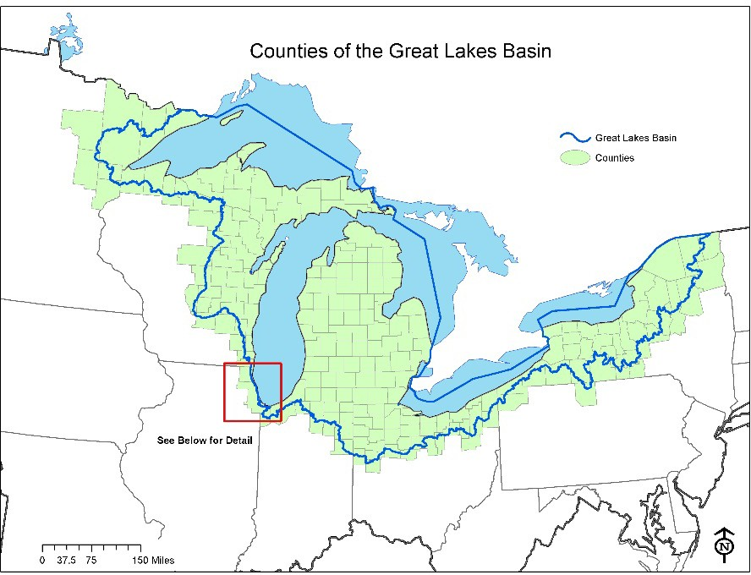
Figure 1.— Great Lakes watershed boundary.
Map Inset for Illinois and Indiana: In Illinois and Indiana, for purposes of this RFA, the Great Lakes Basin includes the historic watersheds of the North Shore channel, Chicago, and Little Calumet Rivers. This description was provided by EPA and supported by the Illinois Department of Natural Resources.
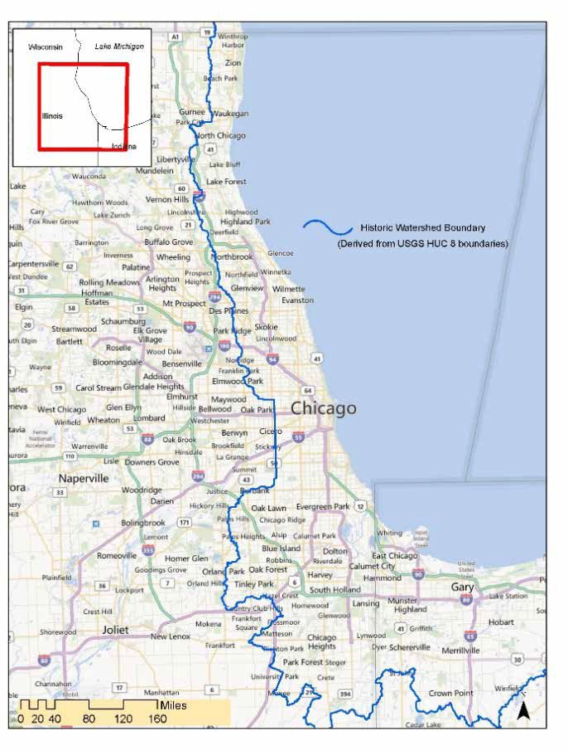
Figure 2.—Map inset for Illinois and Indiana.

Appendix B. Eligible Counties Wholly or Partially in the Great Lakes Watershed
FY 2023 USDA Forest Service
Great Lakes Restoration Initiative (GLRI)

Counties Wholly in the Great Lakes Watershed
- Indiana
DeKalb, LaGrange, Steuben
- Michigan
Alcona, Alger, Allegan, Alpena, Antrim, Arenac, Baraga, Barry, Bay, Benzie, Branch, Calhoun, Cass, Charlevoix, Cheboygan, Chippewa, Clare, Clinton, Crawford, Delta, Dickinson, Eaton, Emmet, Genesee, Gladwin, Grand Traverse, Gratiot, Hillsdale, Houghton, Huron, Ingham, Ionia, Iosco, Isabella, Jackson, Kalamazoo, Kalkaska, Kent, Keweenaw, Lake, Lapeer, Leelanau, Lenawee, Livingston, Luce, Mackinac, Macomb, Manistee, Marquette, Mason, Mecosta, Menominee, Midland, Missaukee, Monroe, Montcalm, Montmorency, Muskegon, Newaygo, Oakland, Oceana, Ogemaw, Ontonagon, Osceola, Oscoda, Otsego, Ottawa, Presque Isle, Roscommon, Saginaw, Sanilac, Schoolcraft, Shiawassee, St. Clair, St. Joseph, Tuscola, Van Buren, Washtenaw, Wayne, Wexford
- New York
Erie, Genesee, Jefferson, Monroe, Niagara, Orleans, Oswego, Seneca, Wayne, Wyoming
- Ohio
Cuyahoga, Defiance, Erie, Fulton, Hancock, Henry, Huron, Lake, Lorain, Lucas, Ottawa, Paulding, Putnam, Sandusky, Seneca, Van Wert, Williams, Wood
- Wisconsin
Brown, Calumet, Door, Florence, Kewaunee, Manitowoc, Marinette, Menominee, Oconto, Outagamie, Ozaukee, Sheboygan, Waupaca, Winnebago

Counties Partially in the Great Lakes Watershed (Project boundaries must be within the watershed)
- Illinois
Cook, Lake
- Indiana
Adams, Allen, Elkhart, Kosciusko, Lake, LaPorte, Noble, Porter, St. Joseph, Wells
- Michigan
Berrien, Gogebic, Iron
- Minnesota
Aitkin, Carlton, Cook, Itasca, Lake, Pine, St. Louis
- New York
Allegany, Cattaraugus, Cayuga, Chautauqua, Chemung, Cortland, Essex, Franklin, Hamilton, Herkimer, Lewis, Livingston, Madison, Oneida, Onondaga, Ontario, Schuyler, St. Lawrence, Steuben, Tioga, Tompkins, Yates
- Ohio
Allen, Ashland, Ashtabula, Auglaize, Crawford, Geauga, Hardin, Marion, Medina, Mercer, Portage, Richland, Shelby, Stark, Summit, Trumbull, Wyandot
- Pennsylvania
Crawford, Erie, Potter
- Wisconsin
Adams, Ashland, Bayfield, Columbia, Dodge, Douglas, Fond du Lac, Forest, Green Lake, Iron, Kenosha, Langlade, Marathon, Marquette, Milwaukee, Oneida, Portage, Racine, Shawano, Vilas, Washington, Waukesha, Waushara

Appendix C. Benefits to Underserved Communities/People
In support of Executive Order 13985, Advancing Racial Equity and Support for Underserved Communities Through the Federal Government, and the Forest Service Equity Action Plan (July 2022), FY 2023 GLRI applicants are strongly encouraged to meaningfully incorporate these environmental justice elements throughout the narrative:
- Describe the benefiting communities or recipients, and how they will be meaningfully included and engaged.
Use data or other evidence to describe the underserved communities or recipients the project will engage and benefit. Applicants may use the national tools and datasets listed below in the Resources section and/or more localized knowledge such as Tribal, State, or local data, to describe the population demographics, such as persistent poverty, or persons of color or other underserved people; or community vulnerabilities such as health, economic, environmental, and climate impacts.
When the project locations are not known at the application stage, describe if and how equity and serving socially vulnerable or underserved populations will be considered in selecting project locations/benefiting communities.
Communities or recipients of the project should be meaningfully engaged and involved in projects that affect or may affect their lives and communities. This means that all people (including those who are minority and low-income) should have an opportunity to participate in and influence decisions about activities that may affect their environment and/or health.
- Describe how the project benefits and engages underserved communities or people.
Benefits and engagement may be social, ecological, or economic, for example:
- Forest management actions that benefit underserved communities and/or people, including landowners.
- Applicants or project partners that represent historically underserved people are actively engaged in project planning/implementation, e.g., minority-led organizations and Historically Black Colleges and Universities.
- Restoration efforts that improve or protect drinking water supplies in communities with persistent poverty.
- Project-generated employment, or forest management job training benefiting underserved people.
- Educational outreach to underserved communities, such as youth programs.
- Technical assistance that helps underserved landowners or communities.
- Definitions
For the purposes of this GLRI RFA, use the following definitions from Executive Order on Advancing Racial Equity and Support of Underserved Communities Through the Federal Government, Sec. 2. Definitions.
- The term “equity” means the consistent and systematic fair, just, and impartial treatment of all individuals, including individuals who belong to underserved communities that have been denied such treatment, such as Black, Latino, and Indigenous and Native American persons, Asian Americans and Pacific Islanders and other persons of color; members of religious minorities; lesbian, gay, bisexual, transgender, and queer (LGBTQ+) persons; persons with disabilities; persons who live in rural areas; and persons otherwise adversely affected by persistent poverty or inequality.
- The term “underserved communities” refers to populations sharing a particular characteristic, as well as geographic communities, that have been systematically denied a full opportunity to participate in aspects of economic, social, and civic life, as exemplified by the list in the preceding definition of “equity.”
- Resources
Applicants are encouraged to use local data and collaborate with local partners to support the information found in national data tools provided in this section. The following national data sources can be used to understand demographic characteristics of specific communities:
- Persistent Poverty Counties: The USDA Economic Research Service (ERS) defines counties as being persistently poor if 20 percent or more of their populations were living in poverty over three decades of U.S. Census Data. Select the ERS County Typology Codes, 2015 Edition, for a full list of counties.
- Climate and Economic Justice Screening Tool (CEJST): In January of 2021, President Biden issued Executive Order 14008, Tackling the Climate Crisis at Home and Abroad. The order directed the Council on Environmental Quality (CEQ) to develop a new tool. This tool is called the Climate and Economic Justice Screening Tool. The tool has an interactive map and uses datasets that are indicators of burdens in eight categories: climate change, energy, health, housing, legacy pollution, transportation, water, and wastewater, and workforce development. The tool uses this information to identify communities that are experiencing these burdens. These communities are disadvantaged because they are overburdened and underserved.
- Environmental Protection Agency (EPA) Environmental Justice Screen and Mapping Tool (EJScreen): With this online tool, under “Socioeconomic Indicators,” the “Demographic Index” is based on the average of low-income and people of color (by Census block group). You can also view each of those indicators separately, as well as other demographic indicators.

Appendix D. Grants.gov Application Submission and Receipt Procedures
This section provides the application submission and receipt instructions for FY 2023 USDA Forest Service GLRI applications through Grants.gov. Please read the following instructions carefully and completely.
- Electronic Submission Required
The Forest Service is participating in the Grants.gov initiative to provide the grant community with a single site to find and apply for grant funding opportunities. The Forest Service requires all applicants to submit their applications for this opportunity online through Grants.gov.
- How to Register to Apply through Grants.gov
- Instructions: Read the instructions below about registering to apply for Forest Service funds. Applicants should read the registration instructions carefully and prepare the information requested before beginning the registration process. Reviewing and assembling the required information before beginning the registration process will alleviate last-minute searches for required information.
  - Organizations must have an active System for Award Management (SAM) registration that provides a Unique Entity Identifier (UEI), and Grants.gov account to apply for grants. If individual applicants (those submitting on their own behalf) are eligible to apply for this funding opportunity, they need only refer to steps 2 and 3 below.
  - Creating a Grants.gov account can be completed online in minutes, but SAM registration may take several weeks. Therefore, an organization should allow sufficient time for SAM registration to meet required application submission deadlines.
  - Find Organization Registration Instructions on Grants.gov.
    - Register with SAM: All organizations (entities) applying online through Grants.gov must register with the System for Award Management (SAM). Failure to register with SAM will prevent your organization from applying through Grants.gov. Allow 7–10 business days to process. SAM registration must be renewed annually. Grants.gov provides detailed instructions for registering with SAM.
    - Create a Grants.gov Account: The next step is to register an account with Grants.gov. Follow the on-screen instructions provided on the registration page.
    - Add an Applicant Profile to a Grants.gov Account: A profile in Grants.gov corresponds to a single applicant organization the user represents (i.e., an applicant) or an individual applicant submitting on their own behalf. If you work for or consult with multiple organizations, you can have a profile for each organization under one Grants.gov account. In such cases, you may log in to one Grants.gov account to access all your grant profiles. To add an organizational profile to your Grants.gov account, enter the UEI (Unique Entity Identifier, from SAM registration) for the organization in the UEI field. If you are an individual applicant submitting on your own behalf, you do not need a UEI to add the profile. Find more detailed instructions about creating a Profile on Grants.gov.
    - EBiz POC Authorized Profile Roles: Ebiz POC) Authorized Profile Roles: After registering with Grants.gov and creating an Organization Applicant Profile, the applicant’s request for Grants.gov roles and access is sent to the E-Business Point of Contact (Ebiz POC). The Ebiz POC is responsible for managing an organization’s grant activities on Grants.gov and authorizes the appropriate roles, including the Authorized Organization Representative (AOR) role, thereby giving permission to complete and submit applications on behalf of the organization. Note: The AOR must have the authority to make legally binding commitments on behalf of the organization. Once assigned the AOR role, you can submit your application through Grants.gov at any time. Find more detailed instructions about authorized Profile Roles on Grants.gov.
      - Track Role Status: Track your role request status through the account profile. Grants.gov has more information about tracking role status.
- Electronic Signature: When applications are submitted through Grants.gov, the name of the organization applicant with the AOR role that submitted the application is inserted into the signature line of the application, serving as the electronic signature. The EBiz POC of the organization must authorize people who are able to make legally binding commitments on behalf of the organization as a user with the AOR role; this step is often missed and it is crucial for valid and timely submissions.
- How to Submit an Application to the Forest Service via Grants.gov
- Grants.gov applicants apply online using Workspace. Workspace is a shared, online environment where members of a grant team may simultaneously access and edit different webforms within an application. For each funding opportunity announcement (FOA), you can create individual instances of a workspace.
  - Applicant Resources includes an overview of how to use Workspace.
    - Create a Workspace: Creating a workspace allows you to complete application online and route it through your organization for review before submitting.
    - Complete a Workspace: Add participants to the workspace to work on the application together, complete all the required forms online or by downloading PDF versions, and check for errors before submission. The Workspace progress bar displays the status of your application process. As you apply using Workspace, you may click the blue question mark icon near the upper-right corner of each page to access context- sensitive help.
      - Adobe Reader: If you prefer to not fill out webforms, you can download individual PDF forms in Workspace. The individual PDF forms can be downloaded and saved to your local device storage, network drive(s), or external drives, then accessed through Adobe Reader.
Note: Visit the Adobe Software Compatibility page on Grants.gov to download the appropriate version of the software.
      - Mandatory Fields in Forms: In the forms, you will note fields marked with an asterisk and a different background color. These fields are mandatory fields that must be completed to successfully submit your application.
      - Complete SF–424 (Application for Federal Assistance) Fields First: These forms are designed to fill in common required fields across other forms (e.g., applicant name, address, and SAM UEI). Once SF–424 is completed, the information will transfer to the other forms.
    - Submit a Workspace: An application may be submitted through Workspace by clicking the Sign and Submit button on the Manage Workspace page, under the Forms tab. Grants.gov recommends submitting your application package at least 24–48 hours prior to the close date to allow time to correct any potential technical issues that may disrupt the application submission.
    - Track a Workspace Submission: After successfully submitting a workspace application, a Grants.gov Tracking Number (GRANTXXXXXXXX) is automatically assigned to the application. The number will be listed on the Confirmation page generated after submission. Enter the tracking number on the Track My Application page under the Applicants tab (or under the Details tab in the submitted workspace). Find more information on the Grants.gov Help tool about Checking an Application Status.
- Additional Training Resources, including video tutorials, can be found under the Applicants tab in Applicant Resources.
- Applicant Support Center: Grants.gov provides applicants 24/7 support via the toll-free number 1–800–518–4726 and email at support@grants.gov. For questions related to the specific grant opportunity, contact the number listed in the application package of the grant you are applying for.
    - If you are experiencing difficulties with your submission, it is best to call the Grants.gov Support Center for a ticket number (or Create a Ticket on the Applicant Support Self-Service Knowledge Base page). The Support Center ticket number will assist the Forest Service with tracking your issue and understanding background information on the issue.
- Timely Receipt Requirements and Proof of Timely Submission
- Online Submission. All applications must be received by 6:00 p.m. Eastern on the due date established for each program. Proof of timely submission is automatically recorded by Grants.gov. An electronic date/time stamp is generated within the system when the application is successfully received by Grants.gov. The applicant with the AOR role who submitted the application will receive an acknowledgement of receipt and a tracking number (GRANTXXXXXXXX) from Grants.gov with the successful transmission of their application. This applicant with the AOR role will also receive the official date/time stamp and Grants.gov Tracking number in an email serving as proof of their timely submission.
- Receipt Acknowledgement: When the Forest Service successfully retrieves the application from Grants.gov, and acknowledges the download of submissions, Grants.gov will provide an electronic acknowledgment of receipt of the application to the email address of the applicant with the AOR role who submitted the application. Again, proof of timely submission shall be the official date and time that Grants.gov receives your application.
    - Applications received by Grants.gov after the established due date for the program will be considered late and will not be considered for funding by the Forest Service.
    - Applicants using unreliable internet connections should be aware that the process of completing the Workspace can take some time. Therefore, applicants should allow enough time to prepare and submit the application before the package closing date.
    - Grants.gov will provide either an error or a successfully received submission message in the form of an email sent to the applicant with the AOR role attempting to submit the application.

