U.S. Fish and Wildlife Service
National Wildlife Refuge System – Southwest Region

Arizona/New Mexico ISST and the Texas/Oklahoma IS Program
Catalog of Federal Domestic Assistance (CFDA) Number: 15.654

Notice of Funding Opportunity

I. Description of Funding Opportunity
This cooperative agreement, between the U.S. Fish and Wildlife Service (Service) and the Recipient, American Conservation Experience (ACE), is authorized by the Service’s Coordination Act, P.L. 86-624, as amended. This program supports projects that address invasive species (IS) issues on national wildlife refuges (NWRs) for the purpose of: 1) priority habitat protection; 2) priority habitat restoration; 3) protection of endangered species; 4) assisting NWRs in detecting new IS invaders; 5) assisting NWRs in control of new invaders with integrated pest management (IPM); and 6) enhance awareness (education) of NWRs IS challenges and solutions to the public. The mechanism through which this work is accomplished includes: herbicide treatments, mechanical removal, restoration, monitoring, and Early Detection, Rapid Response (EDRR). Crews/interns will provide detailed reports concerning treatments, including methods, acreage and effectiveness.

Additionally, the funds may be used for travel/lodging expenses when refuge housing is not available and for equipment and maintenance of equipment when refuges require specific qualifications and equipment of interns and crew members. IS are recognized as one of the highest threats to wildlife and their habitats. Invasive Species Strike Teams (ISST) and IS programs are funded to combat IS on NWRs. The priority of the ISST program is EDRR, resulting in a need to utilize a resource, such as ACE, who has the ability to respond to refuge needs in a very short time period with little advance notice. ACE is a 501(c)(3) non-profit organization dedicated to coordinating and training young adult AmeriCorps members, conservation volunteers, and emerging professional interns to undertake practical environmental restoration projects on public lands. The authorization statute is: Fish and Wildlife Conservation Act of 1934 (16 U.S.C. 2901-2911); Fish and Wildlife Act of 1956 (16 U.S.C. 742(a)-754); Refuge Recreation Act of 1962 (16 U.S.C. 460k-460k(4)); National Wildlife Refuge System Administration Act of 1966 (16 U.S.C. 668dd); Youth Conservation Corps Act of 1972 (16 U.S.C. 1701-1706); Archaeological Resources Protection Act of 1979 (16 U.S.C. 470aa-47011); The National Wildlife Refuge System Act of 1997 (Public Law 105-57); National Wildlife Refuge System Volunteer and Community Partnership Act of 2004 (Public Law 108-327); Federal Aid for Highways, HR 4348 (23 U.S.C. 201-204 and 206, Public Law 112-141).

II. Award Information
This single sole-source opportunity will be advertised on Grants.gov. The period of performance for projects under this program is 5 years. This cooperative agreement may cover a 5-year period contingent on funding. Funding levels will vary on an annual basis. Projects can be performed on any NWR in the southwest region. Existing projects are eligible for renewal or supplementation based on the description of this agreement. The Service will be substantially involved with: 1) planning the projects; 2) individual NWRs staff will be involved in developing the appropriate control/ management/restoration activities with ACE; 3) NWR staff will be onsite with ACE crews to provide "real time" feedback and quality assurance/quality control for crew activities; 4) NWR staff will be responsible for providing project-specific training to ACE crews (i.e., plant identification); and 5) reporting. The Recipient, ACE, will: 1) provide trained crews and interns, and related equipment (e.g., vehicles, chainsaws, personal protective equipment, hand tools, sprayers, etc.) to conduct invasive species control/eradication and habitat restoration projects on Arizona, New Mexico, Oklahoma, and Texas NWRs and on contiguous lands (via ISST and IS program partnerships); 2) perform, coordinate, contract and carry out the proposed project as detailed in the attached proposal and budget, Attachment A. Attachment A is hereby incorporated and made part of this agreement; 3) provide annual reports that summarize the results of IS control/eradication and habitat restoration projects, and include with those reports all raw data from projects (including but not limited to spatial data and data on chemical usage). ACE will be responsible for providing their own equipment and not using federally-funded equipment.

Over the 5-years of this agreement, the Service may contribute a total of $2,000,000. Nothing herein shall be considered as obligating the Service to expend funds or otherwise obligate the Service for the future payment of money in excess of appropriations authorized by law and administratively allocated for the activities associated with this agreement. Amendment(s) to this agreement may be proposed by any party and shall become effective upon approval by all parties in writing. This agreement may also be mutually terminated by agreement of the parties.

The period of performance of this agreement will be from the start date and shall continue in force for a term of no more than 5 years. A Recipient may initiate a one-time extension of the period of performance by up to 12 months unless one or more of the conditions outlined below apply. For one-time extensions, the recipient must notify the Federal awarding agency in writing with the supporting reasons and revised period of performance at least 10 calendar days before the end of the period of performance specified in the Federal award. This one-time extension may not be exercised merely for the purpose of using unobligated balances. Extensions require explicit prior Federal awarding agency approval when: 1) the terms and conditions of the Federal award prohibit the extension; 2) the extension requires additional Federal funds; and 3) the extension involves any change in the approved objectives or scope of the project.

III. Basic Eligibility Requirements
Eligible Applicants:
This Single Source Award is being awarded in accordance with Department of the Interior Policy 505 DM 2.14 B(4) Unique Qualifications: The recipient, ACE, has a great deal of expertise in conducting invasive species control/eradication measures using integrated pest management practices. ACE is headquartered Flagstaff, Arizona, and is able to devote a large number of individuals to meet the objectives of the aforementioned projects in a cost-efficient manner.

ACE has trained pesticide applicators, Service-trained ATV/UTV operators, and sawyers to accomplish invasive species control/eradication projects on NWRs. ACE is a local partner, familiar with the southwestern environment. They have the resources and internal capacity to maintain scheduling flexibility and to respond to project needs on short notice. Their proximity to the project sites, cost efficiency, proven quality of work, flexible availability, expertise, and long-standing track record with the Service justifies a single-source award to ACE.

U.S. non-profit, non-governmental organizations with 501(c)(3) Internal Revenue Status (IRS) must provide a copy of their Section 501(c)(3) status determination letter received from the IRS.

Federal law mandates that all entities applying for Federal financial assistance must have a valid Dun & Bradstreet Data Universal Number System (DUNS) number and have a current registration in the System for Award Management (SAM). See Title 2 of the Code of Federal Regulations (CFR), Part 25 for more information. Exemptions: The SAM registration requirement does not apply to individuals submitting an application on their own behalf and not on behalf of a company or other for-profit entity, state, local or Tribal government, academia or other type of organization.

- DUNS Registration
Request a DUNS number at http://fedgov.dnb.com/webform. For technical difficulties, contact Dun & Bradstreet by email at: govt@dnb.com, or by calling the Government Customer Resource Center at voice phone: 866-705-5711 or TTY line: 877-807-1679 (hearing impaired customers only). Once assigned a DUNS number, entities are responsible for maintaining up-to-date information with Dun & Bradstreet.

- Entity Registration in SAM
Register in SAM at www.sam.gov. Once registered in SAM, entities must renew and revalidate their SAM registration at least every 12 months from the date previously registered. Entities are strongly urged to revalidate their registration as often as needed to ensure that their information is up to date and in synch with changes that may have been made to DUNS and IRS information. Foreign entities who wish to be paid directly to a United States bank account must enter and maintain valid and current banking information in SAM.

Note: The official U.S. government website address for SAM is www.sam.gov. There is NO COST to register in or access SAM.gov. There are third-party vendors who charge a fee in exchange for registering entities in SAM; please be aware that you can register to do business with the U.S. government FOR FREE directly in SAM at www.sam.gov.

- Excluded Entities
Applicant entities or their key project personnel identified in the SAM.gov Exclusions database as ineligible, prohibited/restricted or excluded from receiving Federal contracts, certain subcontracts, and certain Federal assistance and benefits will not be considered for Federal funding, as applicable to the funding being requested under this Federal program. The Service conducts a review of the SAM.gov Exclusions database for all applicant entities and their key project personnel prior to award.

- Cost Sharing or Matching: Applicants may attribute some or all of their volunteers as an in-kind match.

IV. Application Requirements
To be considered for funding under this funding opportunity, an application must contain:

- A completed, signed and dated SF 424 Application for Federal Assistance form. (http://www.grants.gov/web/grants/forms/sf-424-family.html#sortby=1). Do not include other Federal sources of funding, requested or approved, in the total entered in the “Federal” funding box on the Application for Federal Assistance form. Enter only the amount being requested under this program in the “Federal” funding box. Include any other Federal sources of funding in the total funding entered in the “Other” box.

B. Project Summary
The Arizona and New Mexico ISSTs and the Texas/Oklahoma (TX/OK) IS Program contribute to the restoration and maintenance of native plant and wildlife communities on NWR lands and neighboring landscapes by reducing impacts from IS. The ISSTs and TX/OK IS Program are partnering with ACE to accomplish these goals. The primary strategy used by these IS programs is EDRR, which focuses on eradicating new, incipient infestations of highly IS in order to a) increase the potential of eradication and b) increase cost effectiveness. In addition, the programs implement control, restoration and monitoring programs following the principles of IPM. And, in some cases, assist neighboring landowners, in coordination with the refuge, to manage IS through education and partnerships. These projects will benefit the public by eradicating and/or suppressing IS from NWR lands in order to preserve critical habitat for our national trust species for generations to come.

The ACE crews and interns work closely with refuge staffs to manage and mitigate the threat of invasive species and restore natural areas on Arizona, New Mexico, Texas and Oklahoma NWRs. The ACE crews and interns will use the principles of IPM using manual, mechanical, and chemical control methods to control and/or eradicate invasive species that are considered threats to refuge biological and cultural resources and priorities.

The Service will be substantially involved with: 1) planning the projects; 2) individual NWRs staff will be involved in developing the appropriate control/ management/restoration activities with ACE; 3) NWR staff will be onsite with ACE crews to provide "real time" feedback and quality assurance/quality control for crew activities; 4) NWR staff will be responsible for providing project-specific training to ACE crews (i.e., plant identification); and 5) reporting. The Recipient, ACE, will: 1) provide trained crews and interns, and related equipment (e.g., vehicles, chainsaws, personal protective equipment, hand tools, sprayers, etc.) to conduct invasive species control/eradication and habitat restoration projects on Arizona, New Mexico, Oklahoma, and Texas NWRs and on contiguous lands (via ISST and IS program partnerships); 2) perform, coordinate, contract and carry out the proposed project as detailed in the attached proposal and budget, Attachment A. Attachment A is hereby incorporated and made part of this agreement; 3) provide annual reports that summarize the results of IS control/eradication and habitat restoration projects, and include with those reports all raw data from projects (including but not limited to spatial data and data on chemical usage).

C. Project Narrative

1. Statement of Need: Invasive species are recognized as one of the highest threats to wildlife and their habitats. National Wildlife Refuges and other landscapes are consistently battling invasive species intrusions that threaten native wildlife and the habitats upon which they depend for survival. Refuge managers and biologists have been conducting invasive species control/eradication projects for decades; however it has become evident that additional funding and invasive species control efforts via crew teams and dedicated interns are an efficient way to treat invasive species on NWRS lands, and essential to maintain progress against encroaching invasive species.

2. Project Goals and Objectives: The goals of the IS programs are: 1) assist NWRs in detecting invasive species; 2) assist NWRs in control of new or established invasive species with IPM; 3) promote and develop partnerships with adjacent landowners, public and private organizations, and other interested parties to conserve, restore, and enhance native plant and wildlife communities through enhanced control and containment of invasive species over the landscape; and 4) enhance awareness (education) of NWRS invasive species challenges and solutions to the public.

3. Project Activities, Methods and Timetable: The ISSTs and IS Programs in the southwestern region shall assist any NWR in Arizona, New Mexico, Texas or Oklahoma with IS control/eradication and habitat restoration efforts. General oversight and direction is provided by the FWS project area refuge staff, Regional Invasive Species Coordinator, AZ ISST Coordinator and/or NM ISST Coordinator. The IS programs work in cooperation with the refuges and partners to manage and mitigate the threat of invasive species and restore natural areas on refuges. The crew teams and interns will use the IPM approach using manual, mechanical, cultural, and chemical methods to remove invasive species that are considered threats to refuge biological and cultural resources and priorities. Common treatment methods employed include sawing and stump chemical treatment with a backpack sprayer , mechanical (chainsaw) removal of live and treated trees and shrubs, foliar application of herbicides with backpack sprayers and hand wands, and mechanical (hand pulling) removal of perennial and annual invasive plant species. The IS program will also assist with native vegetation restoration activities along with other tasks which may include, but are not limited to, seed and cuttings collection, planting native vegetation, and brush removal. They will maintain accurate records of all project activities (using GPS/GIS technology), track and record herbicide use and provide/report all raw data to refuge biologist or other designated refuge staff at end of the project prior to leaving the refuge, track and map areas surveyed and areas treated, and provide a final report of activities, including maps and raw spatial data, to the FWS Program Coordinator within 30 days of the end of each project period. Invasive species projects on refuges are prioritized by the program coordinator, in conjunction with refuge managers, after each refuge has had the opportunity to submit a proposal request to the IS and ISST Coordinators. Project work in Arizona, New Mexico, Texas and Oklahoma is year-round, depending on the species to be treated and the most effective time of the year to treat for greatest efficiency.

4. Stakeholder Coordination/Involvement: Partners on this project will include The Corps Network. Coordination with stakeholders and partners will be the responsibility of the Service.

5. Project Monitoring and Evaluation: The Service’s ISST and IS Programs have developed protocols and processes for monitoring and evaluating invasive species control efficacy, native plant establishment success, and overall percent change in quality wildlife habitat metrics. The Service’s Southwest Region IS programs will implement a standard monitoring and reporting plan for all work under this project. Individual refuge staffs and IS and ISST Program Coordinators will oversee project progress, monitoring data collections, and reports. The IS and ISST Coordinators have developed a streamlined efficacy evaluation tool that will be used as a pilot methodology to track project progress. Mobile, self-contained crews or interns will collect all field data to the standards provided by the Service and report all work accomplished in a standard format. Results of this evaluation will be shared with all participants in individual projects in order to inform and educate beneficiaries, ACE members, and refuge staff for adaptive management decision making to continuously improve treatment methods. The Recipient is required to provide an annual report to the Service Project Officer.

6. Description of Entities Undertaking the Project: ACE is a non-profit organization dedicated to providing rewarding environmental service opportunities that harness the idealism and energy of a volunteer labor force to help restore America’s public lands. ACE is grounded in the philosophy that cooperative labor on meaningful conservation projects fosters cross-cultural understanding and operates on the belief that challenging volunteer service unites people of all backgrounds in common cause.

NWRs and other public lands throughout the United States are imperiled by a combination of dynamics that threaten habitat, endanger vital ecosystems, and compromise the non-negotiable right of the next generation to explore the natural world. While population growth leads to habitat loss, sacrifice of open space, and acute pressure on native wildlife and habitat, America’s land managers face a chronic shortfall of funding to restore our nation’s most treasured lands.

A popular ethic of service and volunteerism is sweeping through the nation and the world. American citizens and international counterparts are eager to support the cause of environmental conservation, representing a virtually unlimited labor force that properly harnessed, coordinated, and supported, as the potential to revolutionize the capacity of America’s land managers to accomplish restoration work on a scale never before envisioned. However, the national infrastructure to support and manage this unprecedented wave of volunteer dedication has not been fully developed. ACE is committed to capturing this growing worldwide spirit of service by providing the professional level of coordination, training, and supervision necessary to translate idealism into accomplishment for the benefit of America’s NWRs, parks and other protected lands.

Key Personnel

FWS
Grant Harris Heather Whitlaw
Chief, R2 Division of Biological Sciences Regional IS Program Coordinator
grant_harris@fws.gov heather_whitlaw@fws.gov
(505) 248-6817 (580) 429-2128
P.O. Box 1306 Wichita Mountains NWR
Albuquerque, NM 87102 32 Refuge Headquartes Road
Indiahoma, OK 73552

James Dahlkemper, NM ISST Coordinator
james_dahlkemper@fws.gov
(505) 235-1474
Bosque del Apache NWR
1001 State Highway 1
San Antonio, NM 87832

ACE
Matthew Roberts Jordon Rolfe
National Director, ACE Conservation Corps ACE Arizona
mattr@usaconservation.org jordan@usaconservation.org
(928) 814-8226 (c); (928) 226-6960 (o) 928-226-6960 (o); 928-814-8781 (c)
American Conservation Experience American Conservation Experience
2900 N. Fort Valley Road 2900 N. Fort Valley Road
Flagstaff, AZ 86001-8310 Flagstaff, AZ 86001-8310

Peter Woodruff
Outreach Recruitment and EPIC Intern Program Coordinator
pwoodruff@usaconservation.org
(801) 989-7069 (c); 801-946-5201 (o)
American Conservation Experience
1055 East 2100 South, Suite 206
Salt Lake City, UT 84106

7. Sustainability: Funding for this Cooperative Agreement is subject to annual review, renewal, and availability of funds, and will be sustained through April 23, 20122.

8. Literature Cited: None.

9. Map of Project Area: Four (4) maps are included here.
- Map 1. National Wildlife Refuges in Arizona
- Map 2. National Wildlife Refuges in New Mexico
- Map 3. National Wildlife Refuges in Texas
- Map 4. National Wildlife Refuges in Oklahoma

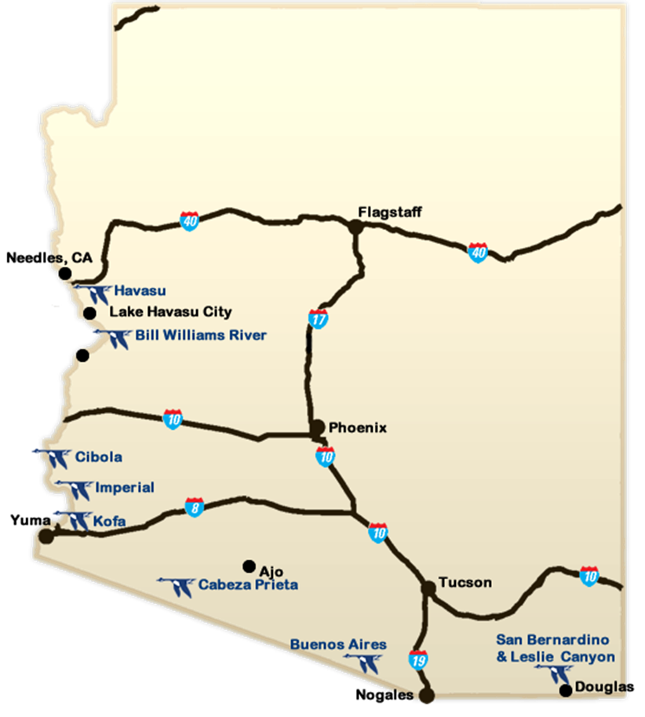

Map 1. National Wildlife Refuges in Arizona

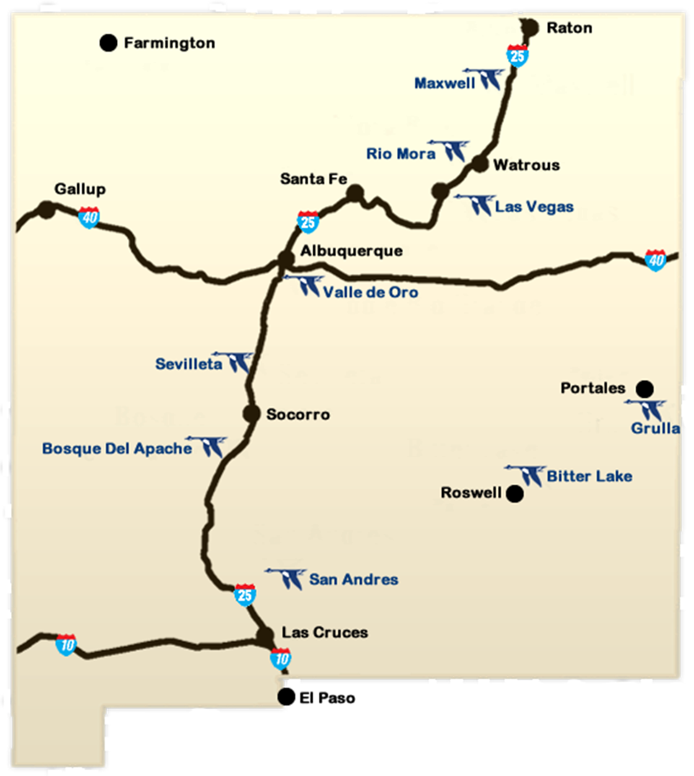

Map 2. National Wildlife Refuges in New Mexico

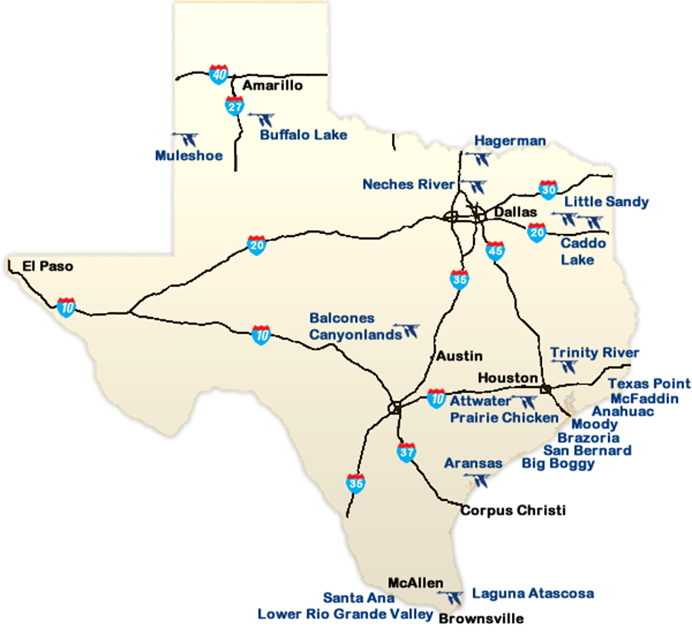

Map 3. National Wildlife Refuges in Texas

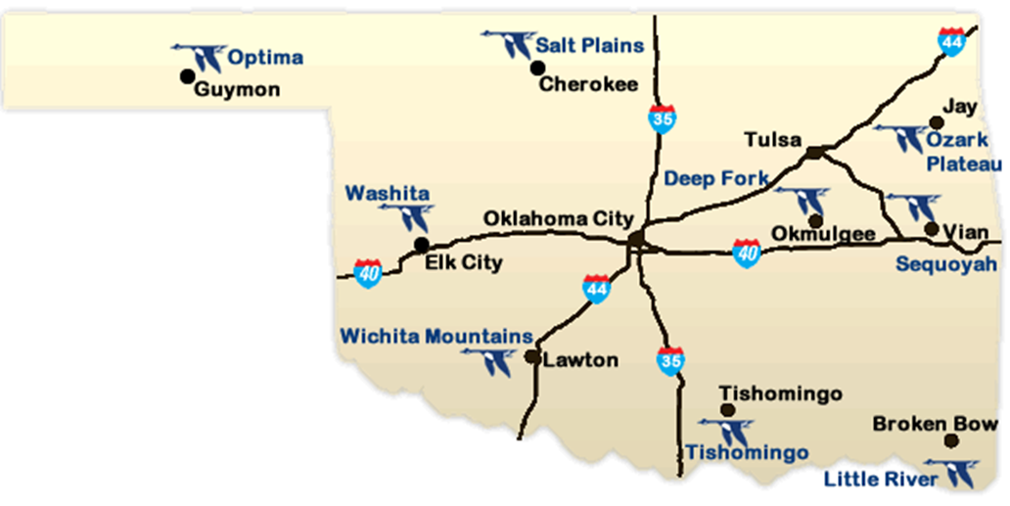

Map 4. National Wildlife Refuges in Oklahoma

D. Budget Form
Complete the Budget Information for Non-Construction Programs (SF 424A) or Budget Information for Construction Programs (SF 424C) form. Use the SF 424A if your project does not include construction and the SF 424C if the project includes construction or land acquisition. The budget forms are available on the Internet at http://www.grants.gov/web/grants/forms/sf-424-family.html#sortby=1. When developing your budget, keep in mind that financial assistance awards and subawards are subject to the Federal cost principles in Title 2 of the Code of Federal Regulations Part 200, as applicable to the recipient organization type. Links to the full text of the Federal cost principles are available on the Internet at http://www.ecfr.gov/.

Note on Multiple Federal Funding Sources: If the project budget includes multiple Federal funding sources, you must show the funds being requested from this Federal program on the budget form separately from any other requested/secured Federal sources of funding. Enter the funds being requested from this Federal program in the first row of the Budget Summary section of the form, and then enter funding related to other Federal programs in the subsequent row(s). Be sure to enter each Federal program’s CFDA number in the corresponding fields on the form. The CFDA number for this Federal program appears on the first page of this funding opportunity.

- Budget Justification
In a separate narrative titled “Budget Justification”, explain and justify all requested budget items/costs. Detail how the SF 424 Budget Object Class Category totals were determined and demonstrate a clear connection between costs and the proposed project activities. For personnel salary costs, include the base-line salary figures and the estimates of time (as percentages) to be directly charged to the project. Describe any item that under the applicable Federal cost principles requires the Service’s approval and estimate its cost.

Required Indirect Cost Statement: Recipients that do not have an approved indirect cost rate cannot charge indirect costs to their Federal award. All applicants except individuals applying for funds separate from a business or non-profit organization he/she may operate must include in the budget justification narrative one of the following statements and attach to their application any required documentation identified in the applicable statement:

“We are:
- A non-profit organization that has previously negotiated or currently has an approved indirect cost rate with our cognizant agency. Our indirect cost rate is 43.9%. A copy of our current, approved rate agreement(s) is attached.
All applicants are hereby notified of the following:
- Recipients without an approved indirect cost rate are prohibited from charging indirect costs to a Federal award. Accepting a flat de minimis rate as a condition of award is an approved rate.
- Failure to establish an approved rate during the award period renders all costs otherwise allocable as indirect costs unallowable under the award.
- Recipients may not charge to their Service award any indirect costs calculated against the portion of total direct project costs paid by any other Federal funding source or non-Federal partner.
- Recipients must have prior written approval from the Service to transfer unallowable indirect costs to amounts budgeted for direct costs or to satisfy cost-sharing or matching requirements under the award.
- Recipients are prohibited from shifting unallowable indirect costs to another Federal award unless specifically authorized to do so by legislation.

Applicants who are individuals applying for funds separate from a business or non-profit organization he/she may operate are not eligible to charge indirect costs to their award. If you are an individual applying for funding, do not include any indirect costs in your proposed budget.

For more information on indirect cost rates, see the Service’s Indirect Costs and Negotiated Indirect Cost Rate Agreements guidance document on the Internet at https://www.fws.gov/grants/atc.html.

Negotiating an Indirect Cost Rate with the Department of the Interior: Entities that do not have a NICRA must first have an open, active Federal award before they can submit an indirect cost rate proposal to their cognizant agency. The Federal awarding agency that provides the largest amount of direct funding to your organization is your cognizant agency, unless otherwise assigned by the White House Office of Management and Budget (OMB). If the Department of the Interior is your cognizant agency, your indirect cost rate will be negotiated by the Interior Business Center (IBC). For more information, contact the IBC at:

Indirect Cost Services
Acquisition Services Directorate, Interior Business Center
U.S. Department of the Interior
650 Capitol Mall, Suite 7-400
Sacramento, CA 95814
Phone: 916-930-3803
Email: Through https://www.doi.gov/ibc/contactus/ibcfeedback web form
Internet address: https://www.doi.gov/ibc/services/finance/indirect-cost-services

F. Single Audit Reporting Statements: As required in Title 2 of the Code of Federal Regulations Part 200, Subpart F, all U.S. states, local governments, federally-recognized Indian tribal governments, and non-profit organizations expending $750,000 USD or more in Federal award funds in a fiscal year must submit a Single Audit report for that year through the Federal Audit Clearinghouse’s Internet Data Entry System. All U.S. state, local government, federally-recognized Indian tribal government and non-profit applicants must provide a statement regarding if your organization was/was not required to submit a Single Audit report for the organization’s most recently closed fiscal year and, if so, state if that report is available on the Federal Audit Clearinghouse Single Audit Database website (https://harvester.census.gov/facweb/) and provide the EIN under which that report was submitted. Include these statements at the end of the Project Narrative in a section titled “Single Audit Reporting Statements”.

G. Assurances: Include the appropriate signed and dated Assurances form available at http://www.grants.gov/web/grants/forms/sf-424-family.html#sortby=1. Use the Assurances for Construction Programs (SF 424D) for construction and land acquisition projects. Use the Assurances for Non-Construction Programs (SF 424B) for all other projects. The form includes a statement that some of the assurances may not be applicable to your organization and/or your project or program. Signing this form does not make you or your organization subject to laws that are otherwise not applicable to you or your organization. Changing, crossing out, or making notations on the form before signing has no impact on the applicability of law.

- Certification and Disclosure of Lobbying Activities: Under Title 31 of the United States Code, Section 1352, an applicant or recipient must not use any federally appropriated funds (both annually appropriated and continuing appropriations) or matching funds under a grant or cooperative agreement award to pay any person for lobbying in connection with the award. Lobbying is defined as influencing or attempting to influence an officer or employee of any agency, a Member of Congress, an officer or employee of Congress, or an employee of a Member of Congress connection with the award. Submission of an application also represents the applicant’s certification of the statements in 43 CFR Part 18, Appendix A-Certification Regarding Lobbying. If you/your organization have/has made or agrees to make any payment using non-appropriated funds for lobbying in connection with this proposal AND the Federal share exceeds $100,000, complete and submit the SF LLL, Disclosure of Lobbying Activities form available at http://www.grants.gov/web/grants/forms/post-award-reporting-forms.html#sortby=1. See 43 CFR, Subpart 18.100 for more information on when additional submission of this form is required.

- Conflict of Interest Disclosures: Applicants must notify the Service in writing of any actual or potential conflicts of interest that are known at the time of application or that may arise during the life of this award, in the event an award is made. Conflicts of interest include any relationship or matter which might place the recipient, the recipient’s employees, or the recipient’s subrecipients in a position of conflict, real or apparent, between their responsibilities under the award and any other outside interests. Conflicts of interest may also include, but are not limited to, direct or indirect financial interests, close personal relationships, positions of trust in outside organizations, consideration of future employment arrangements with a different organization, or decision-making affecting the award that would cause a reasonable person with knowledge of the relevant facts to question the impartiality of the applicant, the applicant’s employees, or the applicant’s future subrecipients in the matter. Upon receipt of such a notice, the Service Project Officer in consultation with their Ethics Counselor will determine if a conflict of interest exists and, if so, if there are any possible actions to be taken by the applicant to reduce or resolve the conflict. Failure to resolve conflicts of interest in a manner that satisfies the Service may result in the project not being select for funding.

- Required Overlap/Duplication Statement: Applicants must provide a statement that addresses if there is any overlap between the proposed project and any other active or anticipated projects in terms of activities, costs, or time commitment of key personnel. If any overlap exists, applicants must provide a description of the overlap in their application. Applicants must also state if the proposal submitted for consideration under this program is/is not in any way duplicative of any proposal that was/will be submitted for funding consideration to any other potential funding source (Federal or non-Federal). If such a circumstance exists, applicants must detail when the other duplicative proposal(s) were submitted, to whom (entity name and program), and when funding decisions are expected to be announced. If at any time a proposal is awarded funds that would be duplicative of the funding requested from the Service, applicants must notify the Service point of contact for this funding opportunity immediately.

Application Checklist
- Evidence of non-profit status: If a non-profit organization, a copy of their Section 501(c)(3) or (4) status determination letter received from the Internal Revenue Service.
- SF 424, Application for Federal Assistance: A complete, signed and dated SF 424 form.
- Project summary
- Project narrative
- Timetable
- Description of key personnel qualifications
- Single Audit Reporting statement: If a U.S. state, local government, federally-recognized Indian tribal government, or non-profit organization, statements regarding applicability of and compliance with Single Audit reporting requirements.
- SF 424 budget form: A complete SF 424A or SF 424C Budget Information form.
- Budget justification
- Indirect cost statement
- NICRA: When applicable, a copy of the organization’s current Negotiated Indirect Cost Rate Agreement.
- SF 424 Assurances form: Signed and dated SF 424B or SF 424D Assurances form.
- SF LLL form: If applicable, completed SF-LLL Disclosure of Lobbying Activities form.
- Conflict of Interest disclosure, when applicable.
- Overlap/Duplication statement

Failure to provide complete information may cause delays, postponement, or rejection of the application.

V. Submission Instructions
SUBMISSION DEADLINE: March 7, 2017, by 4 p.m. MST

Intergovernmental Review: Before submitting an application, U.S. state and local government applicants should visit the following website (http://www.whitehouse.gov/omb/grants_spoc/) to determine whether their application is subject to the state intergovernmental review process under Executive Order (E.O.) 12372 “Intergovernmental review of Federal Programs.” E.O. 12372 was issued to foster the intergovernmental partnership and strengthen federalism by relying on state and local processes for the coordination and review of proposed Federal financial assistance and direct Federal development. The E.O. allows each state to designate an entity to perform this function. The official list of designated entities is posted on the website. Contact your state’s designated entity for more information on the process the state requires to be followed when applying for assistance. States that do not have a designated entity listed on the website have chosen not to participate in the review process.

Download the Application Package linked to this Funding Opportunity on Grants.gov to begin the application process. Downloading and saving the Application Package to your computer makes the required government-wide standard forms fillable and printable. Completed applications may be submitted by mail, by email, electronically through Grants.gov, or as otherwise described in the Grants.gov funding opportunity. Please select ONE of the submission options:

To submit an application by mail:
Number all pages of your printed application. Mail one, single-sided, unbound copy (do not staple or otherwise permanently bind pages) of your complete application to the Service program point of contact identified in the Grants.gov funding opportunity.

The required SF 424 Application for Federal Assistance and Assurances forms and any other required standard forms MUST be signed by your organization’s authorized official. The Signature and Date fields on the standard forms downloaded from Grants.gov are pre-populated with the text “Completed by Grants.gov upon submission” or “Completed on submission to Grants.gov”. Remove this text (manually or digitally) before signing the forms.

To submit an application by e-mail:
Format all of your documents to print on Letter size (8 ½” x 11”) paper. Format all pages to display and print page numbers. Scanned documents should be scanned in Letter format, as black and white images only. Where possible, save scanned documents in .pdf format. E-mail your application to the Service program point of contact identified in the Grants.gov funding opportunity.

The required SF 424 Application for Federal Assistance and Assurances forms and any other required standard forms MUST be signed by your organization’s authorized official. The Signature and Date fields on the standard forms downloaded from Grants.gov are pre-populated with the text “Completed by Grants.gov upon submission” or “Completed on submission to Grants.gov”. Remove this text (manually or digitally) before signing the forms.

To submit an application through Grants.gov:
Go to the Grants.gov Apply for Grants page (http://www.grants.gov/web/grants/applicants/apply-for-grants.html) for an overview of the process to apply through Grants.gov. You/your organization must complete the Grants.gov registration process before submitting an application through Grants.gov. Registration can take between 3-5 business days, or as long as 2 weeks if all steps are not completed in a timely manner.

Important note on Grants.gov application attachment file names: Please do not assign application attachments file names longer than 20 characters, including spaces. Assigning file names longer than 20 characters will create issues in the automatic interface between Grants.gov and the Service’s financial assistance management system.

VI. Application Review Information
Criteria: To be considered for funding, applications must address all of the activities and stipulations listed in Section I – Description of Funding Opportunity and the Application Checklist. Well qualified applicants capable of completing all listed project activities in an efficient manner will receive higher scores.

These scores are not the sole determining factor for final funding decisions. Other review criteria include:
- Relevant experience – Relative level of experience with these kinds of work activities in the ecosystem types of the 4 identified states (AZ, NM, TX and OK). This applies not only to organizational experience, but experience levels of individual workers (crew members and interns).
- Crew size – cost/crew member/week will affect the amount of work that can be completed with the funds available under the Cooperative Agreement. This will be considered when evaluating proposals.
- Positive track record with the Service based on previous financial support, if applicable, including timely submission of financial and performance reports and a summary of major activities and accomplishments of previous Service support in the Statement of Need section.
- Adequate available resources – demonstrated adequate and available resources to carry out the proposed activities will be considered when evaluating proposals
- Technical merit – demonstration that the plan for carrying out the proposed activities is well-reasoned, well-organized, technically sound, scientifically based, and based on a sound rationale will be considered when evaluating proposals
- Societal benefit - What is the potential for the proposed activity to benefit society or advance desired societal outcomes?

Review and Selection Process:
Discretionary programs issuing single source and/or competitive awards must establish a written merit review and selection process following the requirements in Department policy DOI-AAAP-0009, Financial Assistance Application and Merit Review Process.

1) Applications will be reviewed and evaluated by qualified reviewers, including the Service’s Project Officer;
2) Applications will be scored and selected based on announced criteria;
3) Consideration will be given to applicant risk and past performance;
4) Competitive applications will be ranked; and
5) Funding determinations will be made.

The evaluation plan will be comprised of five basic elements: (1) merit review factors and sub-factors; (2) a rating system for competitive applications (e.g., adjectival, color coding, numerical, or ordinal); (3) evaluation standards or descriptions which explain the basis for assignment of the various rating system grades/scores; (4) program policy factors; and (5) the basis for selection.

Prior to participating in any review or evaluation process, all staff and peer reviewers, evaluators, panel members, and advisors must sign and return to the program office point of contact the “Department of the Interior Conflict of Interest Certification” form. For a copy of this form, contact the Service point of contact identified in the Agency Contacts section below.

Prior to award, the Service reviews the selected applicant’s statement regarding potential overlap or duplication in terms of activities, funding, or time commitment of key personnel and makes a determination regarding Service funding. Depending on the circumstances, modification of the application, other pending applications, or an active award may be necessary, or the Service might choose to not fund the proposed project.

Each fiscal year, for every entity receiving one or more awards in that fiscal year, the Service conducts a risk assessment based on eight risk categories. The result of this risk assessment is used to establish a monitoring plan for all awards to the entity in that fiscal year. For a copy of the Service’s risk assessment form, go to https://www.fws.gov/grants/atc.html.

Prior to approving an award with a Federal funding amount that exceeds or is expected to exceed the simplified acquisition threshold, as adjusted (see 2 CFR 200.88), the Service must review and consider any information about the applicant that is in the designated integrity and performance system accessible through SAM (currently FAPIIS; https://www.fapiis.gov/fapiis/index.action) to determine if, at a minimum, the information found in the system for the applicant demonstrates a satisfactory record of Federal award performance and integrity and business ethics (see 2 CFR 200.205(a)(2)). The Service must also report to FAPIIS if an applicant subject to this review is found not qualified for a particular award due to its prior record of integrity or performance under Federal awards (see 2 CFR 200.212).

VII. Award Administration
Award Notices: Following review, applicants may be requested to revise the project scope and/or budget before an award is made. Successful applicants will receive written notice in the form of a notice of award document. Notices of award are typically sent to recipients by e-mail. If e-mail notification is unsuccessful, the documents will be sent by courier mail (e.g., FedEx, DHL or UPS). Award recipients are not required to sign/return the Notice of Award document. Acceptance of an award is defined as starting work, drawing down funds, or accepting the award via electronic means. Awards are based on the application submitted to, and as approved by, the Service. The notice of award document will include instructions specific to each recipient on how to request payment. If applicable, the instructions will detail any additional information/forms required and where to submit payment requests. Applicants whose projects are not selected for funding will receive written notice, most often by e-mail, within 30 days of the final review decision.

Domestic Recipient Payments: Prior to award, the Service program office will contact you/your organization to either enroll in the U.S. Treasury’s Automated Standard Application for Payments (ASAP) system or, if eligible, obtain approval from the Department of the Interior to be waived from using ASAP.

Domestic applicants subject to the SAM registration requirement (see Section III B.) who receive a waiver from receiving funds through ASAP must maintain current banking information in SAM. Domestic applicants exempt from the SAM registration requirement who receive a waiver from receiving funds through ASAP will be required to submit their banking information directly to the Service program. However, do NOT submit any banking information to the Service until it is requested from you by the Service program!

The Notice of Award document from the Service will include instructions specific to each recipient on how to request payment. If applicable, the instructions will detail any additional information/forms required and where to submit payment requests.

Transmittal of Sensitive Data: Recipients are responsible for ensuring any sensitive data being sent to the Service is protected during its transmission/delivery. The Service strongly recommends that recipients use the most secure transmission/delivery method available. The Service recommends the following digital transmission methods: secure digital faxing; encrypted emails; emailing a password protected zipped/compressed file attachment in one email followed by the password in a second email; or emailing a zipped/compressed file attachment. The Service strongly encourages recipients sending sensitive data in paper copy to use a courier mail service. Recipients may also contact their Service Project Officer and provide any sensitive data over the telephone.

Award Terms and Conditions: Acceptance of a financial assistance award (i.e., grant or cooperative agreement) from the Service carries with it the responsibility to be aware of and comply with the terms and conditions applicable to the award. Acceptance is defined as the start of work, drawing down funds, or accepting the award via electronic means. Awards are based on the application submitted to and approved by the Service and are subject to the terms and conditions incorporated into the notice of award either by direct citation or by reference to the following: Federal regulations; program legislation or regulation; and special award terms and conditions. The Service’s Standard Award Terms and Conditions are available on the Internet at https://www.fws.gov/grants/atc.html. If you do not have access to the Internet and require a full text copy of the award terms and conditions, contact the Service point of contact identified in the Agency Contacts section below.

Recipient Reporting Requirements:
Financial and Performance Reports:
Final Reports: Recipients are required to submit final financial and performance reports no later than 90 calendar days after the award period of performance end date or termination date, whichever comes first. For awards lasting 12 months or less, the final reports will be the only financial and performance reports required, except in unusual circumstances or if waived.

Interim Reports: For awards that last longer than 12 months, recipients are required to submit interim financial and performance reports no less frequently than annually and no more frequently than quarterly, except in unusual circumstances or if waived. Requiring a higher frequency of reporting than annual reporting will be based on the Service’s assessment of higher or other unusual circumstance. Quarterly and semiannual interim reports are due within 30 calendar days of the reporting period end date. Annual interim reports are due within 90 calendar days of the reporting period end date.

Recipients must use the Standard Form 425, Federal Financial Report for financial reporting, available on the Internet at http://www.grants.gov/web/grants/forms/post-award-reporting-forms.html#sortby=1.

Performance reports must contain: 1) a comparison of actual accomplishments with the goals and objectives of the award as detailed in the approved scope of work; 2) a description of reasons why established goals were not met, if appropriate; and 3) any other pertinent information relevant to the project results.

Significant Developments Reports: Events may occur between the scheduled performance reporting dates that have significant impact upon the supported activity. In such cases, recipients are required to notify the Service in writing as soon as the following types of conditions become known:
- Problems, delays, or adverse conditions that will materially impair the ability to meet the objective of the Federal award. This disclosure must include a statement of any corrective action(s) taken or contemplated, and any assistance needed to resolve the situation.
- Favorable developments that enable meeting time schedules and objectives sooner or at less cost than anticipated or producing more or different beneficial results than originally planned.

The Service will specify in the notice of award document the reporting and reporting frequency applicable to the award.

Conflict of Interest Disclosures: Recipients are responsible for notifying the Service Project Officer in writing of any actual or potential conflicts of interest that may arise during the life of this award. Conflicts of interest include any relationship or matter which might place the recipient, the recipient’s employees, or the recipient’s subrecipients in a position of conflict, real or apparent, between their responsibilities under this award and any other outside interests. Conflicts of interest may also include, but are not limited to, direct or indirect financial interests, close personal relationships, positions of trust in outside organizations, consideration of future employment arrangements with a different organization, or decision-making affecting the award that would cause a reasonable person with knowledge of the relevant facts to question the impartiality of the Recipient, the Recipient’s employees, or the Recipient’s subrecipients in the matter. Upon receipt of such a notice, the Service Project Officer in consultation with their Ethics Counselor will determine if a conflict of interest exists and, if so, if there are any possible actions to be taken by the Recipient, the Recipient’s employee(s), or the Recipient’s Subrecipient(s) that could reduce or resolve the conflict. Failure to resolve conflicts of interest in a manner that satisfies the Service may result in any of the remedies described in 2 CFR 200.338, Remedies for Noncompliance, including termination of this award.

Other Mandatory Disclosures: The non-Federal entity or applicant for a Federal award must disclose, in a timely manner, in writing to the Federal awarding agency or pass-through entity all violations of Federal criminal law involving fraud, bribery, or gratuity violations potentially affecting the Federal award. Non-Federal entities that have received a Federal award including the term and condition outlined in 2 CFR 200, Appendix XII—Award Term and Condition for Recipient Integrity and Performance Matters are required to report certain civil, criminal, or administrative proceedings to SAM. Failure to make required disclosures can result in any of the remedies described in 2 CFR 200.338 Remedies for noncompliance, including suspension or debarment. (See also 2 CFR Part 180, 31 U.S.C. 3321, and 41 U.S.C. 2313.)

2 CFR Part 200, Appendix XII—Award Term and Condition for Recipient Integrity and Performance Matters is applicable to awards with a total Federal share of more than $500,000, except those to individuals and foreign public entities.

VIII. Agency Contacts
Heather Whitlaw
Regional Invasive Species Program Coordinator
Wichita Mountains WR
32 Refuge Headquarters Rd.
Indiahoma, OK 73552
(580) 429-2128
heather_whitlaw@fws.gov

