CRNBAA14-001

INTRODUCTION:

This publication constitutes a Broad Agency Announcement (BAA) as contemplated in Federal Acquisition Regulation (FAR) 6.102(d)(2) and 35.016, the Department of Defense Grants and Agreements regulations (DoDGARS) 22.315(a) and DoD‟s Other Transaction Guide for Prototypes Projects, USD(AT&L), OT Guide, Jan 2001. A formal Request for Proposals (RFP), solicitation, and/or additional information regarding this announcement will not be issued.

Naval Surface Warfare Center (NSWC) Crane will not issue paper copies of this announcement. NSWC Crane reserves the right to select for award all some or none of the proposals in response to this announcement. Crane reserves the right to fund all, some or none of the proposals received under this BAA. Crane provides no funding for direct reimbursement of proposal development costs. Technical and cost proposals (or any other material) submitted in response to this BAA will not be returned. All proposals will be treated as sensitive competitive information and to disclose their contents only for the purposes of evaluation.

- GENERAL INFORMATION

1. Agency Name

Naval Surface Warfare Center Crane Division
300 HWY 361
Crane, IN 47522

2. Research Opportunity Number CRNBAA14-001

3. Response Date

Full Proposal Due: May 22, 2014 15:00 Eastern Daylight Time

4. Business and Technical Point of Contact:

Brittany Lyons
Code CXNL BLDG. 64
Naval Surface Warfare Center Crane Division
300 HWY 361
Crane, IN 47522
Email: brittany.s.lyons@navy.mil

5. Basic Research Opportunity Titles

* TOF-SIMS Analysis Techniques for Trace Detection of Semiconductor Fabrication Process Contamination
* Black Box Hardware State Machine Characterization - An Undecidable Problem?
* Towards more secure transportable media solutions
* Exploration of Defense-Related Implications of Time-Varying Nuclear Decay Parameters
* Radiation Effects in Memristive Structures
6. Research Opportunity Descriptions

Naval Surface Warfare Center, Crane Division is interested in receiving proposals for the development of novel solutions/concepts to the areas of interest listed below:
- TOF-SIMS Analysis Techniques for Trace Detection of Semiconductor Fabrication Process Contamination
A key aspect of NSWC Crane’s mission is to ensure the integrity and reliability of microelectronics in DoD systems. In order to carry out its mission, NSWC Crane conducts electrical characterization and evaluation on a multitude of microelectronics which range from ASICs to solid state memory devices to analog devices and mixed signal devices. NSWC Crane supports in the development of new microelectronics as well as sustains a myriad of fielded microelectronics through part surveillance and lot acceptance testing. NSWC Crane also conducts root cause failure analysis on field failures of microelectronics. Failure analysis is critical to assessment of system reliability and impact to DOD programs. As semiconductor device feature sizes shrink and device complexity grows the ability to conduct root cause analysis becomes increasingly more difficult, which requires greater precision and sophistication of the failure analysis tools to be used.
One such tool is a Time of Flight Secondary Ion Mass Spectrometry (TOF-SIMS). TOF-SIMS is capable of performing surface spectroscopy, surface imaging, depth profiling, and 3D analysis[1].
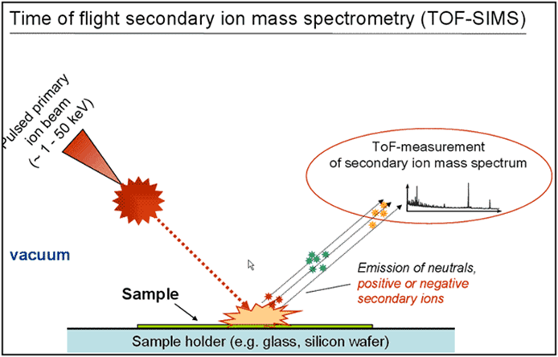
Figure 1. In TOF-SIMS sputtered material from the sample surface is captured and undergoes chemical, isotopic, and elemental analysis.
With this grant from NSWC Crane, the awardee can develop analytical techniques using TOF-SIMS to explore the feasibility of detecting semiconductor fabrication contaminants in Commercial off the Shelf (COTS) semiconductor devices. The ability to detect trace amounts of contaminants unique to particular manufacturer’s devices would have significantly aid NSWC Crane’s ability to assesses the reliability of microelectronics to be used in DoD systems. Test samples could be supplied by NSWC Crane for analysis.

- Black Box Hardware State Machine Characterization - An Undecidable Problem?

Naval Surface Warfare Center, Crane Division is interested in basic research into new techniques that will be utilized to evaluate hardware based state machines [1] for unknown and/or unstable states.
Harrison, Ruzzo and Ullman [2] discussed whether there is an algorithm that takes an arbitrary initial configuration and answers the following question: is there an arbitrary sequence of commands that adds a generic right into a cell of the access matrix where it has not been in the initial configuration? They showed that there is no such algorithm, thus the problem is undecidable in the general case. They also showed a limitation of the model to commands with only one primitive operation to render the problem decidable.
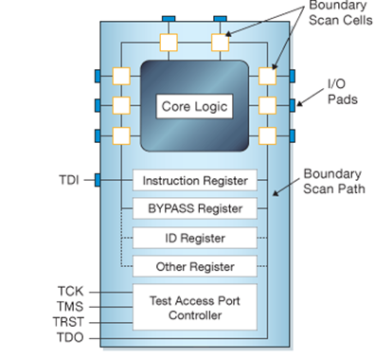
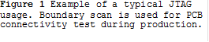
One common use of state machines in hardware is an IEEE 1149.1 JTAG controller [3]. This five signal (TDI, TCK, TMS, TRST and TDO) interface (fig. 1) is used to support manufacturing, production and system test. Boundary scan is used for PCB connectivity test during production. While the IEEE 1149.1 specifies specific modes, such as “BYPASS” and “IDCODE”, it also allows user defined modes. These custom modes are often proprietary manufacturer’s test or control modes that are undocumented.
The IEEE 1149.1 JTAG state machine (fig. 2) utilizes a data and instruction flow path.

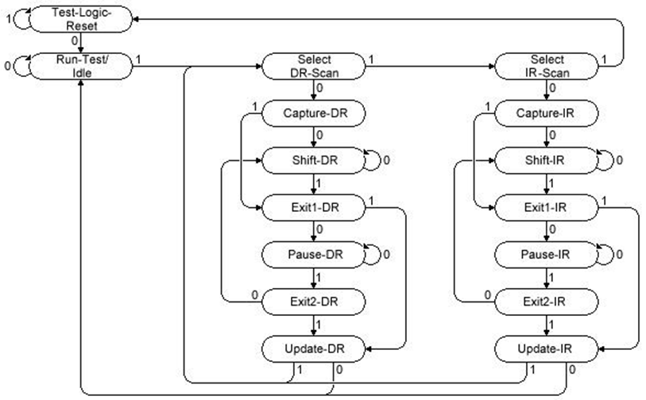
Figure 2 IEEE 1149.1 JTAG state machine flow diagram.
A JTAG state machine is used for the purpose of this discussion because there is much open source information in the hacker community including exploits on iPhones and Xbox game controllers. Renowned hacker, Joe Grand demonstrated such capability (fig. 3) at DEFCON [4].
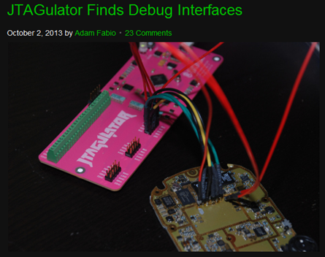
Figure 3 The idea is simple: Connect the JTAGulator to the test points on the PCB under test, issue a few commands via a serial terminal, and let the JTAGulator do the rest. It performs a brute force approach on every permutation of pins, issuing basic JTAG commands – either IDCODE or BYPASS, and looking for a response. If any valid responses are received, the JTAGulator displays the found interface’s pinout.
With this grant from NSWC Crane, the awardee would investigate black box and white machines. While a JTAG state machine was discussed, the awardee could use other common hardware such as routers or switches. NSWC Crane engineers could prepare FPGA based state machines for experimentation if requested

- Towards more secure transportable media solutions
Naval Surface Warfare Center, Crane Division is interested in receiving proposals for the development of concepts for transportable media. Commodity COTS offerings are largely flash memory-based or bare optical media. We seek concepts that offer security properties that address confidentiality, integrity, and availability. Abstracted, given a system named Alice, a system named Bob, and media called Carol, we seek concepts that address, but are not limited to, the following situations:
A malicious entity, Mallory, gains access to Carol or attempts to spoof Carol.
(1) How can Alice or Bob safely interact with Carol?
(2) How can we foil attempts for Mallory to gain information from Carol?
(3) What if Mallory has access to Alice or Bob, but can only access these systems though the transportable media interface?
We prioritize solutions that are COTS-based.

- EXPLORATION OF DEFENSE-RELATED IMPLICATIONS OF TIME-VARYING NUCLEAR DECAY PARAMETERS
A broad scale search for better (i.e. more sensitive) isotopes capable of responding to changes in the flux of incoming neutrinos. To date we have focused on data obtained from a limited number of isotopes, such as Mn-54, Cl-36, Ra-226, and Sr-90. There are hundreds of radioactive isotopes which could be even better as sensitive neutrino detectors. An estimate for detector system including the radioactive source, detector, and associated computer would cost approximately $10K. An ideal experiment would have several sites running at the same time.
The intent of this research is to establish that these neutrino detectors can detect reactor neutrinos, including neutrinos emitted by nuclear powered ships. Several units described above could be used for this purpose.

- Radiation Effects in Memristive Structures

Naval Surface Warfare Center, Crane Division is interested in basic radiation effects research into new technologies that will be utilized in future non-volatile memories. One such new technology is referred to as memristors. Memristors are a new, developing technology that utilizes the electrical hysteretic property of memresitance as seen in Figure 1. These devices are simple structures as seen in Figure 2 [1]. The memristor structure shown in Figure 2 is a TiO2 based memristor. It is believed that density and movement of oxygen vacancies is responsible for the memristive effects observed in these structures. Other materials such as chaclogenides have been used for memristors as well.

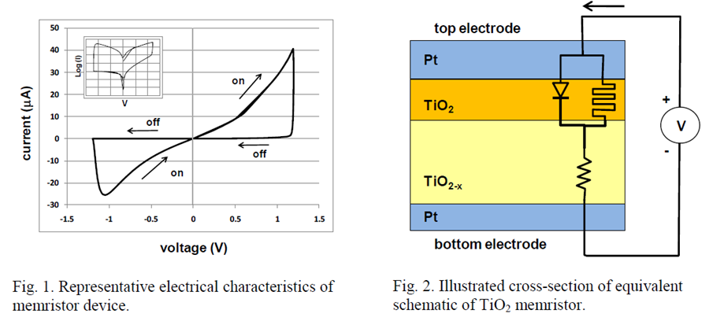
[1] H. Barnaby,etc.

These memristor structures have enormous potential to one day be used in non-volatile memories. However, in order for these structures to be used in high-radiation environments such as those seen in DoD space and missile systems, an understanding of their response to ionizing radiation is needed. At the current time, little is known about radiation effects in newer memristor materials and test structures. We hope that the efforts funded by this microgrant will provide some insights into basic radiation effect mechanisms in memristors.

- AWARD INFORMATION

The Government may make multiple awards. The amount of resources made available to this BAA will depend on the quality of the proposals received and the availability of funds.
The Government reserves the right to select for negotiation all, some, one, or none of the proposals received in response to this solicitation and to make awards without discussions with proposers. The Government also reserves the right to conduct discussions if later determined to be necessary. Proposals identified for negotiation may result in a procurement contract or other transaction depending upon the nature of the work proposed, the required degree of interaction between parties, and other factors. Proposers should note that the required degree of interaction between parties will be to the maximum extent possible as allowed by the contractual vehicle. The Government reserves the right to request any additional necessary documentation once it makes the award instrument determination. Such additional information may include but is not limited to Representations and Certifications. The Government reserves the right to remove proposers from award consideration should the parties fail to reach agreement on award terms, conditions, and cost/price within a reasonable time or the proposer fails to timely provide requested additional information.

Technical Proposal
a. Content. The technical proposal must convey an understanding of the problems or limitations of the general technology area and the intended application(s). The technical proposal shall include the following items.

(1) Executive Summary: Describe the proposed program, objectives, and approach. A description of the innovation and benefits of the proposed approach and relationship to previous efforts should be discussed. It should summarize the technical issues addressed by the offeror’s proposal without repeating the requirements. This should provide a vision of what will ultimately be achieved and what solution this effort will produce.

(2) Program Description: Describe the techniques, methods, materials, or ideas that will be addressed in this proposal, their innovation, and to what degree they advance the state-of-the-art.

(3) Program Plan: Describe in detail the planned approach and how the plan will be executed. This section should include all technical aspects of the approach. Provide technical detail and analysis necessary to support the technical approach proposed. Clearly identify the core of the intended approach. The “new and creative” solution to the problem(s) should be developed and analyzed in this section. Include a risk assessment of key technical, schedule or cost areas and their potential impact on the program. Identify why proposed subcontractors were selected and what tasks they are to perform.

(4) Contractor’s Statement of Work (C-SOW):
(A) The C-SOW, a stand-alone document, should detail the research to be accomplished under the technical area and should be suitable for incorporation into the awarded document. The proposed C-SOW should summarize the technical methodology and the task description, but not to the extent to make the awarded instrument inflexible. Do not include any proprietary information in the C-SOW. Contractors may request copies of our contracts under the Freedom Of Information Act. Consequently, it is imperative that no company-sensitive information be included in the C-SOW. The C-SOW should include the anticipated deliverables (hardware, software, reports, etc.).

(B) The following is offered as a recommended format for the C-SOW. The C-SOW should be structured in three sections; Scope, Applicable Documents, And Requirements.

SCOPE: This section includes a statement of what the program covers. This should include the technology area to be investigated, objectives/goals, and major milestones for the effort. It defines the breadth and limitations of the work to be done.

APPLICABLE DOCUMENTS: This section includes reference documents needed to identify or clarify the work to be performed.

REQUIREMENTS: This section identifies the specific work to be performed. The work effort should be arranged into major tasks and identified in separately numbered paragraphs. Each numbered major task should delineate by subtask the work to be performed and should follow an outline numbering scheme. The C-SOW must identify all reviews and when/where (identify by milestone or task) that will be conducted. It must also identify any and all items (hardware, software, reports, etc.) to be delivered to the Government as a result of the program.

(5) Milestone Chart: A Milestone Chart should indicate when specific objectives are expected to be met in the overall program schedule and should identify the specific accomplishments necessary to proceed to the next task. Provide a schedule of when the deliverable items identified in the award are to be delivered.

(6) Facilities and Equipment description: Describe the facilities that can be used to achieve the goals of the program, in terms of manufacturing capability, testing facilities, and/or any relevant specialized equipment.

(7) Description of Relevant Prior Work: Provide a list of related previous or current government, commercial, or internally funded work during the past five years. For each such effort, provide the principal investigator, title of effort, contract number, brief summary of results, dollar value, and a technical and contracting point of contact, including phone numbers, for the funding organizations.

(8) Management Plan: Offerors should provide an approach that demonstrates the ability to effectively and efficiently manage and administer the research program to a successful conclusion.

(9) Resumes of Key Individuals: Include brief summaries of resumes of relevant key individuals including any consultants or subcontractors that might be proposed.
b. Page Limitations. The technical proposal including the C-SOW shall be limited to 30 pages single spaced, double-sided, 8.5 by 11-inch pages. Select an easy to read font no smaller than 12 pitch fixed or proportional font size 10 or larger. Smaller type may be used in figures and tables as long as it is clearly legible. The page limitation includes all information i.e., indices, photographs, foldouts (2 page), appendices, attachments, resumes, C-SOW, etc. Each printed side counts as one page. Blank pages, title pages, tables of content, lists, tabs or cover sheets are not included in the page count. The Government will not consider pages in excess of this limitation.

Cost/Business Proposal
Separate this proposal into a Cost section and a Business section.
a. Cost Section. The cost proposal containing other than cost or pricing data shall be submitted in the format provided in the announcement and is necessary for the Government to perform a cost realism analysis. Adequate price competition is anticipated for each solicitation issued unless stated otherwise in the announcement. A determination as to the existence of adequate price competition will be made by the cognizant Procuring Contracting Officer on a case by case basis. If adequate price competition is determined not to exist, the Government reserves the right to obtain certified cost or pricing data from the offeror. Each solicitation issued will contain the appropriate cost proposal instructions based upon the type of instrument the Government anticipates awarding. Offerors are required to submit the electronic copy of their cost proposal worksheets on a compact disk in a PC compatible file format in Microsoft Office Excel 2003 or later version. The file must contain all cell formulas. Cost proposals have no page limitations but offerors are requested to keep cost proposals to 75 pages as a goal.
b. Business Section. The business section should contain all business aspects to the proposed contractual arrangement, such as type of contract/instrument, any unique terms and conditions, any exceptions to terms and conditions of the announcement or solicitation, and any information not technically related. Provide rationale for exceptions. As a goal, offerors are requested to keep the business section to 20 pages.

- PROPOSAL REVIEW AND EVALUATION PROCEDURES

A. GENERAL.

The Government reserves the right to select for award to responsible offerors.
Contractors any, all, part, or none of the proposals that are received in response to this announcement, subject to the availability of funds. The technical and cost proposals will be evaluated at the same time. You may be ineligible for award if all requirements of this announcement are not met by the proposal due date and time. At minimum, incomplete proposals may be given lower priority and, although technically acceptable, not awarded due to funding limitations. No further evaluation criteria will be used.

B. EVALUATION CRITERIA.

The selection of one or more sources for award will be based on an evaluation of each offeror’s proposal to determine the overall merit of the proposal in response to this announcement. Proposals will be evaluated in accordance with FAR 35.016, Broad Agency Announcement. The proposals will be evaluated utilizing a peer or scientific review process and shall be evaluated based on the following criteria that are listed in “DESCENDING” order of importance:
- Overall scientific and technical merits of the proposal;
- Importance to NSWC programs;
- Fund availability/affordability

Price will be a substantial consideration in selecting proposals for awards, but will be secondary to technical considerations. Cost realism and reasonableness shall also be considered to the extent appropriate. Price will be evaluated and may be negotiated if necessary on proposals selected for award.

C. REVIEW AND SELECTION PROCESS

The technical and cost proposals will be evaluated at the same time and categorized as follows:
1. CATEGORY I: Well-conceived, scientifically and technically sound proposals important to program goals and objectives. Proposals in Category I are recommended for acceptance subject to funding constraints.

2. CATEGORY II: Scientifically or technically sound proposals that may require further development and may be recommended for acceptance, but are at a lower priority than Category I proposals and are not always funded.

3. CATEGORY III: Proposals not technical sound or do not meet agency needs and may be recommended for rejection.

- ELIGIBILITY INFORMATION

All responsible sources from academia and industry may submit proposals under this BAA. Historically Black Colleges and Universities (HBCUs) and Minority Institutions (MIs) are encouraged to submit proposals and join others in submitting proposals. However, no portion of this BAA will be set aside for HBCU and MI participation.

Federally Funded Research & Development Centers (FFRDCs), including Department of Energy National Laboratories, are not eligible to receive awards under this BAA. However, teaming arrangements between FFRDCs and eligible principal bidders are allowed so long as they are permitted under the sponsoring agreement between the Government and the specific FFRDC.

Navy laboratories and warfare centers as well as other Department of Defense and civilian agency laboratories are also not eligible to receive awards under this BAA and should not directly submit either white papers or full proposals in response to this BAA.

Teams are also encouraged and may submit proposals in any and all areas. However, Offerors must be willing to cooperate and exchange software, data and other information in an integrated program with other contractors, as well as with system integrators, selected by NSWC Crane.

Some topics cover export controlled technologies. Research in these areas is limited to “U.S. persons” as defined in the International Traffic in Arms Regulation (ITAR) – 22 CFR § 1201.1 et seq.

For Grant, Cooperative Agreement and Other Transaction Agreement applications:

The Federal Funding Accountability and Transparency Act of 2006 (Public Law 109-282), as amended by Section 6202 of Public Law 110-252, requires that all agencies establish requirements for recipients reporting information on subawards and executive total compensation as codified in 2 CFR 170.110. Any company, non-profit agency or university that applies for financial assistance (either grants, cooperative agreements or other transaction agreements) as either a prime or sub-recipient under this BAA must provide information in their proposal that describes the necessary processes and systems in place to comply with the reporting requirements identified in 2 CFR 170.220 and Appendix A. Entities are exempt from this requirement UNLESS in the preceding fiscal year, it received: a) 80 percent or more of its annual gross revenue in Federal contracts (and subcontracts), loans, grants (and subgrants), and cooperative agreements; b) $25 million or more in annual gross revenue from Federal contracts (and subcontracts), loans, grants (and subgrants), and cooperative agreements; and c) the public does not have access to information about the compensation of the senior executives through periodic reports filed under section 13(a) or 15(d) of the Securities Exchange Act of 1934 or section 6104 of the Internal Revenue Code of 1986.
The offeror must use the Grants.gov forms from the application package template associated with the BAA on the Grants.gov web site located at http://www.grants.gov/. If options are proposed, the cost proposal must provide the pricing information for the option periods; failure to include the proposed costs for the option periods will result in the options not being included in the award. Assume that performance will start no earlier than three (3) months after the date the cost proposal is submitted. A separate Adobe .pdf document should be included in the application that provides appropriate justification and/or supporting documentation for each element of cost proposed.

The following information must be completed as follows in the SF 424 to ensure that the application is directed to the correct individual for review: Block 4a, Federal Identifier: Enter the previous Crane award number, or N00164 if the application is not a renewal or expansion of an existing award; Block 4b, Agency Routing Number: Enter the three (3) digit Program Office Code (i.e., 321) and the Program Officers name, last name first, in brackets (i.e., [Parsley, Dallas]).

Please note that Volume I, Technical Proposal should be submitted as an attachment to the SF 424 rather than being inserted into Block 8, Project Narrative. Block 8 should be completed with a statement that Volume 1 is attached. To attach the Technical Proposal, open the Attachment Form in the Optional Documents box of the application package, scroll down to the Attachment page, and follow the instructions. The file should be titled “Volume I – Technical Proposal.”

V. Submission of Grant Proposals through Grants.gov

(NOT APPLICABLE TO PROPOSALS FOR CONTRACTS, COOPERATIVE AGREEMENTS, AND OTHER TRANSACTION AGREEMENTS)

Detailed instructions entitled “Grants.gov Electronic Application and Submission Information” on how to submit a grant proposal through Grants.gov may be found at the ONR website listed under the „Acquisition Department – Contracts & Grants Submitting a Proposal” link at: http://www.onr.navy.mil/Contracts-Grants/submit-proposal/grants-proposal/grants-gov.aspx.

By completing Block 17, the Grant Applicant is providing the certification on lobbying required by 32 CFR Part 28. Refer to Section VI, “Award Administration Information” entitled “Certifications” for further information.

For electronic submission of grant full proposals, several one-time actions must be completed in order to submit an application through Grants.gov. These include obtaining a Dun and Bradstreet Data Universal Numbering System (DUNS) number, registering with the Central Contract Registration (CCR), registering with the credential provider, and registering with Grants.gov. See http://www.grants.gov, specifically http://www.grants.gov/GetStarted.

Use the Grants.gov organization Registration Checklist at http://www.grants.gov/applicants/register_your_organziation.jsp which will provide guidance through the process. Designating an E-Business Point of Contact (EBiz POC) and obtaining a special password called “MPIN” are important steps in the CCR registration process. Applicants who are not registered with CCR and Grant.gov should allow at least 21 days to complete these requirements. The process should be started as soon as possible. Any questions relating to the registration process, system requirement, how an application form works, or the submittal process must be directed to Grants.gov at 1-800-518-4726 or support@grants.gov.

Special Notices Relative to Grant Applications to be Submitted Through Grants.gov

All attachments to grant applications submitted through Grants.gov must be in Adobe Portable Document Format (i.e., .pdf files). Proposals with attachments submitted in word processing, spreadsheet, or any format other than Adobe Portable Document Format will not be considered for award.

Applicants who have registered with Grants.gov are urged to submit their proposals electronically at least three days before the date and time that proposals are due so that they will not be received late and be ineligible for award consideration.

Proposal Receipt Notices:

After a full proposal is submitted through Grants.gov, the Authorized Organization Representative (AOR) will receive a series of three e-mails. You will know that your proposal has reached Crane when the AOR receives e-mail Number 3. You will need the Submission Receipt Number (e-mail Number 1) to track a submission. The three e-mails are:

Number 1 – The applicant will receive a confirmation page upon completing the submission to Grants.gov.

Number 2 – The applicant will receive an e-mail indicating that the proposal has been validated by Grants.gov within two days of submission (this means that all of the required fields have been completed).

Number 3 – The third notice is an acknowledgement of receipt in e-mail form from NSWC Crane within ten days from the proposal due date, if applicable. The e-mail is sent to the authorized representative for the institution. The e-mail for proposals notes that the proposal has been received and provides the assigned tracking number.

NOTE: PROPOSALS SENT BY FAX, HARD COPY OR E-MAIL WILL NOT BE CONSIDERED. NO HAND DELIVERIES.

- AWARD NOTICES
Offerors will be notified in writing whether or not their proposal is recommended for award. An award recommendation is not to be construed to mean the award of a contract, grant or assistance instrument is assured, as availability of funds and successful negotiations are prerequisites to any award.
- DEBRIEFINGS
When requested, a debriefing will be provided. The debriefing process will follow the time guidelines set out in 10 USC 2305(b)(5), but the debriefing content will vary to be consistent with the procedures set out in FAR 35.016 governing BAAs.
- OTHER INFORMATION

CERTIFICATION REGARDING LOBBYING ACTIVITIES

(1) No Federal appropriated funds have been paid or will be paid by or on behalf of the applicant, to any person for influencing or attempting to influence an officer or employee of an agency, a Member of Congress, an officer or employee of Congress, or an employee of a Member of Congress in connection with the awarding of any Federal contract, the making of any Federal grant, the making of any Federal loan, the entering into of any cooperative agreement, and the extension, continuation, renewal, amendment, or modification of any Federal contract, grant, loan, or cooperative agreement.

(2) If any funds other than Federal appropriated funds have been paid or will be paid to any person for influencing or attempting to influence an officer or employee of any agency, a Member of Congress, an officer or employee of Congress, or an employee of a Member of Congress in connection with the Federal contract, grant, loan, or cooperative agreement, the applicant shall complete and submit Standard Form-LLL, “Disclosure Form to Report Lobbying,” in accordance with its instructions.

(3) The applicant shall require that the language of this certification be included in the award documents for all subawards at all tiers (including subcontracts, subgrants, and contracts under grants, loans, and cooperative agreements) and that all subrecipients shall certify and disclose accordingly.

This certification is a material representation of fact upon which reliance was placed when this transaction was made or entered into. Submission of this certification is a prerequisite for making or entering into this transaction imposed by Section 1352, title 31, U.S.C. Any person who fails to file the required certification shall be subject to a civil penalty of not less than $10,000 and not more than $100,000 for each such failure.

Organizational Conflicts of Interest

All Offerors and proposed subcontractors must affirm whether they are providing scientific, engineering, and technical assistance (SETA) or similar support to any NSWC Crane technical office(s) through an active contract or subcontract. All affirmations must state which office(s) the offeror supports and identify the prime contract numbers. Affirmations shall be furnished at the time of proposal submission. All facts relevant to the existence or potential existence of organizational conflicts of interest (FAR 9.5) must be disclosed. The disclosure shall include a description of the action the offeror has taken or proposes to take to avoid, neutralize, or mitigate such conflict. In accordance with FAR 9.503 and without prior approval, a contractor cannot simultaneously be a SETA and a research and development performer. Proposals that fail to fully disclose potential conflicts of interests or do not have acceptable plans to mitigate identified conflicts will be rejected without technical evaluation and withdrawn from further consideration for award. If a prospective offeror believes that any conflict of interest exists or may exist (whether organizational or otherwise), the offeror should promptly raise the issue with NSWC Crane by sending his/her contact information and a summary of the potential conflict by e-mail to the Business Point of Contact in Section I, item 7 above, before time and effort are expended in preparing a proposal and mitigation plan. If, in the sole opinion of the Contracting Officer after full consideration of the circumstances, any conflict situation cannot be effectively avoided or mitigated, the proposal may be rejected without technical evaluation and withdrawn from further consideration for award under this BAA

Executive Compensation and First-Tier Subcontract Reporting

Section 2(d) of the Federal Funding Accountability and Transparency Act of 2006 (Pub. L. No. 109-282), as amended by section 6202 of the Government Funding Transparency Act of 2008 (Pub. L. 110-252), requires the Contractor to report information on subcontract awards. The law requires all reported information be made public, therefore, the Contractor is responsible for notifying its subcontractors that the required information will be made public.

Unless otherwise directed by the Contracting Officer, by the end of the month following the month of award of a first-tier subcontract with a value of $25,000 or more, (and any modifications to these subcontracts that change previously reported data), the Contractor shall report the following information at http://www.fsrs.gov for each first-tier subcontract:

(a) Unique identifier (DUNS Number) for the subcontractor receiving the award and for the subcontractor‟s parent company, if the subcontractor has one.

(b) Name of the subcontractor.

(c) Amount of the subcontract award.

(d) Date of the subcontract award.

(e) A description of the products or services (including construction) being provided under the subcontract, including the overall purpose and expected outcomes or results of the subcontract.

(f) Subcontract number (the subcontract number assigned by the Contractor).

(g) Subcontractor‟s physical address including street address, city, state, and country. Also include the nine-digit zip code and congressional district.

(h) Subcontractor‟s primary performance location including street address, city, state, and country. Also include the nine-digit zip code and congressional district.

(i) The prime contract number, and order number if applicable.

(j) Awarding agency name and code.

(k) Funding agency name and code.

(l) Government contracting office code.

(m) Treasury account symbol (TAS) as reported in FPDS.

(n) The applicable North American Industry Classification System (NAICS) code.

By the end of the month following the month of a contract award, and annually thereafter, the Contractor shall report the names and total compensation of each of the five most highly compensated executives for the Contractor‟s preceding completed fiscal year at http://www.ccr.gov, if –

(a) In the Contractor‟s preceding fiscal year, the Contractor received –

(i) 80 percent or more of its annual gross revenues from Federal contracts (and subcontracts), loans, grants (and subgrants) and cooperative agreements; and

(ii) $25,000,000 or more in annual gross revenues from Federal contracts (and subcontracts), loans, grants (and subgrants) and cooperative agreements; and

(b) The public does not have access to information about the compensation of the executives through periodic reports filed under section 13(a) or 15(d) of the Securities Exchange Act of 1934 (15 U.S.C. 78m(a), 78o(d)) or section 6104 of the Internal Revenue Code of 1986. (To determine if the public has access to the compensation information, see the U.S. Security and Exchange Commission total compensation filings at http://www.sec.gov/answers/execomp.htm.).

Unless otherwise directed by the Contracting Officer, by the end of the month following the month of a first-tier subcontract with a value of $25,000 or more, and annually thereafter, the Contractor shall report the names and total compensation of each of the five most highly compensated executives for each first-tier subcontractor for the subcontractor‟s preceding completed fiscal year at http://www.fsrs.gov, if –

(a) In the subcontractor‟s preceding fiscal year, the subcontractor received –

(i) 80 percent or more of its annual gross revenues from Federal contracts (and subcontracts), loans, grants (and subgrants) and cooperative agreements; and

(ii) $25,000,000 or more in annual gross revenues from Federal contracts (and subcontracts), loans, grants (and subgrants) and cooperative agreements; and

(b) The public does not have access to information about the compensation of the executives through periodic reports filed under section 13(a) or 15(d) of the Securities Exchange Act of 1934 (15 U.S.C. 78m(a), 78o(d)) or section 6104 of the Internal Revenue Code of 1986. (To determine if the public has access to the compensation information, see the U.S. Security and Exchange Commission total compensation filings at http://www.sec.gov/answers/execomp.htm.).

If the Contractor in the previous tax year had gross income, from all sources, under $300,000, the Contractor is exempt from the requirement to report subcontractor awards. Likewise, if a subcontractor in the previous tax year had gross income from all sources under $300,000, the Contractor does not need to report awards to that subcontractor.

