U.S. Fish and Wildlife Service
Refuges Division, Valle de Oro National Wildlife Refuge

Riparian Playa Wetland Revegetation Project - Rio Grande Return
Catalog of Federal Domestic Assistance (CFDA) Number: 15.654

Notice of Funding Opportunity

I. Description of Funding Opportunity
This is a single-source funding opportunity to create a habitat restoration project and community outreach project at Valle de Oro National Wildlife Refuge (NWR) in Bernalillo County, New Mexico, which will result in increased access to native riparian and playa landscapes for migratory birds and trail and interpretive feature construction which will provide wellness and educational benefits for local residents living in the South Valley area of the county. The project will revegetate native riparian and playa wetlands on the Valle de Oro NWR and the adjacent New Mexico State Lands property along the Rio Grande. This will be funded under CFDA statue 15.654. This project is authorized under Fish and Wildlife Conservation Act, 16 U.S.C. §§2901-2911; Fish and Wildlife Act, 16 U.S.C. 742 et seq.; Refuge Recreation Act, 16 U.S.C. §§460k-460k(4); National Wildlife Refuge System Administration Act, 16 U.S.C. §§668dd-ee; Public Lands Corps Act - Youth Conservation Corps, 16 U.S.C. §§1701-1706; Public Lands Corps Act - Public Lands Corps, 16 U.S.C. §§1721-1726; Archaeological Resources Protection Act, 16 U.S.C. §§470aa-ll; and Federal Aid for Highways-Other Highways, 23 U.S.C. §§201-204 and §206. The objectives under this authorization are: To provide technical and financial assistance to identify, conserve, manage and enhance the physical and ecological infrastructure of the NWR System; deliver public access and high-quality outdoor recreational opportunities; build a volunteer cadre, and inspire the next generation of hunters, anglers and wildlife enthusiasts through work on and off NWR System managed lands and waters.

II. Award Information
There will be one single-source cooperative agreement awarded for $80,000 beginning July 31, 2018, and ending September 30, 2019, to the Rio Grande Return. This cooperative agreement is part of the Albuquerque Community Engagements and Partnership funding provided by the Service’s Valle de Oro NWR to enhance community relations, outreach, and environmental education in the Albuquerque metropolitan area in coordination with partners.

The Service will be substantially and fully involved in projects under this funding opportunity. Specifically, the Service will coordinate regularly with Rio Grande Return regarding project benchmarks including 1) the U.S. Fish and Wildlife Service (Service) Refuge Manager, Deputy Refuge Manager and Service Biologist will provide habitat and species information to be used as reference material for this project; 2) refuge staff involvement in the planning and harvesting process and 3) refuge staff will be involved in the planting process. The Recipient, Rio Grande Return, will ultimately be responsible for managing the project budget, assigning duties within the project, purchasing needed vegetation, overseeing that all projects are accomplished on time, and coordinating with the refuge on accomplishments and collaborative efforts.

III. Basic Eligibility Requirements
Eligible Applicants:
This cooperative agreement is reserved for Rio Grande Return. Rio Grande Return is a U.S. non-profit, non-governmental organization with a 501 (c)(3) status. U.S. non-profit, non-governmental organizations with 501(c)(3) Internal Revenue Status (IRS) must provide a copy of their status determination letter received by from the IRS.

Federal law mandates that all entities applying for Federal financial assistance must have a valid Dun & Bradstreet Data Universal Number System (DUNS) number and have a current registration in the System for Award Management (SAM). See Title 2 of the Code of Federal Regulations (CFR), Part 25 for more information. Exemptions: The SAM registration requirement does not apply to individuals submitting an application on their own behalf and not on behalf of a company or other for-profit entity, state, local or Tribal government, academia or other type of organization.

- DUNS Registration
Request a DUNS number at http://fedgov.dnb.com/webform. For technical difficulties, contact Dun & Bradstreet by email at: govt@dnb.com, or by calling the Government Customer Resource Center at voice phone: 866-705-5711 or TTY line: 877-807-1679 (hearing impaired customers only). Once assigned a DUNS number, entities are responsible for maintaining up-to-date information with Dun & Bradstreet.

- Entity Registration in SAM
Register in SAM at www.sam.gov. Once registered in SAM, entities must renew and revalidate their SAM registration at least every 12 months from the date previously registered. Entities are strongly urged to revalidate their registration as often as needed to ensure that their information is up to date and in synch with changes that may have been made to DUNS and IRS information. Foreign entities who wish to be paid directly to a United States bank account must enter and maintain valid and current banking information in SAM.

Note: The official U.S. government website address for SAM is www.sam.gov. There is NO COST to register in or access SAM.gov. There are third-party vendors who charge a fee in exchange for registering entities in SAM; please be aware that you can register to do business with the U.S. government FOR FREE directly in SAM at www.sam.gov.

- Excluded Entities
Applicant entities or their key project personnel identified in the SAM.gov Exclusions database as ineligible, prohibited/restricted or excluded from receiving Federal contracts, certain subcontracts, and certain Federal assistance and benefits will not be considered for Federal funding, as applicable to the funding being requested under this Federal program. The Service conducts a review of the SAM.gov Exclusions database for all applicant entities and their key project personnel prior to award.

- Cost Sharing or Matching: Cost sharing is not required for this cooperative agreement.

IV. Application Requirements
To be considered for funding under this funding opportunity, an application must contain:

- A completed, signed and dated Application for Federal Assistance form (SF-424, SF-424A, SF-424B, SF-424C, and SF-424D). Do not include other Federal sources of funding, requested or approved, in the total entered in the “Federal” funding box on the Application for Federal Assistance form. Enter only the amount being requested under this program in the “Federal” funding box. Include any other Federal sources of funding in the total funding entered in the “Other” box.

B. Project Summary
Riparian Playa Wetlands Revegetation Project: This agreement will focus on native riparian re-vegetation on the Valle del Oro NWR and adjacent New Mexico State Lands Office (NMSLO) property along the Rio Grande in the South Valley area of Bernalillo County, New Mexico. Valle de Oro NWR and the NMSLO have signed a memorandum of agreement that will allow Valle de Oro NWR visitors access to the NMSLO lands property along the Rio Grande.

The revegetation project will create a habitat-restoration project and community-outreach project at Valle de Oro NWR, which will result in increased access to native riparian landscapes for migratory birds and trail and interpretive feature construction which will provide wellness and educational benefits for local residents living in the South Valley community in the county. The project highlights the strong partnership between Federal and State agencies, with the common goals of land stewardship and conserving natural resources. The re-vegetation will consist of the planting on cottonwood poles, willow poles, and riparian forage species on NMSLO property. Approximately 1,500 cottonwood poles and 15,000 coyote willows will be planted on NMSLO property.

Additionally, native riparian re-vegetation will occur at the riparian areas immediately adjacent to Wetland Unit 1 and 5 on the Valle de Oro NWR. Plantings will consist of 1,500 cottonwood poles, 300 Gooding willow poles and 10,000 willow poles. Wetland grass plugs will also be planted in the wetland unit, which will consist of 60 trays (98 plug per tray) of wetland grass plugs purchased from Santa Ana (Bernalillo, New Mexico) Pueblo Nursery, and wetland plugs harvested from Bosque del Apache NWR. Additionally, wetland grass seeding will assist in the development the herbaceous component of the wetland. Poles will be harvested from the Bosque del Apache NWR and from the Los Lunas (New Mexico) Plant Materials Center, and wetland plugs and riparian container species will be acquired from the Santa Ana Pueblo Nursery, and Bosque del Apache NWR. Project will be completed in by August 2019.

C. Project Narrative

- Statement of Need: This project is necessary for the enhancement and restoration of sites that focus on addressing key species and habitats, improving water quality for watersheds and enhancing, restoring or improving management of land and natural resources. It provides environmental outreach, education, and training. The outreach engages the public in the outdoor conservation experience that builds awareness of the importance of protecting and recovering priority species and habitats while promoting stewardship. The experienced restoration team from Rio Grande Return will be working alongside the biologists, ecologists, and hydrologists from the Service, volunteers from the Friends of the Valle de Oro, and crew from Youth Conservation Corps (YCC). The volunteers and YCC will learn about the historic Rio Grande ecosystem and the present-day challenges of restoring sustainable wetland habitat. They will also learn about the plants and techniques necessary in reestablishing the native habitats within the historic floodplain of the new refuge. The inclusiveness and collaborative spirit that has been central to the Valle de Oro NWR since its inception, will be modeled by the diverse public/private partnerships and volunteers involved in the hands on implementation of this restoration project.

The Rio Grande is an important migratory, wintering and nesting corridor that supports over 200,000 waterfowl, 18,000 Greater Sandhill Cranes, and tens of thousands of other waterbirds and shorebirds. To date, over 93 percent of the historic wetland and riparian habitats of the Rio Grande have been lost. The Valle de Oro NWR is being developed on some of the last undeveloped land left within the Rio Grande’s historic floodplain in Bernalillo County.

Rio Grande Return is part of an extraordinary vision shared by our Federal and State delegates, the Service, New Mexico Department of Game & Fish, Bernalillo County, and a host of other agencies and organizations who understand the importance of preserving the environmental integrity and cultural heritage of the Rio Grande. There have been political, financial, and programmatic challenges and barriers all along the way. No single individual, governmental agency, or non-profit organization could have been successful in planning and developing this new refuge. Valle de Oro NWR is being actualized only because of the diverse public/private partnerships that have joined together in a shared commitment to preserving New Mexico’s most important natural and cultural resource, the Rio Grande.

2. Project Goals and Objectives: The goal of this project is to revegetate native riparian and playa habitat for migratory and resident species, mammals, insects, reptiles and amphibians and conservation education at Valle de Oro NWR and the NMSLO property near the Rio Grande. This will help support nature-based programs and recreation at the refuge and the NMSLO property. The revegetation of native riparian habitat helps set the standard for the sustainable use of resources and energy conservation, and promotes biological diversity through day-to-day decisions and actions at the refuge and adjacent state property. Planning would include meetings and coordination with agencies, partners, neighborhoods, and groups much in the fashion of refuge planning operations.

The Rio Grande Return restoration team, YCC, and volunteers will be the first beneficiaries of this program. As habitats on the refuge increase to better match their diversity once seen in the Middle Rio Grande, resident and migratory wildlife diversity will increase and benefit from the newly restored playa wetlands. This will be followed by the tens of thousands of visitors who will find education and inspiration from the restored playa wetlands and associated wildlife. This NWR has been envisioned, and is now being realized through a powerful collaboration of dedicated individuals, agencies, and organizations that cut across political, cultural and socioeconomic barriers because of a shared sense of place and responsibility. The Valle de Oro NWR is located in a predominantly Hispanic and lower socioeconomic part of Albuquerque known as the South Valley. It is also just north of the Pueblo of Isleta. The Valle de Oro NWR is a unique wildlife refuge that recognizes community engagement and environmental protection go hand in hand.

3. Project Activities, Methods and Timetable:

Purchase wetland seed plugs; hire labor and operators for project jobs | Cooperative Agreement | Rio Grande Return | Spring/Summer 2018
Harvest woody and herbaceous plant material from Bosque de Apache NWR and Los Lunas Plant Materials Center | Cooperative Agreement | Rio Grande Return | Spring/Summer 2018
Plant harvested and purchased plant material at Valle de Oro NWR and NMSLO property | Cooperative Agreement | Rio Grande Return | Summer/Fall 2018
Project Methods | Unit Cost/Hourly Rates |  | VDO Cooperative Funding
Project Coordinator | 280 hrs @ $65.00/hr. |  | $14,550
Manual Labor-Restoration Staff | 2,000 hrs. @ $25.00/hr. |  | $25,000
Machine Operator (1) | 200 hrs. @ $48.00/hr. |  | $9,600
Manual Labor-YCC Crewmembers | 3,000 hrs.@15.00/hr.
Machine Operator and Biologist (2) | 200 hrs. @$65.00/hr. |  | $13,000
Volunteer Labor | 600hrs. @$21.79
Small Excavator Rental (2) | $3,400/month |  | $3,900
Auger Bits | $1,200/each
Auger Rental | $500/month
Gas for Machinery |  |  | $1,250
Equipment and Material Transportation |  |  | $3,500
Pier Diem | 20 days @ 85.00/day |  | $1,700
Wetland Grass Seed | $20/lbs
Wetland Seed Plugs | 60 trays @$250/per tray |  | $7,500
Total |  |  | $80,000

4. Stakeholder Coordination/Involvement: Rio Grande Return will work with Federal and State agencies, partners, neighborhoods and community groups to complete the projects.

5. Project Monitoring and Evaluation: The project will be monitored and evaluated utilizing a final Project Accomplishment report, which will be provided on August 31, 2019. Rio Grande Return and Valle de Oro NWR staff will tour restoration sites together to make sure the project objectives have been satisfied. In the following spring of 2019, Rio Grande Return and Valle de Oro NWR staff will tour the restoration sites again in order to monitor the success of the revegetation efforts from the previous year. If the mortality rate of any of the plantings is less than 50 percent, Rio Grande Return and the refuge staff will together make plans to do additional restoration as needed.

6. Description of Entities Undertaking the Project: The Rio Grande Return restoration team has implemented dozens of successful wetland restoration and enhancement projects throughout the state. Their experienced crews have a thorough understanding of the biology and hydrology of New Mexico’s unique wetland ecosystems. Alan Hamilton Ph.D., the Executive Director of Rio Grande Return, has been working for the past 4 years as the State Wetlands Coordinator for Ducks Unlimited and the New Mexico Department of Game and Fish. Alan will be coordinating and providing project oversight and will make sure that all the outcomes and objectives are achieved. He can be reached at 505-670-2621, or by email at Alan@riograndereturn.com.

Service manager and project lead will be Jennifer Owen-White, Valle de Oro NWR, (505) 933-2798, or by email at jennifer_owenwhite@fws.gov. Jennifer focuses on refuge management and the importance of integrating community health with land and natural resource stewardship.

The experienced restoration team from Rio Grande Return will be working alongside the biologists, ecologists, and hydrologists from the Service, volunteers from the Friends of the Valle de Oro, and crew from YCC. The volunteers and YCC will learn about the historic Rio Grande ecosystem and the present-day challenges of restoring sustainable wetland habitat. They will also learn about the plants and techniques necessary in reestablishing the native habitats within the historic floodplain of the new refuge. The inclusiveness and collaborative spirit that has been central to the Valle de Oro NWR since its inception, will be modeled by the diverse public/private partnerships and volunteers involved in the hands on implementation of this restoration project.

7. Sustainability: This project sustainability is contingent on future funding. Rio Grande Return and Valle de Oro NWR staff will tour with restoration sites together to make sure the project objectives have been satisfied. In the following spring of 2019, Rio Grande Return and Valle de Oro NWR staff will tour the restoration sites again in order to monitor the success of the revegetation efforts from the previous year. If the mortality rate of any of the plantings is less than 50 percent, Rio Grande Return and the refuge staff will together make plans to do additional restoration as needed.

8. Literature Cited: N/A

9. Map of Project Area: See following page for image of Valle de Oro NWR and NMSLO property.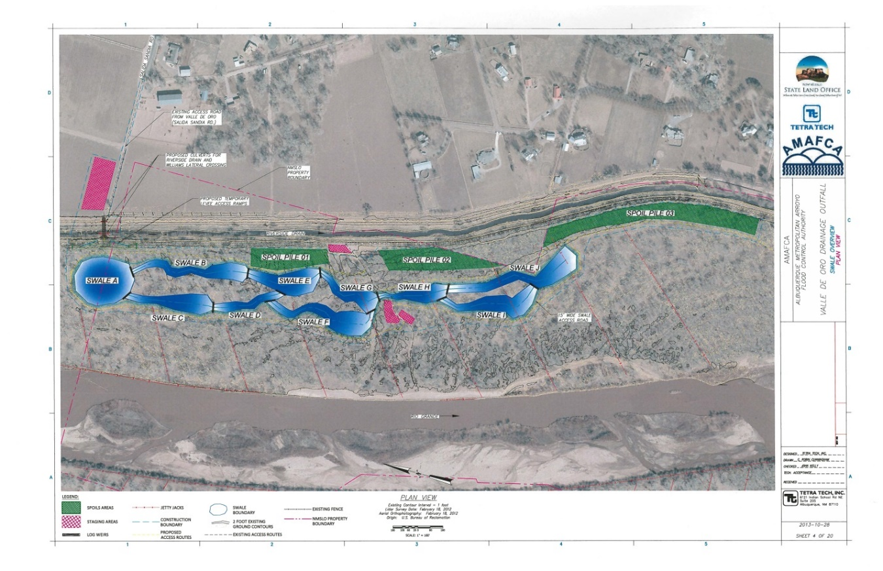

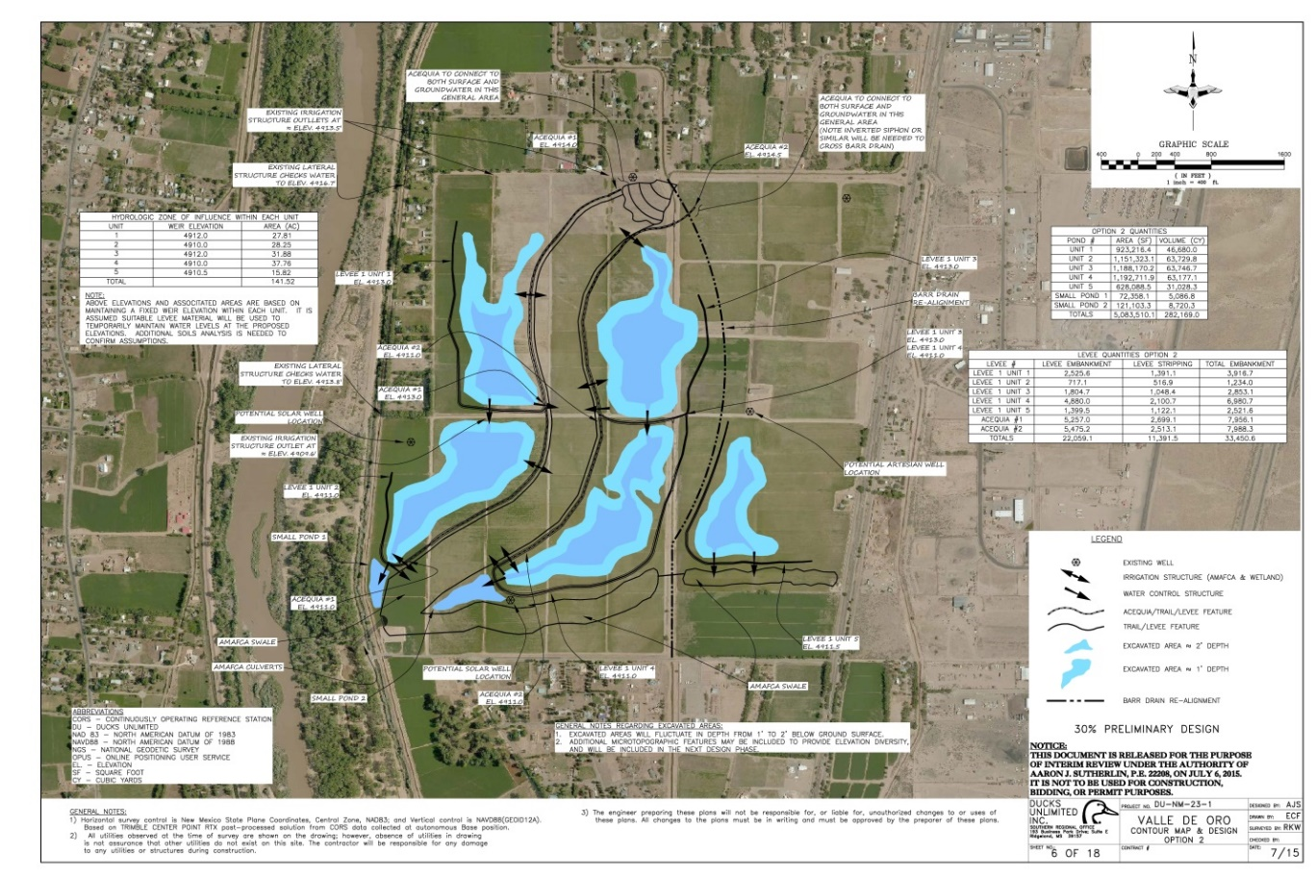

D. Budget Form
Complete the Budget Information for Non-Construction Programs (SF 424A) or Budget Information for Construction Programs (SF 424C) form. Use the SF 424A if your project does not include construction and the SF 424C if the project includes construction or land acquisition. The budget forms are available on the Internet at http://www.grants.gov/web/grants/forms/sf-424-family.html#sortby=1. When developing your budget, keep in mind that financial assistance awards and subawards are subject to the Federal cost principles in Title 2 of the Code of Federal Regulations Part 200, as applicable to the recipient organization type. Links to the full text of the Federal cost principles are available on the Internet at http://www.ecfr.gov/.

Note on Multiple Federal Funding Sources: If the project budget includes multiple Federal funding sources, you must show the funds being requested from this Federal program on the budget form separately from any other requested/secured Federal sources of funding. Enter the funds being requested from this Federal program in the first row of the Budget Summary section of the form, and then enter funding related to other Federal programs in the subsequent row(s). Be sure to enter each Federal program’s CFDA number in the corresponding fields on the form. The CFDA number for this Federal program appears on the first page of this funding opportunity.

- Budget Justification
In a separate narrative titled “Budget Justification”, explain and justify all requested budget items/costs. Detail how the SF 424 Budget Object Class Category totals were determined and demonstrate a clear connection between costs and the proposed project activities. For personnel salary costs, include the base-line salary figures and the estimates of time (as percentages) to be directly charged to the project. Describe any item that under the applicable Federal cost principles requires the Service’s approval and estimate its cost.

If Federally-funded equipment will be used for the project, provide a list of that equipment, including the Federal funding source.

Required Indirect Cost Statement: Recipients that do not have an approved indirect cost rate cannot charge indirect costs to their Federal award. All applicants except individuals applying for funds separate from a business or non-profit organization he/she may operate must include in the budget justification narrative one of the following statements and attach to their application any required documentation identified in the applicable statement:

“We are:
- A [insert your organization type; U.S. states and local governments, please use one of the statements above or below] that has previously negotiated or currently has an approved indirect cost rate with our cognizant agency. Our indirect cost rate is [insert rate]. [Insert either: “A copy of our most recently approved but expired rate agreement is attached. In the event an award is made, we will submit an indirect cost rate proposal to our cognizant agency within 90 calendar days after the award is made.” or “A copy of our current, approved rate agreement(s) is attached.”]

- A [insert your organization type] that has never submitted an indirect cost rate proposal to our cognizant agency. Our indirect cost rate is [insert rate]. In the event an award is made, we will submit an indirect cost rate proposal to our cognizant agency within 90 calendar days after the award is made.
- A [insert your organization type] that has never submitted an indirect cost rate proposal to our cognizant agency and has an indirect cost rate that is lower than 10%. Our indirect cost rate is [insert rate; must be lower than 10%]. However, in the event an award is made, we will not be able to meet the requirement to submit an indirect cost rate proposal to our cognizant agency within 90 calendar days after award. We request as a condition of award to charge a flat indirect cost rate of [insert rate; must be lower than 10%] of [insert a clear description of the direct cost base against which your rate is charged (e.g., salaries; salaries and fringe benefits; or modified total direct costs). However, please note that your organization cannot charge indirect costs in excess of the indirect costs that would be recovered if applied against modified total direct costs as defined in 2 CFR 220.68. We understand that we must notify the Service in writing immediately if we establish an approved rate with our cognizant agency at any point during the award period.
- A [insert your organization type] that has never submitted an indirect cost rate proposal to our cognizant agency and has an indirect cost rate that is 10% or higher. Our indirect cost rate is [insert your organization’s indirect rate; must be 10% or higher]. However, in the event an award is made, we will not be able to meet the requirement to submit an indirect cost rate proposal to our cognizant agency within 90 calendar days after award. We request as a condition of award to charge a flat de minimis indirect cost rate of 10% of modified total direct costs as defined in 2 CFR 200.68. We understand that we must notify the Service in writing immediately if we do establish an approved rate with our cognizant agency at any point during the award period. We understand that additional Federal funds may not be available to support an unexpected increase in indirect costs during the project period and such changes are subject to review, negotiation, and prior approval by the Service.
- A [insert your organization type] that will charge all costs directly.

All applicants are hereby notified of the following:
- Recipients without an approved indirect cost rate are prohibited from charging indirect costs to a Federal award. Accepting a flat de minimis rate as a condition of award is an approved rate.
- Failure to establish an approved rate during the award period renders all costs otherwise allocable as indirect costs unallowable under the award.
- Recipients may not charge to their Service award any indirect costs calculated against the portion of total direct project costs paid by any other Federal funding source or non-Federal partner.
- Recipients must have prior written approval from the Service to transfer unallowable indirect costs to amounts budgeted for direct costs or to satisfy cost-sharing or matching requirements under the award.
- Recipients are prohibited from shifting unallowable indirect costs to another Federal award unless specifically authorized to do so by legislation.

Applicants who are individuals applying for funds separate from a business or non-profit organization he/she may operate are not eligible to charge indirect costs to their award. If you are an individual applying for funding, do not include any indirect costs in your proposed budget.

For more information on indirect cost rates, see the Service’s Indirect Costs and Negotiated Indirect Cost Rate Agreements guidance document on the Internet at https://www.fws.gov/grants/atc.html.

Negotiating an Indirect Cost Rate with the Department of the Interior: Entities that do not have a NICRA must first have an open, active Federal award before they can submit an indirect cost rate proposal to their cognizant agency. The Federal awarding agency that provides the largest amount of direct funding to your organization is your cognizant agency, unless otherwise assigned by the White House Office of Management and Budget (OMB). If the Department of the Interior is your cognizant agency, your indirect cost rate will be negotiated by the Interior Business Center (IBC). For more information, contact the IBC at:

Indirect Cost Services
Acquisition Services Directorate, Interior Business Center
U.S. Department of the Interior
650 Capitol Mall, Suite 7-400
Sacramento, CA 95814
Phone: 916-930-3803
Email: Through https://www.doi.gov/ibc/contactus/ibcfeedback web form
Internet address: https://www.doi.gov/ibc/services/finance/indirect-cost-services

F. Single Audit Reporting Statements: As required in Title 2 of the Code of Federal Regulations Part 200, Subpart F, all U.S. states, local governments, federally-recognized Indian tribal governments, and non-profit organizations expending $750,000 USD or more in Federal award funds in a fiscal year must submit a Single Audit report for that year through the Federal Audit Clearinghouse’s Internet Data Entry System. All U.S. state, local government, federally-recognized Indian tribal government and non-profit applicants must provide a statement regarding if your organization was/was not required to submit a Single Audit report for the organization’s most recently closed fiscal year and, if so, state if that report is available on the Federal Audit Clearinghouse Single Audit Database website (https://harvester.census.gov/facweb/) and provide the EIN under which that report was submitted. Include these statements at the end of the Project Narrative in a section titled “Single Audit Reporting Statements”.

G. Assurances: Include the appropriate signed and dated Assurances form available at http://www.grants.gov/web/grants/forms/sf-424-family.html#sortby=1. Use the Assurances for Construction Programs (SF 424D) for construction and land acquisition projects. Use the Assurances for Non-Construction Programs (SF 424B) for all other projects. The form includes a statement that some of the assurances may not be applicable to your organization and/or your project or program. Signing this form does not make you or your organization subject to laws that are otherwise not applicable to you or your organization. Changing, crossing out, or making notations on the form before signing has no impact on the applicability of law.

- Certification and Disclosure of Lobbying Activities: Under Title 31 of the United States Code, Section 1352, an applicant or recipient must not use any federally appropriated funds (both annually appropriated and continuing appropriations) or matching funds under a grant or cooperative agreement award to pay any person for lobbying in connection with the award. Lobbying is defined as influencing or attempting to influence an officer or employee of any agency, a Member of Congress, an officer or employee of Congress, or an employee of a Member of Congress connection with the award. Submission of an application also represents the applicant’s certification of the statements in 43 CFR Part 18, Appendix A-Certification Regarding Lobbying. If you/your organization have/has made or agrees to make any payment using non-appropriated funds for lobbying in connection with this proposal AND the Federal share exceeds $100,000, complete and submit the SF LLL, Disclosure of Lobbying Activities form available at http://www.grants.gov/web/grants/forms/post-award-reporting-forms.html#sortby=1. See 43 CFR, Subpart 18.100 for more information on when additional submission of this form is required.

- Conflict of Interest Disclosures: Applicants must notify the Service in writing of any actual or potential conflicts of interest that are known at the time of application or that may arise during the life of this award, in the event an award is made. Conflicts of interest include any relationship or matter which might place the recipient, the recipient’s employees, or the recipient’s subrecipients in a position of conflict, real or apparent, between their responsibilities under the award and any other outside interests. Conflicts of interest may also include, but are not limited to, direct or indirect financial interests, close personal relationships, positions of trust in outside organizations, consideration of future employment arrangements with a different organization, or decision-making affecting the award that would cause a reasonable person with knowledge of the relevant facts to question the impartiality of the applicant, the applicant’s employees, or the applicant’s future subrecipients in the matter. Applicants must notify the Service in writing in their application if any key project personnel, including subrecipient and contractor personnel, are known to be related to, married to, or have a close personal relationship with any Federal employee in or associated with the program to which you are applying for funding or who otherwise may be involved in the review and selection of the application. Upon receipt of such a notice, the Service program, in consultation with their Ethics Counselor, will determine if a conflict of interest exists and, if so, if there are any possible actions to be taken by the applicant to reduce or resolve the conflict. Failure to disclose and resolve conflicts of interest in a manner that satisfies the Service may result in the project not being select for funding.

- Required Overlap/Duplication Statement: Applicants must provide a statement that addresses if there is any overlap between the proposed project and any other active or anticipated projects in terms of activities, costs, or time commitment of key personnel. If any overlap exists, applicants must provide a description of the overlap in their application. Applicants must also state if the proposal submitted for consideration under this program is/is not in any way duplicative of any proposal that was/will be submitted for funding consideration to any other potential funding source (Federal or non-Federal). If such a circumstance exists, applicants must detail when the other duplicative proposal(s) were submitted, to whom (entity name and program), and when funding decisions are expected to be announced. If at any time a proposal is awarded funds that would be duplicative of the funding requested from the Service, applicants must notify the Service point of contact for this funding opportunity immediately.

Application Checklist
- Evidence of non-profit status: If a non-profit organization, a copy of their Section 501(c)(3) or (4) status determination letter received from the Internal Revenue Service.
- SF 424, Application for Federal Assistance: A complete, signed and dated SF 424, SF 424-Mandatory, or SF 424-Individual form.
- Project summary
- Project narrative
- Timetable
- Description of key personnel qualifications
- Single Audit Reporting statement: If a U.S. state, local government, federally-recognized Indian tribal government, or non-profit organization, statements regarding applicability of and compliance with Single Audit reporting requirements.
- SF 424 budget form: A complete SF 424A or SF 424C Budget Information form.
- Budget justification
- Federally-funded equipment list: If Federally-funded equipment will be used for the project, a list of that equipment.
- Indirect cost statement
- NICRA: When applicable, a copy of the organization’s current Negotiated Indirect Cost Rate Agreement.
- SF 424 Assurances form: Signed and dated SF 424B or SF 424D Assurances form.
- SF LLL form: If applicable, completed SF-LLL Disclosure of Lobbying Activities form.
- Conflict of Interest disclosure, when applicable.
- Overlap/Duplication statement

Failure to provide complete information may cause delays, postponement, or rejection of the application.

V. Submission Instructions
SUBMISSION DEADLINE: Friday, June 15, 2018, by 4 p.m. MDT

Intergovernmental Review: Before submitting an application, U.S. state and local government applicants should visit the following website (https://obamawhitehouse.archives.gov/omb/grants_spoc) to determine whether their application is subject to the state intergovernmental review process under Executive Order (E.O.) 12372 “Intergovernmental review of Federal Programs.” E.O. 12372 was issued to foster the intergovernmental partnership and strengthen federalism by relying on state and local processes for the coordination and review of proposed Federal financial assistance and direct Federal development. The E.O. allows each state to designate an entity to perform this function. The official list of designated entities is posted on the website. Contact your state’s designated entity for more information on the process the state requires to be followed when applying for assistance. States that do not have a designated entity listed on the website have chosen not to participate in the review process.

Download the Application Package linked to this Funding Opportunity on Grants.gov to begin the application process. Downloading and saving the Application Package to your computer makes the required government-wide standard forms fillable and printable. Completed applications may be submitted by mail, by email, electronically through Grants.gov, or as otherwise described in the Grants.gov funding opportunity.

To submit an application by e-mail:
Format all of your documents to print on Letter size (8 ½” x 11”) paper. Format all pages to display and print page numbers. Scanned documents should be scanned in Letter format, as black and white images only. Where possible, save scanned documents in .pdf format. E-mail your application to the Service program point of contact identified in the Grants.gov funding opportunity.

The required SF 424 Application for Federal Assistance and Assurances forms and any other required standard forms MUST be signed by your organization’s authorized official. The Signature and Date fields on the standard forms downloaded from Grants.gov are pre-populated with the text “Completed by Grants.gov upon submission” or “Completed on submission to Grants.gov”. Remove this text (manually or digitally) before signing the forms.

VI. Application Review Information
Criteria: The Single-Source award is being awarded in accordance with DOI Policy 505 DM 2.14 B (4). See Additional Information of Eligibility Section.

Review and Selection Process: This Single Source Award is being awarded in accordance with DOI Policy 505 DM 2.14 B(4). See Additional Information of Eligibility Section.

Prior to participating in any review or evaluation process, all staff and peer reviewers, evaluators, panel members, and advisors must sign and return to the program office point of contact the “Department of the Interior Conflict of Interest Certification” form. For a copy of this form, contact the Service point of contact identified in the Agency Contacts section below.

Prior to award, the Service reviews the selected applicant’s statement regarding potential overlap or duplication in terms of activities, funding, or time commitment of key personnel and makes a determination regarding Service funding. Depending on the circumstances, modification of the application, other pending applications, or an active award may be necessary, or the Service might choose to not fund the proposed project.

Each fiscal year, for every entity receiving one or more awards in that fiscal year, the Service conducts a risk assessment based on eight risk categories. The result of this risk assessment is used to establish a monitoring plan for all awards to the entity in that fiscal year. For a copy of the Service’s risk assessment form, go to https://www.fws.gov/grants/atc.html.

Prior to approving an award with a Federal funding amount that exceeds or is expected to exceed the simplified acquisition threshold, as adjusted (see 2 CFR 200.88), the Service must review and consider any information about the applicant that is in the designated integrity and performance system accessible through SAM (currently FAPIIS; https://www.fapiis.gov/fapiis/index.action) to determine if, at a minimum, the information found in the system for the applicant demonstrates a satisfactory record of Federal award performance and integrity and business ethics (see 2 CFR 200.205(a)(2)). The Service must also report to FAPIIS if an applicant subject to this review is found not qualified for a particular award due to its prior record of integrity or performance under Federal awards (see 2 CFR 200.212).

VII. Award Administration
Award Notices: Following review, applicants may be requested to revise the project scope and/or budget before an award is made. Successful applicants will receive written notice in the form of a notice of award document. Notices of award are typically sent to recipients by e-mail. If e-mail notification is unsuccessful, the documents will be sent by courier mail (e.g., FedEx, DHL or UPS). Award recipients are not required to sign/return the Notice of Award document. Acceptance of an award is defined as starting work, drawing down funds, or accepting the award via electronic means. Awards are based on the application submitted to, and as approved by, the Service. The notice of award document will include instructions specific to each recipient on how to request payment. If applicable, the instructions will detail any additional information/forms required and where to submit payment requests. Applicants whose projects are not selected for funding will receive written notice, most often by e-mail, within 30 days of the final review decision.

Domestic Recipient Payments: Prior to award, the Service program office will contact you/your organization to either enroll in the U.S. Treasury’s Automated Standard Application for Payments (ASAP) system or, if eligible, obtain approval from the Department of the Interior to be waived from using ASAP.

Domestic applicants subject to the SAM registration requirement (see Section III B.) who receive a waiver from receiving funds through ASAP must maintain current banking information in SAM. Domestic applicants exempt from the SAM registration requirement who receive a waiver from receiving funds through ASAP will be required to submit their banking information directly to the Service program. However, do NOT submit any banking information to the Service until it is requested from you by the Service program!

Transmittal of Sensitive Data: Recipients are responsible for ensuring any sensitive data being sent to the Service is protected during its transmission/delivery. The Service strongly recommends that recipients use the most secure transmission/delivery method available. The Service recommends the following digital transmission methods: secure digital faxing; encrypted emails; emailing a password protected zipped/compressed file attachment in one email followed by the password in a second email; or emailing a zipped/compressed file attachment. The Service strongly encourages recipients sending sensitive data in paper copy to use a courier mail service. Recipients may also contact their Service Project Officer and provide any sensitive data over the telephone.

Award Terms and Conditions: Acceptance of a financial assistance award (i.e., grant or cooperative agreement) from the Service carries with it the responsibility to be aware of and comply with the terms and conditions applicable to the award. Acceptance is defined as the start of work, drawing down funds, or accepting the award via electronic means. Awards are based on the application submitted to and approved by the Service and are subject to the terms and conditions incorporated into the notice of award either by direct citation or by reference to the following: Federal regulations; program legislation or regulation; and special award terms and conditions. The Service’s Standard Award Terms and Conditions are available on the Internet at https://www.fws.gov/grants/atc.html. If you do not have access to the Internet and require a full text copy of the award terms and conditions, contact the Service point of contact identified in the Agency Contacts section below.

Recipient Reporting Requirements:
Financial and Performance Reports:
Final Reports: Recipients are required to submit final financial and performance reports no later than 90 calendar days after the award period of performance end date or termination date, whichever comes first. For awards lasting 12 months or less, the final reports will be the only financial and performance reports required, except in unusual circumstances or if waived.

Interim Reports: For awards that last longer than 12 months, recipients are required to submit interim financial and performance reports no less frequently than annually and no more frequently than quarterly, except in unusual circumstances or if waived. Requiring a higher frequency of reporting than annual reporting will be based on the Service’s assessment of higher or other unusual circumstance. Quarterly and semiannual interim reports are due within 30 calendar days of the reporting period end date. Annual interim reports are due within 90 calendar days of the reporting period end date.

Recipients must use the Standard Form 425, Federal Financial Report for financial reporting, available on the Internet at http://www.grants.gov/web/grants/forms/post-award-reporting-forms.html#sortby=1.

Performance reports must contain: 1) a comparison of actual accomplishments with the goals and objectives of the award as detailed in the approved scope of work; 2) a description of reasons why established goals were not met, if appropriate; and 3) any other pertinent information relevant to the project results.

Significant Developments Reports: Events may occur between the scheduled performance reporting dates that have significant impact upon the supported activity. In such cases, recipients are required to notify the Service in writing as soon as the following types of conditions become known:
- Problems, delays, or adverse conditions that will materially impair the ability to meet the objective of the Federal award. This disclosure must include a statement of any corrective action(s) taken or contemplated, and any assistance needed to resolve the situation.
- Favorable developments that enable meeting time schedules and objectives sooner or at less cost than anticipated or producing more or different beneficial results than originally planned.

The Service will specify in the notice of award document the reporting and reporting frequency applicable to the award.

Conflict of Interest Disclosures: Recipients are responsible for notifying the Service Project Officer in writing of any actual or potential conflicts of interest that may arise during the life of this award. Conflicts of interest include any relationship or matter which might place the recipient, the recipient’s employees, or the recipient’s subrecipients in a position of conflict, real or apparent, between their responsibilities under this award and any other outside interests. Conflicts of interest may also include, but are not limited to, direct or indirect financial interests, close personal relationships, positions of trust in outside organizations, consideration of future employment arrangements with a different organization, or decision-making affecting the award that would cause a reasonable person with knowledge of the relevant facts to question the impartiality of the Recipient, the Recipient’s employees, or the Recipient’s subrecipients in the matter. Upon receipt of such a notice, the Service Project Officer in consultation with their Ethics Counselor will determine if a conflict of interest exists and, if so, if there are any possible actions to be taken by the Recipient, the Recipient’s employee(s), or the Recipient’s Subrecipient(s) that could reduce or resolve the conflict. Failure to resolve conflicts of interest in a manner that satisfies the Service may result in any of the remedies described in 2 CFR 200.338, Remedies for Noncompliance, including termination of this award.

Other Mandatory Disclosures: The non-Federal entity or applicant for a Federal award must disclose, in a timely manner, in writing to the Federal awarding agency or pass-through entity all violations of Federal criminal law involving fraud, bribery, or gratuity violations potentially affecting the Federal award. Non-Federal entities that have received a Federal award including the term and condition outlined in 2 CFR 200, Appendix XII—Award Term and Condition for Recipient Integrity and Performance Matters are required to report certain civil, criminal, or administrative proceedings to SAM. Failure to make required disclosures can result in any of the remedies described in 2 CFR 200.338 Remedies for noncompliance, including suspension or debarment. (See also 2 CFR Part 180, 31 U.S.C. 3321, and 41 U.S.C. 2313.)

2 CFR Part 200, Appendix XII—Award Term and Condition for Recipient Integrity and Performance Matters is applicable to awards with a total Federal share of more than $500,000, except those to individuals and foreign public entities.

VIII. Agency Contacts

U.S. Fish and Wildlife Service
Valle de Oro National Wildlife Refuge
Attn: Jennifer Owen-White
7851 2nd St. SW
Albuquerque, NM 87105
Ph: 505-933-2708
Email: jennifer_owenwhite@fws.gov

