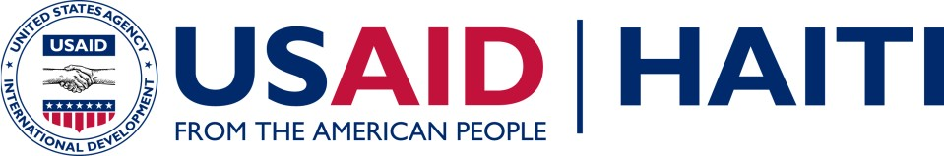

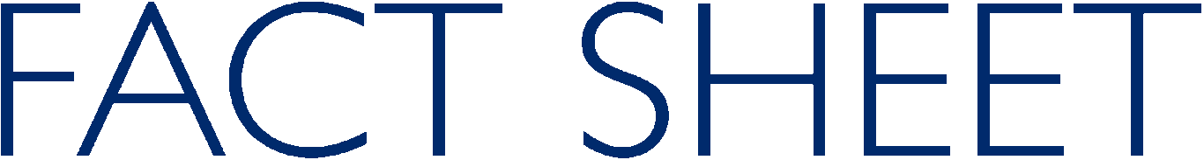

Bien ak Santé Timoun (BEST)

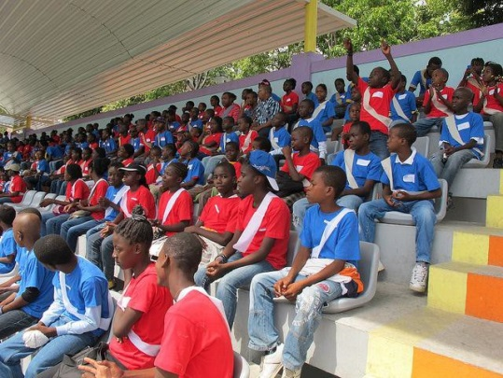
Overview
USAID takes a holistic approach to supporting HIV-affected mothers and youth in Haiti.
Bien ak santé timoun (BEST) supports children affected and infected by HIV/AIDS in Haiti to grow into healthy, educated young adults free from violence and the ill-effects of HIV. BEST operates in communities across Haiti to ensure the healthcare needs are met of HIV positive pregnant women and mothers, HIV positive children and young people 0-18years of age, and HIV positive orphans and vulnerable children (OVC) including HIV negative children living in areas of high HIV prevalence.

300 HIV+ adolescents (aged 9 to 18-years-old) from BEST Kids clubs, representing 30 hospitals or clinics located all around the Port-au-Prince area, enjoy a game day.

Results

BEST works in 145 Hospitals throughout 10 departments
- 11,000 PCR tests done since January 2014.
- 3500 HIV-positive children in follow up.
- 1000 HIV-positive adolescents in support clubs.
- 3600 HIV-positive pregnant women/mothers in support clubs.
- 750 children treated for malnutrition.
- 7000 OVC sent to school to date. Over 90% progressed to next class.
- 18,000 beneficiaries involved in microfinance activities. Over $250,000 in loans made.
Objectives
- Expand early identification of HIV infected infants
- Improve healthcare for HIV infected and HIV affected orphans and vulnera- ble children
- Increase the capacity of families and communities to care for orphans and vulnerable children

Activities
- National Early Infant Diagnosis Program of HIV
- Caris supports sites to provide EID and follow up to HIV exposed infants throughout Haiti.
- Tracking Patients and Assistance for status disclosure to HIV-positive adolescents
  - Tracking of all HIV positive children 0-18 years old in all BEST sites
  - Tracking of HIV-positive pregnant to reduce mother-to-child transmission
- Nutrition Program
- Screening for MAM and SAM via mid-upper arm circumference and treatment of malnutrition in the community
- Schooling
- Psycho-Social Support Groups
  - Kids Clubs (9-17 years old)
  - PTME/Mothers Clubs
- Provision of other medical and non-medical supplies to vulnerable families nationally
- HIV, Health, and Human Rights Education
- Micro-Finance ‘MUSO’ (cash savings)
- Agriculture/’Kitchen Gardens’
- Post-Emergency Support

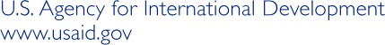
Budget: US $19,998,795.00
Life of Project: December 2013 – December 2018
Implementing Partner: CARIS Foundation

September 2017

