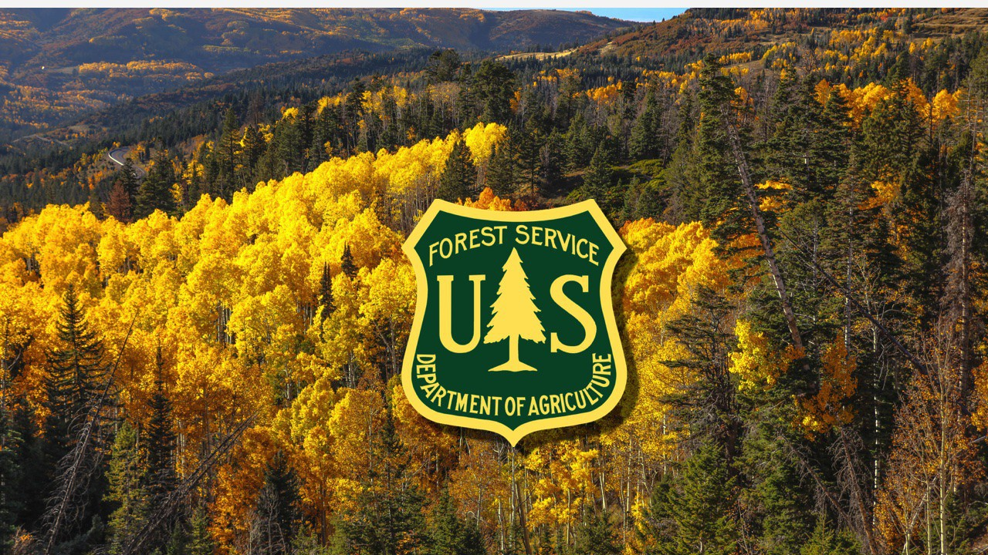
Pre-Award Guide for Applicants

USDA Forest Service
Office of Grants and Agreements
Outreach and Partnership Engagement Branch

COMMUNITY WILDFIRE DEFENSE GRANT (CWDG)

FUNDING OPPORTUNTIES:
USDA-FS-2024-CWDG-CWSF
USDA-FS-2024-CWDG-TRIBES
USDA-FS-2024-CWDG-SGSF
USDA-FS-2024-CWDG-NEMW

This guide addresses high level and routine components of a grant application. It does not replace requirements outlined in the Notice of Funding Opportunity or Detailed Instructions required for any funding opportunity. The guide targets new or infrequent applicants to the USDA Forest Service but is available to all applicants for use. For general assistance or inquiries on the CWDG funding opportunity, contact the Outreach and Partnership Engagement Branch at OPEGA@usda.gov.

Table of Contents
Competitive Application 3
General Tips 3
Sections of a Grant Application 3
Project Introduction 3
Project Justification 3
Project Objectives 4
Project Timeline/Schedule 4
Project Budget 4
The Importance of Additional Support 5
Engage Community Support 5
Assemble a Grant Writing Team 5
Grant Application Checklist 5
System for Award Management (SAM) 7
General 7
Registration and Validation 8
Application Portal 10
Budget 11
Matching/Cost-share 11
Direct vs. Indirect Cost 12
NICRA 13
Financial Capability 13
Financial Management System Standards 13
Property Management System Standards 14
Procurement System Standards and Requirements 14
Equipment 14
Appendix 15
NICRA Instructions & Checklist 15
Budget and Narrative Sample 18
Equipment Justification Form FS-1500-34 20

Tip
You can press Ctrl key to display the clicking hand  , then click at the content to jump to the relative page.

To find a keyword, go to “Home” tab, in the “Editing” group, select Find. Type the word you'd like to find, and it will be highlighted in your document.

Competitive Application

General Tips
Read the entire grant application guide and follow instructions carefully.
- Application requirements vary across programs, so look closely at the Notice of Funding Opportunity (NOFO) for each specific grant program to ensure that you are addressing all the requirements and criteria for the grant program in question.
- Carefully review the scoring criteria and make sure to address each of those criteria in your proposal
- Submit a reasonable budget based on realistic costs. Always double check your budget math. Refer to the Code of Federal Regulations on cost principles when needed: 2 CRF 200 Subpart E.
- Be sure to include any additional forms or attachments that are required. Submit work samples that reflect your ability to carry out the grant project proposed.
- Pay attention to deadlines – these are usually inflexible and if you submit your application past the deadline date, it will not be considered. Try to submit early.
- When writing your proposal, be clear and concise, establish your major points, and avoid unnecessary complexity. These points are the primary items on which the application will be evaluated.
- If provided, use the samples and checklists included in the application.
- Separate fact from opinion.

Sections of a Grant Application
Grant applications are typically comprised of several sections, as outlined below. Know what information you need to include for each section.

Project Introduction
This section is similar to an abstract and is often written after most, if not all, of the proposal is completed. It should clearly explain what you are using funds for and should be written in a way so that any reader can understand quickly and clearly what the project will deliver.

Project Justification
In this section, you should define and explain the problem that your project will attempt to address.
Some questions to answer:
- Why is it critical to address the problem now?
- What plans, studies, and data are available to identify or quantify the need?
- How will the defined population be impacted or different when the project is completed?
- What documented proof/evidence is available to support the need for your project?
- Who will your project serve?
- Are there any special circumstances to consider about your defined area/population?
- What are your organization’s needs?

Project Objectives
The objectives of your project should mirror what you are using the grant funds for in your project. Note, there is a difference between goals and objectives – goals are not measurable, whereas objectives are. Objectives are performance-related, so make sure your project objectives are realistic – they will become the criteria your project is evaluated by if you are selected for funding.

Project Timeline/Schedule
In this section, you should discuss:
- How the project will be managed by your organization;
- How project services will be delivered, and
- Who will be in charge.
Include the planned start date, activity, responsible party, completion date, milestones, and deliverables/products. You should only cover those steps/tasks that will be supported by grant funding. The schedule should be detailed and clear enough that it can give the reviewer a general understanding of what the project involves.

Project Budget
- Budget Narrative vs Budget Forms. Your budget narrative and your budget provide similar information in two different, but important ways. One lists the expenses and income while the other is a narrative description that details what is found in the budget form. The Budget narrative gives context to the information found in the form.
- Costs and project elements must be well-defined—explain what costs are associated with each element and what portion of the costs will be covered by each of the funding sources.
- Check the application directions or ask the grant coordinator to determine how the budget should be organized (usually in columnar form according to general accounting principles).
- Include all costs associated with capital and non-capital expenditures and all assumed in-kind services, volunteer efforts, and indirect costs.
- Only include items covered by the grant funds—do not include a miscellaneous or contingency category.
- Don’t forget that this project will take place in the future, so budget numbers should account for inflation at the time of expenditure.
- Like the project timeline, the project budget should provide enough detail that the reviewer can gain a general understanding of what the project entails.

The Importance of Additional Support

Engage Community Support
Community support is vital for a successful project. Many grant programs require a local funding match and/or community engagement in the project’s design and execution. The stronger the local support for a project, the easier it will be to secure matching funds, letters of support, and in-kind donations. Once the proposal summary is developed, seek out academic, political, and professional individuals or organizations, as well as community members or groups, that may be interested in your proposal. Obtain their support in writing, and then involve these individuals and organizations in project input.
Contact the grant coordinator as well as your district/state/regional representative (depending on the funding source). They can help you determine how well the grant program will work for your project and can provide you with technical assistance and additional guidance in the application process. Some competitions provide pre-proposal/application assistance. This is also specified in the announcement. Subscribe to stay updated on the status of your application.

Assemble a Grant Writing Team
While this is not always possible, it can be helpful to assemble a team to assist with grant writing. Examples of possible team members include:
- Senior-level management (support and sign grant applications)
- The project manager (who is the primary source of project-related information)
- A grant writer
- An editor (otherwise unaffiliated with the project so that they can provide an independent assessment of how well the application presents the required information); and
- Finance expert(s) (to help develop a good budget).
Depending on the size, capacity, and structure of your organization, it may not be feasible to assemble a team dedicated to grant application writing. It is not a requirement for a successful grant application but can help ease the process of the grant application preparation, content, submission and the like.

Grant Application Checklist
Use the checklist below to make sure your application is well written, contains all the necessary supporting documents, and meets the grant criteria. See if you answer ‘YES’ to everything above. However, if you have answered ‘NO’ to any items, you should follow up on these missing items before submitting your application.

1.Guidelines and documents:
▢ YES ▢ NO – I have read all documents and know the aim of the grant program, eligibility criteria, and closing date and time.
2. Application form:
▢ YES ▢ NO – I have used the correct application form and followed the process outlined in the grant guidelines.
3.Checked my idea:
▢ YES ▢ NO – My proposal is strong and aligns with the aim of the grant.
4. Considered my audience:
▢ YES ▢ NO – I have written my grant application assuming the assessor knows nothing about my business/organization or the project.
5. Language and tone:
▢ YES ▢ NO – I have used simple, positive business language (and included no jargon, vague, speculative, or negative wording).
6. Concise:
▢ YES ▢ NO – My answers are concise and within the required word count.
7. Targeted answers:
▢ YES ▢ NO – I have not duplicated my answers and all sections have been completed.
8. Budget:
▢ YES ▢ NO – I have outlined my project budget as required in the guidelines.
9. Headings:
▢ YES ▢ NO – I’ve included useful headings so readers can skim the content.
10. Keywords:
▢ YES ▢ NO – I’ve included the same keywords used as in the grant guidelines and assessment criteria.
11. Formatting:
▢ YES ▢ NO – The consistent formatting applied and answers are in the same sequence as the application form (if applicable).
12. Reviewed:
▢ YES ▢ NO – I have had my application thoroughly reviewed by 2 or more people.
13. Proofread:
▢ YES ▢ NO – I have had my application proofread by 2 or more people.
14. Final check:
▢ YES ▢ NO – All information has been provided to support the application as outlined in the guidelines.

System for Award Management (SAM)

General
Sam.gov is an official website for U.S government. All entities must register with SAM in order to conduct business with the federal government. On April 4, 2022, the unique entity identifier used across the federal government changed from the DUNS Number to the Unique Entity ID (UEI). Once you go to this website for the first time, you will see a window pops up below:
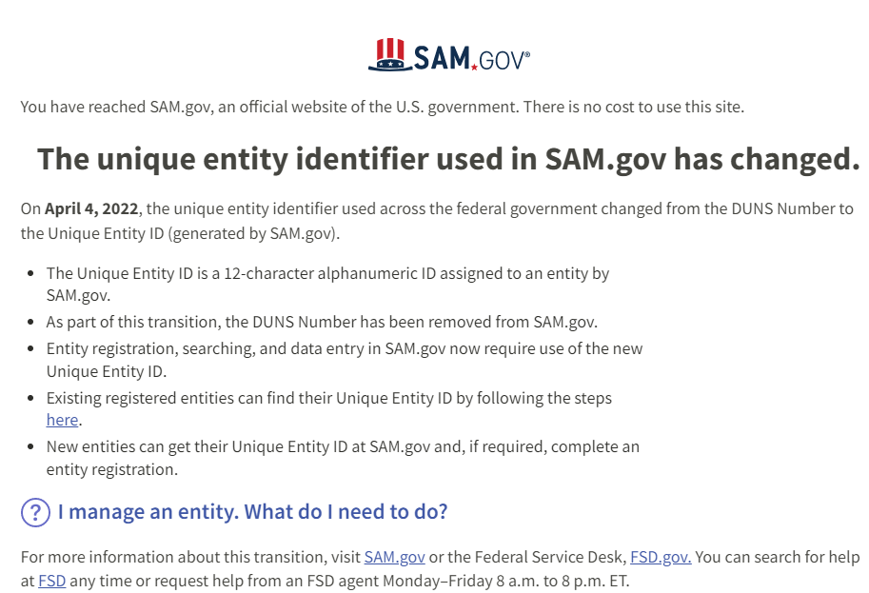

Additionally, you will see all announcements and alerts posted on its homepage. It is important to review them. For example, the latest alert below addresses the delay of validation applicants’ information. Therefore, it is recommended that you register very early on to avoid delays. This link provides FAQ to validating your entity.
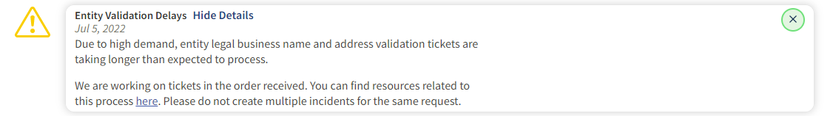

Registration and Validation
- Register/Renew your registration early. You will need to register SAM to do business with the U.S federal government. Every year you will need to update and renew your registration. If your SAM registration expires, there will be a delay in receiving funding or adding new funding through a modification.

- Gather Up Your Basic Information. Before you get started with SAM registration, you will need to know some important information. For instance, you will need your company tax ID number, which should be listed on tax forms. You also will need the routing number and account number for your business bank account, as payments to you will be made through SAM so this info is stored in your SAM account. You also might need to know your North American Industry Classification System Codes if you will be applying for Contracting. These codes identify the specific goods or services (or both) that your company provides.

- Tax ID and Physical Address. Make sure to use the Tax ID number that you have with the federal government. Use the same name as you register with the Internal Revenue Service (IRS). Once you registered, you can add another name as “doing business as” inside of SAM. Use the physical addresses to register for your UEI and have address proof ready to show (i.e., lease) if being requested by SAM.gov for validation.

- Entity Registration Checklist: See checklist link to help you prepare your registration. If you are applying for Financial Assistance award only, click on the 2nd link which will get you straight to the checklist.

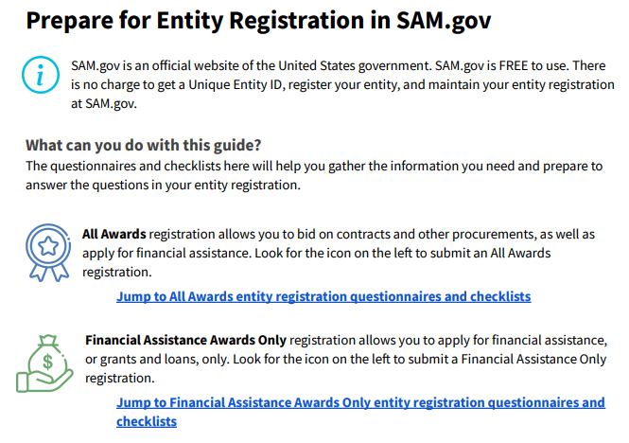

- Socio-Economic Entity: Under General information, make sure that you click all that applies to your organization, especially if you qualify under socio-economic categories, Native-American entity, or Disadvantaged business category. This is important as some grants have set asides if you qualify under this category. Visit https://www.sba.gov/ to learn more about these programs.

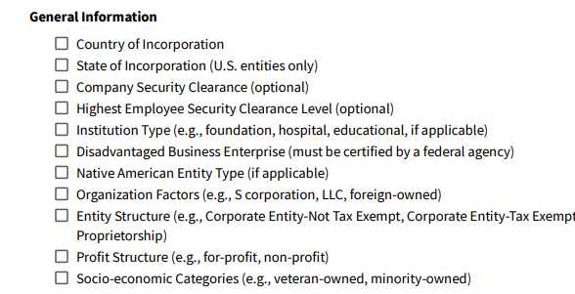

- Two or more administrators for your organization. It is recommended to have multiple people who can renew and update your SAM registration. If you lose access to the email that has the access to SAM, you will have to create a new account and submit a notarized letter to SAM granting you access again. If you leave the organization, the new person will have to go through the same process of submitting a notarized letter and gaining access to the organization’s SAM. This can lead to delays in receiving your funding related to a grant or agreement. A backup person from your organization can go into SAM and give that access immediately removing the delay.

- Review twice! Double check everything and make sure it matches your documentation exactly when setting your SAM account up for the first time or for SAM recertification process. Any information entered incorrectly will create a delay in the process. During times of high volume, it may add several weeks to the time it takes to register your entity.

Application Portal
Submitting an application for CWDG is done through the application portal listed in the NOFO. The Contact listed in the NOFO will give you a unique link for your application. You will not need a password as this unique link will allow all who have the link to access and edit the proposal up until proposal is submitted.
All fields must be filled out before submitting your proposal. You should update each section as you are filling it out to ensure all progress is being saved. Each Section has an update button on the right as in the picture below:

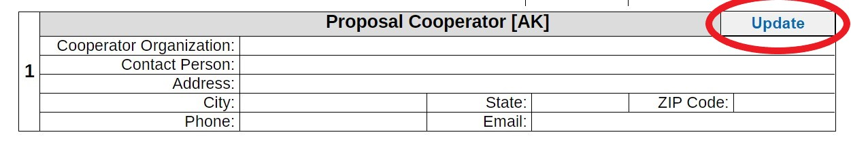
You can return to your proposal anytime by using the unique link provided. It is recommended, but not required, to fill out the pdf version prior to filling out the online version to easily copy and paste the sections in case of any internet disruptions.
The upper left of the application portal has a detail section that allows you to jump to any section. It also lets you know which sections are complete and those that are still incomplete.
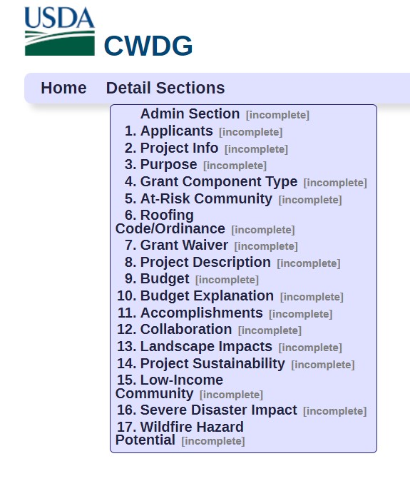
You should save or print a copy of the proposal before submitting. Once you complete the proposal and click submit your unique link will no longer be valid and you will no longer be able to view your proposal.

Budget
As you begin to develop a budget for your grant application and input the relevant costs down on paper, many questions may arise. Your best resources for answering these questions are the grants or sponsored programs office within your own institution, your administrative officials, and/or your peers.
If you are an individual applicant, there are online resources to guide you while you are developing your budget. If you have cost-related questions (i.e., what is allowable), Uniform Guidance is a "government-wide framework for grants management". It is an authoritative set of rules and requirements for Federal awards. Visit Code of Federal Regulations (CFR) – Chapter II, Part 200 covers Grants and Agreements. You will see Subpart A-F; Subpart E addresses cost principles that might be beneficial to review while drafting your budget proposal.

Matching/Cost-share
There are two kinds of matching/cost-share: cash and third-party in-kind.
- Cash: includes cash spent for project-related costs. The allowable cash match must include costs that are necessary, reasonable, and allowable under the federal program.

Matching and cost share funds have the same restrictions as federal funds. These funds must follow the same allowable and unallowable guidelines in their federal award. If, for example, a conference is unallowable under the grant award that has matching requirements, then grantees would not be able to use the matching funds instead. The expense must be allowable with federal funds for it to be allowable with matching or cost share funds.

- Third Party In-Kind: this includes, but is not limited to, the valuation of non-cash contributions provided by a third party. An in-kind match may be in the form of services, supplies, real property, and equipment. The value of the service may be used for the matching requirements, if the services are necessary, reasonable, and allowable under that federal program. Grantees are allowed to use unrecovered indirect costs for matching or cost sharing requirements; however, this requires prior approval of the federal awarding agency.
For third-party in-kind matching—such as supplies, equipment, or space—the value must not exceed the fair market value at the time of the donation.
For volunteer services, the rates must be consistent with the rates normally paid for similar work in the organization. If an employee from another organization conducts services free of charge, the services should be valued at that employee's regular rate of pay, in addition to their fringe benefits and allowable indirect costs. There are online resources to help you determine the value of volunteer time, such as: https://independentsector.org/resource/value-of-volunteer-time/. It is important to maintain a record for tracking and reporting volunteer time and services.
Grantees are required to maintain records, which clearly show the source, amount, and timing for all matched contributions. While grantees are not required to submit their supporting documentation to the Department of Justice, their records must be available in the event of an audit or site visit.

Direct vs. Indirect Cost
Understanding direct costs and indirect costs is important for properly tracking your organization’s expenses. Knowing the difference between the types of costs will help you to prepare a competitive budget proposal and you will have a better grasp on your accounting, thus better equipped to plan.
In cases of government grants or other forms of external funding, identifying direct and indirect costs becomes extra important. Grant rules are often strict about what constitutes a direct or an indirect cost and may allocate a specific amount of funding to each classification.
Often, funding for a specific project will largely support direct costs. Certain government agencies might allow you to explain why indirect costs should be funded, too, but the decision to grant funding is at their discretion.
When a company accepts government funds, the funding agency may also have several strict mandates in place regarding the maximum indirect cost rate and which expenses qualify as indirect costs.
Direct Costs | Indirect Costs
If the cost can be identified specifically with a particular cost objective such as a grant, contract, project, function, or activity, then it is a direct cost | Costs of an organization that cannot readily be assigned to a particular project but are necessary to the operation of the organization and the performance of the project
Examples: raw material, direct labor, fuel | Examples: operating and maintaining facilities, depreciation, and administrative salaries
Highly variable mainly due to market factors | Relatively stable
Direct costs affect the products/services prices, and are thus calculated per project or per item | Indirect costs affect the whole business and are thus calculated monthly or annually

Contractual costs are those services carried out by an individual or organization, other than the applicant, in the form of a procurement relationship. The costs a contractor, including an individual consultant, incurs for travel are included in the contractual line item of the budget.
The budget justification should address each of major cost categories (salaries, fringe benefits, equipment, travel, supplies, other direct costs, and indirect costs), as well as any additional categories required by the sponsor.
Fringe benefits include but are not limited to the cost of leave, employee insurance, pensions, and unemployment benefit plans. The budget narrative should identify the applicant's fringe benefit rate. The applicant should not combine the fringe benefit costs with direct salaries and wages in the personnel category.

NICRA
To be reimbursed for indirect costs, you must first establish an appropriate negotiated indirect cost rate agreement (NICRA). To do this, prepare an indirect cost rate proposal and submit it to the cognizant federal agency. The cognizant federal agency is generally determined based on the preponderance of federal dollars you receive.
The term “de minimis rate” refers to the rate that is available to certain recipients (and certain subrecipients, which is 15% of “modified total direct costs” (MTDC). This is specifically defined in 2 CFR 200.1. This definition must be followed. If your indirect cost rate is over 15%, you will need a NICRA with your cognizant agency, which is the Federal agency responsible for reviewing, negotiating, and approving cost allocation plans and indirect cost proposals on behalf of all Federal agencies.
All direct salaries and wages, applicable fringe benefits, materials and supplies, services, travel, and up to the first $50,000 of each subaward (regardless of the period of performance of the subawards under the award)
If the Forest Service (FS) is your cognizant Agency and you need to obtain a NICRA, please visit FS Resource Audit branch (RAB) Audit and Assurance Staff | US Forest Service (usda.gov). Refer to the Appendix for the FS NICRA application that you may be required to submit. Please contact the RAB before filling out the form below.

Financial Capability
This document does not address all possible circumstances that need to be considered when establishing internal controls or assessing risk. Each applicant is responsible for reviewing their practices and processes to determine where risks exist and where and how controls can be established to mitigate them, and also complying with possible audits.
Grantees need adequate financial management systems to ensure that grants are used for intended purposes and in accordance with regulations. A capability assessment ensures that an applicant has adequate financial systems and enables awarding agencies to decide whether to award the grant, and whether conditions should be added. Assessments of grant applicant capability provide management with confidence that grantees have, or will have, the required financial systems and allow management to plan the level of grantee oversight.
The Forest Service policy requires a pre-award evaluation of the administrative and programmatic capabilities of applicants. Applicants are required to answer questions regarding financial management systems, property, and procurement standards, assigned personnel, and travel policies. Below are the 3 areas to be evaluated. Refer to the Appendix for the Forest Service Form 1500-22 Financial Capability Questionnaire.

Financial Management System Standards
Recipients are required to meet the standards and requirements for financial management systems set forth or referenced in 2 CFR Part 200.302, as applicable. The standards and requirements for a financial management system are essential to the grant relationship.
Recipients must have in place accounting and internal control systems that provide for appropriate monitoring of grant accounts to ensure that obligations and expenditures are reasonable, allocable, and allowable. Internal controls in accounting are procedures that are put in place within an organization to ensure business is carried out in an orderly, effective, and accurate manner. In addition, the systems must be able to identify large unobligated balances, accelerated expenditures, inappropriate cost transfers, and other inappropriate obligation and expenditure of funds.

Property Management System Standards
Generally, recipients may use their own property management policies and procedures for property purchased, constructed, or fabricated as a direct cost provided they observe the regulatory requirements in 2 CFR Parts 200.310 through 200.316, as applicable. State governments will use, manage, and dispose of equipment acquired under a grant in accordance with state laws and procedures as specified in.

Procurement System Standards and Requirements
Recipients may acquire a variety of goods or services in connection with a grant-supported project, ranging from those that are routinely purchased goods or services to those that involve substantive programmatic work. States may follow the same policies and procedures they use for procurements from non-Federal funds and ensure that every purchase order or other contract includes any clauses required by 2 CFR Part 200.327. All other recipients must follow the requirements in 2 CFR Part 200.317 through 200.327 and the purchase of goods or services through contracts under grants, as applicable.

Equipment
Equipment can only be purchased with Federal funds with written approval of Federal Awarding agency (2 CFR 200.439). Instructions for how to handle equipment purchased can be found in 2 CFR 200.313. In addition, review the NOFO carefully to address any additional equipment requirements from the awarding agency. Below is a synopsis to give you a broad understanding, it is recommended to carefully review the entire equipment section referenced in 2 CFR 200.
- Must get written prior approval to purchase
- The Title will Vest upon acquisition with the Non-Federal entity
- The equipment must be properly used and disposed of.
- Equipment must be used in the program or project for which it was acquired.
- Very Detailed records must be kept of the Equipment and damage, or loss must be investigated.
- Must be maintained
- When no longer needed the equipment must be disposed of according to awarding agency.

See Appendix for the Forest Service Equipment Justification & Certification Statement form.

Appendix

NICRA Instructions & Checklist

U.S. Forest Service Albuquerque Service Center
Resource Audit Branch

Indirect Cost Proposal Guidance and Checklist For Non-profit Entities
Subject to 2 CFR Part 200 (Formerly 2 CFR Part 230)

Proposals may be based on prior year actual data, actual data with forward- adjustments or any combination of information.
All documentation requirements described below must be met.
Please E-mail the proposal, adjoining schedules, financial statements (or IRS Form 990) and General Ledger (GL) to rab@fs.fed.us. Since we review proposals electronically, Microsoft Excel is the preferred format for submitting proposal calculations and schedules.

If the GL files and other schedules are too large to submit electronically via e- mail, you may wish to send a CD ROM or other compressed file to:
U.S. Forest Service Albuquerque Service Center
Resource Audit Branch ATTN: Indirect Rates 101B Sun Avenue NE Albuquerque, NM 87109
Our fax number is: (866) 436-5939

Provide a cover letter stating the purpose of the proposal and the proposed rate or rates, as applicable.
Were the agency’s books and records audited in accordance with OMB A-133 or AICPA standards? If so, please submit a copy of the auditor’s report or the grantee internet site where it can be located. If no audit was performed, please provide copies of IRS Form 990 instead.
The proposed indirect cost pool and allocation base must reconcile to the financial statements (or IRS Form 990) and general ledger (G/L):
Provide detailed schedules to tie financial statement amounts (or IRS Form 990) and GL expense accounts to the proposed indirect costs pool and base.
The allocation base must be complete (i.e., does it include all activities that benefit from the indirect cost pool?)
The allocation base must be fully explained (e.g., direct labor with or without direct fringe
Explain any differences between proposed indirect cost pool and allocation base amounts, financial statements (or IRS Form 990), and the GL.

Are unallowable expenses eliminated from the indirect cost pool? The proposed cost pool must have sufficient detail to make an independent determination.
Provide a calculation of the indirect cost rate based on item 3. Above.
An example of this calculation, using total direct cost, is below. Allocation bases typically differ from one organization to another.
CALCULATION OF INDIRECT RATE

Pool | (a) | $ 750,000
Base | (b) | $ 3,225,000
Rate | (a)/(b) | 23.26%

Note: Base is total direct cost, excluding capital expenditures. Unallowable costs are excluded from the calculation.
A schedule of unallowable cost is provided.
During the proposal fiscal year, were there any significant changes to the accounting system or to the definition or accounting treatment of any expense category (e.g., a change in building/equipment costing methodology, a change in charging an expense from direct to indirect or vice versa)?
Provide a narrative description of how like expenses are determined to be direct or indirect (i.e., labor, travel, materials and supplies, etc.)
Certifications.
Submit, as part of the proposal, a certification that the requirements and standards regarding lobbying have been complied with. See Appendix B to Part 230- Selected items of Cost (paragraph 25). A copy is attached.
Certificate of Indirect Cost. A copy is attached.
As appropriate, are previous understandings with the Forest Service or other federal agency incorporated into the proposal (for example, previous rate agreements).
Provide a schedule of expenditures on federal awards (SEFA).
Organizational Chart
Provide the following information:
Organization Name (if different from the non-profit agency submitting the proposal)
Point of Contact for the proposal: name, title, email, phone number, fax number
Name and title of official who is authorized to sign the rate agreement.
Note: All final negotiation agreements are e-mailed using Resource Audit Branch electronic issuance procedures. Please provide the name and e-mail address of the individual who is to receive the agreement

LOBBYING COST CERTIFICATE
I hereby certify that the has complied with the requirements and standards on lobbying cost in 2 CFR Part 200 (formerly 2 CFR Part 230) for the period 20XX through 20XX.
Non-Profit Organization:
Signature:
Name of Official: (Printed)
Title: __________________________________________________
Date of Execution __________________________________________________

This is to certify that I have reviewed the indirect cost proposal submitted herewith and to the best of my knowledge and belief:
All costs included in this proposal based on actual cost incurred as of , and dated , to establish final or billing indirect costs rates for fiscal year ended are allowable in accordance with the requirements of the Federal award(s) to which they apply and 2 CFR Part 200 (2 CFR Part 230). Unallowable costs have been adjusted for in allocating costs as indicated in the indirect cost proposal.
All costs included in this proposal are properly allocable to Federal awards on the basis of a beneficial or causal relationship between the expenses incurred and the agreements to which they are allocated in accordance with applicable requirements. Further, the same costs that have been treated as indirect costs have not been claimed as direct costs. Similar types of costs have been accounted for consistently.

Non-profit Organization

Signature:

Name of Authorized Official:

Title:

Date of Execution:

Budget and Narrative Sample

Below are two examples of Budget and Narrative. These are examples only and may not contain all information you will need to submit your application.

Applicant Budget
 | Grant | Match | Match | Total
 | Funds Requested | Applicant | Non-Federal Contributors | Total Project Cost
Personnel / Labor: |  | $10,000 | $5,000 | $15,000
Fringe Benefits: |  | $2,600 | $1,300 | $3,900
Travel:
Equipment:
Supplies:
Contractual: | $125,000 |  |  | $125,000
Other:
Indirect Costs:
Total: | $125,000 | $12,600 | $6,300 | $143,900

The total budget for this CWPP project, including match, totals $143,900. The grant funds requested total $125,000 which will be used to hire consultants which will assist the Project Steering Committee in performing public outreach/workshops, collecting data to develop a wildfire hazard assessment, providing expert input on issues such as vegetative management and Wildland urban interface identification, mitigation strategies and recovery planning for future wildfire incidents, building code and WUI code provisions that could be recommended to our County Commissioners for approval that will reduce fire risk in the County and assist in drafting the Community Wildfire Plan. The $125,000 contractual cost assumption was based upon communication with one of the consultants who recently assisted State X in developing the State Wildland Fire Protection 10- Year Strategic Plan. The assumption is to have two consultants work together; one conversant in public outreach and one consultant with the technical expertise in Forestry/Wildfire Management. We assume that $35,000 of the contractual grant funds will be used for the Forestry consultant and the balance would be used for the consultant providing public outreach/Plan drafting services. This is precisely the model that the State used for its Strategic Wildfire Plan. There will be a bid process with an RFP. The County will review all service bids and determine the winning bid. A contract will be signed with the winning bidder.

The matching funds of $18,900 are comprised of $15,000 of dedicated personnel costs and $3,900 of fringe benefits (26% of salary). A total of $12,600 ($10,000 in salary and $2,600 in fringe benefit) of the $18,900 match funds will come from a County staff member who has expertise in emergency management and public outreach and will chair the Project Steering Committee. That staff member’s hourly rate will be $40.00 per hour in 2023. We are assuming that this individual will lead the project and dedicate at least 250 hours to this eighteen-month project. The remainder of the matching funds, a total of $6,300 ($5,000 in salary and $1,300 in fringe benefit) will come from the Fire District representatives who will be on the Steering Committee calculated as: 5 representatives x 25 hours x $40 per hour and a 26% fringe benefit rate. This assumes 8-10 meetings of the Steering Committee and some additional time to markup a draft of the revised CWPP.

The matching funds of $18,900 is a 15% match which exceeds the 10% match requirement under the Notice of Funding for CWDG.

Applicant Budget
 | Grant | Match | Match | Total
 | Funds Requested | Applicant | Non-Federal Contributors | Total Project Cost
Personnel / Labor:
Fringe Benefits:
Travel: | $4,000 |  |  | $4,000
Equipment:
Supplies: | $1,000 |  |  | $1,000
Contractual: | $180,500 |  |  | $180,500
Other:
Indirect Costs: | $18,050 | $60,000 |  | $78,050
Total: | $203,550 | $60,000 |  | $263,550

Travel: Mileage reimbursement for grant-related travel of County Y Forester/Coordinator to public meetings and projects identified in the CWPP to be brought into shovel-ready status. Mileage reimbursement will be limited to the current Federal Mileage Reimbursement Rate at the time of service.

Supplies: Estimated copy and printing costs for printed materials directly associated with public/community outreach related to
CWPP project layout and design, including draft project maps, flyers/brochures, and general copy costs for printed materials directly related to CWPP project preparation, layout, and design by County Y Forester.

Contractual: Cost of County Y Forester/Coordinator to:
- Bring 1,000 acres of CWPP-identified projects into shovel-ready status over valid term of grant, meaning all layout, resource surveys, and environmental compliance will be complete, $150,000.00 (1000 acres at $150.00/acre),
- Completion and submittal of 4 grant applications to fund CWPP-identified work, $30,500.00 (estimated $7625.00 per application).

Indirect Cost (Grant Funds): County Y Indirect Cost rate of 10% of contractual line item to manage grant including grant oversight, administration, and accounting (10% of 180,500.00 = $18,050.00).

Indirect Costs (Applicant Match): $12,000.00 annually for County Y Forester/Coordinator paid from County Y General Fund for five years ($12,000.00 x 5 = $60,000.00).

Equipment Justification Form FS-1500-34

