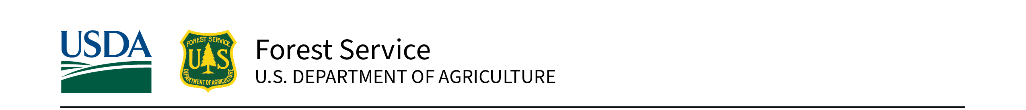
Eastern Region State, Private, and Tribal Forestry | August 23, 2023

Fiscal Year 2023 USDA Forest Service
Great Lakes Restoration Initiative (GLRI)
Forest Restoration Request for Applications
Due by 5 PM Central/6 PM Eastern, October 23, 2023
Contents
Background and Purpose 3
Eligibility 3
Projects Not Eligible 4
Program Area Information 4
Program Area 1. Mitigate Invasive Forest Insect and Disease Impacts 4
Program Area 2. Reduce Runoff from Degraded Sites through Green Infrastructure 5
Program Area 3. Restore and Connect Coastal and Riparian Forest Habitats 6
Criteria for GLRI Forest Restoration Project Selection 7
Minimum Requirements 7
Evaluation Criteria (100 points total) 8
Important Considerations for Applicants 10
Criteria Scoring Rubric: 12
How to Apply 14
Important Dates 15
Contacts 15
Review Process 15
Appendix A. Great Lakes Watershed Map 16
Appendix B. Eligible Counties Wholly or Partially in the Great Lakes Watershed 17
Appendix C. Additional Instruction for Calculating Reduce Runoff Metrics 18
Appendix D. Benefits to Underserved Communities/People 20
Appendix E. Grants.gov Application Submission and Receipt Procedures 22

Background and Purpose
The interagency Great Lakes Restoration Initiative (GLRI) targets improvements to address the most significant environmental problems within the Great Lakes Basin. Through an agreement with the Environmental Protection Agency (EPA), the U.S. Department of Agriculture (USDA), Forest Service anticipates receiving funds to support competitive projects that implement strategic, priority actions within Forest Service authorities to restore, protect, and maintain the Great Lakes ecosystem.
Successful projects will implement reforestation and other forest restoration activities to address invasive species, nonpoint source pollution impacts on nearshore health, and habitat restoration in coastal and riparian areas, while paying attention to measurable on-the-ground impacts, connections between terrestrial forested landscapes and water quality, resilience to climate change and other ecosystem stressors, and environmental justice. Anticipated funds will be distributed across three specific Program Areas described in table 1.
Award of grants is contingent on allocation of EPA funding.
Table 1.—GLRI Forest Restoration Program Areas.
GLRI Focus Area (see GLRI Action Plan) | Programs Areas and Descriptions | Anticipated Funding | Minimum Allowable Federal Request | Maximum Allowable Federal Request
Invasive Species | 1. Mitigate Invasive Forest Insect and Disease Impacts – Implement targeted reforestation and forest protection actions to minimize invasive forest insect and disease impacts on watersheds. | $1,000,000 | $50,000 | $200,000
Nonpoint source pollution impacts on nearshore health | 2. Reduce Runoff from Degraded Sites through Green Infrastructure – Capture or treat stormwater runoff by planting trees and other vegetation as an integral component of green infrastructure. | $3,500,000 | $100,000 | $300,000
Habitat and Species | 3. Restore and Connect Coastal and Riparian Forest Habitats – Protect, restore, and enhance high-quality coastal zone and connecting riparian ecosystems where trees are an important component. | $800,000 | $50,000 | $200,000

Eligibility
State agencies, Tribal communities, nonprofit organizations, educational institutions, and local governments are eligible for GLRI funding in all Program Areas. Projects must be located within the Great Lakes Basin of Minnesota, Wisconsin, Michigan, Illinois, Indiana, Ohio, Pennsylvania, and New York. Eligible applicants are encouraged to consult with their appropriate State Forester, Tribal administrator (for federally recognized Tribes), or Forest Supervisor (for work near National Forests) to develop and submit applications.
Projects must be entirely within the boundaries of the Great Lakes watershed. The Great Lakes watershed is defined as those areas within the United States that currently or historically drain into Lake Superior, Lake Michigan, Lake Huron, Lake Erie, or Lake Ontario, or drain into the St. Lawrence River west of where the International Boundary line leaves the river. A map of the basin is in appendix A, and a list of eligible counties either wholly or partially in the Great Lakes watershed is in appendix B.
To be successful, applications must conform to the authorities of the Cooperative Forestry Assistance Act of 1978 (as amended), specifically Sections 3. Rural Forestry Assistance; Section 5. Forest Stewardship; Section 8. Forest Health Protection; and Section 9. Urban and Community Forestry Assistance.

Projects Not Eligible
- Research: Basic research as defined in 2CFR 422.1, “Systematic study directed toward fuller knowledge or understanding of the fundamental aspects of phenomena and of observable facts without specific applications towards processes or products in mind.” Note: Technical transfer, education, and outreach activities associated with applying research can be included in the application. A research entity can be included as a partner and can contribute (e.g., monitoring activities).
- Construction and capital improvements (e.g., facilities, infrastructure, roads).
- Projects that only have outreach and education as outcomes. However, projects are encouraged to include a component of outreach, education, and/or training as components of the project, or as a means to achieve the project objectives.
- Projects that only have surveying or mapping as outcomes, though projects may include a survey or mapping components.
- Cost-share, reimbursement, and other types of payment provided directly to private landowners; however, funding may be used to perform work on private lands.
- Forest Health authorities may not be used to cut either dead or dying trees, unless used to suppress or slow the spread of an outbreak.

Program Area Information

Program Area 1. Mitigate Invasive Forest Insect and Disease Impacts
GLRI funds for Program Area 1 (Insect and Disease) will address non-native insect and disease impacts and threats to forests and trees through activities such as (1) planting trees to mitigate adverse insect/disease effects, (2) preparedness and prevention planning, (3) targeted (as opposed to general area) insect/disease survey and monitoring, (4) local eradication strategies if feasible, (5) direct suppression with pesticides or approved biological control agents when best suited for long-term management of non-native insects and diseases, and (6) the use of proven (rather than experimental) silvicultural practices to mitigate insect/disease damage. Non-native forest insects and diseases, such as emerald ash borer, hemlock woolly adelgid, beech bark disease, oak wilt, and others pose significant threats to forest and watershed health through high levels of tree mortality. Promoting healthy forests in the Great Lakes Basin will ensure that ecosystems are more resilient to future disturbances, are biologically diverse, and contribute to the availability of abundant clean water. Successful applications will demonstrate how targeted restoration or protection of canopy cover in developed areas, forests, wetlands, riparian corridors, and coastal zones benefits water quality, watershed processes, and/or priority habitats.
Projects in Program Area 1 may include third-party detection surveys, monitoring, evaluations, prevention, and suppression of insect and disease outbreaks on Federal land as part of a landscape effort if consistent with authorities of Title 16 U.S.C §2104 – Forest Health Protection and approved by the Federal entity.
All projects must specify acres treated, since on-the-ground outcomes are an important factor in project ratings. Urban tree planting projects should use a default conversion factor of 100 trees per acre (20-foot spacing) if acreage information is otherwise unavailable. Projects involving insect and disease prevention, detection surveys, eradication, or suppression of insect and disease outbreaks are required to be developed in coordination with Forest Service and/or State agency forest health specialists. Contact the appropriate forest health specialist (see forest health specialist staff list) to discuss technical review and coordination needs for the project and provide documentation of this review and coordination.
Program Area 1 Priorities and activities receiving additional emphasis include projects that:
- Suppress non-native invasive insect and disease threats with a high risk of damage across Great Lakes forests and watersheds.
- Minimize non-native invasive insect and disease impacts where tree damage and mortality pose a particularly high risk to hydrologic function and ecosystem integrity in a watershed.
- Align with State and/or Federal initiatives and strategies for non-native invasive forest pests, showing a high probability of success based on scale and best practices.
- Increase environmental justice through integrated programs for non-native invasive insect and disease resilience, equitable environmental benefits, and improved quality of life.
The aerial detection survey, Forest Service mapping and reporting, and State forest health highlights are data sources that can provide further information on risk and impacts.
Applicants are encouraged to contact their respective Eastern Region State, Private, and Tribal Forestry Forest Health Program specialist for assistance and information:
- New York: Mike Bohne, 603-868-7708, michael.bohne@usda.gov
- Ohio and Pennsylvania: Rick Turcotte, 304-285-1544, richard.m.turcotte@usda.gov
- Midwest States (IL, IN, MI, MN,WI): James Jacobs, 651-649-5266, james.j.jacobs@usda.gov

Required Reporting Metrics:
- Acres treated for mitigation and control of non-native invasive forest insect and disease impacts (all projects)
- Number of trees and other plantings by size class (tree planting projects)
- Acres surveyed for invasive species (projects with a survey element)

Program Area 2. Reduce Runoff from Degraded Sites through Green Infrastructure
GLRI funds for Program Area 2 (Reduce Runoff) will create or improve green infrastructure in developed areas as part of a local stormwater management strategy. Healthy trees and other plantings are critical to maintaining functioning watershed processes that reduce and absorb stormwater flow, soil erosion, and sediment/nutrient loading in Great Lakes tributaries and nearshore waters. Applications must describe how the project relates to a target water body and supports existing watershed management or stormwater reduction plans to address specific water quality impairments or other problems. Note: only non-construction activities are eligible for Federal funding.
Reduce runoff applications must include estimates of annual gallons of rainfall intercepted (20-year average) by the planned number of trees planted over the course of the project using the conversion factors in table 2.
Table 2.—Conversion factors for rainfall intercepted by tree size.
Tree diameter at planting (measured 6 inches above root collar) | Gallon conversion factor (use to obtain values for outcomes table)
Greater than or equal to 1 inch | 200 gallons/tree
Less than 1 inch | 100 gallons/tree
Shrub | 50 gallons/shrub
Final reports must refine estimates using accepted tools (e.g., i-Tree Planting Calculator, i-Tree Design; see appendix C). Projects will be rated competitively, partially on the Federal cost per gallon of annual stormwater interception.
Program Area 2 Priorities and activities receiving additional emphasis include projects that:
- Increase capacity, expertise, and engagement in maintaining community trees, particularly in underserved communities.
- Leverage existing modeling or other green infrastructure planning to plant trees in areas that will maximize filtration of overland flow.
- Improve infiltration through practices such as converting turf to native plantings, amending soil, or removing impervious surfaces in planting areas to improve green infrastructure connectivity,
- Restore riparian and floodplain tree canopy cover in these GLRI agricultural priority watersheds: Lower Fox River, WI; Saginaw River, MI; Maumee River, IN/OH; Genesee River, NY (see page 15 of GLRI Action Plan III).

Required Reporting Metrics:
- Gallons of stormwater runoff intercepted annually (all projects; see appendix C for i-Tree methods).
- Number of trees and other plantings established by size class (all projects).

Program Area 3. Restore and Connect Coastal and Riparian Forest Habitats
GLRI funds for Program Area 3 (Coastal and Riparian Habitats) will protect, restore, and connect high-quality coastal and connecting ecosystems where trees are an important component. Examples of included habitats are coastal wetlands, drowned river mouths, dune and swale habitats, forested coastal buffers, and critical connecting riparian areas.
Funded activities will enhance the cover, diversity, and resilience of native trees and other vegetation in and connecting to coastal ecosystems to improve wildlife habitat and filter out sediments, nutrients, toxic contaminants, pathogens, and other pollutants. Applications should highlight any geographical, hydrological, biological, or habitat-related connections of project areas to coastal wetlands. As an example, view mapped coastal wetland polygons in the Great Lakes Coastal Wetland Monitoring Program Site Mapping Tool.
Projects will be rated competitively, partially on the Federal cost per acre of habitat restored or enhanced. Projects focused only on non-native invasive species management as a restoration method and outcome will not be given priority for this program area. Selected applicants may choose to produce a case study highlighting project contributions to ecosystem resilience (e.g., to climate change or other forest health threats).
Program Area 3 Priorities and activities receiving additional emphasis include projects that:
- Leverage or protect previous GLRI coastal wetland investments.
- Improve habitat quality and connectivity in priority breeding marsh bird habitat zones and connecting riparian or migratory corridors (see Audubon Great Lakes breeding marsh bird priority areas, Upper Mississippi/Great Lakes Joint Venture maps, USFWS avian migrant decision support tool).
- Address other coastal priorities identified in Lakewide Action and Management Plans (LAMPs) and State Forest Action Plans.
- Address environmental justice through equitable access to environmental benefits and improved quality of life.

Required Reporting Metrics:
- Acres of Great Lakes coastal wetlands, nearshore, and other habitats restored or enhanced (all projects).
- Number of trees and other plantings by size class (tree planting projects).

Criteria for GLRI Forest Restoration Project Selection

Minimum Requirements
All minimum requirements must be met to be considered eligible for funding.
- All proposed projects must lie entirely within the Great Lakes watershed of the United States, as shown on project coordinates and maps.
- Projects must address the purpose of one of the three Program Areas and may apply for consideration under only one of those Program Areas.
- No matching funds are required.
- Costs must be allowable and budgeted in accordance with the OMB Uniform Guidance.
- Only non-Federal applicants may apply under this opportunity. Projects must take place on non-Federal lands, except as allowed in Program Area 1, Insect and Disease.
- Applications should include sufficient detail to demonstrate the applicant has the capacity to achieve stated objectives in a timely manner.
- Ownership of the property where grant activities occur must be clear. Letters of support are required from identified partners that own or maintain the project area, and it must be clear in the letter that the letter writer is the landowner and that they are giving permission for work to be done by the applicant. Describe how permission will be obtained if work spans multiple properties not owned by the applicant or current partners.
- Projects involving insect and disease prevention, detection surveys, eradication, or suppression of insect and disease outbreaks are required to be developed in coordination with Forest Service and/or State agency forest health specialists. Contact the appropriate forest health specialist (see forest health specialist staff list) to discuss technical review and coordination needs for the project. Include documentation (e.g., an email conversation) from the agency or specialist with whom coordination has taken place.
- Projects using Forest Health Protection (FHP) authorities for insect or disease activities should follow these guidelines:
  - Show strong potential for meeting project objectives and must be supported by a biological evaluation that substantiates the need for the project and the strategies proposed.
  - Be environmentally acceptable and appropriately documented in accordance with appropriate laws.
  - The entity having ownership or jurisdiction over the affected land must consent, cooperate, and participate in the project; contribute directly to the work to be done; and have the legal authority to carry out such projects.
- Planting projects shall not install any state-listed invasive species, including invasive species listed as “restricted”, “pending further review”, “non-restricted”, on a watch list, etc. Explore State lists at the USDA’s National Invasive Species Information Center.
- Projects must provide documentation of how they calculate any indirect estimated project outcomes (e.g., number of gallons mitigated).

Evaluation Criteria (100 points total)
All applications will be assessed on how well they address the following evaluation criteria below, including applicable considerations under each heading.

Purpose and Need (20%)
The project location is strategically selected to maximize benefits to Great Lakes water quality and watershed health. The project is designed to address a documented need or threat.
- Describe the connection between project activities and priorities of applicable strategic plans, such as the GLRI Action Plan III or a Lakewide Action and Management Plan (LAMP), State Forest Action Plan, or Tribal Land Management Plan. Additional emphasis will be given to projects that address specific rather than general priorities of these regional plans.
- Achieve goals or desired future conditions identified in local/regional watershed or stormwater plans, urban tree canopy management plans, or forest health assessments.
- Leverage past projects, other GLRI-funded work, or long-term commitments beyond the life of the project.
- Demonstrate environmental need using appropriate information on ecosystem stressors, water quality problems, canopy cover, or land use such as impervious cover (see i-Tree Landscape).
- Demonstrate meaningful attention to equity and environmental justice, supported by reliable data sources, such as Tree Equity Score, Climate and Economic Justice Tool, or other equity indicators (see Appendix D for more information).

Technical Merit and Sustainability (30%)
Scope of work demonstrates ability to create and sustain environmental benefits over multiple decades, using science-based best management practices.
- Tree planting projects attach a Tree Planting and Maintenance Plan that follows applicable best practices identified in the Guidance for Landscape Tree Planting.
- Insect and disease mitigation projects use strategies and tools that are known to be effective.
- Projects involving insect and disease prevention, detection surveys, eradication, or suppression of insect and disease outbreaks are coordinated with the appropriate Forest Service or State forest health specialist, and include documentation of this coordination (e.g., an email exchange) with their grant application.
- Applicants describe how project outcomes will be achieved by describing planned methodology (e.g., if pesticides will be used, what type of pesticide and how will it be used?)
- Applicant and partners show adequate expertise to address technical elements of the project, as shown by prior experience, qualifications, and technically sound project plans.
- Application shows capability and clear plans for long-term maintenance or monitoring of project benefits.
- Project is designed to be resilient to the effects of climate change and other ecosystem stressors.

Measurable Results/Outcomes Expected (30%)
Proposed work strategically and cost effectively advances Program Area Priorities. Project implements measurable outcomes using the required metrics at minimum and may include additional specific measurable results. The measures/metrics should be specific, measurable, achievable, realistic, and timely. A map of the on-the-ground impact area(s) for the project is encouraged (upload to Grants.gov using the Attachments Form).
- Application defines expected outcomes (acres or gallons) required for the Program Area and clearly describes units of work to be accomplished (e.g., species, number, and size of trees planted).
- Application includes appropriate on-the-ground outcomes for the Program Area.
- Applicant uses required metrics for the Program Area (see metrics table below).
- Address priority issues, practices, or locations identified in the Program Area description.
- Federal cost per acre treated or per gallon intercepted is cost-effective relative to similar projects.
- Budget information is clear and consistent; costs are reasonable and allowable. In the budget table, provide a brief description to justify each budget category requested. Reviewers will assess if outcomes are commensurate with the budget.

Metrics
Each Program Area has a required metric for GLRI reporting and an additional activity-dependent metric related to tree planting or forest health treatment. To be considered for funding, projects must have outcomes described using the required metric. Additional metrics that may facilitate evaluation and communication of outcomes are encouraged for use as applicable. All reported metrics should be unique (e.g., if the same acres are treated for two different invasive species, those acres should not be counted separately in reporting although the different treatments should be described). The metrics below should be used in the Measurable Results table in the Project Narrative Form.
Table 3.— Program Areas Metrics/Measurable Results.
Metric Name | Required/Optional Status and Description
Acres treated for invasive insect and disease impacts | Required for Insect & Disease Mitigation; includes replacement of trees lost to pests
Gallons of stormwater intercepted (20-year average annual interception for trees) | Required for Reduce Runoff; use conversion factor appropriate to size class below:  - Trees ≥1” diameter: 200 gallons/tree  - Trees <1” diameter: 100 gallons/tree  - Shrub: 50 gallons/shrub
Acres of habitat restored (report coastal wetland, nearshore, and other habitat types separately) | Required for Coastal and Riparian Habitats Program Area
Number of trees planted (number established and surviving at end of grant period) | Required for tree planting projects; include separate lines for each size class
Acres surveyed for invasive species | Required for projects that include invasive species surveys as a budget item
Number of trees treated | Recommended for chemical treatment of trees in Insect & Disease Mitigation; list average tree size
Miles of shoreline or riparian corridors restored or protected | Recommended for projects that target restoration along water bodies in a linear fashion. This metric should be used in addition to acres of habitat restored, not as a substitute.
Number of shrubs planted | Optional; recommended if applicable
Number of plugs/other vegetation planted (refers to neither trees nor shrubs, but non-woody vegetation) | Optional; recommended if applicable
Number of volunteer hours contributed | Optional; estimated
Number of youth (grades K-12) impacted through education and stewardship projects | Optional; estimate active participants (i.e., beyond general site use, viewing signs)
Number of people engaged in education and stewardship | Optional; estimate active participants (i.e., beyond general site use, viewing signs)
Other | Provide units in the “activity description” field
Include descriptions of less quantifiable outcomes in the narrative. Projects that clearly involve and/ or serve historically underserved communities will be given a higher priority.

Partnerships and Engagement (10%)
- Project involves diverse partners and representation in addressing local community interests. All partners and their roles (e.g., providing monetary support, providing volunteers or work hours, helping with outreach, collaborating on data sharing, etc.) are clearly identified.
- Engage a diversity of partners, including members of historically underserved communities, to improve equity, inclusion, and environmental benefits.
- Include key partners with jurisdiction or ownership in the landscape, such as State and local government, watershed organizations, Federal or Tribal land managers, or other organizations.
- Engage a spectrum of local residents in project planning, implementation, and maintenance.
- Demonstrate residual positive benefits, as a result of collaboration, related to capacity, skills, knowledge, infrastructure, or a replicable approach, among others.

Sharing Outcomes and Knowledge (10%)
Projects should include a component of outreach, training, lessons learned, or related opportunities so that carrying out the project results in skills and capability that extend beyond the life of the grant. Describe the project’s potential to inform practitioners and enhance the effectiveness of similar initiatives.
- Identify strategies for outreach beyond current partners.
- Develop deliverables to communicate project results and outcomes.
- Share knowledge, tools, or innovations that have practical application beyond the life of the project.

Important Considerations for Applicants
- Letters are recommended from State agencies or other partners that make substantive commitments towards project planning or implementation. Letters of support should make clear the role the letter writer will play in the project or the commitments they will make, if any.
- Projects should be completed within the 2-year project period after the award date.
- Annual progress reports and annual financial reports are required as well as final reports. Final progress reports must include information on the measurable results and outcomes, as well as spatial data (e.g., shapefiles) of project locations. Supplemental information such as relevant photos, illustrations, diagrams, or maps that help convey the impact of the project will be required as appropriate to project activities.
- Projects must post a visible project identification sign at each project site that includes project information and purpose, GLRI reference, and Federal agencies involved.
- Awardees will be required to comply with all Federal laws and regulations related to the completion of projects as stated in the final Award Document.
- You are encouraged to leverage other Federal programs with your project, including working on EPA Brownfields sites. Identify Brownfields sites in your area.
- You are encouraged to work with State forestry agencies and research how your project fits into the goals and objectives of the State Forest Action Plan. Look up your State Forester.

Criteria Scoring Rubric:
Table 4.—This rubric is for the review team members to reference while scoring the applications.
Criteria | High Score | Medium Score | Low Score
1. Purpose and Need (20 points) | 16-20 points  - Strong and clear contribution to one or more significant goal, issue, and/or priority landscape in relevant strategic or management plans.  - Specific description of meaningful commitment to support/engage underserved communities/people. Includes clear description with data or other evidence of the specific underserved communities/people the project will benefit or how benefits to underserved communities/people were considered in selecting project location(s). (see appendix D).  - Strong and clear description of how project contributes to a specific strategy(ies) in the plan/strategy and leverages past work.  - Strong and clear demonstration of environmental need. | 8-15 points  - Clear contribution to one or more significant goal, issue, and/or priority landscape in relevant strategic or management plans.  - Describes some support/engagement of underserved communities/people.  - Clear description of how project contributes to a specific strategy in the region’s plan/strategy and leverages past work.  - Clear demonstration of environmental need. | 0-7 points  - A simple assertion or weak or general connection to one or more significant goal, issue, and/or priority landscape in relevant strategic or management plans.  - No commitment to support/engage underserved.  - Weak contribution and leverage descriptions, if any.  - General or weak demonstration of environmental need.
2. Technical Merit and Sustainability (30 points) | 20-30 points  - Compelling, clear, and concise description of sustainable environmental benefits and long-term maintenance and monitoring.  - Strategies clearly stated and are known to be effective and considered best management practices.  - All required forms and coordination have been submitted and documented and are clear and precise.  - Applicant and partner expertise is demonstrated clearly for their specific role.  - Project demonstrates strong consideration to the impacts of climate change and other relevant ecosystem stressors and shows clear methods for project resilience. | 10-19 points  - Description of project methods or strategies that are known to be effective.  - Description of project maintenance or monitoring is included, and reference is made to climate change or other potential stressors.  - Applicant demonstrates relevant experience or expertise.  - Forms and coordination are filled out and documented. | 0-9 points  - Weak description or lack of clarity for methods or strategies.  - Weak or missing long-term monitoring or maintenance, with little to no consideration of ecosystem stressors.  - Applicant experience is not clearly relevant to the project and expertise is not otherwise demonstrated.  - Required forms or coordination are incomplete or missing.
3. Measurable Outcomes/Results (30 points) | 20-30 points  - Clearly communicates quantitative outcomes using required metrics appropriate for the Program Area and type of project. Any additional metrics used have a clear purpose and add to the project’s overall effectiveness.  - Outcomes clearly address one or more priority issues described in the relevant Program Area, and/or Purpose and Need.  - Cost per acre is or per gallon intercepted is cost-effective and reasonable, relative to similar projects.  - All budget items are clearly described and justified and are allowable.  - Qualitative outcomes are clearly described and justified and add to the overall project outcomes. | 10-19 points  - Quantitative outcomes are described using the require metrics appropriate for the Program Area and type of project.  - Outcomes make sense in the overall context of the project and stated goals.  - Costs are within reason. High costs are justified.  - Budget items are allowable, with some description.  - Qualitative outcomes are described in context of the overall project and make sense. | 0-9 points  - Metrics used are unclear or do not conform to metric requirements.  - Outcomes are weakly associated with the stated project goals.  - Costs are unreasonably high without justification.  - Budget items are poorly described, if at all.  - Qualitative outcomes or additional metrics do not add to the overall project and may not have clear relevance.
4. Partnerships and Sharing (10 points) | 8-10 points  - All project partners are listed, and their roles are clearly defined in the context of the project.  - Partners are diverse representatives of local community interests.  - There is clear indication of meaningful engagement with diverse communities, with purposeful attention to equity and environmental justice.  - Key partners, including those with jurisdiction or ownership in the project landscape, are included with clear indication of roles and engagement.  - There is strong, clear benefit to partners and local communities from the project outcomes. | 4-7 points  - All partners are listed with their roles.  - There has been some attempt to engage with diverse communities and partners.  - Some engagement with equity or environmental justice is described.  - Partnerships with jurisdiction or ownership are indicated.  - There are benefits to project partners and local communities from the project outcomes. | 0-3 points  - It is unclear if all partners were listed, or their roles are uncertain.  - There little to no indication that an effort was made to engage diverse partners or communities or pay attention to equity or environmental justice.  - It is unclear if those with jurisdiction or ownership in the project area have been engaged.  - It is not clear how the project benefits partners or local communities, or the benefits are weak.
5. Sharing outcomes and knowledge (10 points) | 8-10 points  - Clear and specific description of how others will learn from the project.  - Project has high potential to inform practitioners and enhance effectiveness of similar initiatives. | 4-7 points  - Includes description of how other will learn from the project.  - Project has moderate potential to inform others. | 0-3 points  - A simple assertion or limited description of how others will learn from the project.

How to Apply
Submit all applications for this GLRI funding opportunity through Grants.gov. Search for Grant Opportunity Number USDA-FS-GLRI-FR23. See the Grants.gov organization registration page and appendix C of this document for further detail on how to register and apply for opportunities through Grants.gov. Applicants are encouraged to subscribe to this opportunity in Grants.gov to receive updates.
Applicants are required to apply online through Grants.gov using Workspace. Workspace is a shared, online environment where members of a grant team may access and edit different webforms within an application. After creating a Workspace, you may work online or download the application package, instructions, and forms, if you prefer to work offline. Grants.gov recommends submitting your application package 24 to 48 hours before the closing date to allow time to correct any potential technical issues that disrupt your initial application submission.
If you have not applied for a grant through Grants.gov before, you must complete several registration steps before you can submit your application. Note: System for Award Management (SAM) registrations may take several weeks, after which a Grants.gov organization account can be obtained within a few days. Please review the requirements for submitting an application and take steps early to be ready to submit your application by the deadline.
- SAM registration must be current and in place at the time you submit your application. This registration should include the Certification for Financial Assistance.
- Grants.gov registration by an authorized organization representative (AOR)
Note: there is NO FEE for SAM registration. Go to www.sam.gov to register and find additional help.
Customer Support: Grants.gov provides customer support via the toll-free number 1-800-518-4726 and by email at support@grants.gov. For questions related to this specific grant opportunity, contact program representatives listed in the Contacts section of this document.
Be sure to fill out the required Project Narrative Form and all applicable forms listed below. Other formats will not be accepted. Applications without a form or document marked as required will not be considered. Forms are accessed through the Grants.gov Package tab, or the Related Documents tab, as indicated below.
Complete application packages include the following (complete all forms in your Grants.gov Workspace):
Required forms available in the Grants.gov Application Package tab:
- SF–424, Application for Federal Assistance
- SF–424A, Budget Information – Non-Construction programs
- Attachments Form (must be included in the application package to attach required items below).
Other forms available in the Grants.gov Application Package tab (submit as applicable):
- AD–1047, Certification Regarding Debarment, Suspension, and other Responsibility Matters
- AD–1049, Certification Regarding Drug-Free Workplace (for all non-state entities),–OR–
AD–1052, Certification Regarding Drug-Free Workplace (for State and State agencies)
- AD–3030, Representations Regarding Felony Conviction and Tax Delinquent Status (for Corporate Applicants)
Documents submitted using the Attachments Form in Grants.gov (attach in this order):
Narrative Form is available in the Related Documents tab in the Grants.gov opportunity.
- 2023 GLRI Forest Restoration Project Narrative Form (required)
- Tree Planting and Maintenance Plan (required for all applications that include tree planting)
- Map of project area (required, see Minimum Requirements section)
- Monitoring plan (recommended)
- Letters of Support (see Minimum Requirements and Important Considerations sections)
- Statement of Experience, if needed
- Other attachments needed to support application

Important Dates
- Applications Due: October 23rd, 2023, at 5 pm Central/6 pm Eastern

Contacts
General Questions: SM.FS.glri@usda.gov
If you have questions regarding the types of projects or components that can be considered, please contact your respective Field Office Representative:
- Minnesota, Wisconsin, Michigan, Illinois, and Indiana: Gina Jorgensen, St. Paul Field Office Representative, 651-649-5276, gina.m.jorgensen@usda.gov
- Ohio and Pennsylvania: Joe Koloski, Morgantown Field Office Representative, 304-285-1540, joseph.koloski@usda.gov
- New York: Constance Carpenter, Durham Field Office Representative, 603-868-7694, constance.carpenter@usda.gov
Or contact the Eastern Region, State, Private, and Tribal Forestry, GLRI Coordinator, Erin Barton, at erin.barton@usda.gov or 612-476-5849.

Review Process
All applications will undergo a preliminary review to dismiss incomplete or ineligible applications. An application review team consisting of staff from the Forest Service and State forestry agencies will collaboratively review and evaluate project applications. The review team will complete the review of applications and develop a recommended ranking of projects. The recommended ranking will be submitted to the Regional Forester for the Forest Service, Eastern Region for approval. All applicants will be notified of the final selection or non-selection of their applications. Full text of Project Narrative Forms and reviewer comments may be shared publicly after selections have been made.

Appendix A. Great Lakes Watershed Map
FY 2023 USDA Forest Service
Great Lakes Restoration Initiative (GLRI)
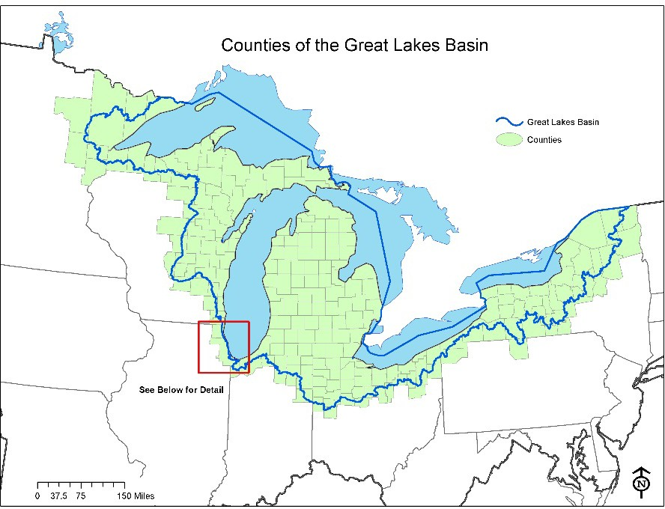
Figure 1.— Great Lakes watershed boundary.
Map Inset for Illinois and Indiana: In Illinois and Indiana, for purposes of this RFA, the Great Lakes Basin includes the historic watersheds of the North Shore channel, Chicago, and Little Calumet Rivers. This description was provided by EPA and supported by the Illinois Department of Natural Resources.
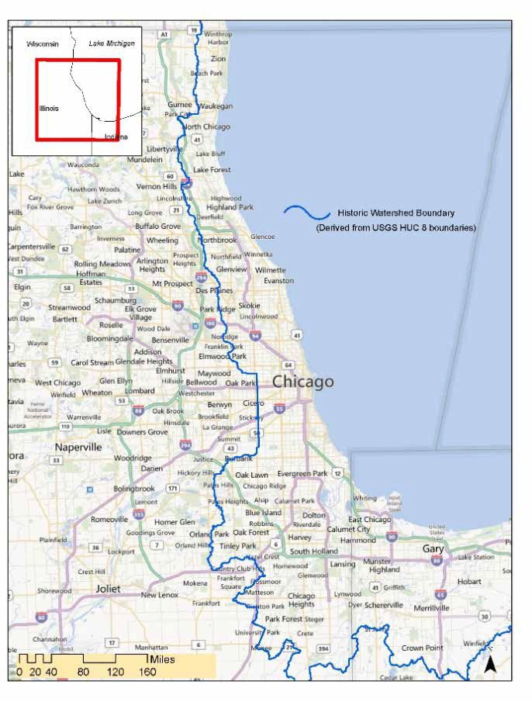
Figure 2.—Map inset for Illinois and Indiana.

Appendix B. Eligible Counties Wholly or Partially in the Great Lakes Watershed
FY 2023 USDA Forest Service
Great Lakes Restoration Initiative (GLRI)

Counties Wholly in the Great Lakes Watershed
- Indiana
DeKalb, LaGrange, Steuben
- Michigan
Alcona, Alger, Allegan, Alpena, Antrim, Arenac, Baraga, Barry, Bay, Benzie, Branch, Calhoun, Cass, Charlevoix, Cheboygan, Chippewa, Clare, Clinton, Crawford, Delta, Dickinson, Eaton, Emmet, Genesee, Gladwin, Grand Traverse, Gratiot, Hillsdale, Houghton, Huron, Ingham, Ionia, Iosco, Isabella, Jackson, Kalamazoo, Kalkaska, Kent, Keweenaw, Lake, Lapeer, Leelanau, Lenawee, Livingston, Luce, Mackinac, Macomb, Manistee, Marquette, Mason, Mecosta, Menominee, Midland, Missaukee, Monroe, Montcalm, Montmorency, Muskegon, Newaygo, Oakland, Oceana, Ogemaw, Ontonagon, Osceola, Oscoda, Otsego, Ottawa, Presque Isle, Roscommon, Saginaw, Sanilac, Schoolcraft, Shiawassee, St. Clair, St. Joseph, Tuscola, Van Buren, Washtenaw, Wayne, Wexford
- New York
Erie, Genesee, Jefferson, Monroe, Niagara, Orleans, Oswego, Seneca, Wayne, Wyoming
- Ohio
Cuyahoga, Defiance, Erie, Fulton, Hancock, Henry, Huron, Lake, Lorain, Lucas, Ottawa, Paulding, Putnam, Sandusky, Seneca, Van Wert, Williams, Wood
- Wisconsin
Brown, Calumet, Door, Florence, Kewaunee, Manitowoc, Marinette, Menominee, Oconto, Outagamie, Ozaukee, Sheboygan, Waupaca, Winnebago

Counties Partially in the Great Lakes Watershed (Project boundaries must be within the watershed)
- Illinois
Cook, Lake
- Indiana
Adams, Allen, Elkhart, Kosciusko, Lake, LaPorte, Noble, Porter, St. Joseph, Wells
- Michigan
Berrien, Gogebic, Iron
- Minnesota
Aitkin, Carlton, Cook, Itasca, Lake, Pine, St. Louis
- New York
Allegany, Cattaraugus, Cayuga, Chautauqua, Chemung, Cortland, Essex, Franklin, Hamilton, Herkimer, Lewis, Livingston, Madison, Oneida, Onondaga, Ontario, Schuyler, St. Lawrence, Steuben, Tioga, Tompkins, Yates
- Ohio
Allen, Ashland, Ashtabula, Auglaize, Crawford, Geauga, Hardin, Marion, Medina, Mercer, Portage, Richland, Shelby, Stark, Summit, Trumbull, Wyandot
- Pennsylvania
Crawford, Erie, Potter
- Wisconsin
Adams, Ashland, Bayfield, Columbia, Dodge, Douglas, Fond du Lac, Forest, Green Lake, Iron, Kenosha, Langlade, Marathon, Marquette, Milwaukee, Oneida, Portage, Racine, Shawano, Vilas, Washington, Waukesha, Waushara

Appendix C. Additional Instruction for Calculating Reduce Runoff Metrics
Projects applying under the Reduce Runoff Program Area will estimate total and average annual rainfall interception over a 20-year period. Rather than use a standard conversion factor for all trees, applicants should use free, publicly available i-Tree tools to incorporate factors like species, size, and general location of trees into the estimated gallons. These tools generate the required Gallons of Stormwater Intercepted metric to be listed in the Outcomes table of the Project Narrative Form. Supporting documents listing input parameters must be included as attachments with the application. An overview of using i-Tree to generate interception values follows, with links to more detailed information and i-Tree support. Direct questions about the specific application of tools to this RFA to Erin Barton at erin.barton@usda.gov.

i-Tree Planting
The i-Tree Planting calculator is designed to help you estimate the long-term environmental benefits from a tree planting project. The focus is on greenhouse gases, but runoff reduction is one of the co-benefits included. The output to be used in this application is Rainfall Interception (gallons) over a 20-year project lifetime. Divide this output by 20 to generate the annual average for the Narrative Form.
Users should customize the following information to reflect best available knowledge of their project:
- Location (select representative city or town)
- Tree species
- Size of trees at planting (d.b.h.)
- Information about the tree’s growing conditions
- Number of trees with each configuration
- Project lifetime (20 years)
Other information such as the distance and direction to the nearest building and specific greenhouse gas values are optional, as they relate to outcomes other than runoff reduction.
Include the sum of the Rainfall Interception (gallons) for all tree types over a 20-year project lifetime, divided by 20 years, in the Measurable Outputs table in the Project Narrative Form. The Avoided Runoff column will not be used in this review due to county-level parameter assumptions that may not reflect project area conditions. Attach an exported data table or report to your application.
The Help Menu contains instructions for how to use i-Tree Planting and references for calculation methods.
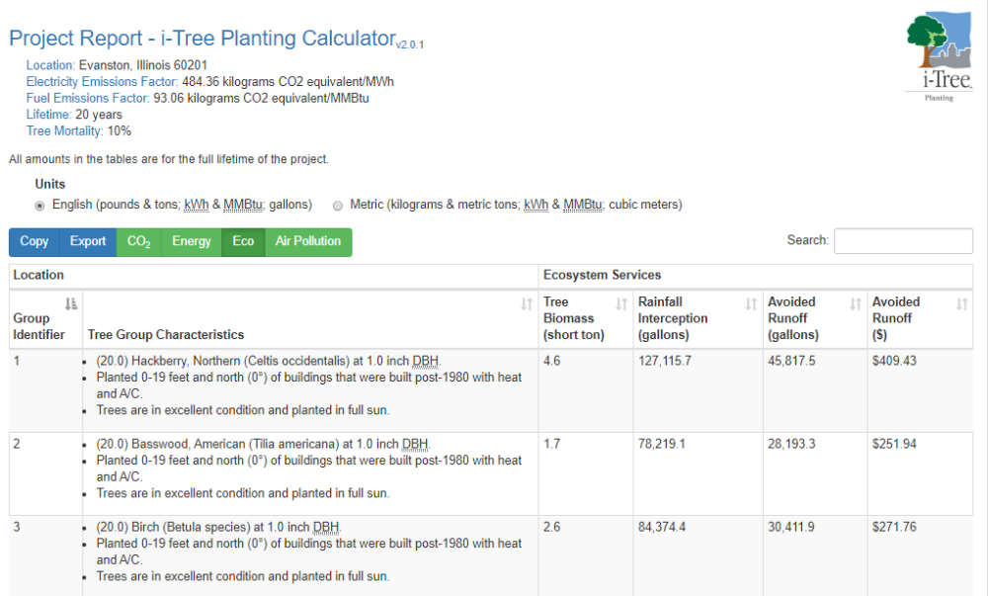
Figure 3. Sample output table for stormwater interception calculation in the i-Tree Planting Calculator. Report the sum of Rainfall Interception (gallons) for all trees, divided by 20, in the Outcomes table of the Project Narrative Form.

Other Tools
While the i-Tree Planting Calculator is likely best suited to pre-implementation assessments for most projects, existing i-Tree users may prefer to use other i-Tree tools that employ similar models. The tools capable of forecasting benefits of individual trees include:
- i-Tree Design allows anyone to make a simple estimation of the benefits provided by individual trees. With inputs of location, species, tree size, and condition, users will receive an understanding of tree benefits related to greenhouse gas mitigation, air quality improvements, and stormwater interception. Tree benefits are estimated for (a) the current year, (b) a user-specified forecast year sometime in the future, (c) the projected total benefits across that future time span, and (d) the total benefits provided to date (based on estimated tree age). Since trees are entered individually, this tool may be labor intensive for most projects or require other calculations to scale up results. If i-Tree Design is used, report the total Rainfall Interception benefits (gallons)over 20 years, divided by 20, and attach the report showing input parameters.
- i-Tree Eco is a model that uses tree measurements and other data to estimate ecosystem services and structural characteristics of the urban or rural forest. Eco is a more advanced desktop application typically used to evaluate large numbers of trees. This level of complexity is beyond the requirements and needs of grant application evaluation. However, it is an acceptable option if existing i-Tree Eco users find it to be efficient or useful for their project purposes.
Though other stormwater calculation methods exist, the consistency of i-Tree tools is preferred for the purposes of review. If you believe another calculation method is more appropriate to the proposed work, contact Erin Barton at erin.barton@usda.gov to discuss.

Appendix D. Benefits to Underserved Communities/People
In support of Executive Order 13985, Advancing Racial Equity and Support for Underserved Communities Through the Federal Government, and the Forest Service Equity Action Plan (July 2022), FY 2023 GLRI applicants are strongly encouraged to meaningfully incorporate these environmental justice elements throughout the narrative:
- Describe the benefiting communities or recipients, and how they will be meaningfully included and engaged.
Use data or other evidence to describe the underserved communities or recipients the project will engage and benefit. Applicants may use the national tools and datasets listed below in the Resources section and/or more localized knowledge such as Tribal, State, or local data, to describe the population demographics, such as persistent poverty, or persons of color or other underserved people; or community vulnerabilities such as health, economic, environmental, and climate impacts.
When the project locations are not known at the application stage, describe if and how equity and serving socially vulnerable or underserved populations will be considered in selecting project locations/benefiting communities.
Communities or recipients of the project should be meaningfully engaged and involved in projects that affect or may affect their lives and communities. This means that all people (including those who are minority and low-income) should have an opportunity to participate in and influence decisions about activities that may affect their environment and/or health.
- Describe how the project benefits and engages underserved communities or people.
Benefits and engagement may be social, ecological, or economic, for example:
- Forest management actions that benefit underserved communities and/or people, including landowners.
- Applicants or project partners that represent historically underserved people are actively engaged in project planning/implementation, e.g., minority-led organizations and Historically Black Colleges and Universities.
- Restoration efforts that improve or protect drinking water supplies in communities with persistent poverty.
- Project-generated employment, or forest management job training benefiting underserved people.
- Educational outreach to underserved communities, such as youth programs.
- Technical assistance that helps underserved landowners or communities.
- Definitions
For the purposes of this GLRI RFA, use the following definitions from Executive Order on Advancing Racial Equity and Support of Underserved Communities Through the Federal Government, Sec. 2. Definitions.
- The term “equity” means the consistent and systematic fair, just, and impartial treatment of all individuals, including individuals who belong to underserved communities that have been denied such treatment, such as Black, Latino, and Indigenous and Native American persons, Asian Americans and Pacific Islanders and other persons of color; members of religious minorities; lesbian, gay, bisexual, transgender, and queer (LGBTQ+) persons; persons with disabilities; persons who live in rural areas; and persons otherwise adversely affected by persistent poverty or inequality.
- The term “underserved communities” refers to populations sharing a particular characteristic, as well as geographic communities, that have been systematically denied a full opportunity to participate in aspects of economic, social, and civic life, as exemplified by the list in the preceding definition of “equity.”
- Resources
Applicants are encouraged to use local data and collaborate with local partners to support the information found in national data tools provided in this section. The following national data sources can be used to understand demographic characteristics of specific communities:
- Persistent Poverty Counties: The USDA Economic Research Service (ERS) defines counties as being persistently poor if 20 percent or more of their populations were living in poverty over three decades of U.S. Census Data. Select the ERS County Typology Codes, 2015 Edition, for a full list of counties.
- Climate and Economic Justice Screening Tool (CEJST): In January of 2021, President Biden issued Executive Order 14008, Tackling the Climate Crisis at Home and Abroad. The order directed the Council on Environmental Quality (CEQ) to develop a new tool. This tool is called the Climate and Economic Justice Screening Tool. The tool has an interactive map and uses datasets that are indicators of burdens in eight categories: climate change, energy, health, housing, legacy pollution, transportation, water, and wastewater, and workforce development. The tool uses this information to identify communities that are experiencing these burdens. These communities are disadvantaged because they are overburdened and underserved.
- Environmental Protection Agency (EPA) Environmental Justice Screen and Mapping Tool (EJScreen): With this online tool, under “Socioeconomic Indicators,” the “Demographic Index” is based on the average of low-income and people of color (by Census block group). You can also view each of those indicators separately, as well as other demographic indicators.

Appendix E. Grants.gov Application Submission and Receipt Procedures
This section provides the application submission and receipt instructions for FY 2023 USDA Forest Service GLRI applications through Grants.gov. Please read the following instructions carefully and completely.
- Electronic Submission Required
The Forest Service is participating in the Grants.gov initiative to provide the grant community with a single site to find and apply for grant funding opportunities. The Forest Service requires all applicants to submit their applications for this opportunity online through Grants.gov.
- How to Register to Apply through Grants.gov
- Instructions: Read the instructions below about registering to apply for Forest Service funds. Applicants should read the registration instructions carefully and prepare the information requested before beginning the registration process. Reviewing and assembling the required information before beginning the registration process will alleviate last-minute searches for required information.
  - Organizations must have an active System for Award Management (SAM) registration that provides a Unique Entity Identifier (UEI), and Grants.gov account to apply for grants. If individual applicants (those submitting on their own behalf) are eligible to apply for this funding opportunity, they need only refer to steps 2 and 3 below.
  - Creating a Grants.gov account can be completed online in minutes, but SAM registration may take several weeks. Therefore, an organization should allow sufficient time for SAM registration to meet required application submission deadlines.
  - Find Organization Registration Instructions on Grants.gov.
    - Register with SAM: All organizations (entities) applying online through Grants.gov must register with the System for Award Management (SAM). Failure to register with SAM will prevent your organization from applying through Grants.gov. Allow 7–10 business days to process. SAM registration must be renewed annually. Grants.gov provides detailed instructions for registering with SAM.
    - Create a Grants.gov Account: The next step is to register an account with Grants.gov. Follow the on-screen instructions provided on the registration page. (The Grants.gov account is associated with the individual/user performing the grant application process.)
    - Add an Applicant Profile to a Grants.gov Account: A profile in Grants.gov corresponds to a single applicant organization that the user represents (i.e., an applicant) or an individual applicant submitting on their own behalf. If you work for or consult with multiple organizations, you can have a profile for each organization under one Grants.gov account. In such cases, you may log in to one Grants.gov account to access all your grant profiles. To add an organizational profile to your Grants.gov account, enter the UEI (Unique Entity Identifier, from SAM registration) for the organization in the UEI field. If you are an individual applicant submitting on your own behalf, you do not need a UEI to add the profile. Find more detailed instructions about creating a Profile on Grants.gov.
    - EBiz POC Authorized Profile Roles: Ebiz POC) Authorized Profile Roles: After registering with Grants.gov and creating an Organization Applicant Profile, the applicant’s request for Grants.gov roles and access is sent to the E-Business Point of Contact (Ebiz POC). The Ebiz POC is responsible for managing an organization’s grant activities on Grants.gov and authorizes the appropriate roles, including the Authorized Organization Representative (AOR) role, thereby giving permission to complete and submit applications on behalf of the organization. Note: The AOR must have the authority to make legally binding commitments on behalf of the organization. Once assigned the AOR role, you can submit your application through Grants.gov at any time. Find more detailed instructions about authorized Profile Roles on Grants.gov.
      - Track Role Status: Track your role request status through the account profile. Grants.gov has more information about tracking role status.
- Electronic Signature: When an application is submitted through Grants.gov, the name of AOR is inserted into the signature line of the application to serve as the electronic signature. The EBiz POC of the organization must authorize people who are able to make legally binding commitments on behalf of the organization as a user with the AOR role; this step is often missed and it is crucial for valid and timely submissions.
- How to Submit an Application to the Forest Service via Grants.gov
- Grants.gov applicants apply online using Workspace. Workspace is a shared, online environment where members of a grant team may simultaneously access and edit different webforms within an application. For each funding opportunity announcement (FOA), you can create individual instances of a workspace.
  - Applicant Resources includes an overview of how to use Workspace.
    - Create a Workspace: Creating a workspace allows you to complete application online and route it through your organization for review before submitting.
    - Complete a Workspace: Add participants to the workspace to work on the application together, complete all the required forms online or by downloading PDF versions, and check for errors before submission. The Workspace progress bar displays the status of your application process. As you apply using Workspace, you may click the blue question mark icon near the upper-right corner of each page to access context- sensitive help.
      - Adobe Reader: If you prefer to not fill out webforms, you can download individual PDF forms in Workspace. The individual PDF forms can be downloaded and saved to your local device storage, network drive(s), or external drives, then accessed through Adobe Reader.
Note: Visit the Adobe Software Compatibility page on Grants.gov to download the appropriate version of the software.
      - Mandatory Fields in Forms: In the forms, you will note fields marked with an asterisk and a different background color. These fields are mandatory fields that must be completed to successfully submit your application.
      - Complete SF–424 (Application for Federal Assistance) Fields First: These forms are designed to fill in common required fields across other forms (e.g., applicant name, address, and SAM UEI). Once SF–424 is completed, the information will transfer to the other forms.
    - Submit a Workspace: An application may be submitted through Workspace by clicking the Sign and Submit button on the Manage Workspace page, under the Forms tab. Grants.gov recommends submitting your application package at least 24–48 hours prior to the close date to allow time to correct any potential technical issues that may disrupt the application submission.
    - Track a Workspace Submission: After successfully submitting a workspace application, a Grants.gov Tracking Number (GRANTXXXXXXXX) is automatically assigned to the application. The number will be listed on the Confirmation page generated after submission. Enter the tracking number on the Track My Application page under the Applicants tab (or under the Details tab in the submitted workspace). Find more information on the Grants.gov Help tool about Checking an Application Status.
- Additional Training Resources, including video tutorials, can be found under the Applicants tab in Applicant Resources.
- Applicant Support Center: Grants.gov provides applicants 24/7 support via the toll-free number 1–800–518–4726 and email at support@grants.gov. For questions related to the specific grant opportunity, contact the number listed in the application package of the grant you are applying for.
    - If you are experiencing difficulties with your submission, it is best to call the Grants.gov Support Center for a ticket number (or Create a Ticket on the Applicant Support Self-Service Knowledge Base page). The Support Center ticket number will assist the Forest Service with tracking your issue and understanding background information on the issue.
- Timely Receipt Requirements and Proof of Timely Submission
- Online Submission. All applications must be received by 6:00 p.m. Eastern on the due date established for each program. Proof of timely submission is automatically recorded by Grants.gov. An electronic date/time stamp is generated within the system when the application is successfully received by Grants.gov. The applicant with the AOR role who submitted the application will receive an acknowledgement of receipt and a tracking number (GRANTXXXXXXXX) from Grants.gov with the successful transmission of their application. This applicant with the AOR role will also receive the official date/time stamp and Grants.gov Tracking number in an email serving as proof of their timely submission.
- Receipt Acknowledgement: When the Forest Service successfully retrieves the application from Grants.gov, and acknowledges the download of submissions, Grants.gov will provide an electronic acknowledgment of receipt of the application to the email address of the applicant with the AOR role who submitted the application. Again, proof of timely submission shall be the official date and time that Grants.gov receives your application.
    - Applications received by Grants.gov after the established due date for the program will be considered late and will not be considered for funding by the Forest Service.
    - Applicants using unreliable internet connections should be aware that the process of completing the Workspace can take some time. Therefore, applicants should allow enough time to prepare and submit the application before the package closing date.
    - Grants.gov will provide either an error or a successfully received submission message in the form of an email sent to the applicant with the AOR role attempting to submit the application.

