FUNDING OPPORTUNITY ANNOUNCEMENT

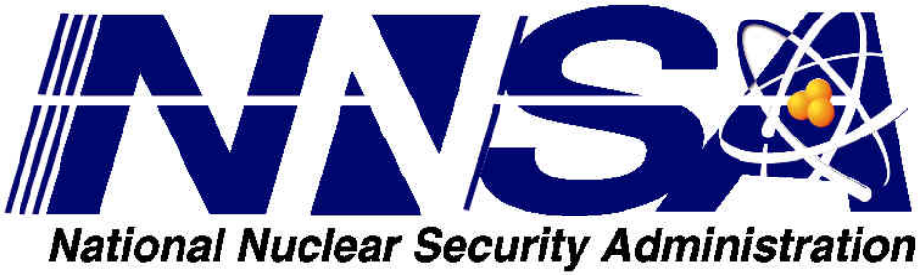

PROJECT TITLE:
MINORITY SERVING INSTITUTIONS PARTNERSHIP PROGRAM (MSIPP)
COMMUNITY AND JUNIOR COLLEGE TRADE OCCUPATION PROGRAM (CJCTOP)

____________________________________________________________________________________

FUNDING OPPORTUNITY ANNOUNCEMENT (FOA) Number:
DE-FOA-0002898

MODIFICATION 0002

U.S. Department of Energy
National Nuclear Security Administration
NNSA Financial Assistance Team

FOA TYPE: REVISION 1
CFDA NUMBER: 81.123

FOA Issue Date: | December 16, 2022
Deadline for Applications: | February 17, 2023  11:59 PM EST
Expected Date for Selection Notifications: | 45 Days after submission of applications

This modification 0002 is issued for the purpose of:

- Page 2 – Updated webinar information for WebEx

- Page 7- New contact information between Argonne National Laboratory and Kansas City National Security Campus (this is a POC add, does not change the purpose)

Brookhaven National Laboratory
Technical Contact: Giuseppe Camarda, giuseppe@bnl.gov
Located on Long Island in New York, Brookhaven National Laboratory delivers discovery science and transformative technology to power and secure the nation’s future. Brookhaven Lab supports a broad rand of U.S. government sponsors. We design, construct and operate complex user facilities to support the global research community, and our current initiatives include nuclear science, energy science, data science, particle physics, accelerator science and technology, quantitative plant science, and quantum information science.

- Page 11 – Updated link under “list” for the first paragraph to reflect the following link: https://www2.ed.gov/about/offices/list/ope/idues/2022eligibilitymatrix.xlsx

- Page 30 – Line under C. Anticipated Notice of Selection and Award Dates, Selection and Award Date to read “DOE anticipates notifying applicants selected for award by the end of August 2023 and making awards by the end of September 2023.

- Page 35: Email msippinfo@nnsa.doe.gov

IMPORTANT: SUBMIT ALL MANADTORY FORMS REQUIRED FOR THE PRIME APPLICANT AND ANY SUB-APPLICANT(S). ANY MANADTORY FORM MISSING FROM AN APPLICATION PACKAGE WILL RENDER THE APPLICATION NON-COMPLIANT AND THE APPLICATION PACKAGE WILL NOT BE FORWARDED FOR FURTHUR REVIEW.
SUBMIT APPLICATION PACKAGE EARLY.
-END-

