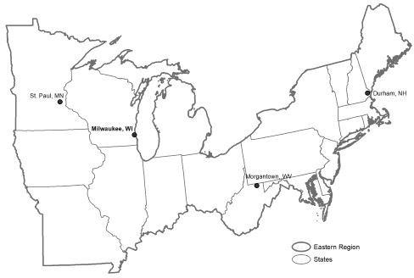
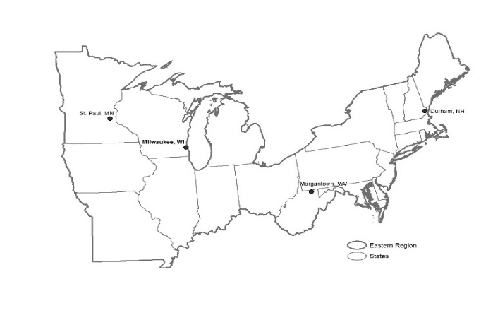
U.S. Department of Agriculture
Forest Service
Eastern Region State and Private Forestry
Forest Health Protection Staff Directory
October 2022
Regional Office - Milwaukee
MAIL | 626 East Wisconsin Avenue  Milwaukee, WI 53202
EMPLOYEE NAME |  | POSITION TITLE | PHONE | EMAIL
Susan Ellsworth |  | Director, Forest Health & Forest Markets | 414-297-3021; 775-750-9809 (c) | susan.ellsworth@usda.gov
David L. Mausel |  | Regional Entomologist | 414-267-7136 (c) | david.mausel@usda.gov
John F. Kyhl |  | Pesticide Coordinator/Invasive Plants | 651-649-5265; 651-366-7706 (c) | john.f.kyhl@usda.gov
Angel Saavedra |  | Regional Pathologist | 208-320-6890 (c) | angel.saavedra@usda.gov
Stephen Burr |  | Forest Health Monitoring Coordinator | 414-297-1535; 414-374-2426 (c) | stephen.burr@usda.gov
Vacant (FHP) |  | Biological Scientist
Nick Hough |  | Regional Aviation Officer (FAM) | 414-297-3165; 414-208-7570 (c) | george.n.hough@usda.gov
Ryne Hicks |  | Regional UAS Program Manager (FAM) | 414-297-3600; 414-208-7108 (c) | ryne.hicks@usda.gov

Durham Field Office
MAIL | USDA Forest Service  Louis Wyman Forestry Bldg. Sciences Lab 271 Mast Road  Durham, NH 03824 |  |  | 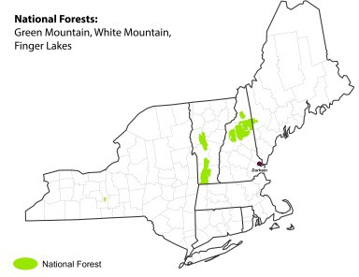
PHONE FAX | 603-868-7693/7600  603-868-7604
EMPLOYEE NAME |  | POSITION TITLE | PHONE | EMAIL
Michael J. Bohne |  | Forest Health Group Leader | 603-868-7708; 802-238-7516 (c) |  | michael.bohne@usda.gov
Robert C. Cooke |  | Forester | 603-868-7705 |  | robert.r.cooke@usda.gov
Marc DiGirolomo |  | Biological Scientist | 603-868-7738 |  | marc.f.digirolomo@usda.gov
Kevin J. Dodds |  | Entomologist | 603-868-7743 |  | kevin.j.dodds@usda.gov
Vacant |  | Remote Sensing Specialist
Cameron McIntire |  | Plant Pathologist | 603-534-3081 |  | cameron.mcintire@usda.gov
Isabel Munck |  | Plant Pathologist | 603-868-7636 |  | isabel.munck@usda.gov
Florence A. Peterson |  | Biologist | 603-868-7714 |  | florence.peterson@usda.gov
Nathan W. Siegert |  | Entomologist | 603-868-7717 |  | nathan.w.siegert@usda.gov
Jon Janelle |  | Forester | 603-868-7628 |  | jonathan.janelle@usda.gov
James Airey |  | Forester |  |  | james.airey@usda.gov

Morgantown Field Office
MAIL | USDA Forest Service 180 Canfield Street  Morgantown, WV 26505 |  |  | 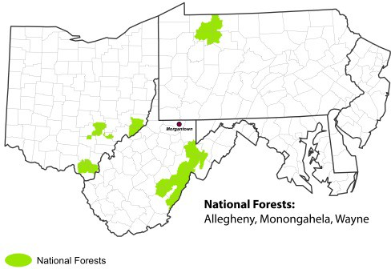
PHONE  FAX | 304-285-1541  304-285-1505
EMPLOYEE NAME |  | POSITION TITLE | PHONE | EMAIL
Richard M. Turcotte |  | Forest Health Group Leader | 304-285-1544 | richard.m.turcotte@usda.gov
Heather Smith |  | Plant Biologist | 304-285-1567 | heather.c.smith@usda.gov
Ivich Fraser¹ |  | Entomologist | 734-626-0632 | ivich.fraser2@usda.gov
Craig Larcenaire |  | Entomologist | 304-285-1565 | craig.j.larcenaire@usda.gov
Kristen Wickert |  | Plant Pathologist | 304-285-1594 | kristen.wickert@usda.gov
Danielle K. Martin |  | Plant Pathologist | 304-285-1531 | danielle.k.martin@usda.gov
William K. Oldland |  | Entomologist | 304-285-1585 | william.k.oldland@usda.gov
Tim Tomon |  | Entomologist | 304-285-1556 | timothy.tomon@usda.gov
Chris J. Hayes |  | Entomologist | 304-285-1553 | christopher.j.hayes@usda.gov
Danielle Kelley² |  | Biological Science Technician | 814-331-3257 | danielle.kelley@usda.gov
¹ Located in Ann Arbor, MI; ² Located in Irvine, PA.

St. Paul Field Office
MAIL | USDA Forest Service 1992 Folwell Avenue St. Paul, MN 55108 |  |  | 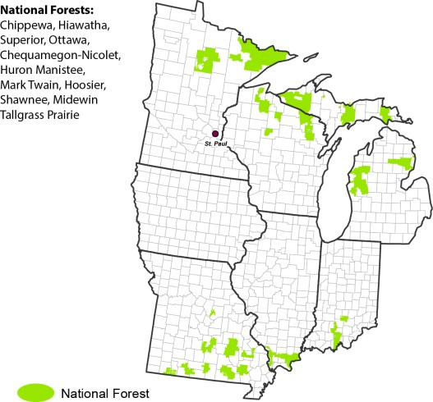
PHONE  FAX | 651-649-5243  651-649-5238
EMPLOYEE NAME |  | POSITION TITLE | PHONE | EMAIL
Kara Costanza  Vacant |  | Forest Health Group Leader (acting, effective 8/1/22)  Forest Health Group Leader | 651-649-5030  651-649-5180 | Kara.Costanza@usda.gov
Steven A. Katovich |  | Entomologist | 651-649-5264 | Steven.Katovich@usda.gov
Marissa Streifel |  | Entomologist | 651-649-5221 | Marissa.Streifel@usda.gov
Patrick Engelken |  | Entomologist | 651-649-5247 | Patrick.Engelken@usda.gov
Andrea Hefty Scholer |  | Entomologist | 651-649-5247 | Andrea.Hefty@usda.gov
James J. Jacobs |  | Plant Pathologist | 651-649-5266 | James.J.Jacobs@usda.gov
Linda M. Haugen |  | Plant Pathologist | 651-649-5029 | Linda.Haugen@usda.gov
Kara Costanza |  | Plant Pathologist | 651-649-5030 | Kara.Costanza@usda.gov
Marc A. Roberts |  | Forester | 651-649-5268 | Marc.Roberts@usda.gov
Hannah Milos |  | Natural Resource Specialist | 651-649-5269 | Hannah.Milos@usda.gov
Jennifer Larson |  | Invasive Plant Specialist | 651-649-5020 | Jennifer.Larson2@usda.gov
Rev. October 2022

