DWIGHT DAVID EISENHOWER
TRANSPORTATION FELLOWSHIP PROGRAM (DDETFP)



PROGRAM ADMINISTRATION GUIDELINES

for

LOCAL COMPETITION

at

DESIGNATED INSTITUTION OF HIGHER EDUCATION

2018 Award Cycle (February 2018)

These guidelines are in effect until further notice and were prepared for participation in the DDETFP Local Competition. Earlier versions do not apply for this award cycle.

Dwight David Eisenhower Transportation Fellowship Program (DDETFP)
Local Competition at Designated Institution of Higher Education
Program Administration Guidelines for Fiscal Year 2018

Attachment to Notice of Funding Opportunity number 693JJ318NF5228

TABLE OF CONTENTS
PURPOSE 3
IHE APPLICATION PACKAGE REQUIREMENTS 3
IMPORTANT INFORMATION AND REVISION NOTES 4
STUDENT ELIGIBILITY CRITERIA 5
DDETFP FELLOWSHIP PROGRAMS 5
AWARD AMOUNTS 6
PROGRAM ADMINISTRATION 6
CRITERIA FOR SELECTION PANEL EVALUATION OF STUDENT APPLICATIONS 8
TENURE 9
FUNDING 9
TRANSPORTATION RESEARCH BOARD (TRB) ANNUAL MEETING 10
INTERNSHIPS 10
PROGRAM REQUIREMENTS 10
RESTRICTIONS 11
U&GP STAFF RESPONSIBILITIES 11
U&GP CONTACT INFORMATION 12
FORM A: IHE TECHNICAL APPLICATION INFORMATION SHEET & CHECKLIST 13
INSTITUTION TECHNICAL APPLICATION INFORMATION 13
APPLICATION FORMS CHECKLIST 13
TECHNICAL APPLICATION CONTENT CHECKLIST 13
SAMPLE STUDENT FILE INFORMATION SHEET 15
SUGGESTED ANNOUNCEMENT INFORMATION 16
SAMPLE LOCAL COMPETITION APPLICATION REPORT AND RANKING SHEET 19
SAMPLE CONFLICT OF INTEREST - NON DISCLOSURE FORM 20
TRANSPORTATION RELATED ACADEMIC DISCIPLINES* 21

BACKGROUND
The Dwight David Eisenhower Transportation Fellowship Program (DDETFP) is currently authorized by Public Law 114-94, Fixing America’s Surface Transportation (FAST) Act. The DDETFP is intermodal, interdisciplinary, and encompasses all modes of transportation. The DDETFP is managed and administered by the FHWA Universities and Grants Programs (U&GP).

The DDETFP seeks to attract the nation's brightest minds to the field of transportation; to enhance the careers of transportation professionals by encouraging them to seek advanced degrees; and to retain top talent in the transportation industry of the United States. To accomplish this, the DDETFP gives fellowship awards to students and transportation professionals pursuing transportation-related disciplines. There are different fellowships supported through the DDETFP:
- Graduate Fellowship enables students to pursue master’s degrees or doctoral degrees in transportation-related fields at the education institution of their choice.
- Grants for Research (GRF) Fellowship acquaints undergraduate and graduate students with transportation research, development, and technology transfer activities at U.S. Department of Transportation facilities.
- Historically Black Colleges and Universities (HBCU) Fellowship provides HBCU students with additional opportunities to pursue transportation-related education preparing them to enter careers in transportation.
- Hispanic Serving Institution (HSI) Fellowship provides HSI students with additional opportunities to pursue transportation-related education preparing them to enter careers in transportation.
- Tribal College and Universities (TCU) Fellowship provides TCU students with additional opportunities to pursue transportation-related education preparing them to enter careers in transportation.
- Asian and Pacific Islander-Serving Institutions (API) Fellowship provides API students with additional opportunities to pursue transportation-related education preparing them to enter careers in transportation.
- Community College (CC) Fellowship provides students at 2 year public institutions with opportunities to enter careers in transportation. This fellowship serves to support other DDETFP fellowships.
- Transportation Research Board (TRB) Minority Student Fellowship provides funding for undergraduate (juniors/seniors) and graduate students conducting transportation research at selected Minority Serving Institutions.

The objective of the DDETFP Local Competition is to facilitate the administration of the DDETFP Fellowship Program at Minority Serving Institutions (MSI) and community colleges.

This program aligns with the FHWA MSI program (https://www.fhwa.dot.gov/civilrights/programs/mihe.cfm).

Institutions of Higher Education (IHE) that are currently designated as the following may apply:

Category | Certification
Historically Black Colleges and Universities (HBCU)  www2.ed.gov/programs/iduestitle3b/eligibility.html | Accredited HBCU as identified by the White House Initiative on Historically Black Colleges and Universities
Hispanic Serving Institutions (HSI)  www2.ed.gov/programs/idueshsi/eligibility.html | FY18 Designation as an Eligible Institution for Title III and Title V Programs
Tribal Colleges and Universities (TCU) www2.ed.gov/programs/iduesaitcc/eligibility.html | Accredited TCU as identified by the White House Initiative on American Indian and Alaskan Native Education
Asian and Pacific Islander-Serving Institutions (API)  www2.ed.gov/programs/aanapi/eligibility.html | Accredited API as identified by the White House Initiative on Asian Americans and Pacific Islanders
Community College (CC)  www2.ed.gov/about/offices/list/ovae/pi/cclo/index.html | Two-year public institutions providing higher education and lower-level tertiary education, granting certificates, diplomas, and associate's degrees

PURPOSE
The purpose of the DDETFP Local Competition is to stimulate interest among students attending HBCUs, HSIs, TCUs, APIs, and CCs to conduct transportation-related research, to pursue transportation-related degrees, and to enter the transportation workforce.

IHE APPLICATION PACKAGE REQUIREMENTS
Each interested IHE is required to submit a DDETFP Local Competition Application Package through www.grants.gov that includes:
- Application for Federal Assistance, SF-424*
- Assurances for Non-Construction Programs, SF-424B*
- Disclosure of Lobbying Activities, SF-LLL*
- Key Contacts Form* for each of the following individuals
  - Campus Program Manager
  - Grant Official
  - All members of the Local Competition Selection Panel
    - comprised of a minimum of three members
    - at least one member must be employed by the FHWA Division Office in your State
- Technical Application Information Sheet & Checklist (Form A in these Program Administration Guidelines)
  - Institution Technical Application Information
  - Technical Application Content - narrative responses required for:
    - Program Administration Plan: Describe how the DDETFP Local Competition Fellowship Program will be managed by your institution. Identify the Campus Program Manager and the Grant Official. A Key Contacts Form must be submitted for each of the individuals included.
    - Selection Panel Evaluation Plan: Describe the evaluation and ranking process that will be used to complete this activity. This narrative should include a complete list of the DDETFP Local Competition Selection Panel members comprised of a minimum of three members including at least one individual who is employed by the local FHWA Division Office. A Key Contacts Form must be submitted for each of the individuals included.
    - Campus Recruitment Plan: Describe how the DDETFP Local Competition Fellowship Program will be advertised, announcements and application distributed, panels convened, and student designees selected and notified. Please include a Timeline / Schedule chart at the end of the Campus Recruitment Plan.
  - DDETFP Local Competition Campus Announcement (please see Suggested Announcement Information)
  - NOFO Questions: Attachment that addresses the nine (9) items in NOFO Section D. Paragraph 7. OTHER SUBMISSION REQUIREMENTS (7a-7i).

* Forms are available through www.grants.gov

Failure to provide all aforementioned items will result in an incomplete application and will not be considered for selection.

FHWA will review submitted DDETFP Local Competition Application Packages to determine the IHE eligibility to participate and host the DDETFP Local Competition. Submissions must be received by the Application Due date and time listed on page 1 of the Notice of Funding Opportunity (NOFO). The Application Package will be evaluated to ensure program requirements are addressed. No educational institution will be permitted to run a local competition unless FHWA approves the submittal and provides notice to proceed. To ensure consistency in program management requirements, there will be no exceptions.

Institutions selected to administer the DDETFP Local Competition are required to ensure students meet the eligibility criteria for DDETFP Fellowship applicants.

IMPORTANT INFORMATION AND REVISION NOTES
IHE Application Packages
- Institution submitting applications in response to NOFO 693JJ318NF5228 must submit via www.grants.gov, as identified in the NOFO and in these Program Administration Guidelines.

IHE Local Competition Administration
- All selected IHEs must receive a notice to proceed prior to administering the Local Competition.
- Student Designees are only allowed to receive the DDETFP Local Competition Fellowship for a maximum of two consecutive years from the same IHE.
- All IHEs will use the same forms for the Local Competition student applications.
- The IHE (“Recipient”) must submit the following electronically to the U&GP Program Manager at FHWA_UGP@dot.gov within 90 days of the end of the Fellowship agreement period:
  - Annual Accomplishments Report
  - Student Designee completed research project.

DDETFP Local Competition Student Application
- Student applications include standard forms found on www.grants.gov and Student File Information Sheet (Sample is included in these Program Administration Guidelines).
- Each student application requires two letters of recommendation, including one from the Faculty Advisor, for a complete application.
- Only one type of DDETFP Fellowship may be awarded to a Student Designee in each award cycle.

STUDENT ELIGIBILITY CRITERIA
DDETFP Fellowship student applicants must:
- Graduate students - Possess a baccalaureate degree from, or be a confirmed graduating undergraduate senior at, an IHE which must be accredited by a federally-recognized accrediting agency and must be located within the United States or its territories, both administratively as well as the campus the student attended;
- Demonstrate confirmation of acceptance in an advanced degree program at an accredited IHE in the U.S. or its territories by the application due date;
- Be enrolled in an accredited IHE within the U.S. or its territories;
- Be pursuing an advanced degree in a full-time program in a transportation-related discipline;
- Have at least one full academic year remaining in program of study;
- Conduct ongoing research in one or more transportation-related disciplines; and
- Plan to enter the transportation profession after completing their higher-level education.
Non-U.S. citizens must also submit a valid copy of their Student and Exchange Visitor Information System Form issued by the IHE the student is enrolled in, or the Form I-20 “Certificate of Eligibility for Nonimmigrant Status”, or the Form I-551 “Permanent Resident Card” issued by the U.S. Citizenship & Immigration Service.

Applicants must meet all of the aforementioned requirements to be considered.

DDETFP FELLOWSHIP PROGRAMS
HBCU, HSI, and API Fellowships are intended for:
- Undergraduate students (juniors and seniors) pursuing transportation-related undergraduate degrees who plan to enter the transportation profession upon completing their higher education.
- Graduate students (Masters or Doctoral) pursuing transportation-related graduate degrees who plan to enter a transportation profession upon completing their higher education.

TCU Fellowships are intended for:
- Undergraduate students (sophomores, juniors, and seniors) pursuing transportation-related undergraduate degrees who plan to enter the transportation profession upon completing their undergraduate education.
- Graduate students (Masters or Doctoral) pursuing transportation-related graduate degrees who plan to enter a transportation profession upon completing their graduate education.

CC Fellowships are intended for:
- Students pursuing transportation-related degrees at a community college who plan to enter the transportation workforce as a technician.
- Students who plan to continue their educational pursuits at a 4-year institution and enter the transportation profession upon completing their higher education.

AWARD AMOUNTS
The funding for the DDETFP Local Competition is based on availability with the award amounts range based on the Fellowship category.

Fellowship Category | Student Designee Award Ranges
HBCU, HSI, TCU, API | $1,500 - $10,000
CC | $1,500 - $5,000

PROGRAM ADMINISTRATION
Each IHE shall designate a DDETFP Local Competition Campus Program Manager. DDETFP Local Competition Campus Program Manager responsibilities are to:
- Serve as liaison to the FHWA U&GP staff and ensure adherence of all DDETFP requirements.
- Respond to the Notice of Funding Opportunity and submit an Application Package by the date and time identified on page 1 of the NOFO to www.Grants.gov. All institutions interested in hosting a DDETFP Local Competition must apply annually.
- Selected institutions are required to ensure the applicants meet the DDETFP Fellowship student eligibility criteria.
- Distribute announcements to all potential applicants as soon as possible after receiving FHWA notice of selection/proceed.
- Distribute student application forms and submission requirements. Complete student application packages must include:
  - Student File Information Sheet
  - SF 424 Individual
  - Personal Statement
  - Research Plan/Plan of Study and Impact Statement
  - Official Transcripts
  - Resume
  - Two letters of recommendation
- Collect the DDETFP Local Competition Fellowship student applications.
- Designate and convene a panel to evaluate and rank Fellowship student applications.
  - The panel will be referred to as the DDETFP Local Competition Selection Panel @ Insert Institution Name Here
  - The panel should be composed of a minimum of three members, at least one of who is employed by the FHWA Division Office in your State.
  - The panel should be convened such that Local Competition Application Review & Recommendation Package is received by FHWA U&GP on or before date specified in the notice to proceed.
- Submit a Local Competition Application Review & Recommendation Package to FHWA U&PG at FHWA_UGP@dot.gov no later than date specified in the notice to proceed. The Local Competition Application Review & Recommendation Package must include:
  - Application Evaluation Summary describing the evaluation and ranking process employed, and DDETFP Local Competition Selection Panel’s recommendations for award;
  - Complete Local Competition Application Report & Ranking Sheet – FHWA will provide formatted spreadsheet to IHEs that receive Notice to Proceed (Sample is provided in these Program Administration Guidelines). Rankings should be listed from the highest to the lowest with #1 listing being the highest rated application;
  - DDETFP Local Competition Selection Panel’s individual ranking for all eligible applications with the highest score as the #1 proposed recipient to the lowest;
  - Signed Conflict of Interest/Non-Disclosure Form - FHWA will provide formatted spreadsheet to institutions that receive Notice to Proceed. (Sample shown in these Program Administration Guidelines). Each DDETFP Local Competition Selection Panel member must provide a signed copy; and
  - Compilation of all student application packages submitted in response to call for applications.
- Notify DDETFP Student Designees of their selection for the fellowship within one (1) week of receipt of FHWA U&GP Program Manager’s written notification. Ensure that all Student Designees meet enrollment criteria and complete all acceptance forms. Acceptance forms must be received by the U&GP staff as indicated in the FHWA U&GP Program Manager’s written notification.
- Meet with students at least two times per quarter/semester to discuss academic progress, Transportation Research Board (TRB) Annual Meeting participation, and opportunities for broader exposure in the transportation field.
- Establish a system to manage DDETFP to include:
  - Reviewing Recipient accounts with the appropriate College / University financial office at the end of each quarter/semester;
  - Electronic submission of each Student Designees completed research project to the FHWA U&GP Program Manager no later than September 30th of the awarding Academic Year;
  - Submit year-end reports as identified in the NOFO to FHWA U&GP; and
  - Ensure that all unused funds are returned to the FHWA U&GP within 90 days of completion of the Fellowship agreements.
- Ensure that all award modifications and changes are approved in advance by the FHWA U&GP Program Manager.
- Ensure that the FHWA U&GP Program Manager is notified of any changes in the recipient’s academic and/or enrollment status.
- Submit an institutional annual accomplishments report to the FHWA U&GP Program Manager for the preceding year within 90 days of completion of the Fellowship agreements. The report should provide summaries of the academic achievements of the fellowship Student Designees, summaries of student research projects conducted by the Student Designees, and a financial accounting of funds received and report of any unused funds to be returned.
  - Future awards are contingent upon the timely receipt of the required accomplishment report.
- Submit Student Designee completed research project within 90 days of completion of the Fellowship agreements.
- Please ensure we meet deadlines for processing DDETFP Local Competition Grants, forms and assist in complying with the dates indicated in the FHWA U&GP Program Manager’s written notification. FHWA will work directly with the Agreement Officer or designee to ensure documents are signed and returned in a timely manner.

CRITERIA FOR SELECTION PANEL EVALUATION OF STUDENT APPLICATIONS
Each IHE will need to document the evaluation and process that will be used to complete this activity as proposed the IHE Technical Application (narrative for Selection Panel Evaluation Plan). These student application evaluation criteria are distinct from STUDENT ELIGIBILITY CRITERIA that must be addressed to identify if an application is eligible or ineligible for evaluation. Eligible student applications need to be evaluated and considered for Fellowships on the basis of merit. Evidence of merit are the following:
- Academic achievement: Level of academic accomplishments, recognitions, and demonstrated leadership.
- Potential for outstanding career in transportation: Demonstration of applicant's potential through personal statements summarizing long-range professional goals in transportation, including transportation work experience (if applicable).
- Proposed research plan/plan of study and impact statement: Demonstrates alignment of research/study plan to impact and enhancement of the field of transportation; to contribution to an understanding of transportation; and/or to provide societal benefits. The proposed research must be conducted in approved transportation-related academic disciplines.
- Recommendations: Caliber of endorsements of applicant's qualifications and of planned study in chosen research area.
- Academic Record: Class standing and grade point average

TENURE
- The duration of the Fellowship will be up to one year.
- Student Designee is eligible for funding only during the months of full-time enrollment in advanced degree programs, or during on-site research projects or internships with approved transportation agencies.
- Student Designee is only allowed to receive the DDETFP Local Competition Fellowship for a maximum of two consecutive years from the same IHE.
- During the tenure of the award, the Student Designees must maintain satisfactory academic performance as established by the IHE.

FUNDING
Fellowship awards may not provide a full award (i.e. tuition, stipend, and travel to the Transportation Research Board (TRB) Annual Meeting in Washington, DC). Fellowship awards will be based on the ranking given and available funding. Fellowship awards will provide a minimum of $1,500 based on the ranking and may include tuition, stipend, and TRB Annual Meeting travel funding.

Restrictions on the use of fellowship funds by the Student Designee are as follows:
- No dependency allowances;
- Fellowship student designee is eligible for funding only during months of enrollment in full-time program leading to graduate degree;
- Unused funds must be returned to FHWA within 90 days of the termination date of the grant; and
- There is a limitation of $10,000 in DDETFP funding toward tuition and fees per year.

The IHE has the responsibility of administering the funds and for making periodic payments to the Student Designee.

The anticipated stipends for the DDETFP Fellowship are based on academic level. Additional stipend amounts may be added by the IHE or other sources. DDETFP Local Competition Campus Program Managers will determine stipends based upon IHE formal policy and available funding and shall be calculated as follows:

Monthly Stipend
Associate Level | Up to $1,000
Bachelor Level | Up to $1,450
Master Level | Up to $1,700
Doctoral Level | Up to $2,000

- Student Designees shall be advised that the stipend portion of the fellowship is subject to taxation.
- Indirect costs and overhead are not allowed under the DDETFP.
- All program-related expenses must be supported by receipts/invoices.
- All unused funds must be returned to the FHWA within 90 days of the conclusion of the fellowship, early departure, or graduation.

TRANSPORTATION RESEARCH BOARD (TRB) ANNUAL MEETING
Student Designees will be provided a one-time expenditure (up to $1,500) for travel to Washington, D.C. to attend the TRB Annual Meeting held January. Attendance at the TRB Annual Meeting is mandatory. Failure to meet this requirement will result in loss of funding designated for this activity.

The Student Designees are responsible for arranging travel and hotel accommodations following IHE travel policy to obtain the most cost-efficient rates. Registration is to be completed by logging on to www.trb.org. In addition to attendance at TRB, it is also required that students attend ALL DDETFP Research Showcase events. All students should plan to arrive by Sunday morning, and leave after the Networking Reception on Tuesday evening. If students have other commitments (i.e., presentations or poster sessions) during TRB they must notify the FHWA U&GP staff in advance to be excused from the Showcase session that conflicts with the event they would like to attend. Campus Program Managers are responsible for students securing per diem for their trip.

Student Designees may be requested, regardless of funding level, to submit an abstract of their research (or proposed research) for review and consideration for presentation at TRB. The abstract shall be submitted by the Student Designees (with a copy to their Faculty Advisor/Campus Program Manager) to FHWA U&PG at FHWA_UGP@dot.gov as indicated in the request. The FHWA U&GP will notify Student Designees if their abstract was selected for presentation. Student Designees selected for TRB presentation will be required to deliver a 10 to 15-minute presentation describing their research project at the TRB Annual Meeting.

Note: Campus Program Managers should ensure student travel arrangements (registration, lodging, per diem and airfare) for TRB Annual Meeting are completed by December 15.

INTERNSHIPS
Student Designees may study or participate in research at transportation organizations during their tenure if:
- it does not constitute paid employment by U.S. Department of Transportation
- in the judgment of the faculty advisor and the DDETFP Local Competition Campus Program Manager, such study will enhance their knowledge in transportation. The FHWA U&GP Program Manager must be notified of all internships. The stipend rate will remain the same.

PROGRAM REQUIREMENTS
- All Student Designees shall prepare a thesis/dissertation, or research paper on a topic directly related to a relevant transportation problem or issue. The Faculty Advisor must approve student research topics.
- Student Designees are required to attend TRB Annual Meeting held in January in Washington, D.C. and be prepared to potentially present on their research project.
- The results of all research will be the property of FHWA and a copy must be made available to FHWA on an unlimited, royalty-free basis.
- Upon completion of the Fellowship, a copy of each student’s thesis/dissertation, or research paper and any other related research must be submitted to the FHWA U&GP Program Manager along with the educational institutions year end DDETFP report.

RESTRICTIONS
- Reimbursements of IHE administrative or overhead costs are prohibited.
- Student Designees are eligible for funding only during the months of full-time enrollment in a degree program, or during on-site research projects or internships at federal, state, or local government agencies.
- All unused funds must be returned to the FHWA within 90 days of the conclusion of the fellowship, early departure or graduation.
- Fellowships do not cover dependents of DDETFP Student Designees.
- Current U.S. Department of Transportation employees are not eligible for the DDETFP.
- Any changes to the grant agreement must be approved, in writing, by the FHWA U&GP Program Manager/Agreement Officer.
- If a recipient declines or departs prior to the DDETFP Fellowship award being made, only the FHWA U&GP Program Manager has the discretion to approve selection of the next applicant on the ranked list.

PRIVACY ACT STATEMENT
The information is required under the authority of the Privacy Act of 1974, as amended and Title 49 U.S.C. 332(b) (3) (4) (5). Your request cannot be processed unless the data below is complete. Disclosure of your race and ethnicity are optional. Refusal to furnish your race and/or ethnicity will not result in the denial of any right, benefit or privilege provided by law. Records maintained in the system are routinely used to determine eligibility/qualifications for fellowships, and for program evaluation and analysis purposes.

U&GP Staff Responsibilities
FHWA U&GP staff will provide all participating IHE with Program Guidelines when the institutions enter the program and when new guidelines are issued. U&GP staff is available to respond to programmatic questions and schedule site visits when requested. The FHWA U&GP Program Manager will make final decisions on any requests for program changes.

IHE DDETFP Local Competition selection: The FHWA U&GP Program Manager will make the final selection of IHE to administer the DDETFP Local Competition and provide a Notice to Proceed.

Fellow Selection: The FHWA U&GP Program Manager will make the final selection of Student Designees and award amounts. Participating institutions will be notified of the selection and funding decisions.

Fellowship Awards: FHWA U&GP staff will send all forms to the DDETFP Campus Program Manager for processing. Grant agreements will be sent to the Campus Grant Official upon receipt of the completed forms.


U&GP Contact information
Universities and Grants Programs
Center for Transportation Workforce Development
Federal Highway Administration
1310 North Courthouse Road, Suite 300
Arlington, VA 22201
Web Site: https://www.fhwa.dot.gov/innovativeprograms/centers/workforce_dev/
E-mail: FHWA_UGP@dot.gov

FORM A: IHE Technical Application Information Sheet & Checklist

Institution Technical Application Information
General Application Data
- Institution Name: _____________________________________________________________________
- Fellowship Program category (check one): HBCU HSI TCU API CC
- Do any of the following academic programs exist at the institution?

Sciences
Business
Engineering
Human Development
Law
Planning
Public Policy
Aviation
Transportation
- Provide web link to the institution course catalog: _________________________________________
Historical Program Data
- Has the institution administered the DDETFP in previous years? No Yes
If yes, please identify the last academic year of participation.
2013 2014 2015 2016 2017 Other________________

Application Forms Checklist
Application for Federal Assistance (SF-424) Key Contacts Form
Assurances for Non-Construction Programs (SF-424B) Disclosure of Lobbying Activities (SF-LLL)

Technical Application Content Checklist
Program Administration Plan (Narrative Response Required)
Describe how the DDETFP Local Competition Fellowship Program will be managed by your institution. Identify the Campus Program Manager and the Grant Official. A Key Contacts Form must be submitted for each of the individuals included.
Selection Panel Evaluation Plan (Narrative Response Required)
Describe the evaluation and ranking process that will be used to complete this activity. This narrative should include a complete list of the DDETFP Local Competition Selection Panel members comprised of a minimum of three members including at least one individual who is employed by the local FHWA Division Office. A Key Contacts Form must be submitted for each of the individuals included.
Campus Recruitment Plan (Narrative Response Required)
Describe how the DDETFP Local Competition Fellowship Program will be advertised, announcements and application distributed, panels convened, and student designees selected and notified. Please include a Timeline / Schedule that includes the following chart at the end of the Campus Recruitment Plan.
Campus Recruitment Plan Timeline / Schedule
Activity | Date
Planned Announcement Posting
Institutional Application Due
DDETFP Local Competition Selection Panel Meeting
Submission of Proposed Recipient Package
DDETFP Local Competition Campus Announcement (Attachment Required)
Submit a copy of the proposed campus announcement(s) you intend to use to announce the funding opportunity to students on your campus.
NOFO Questions (Narrative Response Required)
Address the nine (9) items at Section 7. OTHER SUBMISSION REQUIREMENTS (7a-7i) in the NOFO.

SAMPLE Student File Information Sheet
FHWA will provide a final form to each selected IHE with the Notice to Proceed

Fellowship Category | HBCU HSI TCU API CC
Student Name
 | ^{Prefix} | ^{First Name} |  | ^{Last Name}
RACE (optional)  American Indian  Alaskan Native  Asian  African/African American  Native Hawaiian/Other Pacific Islander  White  Other |  |  | ETHNICITY (optional)  Hispanic or Latino  Not Hispanic or Latino  Hispanic or Latino in Puerto Rico  Not Hispanic or Latino in Puerto Rico
Check one box and place X to indicate your status as of September 1st of the application year:
Associates Bachelors Masters Doctoral
___ 1st Year __ Junior ___ 1st Year ___ 1st Year ___ 3rd Year
___ 2nd Year __ Senior ___ 2nd Year ___ 2nd Year ___ 4th Year
College / University |  |  | Applicant’s Major
Academic Department |  |  | Applicant’s Field of Study
Faculty Advisor Name:  Title:  Telephone No.:  E-mail Address: |  |  | Campus Program Manager Name:  Title:  Telephone No.:  E-mail Address:

Student Application Content Checklist
Complete Student File Information Sheet
SF 424 Individual
Application Essays
Personal Statement: Include relevant background and future goals. Please outline your educational and professional development plans as well as your career goals. Describe how your education will prepare you for a career in transportation (Limit 8000 characters).
Research/Study Plan & Impact Statement: Summarize both your plan of study and research plan. Describe how your research will impact and enhance the field of transportation; contribute to an understanding of transportation; and/or provide societal benefits. The proposed research must be conducted in the approved transportation-related academic disciplines (Limit 8000 characters).
Resume
2 Letters of Recommendation (one of the letters of recommendation must be from current Faculty Advisor)
Name | Type
 | Faculty Advisor (Required)
 | Personal Academic Professional
Official Transcripts
I am applying for funding to support the following degree: | I submitted the following official transcript(s) to complete my application.
Associate Bachelor | Transcript from current institution
Master* | Transcript from current institution
Master* | Transcript from institution that awarded bachelor’s degree
Doctorate* | Transcript from current institution
Doctorate* | Transcript from institution that awarded master’s degree
*Individuals applying for graduate level funding must possess a baccalaureate degree from an Institution of Higher Education (IE) which must be accredited by a federally-recognized accrediting agency and must be located within the United States or its territories, both administratively as well as the campus the student attended.

Suggested Announcement Information
The following information may be helpful in constructing campus announcement.

Program Objectives:
The Dwight David Eisenhower Transportation Fellowship Program (DDETFP) provides funding for the pursuit of Associate’s, Bachelor’s (junior and senior), Master’s or Doctoral Degrees in transportation related fields. The program objectives are to attract the nation's brightest minds to the field of transportation; to enhance the careers of transportation professionals by encouraging them to seek advanced degrees; and to retain top talent in the transportation industry of the United States.

Academic Disciplines:
The list of transportation related academic disciplines approved for the DDETFP can be found at the

Eligibility Requirements:
Include the requirements that are applicable to the Local Competition Fellowship category you are announcing.

For all DDETFP Fellowships:
Student applicants must be
- pursuing a degree
  - in a transportation-related discipline
  - in a full-time program
  - enrolled for the entire academic year
- conducting ongoing research in one or more transportation-related disciplines
- planning to enter the transportation profession after completing their higher-level education

Students who are not U.S. citizens must provide a valid copy of their student I-20 ID from the College / University or I-551 Permanent Resident Card that is issued by the U.S. Citizenship and Immigration Service (CIS).
HBCU, HSI, and API Fellowships: Student applicants must be at least an undergraduate junior or higher at the start of the upcoming Fall Semester.
TCU Fellowships: Student applicants must be at least an undergraduate sophomore or higher at the start of the upcoming Fall Semester.
CC Fellowships: Student applicants must be pursuing a degree in a full-time program, must be in a transportation-related discipline, must conduct ongoing research in one or more transportation-related disciplines, and should be planning to enter the transportation profession after completing their education.
Fellowships for LC IHE offering Graduate Fellowships: Student applicants applying for Graduate Fellowships must possess a baccalaureate degree from a U.S. accredited IHE.

Evaluation Criteria:
The DDETFP Fellowships will be awarded on the basis of merit. Merit includes:
- Academic achievement
- Potential for outstanding career in transportation
- Proposed research plan/plan of study and impact statement
- Recommendations
- Academic Record

Student Application Requirements & Content:
All application materials must be typed. A complete student application consists of the following:
- SF 424 Individual
- Student File Information Sheet
- Official Transcripts
- Resume
- Application Essays
1) Personal Statement: The Personal Statement should include relevant background and future goals. Please outline your educational and professional development plans as well as your career goals. Describe how your education will prepare you for a career in transportation (Limit 8000 characters).
2) Research Plan & Impact Statement: The Research Plan and Impact should summarize both your plan of study and research plan. Describe how your research will impact and enhance the field of transportation; contribute to an understanding of transportation, and provide societal benefits. The proposed research must be conducted in one of the approved transportation-related academic disciplines (Limit 8000 characters).

Fellowship Award:
All Student Designees may not receive a full award (i.e. tuition, stipend, and travel to Transportation Research Board (TRB) Annual Meeting). Fellowship award will be based on the rankings from the local Selection Panel. All selected Student Designees receive up to $1,500 to be used toward attendance at the TRB Annual Meeting in Washington D.C in January.

Tuition Cap:
Annually a maximum of $10,000 in tuition and mandatory fees may be covered by the DDETFP.

Stipend & Taxes:
DDETFP Local Competition Campus Program Managers will determine stipends based on the local cost of living figures and shall be calculated as follows:

Monthly Stipend
Associate Level | Up to $1,000
Bachelor Level | Up to $1,450
Master Level | Up to $1,700
Doctoral Level | Up to $2,000

Recipients shall be advised that the stipend portion of the award is taxable.

Sample Local Competition Application Report and Ranking Sheet
FHWA will provide formatted spreadsheet to each selected IHE with the Notice to Proceed. Below is an example of the Local Competition Application Report and Ranking Sheet (Tab A & Tab B) that includes the data elements required for the Local Competition Application Review and Recommendation Package.

SAMPLE- LOCAL COMPETITION APPLICATION REPORT AND RANKING SHEET
TAB A – Eligible
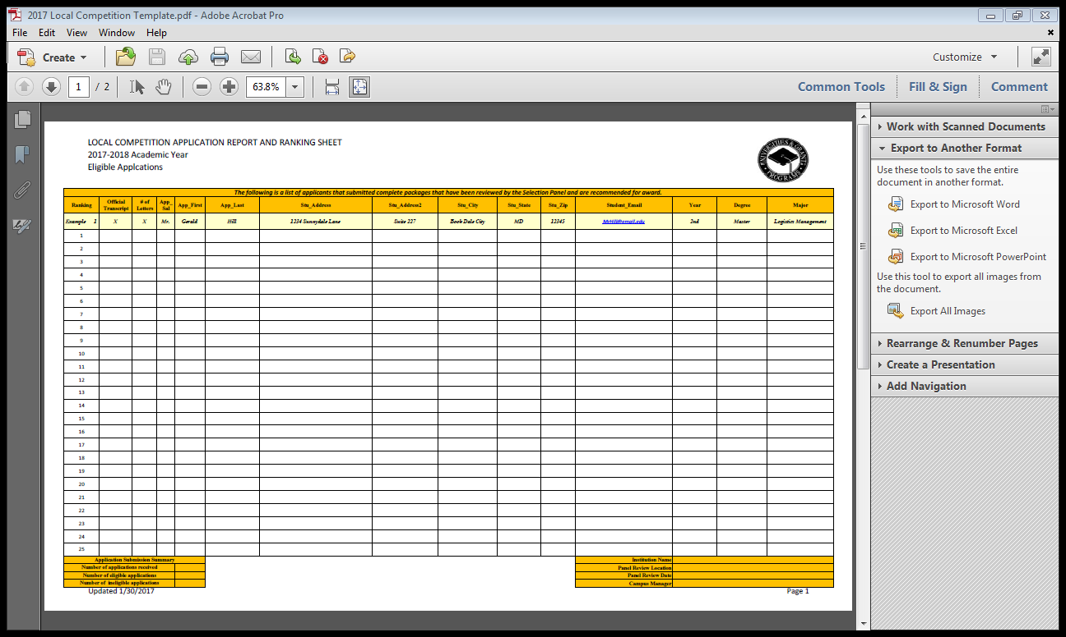

SAMPLE - LOCAL COMPETITION APPLICATION REPORT AND RANKING SHEET
TAB B – Ineligible & Incomplete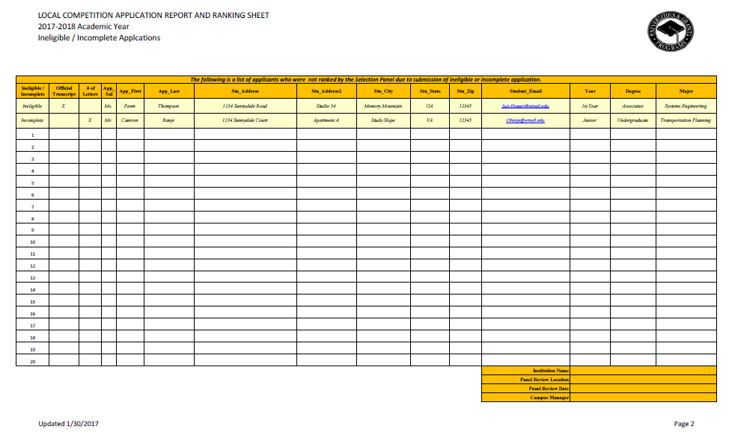

SAMPLE CONFLICT OF INTEREST - NON DISCLOSURE FORM
FHWA will provide the Conflict of Interest - Non Disclosure Form to each selected IHE with the Notice to Proceed. This form is required for each member of the DDETFP Local Competition Selection Panel. The signed forms must be returned to FHWA with the Local Competition Application Review & Recommendation Package.

SAMPLE - CONFLICT OF INTEREST - NON DISCLOSURE FORM

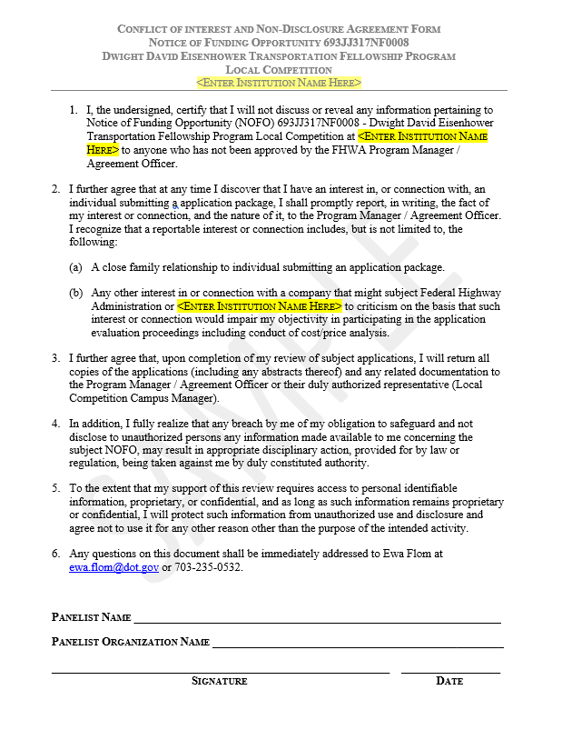


Transportation Related Academic Disciplines*

Sciences
Architecture
Biology
Chemistry
Communication
Computer Science
Criminal Justice
Environmental Science
Information Systems
Mathematics
Physics

Business
Accounting
Business Administration
Finance
Economics
Management

Human Development
Human Factors
Human Resources
Psychology

Aviation
Aeronautical Studies
Airway Science
Flight Management Science

Engineering
Chemical Engineering
Civil Engineering
Construction Engineering
Electrical Engineering
Electronic Engineering
Environmental Engineering
Geotechnical Engineering
Manufacturing Engineering
Mechanical Engineering
Structural Engineering
Transportation Engineering

Law
Environmental
Transportation

Public Policy & Planning
Public Policy and Analysis
Public Administration
Political Science/Government
Urban and Regional Planning
Urban Studies

Transportation
Logistics Management
Planning
Policy

* Other Transportation-Related Academic Disciplines may be approved on a case by case basis by the FHWA Universities and Grants Programs, Program Manager.

IHE must be accredited by a federally-recognized accrediting agency and must be located within the United States or its territories, both administratively as well as the campus the student is attending. The U.S. Department of Education publishes a list of nationally recognized accrediting agencies on https://www.ed.gov/accreditation.
The U.S. Department of Education publishes a list of nationally recognized accrediting agencies on https://www.ed.gov/accreditation
Student and Exchange Visitor Information System (SEVIS) Form I-20 is a Certificate of Eligibility for Nonimmigrant Student Status for foreign exchange students who attend an educational program in the United States. Educational institutions issue Form I-20.
Refer to the Internal Revenue Service Publication 970 – Tax Benefits For Education
Available on Grants.gov
A Permanent Resident Card (Form I-551), commonly known as a Green Card, is evidence of your status as a lawful permanent resident with a right to live and work permanently in the United States. It also is evidence of your registration in accordance with United States immigration laws. Once students are accepted by the school, the University / College provides students a form known as a Certificate of Eligibility (SEVIS I-20).
IHE must be accredited by a federally-recognized accrediting agency and must be located within the United States or its territories, both administratively as well as the campus the student is attending. The U.S. Department of Education publishes a list of nationally recognized accrediting agencies on https://www.ed.gov/accreditation.
Transcripts must be provided from all institutions in which a degree was obtained. If you are applying for the Doctoral Fellowship, official transcripts must be provided from the institution where you obtained your Master degree and your current institution. If you are applying for the Masters Fellowship, official transcripts must be provided from the institution where you obtained your Bachelor degree and your current institution.
Refer to the Internal Revenue Service Publication 970 – Tax Benefits For Education.

