Advanced Tissue Biofabrication
Manufacturing Innovation Institute (ATB-MII) Solicitation

Appendices for Funding Opportunity Announcement (FOA)
W911NF-16-R-0021
Table of Contents
Appendix A: Project Definitions, Overview and Technical Objectives 2

Project Definitions 2

Project Overview 4

Technical Objectives 7
Appendix B: Representation and Certifications 16
Appendix C: Guidance on Intellectual Property Rights for the National Network for Manufacturing Innovation 16

Appendix A: Project Definitions, Overview and Technical Objectives

Project Definitions

Applied Research and Development (R&D): Applied R&D includes efforts that attempt to determine and exploit the potential of scientific discoveries or improvements in technology, such as new materials, devices, methods and processes. Applied R&D includes manufacturability, and spans Technology Readiness Levels (TRLs) 4–7 and Manufacturing Readiness Levels (MRLs) 4 to 7. Applied R&D within the context of this FOA seeks to solve specific problems related to design and fabrication of tissue, tissue-related products and components. Applied R&D may be focused on, but is not limited to, areas outlined within this FOA and towards technology transitions to products that address current and future operational needs of the government and commercial sector.

ATB-MII Product: An ATB- MII product is any of a number of manufacturable or manufacturing-related commercial tools and goods associated with the process of tissue biofabrication. These products can include tissue and tissue-related products as well as virtual products such as a knowledge gateway and/or data repository of information pertaining to tissue biofabrication.

Biofactors: Biofactors is a broad term that describes any number of biomolecules and trace substances that are required by living organisms. These substances include vitamins and trace elements as well as growth factors and regulatory substances made by cells.

Biofabrication: Biofabrication is the use of foundational components (cells, biofactors and scaffolds) to manufacture tissue products for in-vivo or in-vitro applications.

Foundational Components: Any number of a broad range of starting materials for a tissue biofabrication process. These materials could include but are not limited to biofactors, scaffolds, primary cells, stem cells, hydrogels, natural polymers, proteins, extracellular matrix molecules, polymers, monomers, cross-linker molecules, and peptides.

Infrastructure: The physical and organizational structure required to support a sustainable ATB-MII. Includes a physical headquarters and shared user facilities that form a core function within the MII, enabling demonstration, rapid prototyping, and scale-up opportunities for MII members. While centralized facilities are most desirable, it is understood that networked, distributed facilities are also of value and may be necessary based on consortium members’ locations and existing infrastructure. The Government envisions that the ATB-MII shall serve as a technical resource for industry, institutions of higher education and regulators in the design, development and prototype manufacturing of tissue biofabrication platforms, testing, and preservation. To accomplish this, the Government expects the recipient to architect, exercise, and leverage an infrastructure that provides unique capabilities for the Nation.

Intellectual Property: Intellectual Property is defined as technical know-how, inventions, technical data, discoveries, materials, samples, software, software programs, documentation, reports, any and all other copyrightable materials, and/or invention or discovery that is or may be patentable or otherwise protectable under Title 35 of the U.S. Code.

Leadership Council: The ATB-MII Leadership Council (or a similarly named body) guides the operational and technical activities of the ATB-MII organization. This includes operational processes, procedures, technical roadmaps, project selections, and educational & workforce development. The recipient of the ATB-MII award will be the lead organization of the ATB-MII and chair the Leadership Council. It is envisioned the distribution of members in the Leadership Council will be sufficiently represented by the composition of the sub-recipients and Federal Government. The Federal Government participation on the council is required to ensure the Government’s needs are represented.

Non-profit Governance: Governance is the process of providing strategic leadership within a non-profit organization and by extension, to the member organizations that compose an MII. It includes the functions of setting direction, making policy and strategy decisions, overseeing and monitoring organizational performance, and ensuring overall accountability. The non-profit organization recipient of the ATB-MII award is the lead organization for the ATB-MII.

Non-Profit Organization: Any corporation, trust, association, cooperative or other organization that: (1) Is operated primarily for scientific, educational, service, or similar purposes in the public interest; (2) Is not organized primarily for profit; and (3) Uses its net proceeds to maintain, improve, or expand the operations of the organization. The term could include any nonprofit institution of higher education or nonprofit hospital.

Rapid Prototyping: An alternate path for fabrication to provide a short turn-around time option for individual time-critical designs. This path could include integrated biofabrication platforms, developed to transform standardized starting materials into novel and evolving end-product tissue designs. A common component of MIIs is their ability to serve as an affordable, accessible, and rapid prototyping platform(s) in their respective technology space(s) for small-medium size enterprises, entrepreneurs, and academia.

Scaffolds: A scaffold is the technical term to describe a material with variable-scale porosity and/or channels that promote cell attachment, replication, differentiation and/or maturation into tissue. Scaffolds can be constructed from a range of different materials including natural and synthetic polymers and hydrogels. Scaffolds can also be fabricated from a range of different technologies including photolithography, soft lithography, additive manufacturing and molding.

Tissue Product: A tissue product is any assembly of cells and scaffold material in a three dimensional structure that, upon culturing in defined media and environmental conditions over specified times, matures into a product that mimics native tissue, organs or parts of organs.

Tissue-Related Product: Tissue related products consist of: (a) any number of technologies that aid in the biofabrication of tissue products; (b) are an acellular product with the specific purpose of being combined with cells and biofactors by an end user to create a tissue or tissue-based assay; (c) involve any testing or monitoring technology that relates directly to sensing or detecting cell or tissue-related processes or environments in direct contact with cells or tissues; (d) include any vessel whose purpose is to culture and/or mature a tissue product such as bioreactors, high throughput well plates, chemostats and microfluidic chips; or (e) are related in any way to the tissue biofabrication process and could become a value-added manufacturing product for use in commercial or research processes.

Project Overview

The Advanced Tissue Biofabrication Manufacturing Innovation Institute (ATB-MII) will create an end-to-end innovation ‘ecosystem’ in the U.S. for tissue biofabrication. This may include high-throughput culture technologies, bioreactors, storage methodologies, non-destructive or minimally destructive test/sensors, and real-time monitoring/sensing technologies measuring the functionality, viability and chemical nature of engineered tissue constructs. These technologies will support post-delivery assurance of tissue identity, viability, function and efficacy. The ATB-MII will be structured to allow Government, industry and institutions of higher education to come together with the goal of organizing the currently fragmented U.S. capabilities in advanced tissue biofabrication technology and better position the U.S. relative to global competition. The ATB-MII will also enable institutions of higher education and small-to-medium enterprises to participate in and benefit from the ATB-MII’s collaborative manufacturing advances. The ATB-MII must be structured to address both DoD and commercial applications, with a focus on maturing technologies from Manufacturing Readiness Level 4 (technology produced in a laboratory environment) to 7 (technology produced in a production representative environment).

The risk to industry to develop and implement these technologies is high, and access to tissue biofabrication technology for small-and medium-sized enterprises, institutions of higher education, and the Government is limited due to its increasing complexity and high cost of entry. Competition on many fronts makes it difficult for individual companies to capitalize or develop these technologies for a global marketplace. The goal of the ATB-MII is to address these risks by establishing a national institute as a resource to focus on the complex issues in advanced tissue biofabrication manufacturing, developing solutions that create cost-effective manufacturing capabilities to minimize the risk to the U.S. industrial base in adopting these new technologies. This will require a collaborative approach between industry, institutions of higher education, government, and the workforce. The ability to reduce the time and cost to bring products to the marketplace is a common need shared by both Government and industry.

Because global competitiveness is driven by the speed at which products can enter the marketplace at a competitive price point, this ATB-MII’s focus must be on developing technologies or services that have far reaching impact across the broader tissue biofabrication industrial ecosystem. Government and industry also need to develop ways to reduce the risk of adopting new technologies. The ATB-MII is envisioned to reduce risk in tissue biofabrication technologies through advances in manufacturing, testing, and preservation and to support regulatory standards as required. The ATB-MII must also create training and development opportunities to keep the workforce current with the state of technology advancements.

This ATB-MII must bring together the resources and developmental potential of the Federal Government, institutions of higher education, Original Equipment Manufacturers and other manufacturers, synergistic technology contributors, and state and local governments to achieve the vision of the ATB-MII. Essentially, the ATB-MII ecosystem will assemble broad multi-disciplinary sub-recipients that are currently fragmented into a cohesive unit that provides prototyping and process advancements across multiple technology thrust areas. This partnership between the recipient and sub-recipients must foster agile and robust pre-competitive tissue biofabrication technology and knowledge advances that provide support to both government and commercial needs, developing market-focused manufacturing innovations, supporting product and system performance, affordability, and ultimately increased market demand. When combined, these platforms, collaborations, innovations, and related infrastructure will create an advanced manufacturing ecosystem ripe for technology transition and commercial manufacturing of tissue and tissue-related products. Increased quality of sensing and manufacturing controls, led by this Institute, should facilitate development of manufacturing specifications to meet regulatory requirements for product safety, efficacy, identity, purity, and potency.
The ATB-MII ecosystem must also be designed and established in a way that beneficially responds to the political, regulatory, legal, and social systems and structures that could depend on or influence the Institute. This includes being sensitive to the evolving needs and perceptions of customers, recipient and sub-recipients, and regulators; understanding changes occurring in technologies; remaining informed and responsive to threats to domestic competitiveness; and adapting with the legal, social and political climates.
The ATB-MII operational ecosystem should be structured in a way that promotes the collaborative problem-solving vision of the NNMI network. Figure 1 represents an operational concept of key elements in the innovation ecosystem. These elements should be considered in developing the business, technical, educational and workforce, and cost plans that will be evaluated according to the Evaluation Criteria specified.
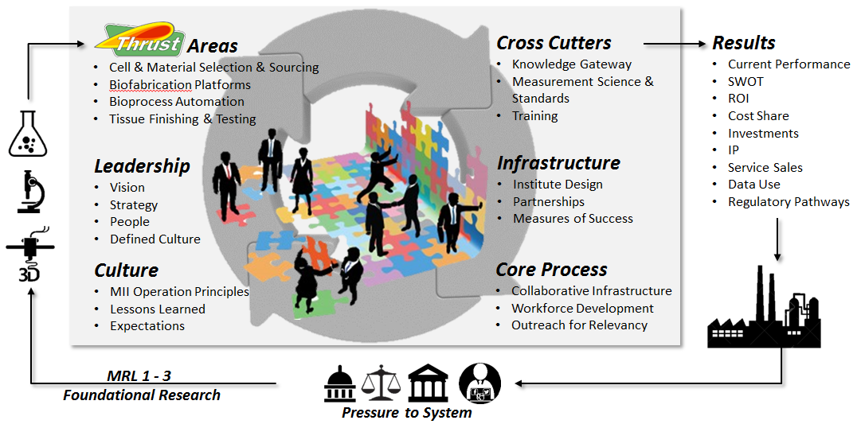
Figure 1: ATB-MII Operational Concept

Within the Business Plan the Applicant should consider the following elements that describe the ATB-MII ecosystem.

Leadership and Culture: The ATB-MII will deliberately design an organizational strategy with a leadership structure and culture that brings together cross-functional expertise. This will include the vision of the ATB-MII to advance manufacturing readiness levels within the technology ecosystem and support product assurance. The overall non-profit governance and ATB-MII leadership council must be designed to support the ATB-MII organization, membership, and business plan. The Leadership Council will contribute to working groups across each of the technology thrust areas. The leadership and culture will outline the leadership style, worker attitudes and habits and management practices that make up the distinctive “personality” of the institute

Infrastructure and Cross-Cutter Systems: Within the business plan, describe the physical and operational infrastructure that will support the institute, to address how the people and processes will interact and collaborate, and the allocation of boundaries, roles, and responsibilities to achieve the ATB-MII intended results. Examples of infrastructure need are the physical and virtual access to ATB-MII resources, coordination of workforce training, development and educational outreach, as well as a structure for decision making, personnel policies and procedures across industry partners. Cross cutter systems are the inter-related sets of tasks or activities that help organize and coordinate work within the ATB-MII. Examples include shared knowledge and communication gateways, membership recruiting, and development. Cross-cutter systems may also contain the underlying databases, software design systems, or reference standards that support a sustainable service model. Developing and defining measures to support standards and regulations for product assurance technologies is an integral cross-cutting need for the ATB-MII.

Core Processes: The core process, the sequence of events or steps necessary to execute a project call and deliver a product or service, dictates the flow of work through the ATB-MII, The core process fosters multi-disciplinary collaboration and should be the focal point around which all other ATB-MII activities are organized. The core process should support adaptive learning to advance the state of the art in tissue biofabrication, integrate workforce development into ATB-MII activities, and ensure sustained relevance through the lifetime of the ATB-MII through continual outreach and feedback loops.

Results: Every organization is designed to get the results they are getting, therefore, define the results, metrics, and success criteria for the proposed ATB-MII. Describe the baseline measure of performance and the measureable criteria to demonstrate progress in annual increments over 7 years. The results should measure business, technical, and educational and workforce performance measures.
In summary, the Government is interested in receiving proposals for an ATB-MII that will lead to a more innovative, competitive, and scaled-up domestic manufacturing industrial base across all elements of tissue biofabrication technology. The goal is to bring together representation from across the ATB-MII membership community to address MRL 4-7 common manufacturing challenges that are beyond the risk of any one company. This will be fostered by a robust and sustainable ATB-MII leadership structure to facilitate and accelerate technical and manufacturing maturity.

Technical Objectives

Essential to the ATB-MII effort are the details on the conceptual technical scope of research and development that will be sought for the ATB-MII, as specified in the evaluation criteria. The envisioned Advanced Tissue Biofabrication manufacturing and design innovation ecosystem includes a wide variety of concepts, theories, components and processes. Figure 2 presents the conceptual functional ecosystem within which an Advanced Tissue Biofabrication Institute operates and drives technological innovation. The technology ecosystem includes specific thrust areas as well as cross-cutting elements, all connected within a collaborative infrastructure. The specific elements of the collaborative and cross-cutting infrastructure are shown associated with varying degrees of federal investment. This is done to reflect the expected sufficiency of infrastructure and/or other cost share that Applicant’s teams will need to make available to complement the federal investment. The federal investment helps enable the overall innovation ecosystem to flourish by targeting those areas for funding emphasis that are mostly beyond the risk of industry and other member organizations. Among the ATB-MII management responsibilities will be the oversight of ATB-MII thrust areas, collaborative infrastructure, and cross-cutting functions to ensure efficient, cost-effective provisioning of advanced tissue biofabrication manufacturing innovation.

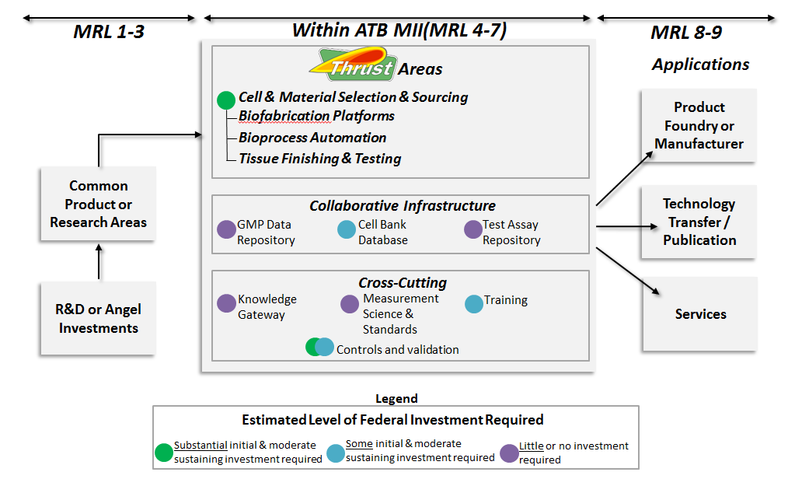
Figure 2: ATB-MII Functional Ecosystem Concept

The conceptual flow illustrated in Figure 2 above characterizes a complete manufacturing and testing support structure ranging from starting material selection to creation of functional platforms or test devices through process automation and product assurance. Common manufacturing and testing challenges to be addressed within the ATB-MII are likely to come from ongoing federal investments in regenerative medicine or medical countermeasures or from emerging industrial opportunities that need focused efforts to advance an enabling technology. The outputs of the ATB-MII could include prototypes or automation to sell to product foundries or commercial manufacturers. This could include technology transfer of protocols, processes, or methods through licensing or other arrangements, and ongoing services for access to data repositories, cell and material characterization, or design-build-test capabilities.
THRUST AREA 1: Cell & Material Selection & Sourcing: Living cells and biomaterials are the foundational components of tissue and tissue-related products. Therefore, selecting and sourcing of these starting materials are of crucial importance to the productivity and sustainability of the ATB-MII. Stem cells are the preferred starting material to biofabricate tissue, while growth media and formulation materials are required for sustainment, expansion and differentiation to end cell types. Precursor materials to biofabricate tissue scaffolds can include synthetic and natural products. Testing and verification of the foundational components are required to minimize lot-to-lot variability, ensure purity and to help develop standards of supply and use. Ready access and supply of starting materials also needs to be considered in any biofabrication process, especially when dealing with natural products and living cells where demand often outpaces or is unsynchronized with time-intensive synthetic processes.
THRUST AREA 1a: Stem Cells. Recent advances in adult-derived stem cells have nearly eliminated reliance on embryonic-sourced cells to create human-like engineered tissues. Specific to tissue biofabrication, induced pluripotent stem cells (iPSCs) enable cell lineages to be differentiated for use in a broad array of tissue applications across nearly every organ in the body (neural, vascular, skin, kidney, liver, etc.). However, for the ATB-MII to fully exploit the potential of iPSCs, common manufacturing practices must be defined and used during scale-out of these crucial starting materials. The ability to induce pluripotency from adult cell sources is a critical enabling technology with multiple manufacturing challenges including the standardization of cellular starting materials, elimination of supply concerns, realization of cost reductions and adaptation to an appropriate time/cost/production scale for precision medicine applications. There is a need to find ways to increase the availability, affordability, and reliability of iPSCs and consistency in cellular differentiation across multiple laboratories and biofabrication foundries. Existing challenges include, but are not limited to, reducing the time from patient-specific harvest to availability of cellular products, cell repository database and tracking system so that researchers and manufacturing centers can benefit from and utilize common knowledge, and product assurance support. Note: If the use of primary cell lines as alternatives to iPSCs is included within the technical aims of the proposal, describe approaches to establish a viable path to improved batch-to-batch variability and stability/increase of supply from non-iPSCs.

THRUST AREA 1b: Growth media and formulation materials. Stem cells are useful to tissue biofabrication only if there is assurance of availability, quantity, quality, and reproducibility of the proper differentiated state. To meet this requirement, the ATB-MII innovation ecosystem must have well defined, characterized and standardized differentiation media formulations and protocols that are optimized for biofabrication. Scale-up and standardization of media formulations should result in cost reductions as well as increased supply and accessibility to the ATB-MII innovation ecosystem. Bioactivity and stability of media components and formulations must be ensured with quality control assurances. The ATB-MII must address the need for sustainable novel formulations that avoid limited supply demands of biosynthesized, rare or poorly defined media components.

THRUST AREA 1c: Biomaterial scaffold precursors and biofactors. Prior to building 3D tissue scaffolds, biofabrication platforms require precursor starting materials that include diverse feed stocks comprised of synthetic and natural polymers, monomers, oligomers, extracellular matrix (ECM), peptides, proteins, hydrogels, cross-linkers and powders. Each biofabrication platform has its own requirements for feedstock. For example, bioprinters require bio-ink formulations with specific viscosities and chemical treatment protocols suitable for living cells, while molding, micro- and nano-fabrication approaches often rely on harsher chemicals with multi-step post-processing protocols required to ensure minimal toxicity to cell components later in the biofabrication process. For manufacturing processes to become standard practice (enabled by the ATB-MII), tissue biofabrication must require a secured and standardized supply of both materials and biofactors during the tissue formation process. For these materials, the ATB-MII must help justify the use of these materials and define protocols for scale-up and manufacturing quality assurance. In all cases, the integration of biomaterial manufacturing and formulation technologies with tissue biofabrication must be ensured at all steps of the process.

THRUST AREA 1d: Testing and verification of starting materials. Verification of these starting materials must require a comprehensive array of analytical and biological testing methods as the diversity of starting materials varies significantly based on tissue end product and the biofabrication platform. Standardized tests and protocols must be established to ensure availability and reproducibility of feedstock materials. Often, scaffold precursors and biofactors are specialty chemicals or materials. It is encouraged that current testing procedures and standards be leveraged with the inclusion of commercial suppliers of these chemicals into the structure of the ATB-MII. Of primary concern to the standardized testing and verification would be: (a) methods, protocols and standards to confirm various differentiated cell states irrespective of source; (b) tolerances and standards to confirm purity and alert to contaminants in media formulations and biomaterials, and; (c) defined and uniform pathways to assure accessibility of all starting materials including biomaterial precursors, bioactive components and living cells. The ATB-MII must also address testing and verification of starting materials, and coordinate and disseminate test plans to standardize starting material verification processes across laboratories and industries.

THRUST AREA 2: Biofabrication Platforms: Biofabrication processes assemble both biomaterials and cells into three dimensional structures to create living tissue simulants. These processes are diverse and have matured over the past two decades from research innovations in the tissue engineering, regenerative medicine and organ-on-a-chip communities. Ideal biofabrication platforms enable control of cell-cell and cell-material interfaces in three dimensions. The ATB-MII must leverage current technologies and elevate emerging technologies to facilitate the manufacture of advanced tissues. The ATB-MII must also improve availability of these potentially disruptive technologies to individual innovators as well as end users in institutions of higher education, government and industry. The ATB-MII must additionally perform the role of incubator and developer for emerging biofabrication tools that will disrupt current tissue scaffold practice at the industrial level. That is, the ATB-MII technology portfolio must include an array of tools across the MRL spectrum from 4-7, acting to both pull technologies that are emerging from the innovation side of the scientific community as well as increasing accessibility of biofabrication platforms by pushing technologies out to the commercial sector.

There is commonality in manufacturing capability gaps between all biofabrication platforms, including the following:

(a) Integrated, multidisciplinary, multi-platform biofabrication laboratories and foundries (overcome stove-piping, workspace, incubator, etc.)
(b) Availability, interoperability and usability of multi-tool platforms (technology together in a way that it can be used from one inventor to another)
(c) Ease of use and accessibility for all levels of industries and technical workforces
(d) Process sequencing and chain of custody
(e) Inability to measure and monitor biofabrication non-destructively
(i) in-line detection technologies
(ii) process analytics
(iii) toxicity to the cells
(iv) biodegradability/biocompatibility
(v) consistency of product during scale-up
(f) Lack of manufacturing specifications for engineered tissue
(i) sterility
(ii) biosafety (containment)
(iii) productivity
(iv) material properties (porosity, diffusion, stability, biodegradation, mechanics, bioactivity)
(v) quality control (reproducible cell number, viability and functionality)

These platforms may include but are not limited to: (a) nano- and micro-fabrication tools, (b) decellularized tissue, and (c) bioprinting technologies.

THRUST AREA 2a: Nano- and Micro-fabrication Tools: A range of nano- and micro-fabrication tools can be used to control the porosity, biodegradation rates, interfacial chemistry, mechanical properties and biocompatibility of tissue scaffolds. Nano- and micro-fabrication platforms can also be used to create sophisticated scaffolds to help control placement and differentiation of cells in the 3D construct through directed cell migration and attachment. These technologies can include electrospinning, photolithography, soft lithography, additive manufacturing, molding/casting and salt leaching. Nano- and micro-fabrication technologies hold advantages as these technologies are often more mature and thus more amenable to Good Manufacturing Practices (GMP). Additionally, as cells and biofactors are usually added to a previously fabricated scaffold, the processing and manufacturing conditions are not as constrained with respect to precursor materials, solvents, sterility and cross-linking procedures. The ATB-MII must address the requirement for finished scaffold materials to meet specifications for purity, biocompatibility, toxicity and biodegradability after any nano- or micro-fabrication processing, but before addition of cells or biofactors.

THRUST AREA 2b: Decellularized Tissue: The use of decellularized tissue as a suitable scaffold for engineered tissue has emerged over the past decade as one of the most promising biofabrication platforms available to researchers, especially for the reconstruction of tissues such as tendons and vasculature as well as for full organs. The decellularization process removes all native cells, leaving the natural biopolymers, extracellular matrix materials and native architecture (including vascularization) intact. Subsequent seeding of cells and biofactors into these scaffolds has resulted in improved nutrient delivery and waste removal, better cell attachment/differentiation, and overall 3D tissue structure and mechanical stability. However, decellularized tissues often have limited availability as they are usually derived from animals or human cadavers. These sources also contribute to lot-to-lot variability issues as scale-up and scale-out for manufacturing purposes is pursued. The ATB-MII will need to help to define and standardize among other things, the scale of production, the protocols for decellularization, and cell seeding and subsequent differentiation.

THRUST AREA 2c: Bioprinting Technologies: The first living mammalian cells were printed over a decade ago using a variety of platforms including ink jet, extrusion pen, electrospinning and laser-based approaches. These technologies have evolved into biofabrication-ready tools, each with their own strengths and weaknesses. Some approaches dispense large amounts of cells and scaffolds (bio-inks) quickly with low resolution (~mm); while others deposit high resolution (~0.01mm) patterns of living cells at a slower overall rate. Some platforms can dispense bio-inks over a large range of viscosities and material properties while others are limited to inks for soft tissues only. Across all technologies, bioprinting tools appear ready to deliver a biofabrication platform that could revolutionize the way biological material is replicated and manufactured, especially for applications that require complex or highly heterogeneous tissues and where high throughput tissue constructs are required. Some common manufacturing challenges in bioprinter technologies include but are not limited to: (a) increasing speed and reproducibility while maintaining or improving print resolution; (b) incorporation of robotics and automation to scale-up and enhance reproducibility; (c) expanding the diversity and mechanical properties of printed 3D human tissue constructs (d) develop test and regulatory pathways for in vitro and in vivo bioprinted tissues, and; (e) define controlled platforms and systems that can be used across multiple laboratories and industries.

THRUST AREA 3: Process Design and Automation: Current practice limits tissue biofabrication as a manufacturing process because most products are made one-by-one and by hand. Additionally, software for biofabrication platforms is often institution-specific, includes little adaptive control, and performs few cross-cutting functions across technologies, platforms or laboratories. The ATB-MII must bring automation and systems engineering to the fields of tissue engineering, regenerative medicine and organs-on-a-chip, elevating them from laboratory phenomena into a manufacturing process. Integrated automation will lead to providing the same amount of material, in the same location, repeatedly, which is a prerequisite to scaling-up of tissue biofabrication platforms in the manufacturing world. Process design and automation tools will also need to help integrate individual technologies into comprehensive, multi-tool biofabrication platforms. In order to bring biofabrication platforms to non-specialized users in industry, institutions of higher education and to individual innovators, the ATB-MII will need to standardize process design, include demonstrating comprehensive and intuitive user interfaces that have assured accuracy and precision within all tissue biofabrication platforms. Additionally, for the ATB-MII to develop and translate biofabrication platform technologies that will drive new products and processes, they must perform at a high and reliable level while maintaining the capabilities developed by specialized users and innovators.

THRUST AREA 3a: Software: ATB-MII activities are needed to develop uniform and standardized software to: (a) lower the barrier to entry for non-specialized technicians, researchers and innovators; (b) promote uniform file types and cross-platform conversion/standardization; (c) promote robust process control, and; (d) include computer aided design and manufacturing (CAD/CAM) for multi-material, 4D (3D + time) products.

THRUST AREA 3b: Design and Automation: The ATB-MII must address manufacturing capability gaps in process design and automation, including: (a) process design for scale-out (move past one-by-one manufacturing) and scale-down (single unit dose or mass-production in quantities of one); (b) design, build and test simulation and rapid prototyping; (c) protocol optimization; (d) compatibility of major industrial processes and materials with biological systems and living cells; (e) integration of robotic hardware into biological procedures; (f) development of fast, high throughput and cost-effective methods to perform automated sampling, sample analysis and to evaluate biological and material characteristics, and; (g) methods for real-time, non-destructive detection and monitoring tools.

THRUST AREA 4: Tissue Finishing and Testing Technologies: Biofabricated living tissues are sensitive to environment and time. They require proper culture conditions to mature and continual nutrient delivery and waste removal. Additionally, significant testing and monitoring of the tissues is required to determine functionality and efficacy of the tissues with time. Multiple culture and maturation schemes can be used to ensure these outcomes and enable proper control and validation of the end products. The ATB-MII must use a diverse portfolio of culture and maturation methods, including but not limited to small and large-scale bioreactors, high throughput well plates and microfluidic chips, optimized to the type of application and scale required. Preservation and transport of the biofabricated tissue products is also a required step that needs to be compatible with the end use with respect to geography, user, and application. The ATB-MII must incorporate testing and validation of the finished biofabricated tissues as a crucial step to advancement of research products into a manufacturing process.

THRUST AREA 4a: Tissue Culture, Conditioning and Maturation: Tissue culture, conditioning and maturation approaches are key components of achieving a human tissue simulant rather than just a collection of cells growing in three dimensions. Bioreactors are sophisticated chambers that can be used to control environmental and culture conditions for 3D tissues and cell/organoid suspensions. High throughput well plates can help scale tissue-based assays and also allow for biological replicates and testing. Microfluidic chips are being used to speed product delivery, reduce the amount of material required in the tissue biofabrication process, and facilitate non-destructive testing. One focus area of the ATB-MII could be the design, integration and scaling of bioreactors (serial, parallel, size-to-fit) and standardizing parameters and models of bioreactors based on tissue type. Although high throughput well plates are routine assay formats throughout all fields of biology, tissue-specific assays (specifically 3D tissue-based systems) lag behind more standard 2D applications such as trans-well inserts and flat-bottomed well plates. For example, the ATB-MII could focus on increasing the functionality, efficiency and accessibility of high throughput cell and tissue-based assays, with special attention to enhancing co-culture, barrier tissue and 3D tissue models that more accurately mimic the human state. This could include integration of bioprinting and/or automated, robotic dispensing technologies. Standardized tissue maturation and conditioning protocols are essential to support the ATB-MII technology strategy.

THRUST AREA 4b: Testing and Validation of Biofabricated Tissues: Biofabricated tissues currently are tested in individual laboratories for viability, functionality and efficacy. Integration of testing and validation procedures with culture, conditioning and maturation technologies oftentimes does not occur. Additionally, there are few if any standards that enable comparison of validation tests between laboratories or industries. The ATB-MII must focus on the reproducibility and scalability of testing methods as well as the integration of fast, high-throughput, non-destructive and cost-effective methods of testing, detection and monitoring of biofabricated tissues. This includes testing and validation methods that include but are not limited to detecting and/or monitoring:

(a) tissue viability and functionality
(b) diffusion parameters of tissue including barrier function
(c) oxygen concentration throughout the tissue and in the media influent and effluent
(d) cell distribution in 3D tissues
(e) cell character (phenotype)
(f) presence, identify and concentration of biomarkers

Biofabricated tissue product testing and validation cannot stop at the laboratory or manufacturing facility. Protocols and directives to ensure post-delivery success must also be developed. Therefore, the need for widely accepted protocols must be propagated to the end-user to measure tissue identity, viability, function and efficacy.

Education and Workforce Development
Specific to the ATB-MII ecosystem is outreach to encourage workforce education, development and training. The ATB-MII has a separate and unique responsibility to support and encourage the integration of the educational programs, internships, and professional training and retraining that will advance the technical workforce for tissue biofabrication manufacturing and testing technologies. One integral part of ATB-MII education and training is creating a structure around product assurance techniques and measures to support standards and regulations.

Creating an educated, skilled, and multi-disciplinary biotech workforce at all technical and supply-chain levels, from technician through researcher, that is capable of sustaining the commercial and DoD industrial base is critical for success of the ATB-MII and as well as a resource for member companies. Success will require the development of tissue biofabrication and testing-relevant curricula for, and in partnership with, educational institutions, including universities and community colleges. Efforts should also be made to provide students with the critical manufacturing and entrepreneurial skills that will prepare them for a successful transition to the workforce and success in the development and commercialization of tissue-related products. Many of these activities can leverage existing research and educational programs, including the research and educational programs of the National Science Foundation.

Appendix B: Representation and Certifications

The Sample Representations and Certifications are as required from the Overview Information in the FOA.

Appendix C: Guidance on Intellectual Property Rights for the National Network for Manufacturing Innovation

