Application Instructions
For instructions on Registering for Grants.gov click here.
Submitting an Application - Individual Applicant Account
In the following screenshots, the asterisk and arrow are your visual indicators of where to click based on the instructions above the screenshot.
On the Grants.gov home page, click the Find Grant Opportunities link on the left hand navigation menu
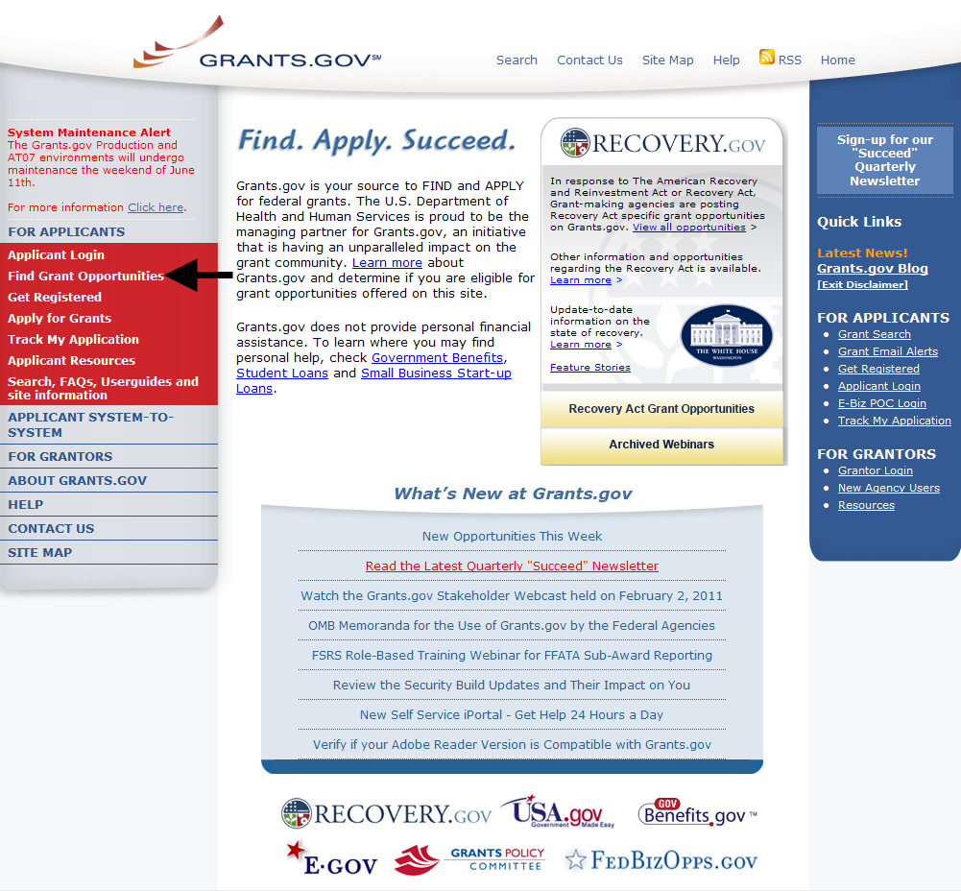

The Find Grants Opportunity screen is displayed. You can search for grant opportunities by clicking on the Basic Search link (arrow) or the Browse by Agency link (asterisk).
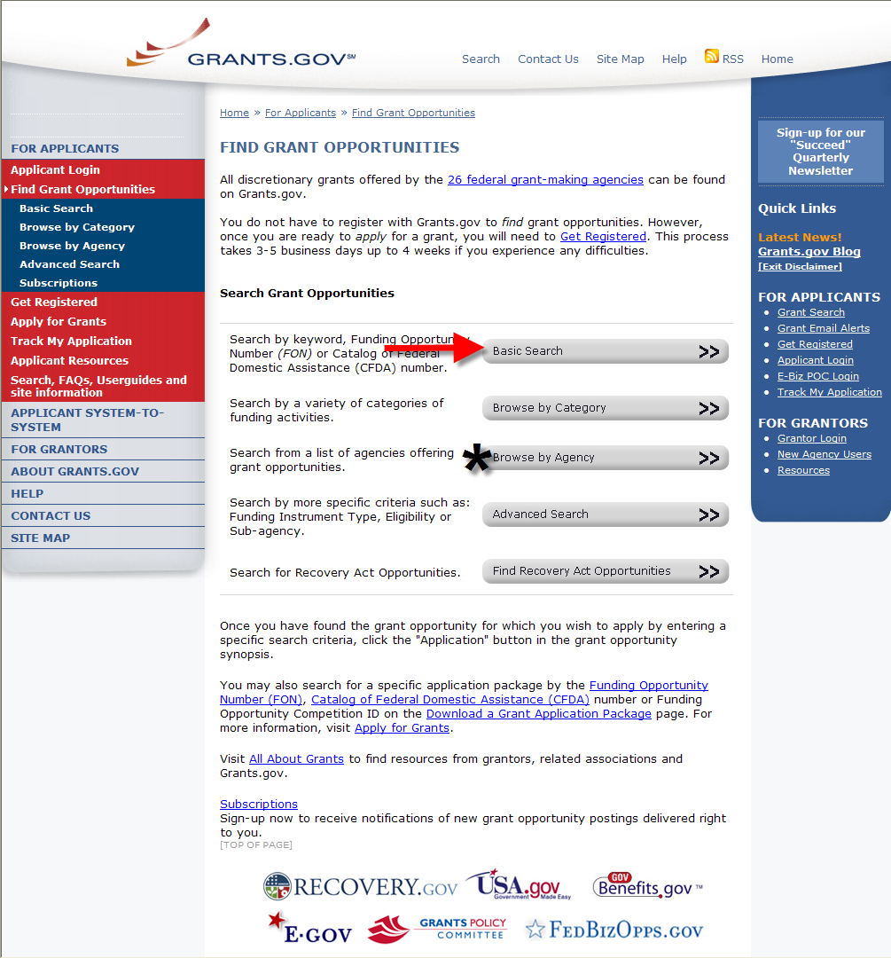

If doing a Basic Search enter a keyword(s), a Funding Opportunity number or a CFDA number then click Search.
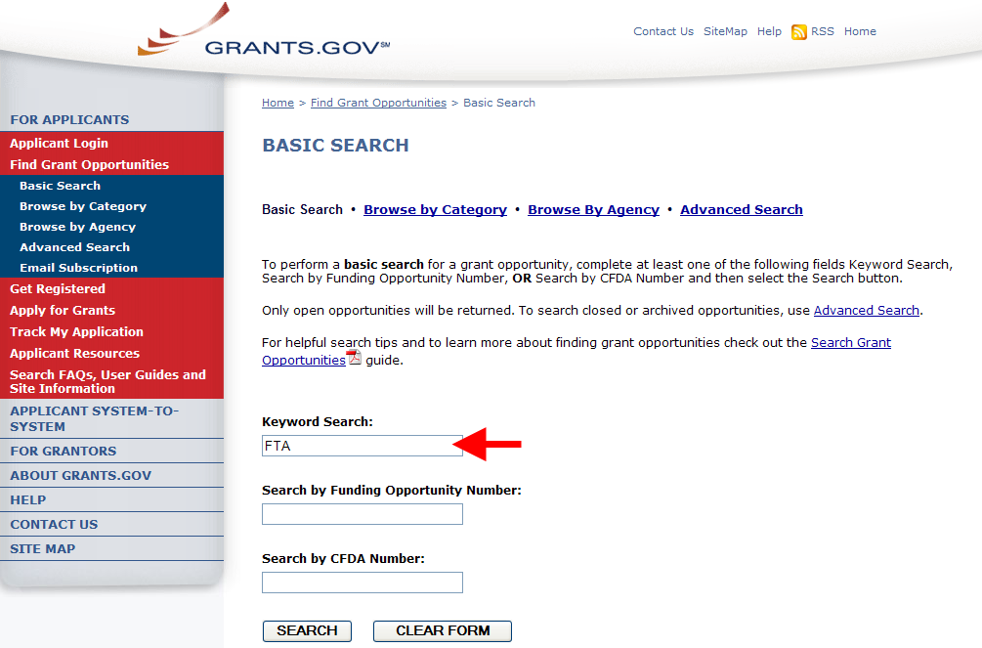

If searching by Agency, scroll down and click on Department of Transportation. Note: There is no separate entry for FTA.
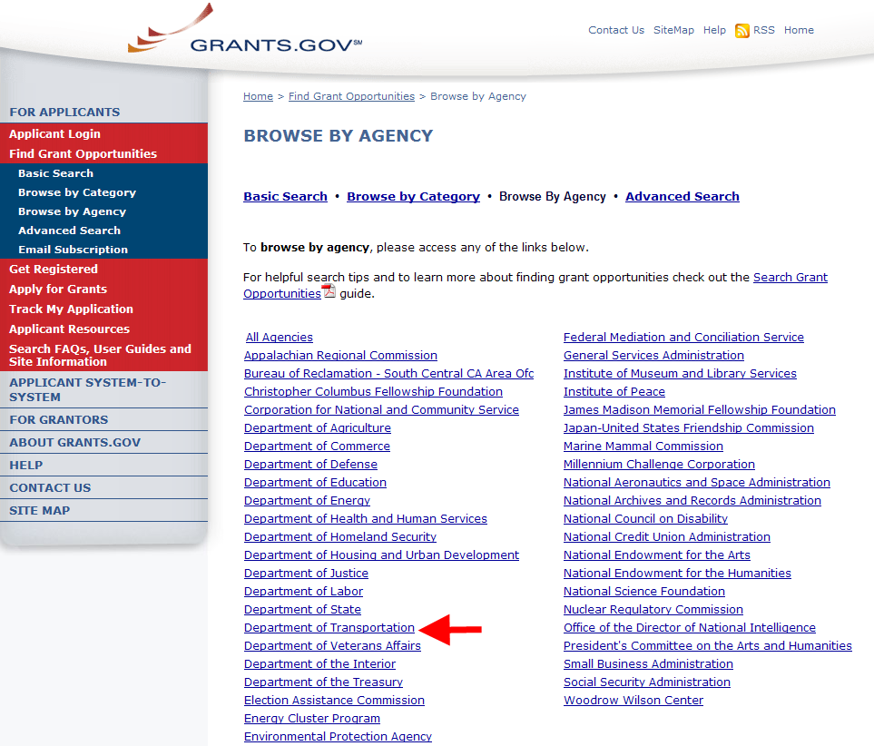

The Search Results page is displayed. All the available opportunities are displayed. Note: You will see more funding opportunities under the Department of Transportation that do not belong to FTA.
To view an opportunity, click on the name link (see the arrow) from the Opportunity Title column.
Note: The remaining screen shots are of data from the Grants.gov test environment. Locate the Grant Opportunity of interest.
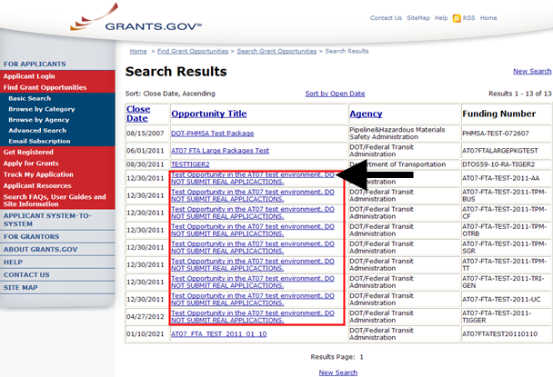

This page displays details about the opportunity. To apply for this opportunity click the Application link at the top right corner.
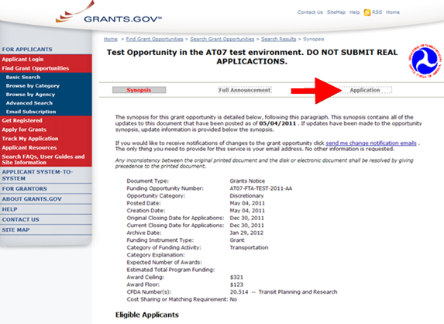

The Selected Grant Applications for Download screen is opened in a new window browser. In the table at the end of the page, click the download link located in the Instructions and Application column.
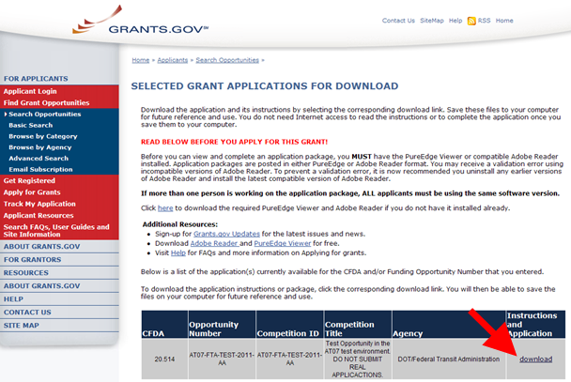

The Download Opportunity Instructions and Application screen is displayed. To download the SF424 application click link number 2. Download Application Package.
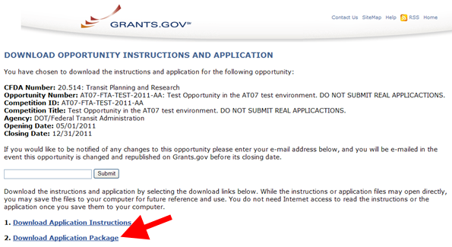

The SF424 is opened as a PDF file.
In the two blue boxes below the Application Filing Name, you must move the SF424 Mandatory Form and the Attachments from the Mandatory Documents to the Mandatory Documents for Submission. Simply highlight each of the forms, then click the Move Form to Complete button (see the arrow).
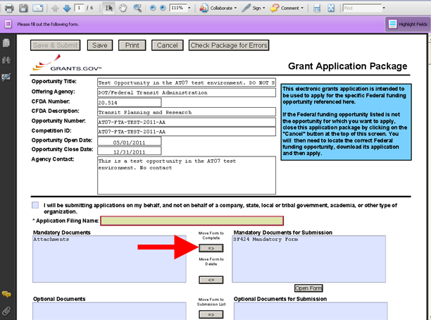

The Attachments Form you just moved over to the Mandatory Documents for Submission box is located at the end of the SF424. You MUST attach your proposal documents as specifed in the Federal Register Notice (Appendix A) in the Attachments Form section of the SF424 Form.
