Carbon Transport Research, Development & Demonstration Consortium

Membership Info Webpage Draft

DE-FOA-0003330
ISSUE DATE: September 18, 2024
Program Area: Office of Fossil Energy and Carbon Management (FECM)
RESPONSES DUE: October 09, 2024, by 5:00 p.m. ET.
The Office of Fossil Energy and Carbon Management (FECM), in partnership with the National Energy Technology Laboratory (NETL), intends to establish a Carbon Transport Research, Development & Demonstration (RD&D) Consortium (Consortium). The consortium would identify and coordinate initiatives for carbon transport RD&D efforts (e.g., pipeline, rail, truck, ship, and barge transportation); facilitate communication among stakeholders; and compile and curate information in an open access platform.

To obtain additional information that could be used to inform DOE’s decisions on the initiation of the Consortium and to gauge interest in the consortium, DOE is issuing a request for information (RFI). FECM intends to launch the Consortium after reviewing responses to the RFI. Please see the email address provided in the RFI to submit your response. Parties that express interest in joining the Consortium through the RFI will be contacted via email with instructions on how to officially register to join.
This webpage includes additional information regarding FECM’s proposed process for reviewing and accepting members for the Consortium. This process is subject to modification based on the feedback FECM receives from the RFI.
To Locate the RFI: The full text and instructions for the RFI can be obtained at:

http://www.fedconnect.net/fedconnect/?doc=DE-FOA-0003330&agency=DOE

Membership Requirements:
The Consortium will be comprised of three standing committees (see Figure 2), each with its own requirements. All members will be required to sign and adhere to a code of conduct to participate in the consortium.
Federal RD&D Steering Committee
- An individual must be employed by the U.S. government; and
- Members must be U.S. federal agencies that have mission capabilities relevant to the carbon management infrastructure value chain or in general with pipeline, rail, truck, ship, or barge transportation.
Committee for Federally Funded Research and Development Centers
- The laboratory or research and development center must be owned by the federal government; and
- Must be operated by contractors, including universities, other nonprofit organizations, and industrial firms (i.e. GOCOs).
Committee for Non-Governmental Organizations, Industry, and Other Subject Matter Experts
- Must be a U.S. citizen or person*;
- Must be an organization based or incorporated in the U.S.; and
- Meet an education requirement of having a bachelors degree or equivalent from an accredited institute of higher learning that is based in science, technology, engineering, mathematics or related field; or
- Meet a professional requirement of having direct work experience of least one year relevant to the carbon management infrastructure value chain or general transportation experience in pipeline, rail, truck, ship, or barge.
*U.S. Person includes foreign nationals that are legal permanent residents or green card holders.

Process to Clear a Potential Member: Organizations and/or individuals must provide the following information, as indicated in the RFI, when expressing interest in joining the Consortium and to the email cited in the RFI.
- First Name
- Last Name
- Position Title
- Entity Type
- Company/Organization Name
- Email Address
Consortium Structure: Figure 1 illustrates the proposed Consortium structure. FECM would be the Consortium manager and co-chair for some of the Consortium committees. FECM would lead and execute the Consortium with technical coordination and logistical/administrative support from the NETL.
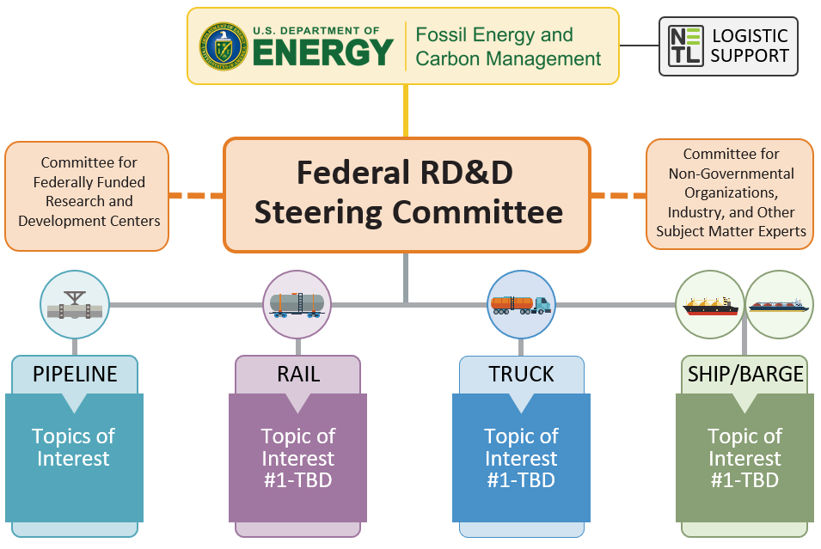
Figure 1 - Carbon Transport RD&D Consortium Structure

