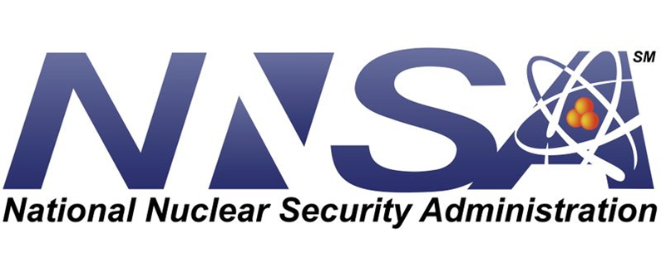

Stewardship Science Academic Alliances Program
______________________________________________________________________

Funding Opportunity Announcement (FOA) Number:
DE-FOA-0002457

FOA Type: Initial
Assistance Listing Number: 81.112

Revisions to FOA:

Invitation webinar has been removed, none available
travel requirement/training: SSAAP Symposium is mandatory for awarded applicants to attend instead of msipp language

