U.S. Fish and Wildlife Service
Anadromous Fish Restoration Program
Notice of Availability of Federal Assistance 2013
Request for Proposals

May 31, 2013

Program Overview Information

Federal Agency Name:
Department of Interior
U.S. Fish and Wildlife Service Red Bluff Fish and Wildlife Office
10950 Tyler Road
Red Bluff, CA 96080
Anadromous Fish Restoration Program

Funding Opportunity Title: Deer Creek DCID Dam Fish Passage Project, Phase 1

Funding Opportunity Number: F13AS00190

Announcement Type: Initial Announcement

Catalog of Federal Domestic Assistance number (CFDA): 15.648

Dates:
Application Deadline: Electronic copy applications must be received by Grants.gov by the close of business (COB) on July 1, 2013 (4:30 p.m. Pacific Standard Time). The U.S. Fish and Wildlife Service (USFWS) strongly encourages potential applicants to use Grants.gov when submitting responses to posted applications. If it is discovered that the proposal cannot be submitted through Grants.gov, the proposal may be submitted to Brenda Olson at Brenda_Olson@fws.gov. Proposals received after the date and time will not be considered for funding.

A site visit is highly encouraged. A site visit will be scheduled for mid-June, 2013. Once the date has been determined, it will be posted as a modification to the RFP on Grants.gov. We will meet at the southwest corner of Vina Road and Hwy 99, Lassen Steakhouse parking lot, 4945 Highway 99E, Vina, CA at 10:00am. Four wheel drive/high clearance vehicles are not required.

I. FUNDING OPPORTUNITY DESCRIPTION

A. LEGISLATIVE AUTHORITY AND BACKGROUND
1. The Central Valley Project Improvement Act (CVPIA; Title 34 of Public Law 102575, Section 3406(b)(1)), authorizes and directs the Secretary of the Department of the
Interior (DOI), in consultation with other State and Federal agencies, Indian tribes, and affected interests, to develop and implement a program which makes all reasonable efforts to at least double natural production of anadromous fish in Central Valley rivers and streams. Further, the CVPIA requires that this program give first priority to measures which protect and restore natural channel and riparian habitat values through habitat restoration actions, modifications to Central Valley Project operations, and implementation of the supporting measures mandated by the CVPIA. The DOI is approaching implementation of this directive through development of an Anadromous Fish Restoration Program (AFRP). The species and races of anadromous fish
addressed by the AFRP include fall-run, late-fall-run, winter-run, and spring-run Chinook salmon; steelhead; striped bass; American shad; white sturgeon; and green sturgeon.

2. The USFWS and Bureau of Reclamation (Bureau) are the DOI agencies responsible for implementing the CVPIA. They are jointly and cooperatively implementing the CVPIA, with the Service assuming lead responsibility for the AFRP. The CVPIA also establishes a Restoration Fund of up to $50 million annually to assist in implementation of the fish and wildlife restoration provisions. Of this sum, DOI allocates $3 to $12 million annually to the AFRP. The AFRP then leverages these funds with other funds provided by partners in restoration projects totaling $12 to $20 million annually.

B. PURPOSES AND FUNDING PRIORITIES
The purpose for the AFRP can be found in the Final Restoration Plan http://www.fws.gov/stockton/afrp/restplan_final.cfm and other program documents for the AFRP (USFWS 2001). These objectives are:

1. Improve habitat for all life stages of anadromous fish through provision of flows of
suitable quality, quantity, and timing, and improved physical habitat;
2. Improve survival rates by reducing or eliminating entrainment of juveniles at
diversions;
3. Improve the opportunity for adult fish to reach their spawning habitats in a timely
manner;
4. Collect fish population, health, and habitat data to facilitate evaluation of restoration
actions;
5. Integrate habitat restoration efforts with harvest and hatchery management; and
involve partners in the implementation and evaluation of restoration actions;
6. Involve partners in the implementation and evaluation of restoration actions.

These objectives are addressed through implementation of projects associated with prioritized actions and evaluations in the Final Restoration Plan for the AFRP.

Funding priorities are based upon the magnitude of the contribution of the restoration project to doubling natural production, the status of target species and races, and on Section 3406(b)(1)(A) of the CVPIA, which directs the AFRP to give first priority to: 1) measures which protect and restore natural channel and riparian habitat values through restoration actions; 2) modification to Central Valley Project operations; and 3) implementation of the supporting measures mandated by subsection 3406(b) of the CVPIA. http://www.fws.gov/stockton/afrp/restplan_final.cfm

C. PROJECT
Funding may be available through the USFWS AFRP to complete Phase I of the Deer Creek DCID Dam Fish Passage Project. Deer Creek is a tributary to the Upper Sacramento River near Vina, CA, in southeastern Tehama County. The USFWS requests submission of proposals for 1) completion of a final engineered design and an engineer’s cost estimate for repairs and/or modifications based upon selection of a preferred alternative by a Technical Advisory Committee; 2) development and completion of all required environmental documents and permits that may be required for this project; and 3) development of a Quality Control plan for the proposed data collection/analysis associated with pre- and post-project monitoring. A map of the project area is attached at the end of this document.

D. SCOPE OF WORK

1. Background:

The need to restore and maintain salmonid passage in Deer Creek is identified in AFRP and Ecosystem Restoration Program (ERP) goals, objectives, and targets. Both of these programs prioritize establishment, restoration, and maintenance of anadromous fish habitat quality on this stream. Providing unimpeded fish passage and maintaining suitable water quality are also of paramount importance. In the AFRP Final Restoration Plan, “…improving the opportunity for adult fish to reach their spawning habitats in a timely manner” is one of six objectives identified in achieving the AFRP program goal of doubling the natural production of anadromous fish in Central Valley rivers and streams on a sustainable and long-term basis.” For more information on Deer Creek as per AFRP and ERP, go to the following websites and obtain the planning documents:

http://www.fws.gov/stockton/afrp/workingpaper.cfm

http://www.fws.gov/stockton/afrp/ws_stats.cfm?code=DEERC

http://www.calwater.ca.gov/calfed/library/Archive_ERP.html

Deer Creek is located within the following EPA HUC designation: Stream Number Sacramento-Mill Big Chico (HUA 18020119). Deer Creek is an especially important watershed because it is one of the few remaining spawning habitats for the federally and state listed spring-run Chinook salmon (Oncorhynchus tshawytscha).

Deer Creek watershed is located within Tehama County. As a major Sacramento River tributary, Deer Creek originates just south of Lost Creek Meadows at an elevation of approximately 6,200 feet above mean sea level (MSL) (Attachment 1). As Deer Creek flows in a southwesterly direction, it is joined by Lost Creek in Upper Deer Creek Meadows; Lost Creek drains Wilson Lake. Gurnsey Creek also enters Deer Creek in Deer Creek Meadows. From these sub-alpine meadows the creek continues in a southwesterly direction into a deeply incised canyon (Evans 1997). It enters the Sacramento River at RM230 near the town of Vina, CA. Deer Creek is approximately 60 miles in length, and the watershed drains approximately 229 square miles. Deer Creek is bounded by a steep narrow canyon in the upper and middle watershed, thus enabling its pristine existence. At the lower valley reach, Deer Creek is more accessible and vulnerable to human impacts.

The Deer Creek watershed consists of relatively equal acreage of public and private lands. Most of the public lands consist of the Lassen National Forest including a portion of the Ishi Wilderness Area. There is a mixture of public and private lands in the upper and middle reaches, but the lower reach is mostly privately owned. Deer Creek is one of the few streams in California that is not altered by a major storage dam. However, due in part to naturally occurring low flows and diversions by Deer Creek Irrigation District (DCID or District) and Stanford Vina Ranch Irrigation Company (SVRIC), the upstream migration of spring-run Chinook salmon adults or downstream migration of juvenile spring-run Chinook salmon may be impeded or blocked during April, May, June and October. Similarly, fall-run Chinook (Oncorhynchus tshawytscha) and Central Valley steelhead (Oncorhynchus mykiss) adult and juvenile passage may be impeded or blocked during the same timeframes as well as Pacific lamprey (Entosphenus tridentatus).

The Deer Creek Irrigation District (DCID) Dam is the uppermost diversion dam on Deer Creek (Attachment 2). The DCID has adjudicated rights to divert a maximum of 60 cubic feet per second (cfs) but no more than one third of Deer Creek surface water for agricultural use. Surface water is diverted from Deer Creek at the DCID Diversion Dam, which is located approximately 10 miles upstream of the confluence with the Sacramento River. The DCID Diversion Dam is an old concrete structure that has vertical I-beams that constitute check board slots. The dam is a flashboard dam about 75-feet long and 2.5-feet high without flashboards. The flashboards are placed in the dam during irrigation season as early as February and remain in place through October. The flashboards consist of 2x6 boards cut in approximate 4.5-foot lengths and can be stacked 5 boards high. Water enters the diversion ditch through a 10-foot wide weir section and is controlled by two 48-inch wide vertical slide gates 3-feet tall. Each spring DCID installs the I-beams and check boards and removes them each fall before winter rains and run-off occur. Downstream of the slide gates is a flat plate fish screen with a juvenile bypass return. The juveniles are returned to the creek through a bypass pipe. The screen is maintained by the California Department of Fish and Wildlife (CDFW)(See Figures 1 through 7 at back of document).

Water diverted at the DCID Main Diversion Dam is directed into the District’s Main Canal, which begins on the south side of Deer Creek. Flow diverted into the Main Canal is measured approximately ¼ mile downstream of the Main Diversion Dam by a Parshall flume constructed by the Department of Water Resources (DWR). From the DCID Main Diversion Dam, the Main Canal conveys water for approximately three miles until it reaches a point referred to as the Main Canal “Y.” At the “Y,” the Main Canal divides into the North Main Canal and South Main Canal. The North Main Canal extends westward parallel to Deer Creek. The South Main Canal runs west and south for a distance of approximately four miles. Most of DCID’s canals are lined with concrete.

The DCID facility is located at latitude 40.011299°, longitude -121.954415° at an elevation of 497 ft. The dam can be identified on the United States Geological Survey, 7.5-minute series, Acorn Hollow quadrangle.

Through a contract with the Ecosystem Restoration Program (ERP), the California Department of Water Resources (DWR) Fish Passage Improvement Program (FPIP) developed alternatives for a solution to fish passage at the DCID Dam. Of the five alternatives developed, in cooperation with a technical advisory committee comprised of a DCID representative, the USFWS, National Marine Fisheries Service (NMFS), DWR, and CDFW, one was selected which includes lowering the existing diversion ditch elevation and potentially replacing the Parshall flume, fish screen, and headworks. To address passage over the dam, a a rock ramp is proposed to be constructed below the dam face to raise the water surface below the dam face. DWR FPIP will complete the conceptual (50%) design of this proposed solution by fall, 2013. Oversight and review of the draft design documents is being provided by DCID and NMFS engineers.

CDFW and NMFS have fish passage and screening criteria for anadromous salmonids in this region of California (CDFW 2010)(NMFS 2011). Due to the location of the diversion within the watershed, CDFW and NMFS have determined the design must meet both adult and juvenile salmonid passage criteria.

2. Goal of Project:

The goal of the Deer Creek DCID Dam Fish Passage Project, Phase I is to complete the design (to 100% engineer stamped designs) and permit/environmental document preparation phase. The overall Project goal is to provide unimpeded fish passage for all life stages of anadromous fish found within Deer Creek over the long term, and to see a corresponding increase in production.

3. Project Objectives:

A. Using the provided 50% designs, complete 100% engineer stamped designs that will provide unimpeded fish passage of both juvenile and adult salmonids over the DCID infrastructure. The 100% designs will meet NMFS and CDFW fish passage criteria.

B. Complete all necessary environmental documents and permits needed, to appropriate agency standards, for Phase 2: Project Implementation. This includes, but is not restricted to, National Environmental Quality Act (NEPA), California Environmental Quality Act (CEQA), Section 7 of the Endangered Species Act (ESA), Section 106 of the National Historict Preservation Act (SHPA), a CDFW Streambed Alteration Agreement (1600 permit), and Clean Water Act Section 401 and 404 permits from the State Water Resources Control Board and U.S. Army Corps of Engineers, respectively.

C. Prepare a quality control plan to develop the pre-and post-project monitoring needs for this project.

4. General Methods:

Project Area: A map is attached at the end of this document (Attachment 2). This Project is entirely on private lands. Access permissions have been acquired, however sideboards may apply such as notifying the landowners as to when the successful Applicant will be on site.

The successful Applicant will perform project management, which includes working with the USFWS, CDFW, NMFS, DCID, DWR, and affected landowners, a subset of which will comprise a Technical Advisory Committee (TAC). Coordination with CDFW Redding Office should occur to determine if design alternatives will be accepted by CDFW and NMFS for implementation. A California licensed engineer should be on the design team.

The design for passage improvement must meet the 2011 NMFS Anadromous Salmonid Passage Facility Design, and CDFW criteria for fish passage as described in the “Fourth Edition (2010), Volume II, Parts IX and XII, of the California Salmonid Stream Habitat Restoration Manual (Manual). These documents can respectively be found at:
http://www.nwr.noaa.gov/habitat/habitat_conservation_in_the_nw/habitat_conservation_in_the_nw.html
http://www.dfg.ca.gov/fish/Resources/HabitatManual.asp

In the below Methods, the applicant is responsible for determining the amount and kinds of topographic and/or other data gathering that is necessary in order to complete the proposed alternative design. Data gathering below is only suggested as a beginning and may not be all that is necessary.

General Methods

The successful applicant will need to accomplish three tasks for Phase I; final stamped engineered design of preferred alternative, environmental compliance, and obtain necessary permits.

Fish passage design will have to comply with NMFS and CDFW requirements as stated above. Design approval should occur with a NMFS and/or CDFW fish passage engineer prior to the start of regulatory agency consultation. In addition, coordination with CDFW Redding Office should occur to determine if design will be accepted by CDFW for implementation. A licensed engineer should be on the design team.

Site Conditions and Assumptions: The preliminary drawings and layouts contained in the 50% design report from DWR will be refined during the final design process. Additional surveys and hydraulic analyses may be necessary because of changes in the site conditions since this investigation was conducted, and to gain additional information required for final design.

Codes and Standards: In addition to the above requirements/compliance concerns, final designs will also be governed by the following criteria:

- Final structural designs will comply with the latest Uniform Building Code requirements, as applicable.

- Final concrete designs will comply with the latest American Concrete Institute Building Code Requirements for Reinforced Concrete Design, as applicable.

- All current applicable Cal Occupational Health and Safety (OSHA) standards will be met.

- An operations and maintenance manual should be made available prior to project completion.

- The elevations shown in drawings are based on North American Vertical Datum (NAVD) of 1988, US Feet. Descriptions and elevations of control points can be obtained from DWR.

- As applicable, actual concrete thickness, foundation requirements, and reinforcement requirements will be determined by the final design engineer.

- Actual rock thickness and key dimensions will be determined by the final design engineer; source of suitable rock to be used in the channel will be identified, and the rock will be evaluated for the rock’s suitability to be used as such.

- The walls and footings associated with the headgate and/or screen, used for cost estimating purposes, will not be shown on the drawings provided by DWR. Actual dimensions of concrete-related structures will be determined by the final design engineer.

- Pacific Lamprey (Entosphenus tridentata) passage will also be evaluated in coordination with the Technical Advisory Committee.

Both State and Federal environmental compliance must be complete in order to implement the project designs. Applicable county permits may also be required. The successful applicant will be responsible for writing needed CEQA and NEPA documents, as well as regulatory documents, in order to complete consultation with regulatory agencies, such as the USFWS, NMFS, CDFW, and the State Historic Preservation Office, to name a few. This includes completing consultation under Section 7 of the Endangered Species Act (ESA) and Section 106 of the National Historic Preservation Act (NHPA). Coordination with the USFWS will need to occur for Section 7 and Section 106 consultation completion. In addition, consultation with CDFW under the California ESA (CESA) will be required.

Access to the project area and permission for inventory/verification has been obtained in writing, although verification of the selected applicant must be provided to and approved by the landowners and the DCID Board of Directors. The entire project area is privately owned.

II. AWARD INFORMATION

The Red Bluff Fish and Wildlife Office, Anadromous Fish Restoration Program is soliciting proposals to complete Deer Creek DCID Dam Fish Passage Project, Phase 1. The AFRP anticipates up to $100,000 may be available for funding this project. Successful awards will be made through a grant.

Anticipated project start date would be initiated in fiscal year 2013 and work may commence as early as September 2013, once all signed grant documents are in place. The Project must be completed within two years upon signing the grant agreement.

III. ELIGIBILITY INFORMATION

A. Eligible Applicants

* Eligible applicants are limited to those institutions, organizations or individuals with a background in fish passage design and completing Federal and California State environmental compliance documents and permitting needs.

* A licensed engineer should be on the fish passage design team and must be licensed by the State of California Board of Professional Engineers.

*Applications from federal agencies or employees of federal agencies cannot be considered.

* The applicant shall be fully capable, qualified, insured, and licensed as required to provide these services.

Please also list all offices used by the respondent and the location of the office from which the primary work on this project would be performed.

B. Cost Sharing or Matching
There is no cost-sharing or matching requirement for this award.

IV. APPLICATION AND SUBMISSION INFORMATION

A. This Announcement Contains All the Information Required to Submit an
Application

1. Electronic Applications Materials The required Standard Form (SF) 424 form set may be accessed at http://www.grants.gov or by contacting Brenda Olson at Brenda_Olson@fws.gov for any other of the required forms as listed in the grant solicitation or in 2) Supplemental Requirements as listed below.

Grants.gov supports the Adobe Reader versions 8.1.1, 8.1.2, 8.1.3, 8.1.4, 8.1.5, 8.1.6,
8.1.7, 9.0, 9.1, 9.1.1, 9.1.2, 9.2, 9.3.2, and 9.4. Some of these versions are available for free download from the Adobe Website:
http://www.adobe.com/products/acrobat/readstep2.html. You may also check this link to see if your version is compatible http://www.grants.gov/help/download_software.jsp. Only these versions should be used when submitting grant applications. Other Adobe Reader versions are not supported.

2. Hard Copy Application Materials

If you do not have access to the web page or have trouble downloading material, and you would like a hard copy you may mail the request to Brenda Olson at the Red Bluff Fish and Wildlife Office (RBFWO), 10950 Tyler Rd, Red Bluff, CA 96080 or call (530) 527-3043 x227. When calling the RBFWO, please indicate that you are requesting the RFP and associated application forms for F13AS00190, Deer Creek DCID Dam Fish Passage Project, Phase 1. Materials may also be requested via Internet by sending an e-mail to Brenda_Olson@fws.gov. For all technical questions, call Brenda Olson at (530) 527-3043 x227.

B. Content and Form of Application Submission
1. Application Requirements

This announcement contains all the information needed to submit a proposal. The project proposal is a narrative description and the budgetary information of the project. Only information that is pertinent to the project should be included. The project proposal should also indicate whether partial funding of the project is practicable, and, if so, what specific portion(s) of the project could be implemented with what level of funding.

A project proposal that is part of a longer term initiative will be considered, however, the proposed project’s objectives, benefits, and tasks must stand on their own, as there are no assurances that additional funding would be awarded in subsequent years for associated or complementary projects. An incomplete proposal will not be considered for funding.

Applications must be no smaller than 12 point font, preferably in Times New Roman type, with 1-inch margins, double-spaced, no longer than 22 pages and submitted in single-sided, electronic or hard copy.

Complete applications must include:
. • Applicant name, mailing address, phone and fax number, and email
. address
. • Budgetary information (including necessary Federal Forms, i.e. SF-424
Application for Assistance)
• Background and need for proposed work
. • Justification for proposed work
. • Approach including study design, hypotheses, goals, methods, equipment
. and facilities, data collection, any statistical analysis and quality assurance
. procedures, tasks
. • Feasibility of the described approach, any contingencies or requirements
. (e.g., dependence on outcome of other projects, environmental compliance or
permitting)
. • Performance measures related to project goals and objectives
. • Data handling and storage
. • Expected products and outcomes
. • Deliverables for each task
. • Work schedule, including estimated start and completion dates of each task
. • Applicant qualifications and experience. In addition, the applicant must
provide a list between one to three projects completed by the firm that
demonstrates the applicant’s competence to perform work similar to that
which is likely to be required on this project. This portion of the proposal will
not be counted as part of the 22 page limit.

The Applicant shall name a project manager for these services who will coordinate all activities with the USFWS and the TAC selected for this Project.

2. Supplemental Requirements

The following table provides a summary of the supplemental forms and requirements that must be included in the application. The Dun & Bradstreet (DUNS number), System for Award Management (SAM) registration, and electronic funds transfer actions are a requirement. Potential applicants must complete these requirements before the award can be made.
What’s required Available at When to submit

Application for  Federal Assistance, Standard Form SF424 Cover sheet, 424 A & B for Non- Construction; C  & D for Construction awards | http://www.whitehouse.gov/omb/grants/grants_for ms.html  http://www.gsa.gov/forms http://www.fedforms.gov | By July 1, 2013
Dun & Bradstreet Number (DUNS) | www.dnb.com www.dnb.com/US/customer_service/index.html  1-800-234-3867.  http://www.dnb.com/us/ | Will need before registering with SAM
Registration in  the System for Award Management (SAM) | http://www.SAM.gov | In time to allow  for processing  if not already in the system. By July 1, 2013
Register in the  Automated Standard Application for Payment (ASAP) or submit a waiver request | Forms are available at the Red Bluff office of the  U.S. Fish and Wildlife Service 530-527-3043 x227 or at www.fws.gov/fbms.  Note: Must be completed for funds transfer to occur. If your organization has already registered with another Governmental agency, you still need to complete this form to register with the USFWS. | Only if awarded
Registration  Grants.gov  *Before applying for a grant opportunity on Grants.gov,  an applicant must complete the registration process | http://www.Grants.gov or support@Grants.gov, or you may call the Contact Center at:  1-800-518-4726  Registration is a 3-step process:  1. Register your organization, then;  2. Register yourself as an Authorized Organization  Representative (AOR) then;  3. Become authorized by your organization to submit applications  Please note: It may take up to two (2) weeks to complete the registration process due to unexpected delays. It is highly recommended that you begin the registration process as soon as possible  SEE THE GRANTS.GOV WEBSITE FOR COMPLETE DETAILS | In time to allow for processing if not already in the system.

3. Data Universal Numbering System Number (DUNS)

On June 27, 2003, The Office of Management and Budget (OMB) published a Federal Register notice (68 FR 38402) that announced final policy issuance on the use of a universal identifier by grant applicants. The policy requires applicants applying for Federal grants or cooperative agreements on or after October 1, 2003 to acquire a Data Universal Number System (DUNS) number. It is the responsibility of the organization seeking Federal funds to obtain a DUNS, as necessary. Grant and cooperative agreement applicants need to ensure they have a DUNS number. Organizations can receive a DUNS number at no cost by calling the dedicated toll-free DUNS number request line at 1-877- 753-1444 or on the web at http://smallbusiness.dnb.com/manage

C. Submission Dates and Times
Electronic applications must be received by Grants.gov by the close of business on July 1, 2013 (4:30 p.m. Pacific Standard Time). If the proposal cannot be submitted via Grants.gov, it may be submitted to Brenda_Olson@fws.gov by 4:30 pm Pacific Standard Time, July 1, 2013. If the electronic application cannot be submitted, a hard copy must be received by the RBFWO Anadromous Fish Restoration Program (address as above in section IV A. 2.), attention Brenda Olson, by July 1, 2013 (4:30 pm Pacific Standard Time). Hard copy applications should be printed on one side only and should not be bound in any manner. Proposals received after the date and time will not be considered for funding.

D. Intergovernmental Review
This program is not covered by Executive Order 12372. Review process is not required.

E. Funding Restrictions:
Awards will not allow reimbursement of pre-award costs. Funding is contingent upon the RBFWO Anadromous Fish Restoration Program’s receipt of an adequate implementation project budget for FY 2013.

V. Application Review and Selection Information
A. Criteria
Applications will be considered complete if they include all the information required in sections IV.B.1-3.

Applications are sought that show the applicants expertise and ability to assess fish passage issues and design fish passage remediation as well as completing environmental compliance documents, consultations, and permits.

Proposals will be reviewed by a team of Federal staff based on the following criteria:

•. Will the proposed approach succeed in
the stated goal?

• Approach is valid and technically sound. Are the proposed deliverables of
value?

• Possess experience and qualifications in assessing and designing fish
passage facilities, particularly the structure that is proposed as the preferred
alternative;

• Possess experience and qualifications in completing environmental compliance
documents, consultations, and permits, and developing technically sound
monitoring plans;

• Primary Investigators and/or sub-recipients record of performance and
expertise, and inclusion of a state licensed engineer on the fish passage
design team;

• Budget is reasonable and provides good value for funds requested; and

• Past performance on projects; working knowledge of fish passage design and
regulatory documents and processes.

B. Review and Selection
Additional technical review will be conducted by reviewers external to the Anadromous Fish Restoration Program and unaffiliated with any organization submitting a proposal or proposed subcontractors. Projects selected for funding may require revision based on internal and/or external review comments. The selection recommendations of the
Federal staff (and any external reviewers) will be provided to the RBFWO Project Leader, who is the Selection Official. The Selection Official will make the final award decision. All applicants will be notified of the results of the selection process by the Grants/Agreements Assistant.

C. Applicant’s and the USFWS responsibilities
1. Applicant’s Responsibilities and Deliverables

Successful applicants shall ensure that the project complies with all applicable Federal, State and local laws and regulations. A successful applicant is ultimately responsible for obtaining all applicable Federal, State and local permits for work to be performed under the award.

The successful applicant will provide status updates in electronic format, frequency to be determined, that tracks project status. Applicant will agree to use the U.S. Treasury’s Automated Standard Application for Payment (ASAP) program for on-line reimbursement. The reimbursement request may not be made more frequently than monthly. Also the applicant will include a detailed narrative explaining costs for labor and materials and documenting the activities conducted for the hours sought in reimbursement to the Grant Manager. Narratives provided will suffice to meet the quarterly status updates if accepted by the Service.

Applicant will provide quarterly status updates in electronic format that track project status. Invoices will include a detailed narrative explaining costs for labor and materials and documenting the activities conducted for the hours invoiced.

Ten percent of the total amount of the agreement may be withheld until all requirements of the agreement are accomplished. If 10% is withheld, a final invoice may be submitted for the 10% withheld once all the requirements are approved.

2. USFWS Responsibilities
USFWS will provide a science-based technical review of selected proposal, may provide technical information, and may be available for assisting with products such as peer- reviewed publications.

VI. AWARD ADMINISTRATION INFORMATION A. Award Notice
Successful applicant will be notified after selection and confirmation of available funding, by August 15, 2013. An applicant should not initiate a project in expectation of USFWS funding, nor should they purchase materials or begin work until such time as they receive the final award document signed by an authorized Service official.

B. Administrative and National Policy Requirements:

Federal awards are subject to Federal financial administrative requirements. Please see the following for a particular application.

Non-Profit Organizations | OMB Circular 2 CFR Part 215  OMB Circular A-122 Cost Principles  OMB Circular A-133, Audits of States, Local
Governments, and Non-Profit Organizations
43 CFR Part 12, Subpart D – Government-wide Debarment and Suspension (Nonprocurement) And Government-wide Requirements for a Drug Free Workplace
43 CFR Part 12, Subpart E – Buy American Requirements for Assistance Programs
43 CFR Part 18 – New Restrictions on Lobbying 48 CFR Part 31.2 – Contracts with Commercial Organizations (if work will be subcontracted out)
48 CFR Part 52.215.2 – Audit and Records Negotiation
For profit, individuals and others excluded from coverage with OMB Circular A-122 | Federal Acquisition Regulations, full text of appropriate clause may be found at http://www.arnet.gov/far  43 CFR Part 18 – New Restrictions on Lobbying 48 CFR Part 31.2 – Contracts with Commercial Organizations  43 CFR Part 12, Subpart E – Buy American Requirements for Assistance Programs
Governments – State, Local, and Federally Recognized Indian tribal governments | OMB Circular A-102  OMB Circular A-87, Cost Principles for State, Local and Indian Tribal Governments  OMB Circular A-133, Audits of States, Local Governments, and Non-Profit Organizations  43 CFR Part 12, Subpart E – Buy American Requirements for Assistance Programs  43 CFR Part 18 – New Restrictions on Lobbying 43 CFR Part 12, Subpart D – Governmentwide Debarment and Suspension (Nonprocurement) And Governmentwide Requirements for a Drug Free Workplace  48 CFR Part 52.215.2 – Audit and Records Negotiation

C. Reporting Requirements
1. Performance and Financial Reports
The successful applicant shall submit an annual interim written performance report to the project contact listed in VII no later than October 1 in Adobe PDF or Microsoft Word. The report’s format must present the activities that occurred and provide a description of the project accomplishments during the calendar year. The Financial Report must use the Standard Form 425 Federal Financial Report. The reports shall be submitted within 90 days after the last day of each annual interim reporting period. Please see the following schedule for due dates of both the Performance and Financial Reports:

Award Effective Date Annual Interim Report Annual Interim Report
End Date Due Date
(90 days after report end date)
January 1 | December 31 | March 31
January 2 – March 31 | March 31 | June 29
April 1 | March 31 | June 29
April 2 – June 30 | June 30 | September 28
July 1 | June 30 | September 28
July 2 – September 30 | September 30 | December 29
October 1 | September 30 | December 29
October 2 – December 31 | December 31 | March 31

The successful applicant shall also submit written progress reports to the project contact
listed in VII on a quarterly basis in Adobe PDF or Microsoft Word format presenting the
activities that occurred and provide a description of the project accomplishments during
each quarter of the calendar year beginning with the quarter immediately succeeding the project start date. The reports shall be submitted within 30 days following the end of each quarter.

2. Final reports
Draft final reports are due no later than 60 days after completion of the project. Final
reports will be due 30 days after receipt of Service comments on the draft report. The
successful applicant shall submit, within 90 calendar days of completion of the project, a
final invoice. The successful applicant shall account for any real and personal property
acquired with Federal funds or received from the Federal Government according to
requirements of regulations referenced in the award. The final report will be provided in
hardcopy and electronic copy, using Adobe PDF or Microsoft Word format, and sent to:
(Habitat Restoration Coordinator’s mailing and e-mail address. See Section VII.).

3. Invoice Reports
Awardee will be required to submit requests for reimbursement through the Automated
Standard Application for Payment (ASAP) system or to submit a waiver request which must be approved for this requirement. ASAP enrollment and waiver forms are available at: www.fws.gov/fbms. The applicant will also send a detailed narrative explaining costs for labor and materials and documenting the activities conducted for the hours sought in
reimbursement to the Grant Manager.

VII. AGENCY CONTACT(S)
For technical questions associated with this project contact Brenda Olson, Anadromous Fish Restoration Program Habitat Restoration Coordinator; 10950 Tyler Road; Red Bluff, CA 96080; telephone 530-527-3043, ext. 227; fax 530-529-0292;
email:Brenda_Olson@fws.gov. For questions of an administrative content, such as
forms completion and for sending hard copies such as the signature page, contact
Brenda Olson.

VIII. OTHER INFORMATION

Please note that the Federal Government is not obliged to make any awards as a result of this announcement, and only official Service grant officers can bind the Government to the expenditure of funds. If you are selected as a Federal grant recipient, the funds you receive may be subject to Federal and other taxes.

A. Proposal preparation instructions and format:
In addition to the required forms identified in Section IV, a narrative proposal is also
required. The following is the format of the proposal, as well as instructions on how to
complete the proposal.

1. Project information page

This proposal (title of proposal) is for the fiscal year 2013:
1) name;
2) proposal title;
3) project duration;
4) lead organization name;
5) enter the name of the agency or institution to whom funds would be awarded;
6) organization contact (please provide information for the primary person responsible for oversight of the project’s operation, management, and reporting requirements at the lead institution, social title, first name, last name, street address, city, state or province, ZIP Code or mailing code, telephone (include area code and email);
7) lead investigator (is the lead investigator the same as the main contact person? If not
please provide information for the primary person responsible for oversight of the award
operation, management, and reporting requirements at the lead institution, social title, first name, last name, street address, city, state or province, ZIP Code or mailing code,
telephone number and e-mail); and,
8) provide information about additional investigators (last name, first name,
organization).

2. Summary or abstract page

Provide a summary of your project including the following: a brief description of your
proposed project, including location, goals, objectives, the actions to be implemented,
and the approach to implement the proposal, expected outcomes, and relationship to
high priority needs.

3. Proposal description text

a. Problem-describe the problem that the project is designed to address including a brief narrative of the project location. Provide background, including a review of relevant past studies of and solutions (if any) to the problem, here and elsewhere, with appropriate citations of relevant reports. Clearly state the goals, objectives and hypotheses of your proposed study.

b. Approach (scope of work) -Provide study design. Describe (if applicable) all sampling, analytical, planning, and construction procedures for each objective as appropriate. Include details about methods and techniques, equipment and facilities, data collection, statistical analysis and quality assurance procedures, performance measures, and describe the criteria to be used in hypothesis testing. Clearly identify how your approach maximizes the information richness and value to decision-makers.

c. Feasibility-Demonstrate that the described approach is both feasible and appropriate to the proposed work, and that the project can be completed in the time allotted, allowing for weather and other exigencies. Any contingencies or requirements (e.g., dependence on outcome or timing of other projects, dependence on natural or operational conditions, environmental compliance and permitting) must be thoroughly addressed.

d. Permits and agreements-If applicable, explain what permits are necessary to proceed with the tasks described. Explain the current status of each permit. Explain any other constraints that could impact the schedule and the ability to implement the project. Identify the nature and approach to resolving other outstanding implementation issues.

e. Private property access and landowner permission and participation-Projects
proposed on private property or that require access of private property owned by someone other than the applicant must provide written permission from the property owner. Projects conducted in the field for which specific locations have not been identified in the proposal will be required to provide access needs and permission for access shortly after notification of approval. Failure to include written permission from the property owner may result in disqualification of the proposal. This is another hard copy item that should be sent, along with other hard copy items (such as the signature page), to the RBFWO Anadromous Fish Restoration Program contact person (See Section VII, Agency contacts).

f. Data handling and storage -describe how the data and other information will be
handled, stored, and made accessible.

g. Expected products/outcomes -Provide a list of planned deliverables such as; reports, presentations, advances in technology, and information transfers via workshops, seminars, education programs, etc. and timing of each.

h. Qualifications. Provide brief biographical sketches of the principal participants,
identifying education and relevant experience as well as contributions (e.g., completed
projects, published reports on the same topic) consistent with their roles and
responsibilities in the proposed project. Explain how these participants provide the range of expertise in sciences or other disciplines needed to achieve the project’s objectives.

Specify individual roles and responsibilities regarding technical, administrative, and
project management. When sub-recipients are identified, explain briefly how they were or will be selected and why. Disclose or discuss any potential problems regarding the
principal participants’ availability to complete their work within the projected timeline.

4. Work Schedule page

Identify the start and completion dates of each of the tasks and associated deliverables
discussed above as well as other key milestones. Clearly identify which tasks are
considered to be inseparable if only a portion of the project were to be funded. Identify the potential to incrementally fund and implement the proposed scope of work.
Identify how payments would relate to milestones, as applicable. Please identify project
management as an independent task. Provide a time line with expected start and stop
dates, and accomplishment of milestones.

Tasks identified in the work schedule should match those shown in the budget.

5. Budget

Provide a detailed budget showing how requested funds will be used to carry out the
project's scope of work. Costs for each major task described in the "Approach (scope of
work)” section of your proposal must be presented. A task for project management should include the specific costs associated with insuring accomplishment of a specific project, such as inspection of work in progress, validation of costs, report preparation, response to project specific questions and necessary costs directly associated with specific project oversight. Applicants should also include costs associated with managing project funds, including preparation of quarterly, annual, and final reports to the funding agency. Tasks for environmental compliance, monitoring, project design, data handling, storage, and dissemination, and public outreach should also be included as appropriate for your project.

Include information related to cost sharing and in-kind contributions.

Suggested Budget Format:
Year 1 ( Months 1 to 12 ) 6. Signature page
task | labor | benefits | travel | supplies and  expendables | services  and consultants | equip ment | lands and rights of way | other direct costs | direct total | indirect costs | total
totals | $0 | $0 | $0 | $0 | $0 | $0 | $0 | $0 | $0 | $0 | $0

References:

California Department of Fish and Wildlife (previously Game). 2010. California Salmonid Stream Habitat Restoration Manual, 4th Edition.
Evans, S. 1997. Comments on draft Deer Creek Existing Conditions Report. Letter to Deer Creek Advisory Committee dated September 15, 1997.

The Habitat Restoration Group. 1998. The Deer Creek Existing Conditions Report.
Prepared for the Deer Creek Watershed Conservancy. Unk. pp.

National Marine Fisheries Service. 2011. Anadromous Salmonid Passage Facility Design. NMFS, Northwest Region, Portland, Oregon.
U.S. Fish and Wildlife Service. 2001. Final Restoration Plan for Anadromous Fish
Restoration Program. 146 pp.

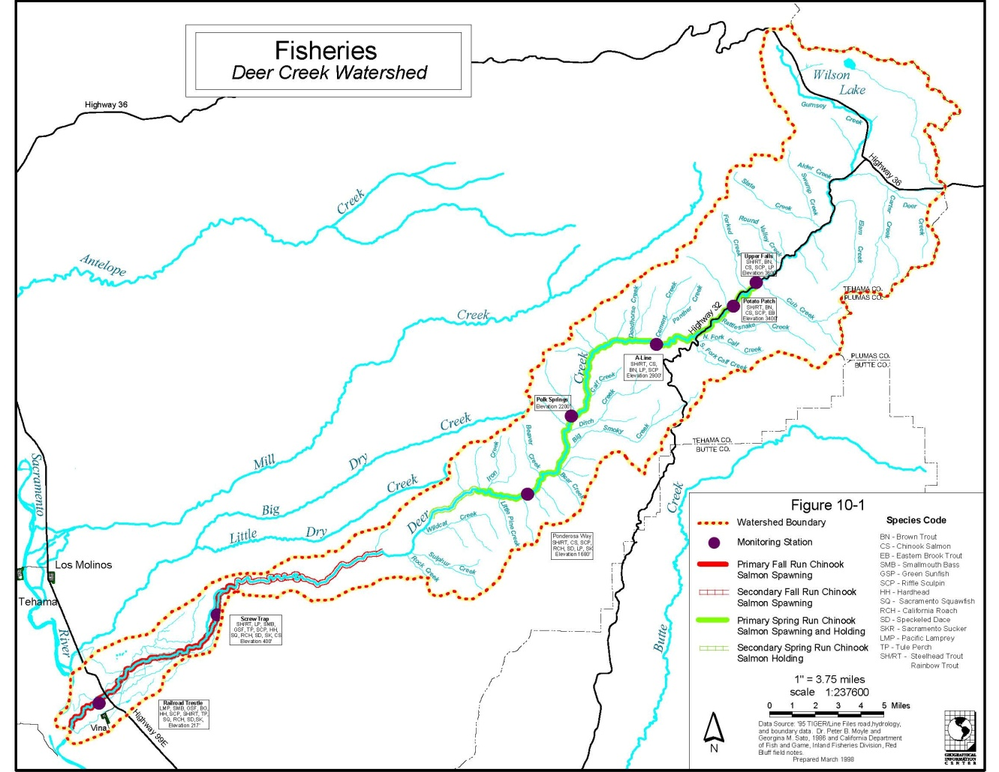
Attachment 1. Map of the Deer Creek watershed. Source, Deer Creek Existing Conditions Report 1998.

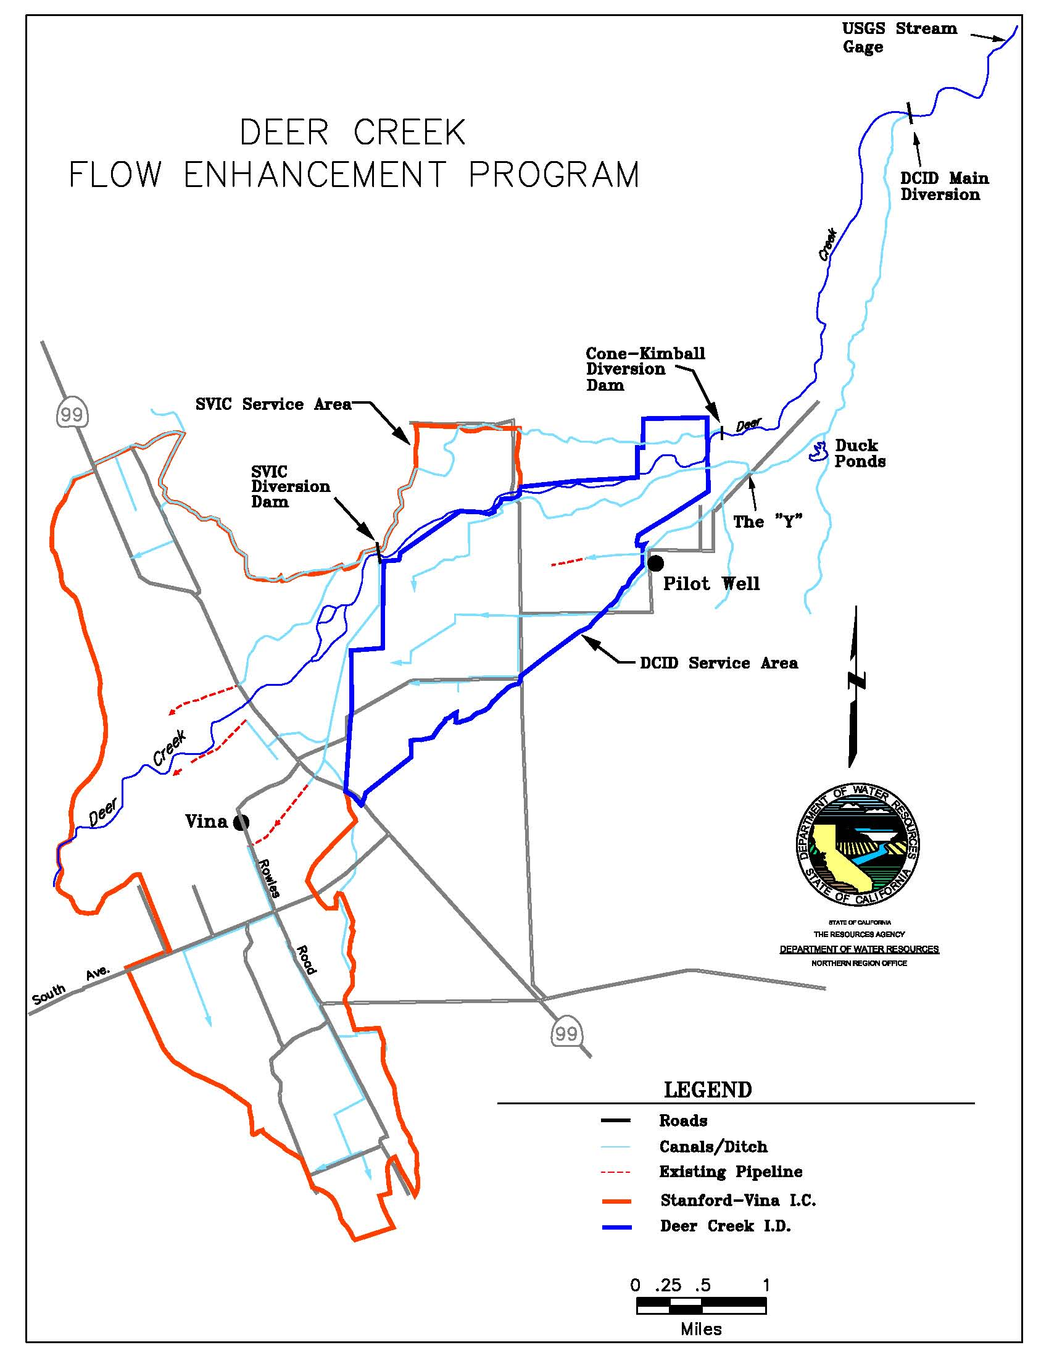
Attachment 2. Map of lower Deer Creek, DCID Dam, and the surrounding area. Source, Deer Creek Flow Enhancement Program Support Document, 2010.

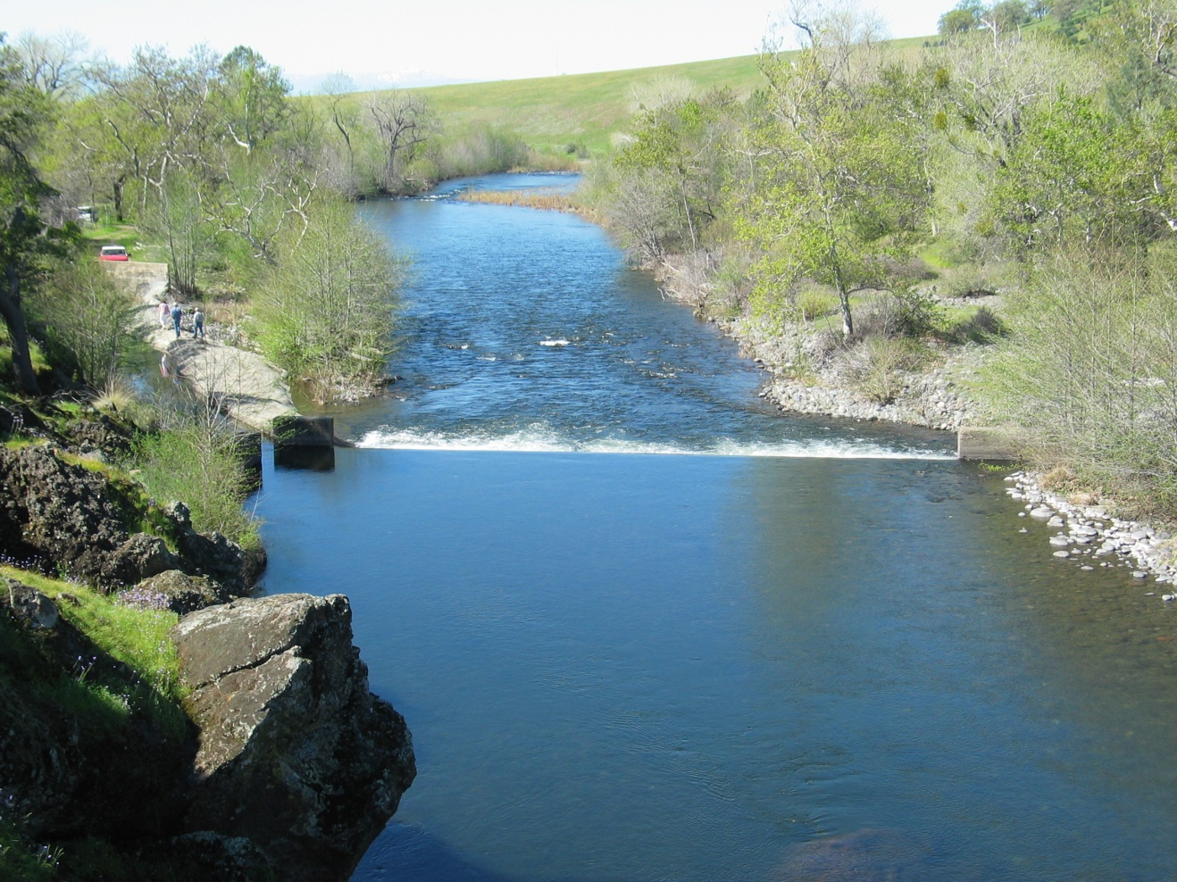
Figure 1. Deer Creek Irrigation Dam and Diversion (March 11, 2005). Photo: DWR

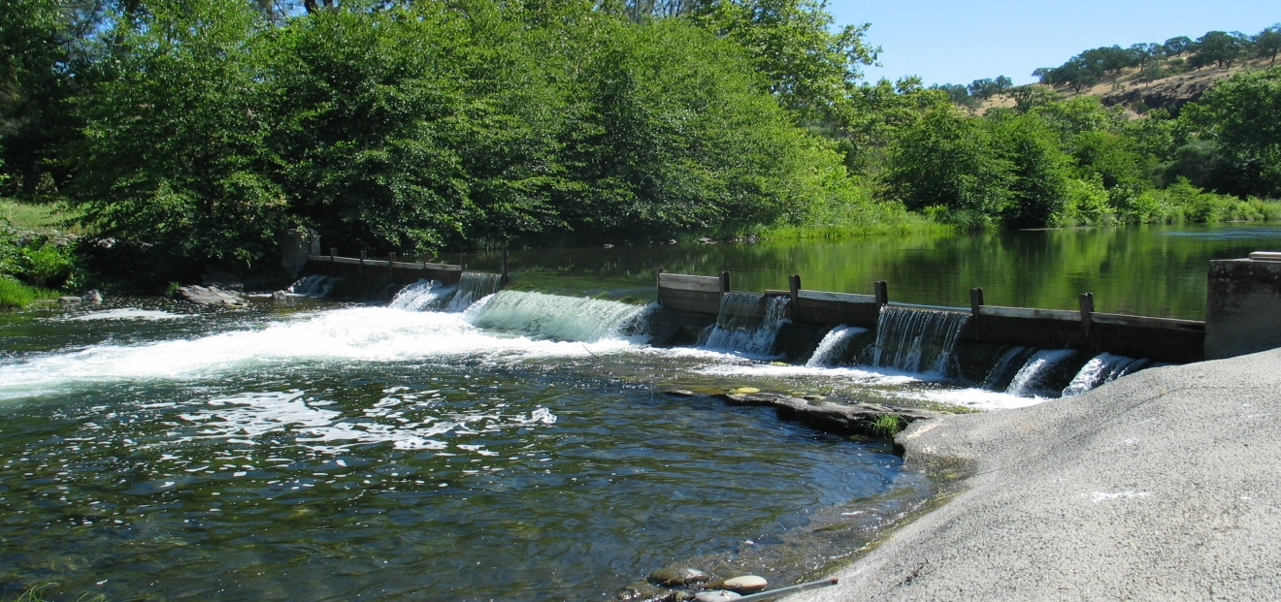
Figure 2. DCID dam without flashboards in the center section for fish passage (July 8, 2005, Deer Creek Flow = 135 cfs, DCID diverting 24 cfs). Photo: DWR
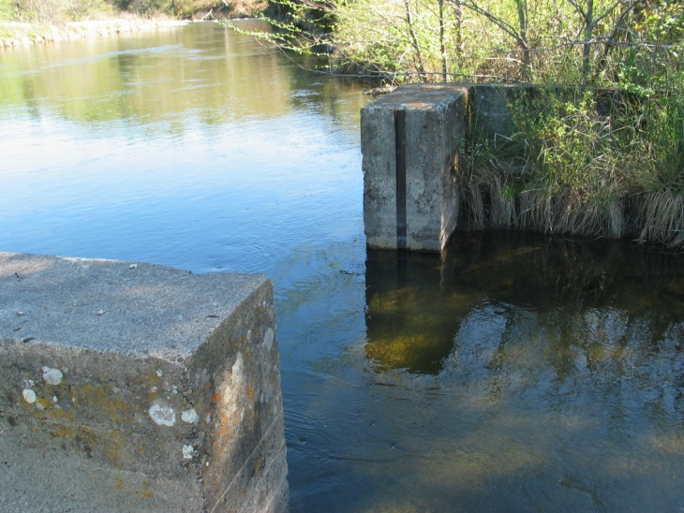
Figure 3. Diversion Ditch Weir Entrance (March 11, 2005). Photo: DWR

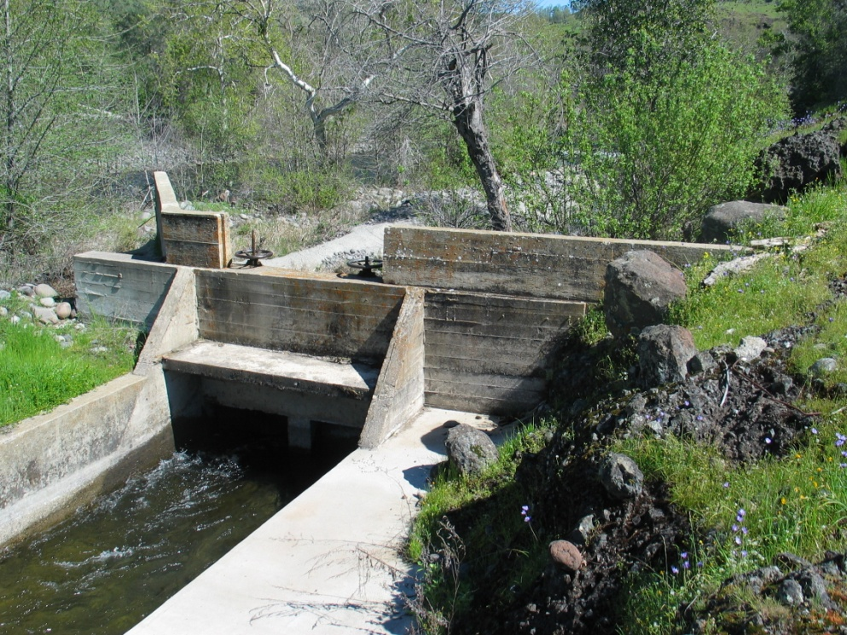
Figure 4. Headwall with two 48-inch vertical slide gates (March 11, 2005). Photo: DWR

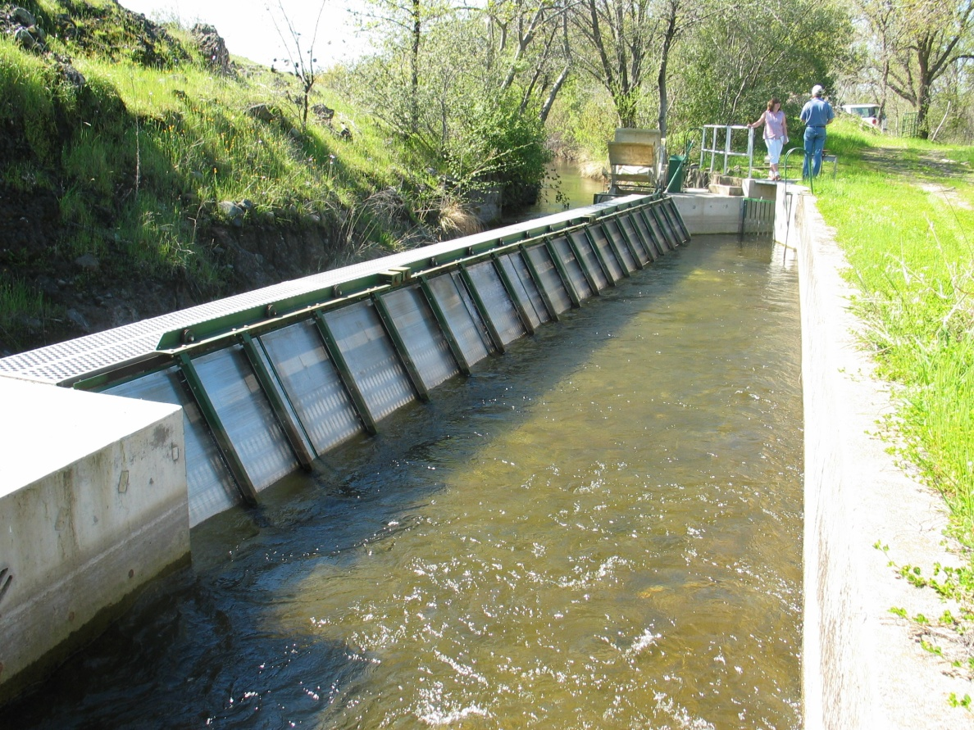
Figure 5. Fish screen structure (March 11, 2005). Photo: DWR
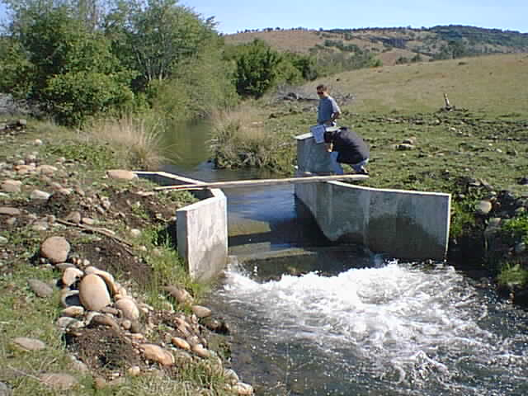
Figure 6. Parshall flume on Deer Creek (May 11, 1999). Photo: DWR

Figure 7. Mean daily diversion rate and percent of flow diverted since 1988. Source: DWR Red Bluff unpub. Data.

