Repair Levee T-24D:
Rehabilitation of the Storm Damaged Levees and Roads
at the
Merritt Island National Wildlife Refuge
Southeastern Region, R4

Notice of Funding Opportunity Number: F19AS00293

Federal Program: U.S. Department of the Interior (DOI), U.S. Fish and Wildlife Service (Service), National Wildlife Refuge System (NWRS), Region 4, Merritt Island National Wildlife Refuge (Refuge).

Catalog of Federal Domestic Assistance (CFDA) Number: 15.654

Authorizing Legislation: Fish and Wildlife Conservation Act, 16 U.S.C. §§2901-2911; Fish and Wildlife Act, 16 U.S.C. 742 et seq.; Refuge Recreation Act, 16 U.S.C. §§460k-460k(4); National Wildlife Refuge System Administration Act, 16 U.S.C. §§668dd-ee; Public Lands Corps Act - Youth Conservation Corps, 16 U.S.C. §§1701-1706; Public Lands Corps Act - Public Lands Corps, 16 U.S.C. §§1721-1726; Archaeological Resources Protection Act, 16 U.S.C. §§470aa-ll; and Federal Aid for Highways-Other Highways, 23 U.S.C. §§201-204 and §206

Paperwork Reduction Act Statement: We are collecting this information in accordance with the authorizing legislation identified above. Your response is required to obtain or retain a benefit. We will use the information you provide to conduct a competitive review and select projects for funding and, if awarded, to evaluate performance. We may not conduct or sponsor and you are not required to respond to a collection of information unless it displays a currently valid Office of Management and Budget (OMB) control number. We estimate that it will take you on average about 40 hours to complete an initial application, about 3 hours to revise the terms of an award, and about 8 hours per report to prepare and submit financial and performance reports, including time to maintain records and gather information. Actual time for these activities will vary depending on program-specific requirements. You may send comments on the burden estimate or any other aspect of this information collection to the Information Collection Clearance Officer, U.S. Fish and Wildlife Service, MS BPHC, 5275 Leesburg Pike, Falls Church, VA 22041-3803.

OMB Control Number: 1018-0100 (Expiration Date: 7/31/2021)
I. Program Description

The Refuge impoundment system had severe damage from Hurricane Irma in 2017. The system was built in the 1960s by Brevard County Mosquito Control to prevent the breeding of saltmarsh mosquitoes. The impoundments continue to be a highly effective method of mosquito control, which is a priority for our partners, including National Aeronautics and Space Administration’s Kennedy Space Center (KSC), Brevard County Mosquito Control, and the City of Titusville. The T-24-D impoundment is located less than two miles from Titusville, Florida and less than six miles from KSC’s primary launch facilities, making it one of the most important impoundments for mosquito control efforts. In addition, water level management through the impoundment system is the primary means of the Refuge to provide high-quality wetland habitat for waterfowl and other wetland-dependent wildlife. The earthen levee separating T-24-D from the Indian River Lagoon is in need of rebuilding after extensive damage as a direct result of Hurricane Irma. The Service will partner with Ducks Unlimited (DU) to protect the Refuge shorelines and reconstruct water management infrastructure and associated public use road to be hardened so they are protected from future storms. Funding will be provided in support of this partnership with DU.

II. Federal Award Information

This is a single-source cooperative agreement. Funds provided to the Service were appropriated for Hurricane Irma Recovery (PL 115-123) and this specific project has been approved by DOI under the Service’s Recovery Plan which will be applied towards this agreement to support DU with the project to protect Refuge shoreline and reconstruct water management infrastructure and the associated public use road. This project will be completed in two phases. DU will coordinate with the Refuge for phase one of the project, which includes the development of the project design and permitting which will be necessary for construction of the project. Coordination efforts include selecting a qualified firm for environmental compliance, working with DU engineers to develop criteria for repairing or designing shoreline protection, levees, and water control structures. DU will award and administer contracts to build the project, including construction oversight. The partners will coordinate on the selection of a qualified construction contractor, frequency/nature of inspections to ensure compliance with all provisions, and protection of wildlife resources. The period of performance of this opportunity is 2 years from the original date this award is signed by the Service.

DU is a 501(c)(3) organization based out of Memphis, Tennessee that began in 1937 and is dedicated to researching, restoring, and protecting waterfowl and wetland habitat and supporting waterfowl hunting and recreational opportunities. DU’s mission is to conserve, restore, and manage wetlands and associated habitats for North America’s waterfowl, also benefiting other wildlife and people. DU’s conservation and habitat restoration work extends across North America. It has worked on numerous projects with the coastal national wildlife refuges and adjacent Wildlife Management Areas. DU will be responsible for managing all aspects of this agreement along with the Service. DU will be responsible for scheduling and overseeing the work described in this agreement and will provide construction oversight for the project. This project would be a continuation of an on-going partnership, from which DU has significant and unique experience, that will facilitate efficient-project completion.

The Service will be substantially involved in projects under the funding opportunity. In particular, the Service will be responsible to: 1) assist DU staff with engineering needs; 2) assist DU staff with selecting a qualified environmental consultant for National Environmental Policy Act compliance, 404 permitting, and coordination as needed; 3) assist DU staff and the environmental consultant to develop criteria for designing erosion protection plans for Refuge shoreline and repair/replacement of levees and water management structures and the associated public use road on the Refuge; and 4) assist DU with selection of a qualified contractor for the construction phase of the project; the Service may provide support materials as available to help in case of problems.

III. Eligibility Information

Eligible Applicants
This is a Notice of Funding Opportunity to issue a sole-source award the recipient, DU. DU is a 501(c)(3) organization based out of Memphis, Tennessee, that began in Texas in 1937 and is dedicated to conserving wetlands and waterfowl across North America. DU has conserved over 14 million acres across North America.

The Indian River Lagoon overwinters 15% of the Continental population of Lesser Scaup. The marshes of Merritt Island are internationally important habitat for shorebirds, wading birds, and waterfowl. Ducks Unlimited has demonstrable project experience working coastal habitats throughout the Southeastern U.S., and on numerous national wildlife refuges. DU has worked on many projects in protected areas, particularly in Florida, and has a demonstrable record of success with technical assistance, design, construction oversight, and successful project completion on Federal lands. DU has designed and constructed projects of similar scale and complexity regarding water control structures, berms, levees, weirs, and associated sheet piling and other retention features in similar conditions. DU has significant experience with design, permitting, and construction oversight of levees in the Carolinas and Georgia. All of the aforementioned qualifications are the criteria we used to award DU this cooperative agreement without competition.

U.S. non-profit, non-governmental organizations must provide a copy of their Section 501(c)(3) status determination letter received from the Internal Revenue Service. Federal law mandates that all entities applying for Federal financial assistance must have a valid Dun & Bradstreet Data Universal Number System (DUNS) number and have a current registration in the System for Award Management (SAM). See Title 2 of the Code of Federal Regulations (CFR), Part 25 for more information. Exemptions: The SAM registration requirement does not apply to individuals submitting an application on their own behalf and not on behalf of a company or other for-profit entity, state, local or Tribal government, academia, or other type of organization.

- Cost Sharing or Matching: Cost sharing or matching is not required in the agreement.

- Other Eligibility Criteria: No other additional criteria at this time.

Unique Entity Identifier and System for Award Management (SAM.gov) Registration: This requirement does not apply to individuals applying for funds as a private citizen (i.e., unrelated to any business or nonprofit organization you may own or operate in your name) or any entity with an exception approved by the Service under 2 CFR 25.110(d). All other applicants are required to obtain a DUNS number from Dun & Bradstreet and then register in SAM.gov prior to submitting a Federal award application. Federal award recipients must continue to maintain an active SAM.gov registration with current information through the life of their Federal award(s). See the “Submission Requirements” section of this document below for more information on SAM.gov registration. The Service may not make a Federal award to an applicant that has not completed the SAM.gov registration. If an applicant selected for funding has not completed their SAM.gov registration by the time the Service is ready to make an award, the program may determine that the applicant is not qualified to receive an award. The program can use that determination as a basis for making an award to another applicant.

Prohibition on Issuing Awards to Entities that Require Certain Internal Confidentiality Agreements: Domestic (U.S.) non-Federal entities requiring their employees or contractors to sign internal confidentiality agreements or statements that prohibit, or otherwise restrict, such employees or contractors from lawfully reporting waste, fraud, or abuse to a designated investigative or law enforcement representative of a Federal department or agency authorized to receive such information are not eligible to compete for or receive a Federal award. See Pub. L. 113-235, Title VII, Division E, Section 743 for more information.

Excluded Parties: The Service conducts a review of the SAM.gov Exclusions database for all applicant entities and their key project personnel prior to award. The Service cannot award funds to entities or their key project personnel identified in the SAM.gov Exclusions database as ineligible, prohibited/restricted or otherwise excluded from receiving Federal contracts, certain subcontracts, and certain Federal assistance and benefits, as their ineligibility condition applies to this Federal program.

IV. Application Requirements
- Requesting Paper Application Package
A completed, signed and dated Application for Federal Assistance form (SF 424, SF-424A, SF-424B, SF-424C, and SF-424D). The forms may be found at the following website: (http://www.grants.gov/web/grants/forms/sf-424-family.html#sortby=1). Do not include other Federal sources of funding, requested or approved, in the total entered in the “Federal” funding box on the Application for Federal Assistance form. Enter only the amount being requested under this program in the “Federal” funding box. Include any other Federal sources of funding in the total funding entered in the “Other” box. Application Form and Content Requirements
Applicants must submit the following:
- SF-424, Application for Federal Assistance
Applicants must submit the appropriate Standard Form (SF)-424, Application for Federal Assistance. Individuals applying as a private citizen (i.e., unrelated to any business or nonprofit organization you may own or operate in your name), must complete the SF-424, Application for Federal Assistance-Individual form. All other applicants must complete the standard SF-424, Application for Federal Assistance. All of the required application forms are available on the “Packages” tab of this Funding Opportunity on Grants.gov. The SF-424, Application for Federal Assistance must be completed, and signed and dated. Please note: Enter only the amount requested from this Federal program in the “Federal” funding box on the SF-424 Application form. Include any other Federal sources of funding in the “Other” box, and provide details on those Federal source(s) and funding amount(s) in the required Budget Narrative (see the “Budget Narrative” section below).

- SF 424, Assurances
Applicants must submit the appropriate signed and dated Assurances form. Complete either the SF-424B, Assurances for Non-Construction Programs and/or the SF-424D, Assurances for Construction Programs, as applicable to your project. All of the required application forms are available on the “Packages” tab of this Funding Opportunity on Grants.gov. The SF-424 Assurances forms include a statement that some of the assurances may not be applicable to your organization and/or your project or program. Signing the required SF-424 Assurances form does not make you or your organization subject to laws that are otherwise not applicable to you or your organization. Changing, crossing out, or making notations on the form before signing has no impact on the applicability of law.

- Project Narrative: Design, permitting (with potential on-site mitigation) and rehabilitation and/or construction of the storm damaged levee road, at the Refuge, to the Standard Specifications for Construction of Roads and Bridges on Federal Highway Projects and the Florida Department of Transportation Standard Specifications for Road and Bridge Construction. The shoreline protection and water management control structure replacement will address erosion loss and damage to water control structures that occurred on the Refuge during Hurricane Irma in Brevard County Florida.

The T-24D impoundment levee is locally known as Peacocks Pocket Road (Figure 1). The T-24D impoundment is one of the most important habitat management areas for waterfowl, shorebirds, wading bird management, and mosquito control. The Refuge is responsible under Memorandum Of Understanding (MOU) with National Aeronautics Space Administration (NASA) and Saint Johns Water Management District (SJWMD) to manage the impoundment for mosquito control. Peacock’s Pocket Road is a narrow two-way public use road which supports wildlife-dependent recreational activities, including hunting, fishing, observing wildlife, photographing wildlife, and participating in environmental education and interpretation. Approximately 15,000 vehicles use Peacocks Pocket Road annually. Waterfowl hunting within this impoundment is very popular and a significant public use for the Refuge. Over 900 waterfowl hunters access this impoundment each year through a quota permit sold through Florida Fish and Wildlife Conservation Commission (FWC).

The T-24D impoundment levee is a barrier between the impoundment’s freshwater marsh and brackish Indian River Lagoon (IRL). This marsh is an important habitat for migratory birds, fish, shellfish and other wildlife and represents the largest impoundment on the Refuge. The buffering effects of coastal marshlands in this area help to protect strategic and economic resources (i.e. KSC) in the IRL system and support a healthy marsh system.

The project will involve the removal of 13 existing water control structures and the replacement of 11 of those structures. Sections of levee will also need to be replaced with earthen fill material and shoreline stabilization to maintain a barrier between freshwater and saltwater habitats. The levee protects more than 2,850 acres of interior freshwater wetland from salinity which causes degraded habitat and loss of wetland value for wildlife and public hunting and recreation.

The project is designed to rehabilitate approximately 25,600 linear feet of earthen embankment on the T-24 D impoundment levee with the supply and installation of earthen fill material to reconstruct the original levee to an elevation of 4.5 feet Mean Sea Level and to the original levee profile (12 feet top width and 1.75H:1V side slopes). This section’s top has eroded approximately one foot and the side slope vary in dimension. This item shall also include the removal and disposal of the vegetative matter on the levee as necessary to install the fill material. See Figure 1 in the Appendix (Work Order 2017301145). See Figure 1 in the Appendix (Work Order 2017301145).

The project includes approximately 2,900 linear feet of new earthen embankment on the T-24 D Levee with the supply and installation of earthen fill material to construct the levee to an elevation of 4.5 feet Mean Sea Level and to the original levee profile (12 feet top width and 1.75H:1V side slopes).

Approximately 2,100 linear feet of this section does not have a levee at present (See Section 1, 2 and 4 in the Appendix) and 800 feet of this section has a deteriorated levee present (see Section 3 in the Appendix). These two sections will replace approximately 4,700 linear feet of levee that will be restored to marsh elevation in Bid Item 4. This item shall also include the design and installation of rock rip-rap toe protection on the river side of this newly constructed levee. See Sections 1, 2, 3 and 4 in the Appendix for details (Work Order 2017301145).

Restore approximately 4,600 linear feet of earthen embankment to marsh elevation by removing the levees and filling the original ditches. This item will constitute the restoration of the portions of the T-24 D Levee to the marsh’s pre-existing condition as shown in Sections 1, 2, 3, and 4 of the Appendix. These sections of levee will be replaced by 2,100 feet of new levee in Bid Item 3 (Work Order 2017301145).

Supply and installation of 13 - 36” diameter, 36 feet long, corrugated aluminum conduits with a 48” diameter flashboard riser, with aluminum stop logs in the riser to the top of the riser elevation which shall be 4.0 feet Mean Sea Level. The item shall also include the removal and disposal of all the existing conduits and risers; the quantity of existing conduits shall be field verified during the design process. The design and installation of the proposed conduits shall address the potential for floatation of the riser and include the design and installation of a concrete riser bottom. The design and installation shall also address the supply and installation of rock riprap to properly protect the outlets from scouring and/or eroding the embankments. The exact installation location of the proposed structures will be determined in the field. All pipe shall comply with Specification Section 707.03 of the Standard Specifications For Construction of Roads and Bridges on Federal Highway Projects (Work Order 2017301145).

Rehabilitate the top of the entire T-24 Levee, also known as Route #102 or Peacock’s Pocket Road, with the supply and installation of 12” of graded aggregate base material on approximately 30,500 linear feet of road. The final finished grade of the road shall be 5.5 feet Mean Seal Level. All graded aggregate base material shall only be Limerock Stabilized Base complying with Section 911 of the Florida Department of Transportation Specifications for Road and Bridge Construction and placed in accordance with Section 200 of the Florida Department of Transportation Specifications for Road and Bridge Construction. See Figure 1 in the Appendix. (Work Order Number 2017301119).

Project Goals and Objectives: The Service is interested in the protection of shoreline and repair/replacement of levees and water management structures and associated public use road on Merritt Island NWR. This project will be completed in phases and will require coordination with other partners and agencies that have an interest in this Refuge and adjacent land and waters. Phases include the design, permitting and implementation of the levee and associated water control structures and public use road to restore water management capability.

Project Activities, Methods and Timetable: The cooperator will complete project design and permitting of the T-24-D levee and associated road to standards provided by the Service. These activities are expected to take 6 months to a year. Subsequently, the cooperator will construct and rehabilitate the levee, road and culverts which are expected to take up to an additional year. These activities may require Section 7 Endangered Species Act compliance or Section 106 National Historic Preservation Act compliance. Permit applications to the U.S. Army Corps of Engineers (COE) and the St. Johns Water Management District (SJWMD) may also be required. The period of performance for this agreement is 2 years from the date of the award.

Stakeholder Coordination/Involvement: This project will be completed in two phases. DU will coordinate with the Refuge for phase one of the project, which includes the development of the project design and permitting which will be necessary for construction of the project. Coordination efforts include selecting a qualified firm for environmental compliance, working with DU engineers to develop criteria for repairing or designing shoreline protection, levees and water control structures. DU will award and administer contracts to build the project including construction oversight. The partners will coordinate on the selection of a qualified construction contractor, frequency/nature of inspections to ensure compliance with all provisions, and protection of wildlife resources.

Participation from DU and the Service will include project planning, field trips, and discussions to assist with developing of designs for the protection of shoreline and infrastructure on the Refuge. Discussions regarding the shoreline protection, which include potential design and permitting between DU, COE, SJWMD, and the Refuge have occurred on similar projects.

Project Monitoring and Evaluation: At this time, the identified funds may be applied to needed shoreline protection and levee/water management structure repair that resulted from Hurricane Irma in September of 2017. Oversight for this project will be provided by DU with assistance from Refuge staff, regional facilities and engineering staff. Oversight will occur throughout the life of the project which will extend 2 years after the award of the agreement. Portions of this work will be monitored to meet COE requirements associated with 404 permitting requirements. The standard forms required in this grant will be used for reporting by the assigned project officer.

Description of Entities Undertaking the Project: DU is a 501(c)(3) organization that began nearly in 1937 and is dedicated to conserving, restoring and managing wetlands and associated habitats for waterfowl. DU’s conservation work extends across North America. DU is well qualified to provide this level of oversight and has extensive experience implementing well-designed, successful habitat restoration projects along the east coast of the United States. DU has worked on projects on the Refuge. DU will be responsible for managing all aspects of this agreement along with the Service. DU will be responsible for scheduling and overseeing the work described in this agreement and will provide construction oversight for the project.

Map of Project Area:
Merritt NWR Project Areas

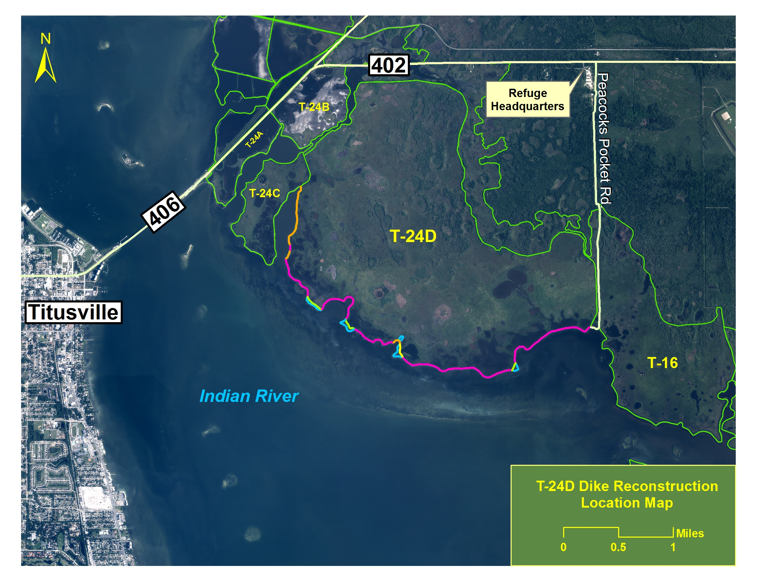
Figure 1: General location of the T-24D Impoundment Levee Project at Merritt Island National Wildlife Refuge.
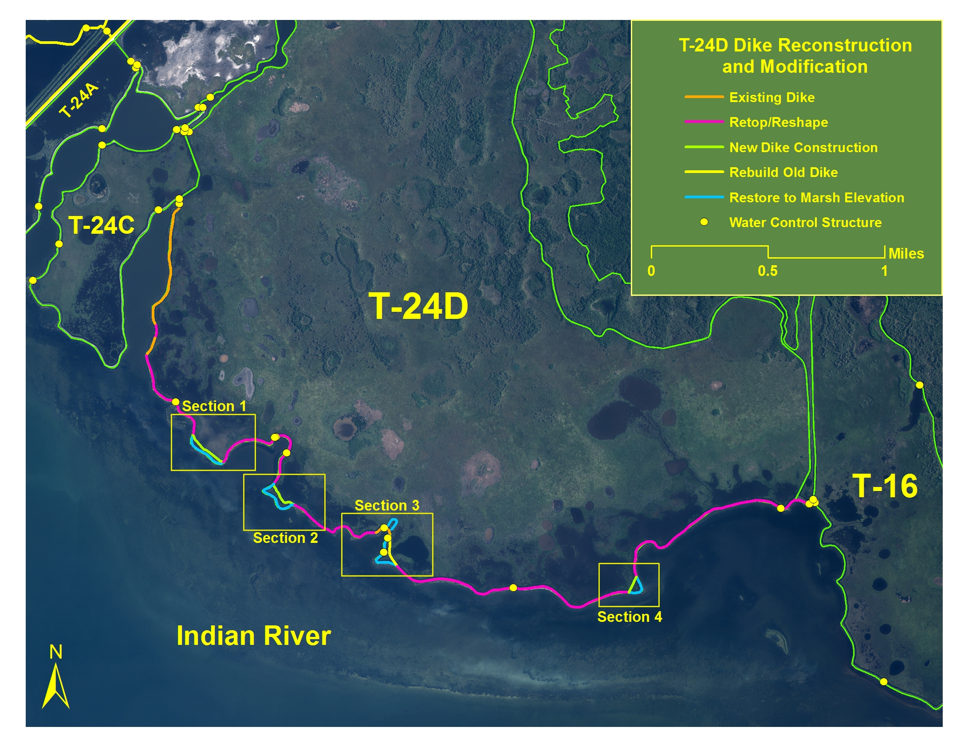
Figure 2: Project map reflecting four sections to be modified for public vehicle safety.

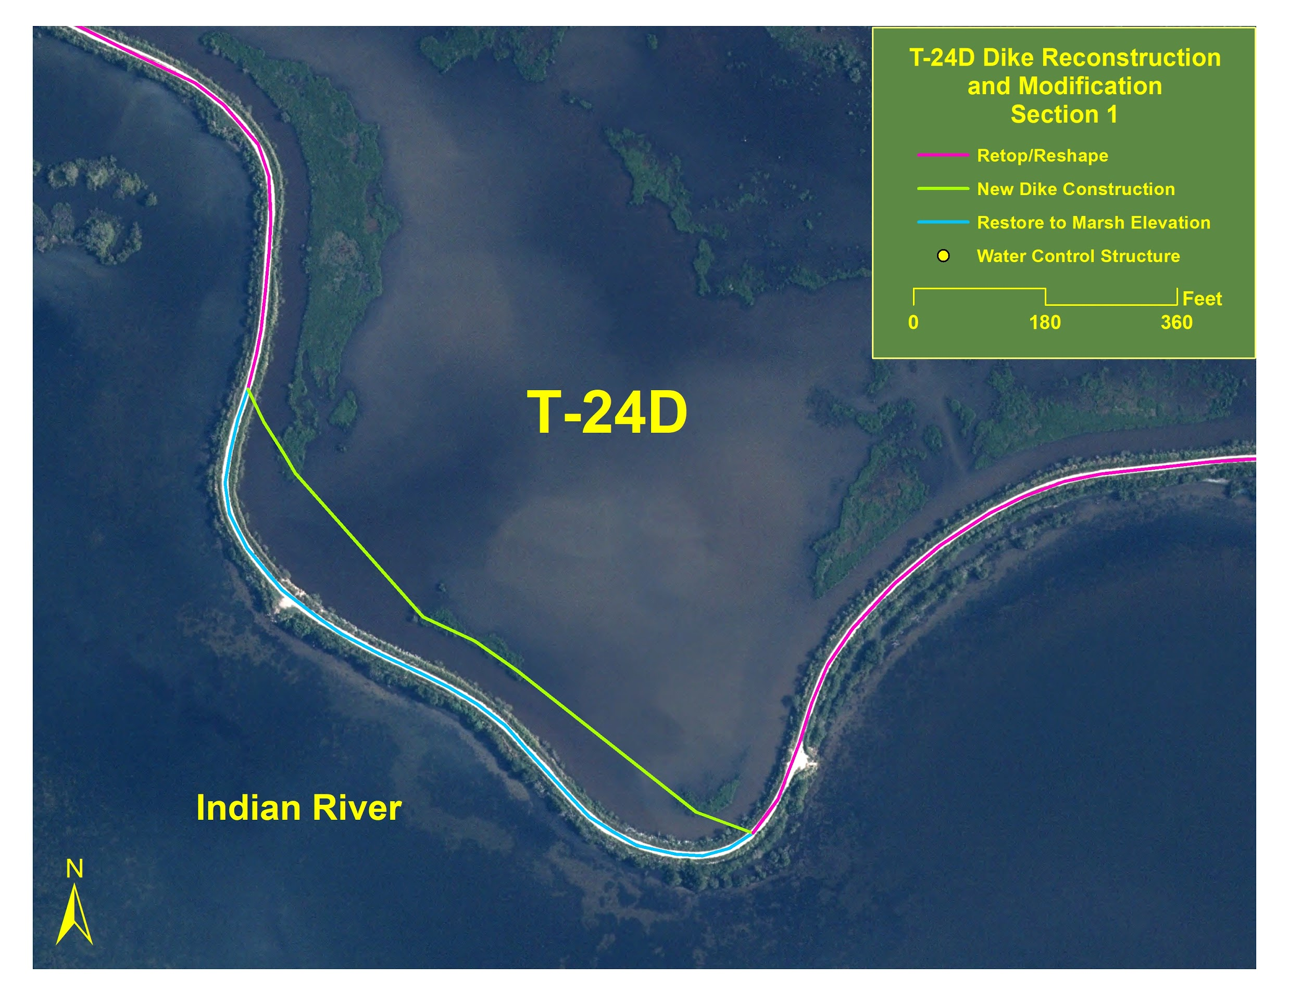
Figure 3: Map reflects T-24D levee reconstruction location for Section 1.

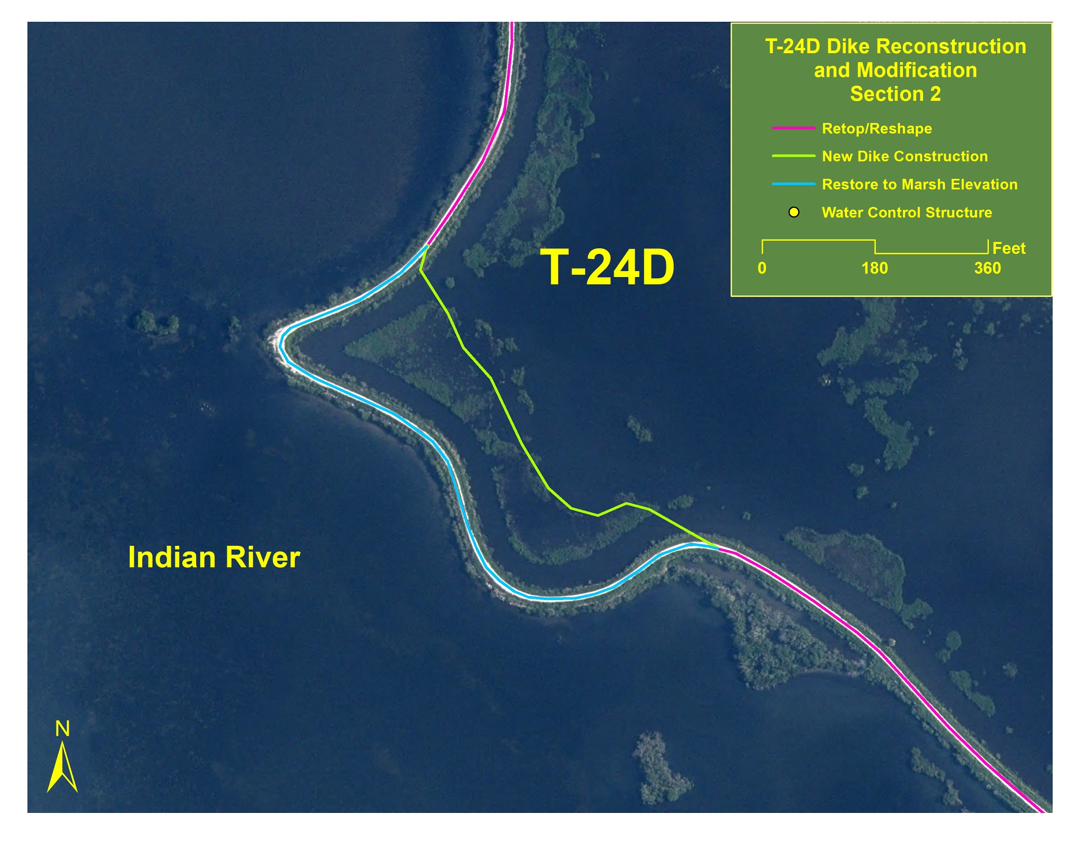
Figure 4: Map reflects T-24D levee reconstruction location for Section 2.

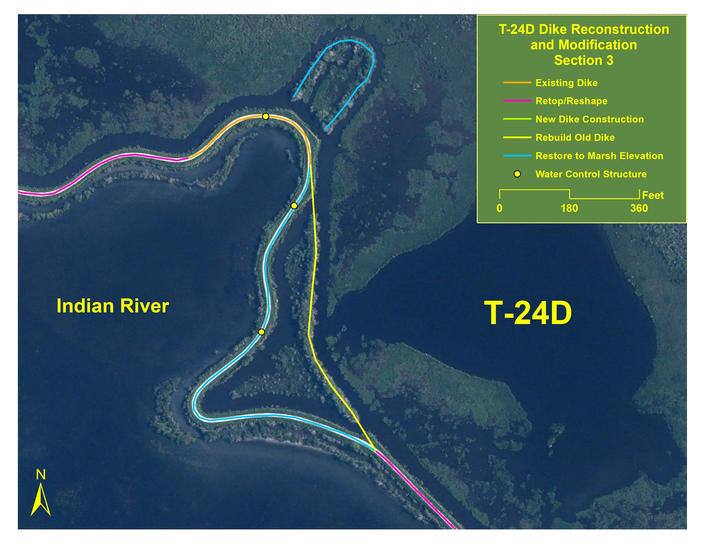
Figure 5: Map reflects T-24D levee reconstruction location for Section 3.

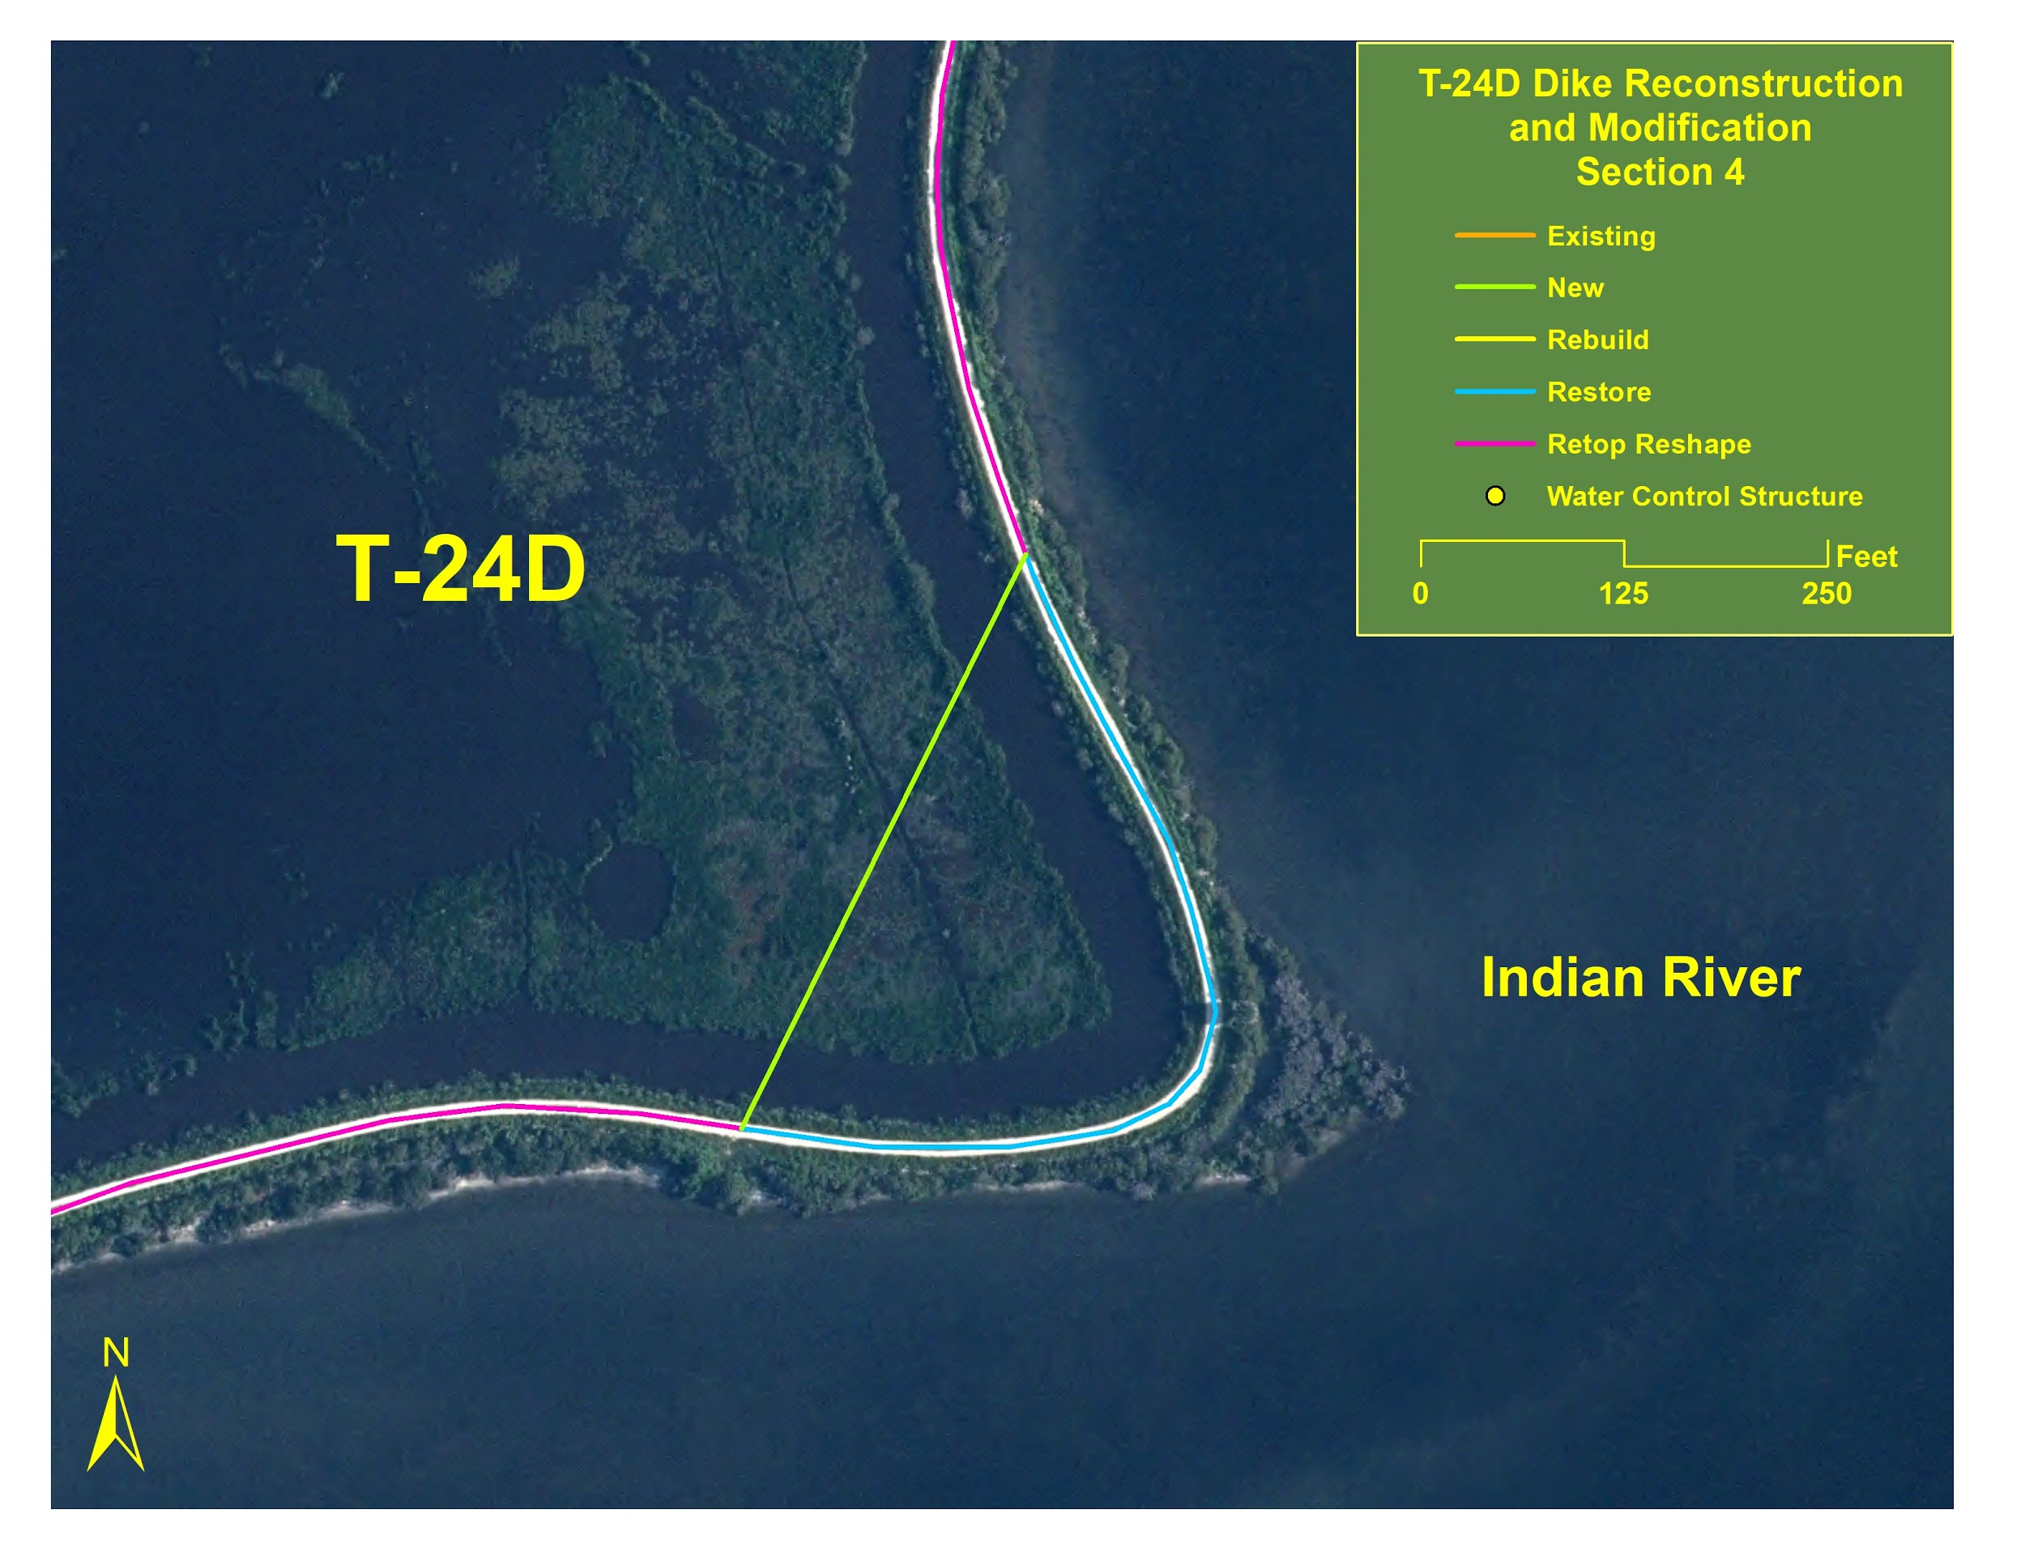
Figure 6: Map reflects T-24D levee reconstruction location for Section 4.

4. SF-424, Budget Information
Applicants must submit the appropriate SF-424 Budget Information form. Complete both the SF-424A, Budget Information for Non-Construction Programs and the SF-424C, Budget Information for Construction Programs for this project. All of the required application forms are available on the “Packages” tab of this Funding Opportunity on Grants.gov. Federal award recipients and subrecipients are subject to Federal award cost principles as detailed in the Service’s “Financial Assistance Award Terms and Conditions”. Please note: Show funds requested from this Federal program separately from any other Federal sources of funding. In the “Budget Summary” section, use the first row for funding requested from this Federal program. Use subsequent row(s) for other Federal funding. Enter each Federal program’s CFDA number(s) in the corresponding fields on the form. The CFDA number(s) for this Federal program appears on the first page of this Funding Opportunity.

- Budget Narrative
The funding will not be provided in advance to the cooperator. Under an approved agreement, the government will require the cooperator to produce a project schedule identifying critical path elements, which may include, but not limited to: surveying, design, permitting, engineering, and construction, that will allow the government to monitor and ensure reasonable and appropriate progress toward completion. Under this method, the government will also require that the cooperator submit a drawdown application for review and approval by the government prior to the drawdown of funds by the cooperator. The drawdown of funds would occur over the life of the project that is anticipated to be approximately 36 months from award.

- Indirect Costs: Individuals
Individuals applying for and receiving funds separate from a business or non-profit organization he/she may operate are not eligible to charge indirect costs to their award. If you are an individual applying for funding, do not include any indirect costs in your proposed budget and skip the next section.

- Indirect Costs: Organizations
The Federal awarding agency that provides the largest amount of direct funding to your organization is your cognizant agency for indirect costs, unless otherwise assigned by the White House Office of Management and Budget (OMB). If the Department of the Interior is your organization’s cognizant agency, the Interior Business Center will negotiate your indirect cost rate. Contact the Interior Business Center by phone 916-930-3803 or using the IBC Email Submission Form. See the IBC Website for more information.

Organizations must have an active Federal award before they can submit an indirect cost rate proposal to their cognizant agency. Failure to establish an approved rate during the award period renders all costs otherwise allocable as indirect costs unallowable under the award. Recipients must have prior written approval from the Service to use amounts budgeted for direct costs to satisfy cost-share or match requirements or to cover unallowable indirect costs. Recipients shall not shift unallowable indirect costs to another Federal award unless specifically authorized to do so by legislation.

Required Indirect Cost Statement
All organizations must include the applicable statement from the following list in their application to the Service, and attach to their application any documentation identified in the applicable statement:

We are a nonprofit having a 501(c)(3) status with the IRS that has previously negotiated or currently has an approved indirect cost rate with our cognizant agency. Our indirect cost rate is 14.90 percent. Attached is a copy of our current negotiated indirect cost rate agreement.

- Conflict of Interest Disclosure
Applicants must state in their application if any actual or potential conflict of interest exists at the time of submission. Conflicts of interest include any relationship or matter that might place the recipient, including their employees and subrecipients, in a position of conflict, real or apparent, between their responsibilities under the award and any other outside interests. Conflicts of interest include direct or indirect financial interests; close personal relationships; positions of trust in outside organizations; consideration of future employment arrangements with a different organization; and decision-making authority related to the proposed project. Conflicts of interest are those circumstances real or perceived that would cause a reasonable person with knowledge of the relevant facts to question the impartiality of the applicant, or the applicant’s employees or subrecipients, in matters pertaining to the proposed project. Applicants must notify the Service in writing in their application if any employees, including subrecipient and contractor personnel, are related to, married to, or have a close personal relationship with any Federal employee in the Federal program receiving this application or who otherwise may be involved in the review and selection of their proposal. The term employee means any individual to be engaged in the performance of work pursuant to the Federal award application. Failure to disclose and resolve conflicts of interest in a manner that satisfies the Service may result in the rejection or disqualification of the application.

- Single Audit Reporting Statement
All U.S. states, local governments, federally recognized Indian tribal governments, and non-profit organizations expending $750,000 USD or more in Federal award funds in the applicant’s fiscal year must submit a Single Audit report for that year through the Federal Audit Clearinghouse’s Internet Data Entry System. U.S. state, local government, federally recognized Indian Tribal government, and non-profit applicants must state if your organization was or was not required to submit a Single Audit report for the most recently closed fiscal year. If your organization was required to submit a Single Audit report for the most recently closed fiscal year, provide the EIN associated with that report and state if it is available through the Federal Audit Clearinghouse website.

- Certification Regarding Lobbying
Applicants requesting more than $100,000 in Federal funding must certify to the statements in 43 CFR Part 18, Appendix A-Certification Regarding Lobbying. If this application requests more than $100,000 in Federal funds, the Authorized Official’s signature on the appropriate SF-424, Application for Federal Assistance form also represents the entity’s certification of the statements in 43 CFR Part 18, Appendix A.

Disclosure of Lobbying Activities
Applicants and recipients must not use any federally appropriated funds (annually appropriated or continuing appropriations) or matching funds under a Federal award to pay any person for lobbying in connection with the award. Lobbying is influencing or attempting to influence an officer or employee of any U.S. agency, a Member of the U.S. Congress, an officer or employee of the U.S. Congress, or an employee of a Member of the U.S. Congress connection with the award. Applicants and recipients must complete and submit the SF-LLL, Disclosure of Lobbying Activities if the Federal share of the proposal or award is more than $100,000 and the applicant or recipient has made or has agreed to make any payment using non-appropriated funds for lobbying in connection with the application or award. The SF-LLL form is available on the “Packages” tab of this Funding Opportunity on Grants.gov. See 43 CFR, Subpart 18.100 for more information on when additional submission of this form is required.

- Overlap or Duplication of Effort Statement
Applicants must provide a statement indicating if there is any overlap between this Federal application and any other Federal application, or funded project, in regards to activities, costs, or time commitment of key personnel. If no such overlap or duplication exists, state, “There are no overlaps or duplication between this application and any of our other Federal applications or funded projects, including in regards to activities, costs, or time commitment of key personnel”. If any such overlap exists, provide a complete description of overlaps or duplications between this proposal and any other federally funded project or application in regards to activities, costs, and time commitment of key personnel, as applicable. Provide a copy of any overlapping or duplicative proposal submitted to any other potential funding entity and identify when that proposal was submitted, to whom (entity name and program), and when you anticipate being notified of their funding decision. When overlap exists, your statement must end with “We understand that if at any time we receive funding from another source that is duplicative of the funding we are requesting from the U.S. Fish and Wildlife Service in this application, we will immediately notify the U.S. Fish and Wildlife Service point of contact identified in this Funding Opportunity in writing.”

- APPLICATION CHECKLIST
- SF-424, Application for Federal Assistance or Application for Federal Assistance-Individual
- SF-424B and D, Assurances
- Project Narrative
- SF-424A and C, Budget Information
- Budget Narrative
- Timetable
- Indirect Cost Statement and related documentation (when applicable)
- Conflict of Interest Disclosure (when applicable)
- Single Audit Reporting Statement (when applicable)
- SF-LLL, Disclosure of Lobbying Activities (when applicable)
- Overlap or Duplication of Effort Statement

Failure to provide complete information may cause delays, postponement, or rejection of the application.

V. Submission Requirements
- Unique Entity Identifier and System for Award Management (SAM.gov) Registration
These requirements do not apply to any individual applying for funds as a private citizen or any entity with an exception approved by the Federal awarding agency under 2 CFR 25.110(d). All other applicants are required to obtain a Data Universal Numbering System (DUNS) number from Dun & Bradstreet and provide that number in the application; complete SAM.gov registration before submitting an application; and continue to maintain an active SAM.gov registration with current information at all times when the entity has an active Federal award or application under consideration. There is NO COST to register with Dun & Bradstreet or SAM.gov. There are third-party vendors who will charge a fee in exchange for registering entities with Dun & Bradstreet and SAM.gov; please be aware you can register and request help for free.

- Obtain a DUNS Number
Request a DUNS Number through the Dun & Bradstreet website. The official website address is http://fedgov.dnb.com/webform. For technical difficulties, send an email to the D&B SAM Help Desk. Please ensure that you are able to receive emails from SAMHelp@dnb.com. The Grants.gov “Obtain a DUNS Number” webpage also provides detailed instructions. Once assigned a DUNS number, your organization must maintain up-to-date information with Dun & Bradstreet. Applicants must enter their DUNS number in the “Organizational DUNS” field on the SF-424, Application for Federal Assistance form.

Register with SAM
Register on the SAM.gov website. The official website address is http://www.sam.gov. The “Help” tab on the website contains User Guides and other information to assist you with registration. The Grants.gov Register with SAM” webpage also provides detailed instructions. You can also contact the supporting Federal Service Desk for help registering in SAM. Once registered in SAM, entities must renew and revalidate their SAM registration at least once every 12 months from the date previously registered. Entities are strongly encouraged to revalidate their registration as often as needed to ensure their information is up to date and reflects changes that may have been to the entity’s DUNS or IRS information. Foreign entities who want to receive payment directly to a U.S. bank account must enter and maintain valid, current banking information in SAM.

- Submission Dates and Times: Wednesday, June 26, 2019, by 4 p.m. EST

- Funding Restrictions: Construction is an allowable activity. There will be no reimbursement of pre-Federal award costs.

- Submission Instructions
This program encourages applicants to submit their applications online through Grants.gov. Follow these steps to apply through Grants.gov.

- Register with Grants.gov
Applicants must first register an account with Grants.gov and complete all steps of the registration process before they can apply through Grants.gov. Grants.gov registration requires the entity to create an account, create an account profile, and establish authorized profile roles, including the applicant’s authorized representative. Registration can take three to five business days or longer, if you do not complete the required steps in a timely manner.

Grants.gov Workspace Application
Grants.gov applicants apply online using Workspace. Workspace is a shared, online environment where members of a grant team may simultaneously access and edit different webforms within an application. For each funding opportunity announcement, you can create individual instances of a workspace. To apply, the applicant will create, complete, and submit a Workspace application package for this Funding Opportunity directly on Grants.gov. Grants.gov recommends submitting your application package at least 24-48 hours prior to the close date to allow time to correct any potential technical issues that may disrupt the application submission. When attaching files to the Grants.gov application, please do not assign file names longer than 20 characters, including spaces. File names longer than 20 characters will prevent your application received by Grants.gov from automatically downloading into the Service’s financial assistance management system. Applicants using slow internet, such as dial-up connections, should be aware that the transmission of the application to Grants.gov takes time. Grants.gov sends either an error message or a “successfully received” message by email to the applicant’s authorized representative once the transmission is complete. Please do not end the transmission process before receiving that message.

- Proof of Timely Submission
Grants.gov automatically generates an electronic date and time stamp in the system upon application receipt. Grants.gov sends an acknowledgement of receipt with the date and time stamp and a unique Grants.gov application tracking number to the authorized representative by email. This email from Grants.gov serves as your proof of timely submission.

VI. Application Review Information
- Criteria:
This Single Source Award is being awarded in accordance with DOI Policy 505 DM 2.14 B(2) and B(4). See Additional Information of Eligibility Section. DU has designed, constructed, and worked on NWRS property on past projects across North America. DU has had great success restoring, enhancing, and establishing wetlands along the Gulf Coast. All past projects have met Service objectives while also benefiting adjacent lands.

- Review and Selection Process
This Single Source Award is being awarded in accordance with DOI Policy 505 DM 2.14 B(2) and B(4). See Additional Information of Eligibility Section. Prior to participating in any review or evaluation process, all staff and peer reviewers, evaluators, panel members, and advisors must sign and return to the program office point of contact the “Department of the Interior Conflict of Interest Certification” form. For a copy of this form, contact the Service Project Officer identified in the Agency Contacts section below.

Prior to award, the Service will review any applicant statement regarding potential overlap or duplication between the project to be funded and any other funded or proposed project in terms of activities, funding, or time commitment of key personnel. Depending on the circumstances, the Service may request modification to the application, other pending applications, or an active award, as needed to eliminate any duplication of effort, or the Service may choose not to fund the selected project.

The Service may not make a Federal award to an applicant that has not completed the SAM.gov registration. If an applicant selected for funding has not completed their SAM.gov registration by the time the Service is ready to make an award, the program may determine that the applicant is not qualified to receive an award. The program can use that determination as a basis for making an award to another applicant.

Prior to award, the Service will evaluate the risk posed by applicants as required in 2 CFR 200.205. Service programs document applicant risk evaluations using the Service’s “Financial Assistance Recipient Risk Assessment” form. Prior to approving awards for Federal funding in excess of the simplified acquisition threshold (currently $250,000), the Service is required to review and consider any information about or from the applicant found in the Federal Awardee Performance and Integrity Information System. The Service will consider this information when completing the risk review. The Service uses the results of the risk evaluation to establish monitoring plans, recipient reporting frequency requirements, and to determine if one or more of the specific award conditions in 2 CFR 200.207 should be applied to the award.

VII. Federal Award Administration
- Federal Award Notices
Following review, applicants may be requested to revise the project scope and/or budget before an award is made. Successful applicants will receive written notice in the form of a notice of award document. Notices of award are typically sent to recipients by e-mail. If e-mail notification is unsuccessful, the documents will be sent by courier mail (e.g., FedEx, DHL or UPS). Award recipients are not required to sign/return the Notice of Award document. Acceptance of an award is defined as starting work, drawing down funds, or accepting the award via electronic means. Awards are based on the application submitted to and approved by the Service and are subject to the terms and conditions incorporated into the Notice of Award either by direct citation or by reference to the following: Federal regulations; program legislation or regulation; and special award terms and conditions. Recipient acceptance of a Federal award from the Service carries with it the responsibility to be aware of and comply with all terms and conditions applicable to the award. Recipients indicate their acceptance of the Federal award by starting work, drawing down funds, or accepting the award via electronic means.

- Award Terms and Conditions
See the Service’s “Financial Assistance Award Terms and Conditions” for the administrative and national policy requirements applicable to Service awards.

Institutions of Higher Education and Non-Profit Organizations
These regulations and requirements always apply as specified below:
- Administrative Requirements: 2 CFR Part 200, Subparts A through D
- Cost Principles: 2 CFR Part 200, Subpart E, except for non-profits identified in 2 CFR 200, Appendix VIII as exempt from these and therefore subject to the cost principles in 48 CFR 1, Subpart 31.2 Contracts with Commercial Organizations.
- Indirect Cost Proposals for IHEs: 2 CFR Part 200, Appendix III
- Indirect Cost Proposals for Non-Profits: 2 CFR 200, Appendix IV
- Audit Requirements for Non-Profits: 2 CFR Part 200, Subpart F
- 2 CFR Part 25, Universal Identifier and System for Award Management
- 2 CFR Part 170, Reporting Subawards and Executive Compensation
- 2 CFR Part 175, Award Term for Trafficking in Persons
- 2 CFR Part 200, Appendix XII, Award Term and Condition for Recipient Integrity and Performance Matters. Applies to awards with a total Federal share of more than $500,000.
- 2 CFR Part 1400, Nonprocurement Debarment and Suspension
- 2 CFR Part 1401, Requirements for Drug-Free Workplace
- 43 CFR 18, New Restrictions on Lobbying: Submission of an application also represents the applicant’s certification of the statements in 43 CFR Part 18, Appendix A, Certification Regarding Lobbying.
- 41 USC §4712, Enhancement of Recipient and Subrecipient Employee Whistleblower Protection. Applies to all awards over the simplified acquisition threshold (currently $250,000). This award, related subawards, and related contracts over the simplified acquisition threshold and all employees working on this award, related subawards, and related contracts over the simplified acquisition threshold are subject to the whistleblower rights and remedies established at 41 USC 4712. Recipients, their subrecipients, and their contractors awarded contracts over the simplified acquisition threshold related to this award, shall inform their employees in writing, in the predominant language of the workforce, of the employee whistleblower rights and protections under 41 USC 4712. The recipient shall insert this clause in all subawards and in all contracts over the simplified acquisition threshold related to this award.
- 41 USC §6306, Prohibition on Members of Congress Making Contracts with Federal Government. No member of or delegate to Congress or Resident Commissioner shall be admitted to any share or part of this award, or to any benefit that may arise therefrom; this provision shall not be construed to extend to an award made to a corporation for the public’s general benefit.
- Section 743 of Division E, Title VII of Pub. L. 113-235, Prohibition on Issuing Financial Assistance Awards to Entities that Require Certain Internal Confidentiality Agreements. Recipients must not require their employees or contractors seeking to report fraud, waste, or abuse to sign internal confidentiality agreements or statements prohibiting or otherwise restricting such employees or contractors from lawfully reporting such waste, fraud, or abuse to a designated investigative or law enforcement representative of a federal department or agency authorized to receive such information. Recipients must notify their employees or contractors that existing internal confidentiality agreements covered by this condition are no longer in effect.
- Executive Order 13513, Federal Leadership on Reducing Text Messaging while Driving. Recipients are encouraged to adopt and enforce policies that ban text messaging while driving, including conducting initiatives of the type described in section 3(a) of the Order.

- Payments
Domestic recipients are required to register in and receive payment through the U.S. Treasury’s Automated Standard Application for Payments (ASAP), unless approved for a waiver by the Service program. Foreign recipients receiving funds to a final destination bank outside the U.S. are required to receive payment through the U.S. Treasury’s International Treasury Services (ITS) System. Foreign recipients receiving funds to a final destination bank in the U.S. are required to enter and maintain current banking details in their SAM.gov entity profile and receive payment through the Automated Clearing House network by electronic funds transfer (EFT). The Service will include recipient-specific instructions on how to request payment, including identification of any additional information required and where to submit payment requests, as applicable, in all Notices of Award.

- Reporting Requirements
The Service will include recipient-specific reporting requirements, including the required reports, reporting frequency, and report due dates in all Notices of Award, as applicable.

- Financial Reports
All recipients must use the SF-425, Federal Financial Report form for financial reporting. At a minimum, all recipients must submit a final financial report. Final reports are due no later than 90 calendar days after the award period of performance end date or termination date. For awards with periods of performance longer than 12 months, recipients are required to submit interim financial reports on the frequency established in the Notice of Award. See Service policy 516 FW 1, Monitoring Financial and Performance Reporting for Financial Assistance for more information.

- Performance Reports
Performance reports must contain a comparison of actual accomplishments with the established goals and objectives of the award; a description of reasons why established goals were not met, if appropriate; and any other pertinent information relevant to the project results. At a minimum, all recipients must submit a final performance report. Final reports are due no later than 90 calendar days after the award period of performance end date or termination date. For awards with periods of performance longer than 12 months, recipients are required to submit interim financial reports on the frequency established in the Notice of Award. See Service policy 516 FW 1, Monitoring Financial and Performance Reporting for Financial Assistance for more information.

- Significant Developments Reports
Events may occur between the scheduled performance reporting dates that have significant impact upon the supported activity. In such cases, recipients are required to notify the Service in writing as soon as the recipient becomes aware of any problems, delays, or adverse conditions that will materially impair the ability to meet the objective of the Federal award. This disclosure must include a statement of any corrective action(s) taken or contemplated, and any assistance needed to resolve the situation. The recipient should also notify the Service in writing of any favorable developments that enable meeting time schedules and objectives sooner or at less cost than anticipated or producing more or different beneficial results than originally planned.

- Real Property Reports
Recipients and subrecipients are required to submit status reports on the status of real property in which the Federal government retains an interest. The required frequency of these reports will depend on the anticipated length of the Federal interest period. The Service will include recipient-specific real property reporting requirements, including the required data elements, reporting frequency, and report due dates, as applicable.

- Conflict of Interest Disclosures
Recipients must notify the Service immediately in writing of any actual or potential conflicts of interest that arise during the life of their Federal award. Conflicts of interest include any relationship or matter that might place the recipient, including their employees and subrecipients, in a position of conflict, real or apparent, between their responsibilities under the award and any other outside interests. Conflicts of interest include direct or indirect financial interests; close personal relationships; positions of trust in outside organizations; consideration of future employment arrangements with a different organization; and decision-making authority related to the award. Conflicts of interest are those circumstances real or perceived that would cause a reasonable person with knowledge of the relevant facts to question the impartiality of the recipient or the recipient’s employees or subrecipients in matters pertaining to the award. Recipients must notify the Service in writing if any employees, including subrecipient and contractor personnel, are related to, married to, or have a close personal relationship with any Federal employee in the Federal funding program or who otherwise may have been involved in the review and selection of the award. The term employee means any individual engaged in the performance of work pursuant to the Federal award. Failure to disclose and resolve conflicts of interest in a manner that satisfies the Service may result in any of the remedies described in 2 CFR 200.338 Remedies for Noncompliance, including termination of the award.

- Other Mandatory Disclosures
The non-Federal entity or applicant for a Federal award must disclose, in a timely manner, in writing to the Federal awarding agency or pass-through entity all violations of Federal criminal law involving fraud, bribery, or gratuity violations potentially affecting the Federal award. Non-Federal entities that receive a Federal award including the terms and conditions outlined in 2 CFR 200, Appendix XII—Award Term and Condition for Recipient Integrity and Performance Matters are required to report certain civil, criminal, or administrative proceedings to SAM. Failure to make required disclosures can result in any of the remedies described in 2 CFR 200.338 Remedies for Noncompliance, including suspension or debarment.

VIII. Federal Awarding Agency Contact(s)
Primary
Steven Trull, Refuge Operations Specialist
U.S. Fish and Wildlife Service, Region 4
Merritt Island NWR Complex
1963 Refuge Headquarters Road, PO Box 2683
Titusville, FL 32780
Ph: 321-861-2352
steven_trull@fws.gov

Secondary
Tom Penn, Deputy Project Leader
U.S. Fish and Wildlife Service, Region 4
Merritt Island NWR Complex
1963 Refuge Headquarters Road, PO Box 2683
Titusville, FL 32780
Ph: 321-861-2288
tom_penn@fws.gov

