Budget Justification – Instructions and Suggested Format:

Using your completed SF424A, Non-Construction Budget form, break-down and describe the individual costs included under each of the object categories in Section B and include a justification for the need for each cost.

A suggested format for providing this information follows. You may use this format or create one of your own provided it contains all of the same information

Each item must indicate how much of the cost is being applied to administration costs and how much is being applied to operations costs. The Historic Preservation Fund limits the amount of grant funds being applied to administration costs and indirect costs to 25% of the total award.

- Administrative Costs are costs NOT RELATED to specific HPF program area activities (such as national register, survey and inventory, education, review and compliance, etc.), but rather related to general office administration or “overhead” activities.

- Operations Costs are costs related to specific HPF program area activities (such as national register, survey and inventory, education, review and compliance, etc.). These are activities that directly contribute to the accomplishments of the THPO responsibilities

Suggested format on following pages.

Budget Justification Suggested Format

A. Personnel: Provide employee position and name, percent of % of salary/or rate x number of hours of those whose job is tied to the proposed work.
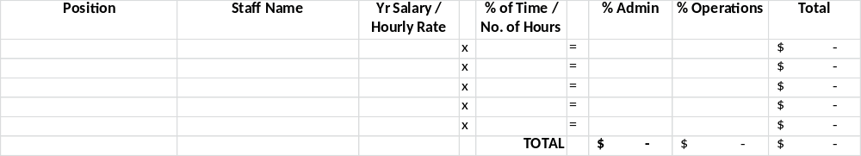
JUSTIFICATION: Describe the role and responsibilities of each position below and state how the work is necessary to the activities under the grant.

B. Fringe Benefits: List all components of fringe benefits rate. Fringe benefits may only be charged for personnel paid under the grant and may only cover the percent of time or hours worked.
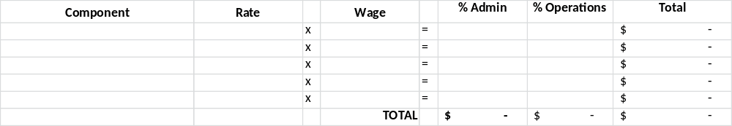JUSTIFICATION: Add any comments below:
C. Travel: Annual Federal per diem and mileage rates must be followed and can be found at http://www.gsa.gov/portal/content/104877.

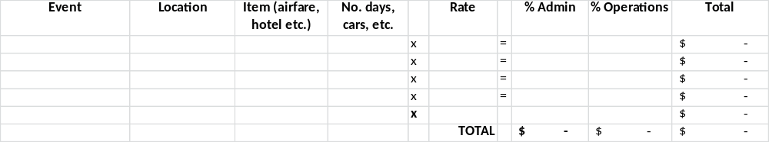
JUSTIFICATION: Describe the purpose of each item of travel and state why each item is necessary is necessary to the activities under the grant.

D. Equipment: Equipment includes any article of tangible, nonexpendable, personal property having a useful life of more than one year and an acquisition cost of $5,000 or more per unit.

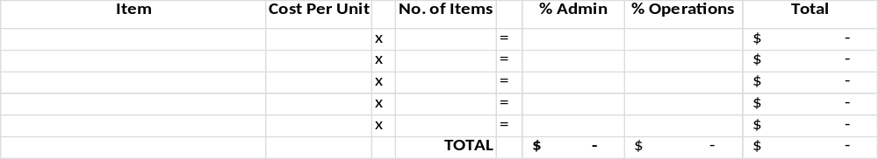
JUSTIFICATION: Describe the need for each item of equipment and state why it is necessary to the activities under the grant.
All equipment must be approved separately in writing by NPS prior to purchase.

E. Supplies: Materials costing less than $5,000 per unit that do not meet the definition of equipment.

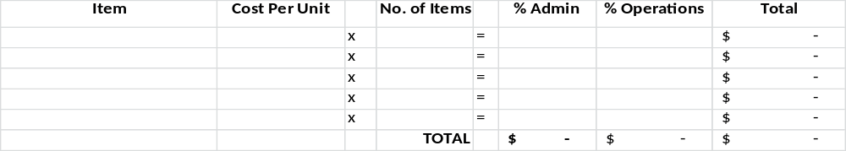
JUSTIFICATION: Describe the supplies needed and state how the supplies are is necessary to the activities under the grant.

F. Contractual: Contracted services to carry out a portion of the project activities or for the acquisition of goods or services under the grant (such as a contract to hire a consultant/contractor to do research or the lease of temporary equipment necessary for the project).

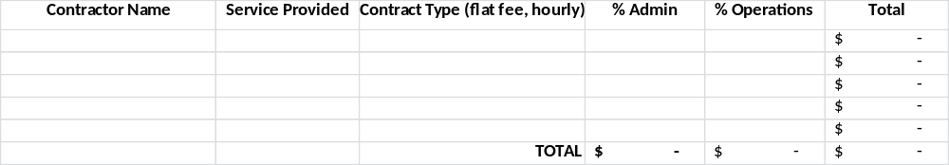
JUSTIFICATION: Describe each contractual agreement and state why each agreement is necessary to the activities under the grant.

G. Construction: Summarize construction costs here, but they must be further broken down on an SF424c, Construction Budget Form.

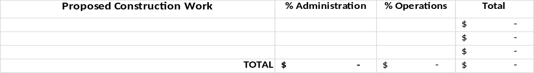
JUSTIFICATION: Describe the construction work proposed and state why it is necessary in meeting the goals of the Tribal Historic Preservation Office.

H. Other: expenses not covered in any of the previous budget categories.

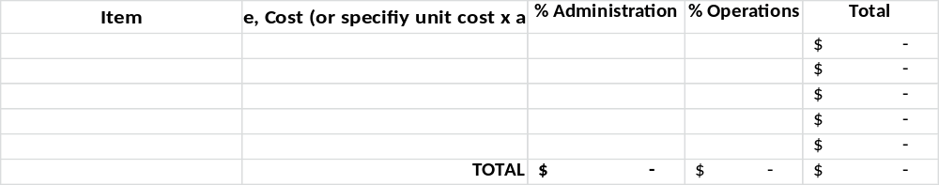
JUSTIFICATION: Break down costs into cost/unit (e.g. cost/square foot, etc.). State how each item is necessary in meeting the goals of the Tribal Historic Preservation Office.

I. Indirect cost rate: HPF Grant funded projects limit indirect costs + any additional grant administration costs to 25% of the grant award.

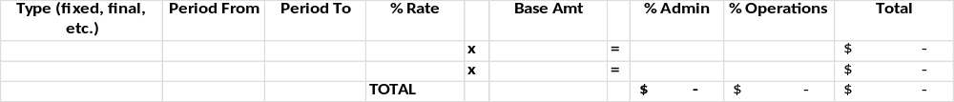JUSTIFICATION: Attach copies of the IDC agreements covering the grant period to the application.

If you need assistance in completing the form, please contact NPS at: 202-354-2020 STLPG@nps.gov.

