Information Collection: 0584-0512
Expiration date: 07/31/2025



WIC Food Packages Research Grants and Symposium

Fiscal Year 2023 Request for Applications (RFA)
Assistance Listing Number (ALN): 10.540

Release Date: | July 14, 2023
Application Due Date: | 11:59 pm, Eastern Daylight Time (EDT), August 30, 2023
Anticipated Award Date: | September 30, 2023

OMB BURDEN STATEMENT: According to the Paperwork Reduction Act of 1995, no persons are required to respond to a collection of information unless it displays a valid OMB control number. The valid OMB control number for this information collection is 0584-0512. The estimated average time required to complete this information collection is 40 hours per response, including time for reviewing instructions, searching existing data sources, gathering and maintaining the data needed, and completing and reviewing the collection of information.

Form RFA 01-23
Application Checklist

This Application Checklist provides applicants with a list of the required actions and documents that must be completed. However, FNS expects that applicants will read the entire RFA prior to the submission of their application and comply with all requirements outlined in the solicitation. The Application Checklist is for applicant use only and should not be submitted as part of the Application Package.

Complete the following at least four weeks prior to submission:
- Obtain a Unique Entity Identifier (UEI) number;
- Register the UEI number in the System for Award Management (SAM); and,
- Register in grants.gov.

When preparing your application, ensure:
- Application format and narrative meet the requirements included in Section 4 – Application and Submission Information. This includes page limits, priorities outlined in Section 5 – Application Review Information, and all necessary attachments.

When preparing your budget, ensure the following information is included:
- All key staff proposed to be paid by this grant.
- The percentage of time the Project Director will devote to the project in full-time equivalents (FTEs).
- Your organization’s fringe benefit rate and amount, as well as the basis for the computation.
- The type of fringe benefits to be covered with Federal funds.
- Itemized travel expenses (including type of travel), travel justification, and basis for lodging estimate.
- Types of equipment and supplies, justifications, and estimates, ensuring that the budget is in line with the project description.
- Information for all contracts and justification for any sole-source contracts
- Justification, description, and an itemized list of all consultant services.
- Indirect cost information (either a copy of a Negotiated Indirect Cost Rate Agreement (NICRA) or if no agreement exists and the applicant has never been approved for a NICRA, they may charge up to 10% de minimis). If an applicant is requesting the de minimis rate or indirect costs are not required, please state this in the budget narrative.

When submitting your application, ensure you have submitted the following:
- FNS-906 – Grant Program Accounting System & Financial Capability Questionnaire
- Negotiated Indirect Cost Rate Agreement (PDF - Upload using the “Add Attachments” button under SF-424 item #15)
- Resumes of key staff
- Letters of support/commitment from key staff and partners

Table of Contents
1. Program Description and Objectives 5
Executive Summary 5
Key Objectives 11
2. Federal Award Information 17
Allowable Costs 19
Unallowable Costs 19
3. Eligibility Information 19
Eligible Applicants 19
Ineligible Applicants 19
Pre-Award Screening Requirements 20
Acknowledgement of USDA Support 20
4. Application and Submission Information 20
Content and Form of Application Submission 20
Special Instructions: 21
Cover Sheet 21
Table of Contents 21
Application Project Summary 21
Project Narrative 21
Activities/Indicators Tracker 23
Application Budget Narrative 24
Indirect Cost Rate 24
Required Grant Application Forms 24
Letter of Intent 24
Submission Date 25
Preparing for Electronic Application Submission through Grants.gov 25
How to Submit an Application via Grants.gov 26
Grants.gov Receipt Requirements and Proof of Timely Submission 27
5. Application Review Information 27
Review Criteria 27
Selection Criteria 1: Key Personnel/ Staffing (20 points) 27
Selection Criteria 2: Budget Appropriateness and Efficiency (10 points) 28
Selection Criteria 3: Management Plan (15 points) 28
Selection Criteria 4: Subgrant Competition and Collaboration (25 points) 28
Selection Criteria 5: Technical Assistance (20 points) 29
Selection Criteria 6: Execution of Symposium (10 points) 29
Review and Selection Process 29
6. Federal Award Administration Information 30
Federal Award Notice 30
Administrative and National Policy Requirements 30
Confidentiality of an Application 30
Conflict of Interest and Confidentiality of the Review Process 31
Administrative Regulations 31
Code of Federal Regulations and Other Government Requirements 33
Reporting Requirements 34
Financial Reports 34
Performance Progress Reports (PPR) 34
7. Federal Awarding Agency Contacts 34
8. Other Information 35
Debriefing Requests 35
Appendix 36
RFA Budget Narrative Checklist 36
FNS-906 Grant Program Accounting System & Financial Capability Questionnaire 38
FNS-908 Performance Progress Report (PPR) 40

1. Program Description and Objectives

Executive Summary
In November 2022, the United States Department of Agriculture (USDA) Food and Nutrition Service (FNS) published proposed changes to the food packages provided by the Special Supplemental Nutrition Program for Women, Infants, and Children (WIC). These changes are intended to better align the WIC food packages with the current Dietary Guidelines for Americans (DGA, 2020-2025) and reflect recommendations made by the National Academies of Sciences, Engineering, and Medicine (NASEM) in its 2017 report. FNS is currently reviewing public comments on the proposed rule and plans to publish a final rule that incorporates that information.

This request for applications (RFA) will provide $1,500,000 in Federal funding, through a one-time cooperative agreement, to one external entity (institute of higher education or other non-profit research organization) that will ultimately provide grants to researchers to conduct pre- and post-implementation research around changes to the WIC food packages. Eligible external entities include accredited institutions of higher education (colleges/universities), nonprofit research organizations, and other nonprofit organizations. The purpose of this cooperative agreement is to better understand facilitators and barriers to implementation encountered by State/local programs, participants, and vendors and to generate evidence around implementation of the final changes to the WIC food packages rule. The goal of this work will be to assess the impacts of the recommended revisions to the WIC food packages on program satisfaction, program participation, availability and redemption of WIC foods, and participants’ diets and health. Furthermore, this research will help FNS and the broader research and public health community understand how changes to the WIC food packages impact WIC participants, vendors, State and local agencies operating the program, and unique and underserved populations.

By the end of the cooperative agreement, the successful recipient of this RFA will accomplish the following three main activities:

- Conduct a competitive subgrant award program, making funding available to academic institutions and other non-profit research organizations for the purposes of WIC food packages research
- Provide technical assistance and guidance to subgrantees for the duration of all subgrant research
- Convene a research symposium at the conclusion of the subgrant award program to share key findings from the WIC food packages research with FNS and other WIC stakeholders

Program Description
USDA FNS works to end hunger and promote nutrition security through the administration of Federal nutrition assistance programs, including WIC. WIC was authorized by the Child Nutrition Act of 1966 Section 17 (g)(5)5 and serves low-income pregnant, postpartum, and breastfeeding individuals; infants; and children up to five years old who are at nutrition risk. WIC provides nutritious foods, nutrition education, breastfeeding promotion and support, and referrals to health and social services to participants in all states, the District of Columbia, Indian Tribal Organizations (ITOs), American Samoa, Guam, the Commonwealth of the Northern Mariana Islands, Puerto Rico, and the U.S. Virgin Islands.

In fiscal year (FY) 2022, roughly 6.2 million participants across the U.S. received WIC benefits. These benefits are intended to provide nutritious foods to supplement the diets of eligible participants. WIC participants can redeem their benefits for WIC approved foods at any WIC authorized vendor (e.g., supermarket, grocery store). Participants can select from a variety of food items on their State’s approved food list based on their food prescription. WIC offers seven distinct food packages that differ in the types and amounts of foods, then tailored to meet the specific needs of each participant.

In November 2022, FNS published a proposed rule to revise regulations governing the WIC food packages. The proposed revisions were guided by the 2020-2025 DGA and recommendations published in NASEM’s 2017 report, “Review of WIC Food Packages: Improving Balance and Choice.” The DGA provided information specific to key groups of WIC participants, including pregnant and lactating individuals, infants, and children under two years of age. The proposed changes to the food packages take these recommendations into account by adjusting the amounts of certain WIC foods, depending on what was defined as a “supplemental amount.” The proposed changes are intended to provide WIC participants with a wider variety of foods that align with the latest nutritional science; provide WIC State agencies with greater flexibility to prescribe and tailor food packages that accommodate participants' special dietary needs and personal and cultural food preferences; provide more equitable access to supplemental foods; and better promote and support individual breastfeeding goals of participants to help establish successful long-term breastfeeding. Public input on the proposed rule was solicited from November 21, 2022, through February 21, 2023. These comments are currently being analyzed for input into the final rule changes. The proposed changes are summarized in Table 1.

Table 1. Summary of the 2022 Proposed Changes to the WIC Food Packages by Food Category
Food Category | Summary of Proposed Changes
Fruits and Vegetables | - Increase CVV maximum monthly allowances for child, pregnant, breastfeeding, and postpartum participants  - Require one other form of fruits and vegetables in addition to fresh  - Require vendors to stock at least three varieties of vegetables  - Expand what can be purchased with the CVV
Juice | - Reduce or remove maximum monthly allowance for juice  - Allow CVV as a substitute for juice
Milk and Milk Substitutions | - Reduce maximum monthly allowances of milk  - Require authorization of lactose-free milk  - Permit only unflavored milk and reduce total sugars allowed in yogurt and soy-based beverages  - Add a calcium specification for tofu and a vitamin D specification for yogurt  - Increase yogurt substitution amounts for milk  - Add soy-based yogurts and soy-based cheeses as substitution options for milk  - Update Food and Drug Administration (FDA) standard of identity citations for yogurt  - Allow reduced-fat yogurts for 1-year-old children without restrictions  - Remove cheese from the fully breastfeeding food package
Infant Foods | - Reduce infant cereal, infant fruits and vegetables, and infant meat  - Increase CVV substitution amounts for infant fruits and vegetables, allow forms other than fresh, and lower the minimum age for infants to receive a CVV  - Prohibit added fats in infant foods
Infant Formula | - Increase formula amounts in the first month for partially (mostly) breastfed infants  - Allow all prescribed infant formula quantities to be considered “up to” amounts  - Create a separate and enhanced food package for partially (mostly) breastfeeding participants
Breakfast Cereals | - Change whole grain criteria for breakfast cereals  - Require all breakfast cereals meet whole grain criteria
Whole Wheat Bread, Whole Grain Bread, and other Whole Grain Options | - Revise maximum monthly allowances for whole wheat and whole grain bread and other whole grain options  - Change criteria for whole grain breads  - Expand whole grain options
Canned Fish | - Add canned fish to food packages for children (2 through 4 years) and specify WIC-eligible varieties for children  - Add canned fish in food packages for pregnant, partially breastfeeding, and postpartum participants not currently receiving canned fish; revise amounts for fully breastfeeding participants, and revise WIC-eligible varieties
Legumes and Eggs | - Require both dried and canned legumes  - Require authorization of legumes and peanut butter as substitutes for eggs and allow State agencies to choose to authorize tofu to substitute for eggs
Maximum Monthly Allowances | - Allow State agencies to authorize a greater variety of package sizes, while still ensuring that participants can receive the full benefit amount (i.e., at least one package size, or a combination of sizes, must add up to the full maximum monthly allowance)

In compliance with legislative requirements to conduct a scientific review of the WIC food packages every ten years, USDA worked with the NASEM to review the WIC food packages in 2014. Prior revisions to the WIC food packages were implemented under an interim rule in 2009 and this rule was made final, with changes, in 2014. These changes were also informed by a prior NASEM review (known at that time as the Institute of Medicine) and aligned with the DGA (at the time). Following publication of the final rule, NASEM conducted a scientific review of the literature and evidence derived, in part, from prior WIC food packages research conducted around the 2009 changes to the WIC food packages. In their review, the committee highlighted several challenges that continue to affect participant redemption of WIC foods and critical research gaps that need to be addressed going forward. One of their key recommendations to FNS was to “fund research to evaluate the effects of the recommended revisions to the WIC food packages on participant satisfaction, participation in the program, redemption of WIC foods, and participants’ diets and health.” In response to these recommendations, FNS seeks to fund a grant program to support WIC food packages research, examining the food packages prior to and after implementation of the upcoming final rule.

Key Objectives
Below is a list of the Program Objectives. As noted in Section 4, within the “Activities/Indicators Tracker,” proposed activities should be clearly aligned to these objectives and their associated activities and indicators.

Application proposals must include all six objectives identified below. Note that if awarded, grantees will be required to report on progress towards activities aligned with the required objective(s) and must use the FNS-908 Performance Progress Report. Carefully considering proposed activities and indicators will prepare grantees for their progress reporting requirements if awarded.

# | Objective
1 | Develop, promote, and administer a competitive subgrant program to fund researchers to conduct pre- and post-implementation research on changes to the WIC food packages.
2 | Provide management and robust technical assistance to potential subgrant applicants throughout the application and award process, and to subgrantees throughout the life of the project.
3 | Provide evaluation technical assistance to subgrantees as they implement their respective WIC food packages research.
4 | Provide a platform for subgrantees to share the results of their research by hosting a WIC food packages research symposium at the conclusion of the grant period.
5 | Develop a research brief suggesting potential future research directions based on the results of the WIC food packages research and symposium.
6 | Submit all deliverables and reports produced from this grant to FNS.

The following paragraphs expand upon the above objectives and link the following activities to the Program Objectives.

Activity 1: Conduct a competitive subgrant award program
Following award of the cooperative agreement, the Grantee shall conduct a competitive subgrant process for researchers from academic institutions (including graduate and postdoctoral students), non-profits, and/or other research organizations to submit proposals for funding of pre- and post-WIC food packages implementation research. No later than September 30, 2024, the Grantee shall make awards to successful applicants. All subgrant research must be completed in time to present results at a research symposium to be held at the conclusion of the subgrant award program.

When determining the amount of funding to be made available for the subgrant award program, applicants for this RFA are encouraged to maximize the amount of the funding that will be made available through subgrants. In doing so, the Grantee shall award the majority of the funding (i.e., at least 51% of total award amount) to research institutions through one subgrant program administered by the Grantee. In their applications, applicants for this RFA should explicitly state:

- The total amount of funding they will make available for subgrantees (i.e., academic institutions, non-profits, or other research organizations) through the subgrant award program

- The range amount of funding they will make available for each subgrantee (i.e., how much money each entity can apply for)

- The number of anticipated subgrant awardees

- The period of performance for the subgrant award program

- A detailed description of how the Grantee will administer the subgrant award program, including a description of the subgrant application process, suggested reviewers for subgrant applications, and subgrant application evaluation criteria, and how they will monitor and provide technical assistance to the subgrantees over the course of the cooperative agreement

Special considerations for the subgrant program(s) RFA:

- When describing how they will administer the subgrant program, the Grantee should consider that FNS intends for the subgrant application process to be as simple as possible. As such, the Grantee shall describe how they will provide application technical assistance to the research entities that wish to apply for subgrant funding.

- The Grantee shall also describe how they will publicize this opportunity to the research community.

- Before the subgrant RFA is published, FNS must approve of all subgrant RFA content. Grantee applicants should build a 6-week review timeline into their overall project timeline.

- The subgrant RFA shall consist of two primary activities: (1) conducting pre- and post-implementation research on changes to the WIC food packages, and (2) participating in a research symposium to highlight key findings from subgrantee evaluation activities.

In response to this RFA, the Grantee shall articulate the various research focus areas and methods that will be considered for subgrantee research on the changes to the WIC food packages. The Grantee shall work with FNS to finalize these focus areas and methods for inclusion in the subgrant RFA. In addition to the focus areas the Grantee may propose, they must include assessment of the preliminary impact of the changes to the WIC food packages on:

- Participants (e.g., satisfaction, customer experience, redemption, and consumption of WIC foods, and intention to enroll or remain enrolled in WIC)
- Vendors and the retail/food environment (e.g., availability of WIC foods)
- State and local agency program operations and policies
- Underserved and unique populations (e.g., Indian Tribal Organizations (ITOs) and U.S. Territories) especially as it pertains to populations that may have had cultural or other challenges with the previous food packages.

To successfully accomplish project-related activities and achieve the Program Objectives outlined in this RFA, the Grantee must possess a wide variety of skills and expertise in research design, quantitative and/or qualitative methodology, and the WIC program and food packages. Specifically, to achieve Program Objective 1 (i.e., develop, promote, and administer a competitive subgrant program to fund researchers to conduct pre- and post-implementation research of changes to the WIC food packages), the applicant must demonstrate it possesses the ability to conduct a subgrant program to research changes to the WIC food packages. Grantee applicants must also demonstrate a commitment to equity and cultural sensitivity and the role this will play in their research, particularly when assessing the impact of the WIC food package changes on underserved and unique populations.

In their proposals, Grantee applicants must propose an appropriate, theory-driven framework that covers the four research focus areas identified above. This framework will serve as a guide for the Grantee and subgrantee research and must include a logic model that can be attached as an appendix to subgrantee applicants’ proposals. All research methods should align with the standards and use definitions consistent with those expressed in Office of Management and Budget (OMB) Memorandum M-20-12 (whitehouse.gov). Key performance indicators (KPIs) must be measured throughout the project life cycle and reported to FNS via regular reporting (i.e., progress reports and final report). KPIs for this grant program must be clearly articulated in Grantee applicants’ proposals.
Activity 2: Provide research and evaluation technical assistance and guidance to subgrantees

To accomplish this activity and achieve the associated Program Objectives, the Grantee must possess a deep expertise in research design, quantitative and/or qualitative methodology and the WIC program and food packages. As such, applicants for this RFA shall include detailed examples of previous work demonstrating these skills in this application, including references to reports, manuscripts, and other related artifacts available in the public domain. The Grantee must also demonstrate the ability to draft and establish partnership agreements and/or comprehensive data sharing agreements between researchers and WIC entities. The Grantee must be able to assist subgrantees in resolving legal, compliance, and technical barriers that may arise when developing agreements between subgrantees and WIC entities to obtain data needed for research and evaluation.

In their application, the Grantee shall explicitly state the strategies they will use to provide research and evaluation technical assistance and guidance to subgrantees. The description shall include, but not be limited to:

- How the Grantee will regularly communicate with subgrantees and the frequency of this communication
- How the Grantee will monitor progress against goals and problem-solve with subgrantees that fall behind schedule, due to unique subgrantee circumstances or timing of final rule implementation, keeping in mind FNS’s interest is timely information about the food packages provided NLT the final symposium
- How the Grantee will resolve issues subgrantees encounter when setting up the evaluations and what tools/expertise/resources it will leverage to resolve these issues
- What resources the Grantee will develop to provide research and evaluation technical assistance to subgrantees.

As noted in Objective 6 (i.e., submit all deliverables and reports gleaned from this grant to FNS), the Grantee shall bear responsibility for collecting and submitting to FNS all deliverables which are developed by the Grantee or by subgrantees through this project. FNS reserves the right to utilize, disseminate, and/or share these and any other deliverables produced with funding under this grant project in accordance with 2 CFR part 200 (including, but not limited to, tools developed by sub-grantees using grant funds).

Activity 3: Convene a research symposium at the conclusion of the subgrant award program

To successfully accomplish project-related activities and achieve the Key Objectives, the Grantee must conclude the grant with a WIC food packages research symposium for subgrantees to convene and share their research findings. The primary purpose of the symposium will be to share key findings with FNS and WIC stakeholders. Proposals should include a description of how they would run the event to ensure it provides a forum for dissemination of research findings and a space for promoting shared learning from this research. The symposium is designed to advance our collective knowledge, evaluation methods, and strategic planning around WIC for improved program and policy implementation. All aspects of the symposium, including locating a space and handling all logistics will be the responsibility of the grantee using grant funds.

When planning the symposium, the Grantee must address the following:
- All subgrantees participating in WIC food packages research should be required to present at the symposium.
- The symposium should be formatted for attendance both virtually and in-person.
- The Grantee must demonstrate how the symposium will be advertised to potential attendees.
- The Grantee has the option to integrate the symposium into an existing conference’s programming.

Per objective 5, following the symposium, the Grantee shall be responsible for putting forth a research brief highlighting the findings presented at the symposium as well as future research directions based on the results of the WIC Food Packages research symposium.

Related Activities:

Beyond the research activities of these subgrants and throughout the course of the grant, FNS will fund the Grantee to conduct WIC food packages research activities of their own. The research proposed may use data from FNS studies or other sources and may involve collaboration with an FNS researcher. The Grantee shall propose what WIC food packages research they plan to conduct as part of their application.
Purpose of Cooperative Agreement
This grant will be awarded in the form of a cooperative agreement. This agreement is a legal instrument reflecting a relationship between the Federal government and the Grantee. Cooperative agreements allow more FNS involvement and collaboration in the project compared to a typical grant and provide less direction of project activities than a contract. The roles and responsibilities of both the Grantee and FNS will be stated in the Terms and Conditions of the cooperative agreement.

FNS’s involvement in this cooperative agreement will largely entail serving as Subject Matter Experts (SMEs) to provide key input and information to the Grantee, reviewing and providing feedback on deliverables, and providing input on the subgrantee selection and performance processes. FNS will approve subgrant RFAs, subgrantee selection criteria, and final subgrantee award decisions as well as all public-facing communications and resource materials.

To the extent practicable, FNS is available to provide policy and technical consultation to the Grantee through a series of pre-planned feedback sessions and/or standing meetings. FNS will comment on major project aspects and issues in advance of their implementation in a manner and timeframe agreed upon between the Grantee and FNS. At FNS’s discretion, FNS involvement with the Grantee may include:

- Providing comments on and having ongoing conversations with the Grantee regarding plans to meet this RFA’s requirements
- Reviewing plans specified in Application and Submission Information section of this RFA and plans associated with projects funded by this cooperative agreement
- Reviewing and/or co-authoring documents
Program Specific Requirements
The Grantee shall clearly illustrate in their application materials and provide documented evidence of:
1. Organizational experience and capacity to conduct all aspects of this cooperative agreement, including but not limited to hiring appropriate staff, managing the administrative and operational aspects of the grant, implementing all required activities successfully, and cooperating fully with FNS and the Grantee's subgrantees.
2. Applicable subject matter expertise, evidenced by extensive publications about WIC and/or public health
3. Applicable methodological expertise to lead this research effort
4. Experience and capacity in all three activities required by this RFA
Subgrant program administration and requirements: The Grantee and subgrantee shall consider the needs of the communities and individuals being targeted through these research efforts and tailor strategies accordingly. The Grantee shall involve subject matter experts to review project plans and documents.
The Grantee shall work cooperatively with FNS to:
- Within 4 weeks of the start of this cooperative agreement’s period of performance, host a kick-off and project planning meeting where the Grantee will summarize the proposal for FNS staff, discuss the timeline with FNS and begin planning with FNS the subgrant requirements, timeline, and process.
- Develop and manage a competitive subgrant award process. The Grantee, along with guidance and approval from FNS, will select, award, and monitor the subgrants through regular communication, reports, and meetings. The Grantee will work with subgrantees to evaluate their projects.
- Develop a Subgrant Request for Application (Subgrant RFA). The RFA will describe the opportunity, explain subgrant eligibility, and establish selection criteria for the award. Principles of diversity and equity shall be considered when selecting subgrantees. In their application, the Grantee shall describe and justify their capacity for the competitive subgrant award process, their criteria for selecting subgrantees, their plans for promoting the opportunity among all relevant stakeholders, and their plans for managing and collaborating with subgrantees upon award.
- Lead virtual meeting(s) with FNS during which the Grantee presents and explains the subgrant RFA, including the communication plan for the RFA, to FNS.
- Prior to selection of subgrantees, submit to FNS the proposals and summaries of all proposals submitted and discuss the proposals with FNS. At a minimum, summaries shall include the following information: the name of the research entity and point of contact for the project, the requested award amount, a brief description of the proposed project, including the research questions and methods proposed, and a subgrant timeline. FNS will approve final selection decisions for the subgrants.
- Following award of subgrants, host a virtual post-competition project meeting with FNS and the subgrant awardees. This meeting will provide an opportunity for subgrantees to present an overview of their project plans and concepts to FNS and the Grantee, who will provide feedback during this meeting and through subsequent communications.
- Fulfill reporting requirements:
  - Subgrantee reporting requirements: The Grantee shall require that each subgrantee submit quarterly progress reports as part of their subgrant requirements. The Grantee shall submit these subgrantee quarterly progress reports to FNS as well. Similarly, the Grantee shall require that each subgrantee submit a final report by the end of the subgrantee’s period of performance, and the Grantee shall also submit the subgrantees’ final report to FNS. Final reports shall describe the approach to evaluation, including methodology and any guiding theories or framework; results of the evaluations; and a discussion of strengths, limitations, lessons learned, and possible next steps in dissemination. Final reports must also include an executive summary.
  - Grantee reporting requirements: The Grantee will submit to FNS quarterly progress reports, annual progress reports, and a final report. The Grantee also must submit Subgrantee reports to FNS.
  - In addition to subgrantee progress and final reports, the Grantee shall submit its own quarterly and final report to FNS. Similar to the requirements for subgrantee reports, the Grantee’s final report shall include an executive summary; a summary of the overall project as well as the subgrant projects funded through this RFA; the approach to evaluation, including methodology and any guiding theories or framework; results of evaluations; a discussion of strengths, limitations, lessons learned, and recommendations for next steps; and next steps for dissemination of project information, results, and materials to various audiences.
- Host an informational webinar for interested research entities within the application period of the subgrantee RFA(s) to help inform potential subgrant applicants and provide answers to questions.
- The Grantee’s proposal shall describe the project management and monitoring process it will use to provide technical assistance, identify risks related to subgrantee performance, monitor subgrantees' progress over time, and assist with corrective actions (if any); the plan should also include how they will stay in regular communication with FNS.
- Aid subgrantee in conducting their proposed evaluation plans. Technical assistance includes, but is not limited to, providing guidance and technical support and, when needed, serving as a liaison between subgrantees and FNS.
- Sponsor and coordinate meetings for subgrantee projects. First, a kick-off and planning orientation meeting at the beginning of the cooperative agreement. Last, a closeout session with subgrantees at the project’s completion.
- Provide FNS with an electronic copy of all dissemination materials (for example, outreach materials and documents, PowerPoint slides, and demonstration and operational versions of applications) resulting from grant and subgrant activity at the time of submission for publication and in final form when published. FNS will provide comments and approval on documentation at FNS discretion. All materials generated by efforts funded through this cooperative agreement must be reviewed by FNS before general distribution.
Deliverables and Implementation Tools: As per Key Objective #6, the Grantee shall “Submit all deliverables and reports produced from this grant to FNS.” To meet this objective, applicants shall propose a suite of products, which it will submit to FNS at the end of the grant period, and this suite of products may include, but not be limited to, webinars, issue briefs, infographics, or other off-the-shelf products that will help FNS communicate the changes to the WIC food packages.
Meetings
In meetings with FNS, the Grantee and subgrantees shall provide an overview of the activities conducted since the last meeting, major accomplishments with completion dates and budget, deviations from the proposed plan, lessons learned, and challenges encountered, solutions developed to overcome difficulties, preliminary findings, assistance needed from FNS on technical issues, and major planned activities for the next quarter. Should a major issue arise between meetings, the Grantee shall contact the FNS Grants and Program Officers immediately. Between the start of this cooperative agreement and the awarding of the subgrants (~ the first year of this cooperative agreement), meetings with FNS shall occur at least monthly. The Grantee shall provide FNS with an agenda a minimum 3 business days prior to each call. The Grantee shall also prepare minutes for each call and distribute to FNS no later than 5 business days after the call.

2. Federal Award Information
The following information is intended to provide applicants with information to help make informed decisions about proposal submissions.

- Total amount of funding expected to award: $1,500,000
- Anticipated number of awards: 1
- Maximum award amount (award ceiling): $1,500,000
- Anticipated award announcement date: September 2023
- Anticipated period of performance (start and end date of the award): September 2023-March 2028
- Application due date: August 30,2023

Please note:
- Grant awards are subject to the availability of funding and/or appropriations of funds.
- FNS reserves the right to use this solicitation and competition to award additional grants this year or the subsequent fiscal year, should additional funds become available.
- For this RFA, FNS will accept one application package per Principal Investigator. Among the required activities, the Grantee will be responsible for utilizing their total awarded amount (i.e., up to $1,500,000) to carry out all objectives described in this RFA. While the Grantee must reserve a portion of the total funding to administer this project and achieve all objectives outlined above, the majority (at least 51%) of the total funding must be made available for subgrants to research entities.

SAMPLE Estimated Award and Performance Timeline
Date | Activity
July 14, 2023 | Grant RFA release
July 28, 2023 | Optional Letter of Intent due
August 30, 2023 | Grant RFA applications due
No later than September 30, 2023 | Grant award
No later than April 30, 2024 | Subgrant RFA release
No later than July 01, 2024 | Subgrant RFA applications due
No later than September 30, 2024 | Subgrant grants awarded
September 30, 2024 – December 31, 2027 | Subgrant period of performance; Grantee provides evaluation technical assistance and guidance
No later than March 31, 2028 | Grantee convenes WIC food packages evaluation symposium
No later than May 31, 2028 | Grantee submits research brief
September 30, 2028 | End of Cooperative Agreement

Allowable Costs
Among other costs, budgets may include expenses related to personnel, contractors, and, whether in-person or virtual, FNS-approved meeting, conference, and training travel expenses.

Travel: To the extent possible, the Grantee should limit travel-related expenses and, instead, rely on virtual meeting platforms (e.g., Zoom, Microsoft Teams). When necessary, however, travel expenses are permissible.

Unallowable Costs
Entertainment: Costs of entertainment, including amusement, diversion, and social activities and any associated costs are unallowable (such as mascot costumes, promotional items, etc.) unless there is a programmatic purpose and prior approval is granted by FNS.

All costs proposed in the budget and detailed in the budget narrative must be allowable, reasonable, necessary, and allocable. Refer to 2 CFR Part 200 Subpart E – Cost Principles for a detailed description of all allowable and unallowable costs.

3. Eligibility Information

Eligible Applicants
This Request for Applications (RFA) is open to all accredited for profit or non-profit institutions of higher education (colleges/universities), nonprofit research entities, and other nonprofit organizations or research institutions. All non-profit organizations must include their 501(c)(3) determination letter issued by the Internal Revenue Service (IRS).
There shall be a single Grantee, but the Grantee may partner with other organizations through subcontracting to meet RFA requirements. Entities not meeting the eligibility definitions will be deemed ineligible and removed from competition without further consideration.

Ineligible Applicants
- Entities not meeting the eligibility requirements
- K-12 schools, school districts, and childcare facilities are not eligible to receive this award.
- International (non-U.S. or non-U.S. territories) entities are not eligible to apply.
- Suspended or debarred organizations are ineligible to submit applications in response to this grant solicitation.

Pre-Award Screening Requirements
In reviewing applications in any discretionary grant competition, prior to making a Federal award, Federal awarding agencies, in accordance with 2 CFR 200.205, are required to review information available through any OMB-designated repositories of government-wide eligibility qualifications or financial integrity information. Additionally, Federal awarding agencies are required to have a framework in place for evaluating the risks posed by applicants before they receive Federal awards. The FNS review of risk posed by applicants will be based on the following:

- SAM.gov, the System for Award Management, the Official U.S. Government system that consolidated the capabilities of CCR/FedReg, ORCA, and EPLS
- FAPIIS, the Federal Awardee Performance and Integrity Information System that has been established to track contractor misconduct and performance
- FNS Risk Assessment Questionnaire
  - Applicants must complete the Grant Program Accounting System & Financial Capability Questionnaire that allows FNS to evaluate aspects of the applicant’s financial stability, quality of management systems, and history of performance, reports, and findings from audits. The questionnaire contains a number of questions that may be an indicator of potential risk.

The evaluation of the information obtained from the designated systems and the risk assessment questionnaire may result in FNS imposing special conditions or additional oversight requirements that correspond to the degree of risk assessed.

Acknowledgement of USDA Support
As outlined in 2 CFR 415.2, grant recipients shall include acknowledgement of USDA Food and Nutrition Service support on any publications written or published with grant support and, if feasible, on any publication reporting the results of, or describing, a grant-supported activity. Recipients shall include acknowledgement of USDA Food and Nutrition Service support on any audiovisual which is produced with grant support, and which has a direct production cost of over $5,000.
- When acknowledging USDA support, use the following language: "This material is based upon work that is supported by the Food and Nutrition Service, U.S. Department of Agriculture.” Grantees should follow the USDA Visual Standards Guide when using the USDA logo.
- Grant recipients may be asked to host USDA officials for a site visit during the course of their grant award. All costs associated with the site visit will be paid for by USDA and are not expected to be included in grant budgets.

4. Application and Submission Information

Content and Form of Application Submission
FNS strongly encourages eligible applicants interested in applying to this program to adhere to the following applicant format. The proposed project plan should be presented on 8 ½” x 11” white paper with at least 1-inch margins on the top and bottom. All pages should be single-spaced in 12-point font. The project description with relevant information should be captured on no more than 20 pages, not including the cover sheet, table of content, resumes, letter(s) of commitment, endorsement letter(s), budget narrative(s), appendices, and required forms. All pages, excluding form pages must be numbered.

Special Instructions:
- Late application submission will not be considered in this competition. FNS will not consider additions or revisions to applications unless they are submitted via Grants.gov by the deadline. No additions or revisions will be accepted after the deadline.
- Applications submitted without the required supporting documents, forms, certification will not be considered.
- Applications missing a written proposal or budget narrative will not be considered and deemed nonresponsive.
- FNS reserves the right to request clarification on any application submitted in response to this solicitation.
- Applications not submitted via Grants.gov will not be considered.
- If multiple application packages are submitted through Grants.gov by the same applicant in response to this solicitation, FNS will accept the latest application package successfully submitted. All other packages submitted by the applicant will be removed from this competition.

Cover Sheet

The cover page should include, at a minimum:
- Applicant’s name and mailing address
- Primary contact’s name, job title, mailing address, phone number and e-mail address
- Grant program title and subprogram title (if applicable)

Table of Contents
The Table of Contents should include relevant sections, subsections and associated page numbers.

Application Project Summary
The application should clearly describe the proposed project activities and anticipated outcomes that would result if the proposal were to be funded.

Project Narrative
The project narrative should clearly identify what the applicant is proposing and how it will address a solution, the expected results and/or benefits once the solution is achieved, and how it will meet the RFA program scope and objectives. The proposed project methodology should describe the project design, address program specific methodology needs, procedures, timetables, monitoring/oversight, and the organization’s project staffing.

The project narrative should also clearly identify what the applicant is proposing for the competitive RFA process and how it will solicit, evaluate, and select subgrant proposals submitted by other research entities. The applicant will also describe its capacity to provide technical assistance to subgrant recipients to initiate and build a theory-based evaluation framework, evaluate program outcomes, report on KPIs related to subgrant projects, and host a symposium on evaluations and lessons learned from the work completed under this RFA. The project narrative should also indicate plans for disseminating all project deliverables.

- Introduction: Provide background information on the proposed team’s experience and plans for administering a competitive subgrant award system for familiarity with WIC operations and food packages, lessons learned, and challenges from previous research and evaluation efforts.
- Background: Describe what is known and highlight what is not known about this project.
- Objectives, Activities, and Timeline: Clearly state project objectives, use descriptive statements that specifically discuss what the project team hopes to accomplish, and include specific activities and deadlines that accomplish all project objectives. All objectives should lead to a clearly stated goal of this RFA, and the proposal should include a logic model showing how objectives and goals will be accomplished. The project timeline should start on the award date and end no more than 48 months later. For planning purposes, use the date of award as planned and include dates for important project milestones and deadlines and include dates for items described in the Key Objectives, Purpose of Cooperative Agreement, and Program Specific Requirements sections of this RFA.
- Management Plan: Describe activities to be undertaken to manage the project to ensure activities are completed on time, within budget, and with high-quality results, including how the grantee will manage contractors to ensure timely, high-quality results. Applicant should describe its organizational structure and identify the staff and/or contractors who will manage the project. Describe roles and responsibilities of these employees or contractors, as well as relevant qualifications and experience, and level of effort specified for each specific staff proposed. Note any relevant experience in managing similar activities. Explain contingency plans for staff turnover and include an abbreviated resume or curriculum vitae (no more than 3 pages) of the key personnel expected to work on the project. Describe how communication, quality assurance, recordkeeping, and accounting activities will be executed. Provide a clear description of how funds will be administered and distributed.
- Administration Plan: Describe the team’s plan to administer a competitive RFA process that includes an overview of the procedures for developing the solicitation, promoting the solicitation among research organizations and selection criteria for received proposals. Planned items that will be included in the solicitation beyond those required by this RFA should also be explained. The applicant should additionally describe plans to manage and collaborate with subgrantees.
- Research Plan: A key component of this work is researching changes to the WIC food packages. The application should demonstrate the ability to provide guidance on how to assess changes to the WIC food packages before, during, and after implementation and use findings to support recommendations and resource development. The application should identify the target hypotheses and/or research questions to be evaluated.
- Technical Assistance Plan: Indicate the process, frequency, and mode by which the Grantee will interact with subgrantees (both individually and as a group) to provide technical assistance, including how subgrantees will be able to request assistance and how requests for assistance will be managed by the Grantee in collaboration with FNS. The plan should describe the personnel that will perform this function, as well as a process to document and track each technical assistance experience. The purpose of technical assistance is to support the grant activities and project objectives throughout the entire subgrant period. Applicants should also articulate a clear plan to communicate the RFA requirements through webinars, prior to award, to those interested in subgrants.
- Symposium and Dissemination Plan: Describe plans for hosting a research symposium following the completion of subgrantee research efforts. Describe specific plans for inviting researchers conducting similar work on changes to the WIC food packages to present at the symposium. Describe plans for disseminating findings from the symposium. Describe specific plans to make research findings accessible to stakeholders, including USDA FNS, WIC State and local agencies, nonprofits, community partners, and others identified throughout the course of this evaluation.

Activities/Indicators Tracker

Proposed Activities and indicators measuring success must be mapped to Program Objectives (as described in Section 1 – Program Description) in the below format (note that additional Activities/Indicators can be added as needed).

Note: Indicators are defined as any metric you anticipate will be able to be tracked during the period of performance of the grant. Common examples include Number of People Attended, Number of People Impacted, Number of Conferences Delivered, Number of Materials Created, Number of Trainings, Number of People Trained.

Example

Example
Objective # | 1. Develop, promote, and administer one competitive funding opportunity for research institutions to conduct pre- and post-implementation research on changes to the WIC food packages rule.
Activity | Develop RFA for subgrant projects.
Indicator(s) | RFA accepted by FNS.
Activity | Administer awards according to approved plans. Deliver a proposal summary capturing all responses to the solicitation.
Indicator(s) | Proposal summary accepted by FNS.

Application Budget Narrative
The budget narrative, formatted as a table, should correspond with the proposed project narrative and application budget. The narrative must justify and support the bona fide needs of the budget’s direct cost. The budget and budget narrative must be in line with the proposed project description. If the budget includes indirect costs, the applicant must provide a copy of its most recently approved Federal indirect cost rate agreement. Budget categories in this table must match those listed on the SF-424A form. If the budget table is created in a spreadsheet, it must be formatted to fit on an 8.5 x 11-inch page, with a font no smaller than 11-point Times New Roman. All funding requests must be in whole dollars.

Indirect Cost Rate
A current Negotiated Indirect Cost Rate Agreement (NICRA), negotiated with a cognizant Federal agency, should be used to charge indirect costs. Indirect costs may not exceed the negotiated rate. If a NICRA is used, the percentage and base should be indicated. If the applicant does not have, and has never been approved for, a NICRA, they may charge up to 10% de minimis. In this instance, the applicant must indicate they are requesting the de minimis rate. An applicant may elect not to charge indirect costs and instead use all grant funds for direct costs. If indirect costs are not charged, the phrase “none requested” should be stated in the budget narrative. For questions related to the indirect cost rate, please work with the Grant Officer as noted in Section 7 of this RFA.

Note: Each organization is assigned to a single federal agency (by the Office of Management and Budget) that acts on behalf of all federal agencies in indirect cost rate negotiations and is referred to as the “cognizant agency.”

Required Grant Application Forms
The required grants.gov forms may be previewed at grants.gov/web/grants/forms/forms-repository.html. These forms are part of the grants.gov Workspace application.

- Non-Construction Grant Projects Forms: SF-424 Family
  - Application and Instruction for Federal Assistance (SF-424)
  - Budget Information and Instructions (SF-424A)
  - Assurance-Non-Construction Programs (SF-424B)
- SF LLL (Disclosure of Lobbying Activities)
  - Indicate on your form whether your organization intends to conduct lobbying activities. If you organization does not intend to lobby, write “Not Applicable” in boxes required to be completed.
- Additional Required Forms and Information
  - Unique Entity Identifier (UEI) number. Please see below for further information
  - SAM registration. Please see below for further information.

Letter of Intent

The eligible applicant who intends to apply should submit a Letter of Intent notice by July 28, 2023. This notice does not obligate the applicant to submit an application but provides FNS with useful information in preparing for the review and selection process. The notice should include the potential applicant’s name and address, organizations’ name, telephone number, and email address of the primary point of contact. The applicant can send the letter via email to the FNS Grant Officer identified in Section 7 of this RFA.

Submission Date
Complete grant applications must be uploaded to grants.gov by 11:59 PM EDT on the due date listed on the cover page
- Applications must be submitted via grants.gov. Mailed, emailed, or hand-delivered application packages will not be accepted. For further instructions, see the “Preparing for Electronic Application Submission through Grants.gov” below.
- Late or incomplete applications will not be considered.
- FNS will not consider additions or revisions to applications unless they are submitted via grants.gov by the deadline. No additions or revisions will be accepted after the deadline.
- If multiple application packages are submitted through grants.gov by the same applicant in response to this solicitation, FNS will accept the latest application package successfully submitted. All other packages submitted by the applicant will be removed from this competition.

FNS strongly encourages applicants to begin the registration process at least four weeks before the due date and to submit applications to grants.gov at least one week before the deadline to allow time to troubleshoot any issues should they arise. Please note that upon submission, grants.gov may send multiple confirmation notices. Applicants should ensure receipt of confirmation that the application was accepted.

FNS will not accept applications outside of grants.gov. Applicants experiencing difficulty submitting applications through grants.gov should contact applicant support via the toll-free number 1-800-518-4726 and email at support@grants.gov. This service is available 24/7.

Preparing for Electronic Application Submission through Grants.gov
Applicants must register with grants.gov and SAM.gov in order to submit an application to FNS via grants.gov as required.

In order to submit an application, you must:
- Obtain a UEI number

What is a Unique Entity Identifier (UEI)?
A UEI is a unique number assigned to all entities (public and private companies, individuals, institutions, or organizations) who register to do business with the federal government. For more information, visit the U.S. General Services Administration website.

Where do I go to learn more about the UEI?
The U.S. General Services Administration Unique Entity Identifier Update page contains the most up-to-date information about the UEI.

Note: After April 4, 2022, entities can register in SAM.gov and will be assigned their “SAM UEI.” They will no longer obtain or use a “DUNS UEI” for entity registration or reporting. For additional information on the UEI process, please visit SAM.gov.

2. Register in the System for Award Management (SAM)

- On April 4, 2022, the UEI used across the federal government changed from the DUNS number to the UEI (generated by SAM.gov).
- SAM combines federal procurement systems and the Catalog of Federal Domestic Assistance into one system. Visit SAM.gov for additional information.
- To register, you must have your organization’s UEI, the organization’s Tax ID Number (TIN), and taxpayer name (as it appears on the last tax return). It may take up to 5 to 7 business days or more to register and/or complete the migration of permissions and/or the renewal of an entity record.
- All applicants must have current SAM status at the time of application submission and throughout the duration of a Federal Award in accordance with 2 CFR Part 25.
- FNS strongly encourages applicants to begin this process at least 3 weeks before the due date of the grant solicitation.

3. Create a Grants.gov Account

The next step in the registration process is to create an account with grants.gov. Applicants must know their organization’s Unique Entity Identifier (UEI) to complete this process. For more detailed instruction about creating a profile on grants.gov, visit grants.gov/web/grants/applicants/registration.html.

How to Submit an Application via Grants.gov
Applicants must apply online using Workspace. Workspace is a shared, online environment where members of a grant team may simultaneously access and edit different web forms within an application. For each funding opportunity announcement or RFA, you can create individual instances of a workspace.

For additional training resources, including video tutorials, visit grants.gov/web/grants/applicants/applicant-training.html.

Applicant Support: Grants.gov provides applicants 24/7 support via the toll-free number 1-800-518-4726 and email at support@grants.gov. If you are experiencing difficulties with your submission, it is best to contact grants.gov support and get a ticket number. The Support Center ticket number will assist the Center with tracking your issue.

For questions related to the specific grant opportunity, please contact the Grant Officer noted in Section 7 – Federal Awarding Agency Contacts of this RFA.

NOTICE: Special Characters and Naming Conventions
All applicants must follow grants.gov guidance on file naming conventions. To avoid submission issues, please follow the guidance provided by grants.gov (per the grants.gov Frequently Asked Questions or FAQ).

Are there restrictions on file names for any attachment I include with my application package?
File attachment names longer than approximately 50 characters can cause problems processing packages. Please limit file attachment names. Also, do not use any special characters (e.g., ! @ # $ % ^ & * - ‘). This includes periods (.) and spacing followed by a dash in the file. To separate words in naming a file, use underscore (_). For example, Attached_File.pdf.

If these guidelines for file names are not followed, your application will be rejected. FNS will not accept any application rejected from the grants.gov portal due to incorrect naming conventions.

Additional information can be found at grants.gov/web/grants/applicants/applicant-faqs.html#attachments.

Grants.gov Receipt Requirements and Proof of Timely Submission
All applications must be received by 11:59 PM EDT on the due date listed on the cover page, as detailed in Section 4 – Submission Date. Proof of timely submission is automatically recorded by grants.gov. An electronic date/time stamp is generated within the system when the application is successfully received by grants.gov. The applicant Authorized Organization Representative (AOR) will receive an acknowledgement of receipt and a tracking number (e.g., GRANTXXXXXXXX) from grants.gov with the successful transmission of their application. Applicant AORs will also receive the official date/time stamp and a grants.gov tracking number in an email serving as proof of their timely submission.

When FNS successfully retrieves the application from grants.gov and acknowledges the download of submissions, grants.gov will provide an electronic acknowledgement of receipt of the application to the email address of the applicant with the AOR role. Again, proof of timely submission shall be the official date and time that grants.gov receives your application. Applications received by grants.gov after the established due date for the program will be considered late and will not be considered for FNS funding.

Applicants using slow internet, such as dial-up connections, should be aware that transmission could take some time before grants.gov receives your application. Again, grants.gov will provide either an error or a successfully received transmission in the form of an email sent to the applicant with the AOR role. The grants.gov Support Center reports that some applicants end the transmission because they think that nothing is occurring during the transmission process. Please be patient and give the system time to process the application.

5. Application Review Information

Review Criteria

FNS will pre-screen all applications to ensure the applicants are eligible entities and are in compliance with all Program regulations. FNS will not approve any waivers from Program regulations for any projects submitted in response to this solicitation.

Selection Criteria 1: Key Personnel/ Staffing (20 points)

- Plan describes and clearly demonstrates: the roles and responsibilities of key personnel and other partners and staff involved in the proposed project; key personnel and their relevant education, skills, and experience as it relates to the WIC, event hosting, and program evaluation for their proposed roles on the project; and staff experience with writing, technical assistance, evaluation, and resource development including notable past grant effort experience in the form of publications, reports, etc.
- Documentation of the time commitment of key personnel is appropriate, complete, and sufficient for the project roles.
- Demonstration that partners, if any, have appropriate experience and commitment to effectively fulfill their proposed roles within the time and financial constraints of the project (note: letters of commitment are required from established partners in the application and serve as evidence of these commitments).
- Plan describes how project will be managed by a multi-disciplinary, inclusive, and diverse team of personnel that reflect the diversity of communities served by WIC.

Selection Criteria 2: Budget Appropriateness and Efficiency (10 points)

- Total funding amount requested in the budget and corresponding narrative is appropriate for the scope of the project. Proposed costs are reasonable, necessary, and allocable to carry out the project’s goals and objectives.
- Budget considers all operational costs that are necessary to accomplish the objectives of the project. Budget includes a line-item description for allowable costs and shows how each line item supports the project goals.
- Budget calculations and documentation are complete and clearly show how budget components were developed and costs were estimated.
- Budget specifically describes how the Grantee will allocate its awarded amount to: carry out a competition to award subgrants to research entities to conduct evaluations of changes to the WIC food packages; provide technical assistance to subgrant recipients; and host a research symposium.

Selection Criteria 3: Management Plan (15 points)

- Plan articulates how the applicant will provide the oversight necessary to ensure high-quality subgrant project monitoring, technical assistance, and deliverables to keep the project on time and within budget.
- Presented project timeline is practical and presented milestones and deadlines are realistic and achievable.
- Plan demonstrates effective internal controls of funds provided to subgrantees and contractors (when applicable) to ensure funds are used only for relevant project purposes and includes planning for an accounting record and audit trail.
- Plan includes managing personnel associated with the project and addresses any contingencies, such as a loss of key personnel.
- Plan shows potential for strong interrelationships, teamwork, and cooperation between the Grantee and stakeholders, including collaboration with FNS.

Selection Criteria 4: Subgrant Competition and Collaboration (25 points)

- Plan details experience collaborating with program stakeholders.
- Proposed platform and technology Grantee will use to communicate and execute the competitive RFA process for subgrantees is adequate. Grantee recognizes FNS reserves the right to approve the platform/technology to be used.
- Proposed administration plan for executing the competitive RFA process is clearly demonstrated. Plan includes form-based application development and an approach to engaging all potential subgrantee applicants.
- Proposed approach to collaboratively designing evaluations with subgrantees demonstrates familiarity with common challenges specific to WIC outreach. Proposed approach also includes preliminary planning of the research symposium.
- Proposed approach outlines the criteria to be used to select subgrantee applicants.
- Timeline for delivery of project milestones and deliverables is reasonable.

Selection Criteria 5: Technical Assistance (20 points)

- Previous experience providing technical assistance to public, service-providing agencies or similar organizations including but not limited to WIC State or local agencies is described and documented. Demonstrated capacity to provide high-quality technical assistance.
- Proposed technical assistance approach supports subgrantees to implement evaluation strategies, analyze results, and present conclusions.
- Familiarity and experience with WIC benefits (especially WIC foods and food packages), services, regulations, eligibility, and enrollment and retention challenges are demonstrated.
- Clear articulation of applicant’s plan to communicate the RFA requirements to interested subgrantee applicants though multiple webinars and individual technical assistance before, during, and after award.

Selection Criteria 6: Execution of Symposium (10 points)

- Previous experience in hosting research symposiums or other research platform.
- Plan includes details on how research symposium will be organized, conducted, and planned.
- Plan accounts for creation of draft and final evaluation summary reports.
- Plan describes willingness to collaborate with FNS or FNS-sponsored contractors.
- Plan accounts for ability to organize and host research symposium at the conclusion of evaluations.

Total Points Available: 100

Review and Selection Process
Following the initial screening process, FNS will assemble a panel group to review and determine the technical merits of each application. The panel will evaluate the proposals based on how well they address the required application components and array the applications from highest to lowest score. The panel members will recommend applications for consideration for a grant award based on the evaluation scoring. FNS may request information from the applicant not clearly addressed in their proposal. The Selecting Official reserves the right to accept the panel’s recommendation or to select an application for funding out of order to meet agency priorities, program balance, geographical representation, or project diversity. FNS reserves the right to use this solicitation and competition to award additional grants in the next fiscal year should additional funds be made available.

6. Federal Award Administration Information

Federal Award Notice
The Government is not obligated to make any award as a result of this RFA. Unless an applicant receives a signed award document with terms and conditions, any contact from a FNS Grants or Program Officer should not be considered as a notice of a grant award. No pre-award or pre-agreement costs incurred prior to the effective start date are allowed unless approved and stated on FNS’ signed award document (FNS-529). Only the recognized FNS authorized signature can bind the USDA, Food and Nutrition Service to the expenditure of funds related to an award’s approved budget.

Administrative and National Policy Requirements

Confidentiality of an Application
When an application results in an award, it becomes a part of the record of FNS transactions, available to the public upon specific request. Information that the Secretary determines to be of a confidential, privileged, or proprietary nature will be held in confidence to the extent permitted by law. Therefore, any information that the applicant wishes to have considered as confidential, privileged, or proprietary should be clearly marked within the application. Any application that does not result in an award will be not released to the public. An application may be withdrawn at any time prior to the final action thereon.

Safeguarding Personally Identifiable Information
“Personally identifiable information” means information that can be used to distinguish or trace an individual’s identity, either alone or when combined with other information that is linked or linkable to a specific individual (OMB Circular A-130, Managing Information as a Strategic Resource).

Applicants submitting applications in response to this RFA must recognize that confidentiality of PII and other sensitive data is of paramount importance to the USDA Food and Nutrition Service. All federal and non-federal employees (e.g., contractors, affiliates, or partners) working for or on behalf of FNS are required to acknowledge understanding of their responsibilities and accountability for using and protecting PII in accordance with applicable law, regulation, and policy [e.g., the Privacy Act of 1974; Office of Management and Budget (OMB) Memorandum, M-17-12, Preparing for and Responding to a Breach of Personally Identifiable Information; OMB Circular A-130, Managing Information as a Strategic Resource (this is a non-exhaustive list of requirements in this area)].

By submitting an application in response to this RFA, applicants are assuring that all data exchanges conducted throughout the application submission and pre-award process (and during the performance of the grant, if awarded) will be conducted in a manner consistent with applicable Federal laws, regulations, and policies. By submitting a grant application, applicants agree to take all necessary steps to protect PII, including the following: (1) ensuring that PII and sensitive data developed, obtained or otherwise associated with UDSA FNS funded grants is securely transmitted; (2) ensuring that PII is not transmitted to unauthorized users, and that PII and other sensitive data is not submitted via email; (3) data is transmitted via FNS approved file sharing services or encrypted mobile media storage devices; and (4) ensuring that PII is encrypted and password protected both in transit and at rest.

Conflict of Interest and Confidentiality of the Review Process
The agency requires all panel reviewers to sign a conflict of interest and confidentiality form to prevent any actual or perceived conflicts of interest that may affect the application review and evaluation process. Names of applicants, including States and tribal governments, submitting an application will be kept confidential, except to those involved in the review process, to the extent permitted by law. In addition, the identities of the reviewers will remain confidential throughout the entire process. Therefore, the names of the reviewers will not be released to applicants.

Administrative Regulations
Federal Tax Liabilities Restrictions
None of the funds made available by this or any other Act may be used to enter into a contract, memorandum of understanding, or cooperative agreement with, make a grant to, or provide a loan or loan guarantee to, any corporation that has any unpaid Federal tax liability that has been assessed, for which all judicial and administrative remedies have been exhausted or have lapsed, and that is not being paid in a timely manner pursuant to an agreement with the authority responsible for collecting the tax liability, where the awarding agency is aware of the unpaid tax liability, unless a Federal agency has considered suspension or debarment of the corporation and has made a determination that this further action is not necessary to protect the interests of the Government.

Felony Crime Conviction Restrictions
None of the funds made available by this or any other Act may be used to enter into a contract, memorandum of understanding, or cooperative agreement with, make a grant to, or provide a loan or loan guarantee to, any corporation that was convicted of a felony criminal violation under any Federal law within the preceding 24 months, where the awarding agency is aware of the conviction, unless a Federal agency has considered suspension or debarment of the corporation and has made a determination that this further action is not necessary to protect the interests of the Government.

Debarment and Suspension 2 CFR Part 180 and 2 CFR Part 417
A recipient chosen for an award shall comply with the non-procurement debarment and suspension common rule implementing Executive Orders (E.O.) 12549 and 12689, “Debarment and Suspension,” codified at 2 CFR Part 180 and 2 CFR Part 417. This common rule restricts sub-awards and contracts with certain parties that are debarred, suspended or otherwise excluded from or ineligible for participation in Federal assistance programs or activities. The approved grant recipient will be required to ensure that all sub-contractors and sub-grantees are neither excluded nor disqualified under the suspension and debarment rules prior to approving a sub-grant award by checking the System for Award Management (SAM) at SAM.gov.

Universal Identifier and Central Contractor Registration 2 CFR Part 25
Requirement for System for Award Management. Unless you are exempted from this requirement under 2 CFR 25.110, you as the recipient must maintain current information in the SAM. This includes information on your immediate and highest-level owner and subsidiaries, as well as on all of your predecessors that have been awarded a Federal contract or Federal financial assistance within the last three years, if applicable, until you submit the final financial report required under this Federal award or receive the final payment, whichever is later. This requires that you review and update the information at least annually after the initial registration, and more frequently if required by changes in your information or another Federal award term.

Requirement for Unique Entity Identifier: If you are authorized to make subawards under this Federal award, you:
- Must notify potential subrecipients that no entity (see definition in paragraph C of this award term) may receive a subaward from you until the entity has provided its Unique Entity Identifier to you.
- May not make a subaward to an entity unless the entity has provided its Unique Entity Identifier to you. Subrecipients are not required to obtain an active SAM registration, but must obtain a Unique Entity Identifier.

Reporting Sub-award and Executive Compensation Information 2 CFR Part 170
The Federal Funding Accountability and Transparency Act (FFATA) of 2006 (Public Law 109–282), as amended by Section 6202 of Public Law 110–252, requires primary grantees of Federal grants and cooperative agreements to report information on sub-grantee obligations and executive compensation. FFATA promotes open government by enhancing the Federal Government’s accountability for its stewardship of public resources. This is accomplished by making Government information, particularly information on Federal spending, accessible to the general public.

Primary grantees, including State agencies, are required to report actions taken on or after October 1, 2010, that obligates $30,000 or more in Federal grant funds to first- tier sub-grantees. This information must be reported in the Government-wide FFATA Sub-Award Reporting System (FSRS). In order to access FSRS a current SAM registration is required. A primary grantee and first-tier sub-grantees must also report total compensation for each of its five most-highly compensated executives. Every primary and first-tier grantee must obtain a UEI prior to being eligible to receive a grant or sub-grant award. Additional information will be provided to grant recipients upon award.

Duncan Hunter National Defense Authorization Act of Fiscal Year 2009, Public Law 110-417
Section 872 of this Act requires the development and maintenance of a Federal Government information system that contains specific information on the integrity and performance of covered Federal agency contractors and grantees. The Federal Awardee Performance and Integrity Information System (FAPIIS) is designed to address these requirements. FAPIIS contains integrity and performance information from the Contractor Performance Assessment Reporting System, information from SAM.gov, and suspension and debarment information from the SAM. FNS will review and consider any information about the applicant reflected in FAPIIS when making a judgment about whether an applicant is qualified to receive an award.

Freedom of Information Act (FOIA) Requests
The Freedom of Information ACT (FOIA), 5 U.S.C. 552, provides individuals with a right to access records in the possession of the Federal Government. The Government may withhold information pursuant to the nine exemptions and the three exclusions contained in the Act.

Application packages submitted in response to this grant solicitation may be subject to FOIA by requests by interested parties. In response to these requests, FNS will comply with all applicable laws and regulations, including departmental regulations.

FNS will forward a Business Submitter Notice to the requested applicant’s point-of-contact. Applicants will need to review requested materials and submit and submit any recommendations within 10 days from the date of FNS notification. FNS will redact Personally Identifiable Information (PII).

For additional information on the Freedom of Information (FOIA) process, please contact the FNS Freedom of Information Act officer at FOIA@usda.gov.

USDA Non-Discrimination Statement
In accordance with Federal civil rights law and U.S. Department of Agriculture (USDA) civil rights regulations and policies, the USDA, its Agencies, offices, and employees, and institutions participating in or administering USDA programs are prohibited from discriminating based on race, color, national origin, religion, sex, gender identity (including gender expression), sexual orientation, disability, age, marital status, family/parental status, income derived from a public assistance program, political beliefs, or reprisal or retaliation for prior civil rights activity, in any program or activity conducted or funded by USDA (not all bases apply to all programs). Remedies and complaint filing deadlines vary by program or incident.

Persons with disabilities who require alternative means of communication for program information (e.g., Braille, large print, audiotape, American Sign Language, etc.) should contact the responsible Agency or USDA's TARGET Center at (202) 720-2600 (voice and TTY) or contact USDA through the Federal Relay Service at (800) 877-8339. Additionally, program information may be made available in languages other than English.

To file a program discrimination complaint, complete the USDA Program Discrimination Complaint Form, AD-3027, found online at How to File a Program Discrimination Complaint and at any USDA office or write a letter addressed to USDA and provide in the letter all of the information requested in the form. To request a copy of the complaint form, call (866) 632-9992. Submit your completed form or letter to USDA by: (1) mail: U.S. Department of Agriculture, Office of the Assistant Secretary for Civil Rights, 1400 Independence Avenue, SW, Washington, D.C. 20250-9410; (2) fax: (202) 690-7442; or (3) email: program.intake@usda.gov.

USDA is an equal opportunity provider, employer, and lender.

Privacy Policy
The USDA Food and Nutrition Service does not collect any personal identifiable information without explicit consent. To view USDA’s Privacy Policy, visit: usda.gov/privacy-policy.

Code of Federal Regulations and Other Government Requirements
This grant will be awarded and administered in accordance with the following regulations 2 Code of Federal Regulations (CFR), Subtitle A, Chapter II. Any Federal laws, regulations, or USDA directives released after this RFA is posted will be implemented as instructed.

Government-wide Regulations
- 2 CFR Part 25: “Universal Identifier and System for Award Management”
- 2 CFR Part 170: “Reporting Sub-award and Executive Compensation Information”
- 2 CFR Part 175: “Award Term for Trafficking in Persons”
- 2 CFR Part 180: “OMB Guidelines to Agencies on Government-wide Debarment and Suspension (Non-Procurement)”
- 2 CFR Part 200: “Uniform Administrative Requirements, Cost Principles, and Audit Requirements for Federal Awards”
- 2 CFR Part 400: USDA’s implementing regulation of 2 CFR Part 200 “Uniform Administrative Requirements, Cost Principles, and Audit Requirements for Federal Awards”
- 2 CFR Part 415: USDA “General Program Administrative Regulations”
- 2 CFR Part 416: USDA “General Program Administrative Regulations for Grants and Cooperative Agreements to State and Local Governments”
- 2 CFR Part 417: USDA “Non-Procurement Debarment and Suspension”
- 2 CFR Part 418 USDA “New Restrictions on Lobbying
- 2 CFR Part 421: USDA “Requirements for Drug-Free Workplace (Financial Assistance)”
- 7 CRR Part 16: “Equal Opportunity for Religious Organizations”
- 41 U.S.C. Section 22 “Interest of Member of Congress”
- Freedom of Information Act (FOIA). Public access to Federal Financial Assistance records shall not be limited, except when such records must be kept confidential and would have been excepted from disclosure pursuant to the “Freedom of Information” regulation (5 U.S.C. 552)

General Terms and Conditions (T&Cs) of FNS grant awards may be obtained electronically in advance of an award. For a copy of T&Cs, please contact the Grant Officer noted in Section 7 – Federal Awarding Agency Contacts of this RFA.

Reporting Requirements

Financial Reports
The award recipient will be required to enter the SF-425 (Federal Financial Report) into the FNS Food Program Reporting System (FPRS) on a quarterly basis. In order to access FPRS, the grant recipient must obtain USDA e-Authentication, verify their identity, and submit an FNS-674 form, which will be provided by the Grant Officer to access FPRS. For additional information on FPRS, visit fprs.fns.usda.gov.

Performance Progress Reports (PPR)
Grantees will be required to submit progress reports to FNS 30 days following the end of each quarterly period, using the FNS-908 PPR form that will be sent to grantees at the time of award or the initial orientation. The reports should cover the preceding period of activity. A final report identifying the accomplishments and results of the project will be due 120 days after the end date of the award.

Please note: The FNS-908 PPR form specific to this opportunity will be sent to grantees at the time of award or the initial orientation. Use of the FNS-908 PPR form for progress reports is required. Previous grantees that have not submitted reports timely will be evaluated as high risk. All activities reported on the FNS-908 must align with the required objective(s) from the “Key Objectives” Section above.

7. Federal Awarding Agency Contacts
Benjamin Snyder
Grant Officer, Grants and Fiscal Policy Division
U.S. Department of Agriculture, FNS
E-mail: benjamin.snyder@usda.gov

8. Other Information

Debriefing Requests
Non-selected applicants may request a debriefing to discuss the strengths and weakness of submitted proposals. This information may be useful when preparing future grant proposals. Additional information on debriefing requests will be forwarded to non-selected applicants. FNS reserves the right to provide this debriefing orally or in written format.

Appendix

RFA Budget Narrative Checklist
FOR GRANT APPLICANT USE ONLY. DO NOT RETURN THIS FORM WITH THE APPLICATION.

This checklist will assist you in completing the budget narrative portion of the application. Please review the checklist to ensure the items below are addressed in the budget narrative.

NOTE: The budget and budget narrative, as well as forms SF-424 and SF-424A must be in line with the proposal project description (statement of work) bona fide need. FNS reserves the right to request information not clearly addressed. All funding requests must be in whole dollars.

ITEM | YES | NO
Personnel
Did you include all key employees paid for by this grant under this heading?
Are employees of the applicant’s organization identified by name and position title?
Did you reflect percentage of time the Project Director will devote to the project in full-time equivalents (FTE)?
Fringe Benefits
Did you include your organization’s fringe benefit amount along with the basis for the computation?
Did you list the type of fringe benefits to be covered with Federal funds?
Travel
Are travel expenses itemized? For example origination/destination points, number and purpose of trips, number of staff traveling, mode of transportation and cost of each trip.
Are the Attendee Objectives and travel justifications included in the narrative?
Is the basis for the lodging estimates identified in the budget? For example, include excerpt from travel regulations.
Equipment
Is the need for the equipment justified in the narrative?
Are the types of equipment, unit costs, and the number of items to be purchased listed in the budget?
Is the basis for the cost per item or other basis of computation stated in the budget?
Supplies
Are the types of supplies, unit costs, and the number of items to be purchased reflected in the budget?
Is the basis for the costs per item or other basis of computation stated?
Contractual: (FNS reserves the right to request information on all contractual awards and associated costs after the contract is awarded.)
Has the bona fide need been clearly identified in the project description to justify the cost for a contract or sub-grant expense(s) shown on the budget?
A justification for all Sole-source contracts must be provided in the budget narrative prior to approving this identified cost.

Other
Consultant Services –
Has the bona fide need been clearly identified in the project description to justify the cost shown on the budget? The following information must be provided in the justification: description of service, the consultant’s name and an itemized list of all direct cost and fees, number of personnel including the position title (specialty and specialized qualifications as appropriate to the costs), number of estimated hours and hourly wages per hour, and all expenses and fees directly related to the proposed services to be rendered to the project.
For all other line items listed under the “Other” heading –
List all items to be covered within “Other” along with the methodology on how the applicant derived the costs to be charged to the program.
Indirect Costs
Has the applicant obtained a Negotiated Indirect Cost Rate Agreement (NICRA) from a cognizant Federal Agency? If yes, a copy of the most recent and signed negotiated rate agreement must be provided along with the application.
2 CFR 200 allows any non-Federal entity (NFE) that has never received a negotiated indirect cost rate to charge a de Minimis rate of 10% of modified total direct costs (MTDC), which the NFE may use indefinitely as a Federally-negotiated rate.

FNS-906 Grant Program Accounting System & Financial Capability Questionnaire
This form is required. Please submit this questionnaire along with your applicant package.

PURPOSE
Recipients of Federal funds must maintain adequate accounting systems that meet the criteria outlined in 2 CFR §200.302 Standards for Financial and Program Management. The responses to this questionnaire are used to assist in the Food and Nutrition Service Agency’s (FNS) evaluation of your accounting system to ensure the adequate, appropriate, and transparent use of Federal funds. Failure to comply with the criteria outlined in the regulations above may preclude your organization from receiving an award. This form applies to FNS’ competitive and noncompetitive grant programs.
ORGANIZATION INFORMATION
Legal Organization Name: _____________________________________
UEI Number: _____________________________________________
Financial Stability and Quality of Management Systems
Requirement |  |  | Yes | No
- Has your organization received a Federal award within the past 3 years? |  |  | ☐ | ☐
- Does your organization utilize accounting software to manage your financial records? |  |  | ☐ | ☐
- Does your accounting system identify the receipt and expenditure of program funds separately for each grant? |  |  | ☐ | ☐
- Does your organization have a dedicated individual responsible for monitoring organizational funds, such as an accountant or a finance manager? |  |  | ☐ | ☐
- Does your organization separate the duties for staff handling the approval of transactions and the recording and payment of funds? |  |  | ☐ | ☐
- Does your organization have the ability to specifically identify and allocate employee effort to an applicable program? |  |  | ☐ | ☐
- Does your organization have a property /inventory management system in place to track location and value of equipment purchased under the award? |  |  | ☐ | ☐
AUDIT REPORTS AND FINDINGS  Requirement |  |  | Yes | No
- Has your organization been audited within the last 5 fiscal years? (If the answer is “Yes” and this report was issued under the Single Audit Act please note this in the box below marked “Additional Information” and if not issued under the “Single Audit Act”, please attach a copy or provide a link to the audit report in the Hyperlink space below). |  |  | ☐ | ☐
- If your organization has been audited within the last 5 fiscal years, was there a “Qualified Opinion” or an “Adverse Opinion”? |  |  | ☐ | ☐
- If your organization has been audited within the last 5 fiscal years, was there a “Material Weakness” disclosed? |  |  | ☐ | ☐
- If your organization has been audited within the last 5 fiscal years, was there a “Significant Deficiency” disclosed? |  |  | ☐ | ☐
Hyperlink (if available):
Additional information including expanding on responses in previous sections:

Applicant Certification
I certify that the above information is complete and correct to the best of my knowledge.
Signature of Authorized Representative |  | Date

Name of Authorized Representative:
Phone Number:
Email:

FNS-908 Performance Progress Report (PPR)
FOR REFERENCE ONLY.

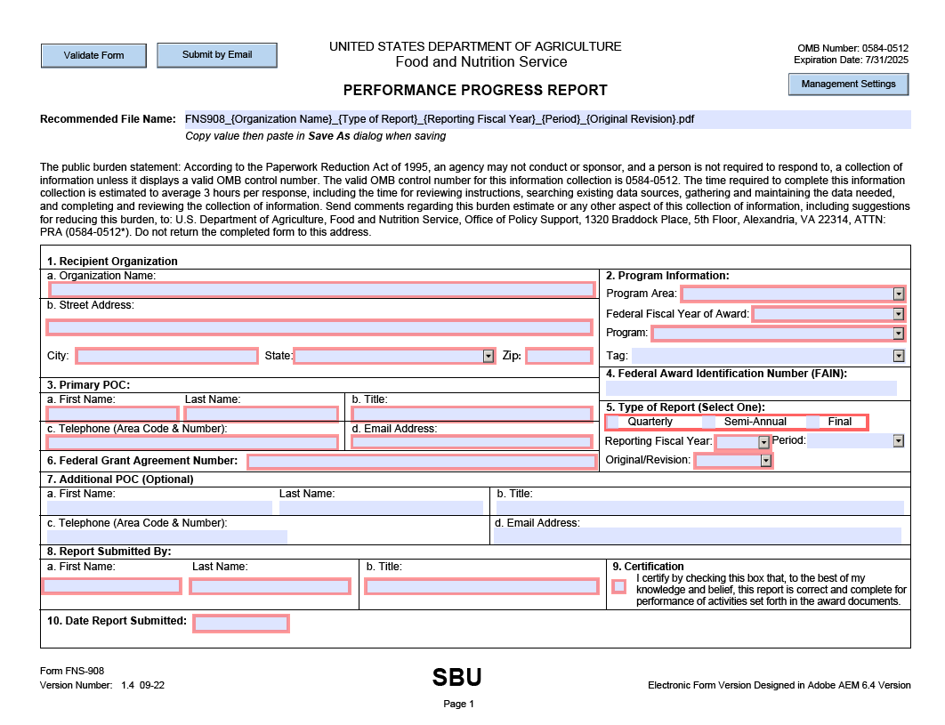

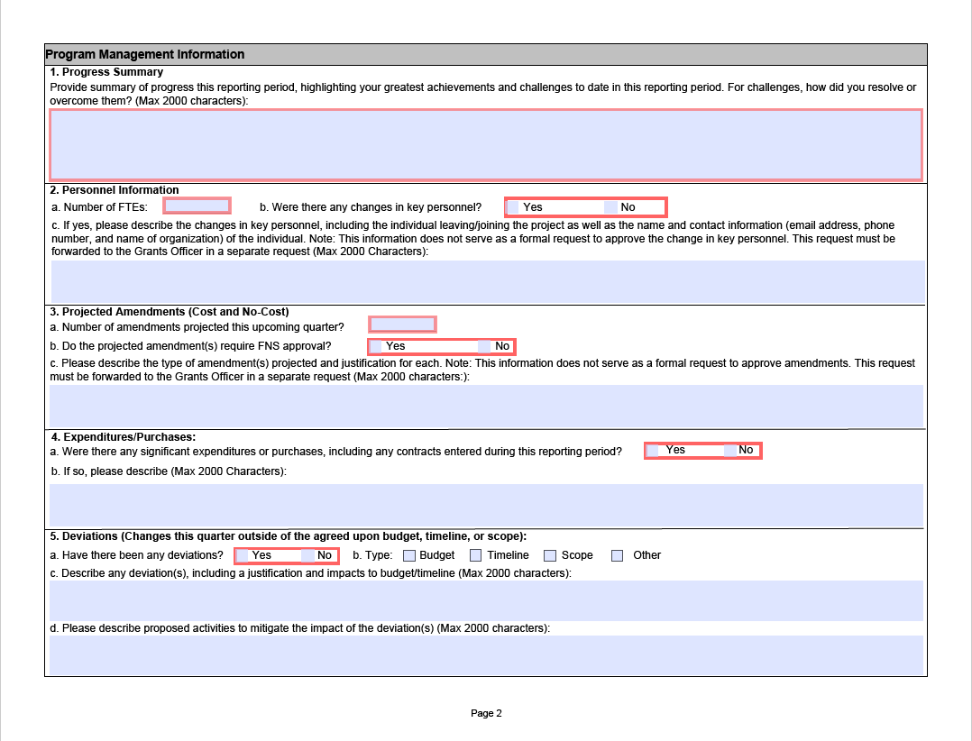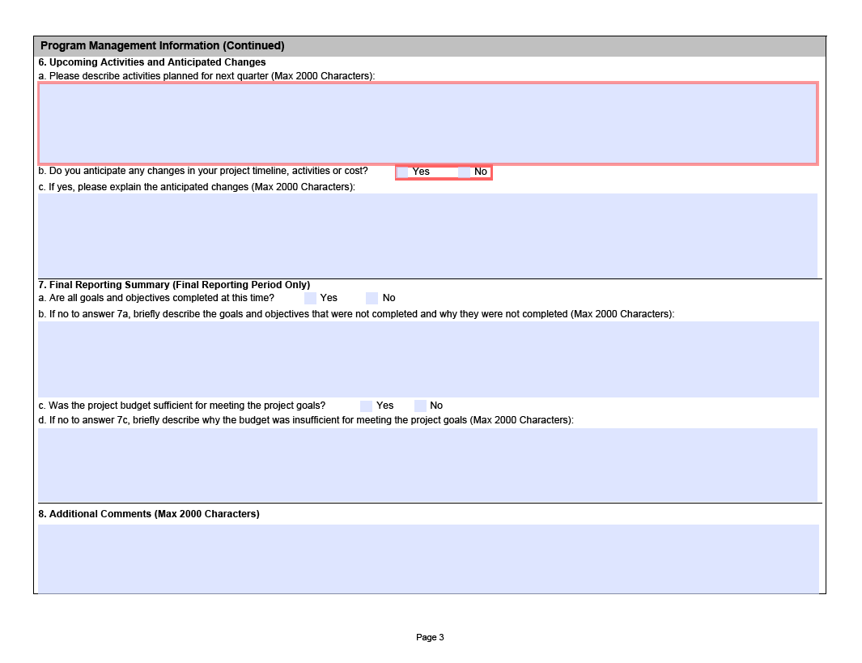
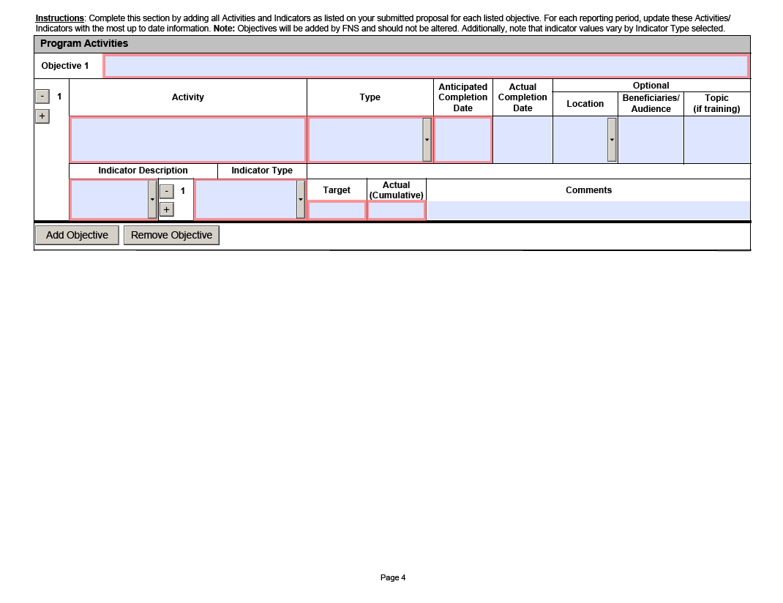

Federal Register. (2022). Available at: https://www.govinfo.gov/content/pkg/FR-2022-11-21/pdf/2022-24705.pdf. Accessed on April 4, 2023.
The exact date of publication of the final rule is unavailable; for planning purposes applicants should estimate the final rule would be published within the next two years.
USDA Food and Nutrition Service. (2022). USDA Actions on Nutrition Security. Available at: https://fns-prod.azureedge.us/sites/default/files/resource-files/usda-actions-nutrition-security.pdf. Accessed on April 1, 2022.
USDA Food and Nutrition Service (2023). National Level Annual Summary. Available at https://www.fns.usda.gov/pd/wic-program. Accessed May 4, 2023.
USDA Food and Nutrition Service. (2022). WIC Food Packages. Available at https://www.fns.usda.gov/wic/wic-food-packages. Accessed April 19, 2023.
National Academies of Sciences, Engineering, and Medicine (NASEM) (2017). Review of WIC Food Packages: Improving Balance and Choice: Final Report. Washington, DC: The National Academies Press. https://doi.org/10.17226/23655.
Federal Register (2014). Available at: Federal Register: Special Supplemental Nutrition Program for Women, Infants and Children (WIC): Revisions in the WIC Food Packages. Accessed May 24, 2023.

